Evaluating methodological constraints in PET Imaging of Neuropeptide Y2 receptors with N-[¹¹C]-methyl-(R)-JNJ-31020028 in brains of C57BL/6J mice.
Karsten Bamminger^{1,4#}, Eduardo Felipe Alves Fernandes^{2#}, Lena Zachhuber^{1,4}, Ines Lopez-Martinez^{1,4}, Claudia Kuntner^{1,5}, Oliver Langer^{3,4}, Severin Mairinger^{3,4}, Berit Ø Christoffersen², Marcus Hacker⁴, Thomas Wanek¹

Supplementary Material

¹ Preclinical Imaging Lab (PIL), Department of Biomedical Imaging and Image-guided Therapy, Medical University of Vienna, Vienna, Austria
² Global Research, Novo Nordisk A/S, Måløv, Denmark
³ Department of Clinical Pharmacology, Medical University of Vienna, 1090 Vienna, Austria
⁴ Division of Nuclear Medicine, Department of Biomedical Imaging and Image-guided Therapy, Medical University of Vienna, Vienna, Austria
⁵ Research Platform Medical Imaging (RPMI), Medical University of Vienna, 1090 Vienna, Austria

# These authors contributed equally to this work

Corresponding Author:

Thomas Wanek
Department of Biomedical Imaging and Image-guided Therapy
Währinger Gürtel 18-20
1090 Vienna
Austria
Email: thomas.wanek@meduniwien.ac.at

Running title: NPY2 Imaging in mice

Table of contents:

Table of contents
1. Synthesis of (R)-JNJ-31020028 3
2. Synthesis of N-methyl-(R)-JNJ-31020028 8
3. Scintillation Proximity Assy (SPA) binding assays 14
3.1 mNPY1 SPA binding assay 14
3.2 mNPY2 SPA binding assay 14
3.3 mNPY4 SPA binding assay 15
3.4 mNPY5 SPA binding assay 15
4. Binding curves to murine NPYR subtypes measured by SPA 18
5. Radiolabeling of N-[¹¹C]methyl-(R)-JNJ-31020028 19
6. Whole-body PET images of N-[¹¹C]methyl-(R)-JNJ-31020028 20
7. Ex vivo Biodistribution of N-[¹¹C]methyl-(R)-JNJ-31020028 21
8. Metabolite analyses of N-[¹¹C]methyl-(R)-JNJ-31020028 22

Synthesis of (R)-JNJ-31020028
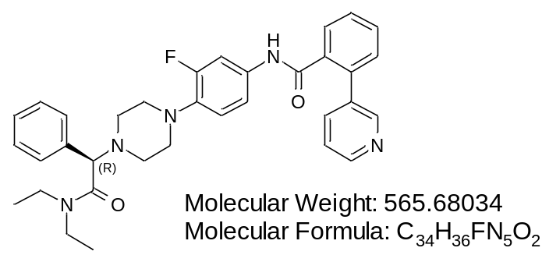

(R)-JNJ-31020028 was synthesized by a contract research organization (Apigenex, Czech Republic) following a procedure previously reported and described below (Scheme 1).¹
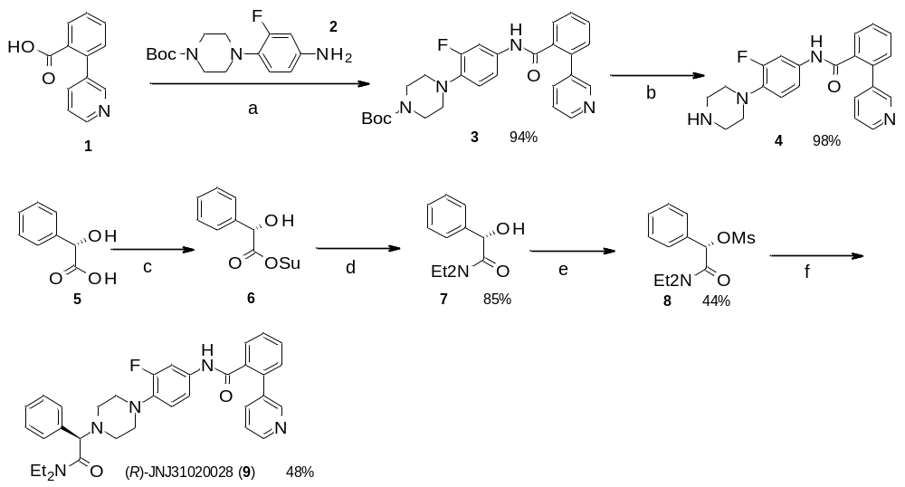
Scheme 1. Reagents and conditions for the synthesis of (R)-JNJ-31020028. (a) 2, HATU, Et₃N, DMF, rt, 4.5 h; (b) 4 M HCl in dioxane, MeOH, rt, 5 h; (c) HOSu, DCC, EtOAc, rt, 4 h; (d) Et₂NH, THF, rt, o/n; (e) MsCl, Et₃N, DCM, 0 °C, 1 h; (f) 4, Na₂CO₃, DMF, 60 °C, o/n.
tert-Butyl 4-(2-fluoro-4-(2-(pyridin-3-yl)benzamido)phenyl)piperazine-1-carboxylate (3)
A solution of 2-(pyridin-3-yl)benzoic acid (1, 1.00 g, 5.00 mmol), 1-((dimethylamino)(dimethyliminio)methyl)-1H-[1,2,3]triazolo[4,5-b]pyridine 3-oxide hexafluorophosphate(V) (HATU, 2.00 g, 5.25 mmol) and triethylamine (1.40 mL, 10.0 mmol) in N,N-dimethylformamide (10 mL) was stirred at room temperature for 30 minutes. tert-Butyl 4-(4-amino-2-fluorophenyl)piperazine-1-carboxylate (2, 1.55 g, 5.25 mmol) was then added and resulting mixture was stirred for 4 hours. Reaction was diluted with water (100 mL) and extracted with ethyl acetate (1 x 150 mL). Organic phase was washed with 5% aqueous solution of lithium chloride (1 x 100 mL), dried and evaporated. The residue was purified by flash column chromatography (Silicagel 60, 0.040-0.063 mm; eluent: dichloromethane/methanol 99:1 to 96:4) to give tert-butyl 4-(2-fluoro-4-(2-(pyridin-3-yl)benzamido)phenyl)piperazine-1-carboxylate (3) as an off-white solid. Yield: 2.23 g (94%).
4-(2-Fluoro-4-(2-(pyridin-3-yl)benzamido)phenyl)piperazin-1-ium chloride (4)
Into the solution of tert-butyl 4-(2-fluoro-4-(2-(pyridin-3-yl)benzamido)phenyl)piperazine-1-carboxylate (3, 2.23 g, 4.68 mmol) in methanol (20 mL) was added 4 M solution of hydrogen chloride in 1,4-dioxane (20 mL) and resulting mixture was stirred for 5 hours. Volatiles were then evaporated and residue was triturated from 1,4-dioxane. Resulting powder was washed with diethyl ether and hexane to afford 4-(2-fluoro-4-(2-(pyridin-3-yl)benzamido)phenyl)piperazin-1-ium chloride (4) as a brown powder. Yield: 1.90 g (98%).
(S)-N,N-Diethyl-2-hydroxy-2-phenylacetamide (7)
A solution of N,N’-dicyclohexylcarbodiimide (4.13 g, 20.0 mmol) in ethyl acetate (15 mL) was added dropwise into the solution of (S)-2-hydroxy-2-phenylacetic acid (5, 3.04 g, 20.0 mmol) and N-hydroxysuccinimide (2.30 g, 20.0 mmol) in tetrahydrofuran (30 mL) and mixture was stirred for 4 hours at room temperature. The resulting precipitate was filtered off; the filtrate was evaporated and re-dissolved in tetrahydrofuran (30 mL). Diethylamine (2.07 mL, 20.0 mmol) was added and reaction was stirred overnight. Volatiles were then evaporated and the residue was partitioned between water (150 mL) and ethyl acetate (150 mL). Organic phase was washed with water (2 x 100 mL), dried and evaporated to afford (S)-N,N-diethyl-2-hydroxy-2-phenylacetamide (7) as a colorless oil. Yield: 3.53 g (85%).
(S)-2-(Diethylamino)-2-oxo-1-phenylethyl methanesulfonate (8)
Methanesulfonyl chloride (1.45 mL, 18.7 mmol) was added dropwise to a solution of (S)-N,N-diethyl-2-hydroxy-2-phenylacetamide (7, 3.53 g, 17.0 mmol) and triethylamine (7.20 mL, 5.16 mmol) in dichloromethane (100 mL) at 0 °C. Reaction was stirred for 1 hour at room temperature. Water (50 mL) was then added and the phases were separated. Organic phase was dried and evaporated. The residue was purified by flash column chromatography (Silicagel 60, 0.040-0.063 mm; eluent: dichloromethane/methanol 100:0 to 99:1). Fractions containing product were evaporated and the residue was crystallized from hexane/ethyl acetate mixture to give (S)-2-(diethylamino)-2-oxo-1-phenylethyl methanesulfonate (8) as colorless crystals. Yield: 2.11 g (44%).
(R)-JNJ-31020028
Suspension of (S)-2-(diethylamino)-2-oxo-1-phenylethyl methanesulfonate (8, 0.57 g, 2.00 mmol), 4-(2-fluoro-4-(2-(pyridin-3-yl)benzamido)phenyl)piperazin-1-ium chloride (4, 1.14 g, 2.40 mmol) and sodium carbonate (636 mg, 6.00 mmol) in N,N-dimethylformamide (10 mL) was stirred at 60 °C overnight. After cooling to room temperature, mixture was diluted with water (100 mL) and extracted with ethyl acetate (2 x 100 mL). Organic phase was washed with 5% aqueous solution of lithium chloride (1 x 100 mL), dried and evaporated. The residue was purified by flash column chromatography (Silicagel 60, 0.040-0.063 mm; eluent: dichloromethane/methanol 99:1 to 95:5). Fractions containing product were evaporated and re-purified by HPLC (Column Gemini, C18, 5 µm, 250 mm x 50 mm, acetonitrile/water 5:95 to 40:60 + 0.1% FA) to give (R)-JNJ-31020028 as a white solid. Yield: 0.54 g (48%). ¹H NMR spectrum (300 MHz, CDCl3): 8.69 (s, 1H, NHCO); 8.58 (d, J=4.1 Hz, 1H, H_{Ar}); 7.74-7.79 (m, 2H, H_{Ar}); 7.58-7.52 (m, 1H, H_{Ar}); 7.51-7.44 (m, 3H, H_{Ar}); 7.43-7.34 (m, 5H, H_{Ar}); 7.33-7.28 (m, 1H, H_{Ar}); 7.14 (s, 1H, H_{Ar}); 6.82-6.72 (m, 2H, H_{Ar}); 3.47-3.36 (m, 2H, CONCH₂CH₃); 3.35-3.25 (m, 2H, CONCH₂CH₃); 3.20-3.05 (m, 2H, NCH₂CH₂); 2.95-2.80 (s, 2H, NCH₂CH₂); 1.09 (t, J= 7.1 Hz, 3H, CONCH₂CH₃); 0.99 (t, J= 7.1 Hz, 3H, CONCH₂CH₃). LC-MS purity: 100% (ELSD). LC-MS R_{t} (Kinetex C18, 4.6 mm x 50 mm, acetonitrile/water 5:95 to 100:0 + 0.1% FA): 3.63 min. LC-MS m/z: 566.2 (M+H)⁺.

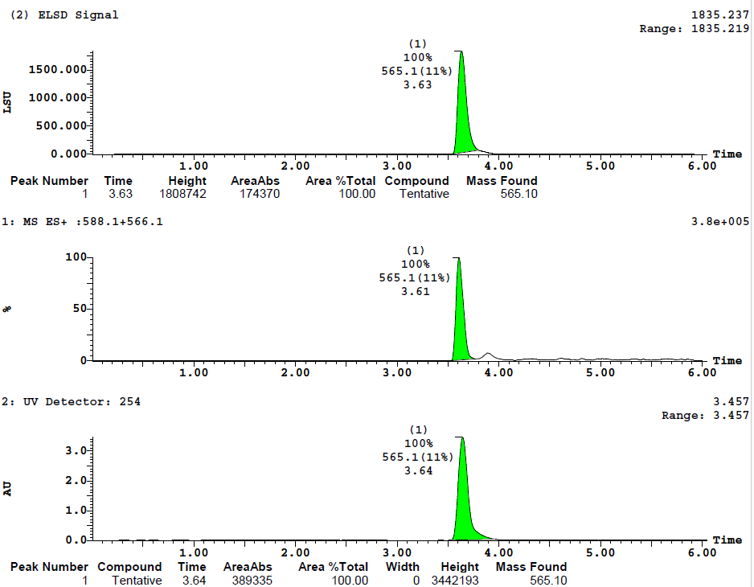
HPLC-UV-MS-ELSD analysis of (R)-JNJ-31020028

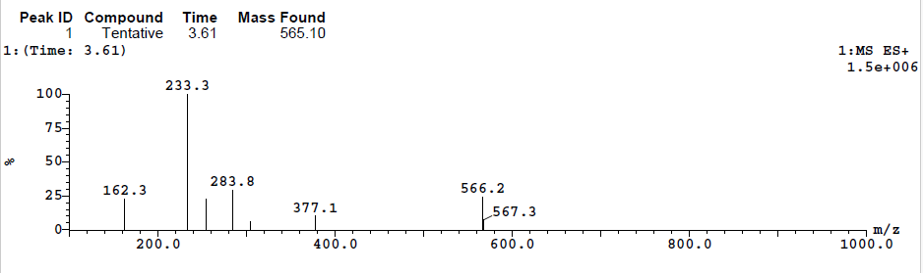

¹H-NMR (300 MHz) of (R)-JNJ-31020028
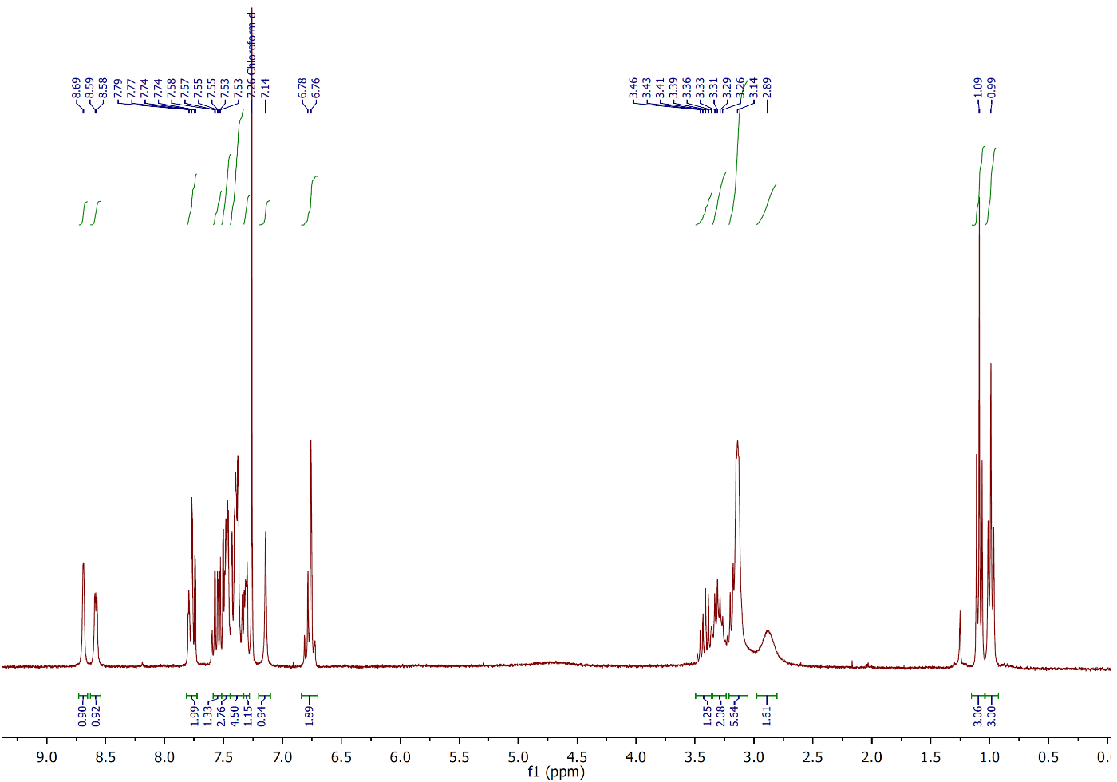

Synthesis of N-methyl-(R)-JNJ-31020028
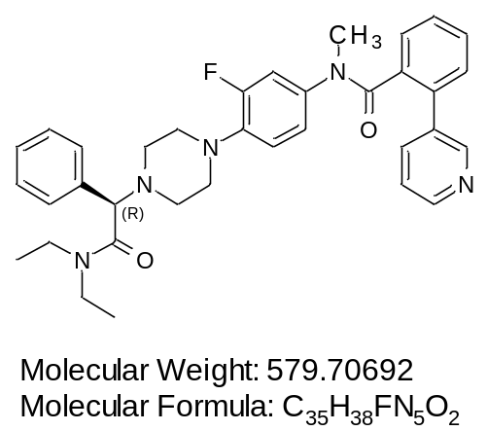

N-Methyl-(R)-JNJ-31020028 was synthesized by a contract research organization (Apigenex, Czech Republic) following the procedure described below (Scheme 2).
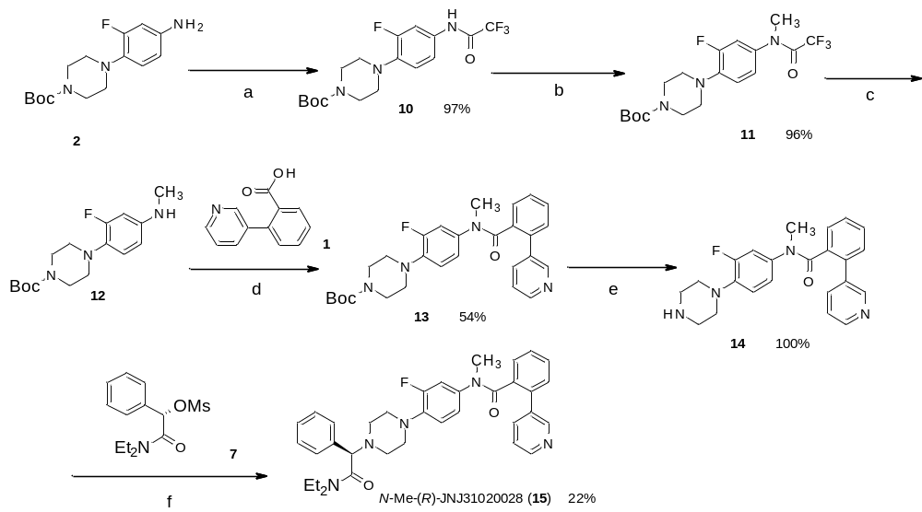
Scheme 2. Reagents and conditions for the synthesis of N-methyl-(R)-JNJ-31020028. (a) Tfa₂O, Et₃N, DCM, RT, 1 h; (b) CH₃I, K₂CO₃, DMF, 45 °C, 5 h; (c) K₂CO₃, aq. MeOH, rt, o/n; (d) 1, HATU, Et₂N, DMF, rt, o/n; (e) 4M HCl in dioxane, MeOH, rt, 5 h; (f) 7, Na₂CO₃, DMF, 60 °C, o/n.
tert-Butyl 4-(2-fluoro-4-(2,2,2-trifluoroacetamido)phenyl)piperazine-1-carboxylate (10)
Solution of tert-butyl 4-(4-amino-2-fluorophenyl)piperazine-1-carboxylate (2, 1.48 g, 5.00 mmol) and triethylamine (1.10 mL, 7.50 mmol) in dichloromethane (20 mL) was cooled to 0 °C and triflouroacetanhydride (0.89 mL, 6.25 mmol) was added dropwise. Reaction was then stirred for 1 hour at room temperature. Mixture was washed with saturated aqueous solution of sodium hydrogen carbonate (1 x 20 mL); organic phase was separated, dried and evaporated. The residue was purified by flash column chromatography (Silicagel 60, 0.040-0.063 mm; eluent: dichloromethane/methanol 100:0 to 99:1) to afford tert-butyl 4-(2-fluoro-4-(2,2,2-trifluoroacetamido)phenyl)piperazine-1-carboxylate (10) as a yellow solid. Yield: 1.90 g (97%).
tert-Butyl 4-(2-fluoro-4-(2,2,2-trifluoro-N-methylacetamido)phenyl)piperazine-1-carboxylate (11)
Methyl iodide (0.33 mL, 5.34 mmol) was added into a suspension of tert-butyl 4-(2-fluoro-4-(2,2,2-trifluoroacetamido)phenyl)piperazine-1-carboxylate (10, 1.90 g, 4.85 mmol) and potassium carbonate (0.48 g, 3.42 mmol) in N,N-dimethylformamide (20 mL) and mixture was stirred for 5 hours at 45 °C. After cooling to room temperature, water (200 mL) was added to the reaction and resulting mixture was extracted with ethyl acetate (2 x 100 mL). Organic phase was washed with 5 % aqueous solution of lithium chloride (1 x 50 mL), dried and evaporated. The residue was purified by flash column chromatography (Silicagel 60, 0.040-0.063 mm; eluent: dichloromethane/methanol 100:0 to 99:1) to afford tert-butyl 4-(2-fluoro-4-(2,2,2-trifluoro-N-methylacetamido)phenyl)piperazine-1-carboxylate (11) as a yellow oil. Yield: 1.90 g (96%).
tert-Butyl 4-(2-fluoro-4-(methylamino)phenyl)piperazine-1-carboxylate (12)
Into a solution of tert-butyl 4-(2-fluoro-4-(2,2,2-trifluoro-N-methylacetamido)phenyl)piperazine-1-carboxylate (11, 1.90 g, 4.68 mmol) in methanol (25 mL) was added a solution of potassium carbonate (0.65 g, 4.68 mmol) in water (8 mL) and mixture was stirred overnight at room temperature. Methanol was then evaporated and the residue was partitioned between water (100 mL) and dichloromethane (150 mL). Organic phase was dried and evaporated to afford tert-butyl 4-(2-fluoro-4-(methylamino)phenyl)piperazine-1-carboxylate (12) as a yellow solid. Yield: 1.45 g (100%). LC-MS purity: 100% (ELSD). LC-MS R_{t} (Kinetex C18, 4.6 mm x 50 mm, acetonitrile/water 40:60 to 100:0 + 0.1% FA): 2.76 min. LC-MS m/z: 310.2 (M+H)⁺.
tert-Butyl 4-(2-fluoro-4-(N-methyl-2-(pyridin-3-yl)benzamido)phenyl)piperazine-1-carboxylate (13)
Solution of 2-(pyridin-3-yl)benzoic acid (1, 0.89 g, 4.46 mmol), 1-((dimethylamino)(dimethyliminio)methyl)-1H-[1,2,3]triazolo[4,5-b]pyridine 3-oxide hexafluorophosphate(V) (HATU, 1.78 g, 4.68 mmol) and triethylamine (1.90 mL, 13.4 mmol) in N,N-dimethylformamide (10 mL) was stirred at room temperature for 30 minutes. tert-Butyl 4-(2-fluoro-4-(methylamino)phenyl)piperazine-1-carboxylate (12, 1.45 g, 4.68 mmol) was then added and resulting mixture was stirred for another 4 hours. Reaction was diluted with water (100 mL) and extracted with ethyl acetate (1 x 150 mL). Organic phase was washed with 5% aqueous solution of lithium chloride (1 x 100 mL), dried and evaporated. The residue was purified by flash column chromatography (Silicagel 60, 0.040-0.063 mm; eluent: dichloromethane/methanol 99:1 to 96:4) to give tert-butyl 4-(2-fluoro-4-(N-methyl-2-(pyridin-3-yl)benzamido)phenyl)piperazine-1-carboxylate (13) as a brown solid. Yield: 1.44 g (59%).
4-(2-fluoro-4-(N-methyl-2-(pyridin-3-yl)benzamido)phenyl)piperazin-1-ium chloride (14)
tert-Butyl 4-(2-fluoro-4-(N-methyl-2-(pyridin-3-yl)benzamido)phenyl)piperazine-1-carboxylate (13, 1.44 g, 2.94 mmol) was dissolved in methanol (15 mL) and 4 M solution of hydrogen chloride in 1,4-dioxane (15 mL) was added. Mixture was stirred for 5 hours at room temperature. Volatiles were then evaporated and the residue was triturated from diethyl ether to give 4-(2-fluoro-4-(N-methyl-2-(pyridin-3-yl)benzamido)phenyl)piperazin-1-ium chloride (14) as a brown solid. Yield: 1.26 g (100%). LC-MS purity: 100% (ELSD). LC-MS R_{t} (Kinetex C18, 4.6 mm x 50 mm, acetonitrile/water 5:95 to 100:0 + 0.1% FA): 3.13 min. LC-MS m/z: 391.1 (M+H)⁺.
N-Methyl-(R)-JNJ-31020028
Suspension of (S)-2-(diethylamino)-2-oxo-1-phenylethyl methanesulfonate (7, 0.70 g, 2.45 mmol), 4-(2-fluoro-4-(N-methyl-2-(pyridin-3-yl)benzamido)phenyl)piperazin-1-ium chloride (14, 1.26 g, 2.94 mmol) and sodium carbonate (0.78 g, 7.35 mmol) in N,N-dimethylformamide (10 mL) was stirred at 60 °C overnight. After cooling to room temperature, mixture was diluted with water (100 mL) and extracted with ethyl acetate (2 x 100 mL). Organic phase was washed with 5% aqueous solution of lithium chloride (1 x 100 mL), dried and evaporated. The residue was purified by HPLC (Column Gemini, C18, 5 µm, 250 mm x 50 mm, acetonitrile/water 5:95 to 40:60 + 0.1% HCOOH) to give N-methyl-(R)-JNJ-31020028 as a white solid. Yield: 370 mg (22%). ¹H NMR spectrum (300 MHz, CDCl₃): 8.59 (dd, J= 4.8, 1.2 Hz, 1H, H_{Ar}); 8.22 (d, J= 1.8 Hz, 1H, H_{Ar}); 7.58 (dd, J= 7.3, 1.6 Hz, 1H, H_{Ar}); 7.49 (dt, J= 7.8, 2.0 Hz, 1H, H_{Ar}); 7.45- 7.38 (m, 3H, H_{Ar}); 7.38-7.28 (m, 5H, H_{Ar}); 7.09 (dd, J= 7.4, 1.3 Hz, 1H, H_{Ar}); 6.45 (t, J = 9.2 Hz, 1H, H_{Ar}); 5.88 (td, J= 9.0, 2.4 Hz, 2H, H_{Ar}); 4.26 (s, 1H, CH-CONCH₂CH₃); 3.50-3.37 (m, 2H, CONCH₂CH₃); 3.35-3.23 (m, 2H, CONCH₂CH₃); 3.20 (s, 3H, N-CH₃); 3.05-2.95 (m, 4H, NCH₂CH₂); 2.75-2.55 (m, 4H, NCH₂CH₂); 1.08 (t, J= 7.1 Hz, 3H, CONCH₂CH₃); 1.02 (t, J= 7.1 Hz, 3H, CONCH₂CH₃).
LC-MS purity: 100% (ELSD). LC-MS R_{t} (Kinetex C18, 4.6 mm x 50 mm, acetonitrile/water 5:95 to 100:0 + 0.1% FA): 3.73 min. LC-MS m/z: 580.2 (M+H)⁺.

HPLC-UV-MS-ELSD analysis of N-Methyl-(R)-JNJ-31020028
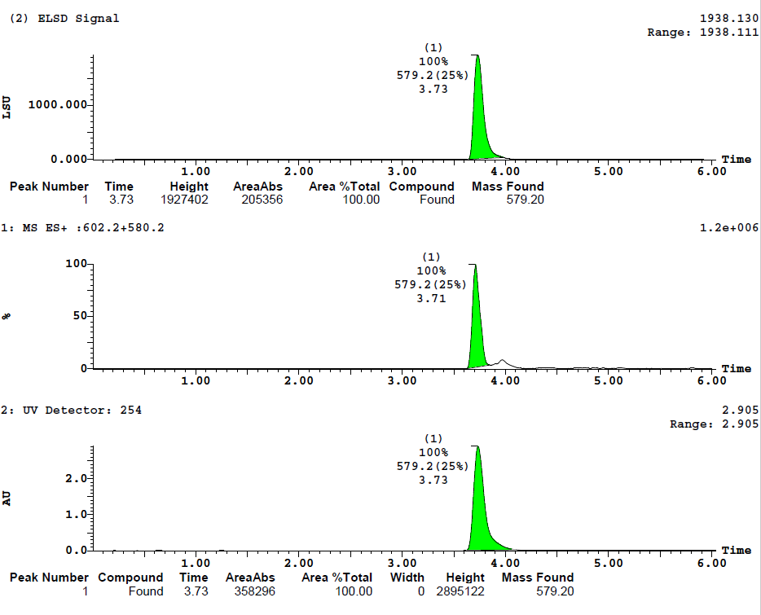

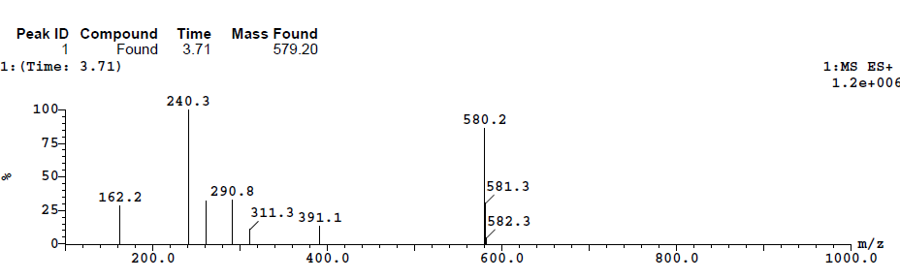

¹H-NMR (300 MHz) of N-Methyl-(R)-JNJ-31020028
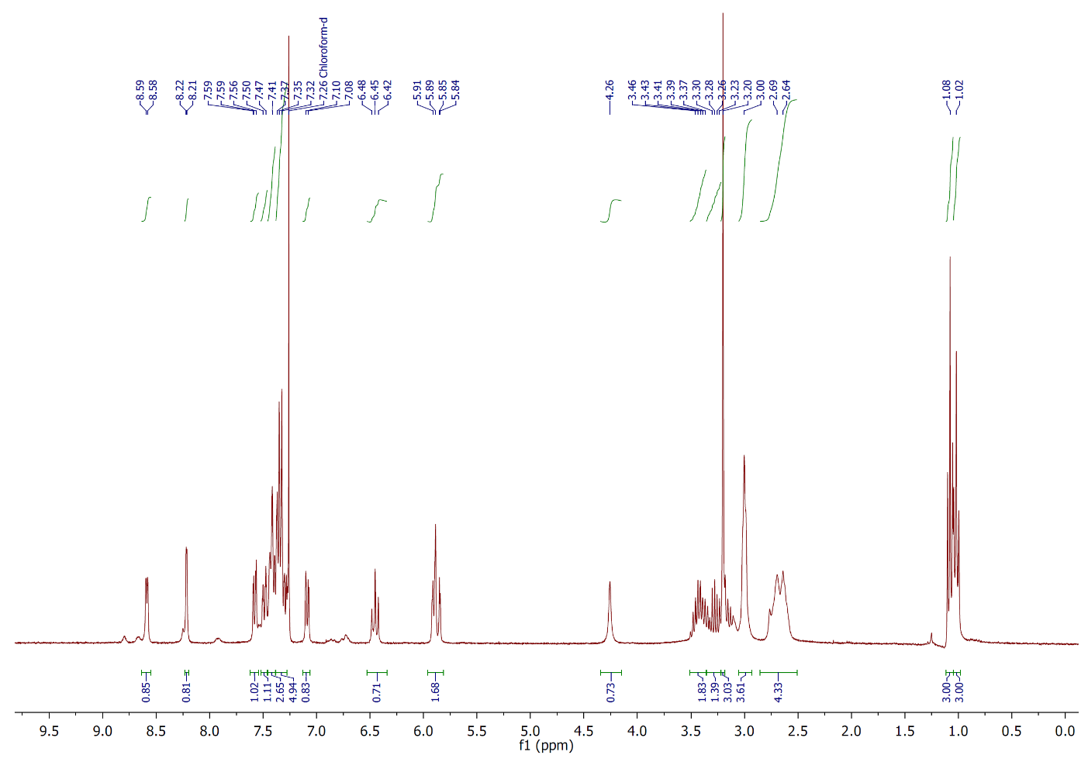

Scintillation Proximity Assy (SPA) binding assays

mNPY1 SPA binding assay
Beads were reconstituted in Y1 SPA buffer (50 mM HEPES, 1 mM CaCl₂, 5 mM MgCl₂, 0.02% Tween 20, 0.25% Ovalbumin, pH 7.4) at 5 mg/mL and mixed with the membrane suspension expressing the mNPY₁ receptor (UniProt: Q04573, 400 µg/mL) at a 2:1 ratio (v/v) to a final SPA beads concentration of 3.3 mg/mL and of 133.3 µg/mL of protein membranes. 150 uL of this mixture was added to each well (20 µg of protein and 0.5 mg of beads). Stock solutions of tested compounds were serially diluted in Y1 SPA buffer (final DMSO concentration < 1%) and added to the wells (25 µL) followed by 25 µL (50.000 dpm, final concentration: 50 pM) of human [¹²⁵I]-Peptide YY₁₋₃₆ (Perkin Elmer, #NEX341). The plate was sealed and incubated at 25 °C for 2 hours in an iEMS plate shaker (Thermo Fisher Scientific) set at 400 rpm and thereafter centrifuged at 1500 rpm for 10 minutes (Heraeus Multifuge 3s) and incubated in room temperature for 16 hours before reading the SPA bead light emission.

mNPY2 SPA binding assay
Beads were reconstituted in Y2 SPA buffer (50 mM HEPES, 1 mM CaCl₂, 5 mM MgCl₂, 0.02% Tween 20, 0.25% Ovalbumin, pH 7.4) at 5 mg/mL and mixed with the membranes suspension expressing the mNPY₂ receptor (UniProt: P97295, 60 µg/mL) at a 2:1 ratio (v/v) to a final SPA beads concentration of 3.3 mg/mL and 20 µg/mL of protein membranes. 150 uL of this mixture was added to the each well (3 µg of membranes and 0.5 mg of beads). Stock solutions of tested compounds were serially diluted in Y2 SPA buffer (final DMSO concentration < 1%) added to the wells (25 µL) followed by 25 µL (50.000 dpm, final concentration: 50 pM) of human [¹²⁵I]-Peptide YY₁₋₃₆ (Perkin Elmer, #NEX341). The plate was sealed and incubated at 25 °C for 2 hours in an iEMS plate shaker (Thermo Fisher Scientific) set at 400 rpm and thereafter centrifuged at 1500 rpm for 10 minutes (Heraeus Multifuge 3s) and immediately measured via SPA bead light emission.

mNPY4 SPA binding assay
Beads were reconstituted in Y4 SPA buffer (20 mM HEPES, 10 mM NaCl, 0.2 mM KH₂PO₄, 1.3 mM CaCl₂, 0.8 mM MgCl₂, 0,1% bacitracin, 0.25% Ovalbumin, pH 7.4) at 5 mg/mL and mixed with the membranes suspension expressing the mNPY₄ receptor (UniProt: Q61041, 20 µg/mL ) to a final SPA beads concentration of 3.3 mg/mL and membranes of 6.6 µg/mL. 150 uL of this mixture was added to each well (1 µg of membranes and 0.5 mg of beads). Stock solutions of tested compounds were serially diluted in Y4 SPA buffer (final DMSO concentration < 1%) added to the wells followed by 25 µL (50.000 dpm, final concentration 50 pM) of human [¹²⁵I]-Pancreatic polypeptide (Isotope Chemistry Department, Novo Nordisk A/S. The plate was sealed and incubated at 25 °C for 2 hours in an iEMS plate shaker (Thermo Fisher Scientific) set at 400 rpm and thereafter centrifuged at 1500 rpm for 10 minutes (Heraeus Multifuge 3s) and immediately measured via SPA bead light emission.

mNPY5 SPA binding assay
Cell culture: Human embryonic kidney (HEK293) cells were cultured at 37 °C in a humidified atmosphere with 5% CO₂ in DMEM (Lonza) with 10% heat inactivated FBS (Gibco®), and 1% Penicillin-Streptomycin (Lonza). The expression vector pcDNA3 (Life Technologies) with cDNA encoding for mouse Y5 receptor (Uniprot: O70342) was used for transient transfections. Cells were cultured in 500 cm² Nunclon dishes (Thermo Fisher Scientific) to approximately 80% confluency. For each individual cell culture dish, 2.4 ml of DMEM medium, without serum, was mixed with 150 μl of FuGENE® transfection reagent ( Promega, # E2691) and incubated for 5 minutes. 46 μg of the plasmid was added to the solution and incubated for 20 minutes before being added to the cultured cells. Cells were incubated for 24 hours for transfection and expression of the constructs.
Membrane preparation
Cells were detached mechanically by scraping. Plates were washed in ice cold DPBS buffer (Lonza, #17-512F) and cells were transferred to tubes and centrifuged for 5 min at 1000 g at 4 °C in a Heraeus Multifuge 3s (Thermo Fisher Scientific). Pellets were resuspended in ice cold buffer (20 mM HEPES, 10 mM EDTA, pH 7.4) homogenized for 30 seconds using an Ultra-Turrax T25 homogenizer (IKA, Staufen, Germany) at medium speed. The homogenate was centrifuged at 35000 g (18000 rpm) using a Sorvall RC6+ ultracentrifuge (Thermo Fisher Scientific) for 15 minutes at 4 °C and the supernatant was discarded. The pellet was reconstituted in Y₅ homogenization buffer (20 mM HEPES, 10 mM NaCl, 0.2 mM KH₂PO₄, 1.3 mM CaCl₂, 0.8 mM MgCl₂, 0,1% bacitracin, 0.25% Ovalbumin, pH 7.4) containing one cOmplete™ EDTA-free protease inhibitor cocktail tablet/50 ml (Roche Diagnostics, #11873580001). Homogenization of the pellet was repeated two more times. The final pellet was resuspended in Y5 homogenization buffer and protein concentration was determined by Bio-Rad protein assay kit II (Hercules, #500-0002). Samples were stored at -80 °C until the assay
Assay
Beads were reconstituted in Y5 SPA buffer (10 mM NaCl, 20 mM Hepes, 0.22 mM KH₂PO₄, 1.26 mM CaCl₂, 0.81 mM MgSO₄, pH 7.4) at 5 mg/mL and mixed with the membrane suspension expressing the mNPY₅ receptor (200 µg/mL) at a 2:1 (v/v) ratio to a final SPA beads concentration of 3.3 mg/mL and membranes of 66.6 µg/mL. 150 uL of this mixture was added to the each well (10 µg of membranes and 0.5 mg of beads). Stock solutions of tested compounds were serially diluted in Y5 SPA buffer (final DMSO concentration < 1%) added to the wells (25 µL) followed by 25 µL (50.000 dpm, final concentration 50 pM) of human [¹²⁵I]-Peptide YY₁₋₃₆ (Perkin Elmer, # NEX341). The plate was sealed and incubated at 25 °C for 2 hours in an iEMS plate shaker (Thermo Fisher Scientific) set at 400 rpm and thereafter centrifuged at 1500 rpm for 10 minutes (Heraeus Multifuge 3s) and immediately measured via SPA bead light emission.

Binding curves to murine NPYR subtypes measured by SPA
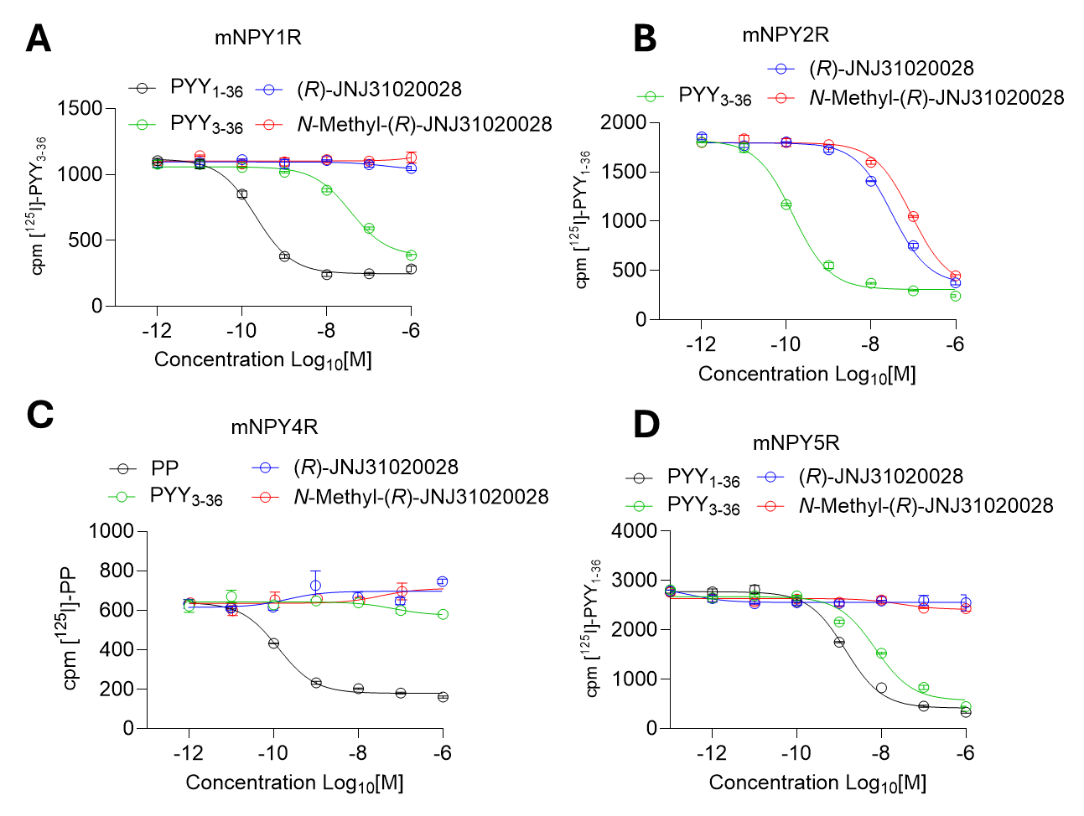

Figure S1: Representative inhibition curves of [¹²⁵I]PYY and [125I]PP binding by (R)-JNJ-31020028 and N-methyl-(R)-JNJ-31020028 to murine NPY receptor subtypes (A) Y₁, (B) Y₂, (C) Y_{4,} and (D) Y₅ expressing HEK239 cell membranes. Mean IC₅₀ values are summarized in Table 1 of the main manuscript.

Radiolabeling of N-[¹¹C]methyl-(R)-JNJ-31020028
Figure S2: (A) Analytical HPLC chromatogram of purified N-[¹¹C]methyl-(R)-JNJ-31020028 formulated for intravenous administration, showing a radiochemical purity >98%. (B) Analytical HPLC chromatogram of N-[¹¹C]methyl-(R)-JNJ-31020028 co-injected with the unlabeled precursor (R)-JNJ-31020028, illustrating clear baseline separation between the two compounds. Radioactivity detection is shown in the upper trace, UV absorbance at 254 nm in the lower trace. HPLC conditions are detailed in the Experimental Section.

Whole-body PET images of N-[¹¹C]methyl-(R)-JNJ-31020028
Figure S3: Representative horizontal PET summation images (0–60 minutes) depicting whole-body distribution of N-[¹¹C]methyl-(R)-JNJ-31020028 in male C57BL/6J mice. Mice were pretreated 30 minutes prior to PET imaging with either (A) vehicle (2.5% w/v aqueous glucose solution) or (B) the P-glycoprotein inhibitor tariquidar (TQD; 10 mg/kg body weight; 4 mL/kg injection volume). Images are presented in units of percent injected dose per cubic centimeter (%ID/cc). For anatomical reference in the liver region, the same transversal image plane is shown with two different image intensity ranges: 0–5 %ID/cc (left) and 0–50 %ID/cc (right).

Ex vivo Biodistribution of N-[¹¹C]methyl-(R)-JNJ-31020028
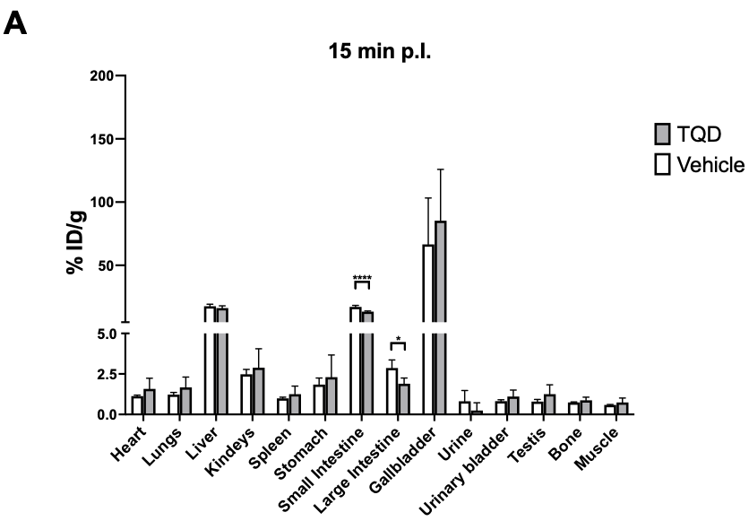
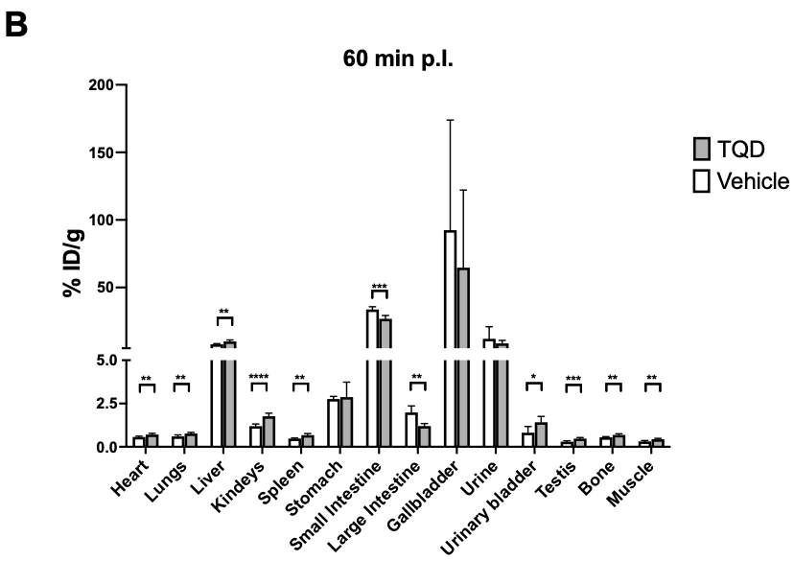
Figure S4: Biodistribution of N-[¹¹C]methyl-(R)-JNJ-31020028 in male C57BL/6J mice (n = 4–5 per group) at (A) 15 min and (B) 60 min following intravenous administration. Mice were pretreated 30 min prior to tracer injection with either vehicle (2.5% [w/v] aqueous glucose solution;) or the P-glycoprotein inhibitor tariquidar (TQD; 10 mg/kg body weight; 4 mL/kg injection volume). Data are expressed as mean ± SD. Statistical comparisons between CTRL and TQD groups at each time point were performed using Student’s t-test.*p < 0.05, **p < 0.01, ***p < 0.001, ****p < 0.0001; ns, not significant.

Metabolite analyses of N-[¹¹C]methyl-(R)-JNJ-31020028
Figure S5: Representative thin-layer chromatography (TLC) analyses of tissues collected at 15 and 60 minutes following intravenous administration of N-[¹¹C]methyl-(R)-JNJ-31020028 in male C57BL/6J mice. Animals were pretreated 30 minutes before PET imaging with either vehicle (2.5% w/v aqueous glucose solution) or the P-glycoprotein inhibitor tariquidar (TQD; 10 mg/kg body weight, 4 mL/kg injection volume). Plasma and urine samples were deproteinized with acetonitrile; brain tissue was homogenized and similarly treated with acetonitrile. Following centrifugation, supernatants were spotted on Merck silica gel 60 F₂₅₄ TLC plates and developed for 20 minutes using a mobile phase consisting of ethyl acetate/ethanol/ammonia (25%) in a 15:5:1 ratio (v/v/v). Arrow indicates the direction of mobile phase migration. Std (diluted N-[¹¹C]methyl-(R)-JNJ-31020028 solution); S (Start); F (Mobile phase front); DLU (Digital light units).

