Preclinical characterization of 3p-C-DEPA_{-NCS} and 3p-C-DEPA_{-TFP}-PEG₄ as potential Actinium-225 bifunctional chelators using DOTA_{-NCS} and macropa_{-NCS} as benchmarks.
Jessica Pougoue Ketchemen^{1,2‡}, Stephen Ahenkorah^{3,4,5‡}, Emmanuel Nwangele^{1,2}, Siphelele Siphesihle Pearl Malaza⁴, Maarten Ooms³, Thomas Cardinaels^{6,7}, Simon Leekens⁴, Frederik Cleeren^{4*}, Humphrey Fonge^{1,2,8*}
¹Faculté de Pharmacie, Université Laval, Québec, QC, Canada
²Axe Oncologie, Centre de Recherche du CHU de Québec-Université Laval, Québec, QC, Canada
³Nuclear Medical Applications Institute, Belgian Nuclear Research Center (SCK CEN), Mol, Belgium.
⁴Radiopharmaceutical Research, Department of Pharmaceutical and Pharmacological Sciences, University of Leuven, Leuven, Belgium.
⁵Department of Radiology, University of Iowa Health Care, 200 Hawkins Drive, Iowa City, IA, USA
⁶Department of Chemistry, University of Leuven, Leuven, Belgium
⁷Flemish Institute for Technological Research (VITO), Materials and Chemistry Unit, Mol, Belgium
⁸Department of Medical Imaging, College of Medicine, University of Saskatchewan, Saskatoon, SK, Canada

Supplementary information:
Chemicals
Triethylamine was purchased from Sigma-Aldrich and used without purification. All HPLC grade solvents used were purchased from Merck and de-ionized water was generated in-house using a Millipore water purification system. Bis-TFP-PEG₄ was purchased from MedChemExpress (Monmouth Junction, NJ).

Synthesis, purification and characterization of 3p-C-DEPA_{-TFP}-PEG₄
3p-C-DEPA-NH₂ (^{t}Bu₅) was synthesized analogous to the method by Song et al. [1] 16.2 mg (1 molar eq.) of 3p-C-DEPA-NH2 (tBu)5 in 0.5 mL ACN was added to 1.5 molar eq. of TFP-PEG₄-TFP (MedChemExpress, Monmouth Junction, USA) and 1.5 molar eq. of DIPEA in 0.5 mL ACN (drop-by-drop). The reaction was carried out at 60°C, for 48 h under continuous stirring. The resulting crude mixture was purified using preparative HPLC. 3p-C-DEPA-TFP(tBu)₅ was redissolved in 2 mL 100% TFA and left to deprotect for 4.5 h under continuous stirring at room temperature followed by purification using preparative HPLC.
Preparative HPLC was performed using an Agilent 1100 Series HPLC system fitted with an X-Bridge C-18 (5 µm, 4.6 x 250 mm) column and injection volume of 10 – 15 µL. The analysis software was GINA star 5.8 (Elysia-Raytest). Mobile phase comprised of 0.1%TFA/deionized Water (solvent A) and 0.1%TFA/Acetonitrile (solvent B) at a flow rate of 1 mL/min over 30 minutes. To remove impurities, a gradient of 30 – 80% solvent B over 10 minutes followed by isocratic 10% solvent B over 5 minutes was used. Thereafter, isocratic 95% solvent B for 10 minutes to elute the desired compound. Subsequently, the mobile phase was set to a gradient from 95 – 30% solvent B for equilibration. The collected fractions were dried using a benchtop Labconco FreeZone 2.5 L freeze dryer at -84 ºC prior to characterization.
Nuclear magnetic resonance (NMR) spectra were recorded on a Bruker Ultrashield 300 Plus spectrometer (¹H: 300 MHz, ¹⁹F{¹H}:282 MHz) at ambient temperature. All chemical shifts are reported in the standard δ notation of parts per million using tetramethylsilane (TMS) as an internal standard and were referenced relative to the signal of the deuterated solvent, DMSO-d₆. The J coupling constants are reported in Hertz (Hz). Spin multiplicities are reported in abbreviated conventional format (s = singlet, m = multiplet, d = doublet, br t = broad triplet). ¹H NMR (300 MHz, DMSO-d₆) δ 9.86 (s, 1H), 7.97-7.88 (m, 1H), 7.50 (d, ²J =9 Hz, 2H) , 7.12 (d, ²J =9 Hz, 2H) , 4.20 - 4.23 (m, 4H), 3.89 - 3.68 (coalesce signals, 28H), 3.18- 2.99 (coalesce signals, 10H), 2.43 (br t, 2H) 2.28 (s, 2H), 1.82 (s, 2H), 1.56 - 1.40 (coalesce signals, 10H), 1.23 (s, 6H), 0.8- 0.83 (m, 2H).
Purity and identity of the end-product was verified using LC-HRMS. LC-MS data was obtained using a Waters e-2695 Separations Module coupled to a Waters 2998 PDA UV Detector (λ =210-400 nm) and a Waters Acquity ESI QDa (negative mode, 100-1200 Da) system. The data was analysed using Waters’ Empower 3 software. The column used was an X-Bridge C-18 (3.5 µm, 3.0 x 100 mm). The mobile phase comprised 0.1% formic acid/deionized Water (solvent A) and 0.1% formic acid/Acetonitrile (solvent B) at a flow rate of 0.8 mL/min. The mobile phase was isocratic 5% solvent B for 3 minutes, a gradient of 5 – 95% solvent B over 10 minutes and isocratic 95% solvent B for a minute followed by 5% solvent B for 2 minutes. The following m/z value was observed after deprotection; 532.37 (calculated for C₄₇H₆₆F₄N₆O₁₇ [M + 2H]^{2+;} 532.23).

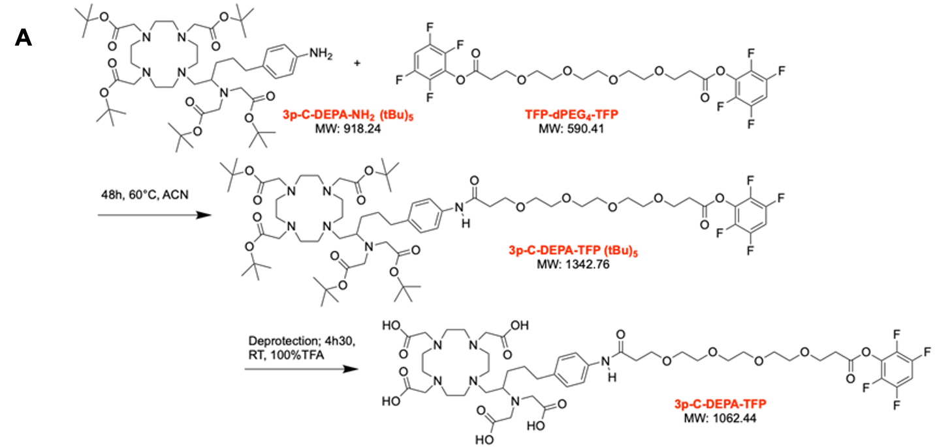
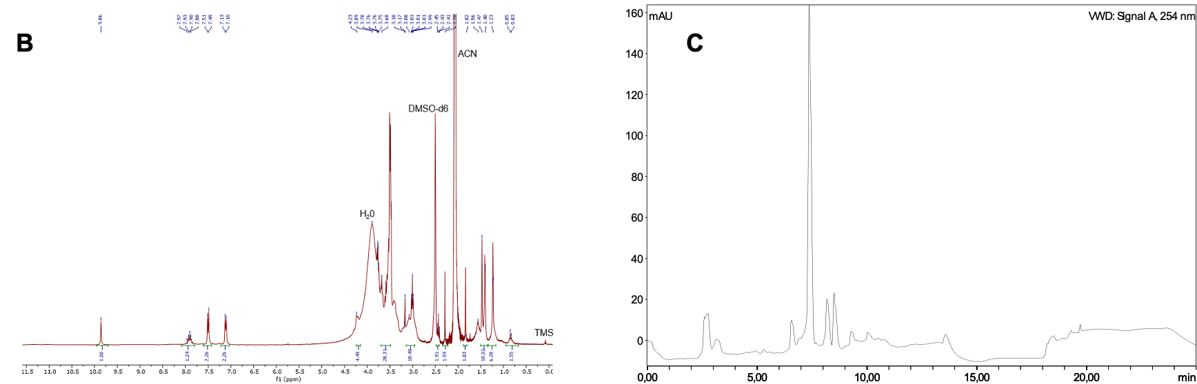
Fig. S1: Synthesis and analyses of 3p-C-DEPA_{-TFP}-PEG₄. (A) reaction scheme, (B) ¹H-NMR spectrum of 3p-C-DEPA_{-TFP}-PEG₄ in DMSO-d6; (D) High Performance Liquid Chromatography (HPLC) of the crude reaction mixture of 3p-C-DEPA_{-TFP}-PEG₄ using X-Bridge C18 column (5 µm) 4.6 X 250 mm.

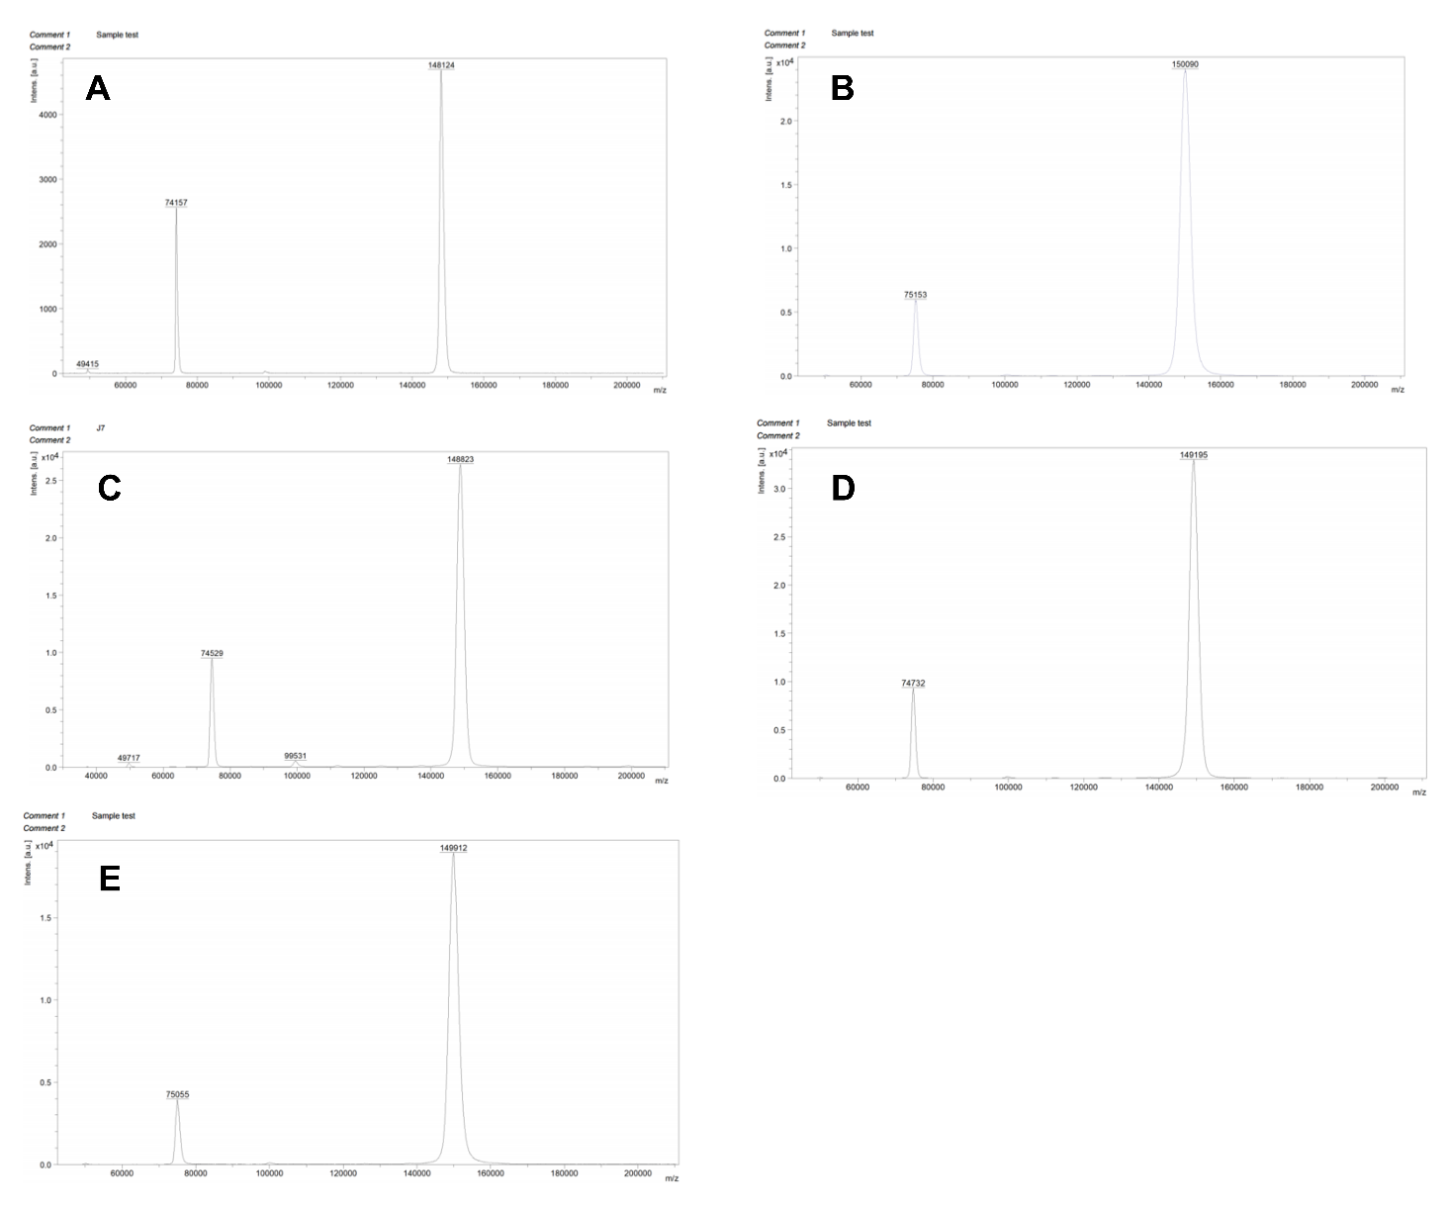
Fig. S2: Matrix-assisted laser desorption/ionization- Time of flight (MALDI-TOF) mass spectrometry of trastuzumab and its conjugates. (A) trastuzumab, and (B) DOTA-trastuzumab, (C) 3p-C-DEPA-trastuzumab, (D) macropa-trastuzumab, and (E) 3p-C-DEPA_{-TFP}-PEG₄-trastuzumab

Table S1. Chelator-to-antibody ratio (CAR) of trastuzumab immunoconjugates based on MALDI-TOF mass spectrometry.

Construct | 3p-C-DEPA-trastuzumab | DOTA-trastuzumab | Macropa-trastuzumab | 3p-C-DEPA-_{TFP}-PEG₄-trastuzumab
Chelator-to-antibody ratio (CAR) | 1.2 | 3.6 | 2.1 | 2.0

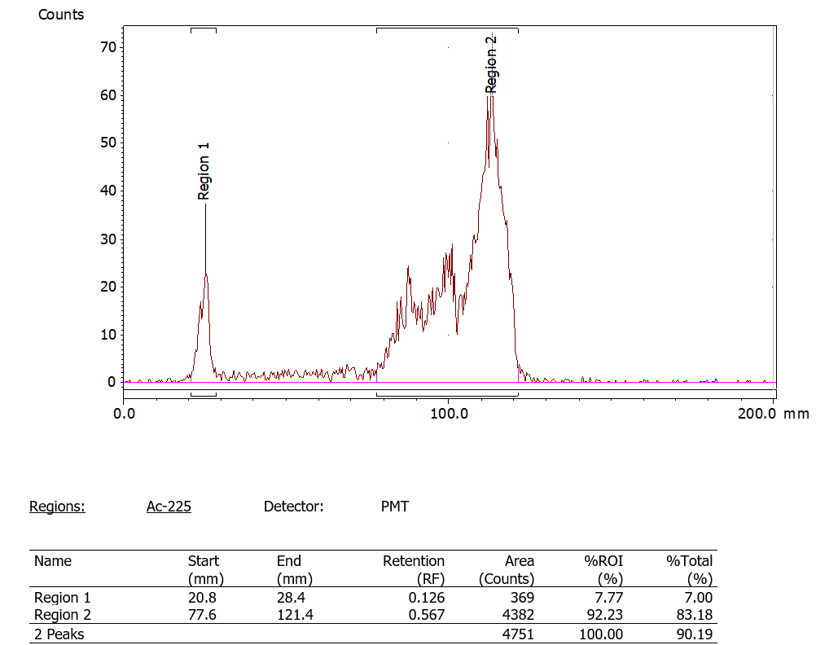
Fig. S3. Radio Instant thin layer chromatography (radio-iTLC) of free actinium nitrate [²²⁵Ac]AcNO₃. More than 92% of free actinium (²²⁵Ac) is observed at the top of the ITLC strip.

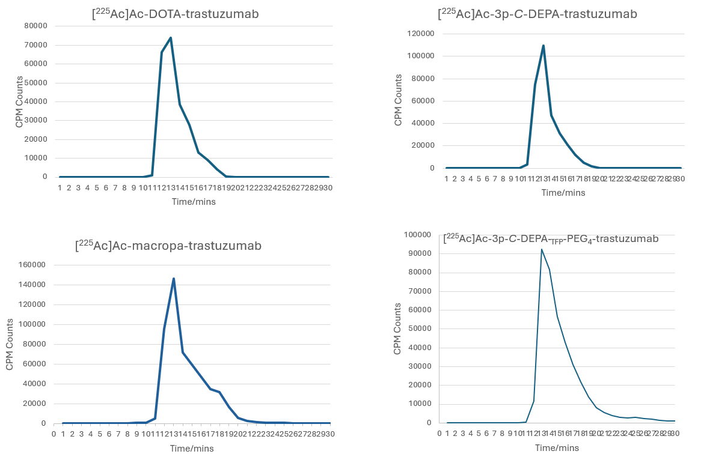
Fig. S4. Radio-SEC HPLC of radioimmunoconjugates (RIC). Each 50 kBq of radioimmunoconjugate (RIC) was injected in the radio-SEC HPLC for a 30 minute run. The activity of the samples collected into tubes were counted using the gamma counter and the results were then plotted with respect to time, confirming the purity of the RICs.

Table S2: Biodistribution of [²²⁵Ac]Ac-labeled antbody conjugates expressed as % injected activity per gram tissue (%IA/g)
Organs % IA/g (mean ± SEM) | [²²⁵Ac]Ac-3p-C-DEPA-trastuzumab | [²²⁵Ac]Ac-DOTA-trastuzumab | [²²⁵Ac]Ac-macropa-trastuzumab | [²²⁵Ac]Ac-3p-C-DEPA-_{TFP}-PEG₄-trastuzumab
Bladder | 4.2 ± 2.2 | 4.2 ± 2.4 | 6.0 ± 1.5 | 2.9 ± 0.1
Kidney | 16.3 ± 8.1 | 11.6 ± 0.8 | 6.8 ± 1.9 | 6.5 ± 0.5
Liver | 9.0 ± 3.3 | 14.1 ±2.9 | 6.7 ± 0.8 | 12.9 ± 1
Pancreas | 1.2 ± 0.5 | 1.7 ± 0.2 | 2.1 ± 0.2 | 2.0 ± 0.2
Spleen | 5.5 ± 3.0 | 4.8 ± 0.8 | 8.3 ± 1.1 | 9.8 ± 0.2
Lungs | 5.6 ± 3.1 | 6.7 ±1 | 9.2 ± 1 | 6.5 ± 0.6
Heart | 3.1 ± 1.1 | 4.4 ± 0.2 | 6.9 ± 1.3 | 5.0 ± 0.4
Large intestine | 1.2 ± 0.5 | 1.1 ± 0.1 | 2.2 ± 0.1 | 2.4 ± 0.4
Small intestine | 1.1 ± 0.6 | 1.6 ± 0.2 | 2.4 ± 0.4 | 2.6 ± 0.1
Stomach | 0.9 ± 0.3 | 1.2 ± 0.1 | 1.3 ± 0.1 | 1.9 ± 0.3
Skull | 3.8 ± 1.3 | 4.2 ± 0.4 | 3.6 ± 0.4 | 3.7 ± 0.4
Brain | 0.5 ± 0.2 | 0.3 ± 0.3 | 0.3 ± 0.1 | 0.2 ± 0.01
Limbs | 3.7 ± 1.4 | 2.7 ± 0.2 | 2.5 ± 0.2 | 3.2 ± 0.3
Spine | 2.6 ± 0.9 | 3.2 ± 0.3 | 2 ± 0.2 | 2.9 ± 0.3
Blood | 19.1 ± 6.5 | 18.3 ± 0.5 | 19.4 ± 2.8 | 18.8 ± 1.1
Bone | 2.1 ± 0.7 | 2.2 ± 0.4 | 2.3 ± 0.4 | 2.8 ± 0.3
Muscles | 1.2 ± 0.5 | 0.9 ± 0 | 1.7 ± 0.1 | 1.5 ± 0.1
Tail | 2.3 ± 0.8 | 4.3 ± 1.3 | 3.1 ± 0.3 | 4.2 ± 0.9
Skin | 6.2 ± 2.2 | 2.8 ± 0.8 | 3.8 ± 0.7 | 4.7 ± 0.2

Reference
1. Song HA, Kang CS, Baidoo KE, Milenic DE, Chen Y, Dai A, et al. Efficient bifunctional decadentate ligand 3p-C-DEPA for targeted alpha-radioimmunotherapy applications. Bioconjug Chem. 2011;22:1128-35. doi:10.1021/bc100586y.

