cGMP-Compliant High-Yield Automated Production of [¹⁸F]AlF-FAPI-74: Optimization of Quality Control and Evaluation of Molar Dose Impact
Supplementary information
Ward Storms¹, Sofie Celen², Justine Maes², Kim Serdons², Karolien Goffin², Tjibbe De Groot², Laura Trump³, Corentin Warnier³, Thibeau Gendron⁴ Romaric Gerardy³, Koen Van Laere², Christophe M. Deroose², Janke Kleynhans¹, and Frederik Cleeren¹*
¹Radiopharmaceutical Research, Department of Pharmaceutical and Pharmacological Sciences, KU Leuven, Belgium
² Nuclear Medicine, University Hospital Leuven, Leuven, Belgium
³Trasis, Ans, Belgium
⁴ University of Liège, Luik, Belgium
Corresponding author: frederik.cleeren@kuleuven.be
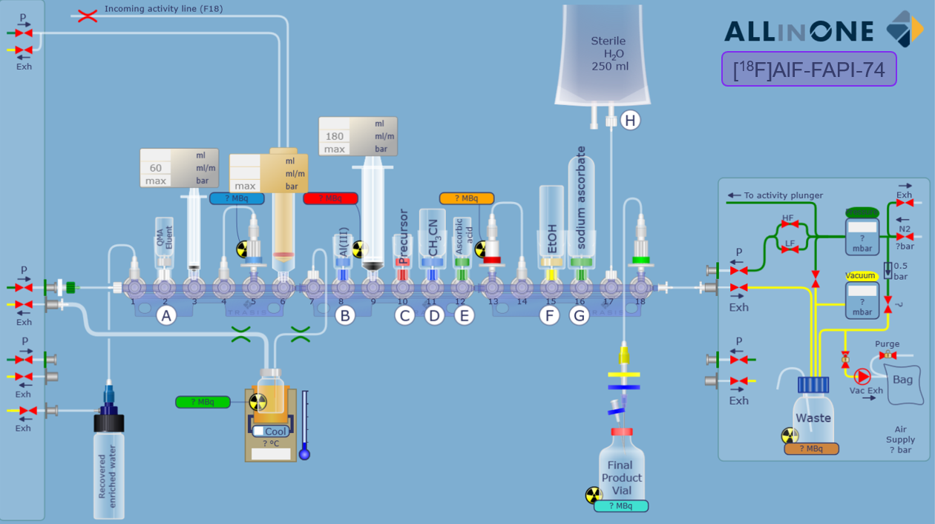
Figure S1: Schematic depiction of the cassette and consumables for [¹⁸F]AlF-FAPI-74 production on the Trasis AllinOne unit

Table S1: Positioning of reagents/materials on cassettes
Position | Reagent/Material
1, horizontal | Silicone tubing to pressure inlet
1, vertical | Silicone tubing to [¹⁸O]H₂O recovery vial
2 | QMA eluent
3 | 3 mL syringe
4 | Silicone tubing to QMA cartridge at position 5
5 | QMA cartridge
6 | 20 mL syringe (without a plunger, activity inlet)
7 | Silicone tubing to reactor
8 | Buffered Al(III) solution
9 | 20 mL syringe
10 | Precursor (in COP vial)
11 | Acetonitrile
12 | Ascorbic acid
13 | tC18 cartridge
14 | Silicone tubing to tC18 cartridge on position 13
15 | Ethanol
16 | Sodium ascorbate
17 | Silicone tubing to water for injection
18, horizontal | Silicone tubing to exhaust
18, vertical | Alumina N + Silicone tubing to dispensing cell

Visual representation of the LigandTracer Kinetic Evaluation
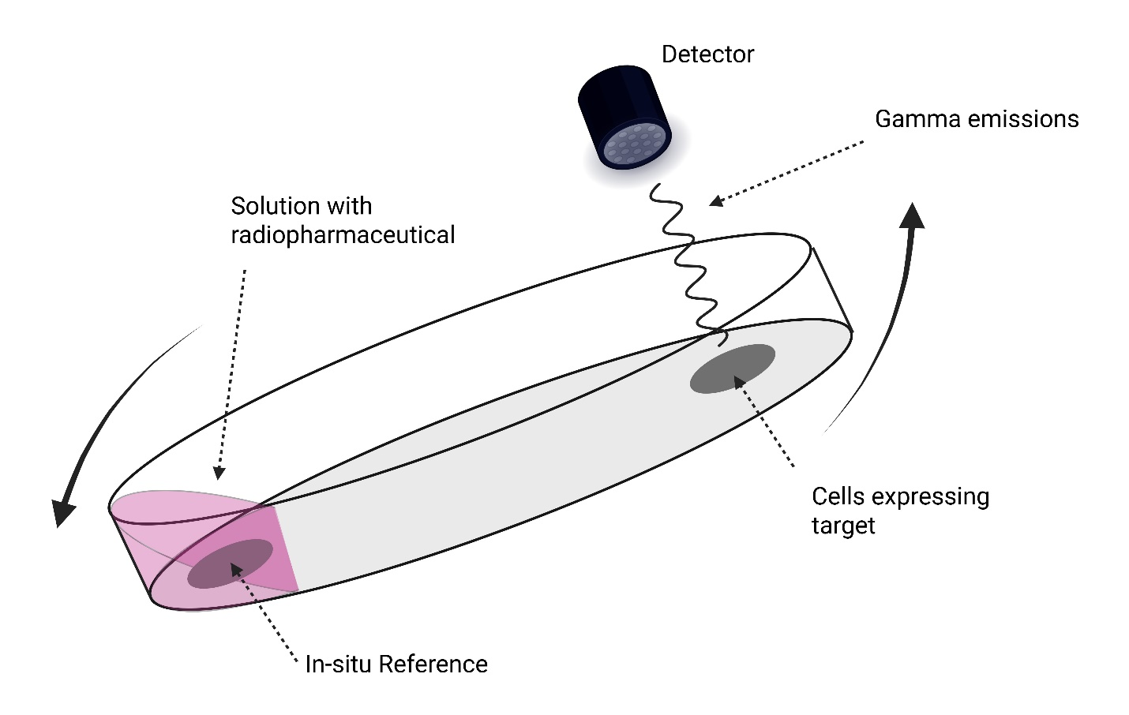
Figure S2: Simple visual representation of LigandTracer Kinetic Evaluation set-up, redrawn with a licensed version of Biorender.com [1].

LC/HRMS-analysis
To further identify the radiolabeled compound, its molecular weight was determined using electrospray ionization mass spectrometry (ESI-MS). The corresponding spectra for both the starting material and commercial standard are also provided for comparison.
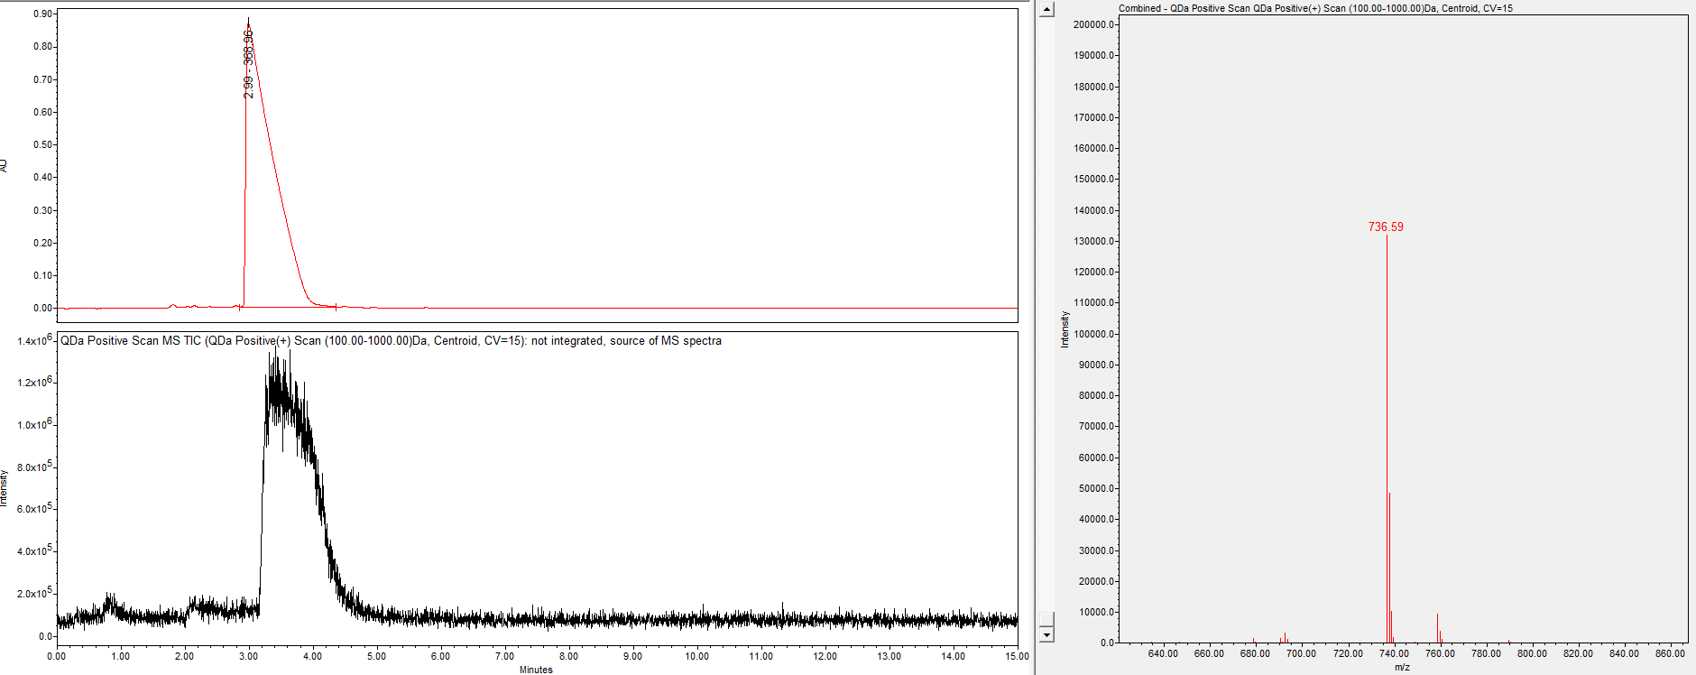
Figure S3: LC/HRMS-analysis of FAPI-74 precursor

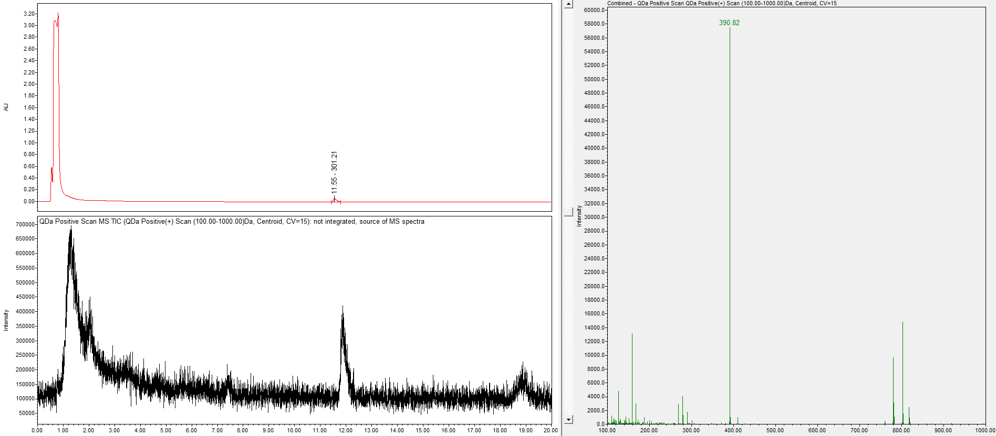
Figure S4: LC/HRMS-analysis of AlF-FAPI-74 standard

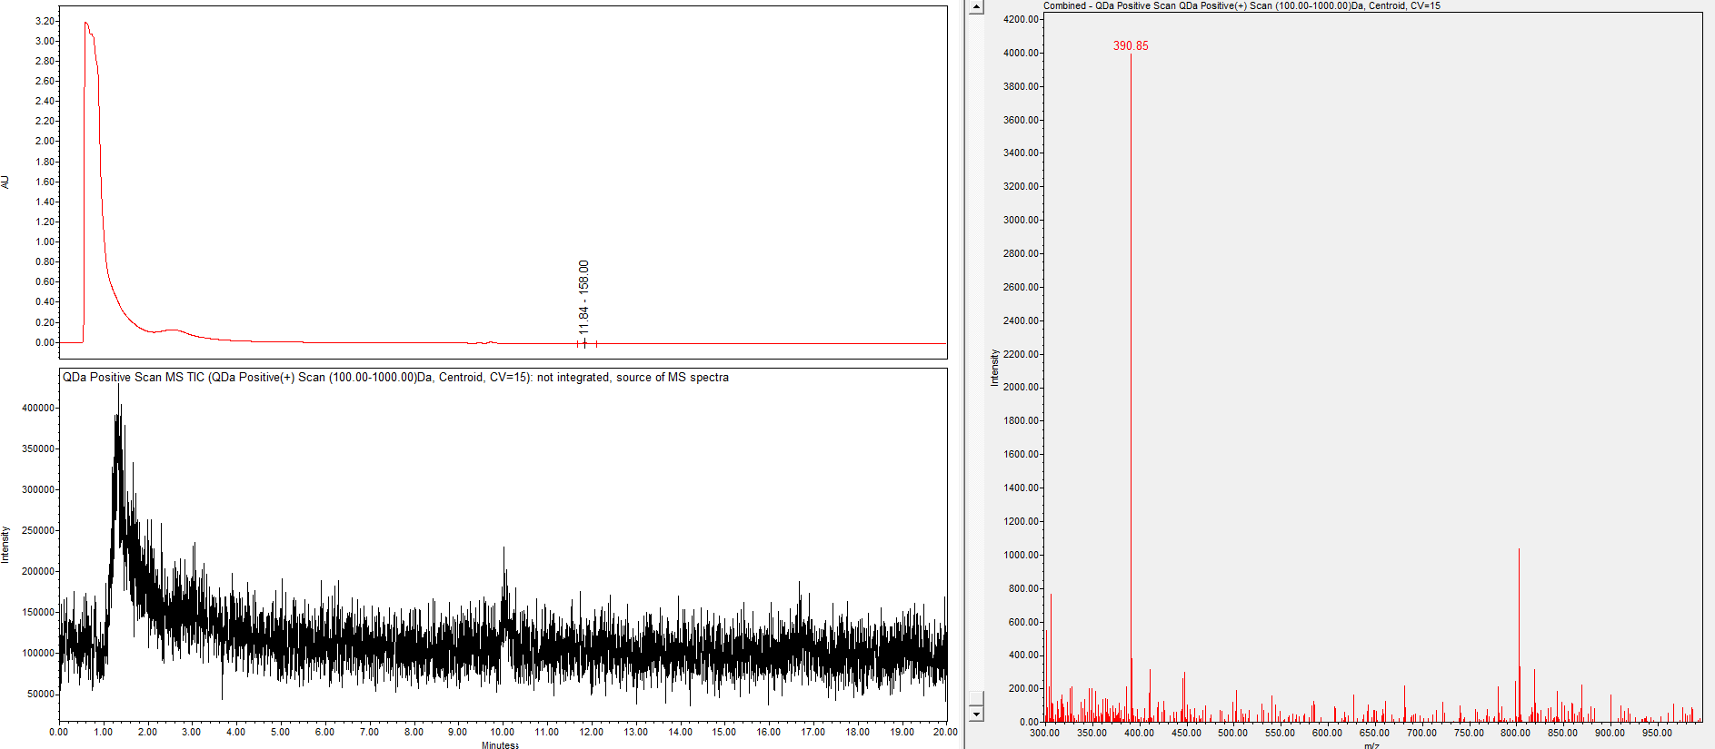
Figure S5: LC/HRMS-analysis of [¹⁸F]AlF-FAPI-74, with trace amounts of [¹⁸F]AlF-FAPI-74 eluting at 11.8 minutes. Mass spectrum at this timepoints shows a main peak for 390.85 m/z value, corresponding with the m/z value of the reference AlF-FAPI-74 compound ([M+2H]²⁺ = 390.67).
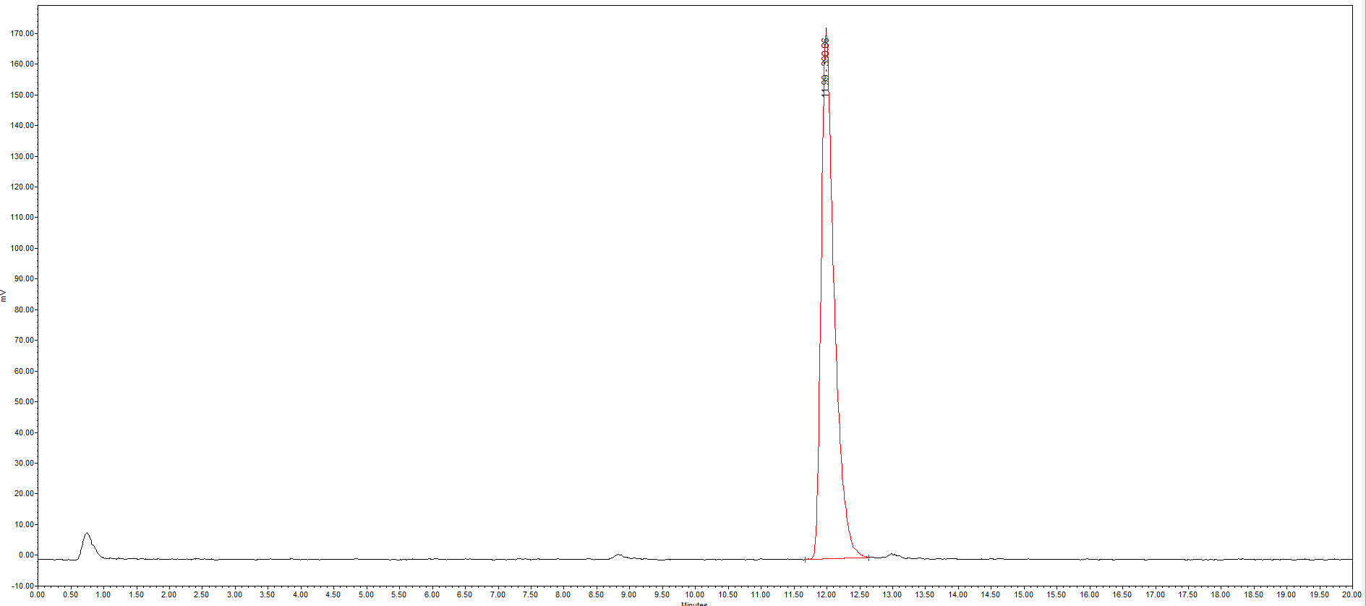
Figure S6: Radio-signal of [¹⁸F]AlF-FAPI-74 in LC/HRMS analysis, confirming the retention time of approximately 12 minutes for [¹⁸F]AlF-FAPI-74.
Stability assay
Figure S7: Radiochromatograms of [¹⁸F]AlF-FAPI-74 stability tests (in formulation vehicle at room temperature), recorded at 2-hour intervals up to 10 hours post end-of-synthesis (EOS), along with the corresponding radiochemical purity (RCP) at each time point.
Radio-metabolite analysis
The in vivo stability of [¹⁸F]AlF-FAPI-74 is illustrated through reconstructed radiochromatograms obtained from Gamma Counter output.
Figure S8: Reconstructed chromatogram of radio-metabolite analysis of mouse urine collected 10 min. p.i., showing %intact tracer with mean ± SD (n=3).
Figure S9: Reconstructed chromatogram of radio-metabolite analysis of mouse plasma, showing %intact tracer with mean ± SD (n=3).

Reference List
[1] Bondza S, Foy E, Brooks J, Andersson K, Robinson J, Richalet P, Buijs J. Real-time Characterization of Antibody Binding to Receptors on Living Immune Cells. Front Immunol. 2017 Apr 24;8:455. DOI: 10.3389/fimmu.2017.00455.

