Supplemental Information
Title: Quality Control of Actinium-225 and ²²⁵Ac-Radiopharmaceuticals: Francium-221 to be or not to be?

Authors:
Miguel Toro Gonzalez,¹ Luke Wheeless,¹ Vijai Kumar Reddy Tangadanchu,¹ Cory Hawkins,¹ Shannon Provo,¹ William Smith,¹ Michael Hommen,¹ Dan De Vries,¹ Jim Harvey,¹ Tyler Drum,¹ Diane S. Abou.^{1,2}

Affiliation:
¹ NorthStar Medical Radioisotopes, LLC Research and Development, 1800 Gateway Boulevard, Beloit, WI 53511, USA
² Mallinckrodt Institute of Radiology, Washington University School of Medicine in St. Louis, 510 S Kingshighway Blvd, St. Louis, MO 63110, USA

Corresponding Author: Diane S. Abou, PhD; dabou@northstarnm.com

Keywords: Actinium-225 quality control, Liquid Scintillation, High Purity Germanium, Gamma well counting, Thin Layer Chromatography, HPLC

Suppl. Table 1A: Sample identification for the francium-221 versus bismuth-213 comparision Figure 2 listing radioactive concentrations.
Figure | Technique | Sample | RAC (Bq/µL)
2A | Gas Proportional | DOTA-peptide | 1702
2B | Silicon | DOTA-peptide | 1665
2C | LSC | DOTA-peptide | 1036
2D | HPGe | DOTA-peptide | 1036
2E | γ | DOTA-peptide | 1665
2F-1 | HPLC - γ | DOTA-peptide | 1295
2F-2 | HPLC - γ | DOTA-peptide | 1036
2F-3 | HPLC - γ | DOTA-peptide | 851

Suppl. Table 1B: Sample identification for the accuracy assessment Figure 7 listing radioactive concentrations and TLC spotted activity.

Figure | Technique | Sample | RAC  (nCi/µL) | Expected  spike % | Total Act.  spotted (kBq) | Spiked Act.  spotted (kBq)
3A | Gas Proportional | DOTA-peptide | 46 | 6.3 | 17.0 | 1.1
3B1 | Silicon | DOTA-peptide | 40 | 6.8 | 14.8 | 1.00
3B2 | Silicon | DOTA-mAb | 36 | 6 | 4.0 | 0.26
3B3 | Silicon | DOTA-mAb | 4 | 4.5 | 1.5 | 0.074
3C | LSC | DOTA-peptide | 28 | 7.2 | 10.4 | 0.740
3D1 | HPGe | DOTA-mAb | 36 | 6 | 4.0 | 0.259
3D2 | HPGe | DOTA-mAb | 4 | 4.5 | 1.5 | 0.074
3E1 | γ | DOTA-peptide | 30 | 3.5 | 11.1 | 0.407
3E2 | γ | DOTA-peptide | 30 | 4 | 11.1 | 0.444
3E3 | γ | DOTA-peptide | 30 | 5.5 | 11.1 | 0.629
3E4 | γ | DOTA-peptide | 30 | 7 | 11.1 | 0.777
3F1 | HPLC + γ | DOTA-peptide | 43 | 3.1 | n/a | n/a
3F2 | HPLC + γ | DOTA-peptide | 40 | 6.8 | n/a | n/a
3F3 | HPLC + γ | DOTA-peptide | 37 | 13.1 | n/a | n/a

Suppl. Table 2: Relevant alpha and beta decay energies and abundance of ²²⁵Ac daughters
Isotopes | Decay and Energy | Abundance %I
²²¹Fr | α 6241 keV | 83.3
²¹⁷At | α 7066.9 keV | 99.89
²¹³Bi | α 5875 keV  β⁻ 491.8 keV | 1.96  66.8
²¹³Po | α 8536.2 keV | 99.99
²⁰⁹Tl | β⁻ 660.0 keV | 97.7
²⁰⁹Pb | β⁻ 197.4 keV | 100

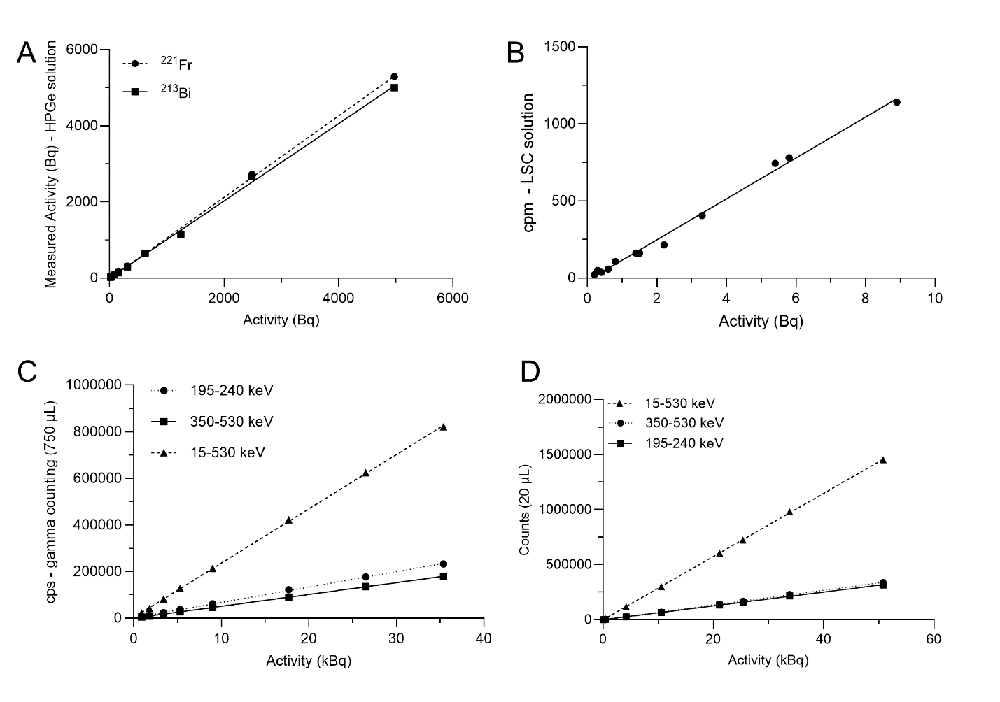
Suppl. Figure 1: Varying actinium-225 solutions activities measured using (A) HPGe, LOQ (218 keV) = 15 Bq; LOQ (440 keV) = 56 Bq; (B) LSC; LOQ = 0.7 Bq; (C) Gamma well counting at 750 µL, LOQ francium-221 = 772 Bq; LOQ bismuth-213 = 642 Bq; LOQ open = 565 Bq; (D) Gamma well counting at 20 µL, LOQ francium-221 = 92.5 Bq; LOQ bismuth-213 = 40.7 Bq; LOQ open= 11.1 Bq. All linear regressions resulted in R² > 0.99.

Suppl. Figure 2: Varying activities of actinium-225 spotted on TLC measured using: (A) silicon detector TLC plate scanner; LOQ = 1,251 kBq (B) gas-filled proportional counter TLC scanner, 1,000 V; LOQ = 11.1 Bq (C) Gamma well counting (cut/count) bismuth-213 window (350-530 keV) LOQ = 67 Bq; Francium-221 (195-240 keV) LOQ = 62 Bq; Open (15-530 keV) LOQ = 64.7 Bq; (D) LSC (cut/count) PLI39; LOQ = 0.3 Bq; (E) HPGe (cut/count) 218 keV (30 m) LOQ=36 Bq and 440 keV (> 5 h) LOQ =15 Bq. All linear regressions resulted in R² > 0.99.
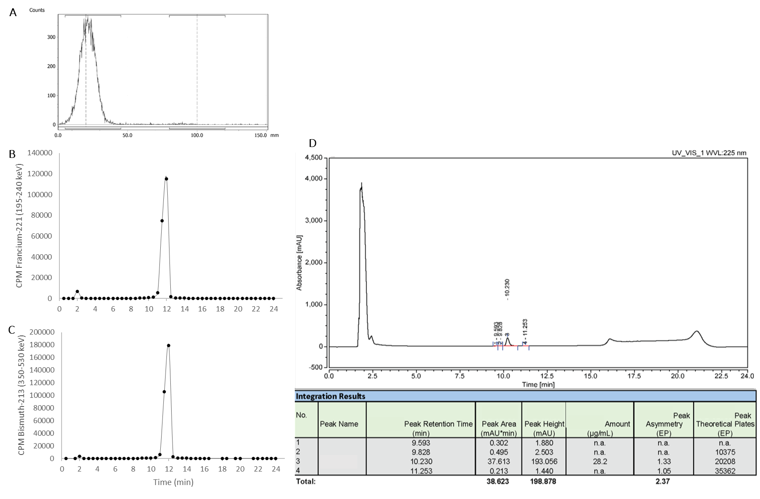
Suppl Fig 3: TLC and HPLC chromatograms of sample 2F1 (DOTA-peptide): (A) Silicon detector TLC scanner radiochromatogram acquired at > 5 h post-development RCY% = 99.1; (B) Fraction collected gamma counting at francium-221 window (195-240 keV) at 1 h post-collection resulting in RCP% = 96.5; (C) Fraction collected gamma counting at bismuth-213 window (350-530 keV) at > 5 h post-collection resulting in RCP% = 98.6.

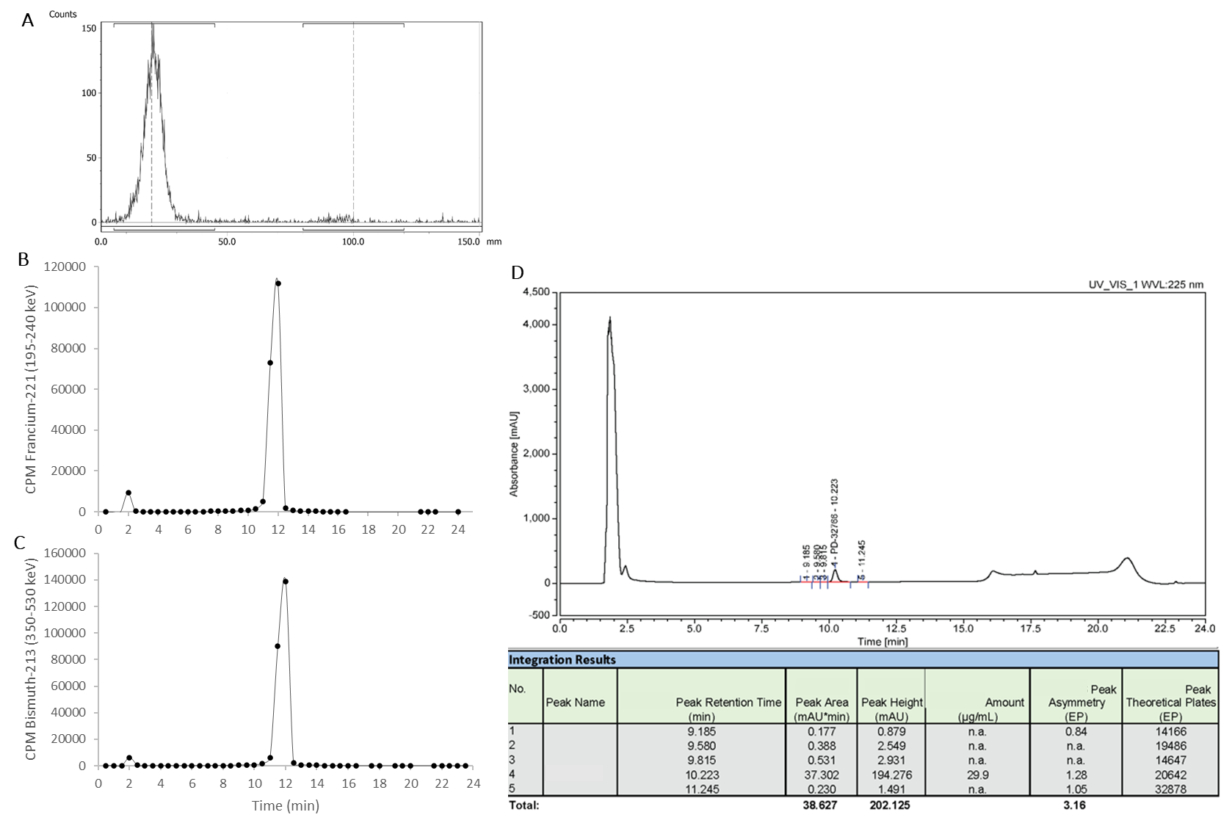
Suppl Fig 4: TLC and HPLC chromatograms of sample 2F3 (DOTA-peptide): (A) Silicon detector TLC scanner radiochromatogram acquired at > 5 h post-development RCY% = 96.9; (B) Fraction collected gamma counting at francium-221 window (195-240 keV) at 1 h post-collection resulting in RCP% = 95.2; (C) Fraction collected gamma counting at bismuth-213 window (350-530 keV) at > 5 h post-collection resulting in RCP% = 96.5.

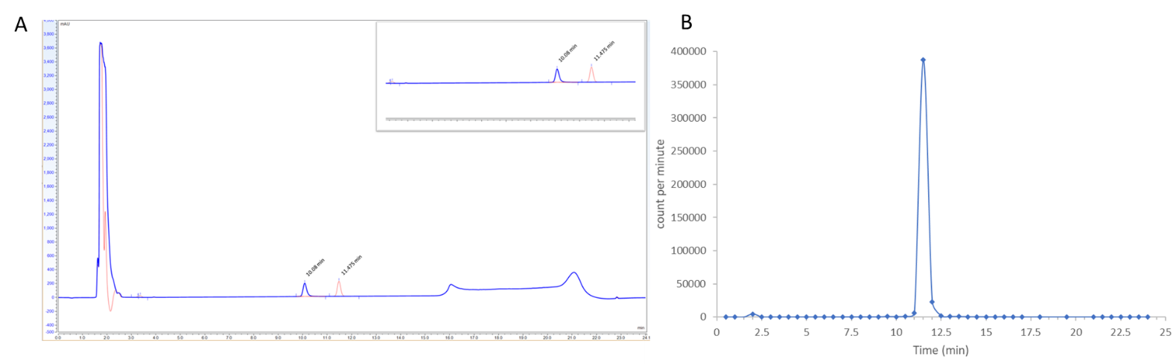
Suppl. Figure 5: (A) Overlaid UV-HPLC chromatograms of [²²⁵Ac]Ac-DOTA-peptide in blue Rt = 10.1 min and the analog [La]-DOTA-peptide in red Rt = 11.5 min; (B) matching [²²⁵Ac]Ac-DOTA-peptide radiochromatogram Rt =11. 5 min plotted using gamma well counting of collected fractions.

The UV-HPLC chromatogram and radiochromatograms (gamma counted collected fractions) of [²²⁵Ac]Ac-DOTA-peptide both confirmed the absence of radiolytic products with no apparent degradation peak between the void volume peak and the precursor peak. A retention time delay of 1.5 min is noticed between the UV chromatogram of DOTA-peptide blue peak (Suppl. Fig. 3) at 10.1 min and the radio peak at 11.5 min. The dead-time looping between the UV detector and the fraction collector is less than 0.73 s. This Rt difference is confirmed with the [La]-DOTA-peptide Rt of 11.5 min (Suppl. Fig. 3A in red), matching that of [²²⁵Ac]Ac-DOTA-peptide radiochromatogram. This Rt shift demonstrates the effect of DOTA chelation by ²²⁵Ac³⁺ or the metal surrogate La³⁺.

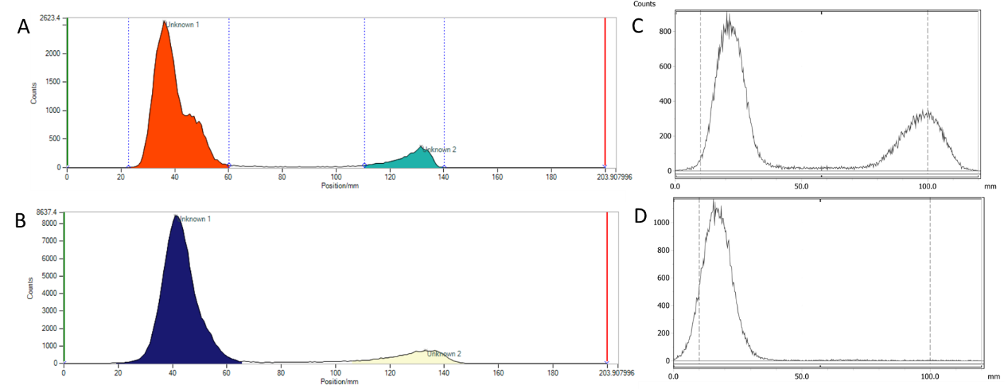Suppl Fig 6: TLC radiochromatograms of [²²⁵Ac]Ac-DOTA-peptide plotted in Figure 2 comparing francium-221 and bismuth-213 detection using gas proportional counter (A) 1,000V acquired at 30 min post-development RCY% = 87.9; (B) 1,500V after > 5 h RCY% = 88; and silicon detector measured (C) at 30 min RCY% = 61 and (D) after > 5 h RCY% = 99. Different samples listed in suppl. Table 1A were utilized for each scanner evaluation.

Suppl Fig 7: LSC spectra acquired for the half TLC strips of migrated DP (Fig. 2C) measured at francium-221 equilibrium (at 30 min post-development) for top TLC strip (A) topographical, (B) beta, and (C) alpha; and bottom TLC strip spectra (D) topographical, (E) beta, and (F) alpha for bottom TLC strip.
Suppl Fig 8: LSC spectra acquired for the half TLC strips of migrated DP (Fig. 2C) measured at bismuth-213 equilibrium (> 5 h post-TLC development) for top TLC strip (A) topographical, (B) beta, and (C) alpha; and bottom TLC strip spectra (D) topographical, (E) beta, and (F) alpha for bottom TLC strip.
Topographical 3D spectrum (Suppl. Fig. 7A/8A) shows some alpha/beta discrimination for the top TLC strip (Suppl. Figs. 7-8 B&C), with a beta signal ranging from 200-800 channels and alpha from 400-900. This somehow modest separation elected from gross alpha count quantification (Suppl. Fig. 7C/8C). However, for the bottom strip, the topographical 3D spectrum shows significant quenching and poor discrimination of alpha and beta signals (Suppl. Fig. 7D/8D). The overwhelming beta contributions of bismuth-213 spilled over in the 600-800 channels (Suppl. Fig. 7E/8E), overlapping with the main peak of the alpha spectrum (Suppl. Fig. 7F/8F). This effect limited the alpha/beta discrimination, and consequently LSC detection for TLC was found unfit to read RCY% before bismuth-213 equilibrium.

