Supplementary Material
Fluorine-18-labeled PET radiotracers for imaging the macrophage colony-stimulating factor 1 receptor (CSF1R).
Deepankar Das, Hyojin Cha, Ravi Naik, Daniel Holt, Hong Fan, Andrew Hall, Wojtek Lesniak, Yong Du, Il Minn, Robert F. Dannals, Martin G. Pomper, Andrew G. Horti

Chemistry
NMR spectra.
¹H NMR (500 MHz, CDCl₃) of compound 3:
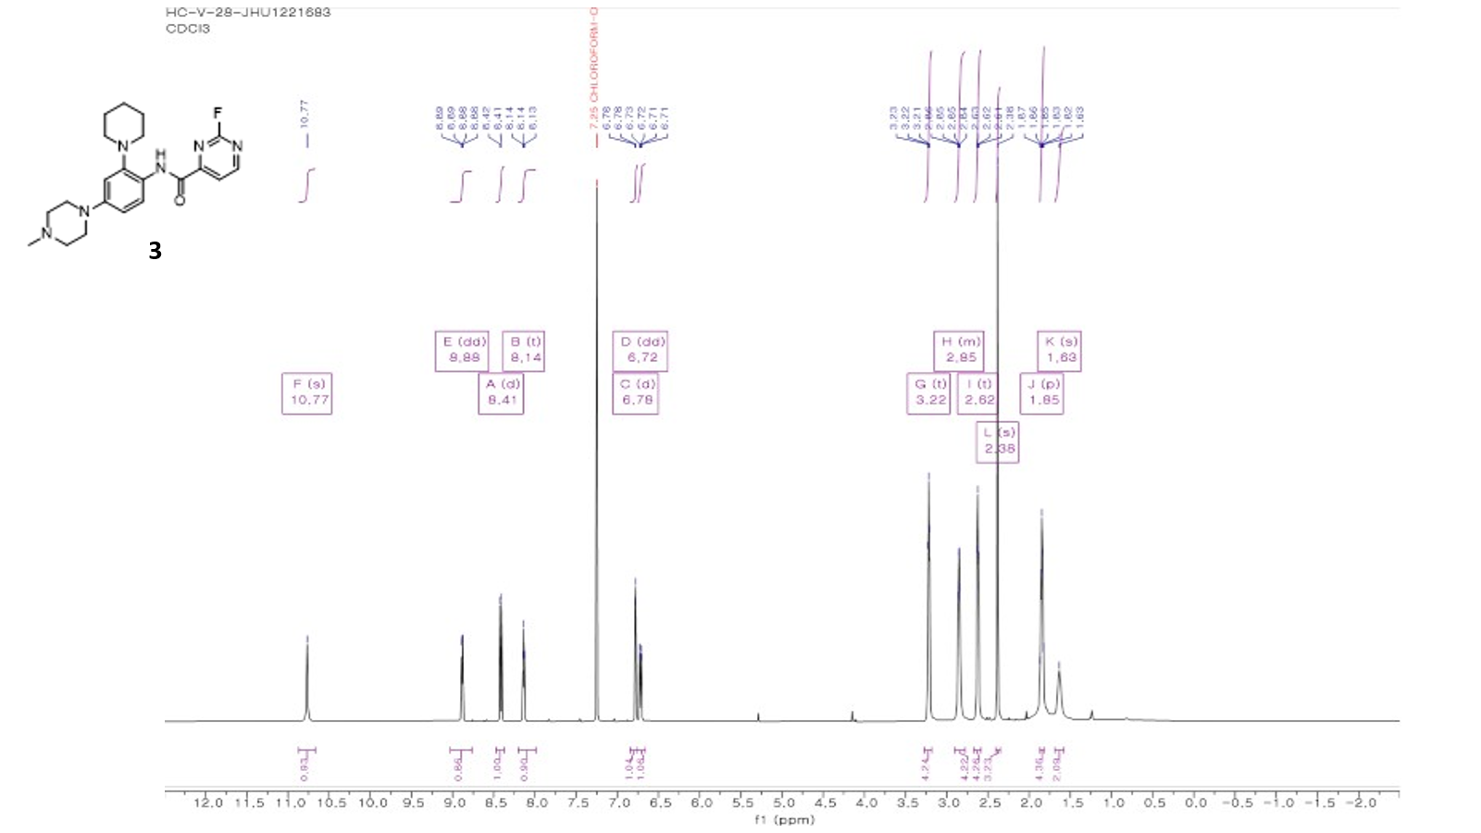

¹³C NMR (500 MHz, CDCl₃) of compound 3:
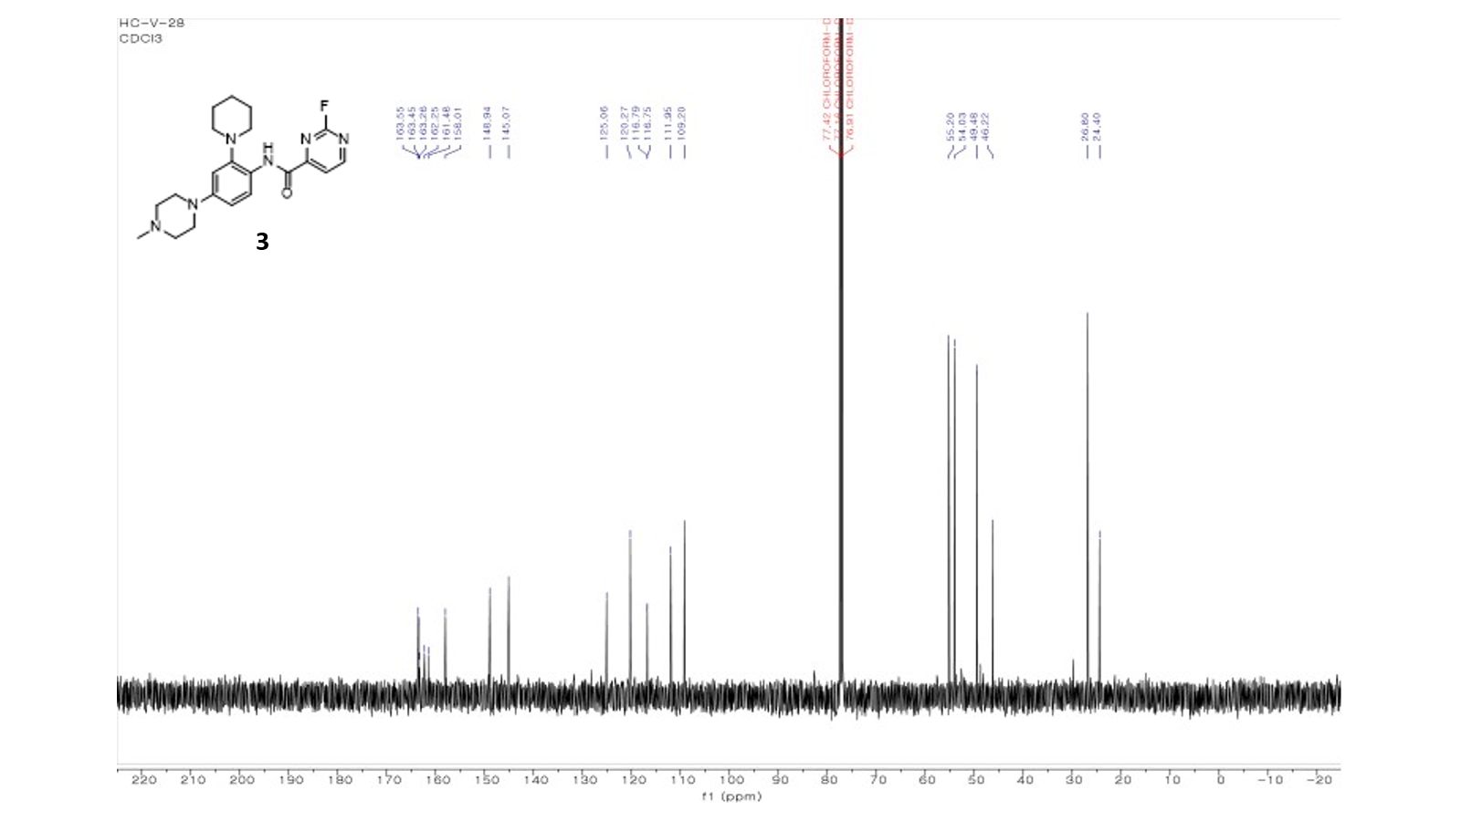

Synthesis of precursors pre-3 – pre-6
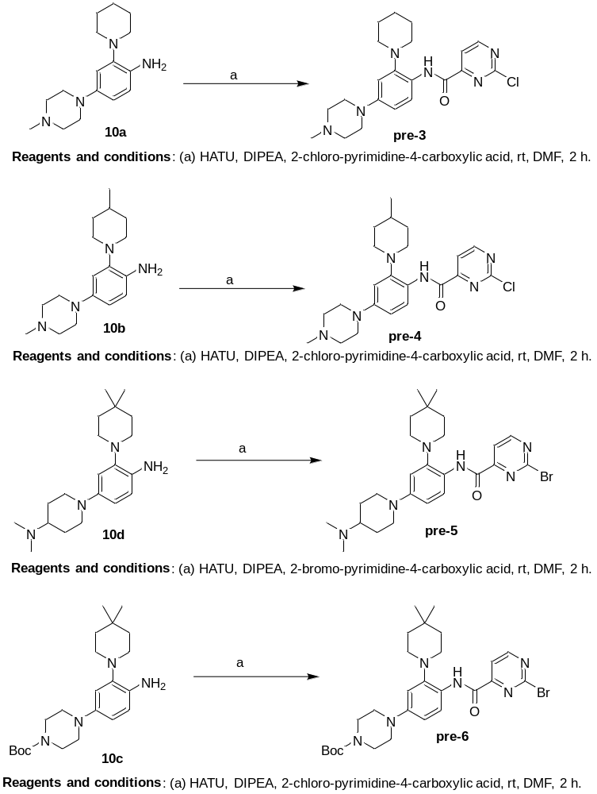
Scheme S1. Synthesis of precursors for ¹⁸F-radiolabeling (see experimental conditions below).
2-chloro-N-(4-(4-methylpiperazin-1-yl)-2-(piperidin-1-yl)phenyl)pyrimidine-4-carboxamide, pre-3: A flamed-dried 2-neck flask (25 mL) was charged with a mixture of 4-(4-methylpiperazin-1-yl)-2-(piperidin-1-yl) aniline 10a (45 mg, 0.16 mmol), 2-chloro-pyrimidine-4-carboxylic acid (31 mg, 0.19 mmol), HATU (75 mg, 0.19 mmol), DMF (3 mL). DIPEA (0.10 mL, 0.57 mmol) was added dropwise. The reaction mixture was stirred at 35 ˚C for 4 hours. The solvents were removed under vacuum by rotary evaporation. The residue was dissolved in the mixture of water/ACN (90%/10%), divided in three equal portions and each portion was purified by reverse column gradient chromatography using a Biotage® Sfär C18 D Duo 30 um cartridge (30 g), flow rate – 30 mL/min, gradient mobile phase: A – water +0.1% TFA; solvent B – ACN + 0.1% TFA. Initial – A=100%, final – A=70%, time – 75 min. Retention time is 53 – 56 min. The combined purified product solution in mobile phase was cooled in ice bath. Then the solution was partitioned between dichloromethane (50 mL) and sodium bicarbonate (1%, aq). The aqueous layer was extracted with dichloromethane (2 x 50 mL). The combined dichloromethane extracts were dried (anhydrous Na₂SO₄), filtered through Celite 545 on the glass filter and concentrated to give orange solid. The solid was washed with n-hexane (HPLC grade) (1 mL x 3 times) and dried under vacuum to give pre-3 as a yellow solid. Yield 22 mg (31% yield). (500 MHz, CHLOROFORM-D) ¹H NMR (500 MHz, CHLOROFORM-D) δ 10.92 (s, 1H), 8.87 (d, J = 5.0 Hz, 1H), 8.41 (d, J = 8.9 Hz, 1H), 8.13 (d, J = 4.9 Hz, 1H), 6.79 (d, J = 2.7 Hz, 1H), 6.72 (dd, J = 8.9, 2.7 Hz, 1H), 3.22 (t, J = 4.9 Hz, 4H), 2.96 – 2.76 (m, 4H), 2.62 (t, J = 4.9 Hz, 4H), 2.38 (s, 3H), 1.88 (p, J = 5.5 Hz, 4H).; ¹³C NMR (126 MHz, CHLOROFORM-D) δ 162.00, 160.70, 160.64, 157.95, 148.82, 145.05, 125.24, 120.11, 117.01, 112.08, 109.31, 55.15, 54.04, 49.41, 46.15, 26.82, 24.41.; (ESI) m/z: [M+H]⁺ Calcd for C₂₁H₂₈ClN₆O+ 415.2; Found 415.1
2-chloro-N-(4-(4-methylpiperazin-1-yl)-2-(4-methylpiperidin-1-yl)phenyl)pyrimidine-4-carboxamide, pre-4: To a mixture of 4-(4-methylpiperazin-1-yl)-2-(4-methylpiperidin-1-yl)aniline 10b (35 mg, 0.1213 mmol), 2-chloropyrimidine-4-carboxylic acid (23 mg, 0.1456 mmol and HATU (55.4 mg, 0.1456 mmol), in DMF (1.5 mL) was added DIPEA (53 µL, 0.3034 mmol), The reaction mixture was stirred at room temperature for 2h and then partitioned between EtOAc and brine. The organic layer was separated, dried over anhydrous Na₂SO₄, filtered, and concentrated under vacuum. The resulting residue was purified by silica gel column chromatography (CH₂Cl₂:MeOH = 90:10) to give 43 mg of the title compound in 83% yield. ¹H NMR (500 MHz, CDCl₃) δ 10.93 (s, 1H), 8.88 (d, J = 8.88 Hz, 1H), 8.42 (d, J = 8.41 Hz, 1H), 8.14 (d, J = 8.13 Hz, 1H), 6.79 (d, J = 6.79 Hz, 1H), 6.75-6.71 (m, 1H), 3.25-3.19 (comp, 4H), 3.05-3.00 (comp, 2H), 2.76-2.69 (comp, 2H), 2.64-2.58 (comp, 4H), 2.37 (s, 3H), 1.82-1.77 (m, 1H), 1.73-1.640 (comp, 4H), 1.08 (d, J = 6.0 Hz, 3H).
2-bromo-N-(4-(4-(dimethylamino)piperidin-1-yl)-2-(4,4-dimethylpiperidin-1-yl)phenyl)pyrimidine-4-carboxamide, pre-5: To a mixture of 1-(4-amino-3-(4,4-dimethylpiperidin-1-yl)phenyl)-N,N-dimethylpiperidin-4-amine 10d (40 mg, 0.1210 mmol), 2-bromopyrimidine-4-carboxylic acid (29.5 mg, 0.1452 mmol and HATU (55 mg, 0.1452 mmol), in DMF (2 mL) was added DIPEA (53 µL, 0.3026 mmol), The reaction mixture was stirred at room temperature for 2h and then partitioned between EtOAc and brine. The organic layer was separated, dried over anhydrous Na₂SO₄, filtered, and concentrated under vacuum. The resulting residue was purified by silica gel column chromatography (CH₂Cl₂:MeOH = 90:10) to give 54 mg of the title compound in 87% yield. ¹H NMR (500 MHz, CDCl₃) δ 10.83 (s, 1H), 8.82 (s, 1H), 8.43 (d, J = 8.42 Hz, 1H), 8.17 (s, 1H), 6.83 (s, 1H), 6.72 (d, J = 6.71 Hz, 1H), 3.78 (d, J = 3.77 Hz, 2H), 3.07-2.96 (m, 1H), 2.88-2.84 (comp, 4H), 2.81-2.76 (comp, 8H), 2.13 (d, J = 2.12 Hz, 2H), 1.89-1.84 (comp, 2H), 1.75-1.70 (comp, 4H), 1.09 (s, 6H).
Tert-butyl 4-(4-(2-bromopyrimidine-4-carboxamido)-3-(4,4-dimethylpiperidin-1-yl)phenyl)piperazine-1-carboxylate, pre-6: To a mixture of tert-butyl 4-(4-amino-3-(4,4-dimethylpiperidin-1-yl)phenyl)piperazine-1-carboxylate 10c (30 mg, 0.0772 mmol), 2-chloropyrimidine-4-carboxylic acid (19 mg, 0.0926 mmol and HATU (35.2 mg, 0.0926 mmol) in DMF (1.5 mL) was added DIPEA (33.6 µL, 0.1930 mmol). The reaction mixture was stirred at room temperature for 2h and then partitioned between EtOAc and brine. The organic layer was separated, dried over anhydrous Na₂SO₄, filtered, and concentrated under vacuum. The resulting residue was purified by silica gel column chromatography (CH₂Cl₂:EtOAc = 90:10) to give 37 mg of the title compound in 84% yield. ¹H NMR (500 MHz, CDCl₃) δ 10.84 (s, 1H), 8.82 (s, 1H), 8.44 (d, J = 8.43 Hz, 1H), 8.17 (s, 1H), 6.84 (s, 1H), 6.73 (d, J = 6.72 Hz, 1H), 3.63-3.55 (comp, 4H), 3.17-3.09 (comp, 4H), 2.89-2.83 (comp, 4H), 1.78-1.66 (comp, 4H), 1.49 (s, 9H), 1.09 (s, 6H).
Radiochemistry
4-Cyano-N-(4-(4-(2-[¹⁸F]fluoroethyl)piperazin-1-yl)-2-(4-methylpiperidin-1-yl)phenyl)-1H-pyrrole-2-carboxamide, [¹⁸F]1: A solution of ¹⁸F-fluoride obtained from proton bombardment of ¹⁸O-water in a General Electric PETtrace cyclotron and 2 mg of K₂CO₃ in 0.4 mL of water and 10 mg of Kryptofix 222® in 2 mL ACN were added to a reaction vessel of a GE MicroLab module (Waukesha, WI). The mixture was evaporated azeotropically at 90-140°C under a stream of argon after the addition of 2 mL of CH₃CN and cooled to 50ºC. A solution of ethylene glycol bis-p-toluenesulfonate (2 mg) in ACN (1.2 mL) was added to the reaction vessel, sealed and the mixture was heated at 100°C for 15 min. The reaction mixture was cooled, diluted with 1 mL water, and injected onto the reverse-phase semi-preparative high performance liquid chromatography (HPLC) column (conditions 1). The radioactive product peak of 2- [¹⁸F]Fluoroethyltosylate ([¹⁸F]FEtOTs) was collected in solution of 50 mL HPLC grade water. The aqueous solution was transferred through an activated Waters Sep-Pak C18 light cartridge (Milford, MA). The cartridge was rinsed with 10 mL saline and dried with a stream of nitrogen for 20 min, and [¹⁸F]FEtOTs was eluted with 1 mL DMF into a V-vial (4 mL) containing 2 mg pre-1 solution in 0.1mL DMF with 0.002 mL N,N-diisopropylethylamine. The alkylation reaction mixture was heated at 160ºC for 30 min. The reaction mixture was cooled, diluted with 1 mL water, and injected onto the reverse-phase semi-preparative high performance liquid chromatography (HPLC) column (conditions 2). The radioactive product peak of [¹⁸F]1 was collected in solution of 50 mL HPLC grade water and 0.3 g sodium ascorbate. The aqueous solution was transferred through an activated Waters Sep-Pak C18 light cartridge (Milford, MA). The cartridge was rinsed with 10 mL saline, eluted with 1 mL ethanol and diluted with 10 mL saline. The final product [¹⁸F]1 was then analyzed by analytical HPLC to determine the radiochemical purity and specific radioactivity. The total preparation time including quality control was ~2 h.
Semi-preparative HPLC conditions-1: Luna C18, 10 micron, 10 x 250 mm; mobile phase: 410:590 (ACN : water); flow rate 12 mL/min; UV - 254 nm; retention time of [¹⁸F]FEtOTs - 8 min).
Semi-preparative HPLC conditions-2: Waters XBridge C18, 10 micron, 10 x 250 mm; mobile phase: 60:40 (methanol : 0.1M ammonium formate in water); flow rate 6 mL/min; UV - 254 nm; retention time [¹⁸F]1 – 18-19 min).
Analytical HPLC conditions: Waters XBridge, 3.5 micron, 4.6 x 100 mm; mobile phase 37:63 (ACN : 0.1M ammonium formate in water); flow rate 2 mL/min; UV - 280 nm; retention time: [¹⁸F]1 – 10 - 11 min.
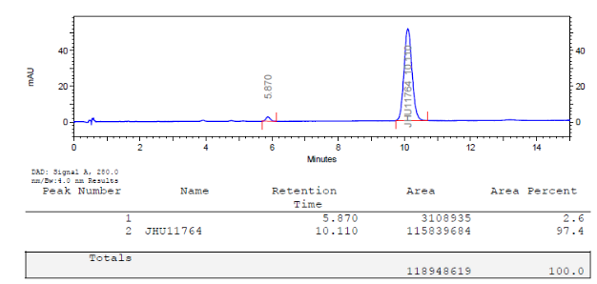

The co-elution (spike) analytical HPLC of the final product [¹⁸F]1 and standard 1 is shown below:
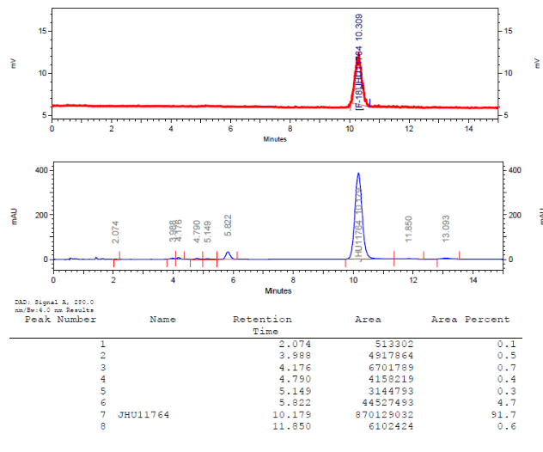
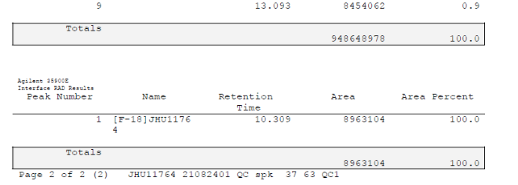

Radiochemistry HPLC’s for [¹⁸F]3 (see the labeling procedure in Methods)
Semi-preparative HPLC of [¹⁸F]3, XBridge C18, 10 micron, 10 x 250 mm, 190:810:1 CH₃CN:H₂O:TFA, 12 ml/min
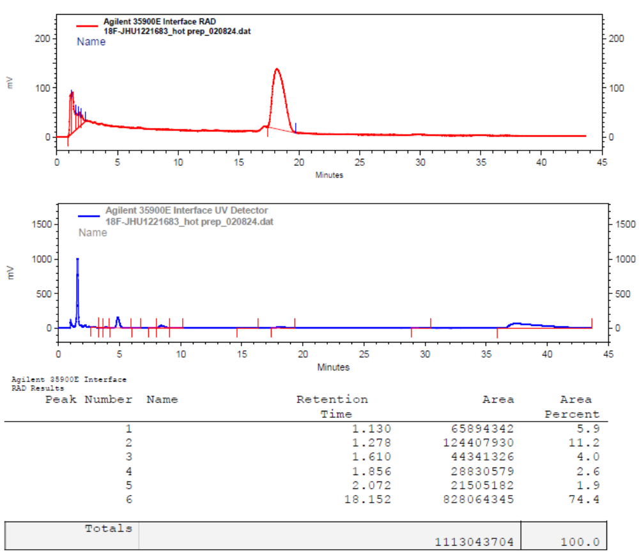
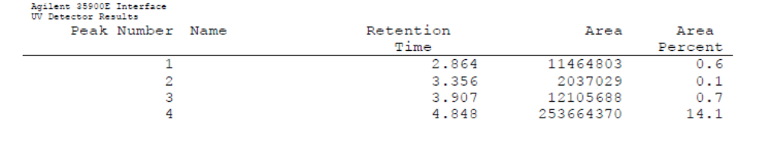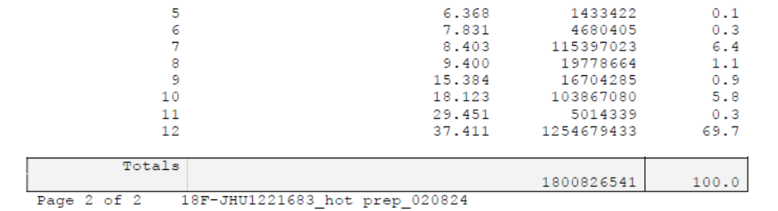

Analytical HPLC, quality control of [¹⁸F]3: Luna C18, 10 micron, 4.6 x 250 mm, 280:720:1 CH₃CN:H₂O:TFA, 3 ml/min
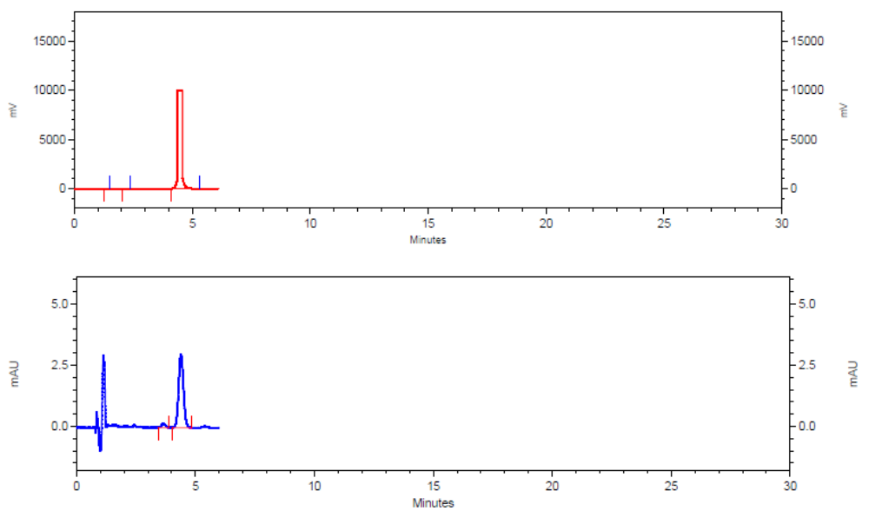

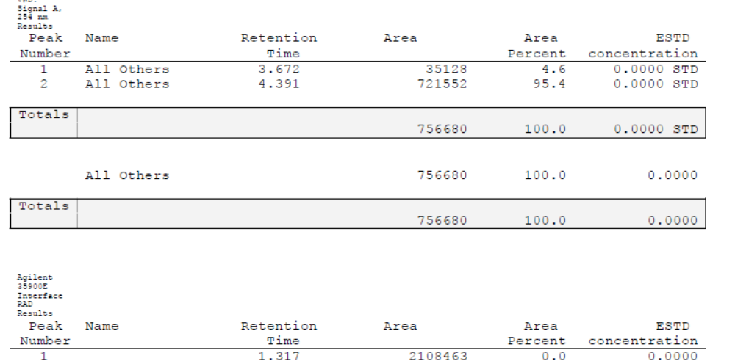
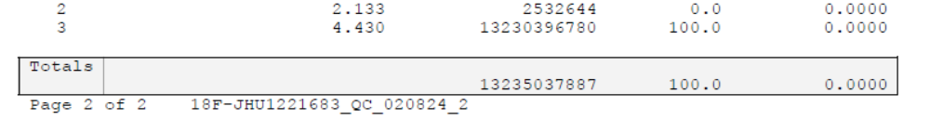

Analytical HPLC, co-elution (SPIKE) of [¹⁸F]3 and 3: Luna C18, 10 micron, 4.6 x 250 mm, 280:720:1 CH₃CN:H₂O:TFA, 3 ml/min
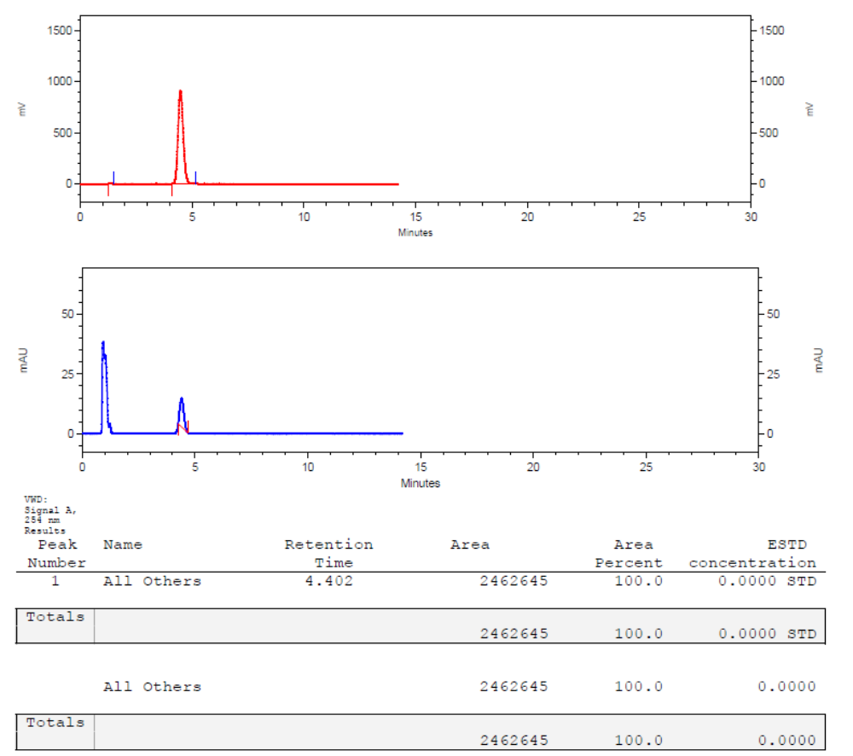
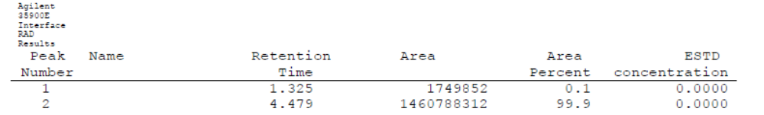

2-[¹⁸F]fluoro-N-(4-(4-methylpiperazin-1-yl)-2-(4-methylpiperidin-1-yl)phenyl)pyrimidine-4-carboxamide, [¹⁸F]4: A solution of ¹⁸F-fluoride obtained from proton bombardment of ¹⁸O-water in a General Electric PETtrace cyclotron and 2 mg of K₂C₂O₄ monohydrate in 0.4 mL of water and 7 mg of Kryptofix 222® in 2 mL ACN were added to a reaction vessel of a GE MicroLab module (Waukesha, WI). The mixture was evaporated azeotropically at 90-140°C under a stream of argon after the addition of 2 mL of CH₃CN and cooled to 60ºC. A solution of the pre-4 (2 mg) in DMSO (0.8 mL) was added to the reaction vessel and the mixture was heated at 120°C for 15 min. The reaction mixture was cooled, diluted with 1 mL water, and injected onto the reverse-phase semi-preparative high performance liquid chromatography (HPLC) column. The radioactive product peak was collected in solution of 50 mL HPLC grade water and 0.3 g sodium ascorbate. The aqueous solution was transferred through an activated Waters Oasis Light Plus HLB cartridge (Milford, MA). After washing the cartridge with 10 mL saline, the product was eluted with 1 mL of ethanol through a 0.2 μM sterile filter into a sterile, pyrogen-free vial containing 4 mL saline and 10 mL of 0.9% saline was added through the same filter. The final product [¹⁸F]4 was then analyzed by analytical HPLC to determine the radiochemical purity and specific radioactivity. The total preparation time including quality control was ~65 min.
Semi-preparative HPLC conditions: XBridge C18, 10 micron, 10 x 250 mm; mobile phase: 230:770:1 (ACN : water: TFA); flow rate 12 mL/min; UV - 254 nm; retention time 25 min.
Analytical HPLC conditions: Luna C18, 10 micron, 4.6 x 250 mm; mobile phase: 360:640:1 (ACN : water: TFA); flow rate 3 mL/min; UV - 254 nm; retention time 3.4 min.
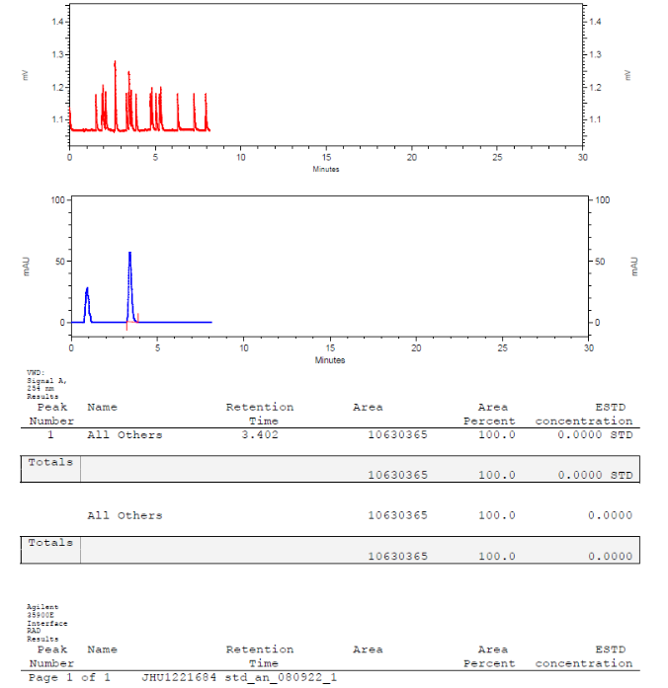

The co-elution (spike) analytical HPLC of the final product [¹⁸F]4 and standard 4 is shown below:
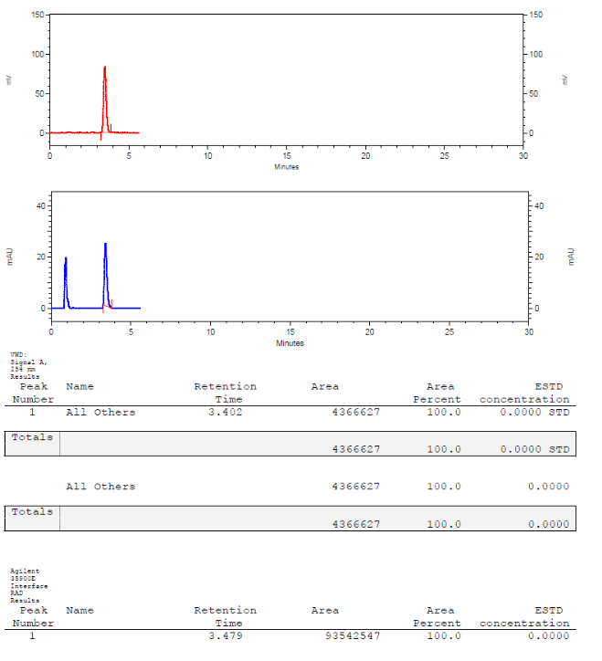

N-(4-(4-(dimethylamino)piperidin-1-yl)-2-(4,4-dimethylpiperidin-1-yl)phenyl)-2-[¹⁸F]fluoropyrimidine-4-carboxamide, [¹⁸F]5: A solution of ¹⁸F-fluoride obtained from proton bombardment of ¹⁸O-water in a General Electric PETtrace cyclotron and 2 mg of potassium oxalate monohydrate in 0.4 mL of water and 7 mg of Kryptofix 222® in 2 mL ACN were added to a reaction vessel of a GE MicroLab module (Waukesha, WI). The mixture was evaporated azeotropically at 90-140°C under a stream of argon after the addition of 2 mL of CH₃CN and cooled to 60ºC. A solution of the pre-5 (2 mg) in DMSO (0.8 mL) was added to the reaction vessel and the mixture was heated at 140°C for 15 min. The reaction mixture was cooled, diluted with 1 mL water, and injected onto the reverse-phase semi-preparative high performance liquid chromatography (HPLC) column. The radioactive product peak was collected in solution of 50 mL HPLC grade water and 0.3 g sodium ascorbate. The aqueous solution was transferred through an activated Waters Oasis Light Plus HLB cartridge (Milford, MA). After washing the cartridge with 10 mL saline, the product was eluted with 1 mL of ethanol through a 0.2 μM sterile filter into a sterile, pyrogen-free vial containing 4 mL saline and 10 mL of 0.9% saline was added through the same filter. The final product [¹⁸F]5 was then analyzed by analytical HPLC to determine the radiochemical purity and specific radioactivity. The total preparation time including quality control was ~70 min.
Semi-preparative HPLC conditions: XBridge C18, 10 micron, 10 x 250 mm; mobile phase: 390:610:1 (ACN : water: TFA); flow rate 12 mL/min; UV - 254 nm; retention time 15-16 min.
Analytical HPLC conditions: XBridge, 3.5 micron, 4.6 x 250 mm; mobile phase: 440:560 (ACN : Phosphate/triethylamine buffer, pH 7.2); flow rate 3 mL/min; UV - 254 nm; retention time 7.4 min.
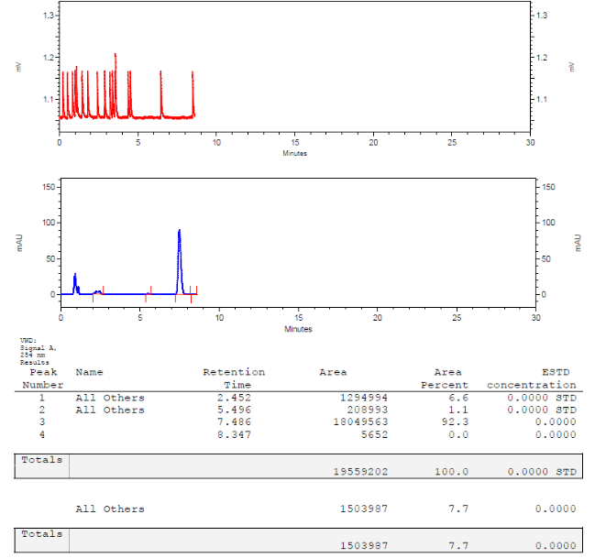

The co-elution (spike) analytical HPLC of the final product [¹⁸F]5 and standard 5 is shown below:
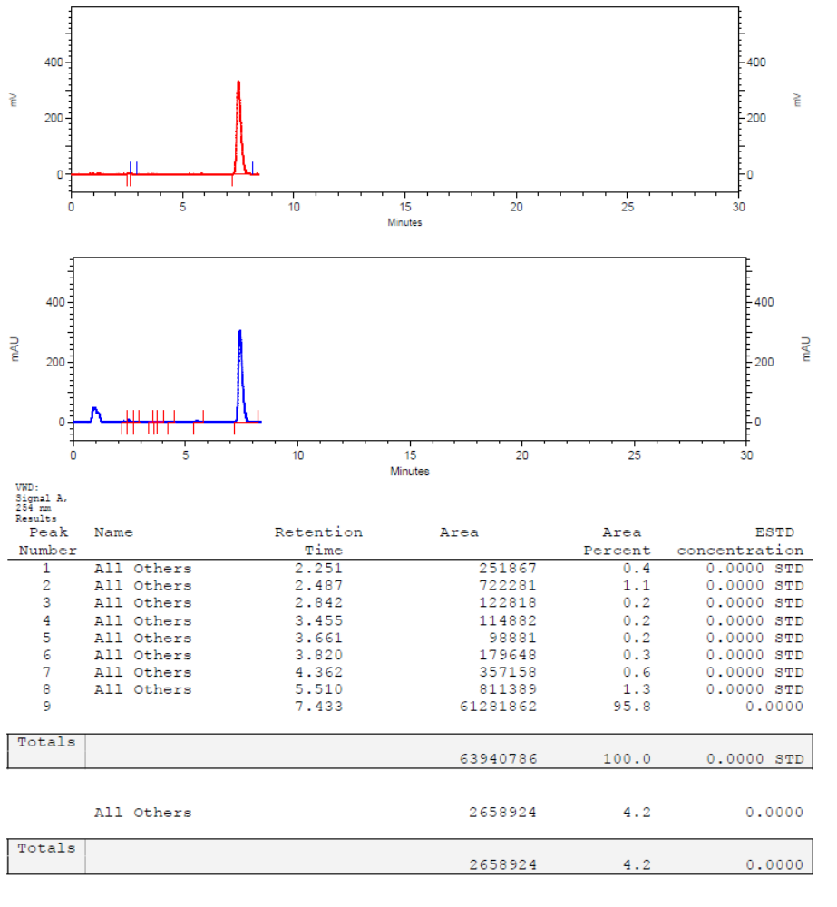
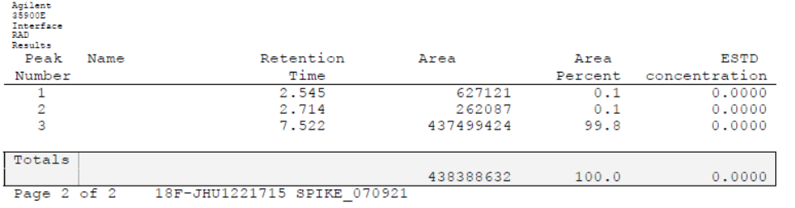

N-(2-(4,4-Dimethylpiperidin-1-yl)-4-(piperazin-1-yl)phenyl)-2-[¹⁸F]fluoropyrimidine-4-carboxamide, [¹⁸F]6: A solution of ¹⁸F-fluoride obtained from proton bombardment of ¹⁸O-water in a General Electric PETtrace cyclotron and 2 mg of potassium oxalate monohydrate in 0.4 mL of water and 7 mg of Kryptofix 222® in 2 mL ACN were added to a reaction vessel of a GE MicroLab module (Waukesha, WI). The mixture was evaporated azeotropically at 90-140°C under a stream of argon after the addition of 2 mL of CH₃CN and cooled to 60ºC. A solution of 10c (3 mg) in DMSO (0.75 mL) was added to the reaction vessel and the mixture was heated at 140°C for 15 min. The reaction mixture was cooled to room temperature, TFA (0.5 mL) was added and stirred at 35ºC for 30 min. The resulting mixture was diluted with solution of ammonium formate (0.41 g) in water (1 mL) and injected onto the reverse-phase semi-preparative high performance liquid chromatography (HPLC) column. The radioactive product peak was collected in solution of 50 mL HPLC grade water and 0.3 g sodium ascorbate. The aqueous solution was transferred through an activated Waters Oasis Light Plus HLB cartridge (Milford, MA). After washing the cartridge with 10 mL saline, the product was eluted with 1 mL of ethanol through a 0.2 μM sterile filter into a sterile, pyrogen-free vial containing 4 mL saline and 10 mL of 0.9% saline was added through the same filter. The final product [¹⁸F]6 was then analyzed by analytical HPLC to determine the radiochemical purity and specific radioactivity. The total preparation time including quality control was ~2 h.
Semi-preparative HPLC conditions: XBridge C18, 10 micron, 10 x 250 mm; mobile phase: 300:700:1 (ACN : water: TFA); flow rate 12 mL/min; UV - 254 nm; retention time 17-18 min.
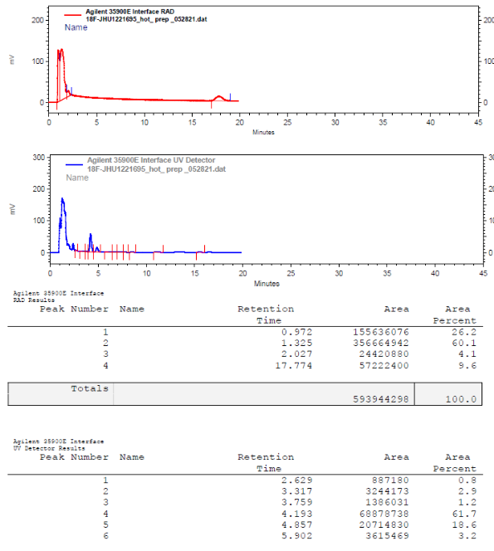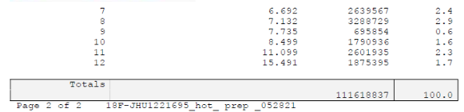

Analytical HPLC conditions: XBridge, 3.5 micron, 4.6 x 250 mm mobile phase: 360:640:1 (ACN : water: TFA); flow rate 2.5 mL/min; UV - 254 nm; retention time 6.9 min.
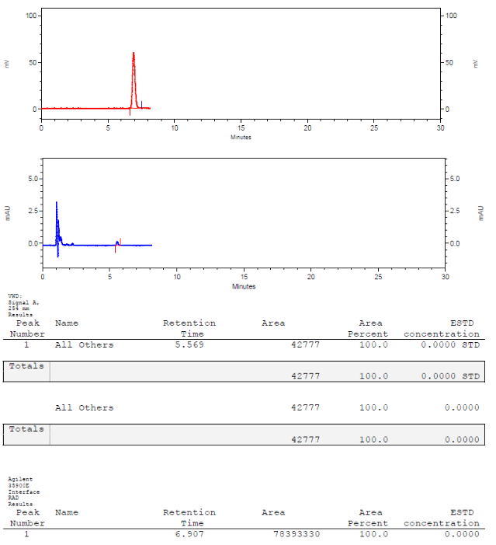

CSF1R binding assay (commercial assay, Eurofins, study code 87-0007-1104, Fms (CSFR) (CSF1R) Human RTK Kinase Binding Assay, KINOMEscan (KdELECT) - DiscoverX)

Fluoroethyl-CPPC
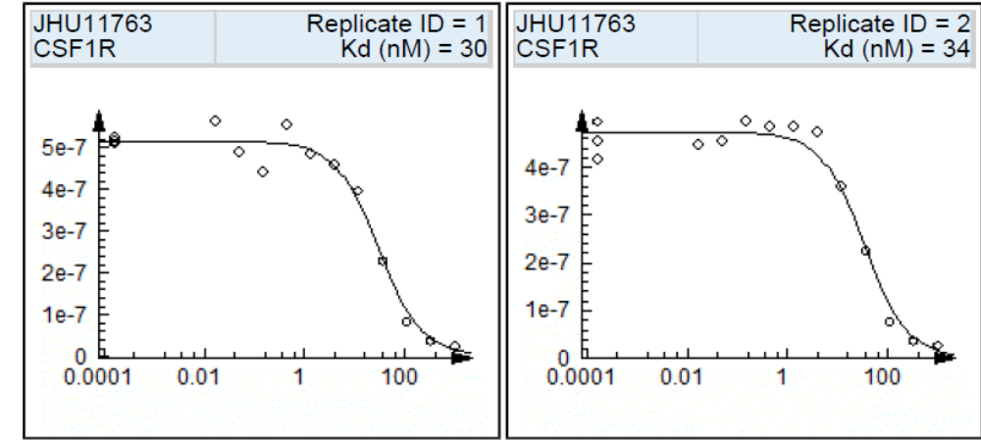

Compound 1
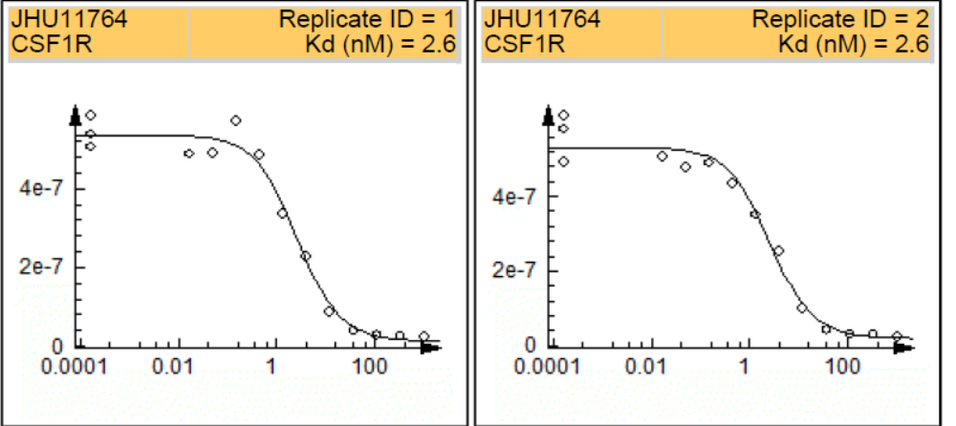

Compound 2
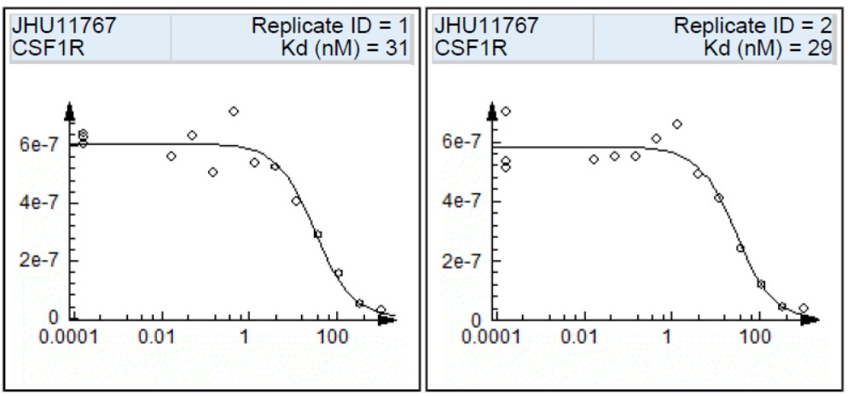

Compound 3
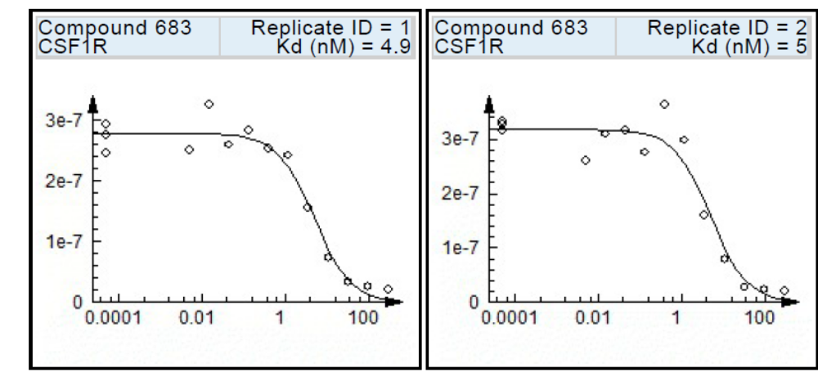

Compound 4
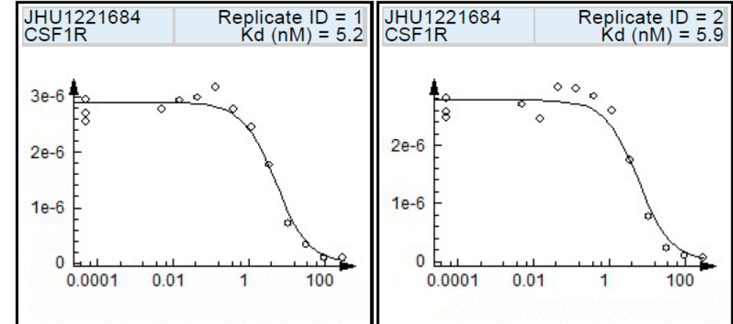

Compound 5
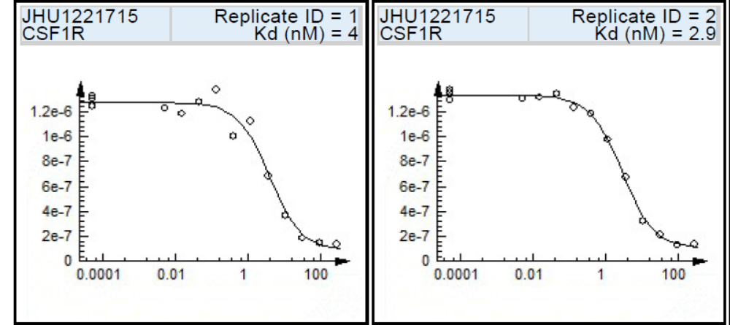

Compound 6
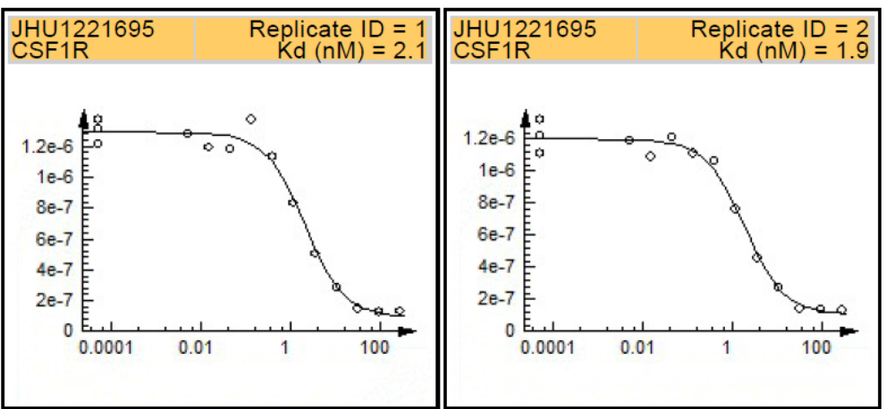

Stability of [¹⁸F]3 formulation.
For the stability testing the radiotracer [¹⁸F]3 was synthesized and formulated in saline with 7% alcohol as described in Methods. The formulation of [¹⁸F]3 was stored at room temperature for 2.5 hours and analyzed by analytical HPLC under the same conditions as those of radiosynthesis (Table S1)
Table S1. Stability test of [¹⁸F]3 formulation during storage for 2.5 hours at room temperature. Radiochemical purity was determined by HPLC.

Purity, %  EOS time | Purity, %  1.5 h | Purity, %  2.5 h
100% | 100% | 100%

Blocking of [¹⁸F]3 in control mice.
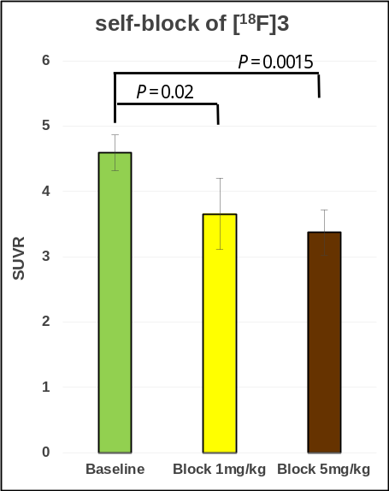
Figure S1. Dose-escalation blocking study of [¹⁸F]3 in the whole brain of control mice. Time-point – 60 min. Data: SUVR ± SD (n=4) (ANOVA)

Effect of elacridar on the whole brain uptake of [¹⁸F]3 in control mice.
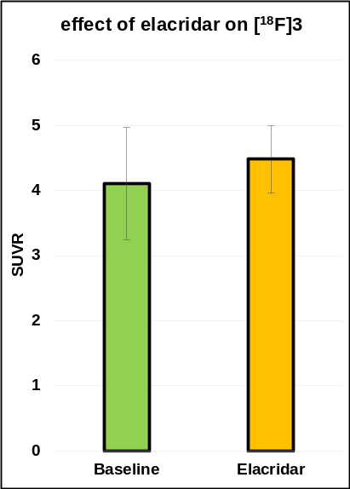
Figure S2. Effect of elacridar (10 mg/kg, ip) on the whole brain uptake of [¹⁸F]3 in control mice. Time-point – 60 min. Data: SUVR ± SD (n=4), (P = 0.48, ANOVA). The study demonstrated no significant effect of elacridar on the whole brain uptake of radiotracer [¹⁸F]3

Table S2. Inhibition of various kinases by compound 3 at concentration of 1 µM, 10 µM and 100 µM is indicated as percent of control (0% - full inhibition or a hit; 100% - no inhibition). Previously published (Knight et al. 2021) inhibition of the same kinases by CPPC is shown for comparison.
Kinases | compound 3 @ 1 µM | compound 3 @ 10 µM | compound 3 @ 100 µM | CPPC @  10 µM (Knight et al. 2021)
Abl (H396P) (h) | 59 | 11 | 0 | 0.01
ALK(h) | 30 | 4 | 2 | 0.1
Blk(h) | 27 | 2 | 0 | 0.01
BTK(R28H)(h) | 41 | 8 | 5 | 0
cKit(D816H)(h) | 32 | 4 | 2 | 0.3
Flt1(h) | 39 | 4 | 1 | 1.2
Flt3(D835Y)(h) | 2 | 2 | 2 | 1.8
JAK2(h) | 78 | 23 | 2 | 0
JAK3(h) | 88 | 45 | 11 | 0.15
KDR(h) | 48 | 9 | 4 | 0.85
Lck(h) activated | 20 | 1 | 0 | 0.05
Flt4(h) |  | 1 |  | 0
HPK1(h) |  | 5 |  | 0
IKKε(h) |  | 98 |  | 0
IRAK1(h) |  | 19 |  | 0
KDR(h) |  | 11 |  | 0.85
MST2(h) |  | 52 |  | 0
PDGFRβ(h) |  | 74 |  | 0
TAK1(h) |  | 4 |  | 0
TBK1(h) |  | 70 |  | 0

In vitro Flt3 inhibition binding assay of compound 3 (commercial assay, Eurofins, 87-0007-1436 FLT3 (D835H) Human RTK Kinase KINOMEscan, KdELECT Binding)
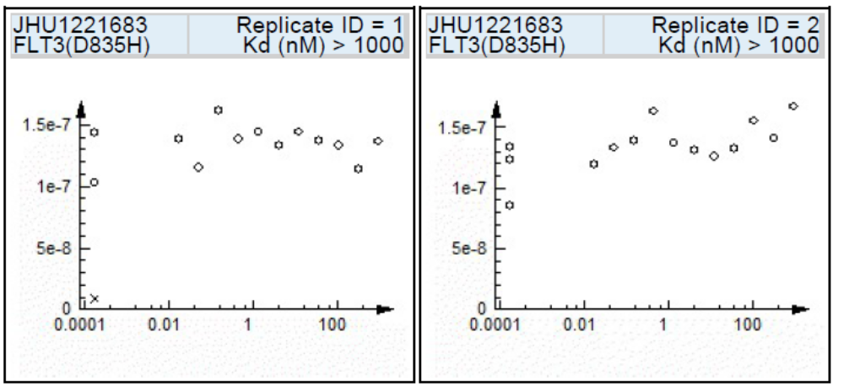

Table S3. Mouse whole body distribution of [¹⁸F]3, data – mean %ID/organ. The bottom table shows the corresponding standard deviations (n = 3)
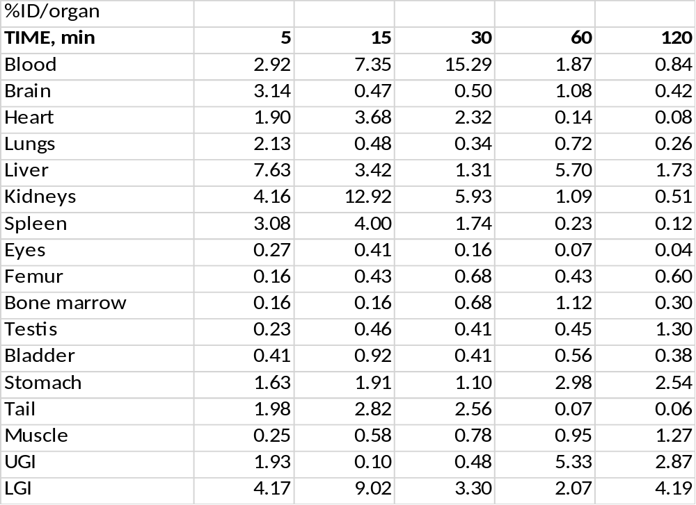
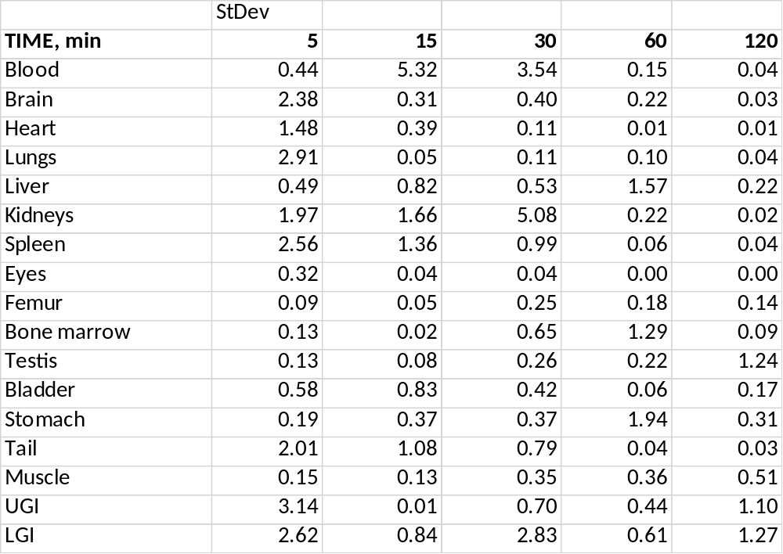

Analysis of radiometabolites in baboon plasma (see methods in (Hilton et al. 2000) for details)

Metabolites of [¹⁸F]3
Mobile Phase A [1%ACN: 99% Water] and B[70%-30% ACN, 0.06M TEA pH 7.2], Capture Column Elution, 4.6 x 250 mm, Gemini Column, 5 um (S/N: H16-435837), 2 mL injection loop, capture column, 5 uL of cold standard 3 and 2409 Bq of [¹⁸F]3 injected.
 | Met-1 of [¹⁸F]3 | Met-2 of [¹⁸F]3 | Parent [¹⁸F]3
Retention time, min* | 1.0 | 6.0 | 9.6

[¹⁸F]3 metabolites analysis in baboon plasma at 20 min after radiotracer injection.
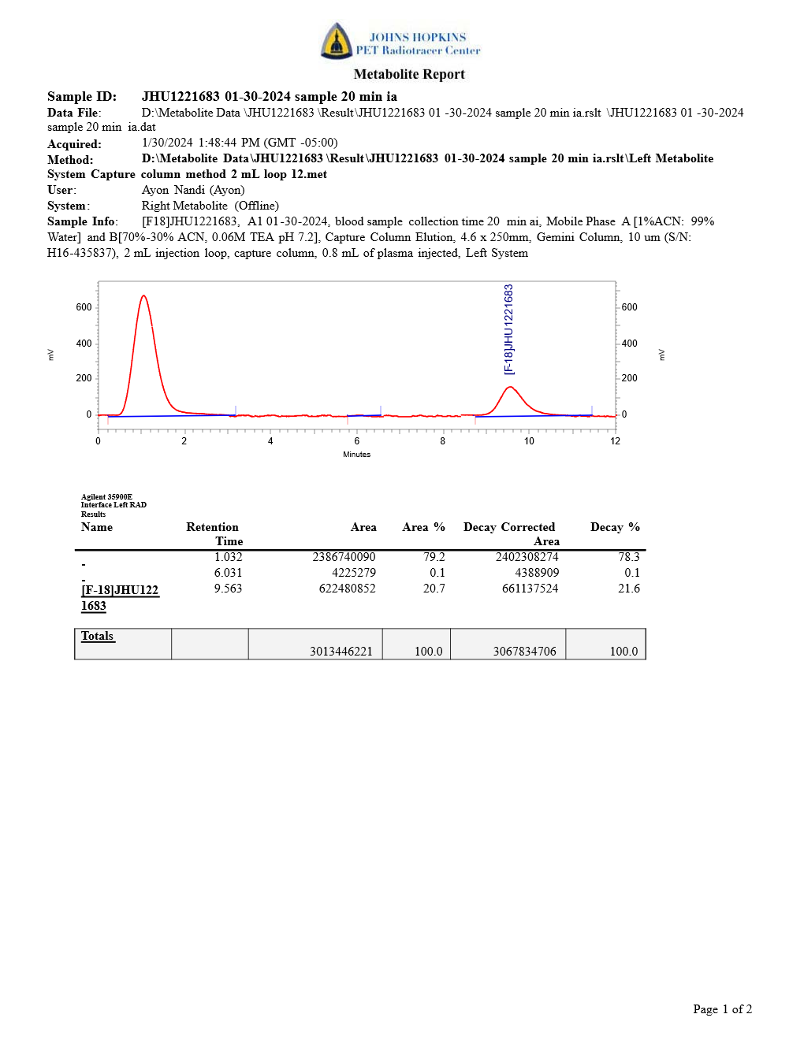

Metabolites of [¹⁸F]1
Mobile Phase A [1%ACN: 99% Water] and B[50%-50% ACN, 0.045M ammonium formate pH 4.5], Capture Column Elution, 4.6 x 250 mm, Gemini Column, 5 um (S/N: H16-435837), 2 mL injection loop, capture column, 5uL of cold std and 2409 Bq of [¹⁸F]1 injected.
 | Met-1 of [¹⁸F]1 | Met-2 of [¹⁸F]1 | Parent [¹⁸F]1
Retention time, min | 1.0 | 6.1 | 7.4

[¹⁸F]1 metabolites analysis in baboon plasma at 20 min after radiotracer injection
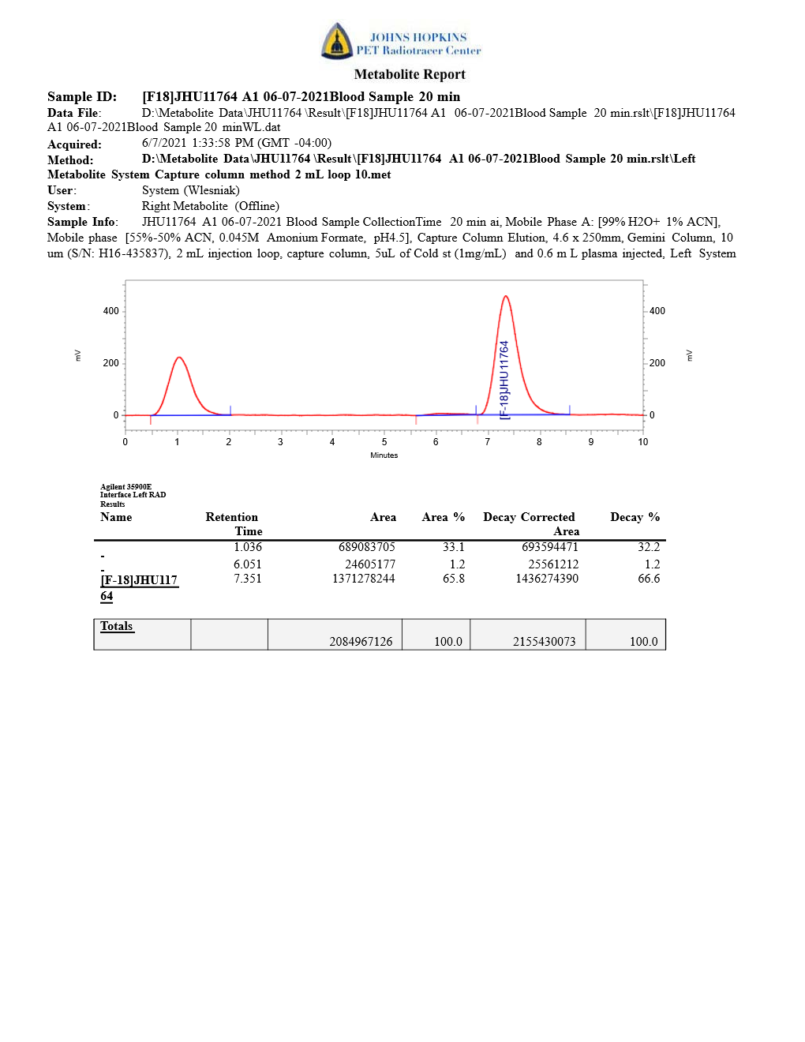

Supplemental References
Hilton, J., F. Yokoi, R. F. Dannals, H. T. Ravert, Z. Szabo and D. F. Wong. Column-switching HPLC for the analysis of plasma in PET imaging studies. Nucl Med Biol. 2000; 27(6): 627-30.
Knight, A. C., C. Varlow, T. Zi, S. H. Liang, L. Josephson, K. Schmidt, S. Patel and N. Vasdev. In Vitro Evaluation of [(3)H]CPPC as a Tool Radioligand for CSF-1R. ACS Chem Neurosci. 2021; 12(6): 998-1006.

