Optimization of automated radiosynthesis method for [¹⁸F]AlF-NOTA-Octreotide and PET/CT imaging in neuroendocrine neoplasms
Xiaoting Wan^{1†} ,Jiangyue Yan^{1†}, Jieting Hu^{1†}, Ruiyun Zhang¹ , Shiliang Zhu², Hao Sun², Jingwen Cao², Kaixuan Li², Dacan Yang², Lingyun Yang³, Kaizhen Xianyu³, Di xia³, Zijian He³ and Dan LI¹ *
1 Department of Nuclear Medicine, Sun Yat-sen Memorial Hospital, 33 Yingfeng Road, Guangzhou, 510288, Guangdong, China.
2 JYAMS PET Research &Development Limited, No. 5 Qiande Road, Nanjing 211100, Jiangsu, China.
3 Guangdong AMS Pharmaceutical Co. Ltd., No. 6 Jiangwan Road, Zhongshan 528437, Guangdong, China.
Table S1. Summary of the basic patient information and clinical diagnosis for [¹⁸F]F-FDG imaging results with [¹⁸F]AlF-NOTA-Octreotide
Number | Gender | Age | [¹⁸F]F-FDG | [¹⁸F]AlF-NOTA-Octreotide | Final diagnosis
#1 | Female | 53 | ⁺ | ⁺ | GEP-NEN G1
#2 | Female | 45 | ⁺ | ⁺ | SDHD PPGLs
#3 | Female | 51 | ⁻ | ⁺ | Renal NEN
#4 | Female | 45 | ⁻ | ⁺ | GEP-NEN G2
#5 | Female | 61 | ⁻ | ⁺ | GEP-NEN G2
#6 | Female | 54 | ⁻ | ⁺ | GEP-NEN
#7 | Female | 59 | ⁻ | ⁺ | GEP-NEN G2
#8 | Male | 43 | ⁻ | ⁺ | GEP-NEN G2
#9 | Male | 44 | ⁺ | ⁻ | pNET (AC)
#10 | Female | 44 | ⁻ | ⁻ | MEN2A
#11 | Female | 25 | ⁻ | ⁻ | GEP-NEN G1
#12 | Male | 53 | ⁻ | ⁻ | GIST
#13 | Female | 50 | ⁻ | ⁻ | ACTH-Dep CS
#14 | Male | 57 | ⁻ | ⁻ | ACTH-Dep CS
#15 | Female | 52 | ⁻ | ⁻ | ACTH-Dep CS
#16 | Male | 50 | ⁻ | ⁻ | ACTH-Dep CS
GEP-NEN: Gastro-Entero-Pancreatic Neuroendocrine Neoplasm; SDHD PPGLs: SDHD-related Pheochromocytoma and Paraganglioma; Renal NEN: Renal Neuroendocrine Neoplasm; pNEN (AC): Pulmonary Neuroendocrine Neoplasm (Atypical Carcinoid); MEN2A: Multiple Endocrine Neoplasia type 2A; GIST: Gastrointestinal Stromal Tumor; ACTH-Dep CS: ACTH-Dependent Cushing's Syndrome.
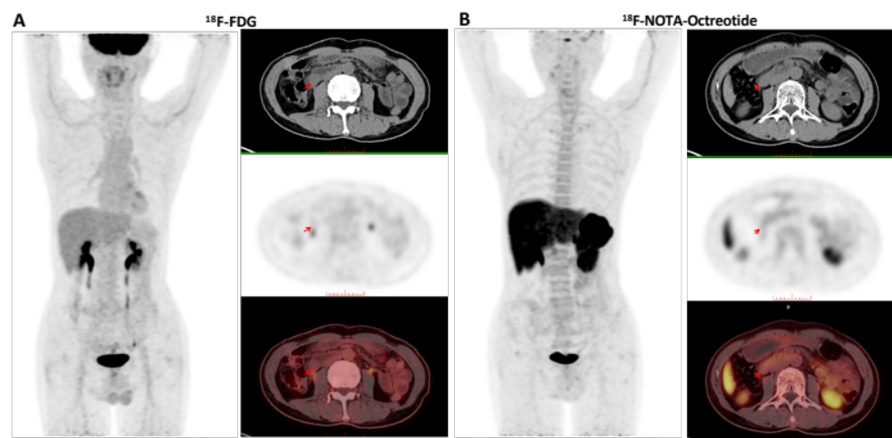
Figure S1. A 53-year-old male with suspected neuroendocrine tumor based on clinical and CT findings, scheduled for PET/CT for further diagnostic clarification. Both [¹⁸F]F-FDG (A) and [¹⁸F]AlF-NOTA-Octreotide (B) PET/CT scans showed negative radiotracer uptake. Subsequent postoperative pathology of this duodenal lesion confirmed it as a gastrointestinal stromal tumor (GIST).
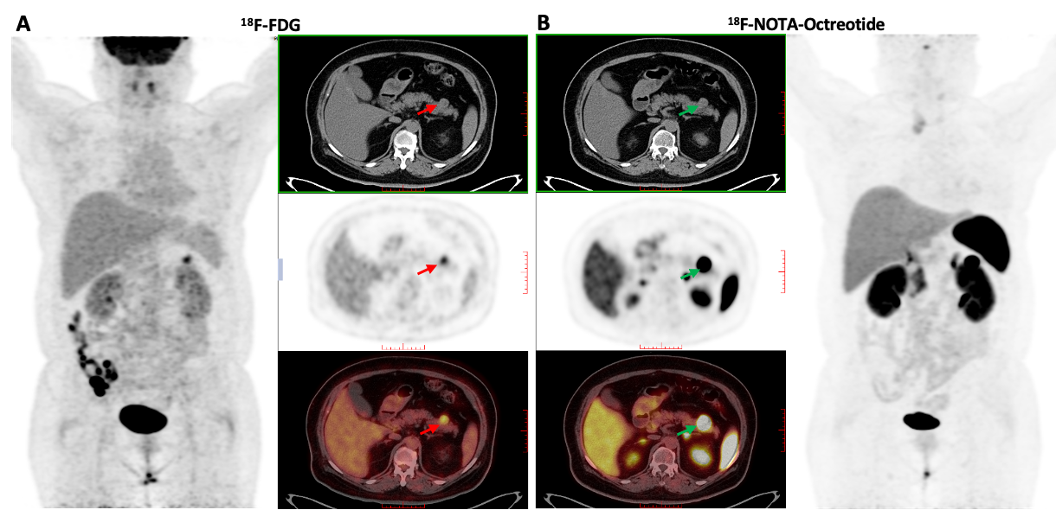
Figure S2. Representative case with both [¹⁸F]AlF-NOTA-Octreotide PET/CT and [¹⁸F]F-FDG PET/CT showing positive findings (Patient #1). A 53-year-old woman, incidental pancreatic lesion on routine physical examination. (A) [¹⁸F]F-FDG PET/CT shows moderate uptake in pancreatic lesion (red arrows, SUVmax=7.6). (B) [¹⁸F]AlF-NOTA-Octreotide PET/CT shows intense uptake in these lesions (green arrows, SUVmax=71.6). Subsequent postoperative pathology in this pancreatic lesion confirmed NENs(G2).

