Supplementary information:

eFAP-51, a Novel FAPI Dimer with Enhanced Tumor Uptake and Retention for Theranostic Applications
Le Li^{1,2}, Hanyue Ma^{1,2}, Amber Piet^{1,2}, Corrina de Ridder^{1,2}, Debra Stuurman^{1,2}, Priciana Paraïso^{1,2}, Yann Seimbille^{1,2,*}
- Erasmus MC, University Medical Center Rotterdam, Department of Radiology and Nuclear Medicine, Rotterdam, The Netherlands
- Erasmus MC Cancer Institute, Rotterdam, The Netherlands
* Correspondence: y.seimbille@erasmusmc.nl; Tel: +31 10-703-8961
Table of Contents
Synthetic method | 4
Figure S1. LC-MS spectrum of compound 2. | 10
Figure S2. ¹H NMR (600 MHz, DMSO-d₆) spectrum of compound 2. | 10
Figure S3. LC-MS spectrum of compound 3. | 11
Figure S4. LC-MS spectrum of eFAP-20. | 11
Figure S5. LC-MS spectrum of compound 4. | 12
Figure S6. ¹H NMR (600 MHz, CD₃OD) spectrum of compound 4. | 12
Figure S7. LC-MS spectrum of compound 5. | 13
Figure S8. LC-MS spectrum of eFAP-31. | 13
Figure S9. LC-MS spectrum of compound 7. | 14
Figure S10. ¹H NMR (60 MHz, DMSO-d₆) spectrum of compound 7. | 14
Figure S11. LC-MS spectrum of compound 8. | 15
Figure S12. LC-MS spectrum of eFAP-34. | 15
Figure S13. LC-MS spectrum of compound 9. | 16
Figure S14. ¹H NMR (600 MHz, DMSO-d₆) spectrum of compound 9. | 16
Figure S15. LC-MS spectrum of compound 10. | 17
Figure S16. LC-MS spectrum of eFAP-35. | 17
Figure S17. LC-MS spectrum of compound 11. | 18
Figure S18. ¹H NMR (600 MHz, DMSO-d₆) spectrum of compound 11. | 18
Figure S19. LC-MS spectrum of compound 12. | 19
Figure S20. LC-MS spectrum of eFAP-36. | 19
Figure S21 LC-MS spectrum of compound 14. | 20
Figure S22. ¹H NMR (60 MHz, CDCl₃) spectrum of compound 14. | 20
Figure S23. LC-MS spectrum of compound 15. | 21
Figure S24. ¹H NMR (600 MHz, CD₃OD) spectrum of compound 15. | 21
Figure S25. LC-MS spectrum of compound 16. | 22
Figure S26. LC-MS spectrum of eFAP-37. | 22
Figure S27. LC-MS spectrum of compound 17. | 23
Figure S28. ¹H NMR (600 MHz, CD₃OD) spectrum of compound 17. | 23
Figure S29. LC-MS spectrum of compound 18. | 24
Figure S30. LC-MS spectrum of eFAP-50. | 24
Figure S31. LC-MS spectrum of compound 19. | 25
Figure S32. LC-MS spectrum of eFAP-51. | 25
Figure S33. LC-MS spectrum of compound 20. | 26
Figure S34. LC-MS spectrum of eFAP-52. | 26
Figure S35. iTLC spectrum (A) and radio-HPLC chromatograms of [¹¹¹In]In-eFAP-20 directly after labeling (T0), 1, 4, and 24 h post-incubation at 37˚C in PBS (B). | 27
Figure S36. iTLC spectrum (A) and radio-HPLC chromatograms of [¹¹¹In]In-eFAP-31 directly after labeling (T0), 1, 4, and 24 h post-incubation at 37˚C in PBS (B) and MS (C). | 27
Figure S37. iTLC spectrum (A) and radio-HPLC chromatograms of [¹¹¹In]In-eFAP-34 directly after labeling (T0), 1, 4, and 24 h post-incubation at 37˚C in PBS (B) and MS (C). | 28
Figure S38. iTLC spectrum (A) and radio-HPLC chromatograms of [¹¹¹In]In-eFAP-35 directly after labeling (T0), 1, 4, and 24 h post-incubation at 37˚C in PBS (B) and MS (C). | 28
Figure S39. iTLC spectrum (A) and radio-HPLC chromatograms of [¹¹¹In]In-eFAP-36 directly after labeling (T0), 1, 4, and 24 h post-incubation at 37˚C in PBS (B) and MS (C). | 29
Figure S40. iTLC spectrum (A) and radio-HPLC chromatograms of [¹¹¹In]In-eFAP-37 directly after labeling (T0), 1, 4, and 24 h post-incubation at 37˚C in PBS (B) and MS (C). | 29
Figure S41. iTLC spectrum (A) and radio-HPLC chromatograms of [¹¹¹In]In-eFAP-50 directly after labeling (T0), 1, 4, and 24 h post-incubation at 37˚C in PBS (B) and MS (C). | 30
Figure S42. iTLC spectrum (A) and radio-HPLC chromatograms of [¹¹¹In]In-eFAP-51 directly after labeling (T0), 1, 4, and 24 h post-incubation at 37˚C in PBS (B) and MS (C). | 30
Figure S43. iTLC spectrum (A) and radio-HPLC chromatograms of [¹¹¹In]In-eFAP-52 directly after labeling (T0), 1, 4, and 24 h post-incubation at 37˚C in PBS (B) and MS (C). | 31
Table S1. Cell uptake of [¹¹¹In]In-FAPI-46 and [¹¹¹In]In-eFAPs (n=3) using HT1080.huFAP cells at different time points. | 31
Table S2. Quantitative analysis of SPECT/CT images comparing [¹¹¹In]In-FAPI-46, [¹¹¹In]In-eFAP-51, and [¹¹¹In]In-eFAP-52 at 1, 4, 24, and 48 h post-injection. | 32
Table S3. Ex vivo biodistribution analysis of [¹¹¹In]In-FAPI-46, [¹¹¹In]In-eFAP-51 and [¹¹¹In]In-eFAP-52 in HT-1080.huFAP and HT-1080.WT tumor bearing mice at 48 h post-injection. | 32
Figure S44. Quantitative analysis of SPECT/CT images comparing [¹¹¹In]In-FAPI-46, [¹¹¹In]In-eFAP-51, and [¹¹¹In]In-eFAP-52 at 1, 4, 24, and 48 h post-injection. | 33
Figure S45. iTLC spectrum (A) and radio-HPLC chromatograms of [¹⁷⁷Lu]Lu-eFAP-51 directly after labeling (T0), 1, 4, and 24 h post-incubation at 37˚C in PBS (B) and MS (C). | 34
Table S4. Cell uptake of [¹⁷⁷Lu]Lu-FAPI-46 and [¹⁷⁷Lu]Lu-eFAP-51 using HT1080.huFAP cells with different masses. | 34
Figure S46. SPECT/CT images of mice bearing HT1080.hFAP (right shoulder) and HT1080-WT tumors (left shoulder) at 1, 4, 24 and 48 h after injection of [¹⁷⁷Lu]Lu-eFAP-51 across four molar doses. | 35
Table S5. Ex vivo biodistribution analysis of [¹⁷⁷Lu]Lu-eFAP-51 with different dose in HT-1080.huFAP and HT-1080.WT tumor bearing mice at 48 h p.i. | 36
Figure S47. Dose-dependent uptake of [¹⁷⁷Lu]Lu-eFAP-51 in (A) liver, (B) spleen, and (C) kidneys at 48 h p.i. in HT-1080.huFAP tumor-bearing mice. Data are presented as mean ± SD (n = 3 per group). Statistical significance was determined by One-way ANOVA with Tukey's multiple comparisons test. *p < 0.05, **p < 0.01, ***p < 0.001 vs. the 0.1 nmol group; ns, not significant. No significant differences were observed between the 0.3 and 0.6 nmol groups for any of the three organs (p > 0.05). | 36
Table S6. Ex vivo biodistribution analysis of [¹⁷⁷Lu]Lu-eFAP-51 with different dose in HT-1080.huFAP and HT-1080.WT tumor bearing mice at 1, 4, 24, 48 h p.i. | 37

Synthetic method
Synthesis of 3,3'-((1,2,4,5-tetrazine-3,6-diyl)bis(sulfanediyl))dipropionic acid (2)
3,6-Dichloro-1,2,4,5-tetrazine (1, 4.0 mg, 25.6 µmol) was dissolved in anhydrous DMF (1 mL), followed by sequential addition of 3-mercaptopropanoic acid (5.9 mg, 56.3 µmol, 2.2 equiv.) and DIPEA (20 µL). The reaction mixture was stirred at room temperature for 30 min. After removal of the solvent under reduced pressure, the crude product was purified by prep-HPLC to afford compound 2 as a pink powder (3.1 mg, 71% yield). ESI-MS: m/z calc’ for C₈H₁₀N₄O₄S₂ 290.01; found 291.00 [M + H]⁺. ¹H NMR (600 MHz, DMSO-d₆): δ 3.38 (td, J = 6.9, 1.5 Hz, 4H), 2.69 (td, J = 6.9, 1.5 Hz, 4H).
Synthesis of 8,8'-((((3,3'-((1,2,4,5-tetrazine-3,6-diyl)bis(sulfanediyl))bis(propanoyl))bis(azanediyl))bis(propane-3,1-diyl))bis(oxy))bis(N-(2-((S)-2-cyano-4,4-difluoropyrrolidin-1-yl)-2-oxoethyl)quinoline-4-carboxamide) (3)
Compound 2 (1.1 mg, 3.9 µmol) was redissolved in DMF (1 mL), followed by the addition of 8-QCP (3.6 mg, 8.7 µmol, 2.2 equiv.), HBTU (3.0 mg, 7.9 µmol, 2.0 equiv.), and DIPEA (20 µL). The reaction mixture was stirred at rt for 1 h. The solvent was then removed under vacuum, and the crude product was purified by prep-HPLC to yield compound 3 (1.9 mg, 1.7 µmol, 45%) as an off-yellow powder. ESI-MS: m/z calc’ for C₄₈H₄₈F₄N₁₄O₈S₂ 1088.32; found 1089.12 [M + H]⁺; 845.30 [M + 2H]²⁺.
Synthesis of eFAP-20
Compound 3 (1.9 mg, 1.7 µmol) was redissolved in ACN/H₂O (1 mL, 1:1), followed by the addition of TCO-DOTA-GA (1.3 mg, 1.9µmol, 1.1 equiv.). The reaction was stirred at 37 ℃ for 30 min, and the product was purified by prep-HPLC to yield eFAP-20 (1 mg, 0.6 µmol, 34%) as an off-white powder. ESI-MS: m/z calc’ for C₇₉H₉₈F₄N₁₈O₁₉S₂ 1743.87; found 1746.40 [M + H]⁺; 873.40 [M + 2H]²⁺; 582.70 [M + 3H]³⁺.
Synthesis of 6,6'-((1,2,4,5-tetrazine-3,6-diyl)bis(sulfanediyl))dihexanoic acid (4)
3,6-Dichloro-1,2,4,5-tetrazine (1, 4 mg, 26.5 µmol) was dissolved in DMF (1 mL). 6-Mercaptohexanoic acid (8.6 mg, 58.3 µmol, 2.2 equiv) and DIPEA (20 µL) were added. The reaction mixture was stirred at room temperature for 30 min. The solvent was removed under vacuum, and the crude product was purified by prep-HPLC to yield afford compound 4 as a pink powder (7.7 mg, 20.6µmol,78%). ESI-MS: m/z calc’ for C₁₄H₂₂N₄O₄S₂ 374.11; found 375.10 [M + H]⁺. ¹H NMR (600 MHz, CD₃OD): δ 3.39-3.33 (m, 4H), 2.34 (t, J = 7.4 Hz, 4H), 1.85 (p, J = 7.5 Hz, 4H), 1.69 (p, J = 7.3 Hz, 4H), 1.62-1.9 (m, 4H).
Synthesis of 8,8'-((((6,6'-((1,2,4,5-tetrazine-3,6-diyl)bis(sulfanediyl))bis(hexanoyl))bis(azanediyl))bis(propane-3,1-diyl))bis(oxy))bis(N-(2-((S)-2-cyano-4,4-difluoropyrrolidin-1-yl)-2-oxoethyl)quinoline-4-carboxamide) (5)
Compound 4 (1.3 mg, 3.4 µmol)was redissolved in DMF (1 mL), followed by the addition of 8-QCP (3.2 mg, 7.6 µmol, 2.2 equiv.), HBTU (2.6 mg, 6.9 µmol, 2.0 equiv.), and DIPEA (20 µL). The reaction mixture was stirred at rt for 1 h. The solvent was removed under vacuum, and the crude product was purified by prep-HPLC to yield compound 5 (1.9 mg, 1.6 µmol, 51%) as an off-yellow powder. ESI-MS: m/z calc’ for C₅₄H₆₀F₄N₁₄O₈S₂ 1172.41; found 1173.40 [M + H]⁺; 587.30 [M + 2H]²⁺.
Synthesis of eFAP-31
Compound 5 (1.9 mg, 1.6 µmol) was redissolved in ACN/H₂O (1 mL, 1:1), followed by the addition of TCO-DOTA-GA (1.2 mg, 1.8 µmol, 1.1 equiv.). The reaction was stirred at 37 ℃ for 30 min, and the product was purified by prep-HPLC to yield eFAP-31 (2 mg, 1 µmol, 64%) as an off-white powder. ESI-MS: m/z calc’ for C₈₅H₁₁₀F₄N₁₈O₁₉S₂ 1828.04; found 1830.40 [M + H]⁺; 915.40 [M + 2H]²⁺; 610.70 [M + 3H]³⁺.
Synthesis of 3,3'-(((5-(2-azidoacetyl)-1,3,5-triazinane-1,3-diyl)bis(2-oxoethane-2,1-diyl))bis(sulfanediyl))dipropionic acid (7)
Compound 6 was synthesized as previously described by van de Langemheen et al (1). 6 (25 mg, 65.3 µmol) was dissolved in DMF (1 mL), followed by the addition of 3-mercaptopropanoic acid (15.2 mg, 143.6 µmol, 2.2 equiv.) and DIPEA (20 µL). The reaction mixture was stirred at rt for 30 min. After removal of the solvent under vacuum, product was purified to afford compound 7 (10.6 mg, 22.8 µmol, 35%) as an off-white powder. ESI-MS: m/z calc’ for C1₅H₂₂N₆O₇S₂ 462.10; found 463.10 [M + H]⁺. ¹H NMR (60 MHz, DMSO-d₆): δ 5.18 (s, 6H), 4.23 (s, 2H), 3.54 (s, 4H), 2.84 (t, J = 3.3 Hz, 4H), 2.40 (t, J = 3.3 Hz, 4H).
Synthesis of 8,8'-((((3,3'-(((5-(2-azidoacetyl)-1,3,5-triazinane-1,3-diyl)bis(2-oxoethane-2,1-diyl))bis(sulfanediyl))bis(propanoyl))bis(azanediyl))bis(propane-3,1-diyl))bis(oxy))bis(N-(2-((S)-2-cyano-4,4-difluoropyrrolidin-1-yl)-2-oxoethyl)quinoline-4-carboxamide) (8)
Compound 7 (2.5 mg, 5.3 µmol) was dissolved in DMF (1 mL), followed by the addition of 8-QCP (5.0 mg, 11.7 µmol, 2.2 equiv.), HBTU (4.0 mg, 10.5 µmol, 2.0 equiv.), and DIPEA (20 µL). The reaction mixture was stirred at rt for 1 h. The solvent was removed under vacuum, and the crude product was purified by prep-HPLC to yield compound 8 (4.0 mg, 3.1 µmol, 60%) as an off-white powder. ESI-MS: m/z calc’ for C₅₅H₆₀F₄N₁₆O₁₁S₂ 1260.40; found 1261.3 [M + H]⁺.
Synthesis of eFAP-34
Compound 8 (2.9 mg, 2.2 µmol) was redissolved in ACN/H₂O (1 mL, 1:1), followed by the addition of BCN-DOTA-GA (1.7 mg, 2.4 µmol, 1.1 equiv.). The reaction was stirred at 37 ℃ for 30 min, the product was purified by prep-HPLC to yield eFAP-34 (1.4 mg, 0.7 µmol, 31%) as an off-white powder. ESI-MS: m/z calc’ for C₈₇H₁₁₀F₄N₂₂O₂₂S₂ 1956.08; found 1956.60 [M + H]⁺; 978.40 [M + 2H]²⁺; 652.70 [M + 3H]³⁺.
Synthesis of 6,6'-(((5-(2-azidoacetyl)-1,3,5-triazinane-1,3-diyl)bis(2-oxoethane-2,1-diyl))bis(sulfanediyl))dihexanoic acid (9)
Compound 6 (7.0 mg, 18.2 µmol) was dissolved in DMF (1 mL), followed by the addition of 6-mercaptohexanoic acid (6.2 mg, 41.9 µmol, 2.3 equiv.) and DIPEA (20 µL). The reaction mixture was stirred at rt for 30 min. After removal of the solvent under vacuum, product was purified to afford compound 9 (4.5 mg, 8.3 µmol, 46%) as an off-white powder. ESI-MS: m/z calc’ for C₂₁H₃₄N₆O₇S₂ 546.19; found 547.10 [M + H]⁺. ¹H NMR (600 MHz, DMSO-d₆): δ 5.15 (s, 6H), 4.20 (s, 2H), 3.47 (s, 4H), 2.45 (t, J = 7.2 Hz, 4H), 2.12 (t, J = 7.3 Hz, 4H), 1.43-1.25 (m, 12H).
Synthesis of 8,8'-((((6,6'-(((5-(2-azidoacetyl)-1,3,5-triazinane-1,3-diyl)bis(2-oxoethane-2,1-diyl))bis(sulfanediyl))bis(hexanoyl))bis(azanediyl))bis(propane-3,1-diyl))bis(oxy))bis(N-(2-((S)-2-cyano-4,4-difluoropyrrolidin-1-yl)-2-oxoethyl)quinoline-4-carboxamide) (10)
Compound 9 (2.8 mg, 5.2 µmol) was dissolved in DMF (1 mL), followed by the addition of 8-QCP (4.8 mg, 11.4 µmol, 2.2 equiv.), HBTU (3.9 mg,10.4 µmol, 2.0 equiv.), and DIPEA (20 µL). The reaction mixture was stirred at rt for 1 h. The solvent was removed under vacuum, and the crude product was purified by prep-HPLC to yield compound 10 (2.2 mg, 1.6 µmol, 31%) as an off-white powder. ESI-MS: m/z 1346.3 [M + H]⁺. ESI-MS: m/z calc’ for C₆₁H₇₂F₄N₁₆O₁₁S₂ 1345.46; found 1346.30 [M + H]⁺;880.10 [M + 2H]²⁺; 673.30 [M + 3H]³⁺.
Synthesis of eFAP-35
Compound 10 (2.2 mg, 1.6 µmol) was redissolved in ACN/H₂O (1 mL, 1:1), followed by the addition of BCN-DOTA-GA (1.3 mg, 1.7µmol, 1.1 equiv.). The reaction was stirred at 37 ℃ for 30 min, the solvent was purified by prep-HPLC to yield eFAP-35 (1.8 mg, 0.9 µmol, 54%) as an off-white powder. ESI-MS: m/z calc’ for C₉₃H₁₂₂F₄N₂₂O₂₂S₂ 2040.24; found 2040.80 [M + H]⁺; 1020.50 [M + 2H]²⁺; 680.80 [M + 3H]³⁺.
Synthesis of 3,3'-(((((((5-(2-azidoacetyl)-1,3,5-triazinane-1,3-diyl)bis(2-oxoethane-2,1-diyl))bis(azanediyl))bis(ethane-2,1-diyl))bis(oxy))bis(ethane-2,1-diyl))bis(oxy))dipropionic acid (11)
Compound 6 (8 mg, 19 µmol) was dissolved in DMF (1 mL), followed by addition of NH₂-PEG₂-tBu (13 mg, 57 µmol, 3.0 equiv.) and DIPEA (20 µL). After stirring at rt for 2 h, the mixture wasdiluted with EtOAc (15 mL), washed with water (3 x 5 mL), dried over MgSO₄ and concentrated under vacuum to obtain a light-white solid. The residue was treated with a solution of DCM/TFA (1:1, 3 mL) at rt for 30 min. All volatiles were removed under a gentle air flow to obtain a light-white crude solid. The crude was purified by prep-HPLC to yield compound 11 (5.7 mg, 9.5 µmol, 55%), as a light-white oil. ESI-MS: m/z calc’ for C₂₃H₄₀N₈O₁₁ 604.62; found 605.20 [M + H]⁺. ¹H NMR (600 MHz, DMSO-d₆): δ 5.27 (s, 6H), 4.30 (s, 2H), 3.69-3.56 (m, 16H), 3.13 (t, J =4.3 Hz, 4H), 2.46 (t, J = 6.3 Hz, 4H).
Synthesis of 8,8'-(((5-(2-azidoacetyl)-1,3,5-triazinane-1,3-diyl)bis(1,12-dioxo-6,9-dioxa-3,13-diazahexadecane-1,16-diyl))bis(oxy))bis(N-(2-((S)-2-cyano-4,4-difluoropyrrolidin-1-yl)-2-oxoethyl)quinoline-4-carboxamide) (12)
Compound 11 (4.8 mg, 7.9 µmol) was dissolved in DMF (1 mL), followed by the addition of 8-QCP (7.2 mg, 17.4 µmol, 2.2 equiv.), HBTU (6.0 mg, 15.8 µmol, 2.0 equiv.), and DIPEA (20 µL). The reaction mixture was stirred at rt for 1 h. The mixture was diluted with EtOAc (15 mL), washed with water (3 x 5 mL), dried over MgSO₄, and concentrated under vacuum. The crude was purified by prep-HPLC to yield compound 12 (4.9 mg, 3.5 µmol, 44%) as an off-white powder. ESI-MS: m/z calc’ for C₆₃H₇₈F₄N₁₈O₁₅ 1402.58; found 1403.40 [M + H]⁺; 702.40 [M + 2H]²⁺; 468.60 [M + 3H]³⁺.
Synthesis of eFAP-36
Compound 12 (4.9 mg, 3.5 µmol) was dissolved in ACN/H2O (1 mL, 1:1), followed by the addition of BCN-DOTA-GA (2.7 mg, 3.8 µmol, 1.1 equiv.). The reaction mixture was stirred at 37 ℃ for 30 min. The crude product was purified by prep-HPLC to yield eFAP-36 (2.5 mg, 1.3 µmol, 34%) as an off-white powder. ESI-MS: m/z calc’ for C₉₅H₁₂₈F₄N₂₄O₂₆ 2098.20; found 2098.60 [M + H]⁺; 1049.50 [M + 2H]²⁺; 700.01 [M + 3H]³⁺.
Synthesis of 3,3'-((((((6-chloro-1,3,5-triazine-2,4-diyl)bis(azanediyl))bis(ethane-2,1-diyl))bis(oxy))bis(ethane-2,1-diyl))bis(oxy))dipropionic acid (14)
2,4,6-Trichloro-1,3,5-triazine (13, 25 mg, 135.8 µmol) was dissolved in DMF (1 mL), followed by the addition of NH₂-PEG₂-tBu (72.7 mg, 312.5 µmol, 2.3 equiv.) and DIPEA (40 µL). After stirring at rt for 2 h, the mixture was diluted with EtOAc (15 mL), washed with water (3 x 5 mL), dried over MgSO₄ and concentrated under vacuum. The residue was treated with a solution of DCM/TFA (3 mL, 1:1) at rt for 30 min. All volatiles were removed under a gentle air flow. The crude was purified by prep-HPLC to yield compound 14 (45.4 mg, 97.8 µmol, 72%) as an off-white oil. ESI-MS: m/z calc’ for C₁₇H₂₈ClN₅O₈ 465.16; found 466.10 [M + H]⁺. ¹H NMR (60 MHz, CDCl₃): δ 4.16-3.62 (m, 16H), 3.46-3.05 (m, 4H), 3.00-2.43 (m, 4H).
Synthesis of 3,3'-((((((6-((3-azidopropyl)amino)-1,3,5-triazine-2,4-diyl)bis(azanediyl))bis(ethane-2,1-diyl))bis(oxy))bis(ethane-2,1-diyl))bis(oxy))dipropionic acid (15)
Compound 14 (7.4 mg, 15.9 µmol) was dissolved in DMF (1 mL), followed by the addition of 3-azidopropan-1-amine (3.7 mg, 36.6 µmol, 2.3 equiv.) and DIPEA (40 µL). The reaction mixture was stirred at rt for 24 h. The mixture was diluted with EtOAc (15 mL), washed with water (3 x 5 mL), dried over MgSO₄, and concentrated under vacuum. The crude was purified by prep-HPLC to yield compound 15 (3.0 mg, 8.6 µmol, 54%) as a light-white oil. ESI-MS: m/z calc’ for C₂₀H₃₅N₉O₈ 529.56; found 530.20 [M + H]⁺. ¹H NMR (600 MHz, CD₃OD): δ 3.80-3.45 (m, 22H), 3.43 (t, J = 6.5 Hz, 2H), 2.57 (t, J = 6.3 Hz, 4H), 1.88 (m, 2H).
Synthesis of 8,8'-((((3,3'-((((((6-((3-azidopropyl)amino)-1,3,5-triazine-2,4-diyl)bis(azanediyl))bis(ethane-2,1-diyl))bis(oxy))bis(ethane-2,1-diyl))bis(oxy))bis(propanoyl))bis(azanediyl))bis(propane-3,1-diyl))bis(oxy))bis(N-(2-((S)-2-cyano-4,4-difluoropyrrolidin-1-yl)-2-oxoethyl)quinoline-4-carboxamide) (16)
Compound 15 (3.0 mg, 8.6 µmol) was dissolved in DMF (1 mL), followed by the addition of 8-QCP (7.9 mg, 18.9 µmol, 2.2 equiv.), HBTU (6.5 mg, 17.1 µmol, 2.0 equiv.), and DIPEA (20 µL). The reaction mixture was stirred at rt for 1 h. The mixture was diluted with EtOAc (15 mL), washed with water (3 × 5 mL), dried over MgSO₄, and concentrated under vacuum. The crude was purified by prep-HPLC to yield compound 16 (5.9 mg, 4.5 µmol, 52%) as a light-white oil. ESI-MS: m/z calc’ for C₆₀H₇₃N₁₉O₁₂ 1327.56; found 1328.40 [M + H]⁺; 664.90 [M + 2H]²⁺; 443.60 [M + 3H]³⁺.
Synthesis of eFAP-37
Compound 16 (5.9 mg, 4.5 µmol) was dissolved in ACN/H2O (1 mL, 1:1), followed by the addition of BCN-DOTA-GA (3.4 mg, 4.9 µmol, 1.1 equiv.). The reaction mixture was stirred at 37℃ for 30 min. The crude product was purified by prep-HPLC to yield eFAP-37 (3.5 mg, 1.7 µmol, 39%) as an off-white powder. ESI-MS: m/z calc’ for C₉₂H₁₂₃F₄N₂₅O₂₃ 2023.14; found 2023.70 [M + H]⁺; 1012.10 [M + 2H]²⁺; 675.10 [M + 3H]³⁺.
Synthesis of 3,3'-((((((6-((6-((tert-butoxycarbonyl)amino)hexyl)amino)-1,3,5-triazine-2,4-diyl)bis(azanediyl))bis(ethane-2,1-diyl))bis(oxy))bis(ethane-2,1-diyl))bis(oxy))dipropionic acid (17)
Compound 14 (27.1 mg, 58.3 µmol) was dissolved in DMF (1 mL), followed by addition of N-Boc-1,6-diaminohexane (18.9 mg, 87.4µmol, 1.5 equiv.) and DIPEA (20 µL). The reaction was stirred at rt for 24 h, the solvent was removed under vacuum and the crude product was purified by prep-HPLC to yield compound 17 (18.1 mg, 28.0 µmol, 48%), as a light-white solid. ESI-MS: m/z calc’ for C₂₈H₅₁N₇O₁₀ 645.76; found 646.40 [M + H]⁺. ¹H NMR (600 MHz, CD₃OD): δ 3.77-3.59 (m, 20H), 3.29-3.26 (m, 2H), 3.04 (t, J = 7.1 Hz, 2H), 2.57 (t, J = 6.1 Hz, 4H), 1.49-1.42 (m, 17H).
Synthesis of 8,8'-((((3,3'-((((((6-((6-aminohexyl)amino)-1,3,5-triazine-2,4-diyl)bis(azanediyl))bis(ethane-2,1-diyl))bis(oxy))bis(ethane-2,1-diyl))bis(oxy))bis(propanoyl))bis(azanediyl))bis(propane-3,1-diyl))bis(oxy))bis(N-(2-((S)-2-cyano-4,4-difluoropyrrolidin-1-yl)-2-oxoethyl)quinoline-4-carboxamide) (18)
Compound 17 (5.4 mg, 8.5 µmol) was dissolved in DMF (1 mL), followed by the addition of 8-QCP (7.8 mg, 18.7 µmol, 2.2 equiv.), HBTU (6.4 mg, 16.9 µmol, 2.0 equiv.), and DIPEA (20 µL). After stirring at rt for 2 h, the mixture was diluted with EtOAc (15 mL), washed with water (3 × 5 mL), dried over MgSO₄, and concentrated under vacuum. The residue was treated with a solution of DCM/TFA (3 mL, 1:1) at rt for 30 min. All volatiles were removed under a gentle air flow. The crude was purified by prep-HPLC to yield compound 18 (6.3 mg, 4.7 µmol, 55%) as an off-white oil. ESI-MS: m/z calc’ for C₆₃H₈₁F₄N₁₇O₁₂ 1343.62; found 1344.60 [M + H]⁺; 673.00 [M + 2H]²⁺; 449.00 [M + 3H]³⁺.
Synthesis of eFAP-50
Compound 18 (6.3 mg, 4.7 µmol) was dissolved in DMF (1 mL), followed by the addition of DOTA-GA anhydride (2.6mg, 5.6 µmol, 1.2 equiv.) and DIPEA (20 µL). The reaction mixture was stirred at rt for 30 min. The solvent was removed under vacuum, and the crude product was purified by prep-HPLC to yield eFAP-50 (2.8 mg, 1.6 µmol, 33%) as an off-white powder. ESI-MS: m/z calc’ for C₈₂H₁₁₁F₄N₂₁O₂₁ 1802.91; found 1803.50 [M + H]⁺; 902.00 [M + 2H]²⁺; 601.80 [M + 3H]³⁺.
Synthesis of 8,8'-((((4,4'-(((3,3'-((((((6-((6-aminohexyl)amino)-1,3,5-triazine-2,4-diyl)bis(azanediyl))bis(ethane-2,1-diyl))bis(oxy))bis(ethane-2,1-diyl))bis(oxy))bis(propanoyl))bis(azanediyl))bis(methylene))bis(cyclohexane-4,1-diyl-1-carbonyl))bis(azanediyl))bis(propane-3,1-diyl))bis(oxy))bis(N-(2-((S)-2-cyano-4,4-difluoropyrrolidin-1-yl)-2-oxoethyl)quinoline-4-carboxamide) (19)
Compound 17 (4.5 mg, 7.0 µmol) was dissolved in DMF (1 mL), followed by the addition of 8-QCP-AMCHA (8.6 mg, 15.4 µmol, 2.2 equiv.), HBTU (5.3 mg, 14.0 µmol, 2.0 equiv.), and DIPEA (20 µL). After stirring at rt for 2 h, the mixture was diluted with EtOAc (15 mL), washed with water (3 × 5 mL), dried over MgSO₄, and concentrated under vacuum. The residue was treated with a solution of DCM/TFA (3 mL, 1:1) at rt for 30 min. All volatiles were removed under a gentle air flow. The crude was purified by prep-HPLC to yield compound 19 (5.3 mg, 3.3 µmol, 47%) as an off-white oil. ESI-MS: m/z calc’ for C₇₉H₁₀₇F₄N₁₉O₁₄ 1621.82; found 1623.70 [M + H]⁺; 812.10 [M + 2H]²⁺; 541.80 [M + 3H]³⁺.
Synthesis of eFAP-51
Compound 19 (5.3 mg, 3.3 µmol) was dissolved in DMF (1 mL), followed by the addition of DOTA-GA anhydride (1.8 mg, 3.9 µmol, 1.2 equiv.) and DIPEA (20 µL). The reaction mixture was stirred at rt for 30 min. The solvent was removed under vacuum, and the crude product was purified by prep-HPLC to eFAP-51 (2.0 mg, 1.0 µmol, 30%) as an off-white powder. ESI-MS: m/z calc’ for C₉₈H₁₃₇F₄N₂₃O₂₃ 2080.02; found 2081.80 [M + H]⁺; 1041.20 [M + 2H]²⁺; 694.50 [M + 3H]³⁺.
Synthesis of 8,8'-((((2,2'-((3,3'-((((((6-((6-aminohexyl)amino)-1,3,5-triazine-2,4-diyl)bis(azanediyl))bis(ethane-2,1-diyl))bis(oxy))bis(ethane-2,1-diyl))bis(oxy))bis(propanoyl))bis(piperazine-4,1-diyl))bis(acetyl))bis(azanediyl))bis(propane-3,1-diyl))bis(oxy))bis(N-(2-((S)-2-cyano-4,4-difluoropyrrolidin-1-yl)-2-oxoethyl)quinoline-4-carboxamide) (20)
Compound 17 (4.5 mg, 7.0 µmol) was dissolved in DMF (1 mL), followed by the addition of 8-QCP-Pipa (8.4mg, 15.4 µmol, 2.2 equiv.), HBTU (5.3 mg, 14.0 µmol, 2.0 equiv.), and DIPEA (20 µL). The reaction mixture was stirred at rt for 2 h. The mixture was diluted with EtOAc (15 mL), washed with water (3 × 5 mL), dried over MgSO₄, and concentrated under vacuum. The residue was treated with a solution of DCM/TFA (3 mL, 1:1) at rt for 30 min. All volatiles were removed under a gentle air flow. The crude was purified by prep-HPLC to yield compound 20 (6.4 mg, 4.0 µmol, 57%) as an off-white oil. ESI-MS: m/z calc’ for C₇₅H₁₀₁F₄N₂₁O₁₄ 1595.78; found 1597.50 [M + H]⁺; 799.00 [M + 2H]²⁺; 533.00 [M + 3H]³⁺.
Synthesis of eFAP-52
Compound 20 (6.4 mg, 4.0 µmol) was dissolved in DMF (1 mL), followed by the addition of DOTA-GA anhydride (2.2 mg, 4.8 µmol, 1.2 equiv.) and DIPEA (20 µL). The reaction mixture was stirred at rt for 30 min. The solvent was removed under vacuum, and the crude product was purified by prep-HPLC to yield eFAP-52 (3.7 mg, 1.8 µmol, 45%) as an off-white powder. ESI-MS: m/z calc’ for C₉₈H₁₃₇F₄N₂₃O₂₃ 2055.23; found 2055.50 [M + H]⁺; 1028.00 [M + 2H]²⁺; 685.70 [M + 3H]³⁺.

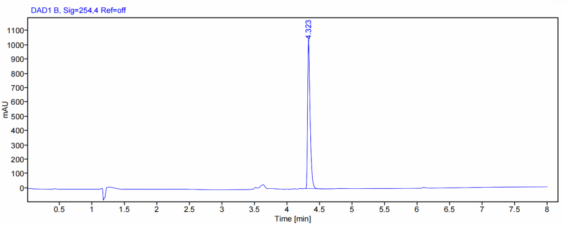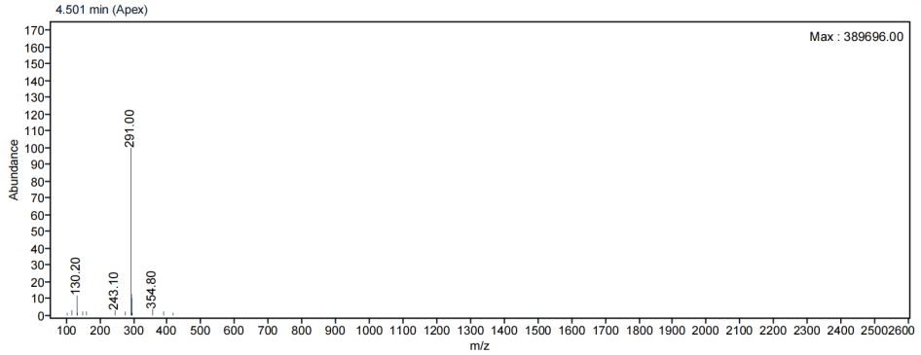
Figure S1. LC chromatogram and ESI-MS spectrum of compound 2
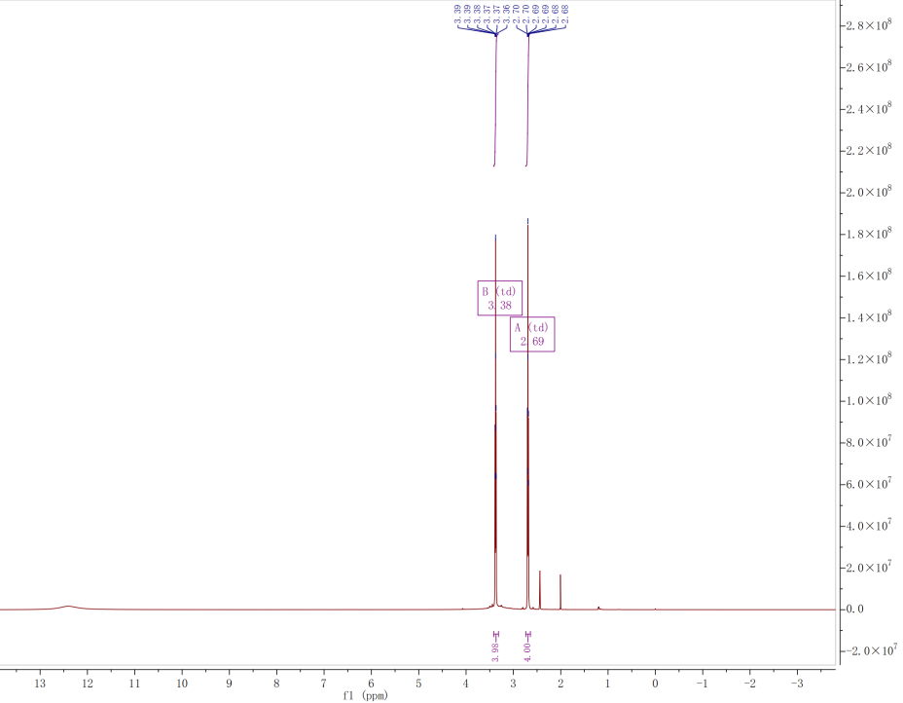
Figure S2. ¹H NMR (600 MHz, DMSO-d₆) spectrum of compound 2.
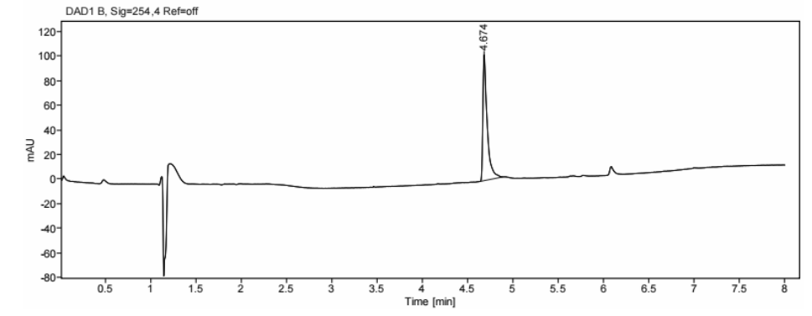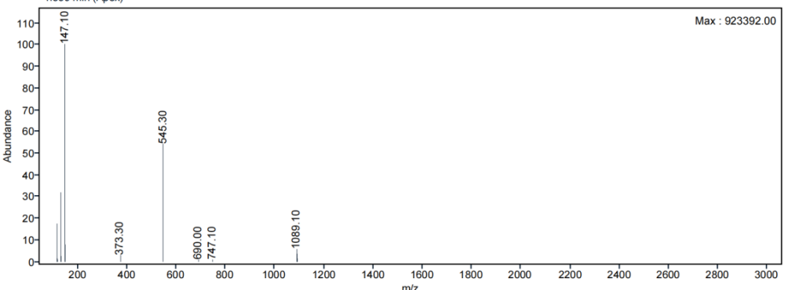
Figure S3. LC chromatogram and ESI-MS spectrum of compound 3.
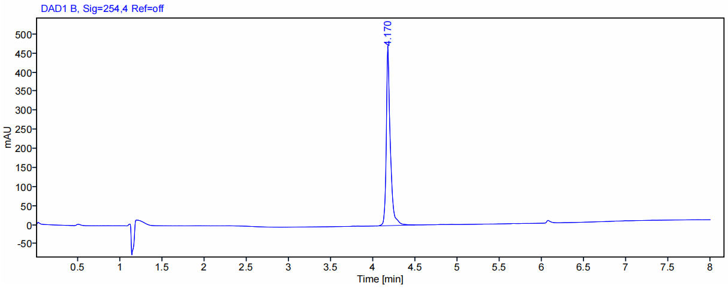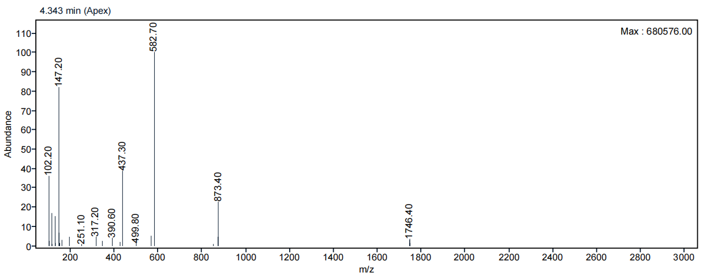
Figure S4. LC chromatogram and ESI-MS spectrum of eFAP-20.
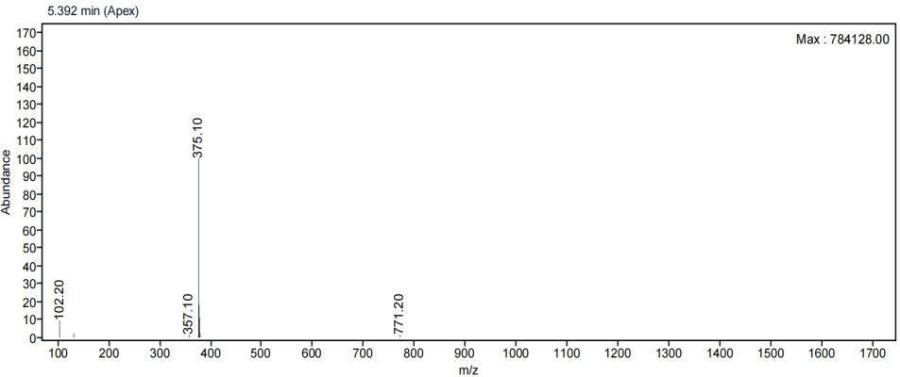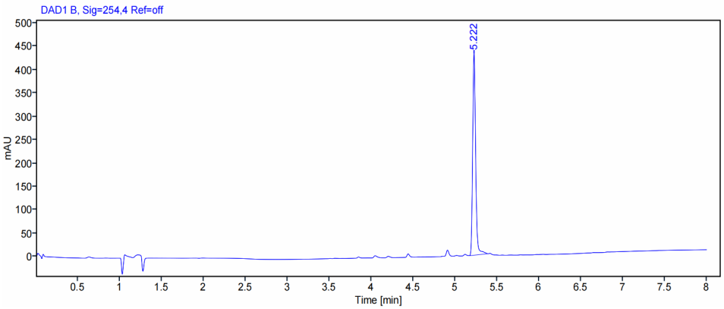
Figure S5. LC chromatogram and ESI-MS spectrum of compound 4
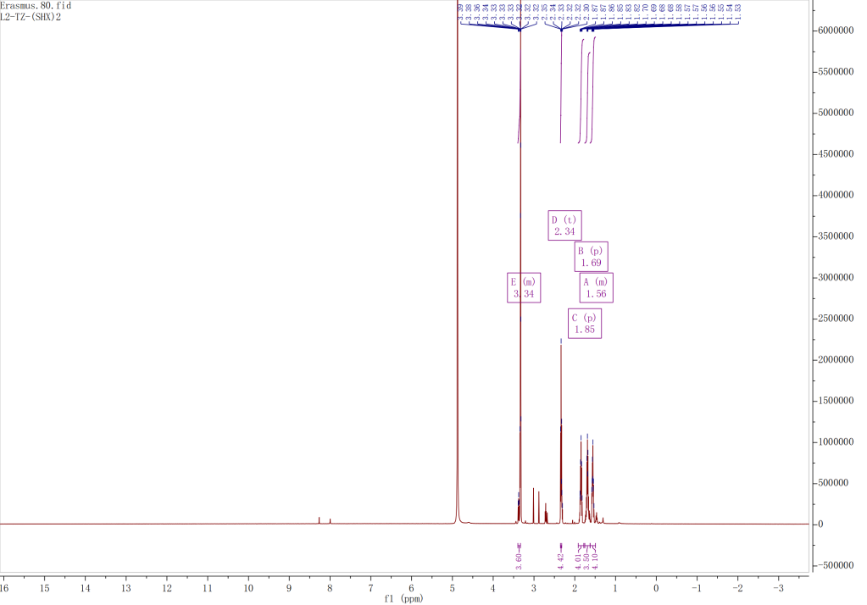
Figure S6. ¹H NMR (600 MHz, CD₃OD) spectrum of compound 4.

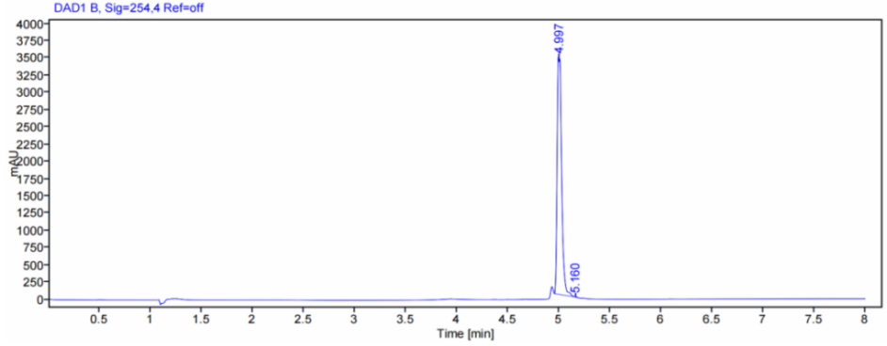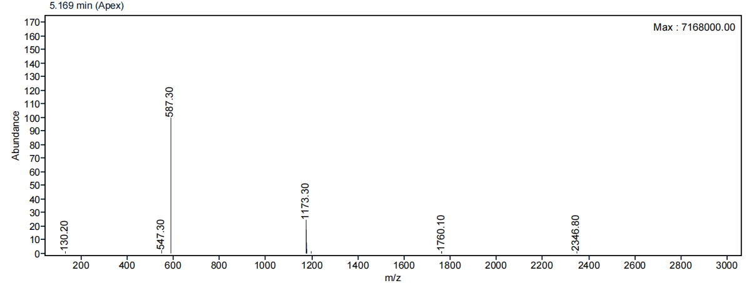
Figure S7. LC chromatogram and ESI-MS spectrum of compound 5.
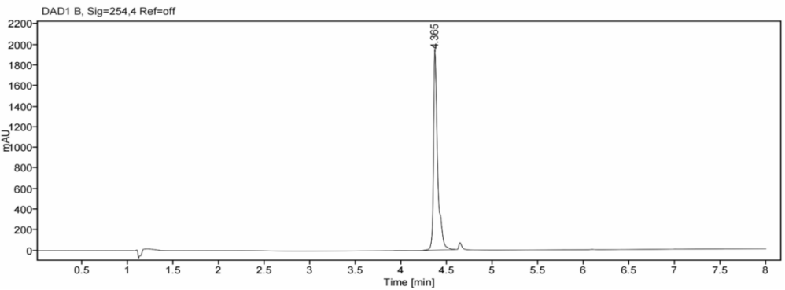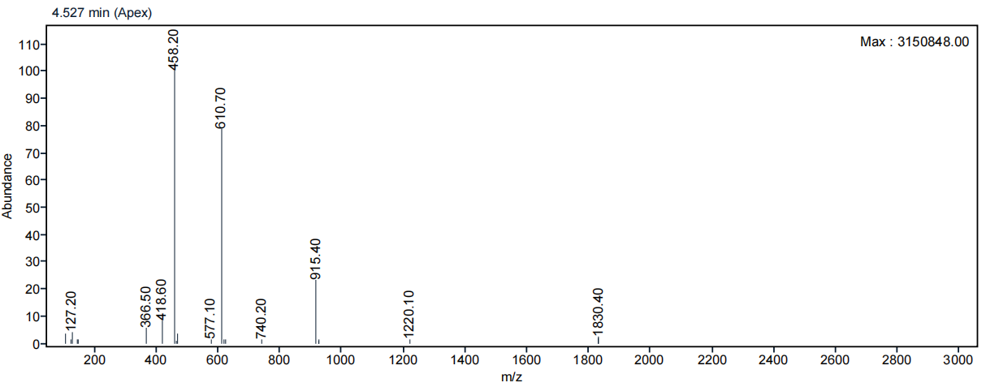
Figure S8. LC chromatogram and ESI-MS spectrum of eFAP-31.
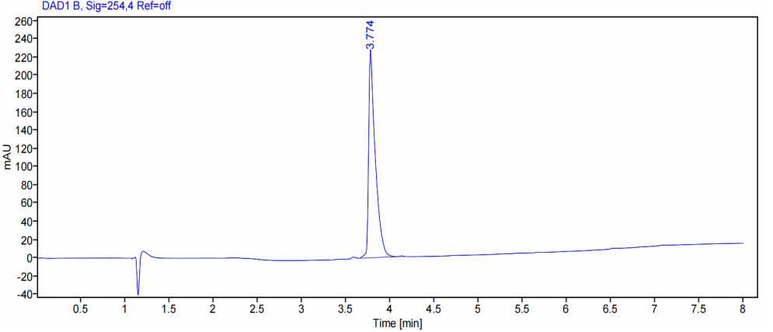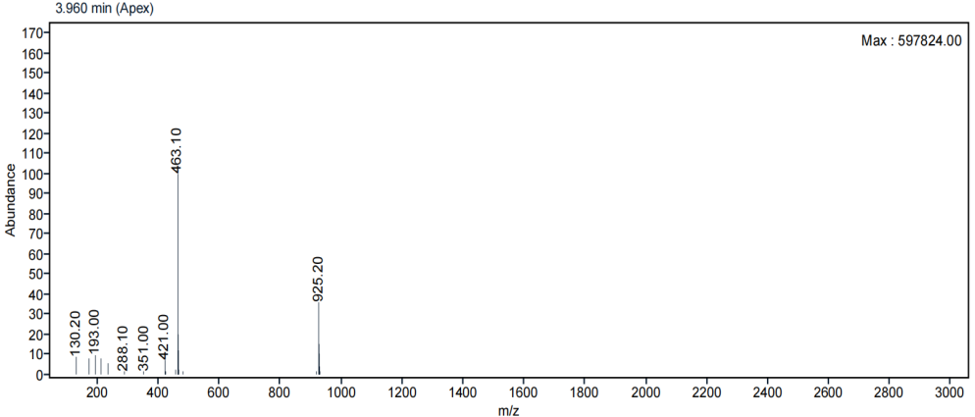
Figure S9. LC chromatogram and ESI-MS spectrum of compound 7.
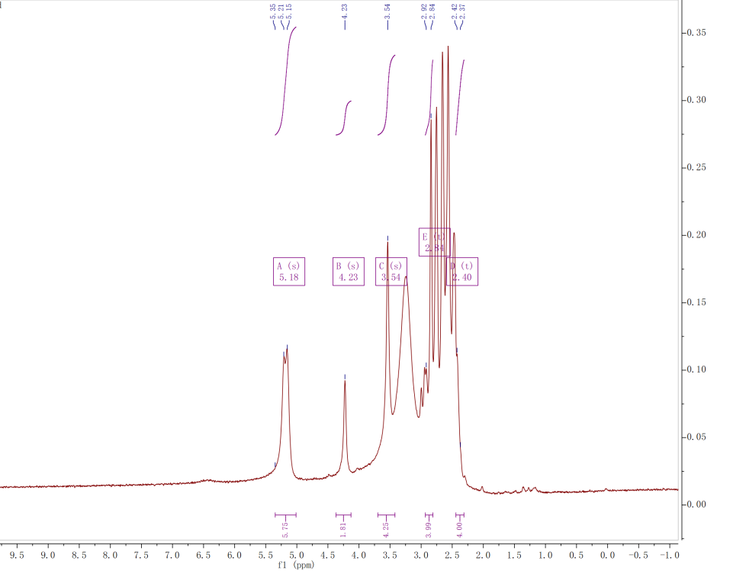
Figure S10. ¹H NMR (60 MHz, DMSO-d₆) spectrum of compound 7.
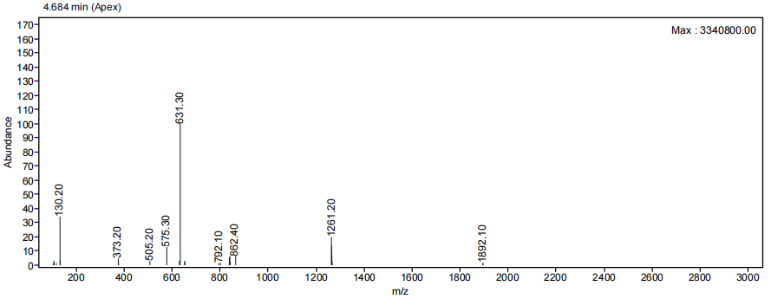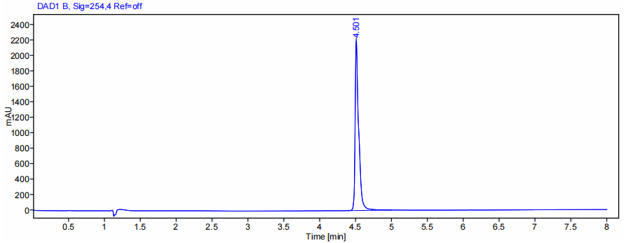
Figure S11. LC chromatogram and ESI-MS spectrum of compound 8.
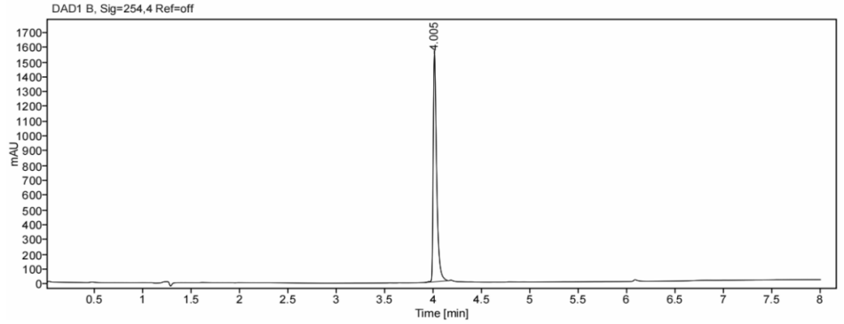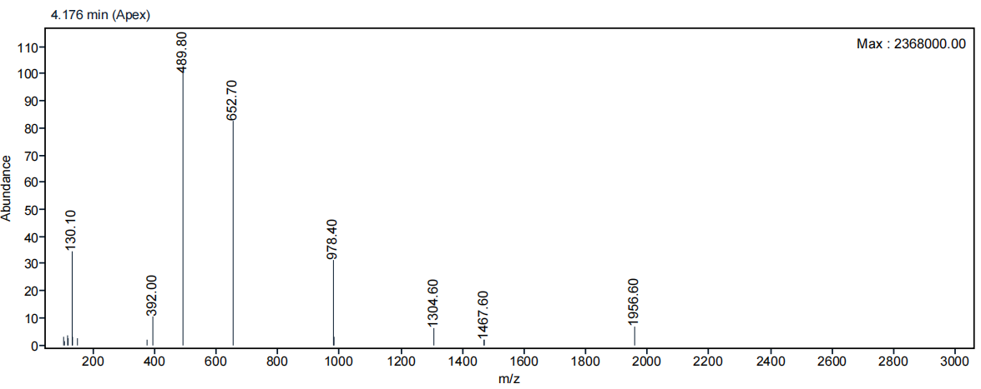
Figure S12. LC chromatogram and ESI-MS spectrum of eFAP-34.

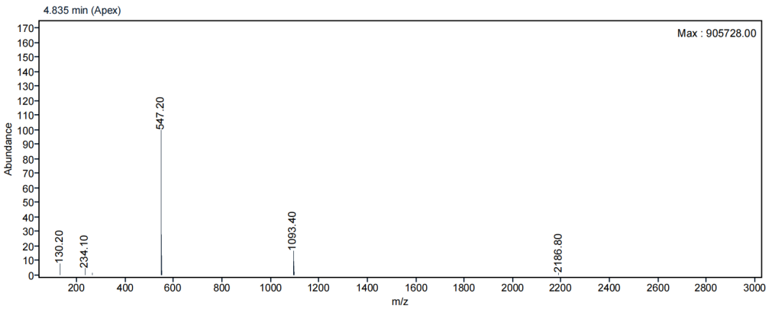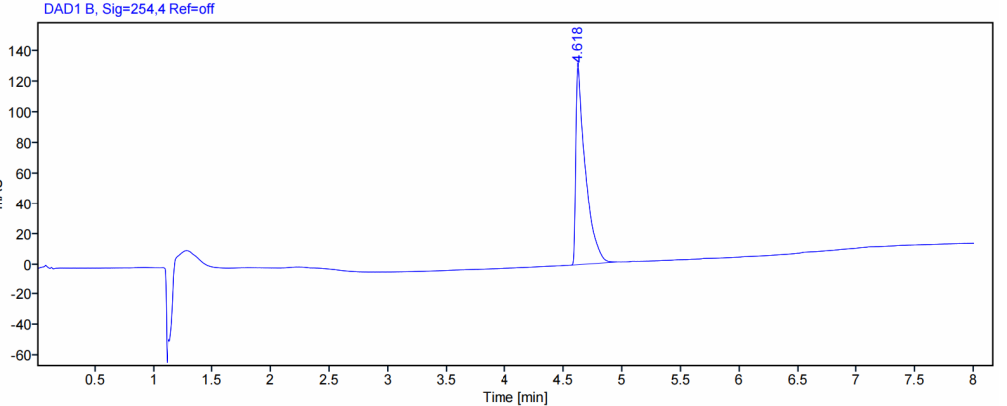
Figure S13. LC chromatogram and ESI-MS spectrum of compound 9.
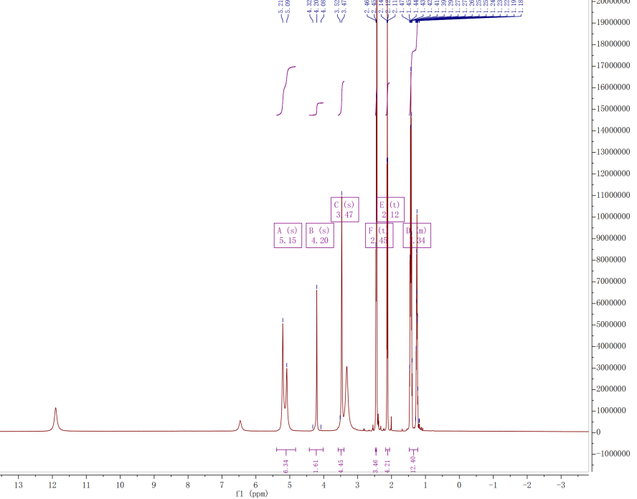
Figure S14. ¹H NMR (600 MHz, DMSO-d₆) spectrum of compound 9.

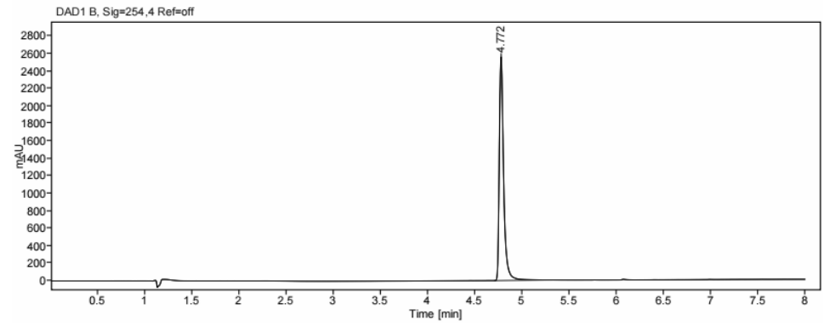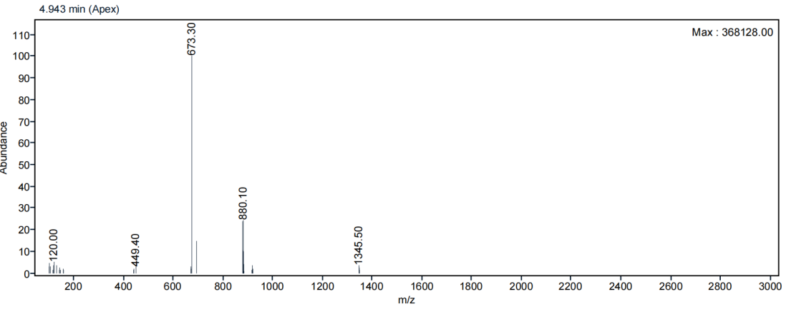
Figure S15. LC chromatogram and ESI-MS spectrum of compound 10.
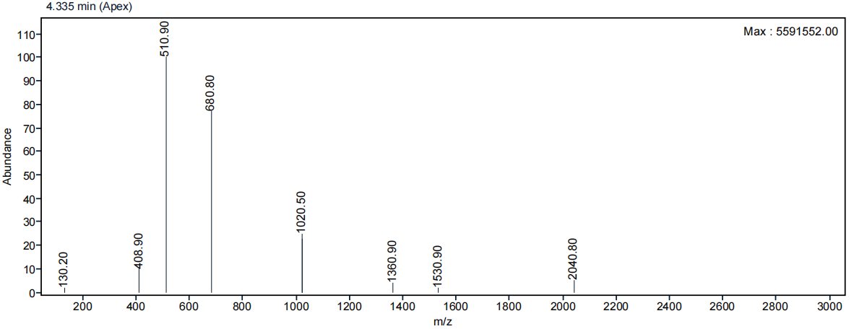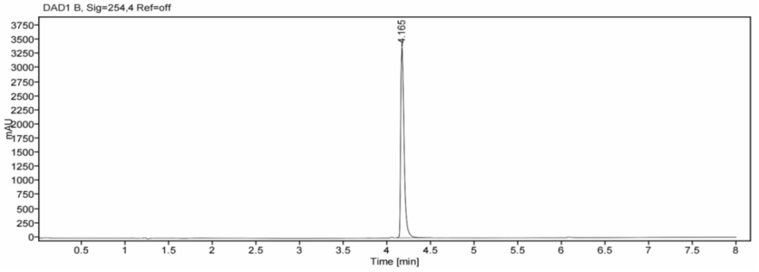
Figure S16. LC chromatogram and ESI-MS spectrum of eFAP-35.
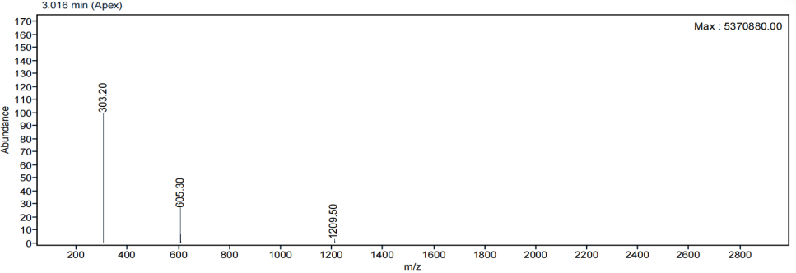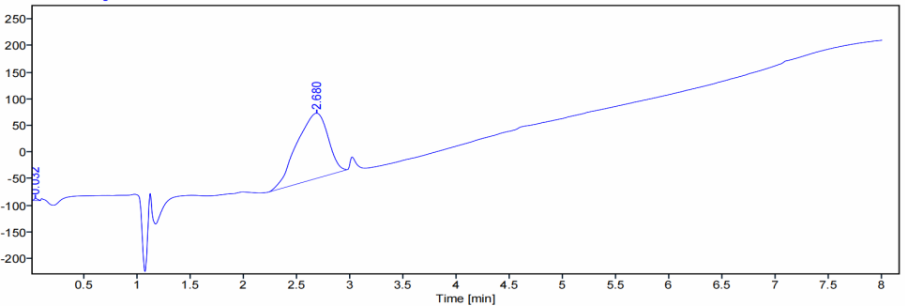
Figure S17. LC chromatogram and ESI-MS spectrum of compound 11.
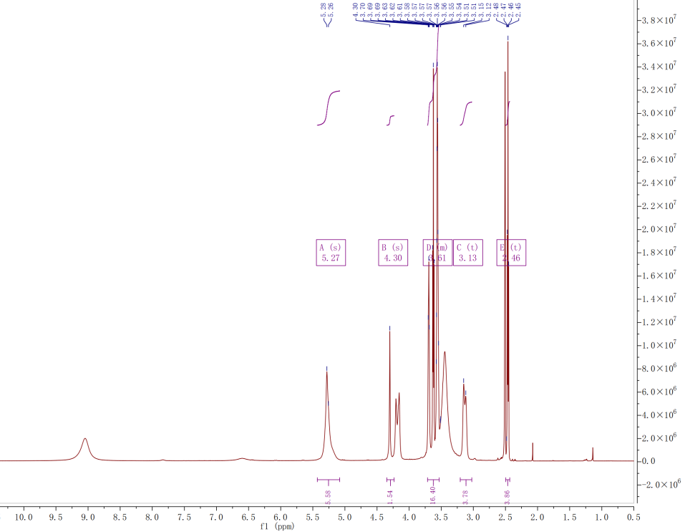
Figure S18. ¹H NMR (600 MHz, DMSO-d₆) spectrum of compound 11.

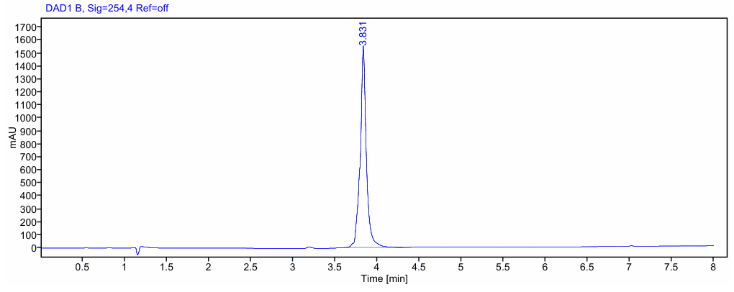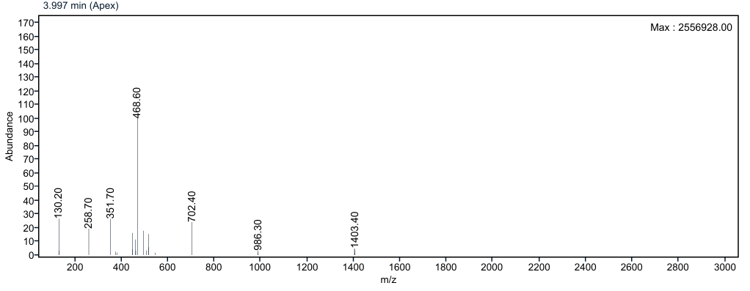
Figure S19. LC chromatogram and ESI-MS spectrum of compound 12.
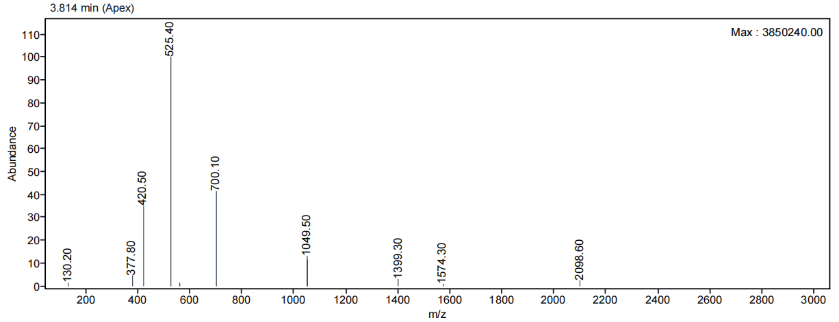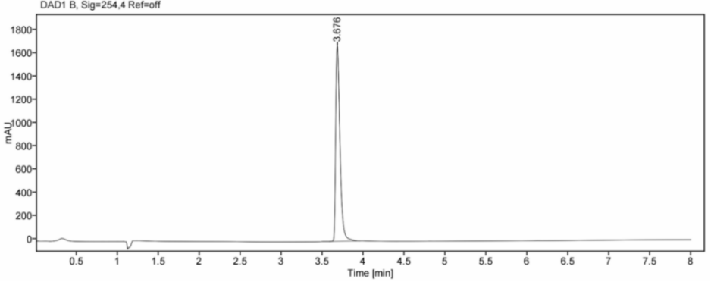
Figure S20. LC chromatogram and ESI-MS spectrum of eFAP-36.

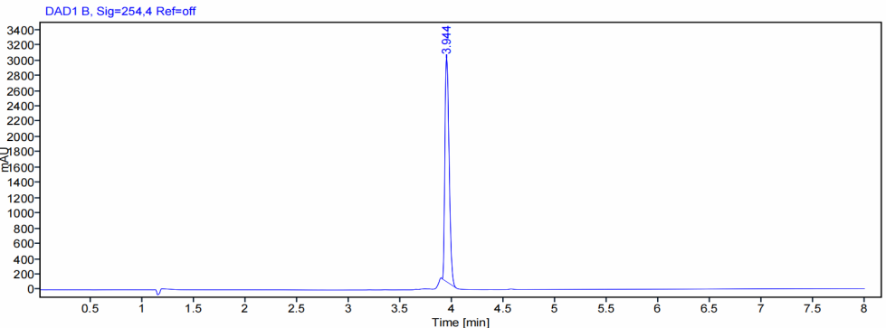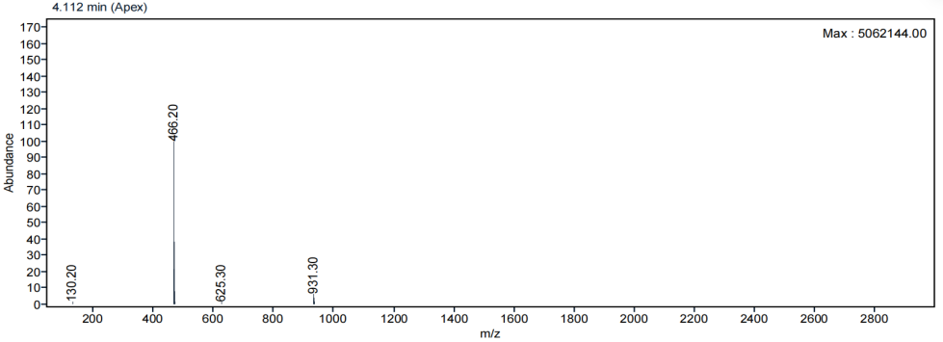
Figure S21. LC chromatogram and ESI-MS spectrum of compound 14.
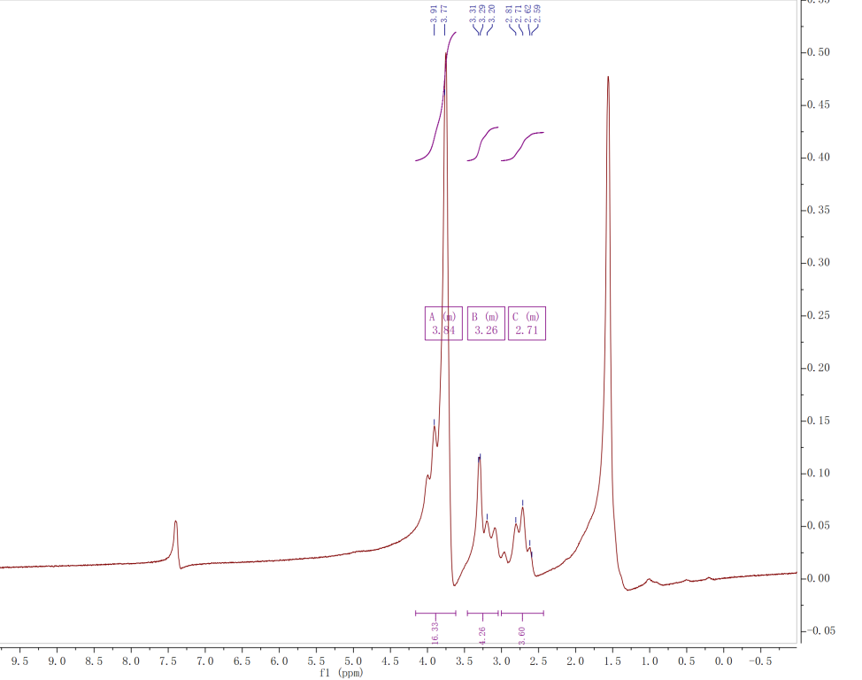
Figure S22. ¹H NMR (60 MHz, CDCl₃) spectrum of compound 14.

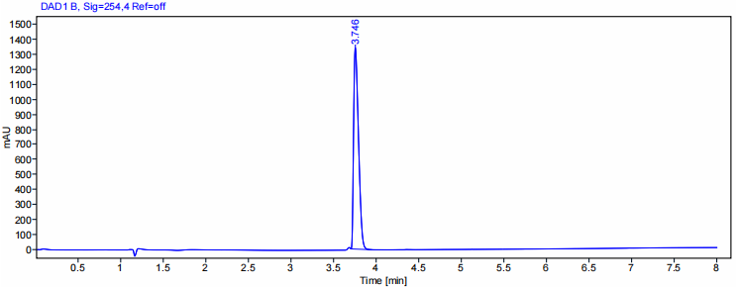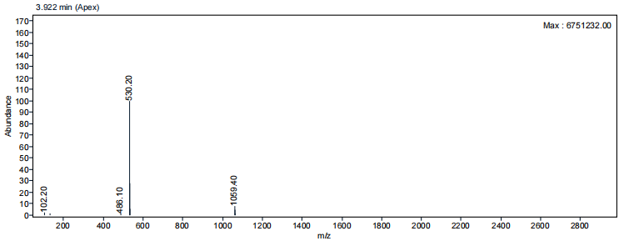
Figure S23. LC chromatogram and ESI-MS spectrum of compound 15.
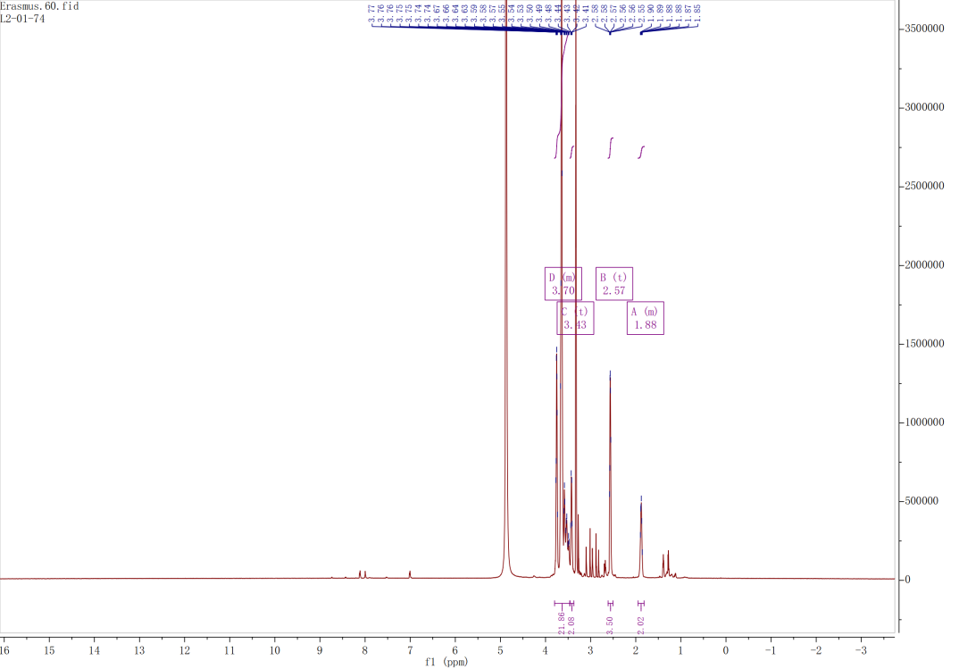
Figure S24. ¹H NMR (600 MHz, CD₃OD) spectrum of compound 15.

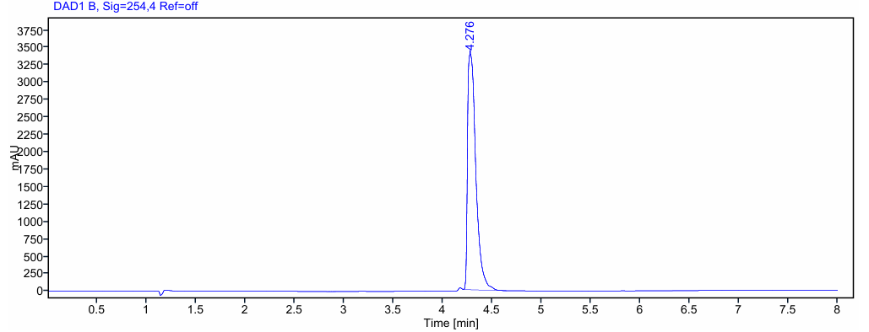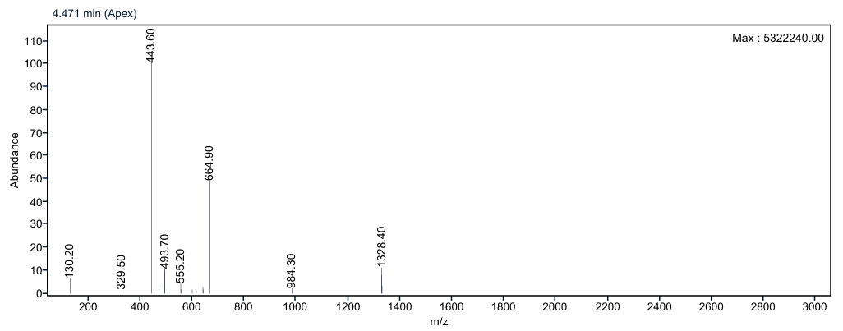
Figure S25. LC chromatogram and ESI-MS spectrum of compound 16.
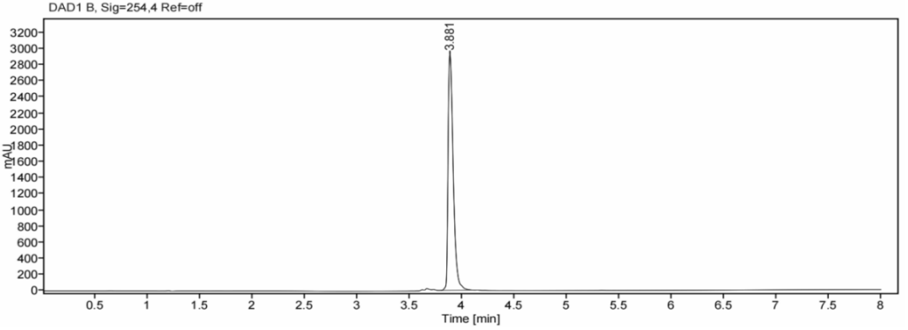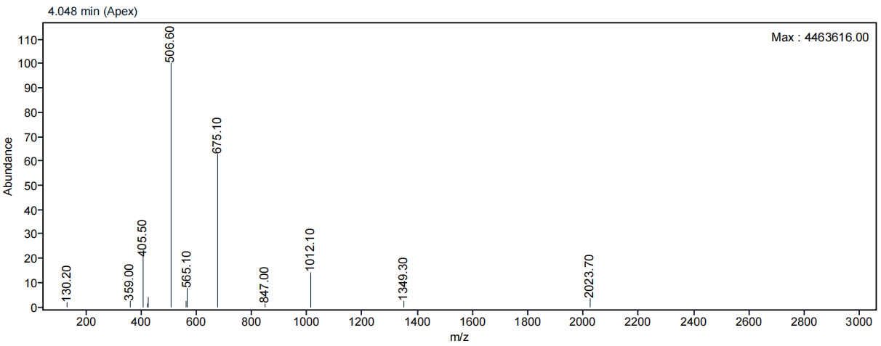
Figure S26. LC chromatogram and ESI-MS spectrum of eFAP-37.
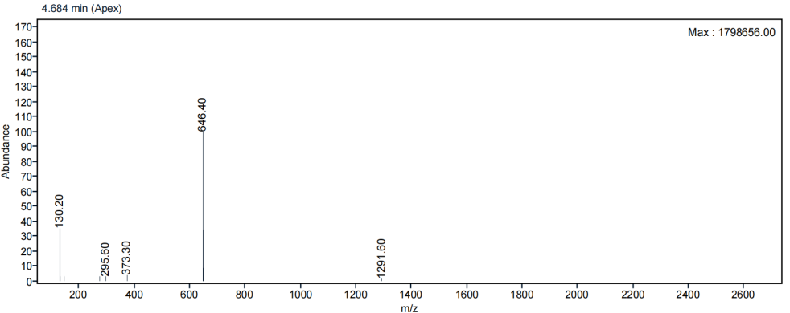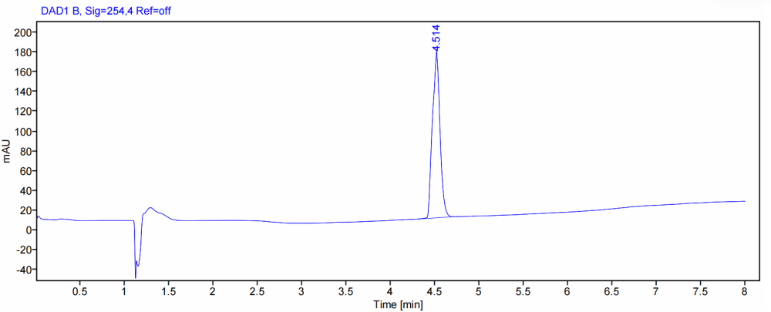
Figure S27. LC chromatogram and ESI-MS spectrum of compound 17.
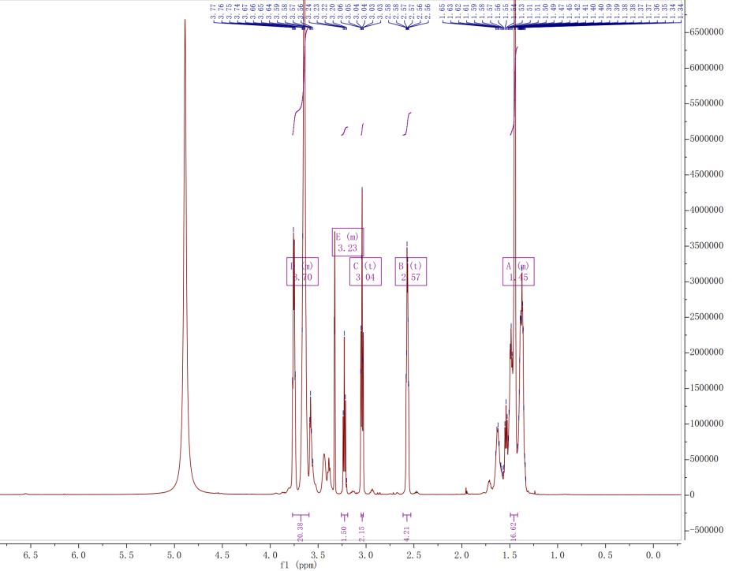
Figure S28. ¹H NMR (600 MHz, CD₃OD) spectrum of compound 17.
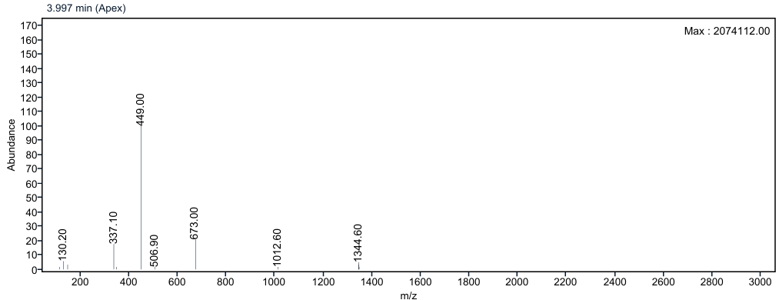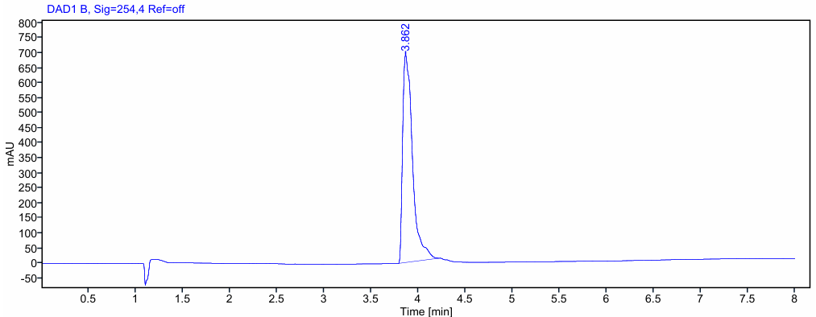
Figure S29. LC chromatogram and ESI-MS spectrum of compound 18.
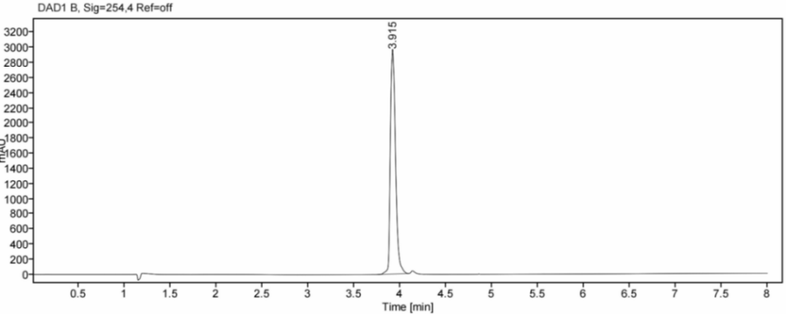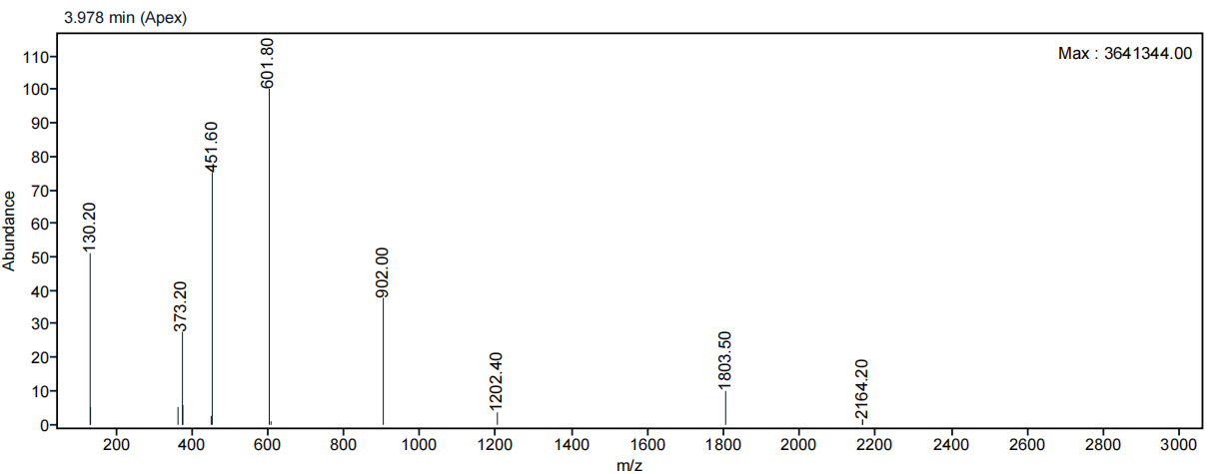
Figure S30. LC chromatogram and ESI-MS spectrum of eFAP-50.
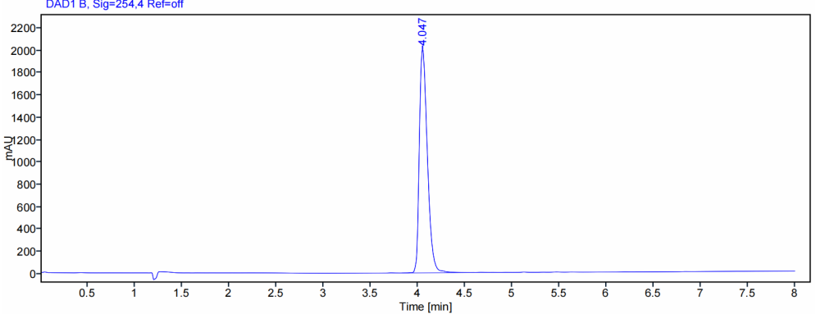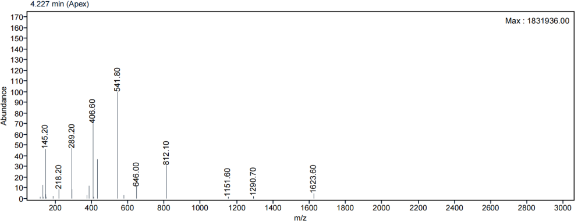
Figure S31. LC chromatogram and ESI-MS spectrum of compound 19.
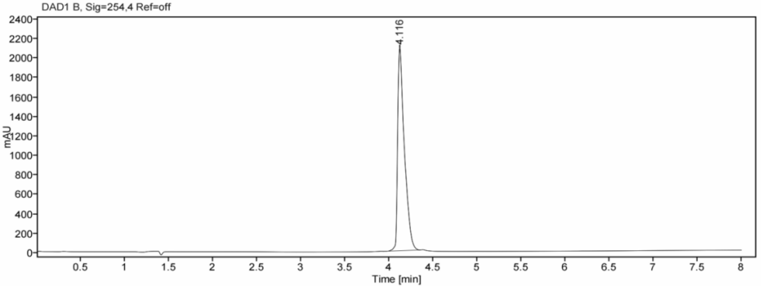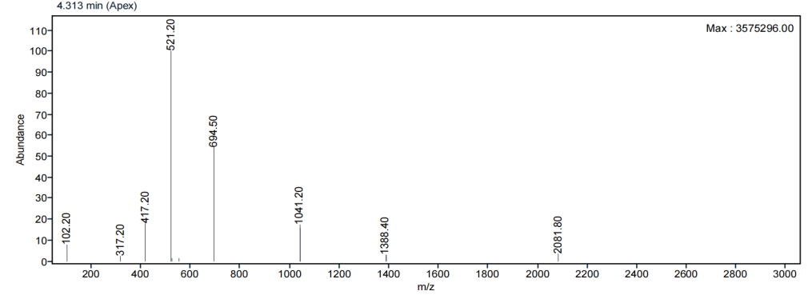
Figure S32. LC chromatogram and ESI-MS spectrum of eFAP-51.
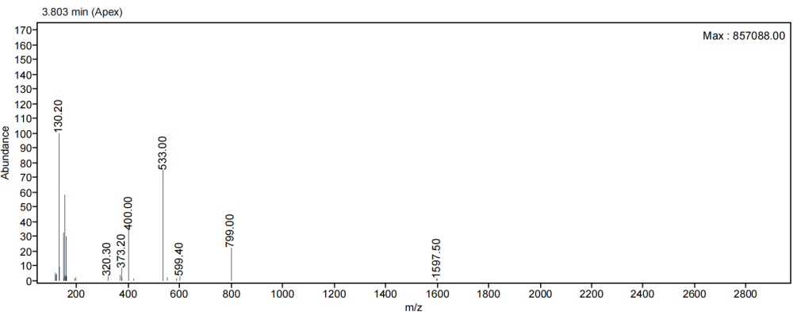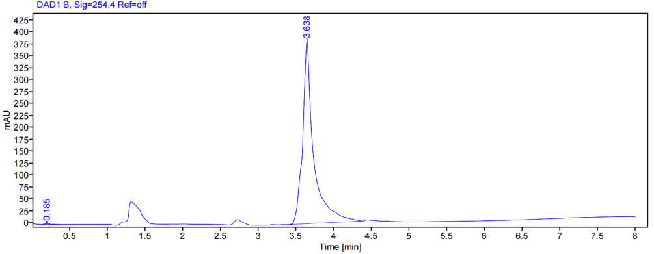
Figure S33. LC chromatogram and ESI-MS spectrum of compound 20.
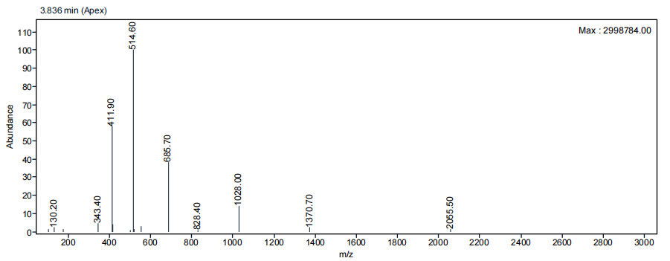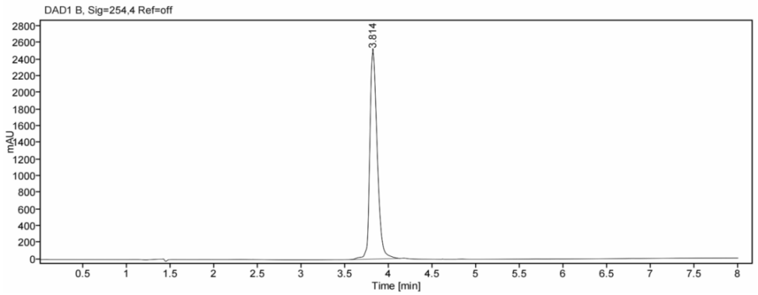
Figure S34. LC chromatogram and ESI-MS spectrum of eFAP-52.
Radiochemistry
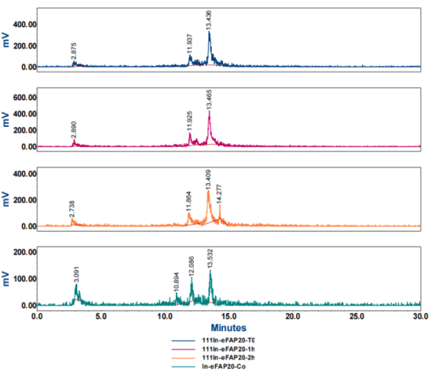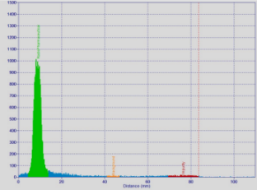
(A) (B)
T=0 h

T=1 h

T=4 h

T=24 h

Figure S35. iTLC spectrum (A) and radio-HPLC chromatograms of [¹¹¹In]In-eFAP-20 directly after labeling (T0), 1, 4, and 24 h post-incubation at 37˚C in PBS (B).
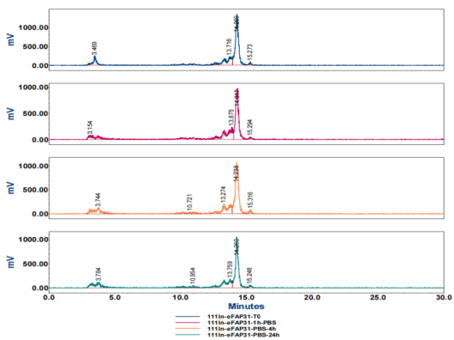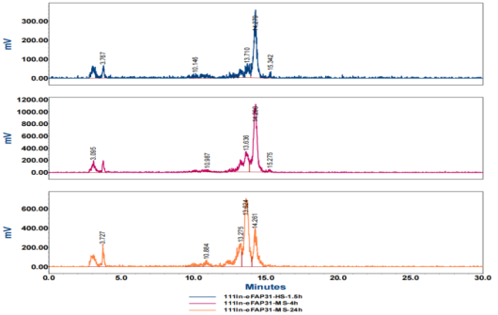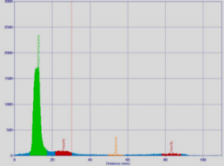Figure S36. iTLC spectrum (A) and radio-HPLC chromatograms of [¹¹¹In]In-eFAP-31 directly after labeling (T0), 1, 4, and 24 h post-incubation at 37˚C in PBS (B) and MS (C).
T=0 h
T=1 h
T=4 h
T=24 h

T=1 h

T=4 h
T=24 h

(A)

(B) (C)
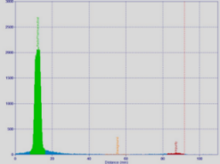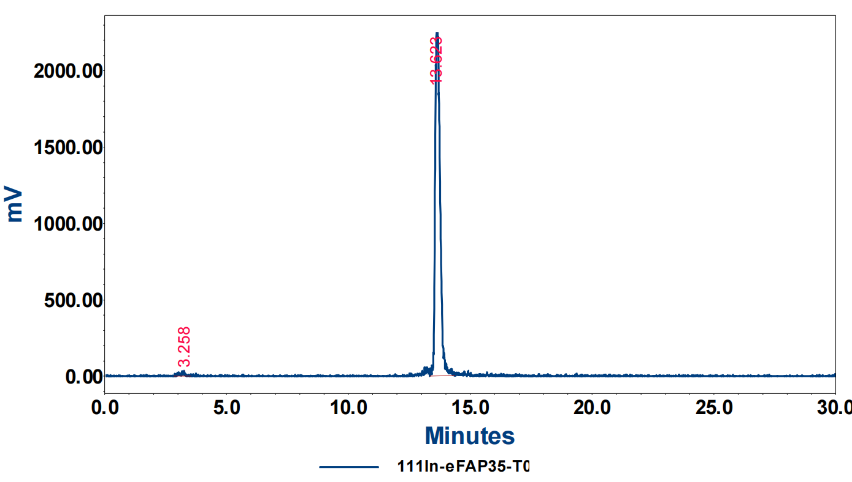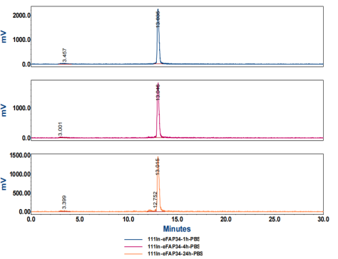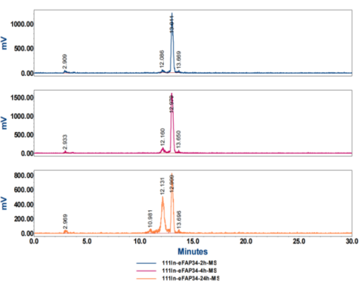
T=0 h
T=1 h
T=4 h
T=24 h

(A)

- (C)
T=1 h
T=4 h
T=24 h

Figure S37. iTLC spectrum (A) and radio-HPLC chromatograms of [¹¹¹In]In-eFAP-34 directly after labeling (T0), 1, 4, and 24 h post-incubation at 37˚C in PBS (B) and MS (C).
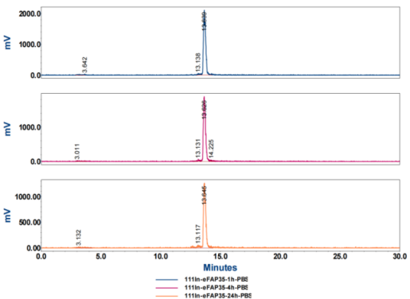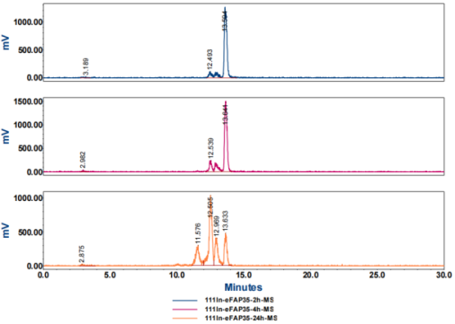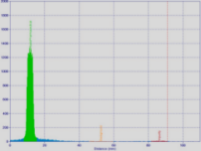
T=0 h
T=1 h
T=4 h
T=24 h

T=1 h
T=4 h
T=24 h

(A)

(B) (C)
Figure S38. iTLC spectrum (A) and radio-HPLC chromatograms of [¹¹¹In]In-eFAP-35 directly after labeling (T0), 1, 4, and 24 h post-incubation at 37˚C in PBS (B) and MS (C).
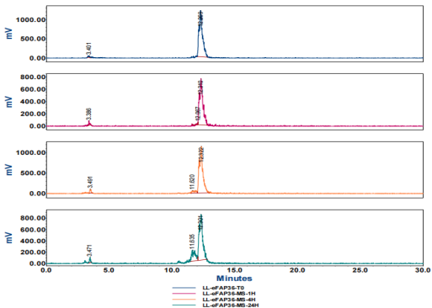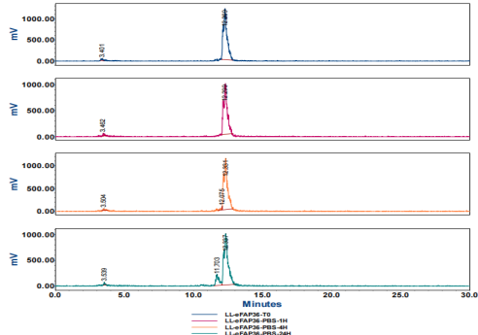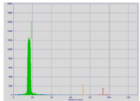
(A)

(B) (C)
T=0 h
T=1 h
T=4 h
T=24 h

T=0 h
T=1 h
T=4 h
T=24 h

Figure S39. iTLC spectrum (A) and radio-HPLC chromatograms of [¹¹¹In]In-eFAP-36 directly after labeling (T0), 1, 4, and 24 h post-incubation at 37˚C in PBS (B) and MS (C).
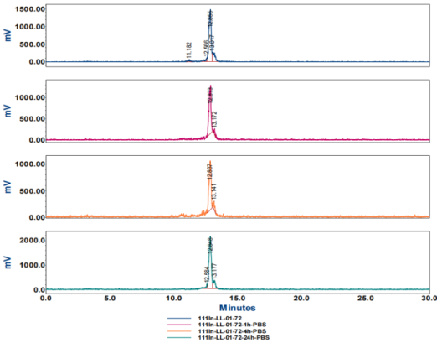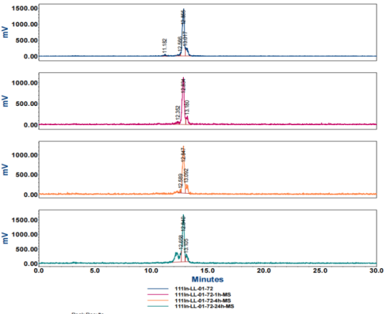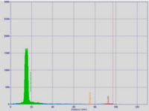Figure S40. iTLC spectrum (A) and radio-HPLC chromatograms of [¹¹¹In]In-eFAP-37 directly after labeling (T0), 1, 4, and 24 h post-incubation at 37˚C in PBS (B) and MS (C).
(A)

(B) (C)
T=0 h
T=1 h
T=4 h
T=24 h

T=0 h
T=1 h
T=4 h
T=24 h

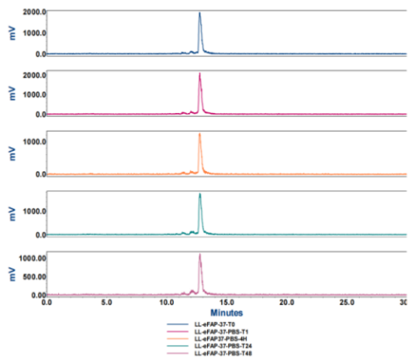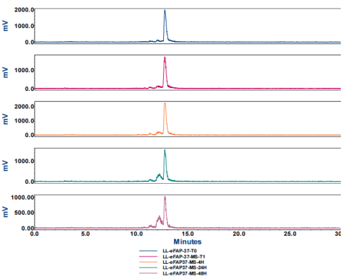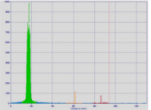Figure S41. iTLC spectrum (A) and radio-HPLC chromatograms of [¹¹¹In]In-eFAP-50 directly after labeling (T0), 1, 4, and 24 h post-incubation at 37˚C in PBS (B) and MS (C).
(A)

(B) (C)
T=0 h
T=1 h
T=4 h
T=24 h

T=0 h
T=1 h
T=4 h
T=24 h

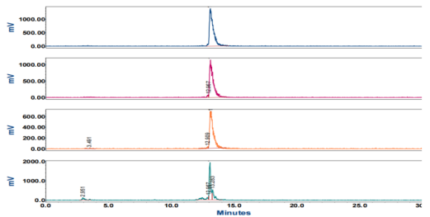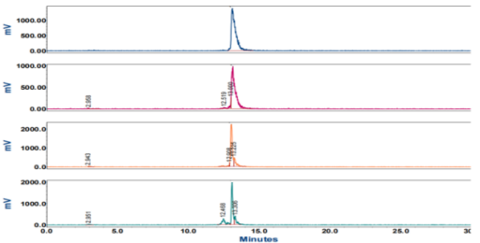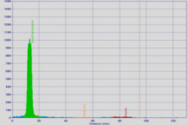
T=0 h
T=1 h
T=4 h
T=24 h

(A)

(B) (C)
T=0 h
T=1 h
T=4 h
T=24 h

Figure S42. iTLC spectrum (A) and radio-HPLC chromatograms of [¹¹¹In]In-eFAP-51 directly after labeling (T0), 1, 4, and 24 h post-incubation at 37˚C in PBS (B) and MS (C).
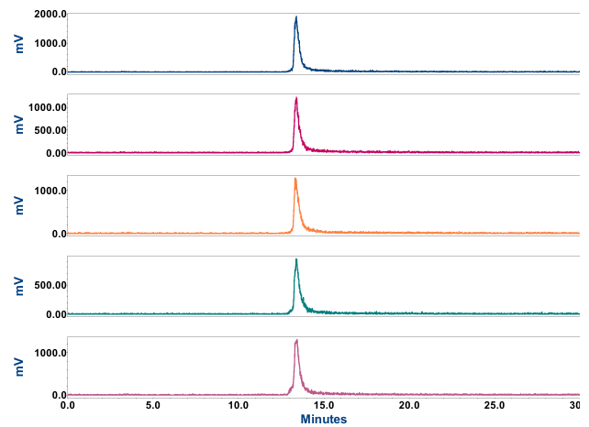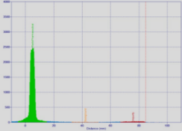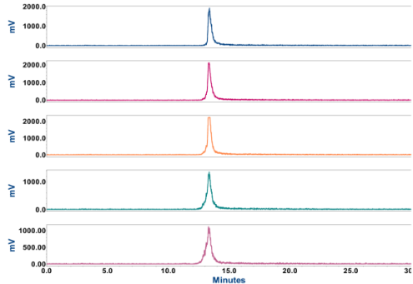
(A)

(B) (C)
T=0 h
T=1 h
T=4 h
T=24 h

T=0 h
T=1 h
T=4 h
T=24 h

Figure S43. iTLC spectrum (A) and radio-HPLC chromatograms of [¹¹¹In]In-eFAP-52 directly after labeling (T0), 1, 4, and 24 h post-incubation at 37˚C in PBS (B) and MS (C).

Table S1. Cell uptake of [¹¹¹In]In-FAPI-46 and [¹¹¹In]In-eFAPs (n = 3) using HT1080.huFAP cells at different time points. Uptake of all compounds was blocked with a 1000-fold excess of FAPI-46.

Compound | %AD
Compound | 0.5 h | 1 h | 2 h | Block
[¹¹¹In]In-FAPI-46 | 12.0 ± 1.3 | 12.6 ± 1.4 | 13.9 ± 1.7 | 0.3 ± 0.1
[¹¹¹In]In-eFAP-50 | 12.8 ± 1.2 | 15.8 ± 1.6 | 18.3 ± 1.1 | 0.2 ± 0.6
[¹¹¹In]In-eFAP-51 | 15.8 ± 3.9 | 23.7 ± 3.4 | 31.9 ± 3.4 | 0.3 ± 0.2
[¹¹¹In]In-eFAP-52 | 11.3 ± 1.2 | 12.2 ± 1.3 | 11.9 ± 1.2 | 0.2 ± 0.1

Table S2. Quantitative analysis of SPECT/CT images comparing [¹¹¹In]In-FAPI-46, [¹¹¹In]In-eFAP-51, and [¹¹¹In]In-eFAP-52 at 1, 4, 24, and 48 h post-injection (n = 4 mice/group)
Compound | Tissues | Tumor | Liver | Kidneys
[¹¹¹In]In-FAPI-46 | 1 h | 3.464 ± 1.662 | 0.422 ± 0.092 | 0.672 ± 0.072
[¹¹¹In]In-FAPI-46 | 4 h | 3.178 ± 1.572 | 0.285 ± 0.070 | 0.583 ± 0.090
[¹¹¹In]In-FAPI-46 | 24 h | 0.695 ± 0.159 | 0.177 ± 0.047 | 0.347 ± 0.262
[¹¹¹In]In-FAPI-46 | 48 h | 0.266 ± 0.164 | 0.148 ± 0.030 | 0.121 ± 0.015
[¹¹¹In]In-eFAP-51 | 1 h | 6.508 ± 0.437 | 1.840 ± 0.400 | 2.442 ± 0.301
[¹¹¹In]In-eFAP-51 | 4 h | 6.986 ± 0.951 | 1.707 ± 0.082 | 2.684 ± 0.597
[¹¹¹In]In-eFAP-51 | 24 h | 3.374 ± 0.627 | 0.840 ± 0.057 | 0.561 ± 0.284
[¹¹¹In]In-eFAP-51 | 48 h | 1.423 ± 0.193 | 0.331 ± 0.031 | 0.176 ± 0.017
[¹¹¹In]In-eFAP-52 | 1 h | 3.715± 0.413 | 0.894 ± 0.176 | 1.614 ± 0.156
[¹¹¹In]In-eFAP-52 | 4 h | 3.610 ± 0.226 | 1.001 ± 0.103 | 1.354 ± 0.071
[¹¹¹In]In-eFAP-52 | 24 h | 1.596 ± 0.179 | 0.777 ± 0.033 | 0.703 ± 0.098
[¹¹¹In]In-eFAP-52 | 48 h | 0.798 ± 0.123 | 0.623 ± 0.085 | 0.366 ± 0.017

Table S3. Ex vivo biodistribution analysis of [¹¹¹In]In-FAPI-46, [¹¹¹In]In-eFAP-51 and [¹¹¹In]In-eFAP-52 in HT-1080.huFAP and HT-1080.WT tumor bearing mice at 48 h p.i. (n = 4 mice/compound); uptake in tissues is expressed as the percentage of the injected dose per gram of tissue (% ID/g)

Tissues | [¹¹¹In]In-FAPI-46 | [¹¹¹In]In-eFAP-51 | [¹¹¹In]In-eFAP-52
Blood | 0.008 ± 0.004 | 0.152 ± 0.013 | 0.033 ± 0.004
Tumor | 0.714 ± 0.109 | 3.272 ± 0.543 | 1.773 ± 0.098
Heart | 0.039 ± 0.008 | 0.124 ± 0.009 | 0.292 ± 0.022
Lungs | 0.034 ± 0.010 | 0.187 ± 0.046 | 0.152 ± 0.023
Liver | 0.269 ± 0.087 | 0.603 ± 0.053 | 1.011 ± 0.044
Spleen | 0.208 ± 0.055 | 0.644 ± 0.150 | 1.221 ± 0.219
Stomach | 0.054 ± 0.036 | 0.078 ± 0.024 | 0.114 ± 0.048
Intestines | 0.070 ± 0.025 | 0.136 ± 0.026 | 0.202 ± 0.050
Pancreas | 0.049 ± 0.014 | 0.218 ± 0.015 | 0.396 ± 0.107
Kidneys | 0.405 ± 0.053 | 0.489 ± 0.101 | 1.534 ± 0.207
Muscle | 0.039 ± 0.016 | 0.175 ± 0.022 | 0.281 ± 0.041
Skin | 0.294 ± 0.110 | 0.857 ± 0.137 | 1.339 ± 0.150
Bones | 0.555 ± 0.123 | 0.927 ± 0.402 | 1.220 ± 0.151
WT | 0.369 ± 0.200 | 1.591 ± 0.745 | 1.042 ± 0.326

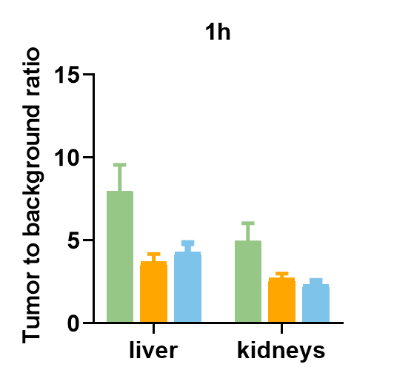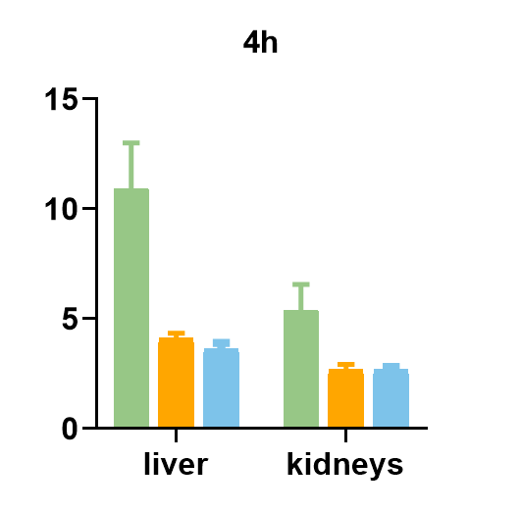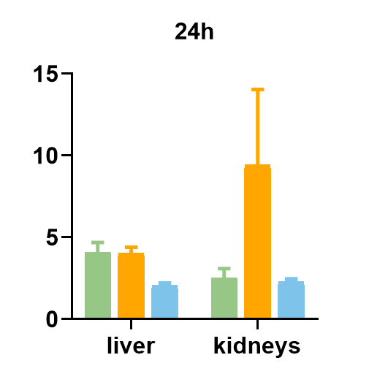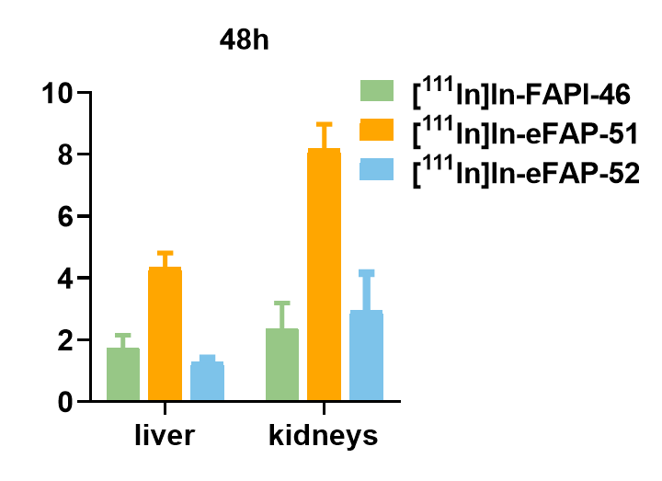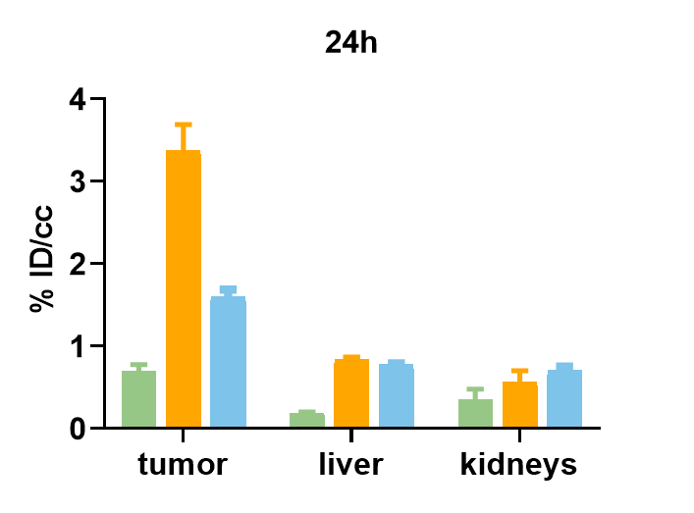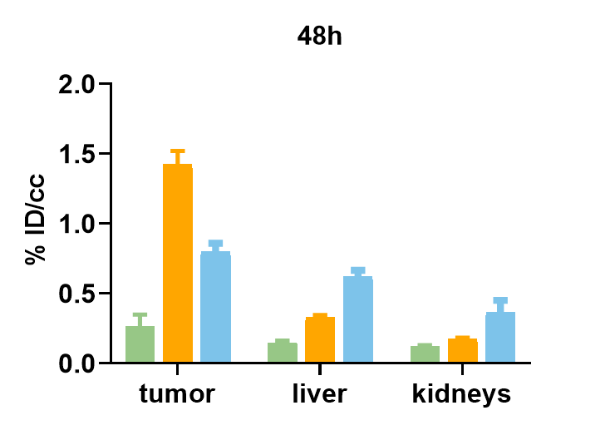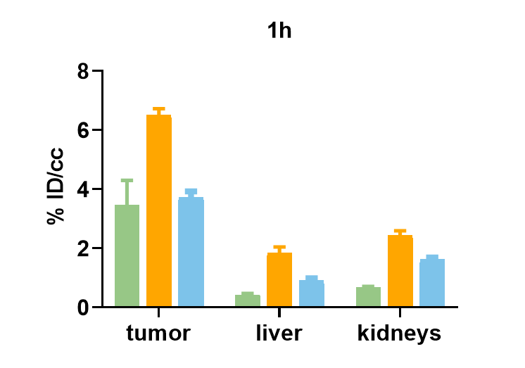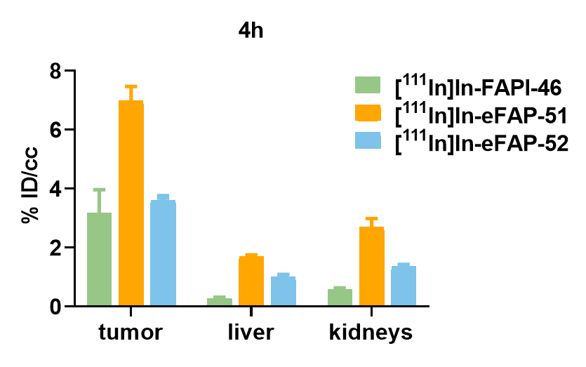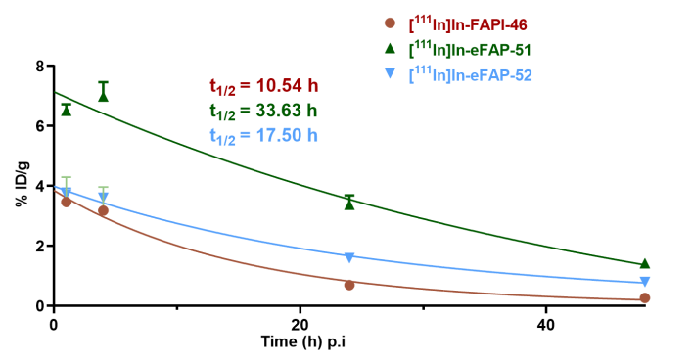
(A)

(B)

(C)

Figure S44. Quantitative analysis of SPECT/CT images comparing [¹¹¹In]In-FAPI-46, [¹¹¹In]In-eFAP-51, and [¹¹¹In]In-eFAP-52 at 1, 4, 24, and 48 h post-injection (n = 4 mice/group). (A) Tumor uptake values expressed as %ID/cc. (B) Tumor time-activity curves derived from image quantification. (C) Tumor-to-background ratios over time. Data are presented as mean ± SD.
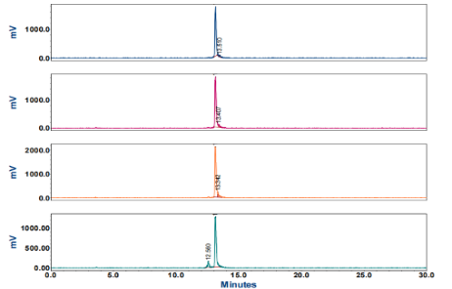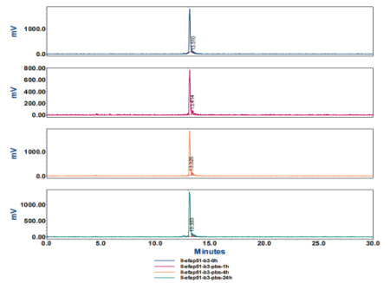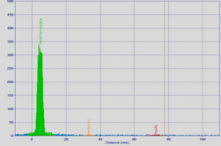
(A)

- (C)
T=0 h
T=1 h
T=4 h
T=24 h
T=0 h
T=1 h
T=4 h
T=24 h
Figure S45. TLC spectrum (A) and radio-HPLC chromatograms of [¹⁷⁷Lu]Lu-eFAP-51 directly after labeling (T0), 1, 4, and 24 h post-incubation at 37˚C in PBS (B) and MS (C).

Table S4. Cell uptake of [¹⁷⁷Lu]Lu-FAPI-46 and [¹⁷⁷Lu]Lu-eFAP-51 using HT1080.huFAP cells with different masses. Uptake of all compounds was blocked with a 1000-fold excess of FAPI-46.
Compound | %AD
Compound | 0.3 nmol | 0.6 nmol | 1 nmol
[¹⁷⁷Lu]Lu-FAPI-46 | - | - | 12.9 ± 0.5
[¹⁷⁷Lu]Lu-FAPI-46 + Block | - | - | 0.05 ± 0.01
[¹⁷⁷Lu]Lu-eFAP-51 | 28.2 ± 1.1 | 20.5 ± 0.7 | 13.7 ± 0.8
[¹⁷⁷Lu]Lu-eFAP-51 + Block | 0.5 ± 0.03 | 0.5 ± 0.06 | 0.4 ± 0.02

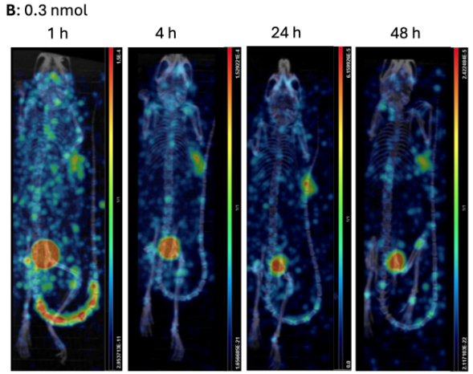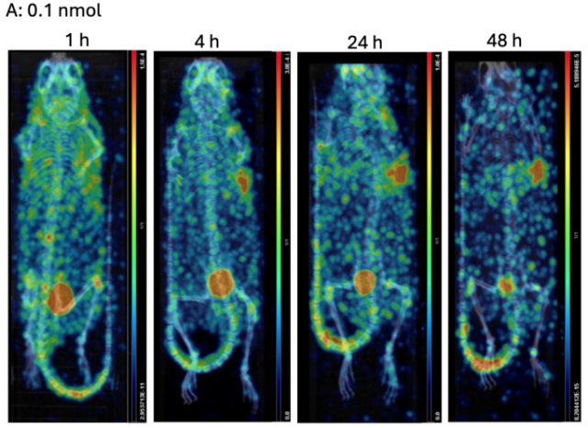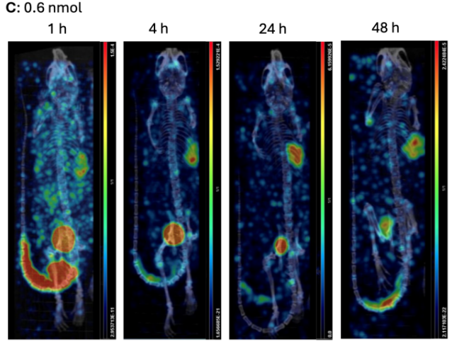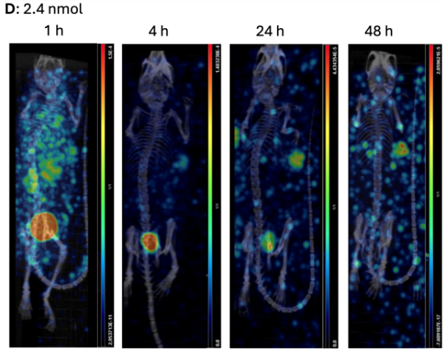
Figure S46. SPECT/CT images of mice bearing HT-1080.huFAP (right shoulder) and HT-1080-WT tumors (left shoulder) at 1, 4, 24 and 48 h after injection of [¹⁷⁷Lu]Lu-eFAP-51 across four molar doses. (A) 0.1 nmol/mouse; (B) 0.3 nmol/mouse; (C) 0.6 nmol/mouse; (D) 2.4 nmol/mouse.
Table S5. Ex vivo biodistribution analysis of [¹⁷⁷Lu]Lu-eFAP-51 with different dose in HT-1080.huFAP and HT-1080.WT tumor bearing mice at 48 h p.i. (n = 4 mice/group); uptake in tissues is expressed as the percentage of the injected dose per gram of tissue (% ID/g)
Tissues | 0.1 nmol | 0.3 nmol | 0.6 nmol | 2.4 nmol
Blood | 0.098 ± 0.016 | 0.065 ± 0.009 | 0.058 ± 0.019 | 0.018± 0.003
Tumor | 2.492 ± 1.629 | 1.797 ± 0.445 | 1.457 ± 0.571 | 0.988 ± 0.437
Heart | 0.079 ± 0.012 | 0.054 ± 0.004 | 0.044 ± 0.013 | 0.017 ± 0.002
Lungs | 0.102 ± 0.009 | 0.096 ± 0.045 | 0.060 ± 0.016 | 0.038 ± 0.020
Liver | 0.493 ± 0.052 | 0.301 ± 0.028 | 0.300 ± 0.102 | 0.185 ± 0.028
Spleen | 0.577 ± 0.100 | 0.264 ± 0.038 | 0.265 ± 0.130 | 0.113 ± 0.033
Stomach | 0.174 ± 0.107 | 0.059 ± 0.024 | 0.075 ± 0.040 | 0.025 ± 0.021
Intestines | 0.202 ± 0.088 | 0.085 ± 0.019 | 0.076 ± 0.022 | 0.182 ± 0.241
Pancreas | 0.192 ± 0.026 | 0.088 ± 0.003 | 0.072 ± 0.017 | 0.025 ± 0.001
Kidneys | 0.164 ± 0.030 | 0.122 ± 0.022 | 0.101 ± 0.025 | 0.059 ± 0.014
Muscle | 0.099 ± 0.035 | 0.094 ± 0.009 | 0.075 ± 0.021 | 0.022 ± 0.005
Skin | 0.554 ± 0.039 | 0.451 ± 0.032 | 0.301 ± 0.043 | 0.157 ± 0.030
Bones | 0.555 ± 0.134 | 0.488 ± 0.018 | 0.390 ± 0.070 | 0.145 ± 0.010
WT | 0.455 ± 0.108 | 0.299 ± 0.075 | 0.237 ± 0.054 | 0.156 ± 0.098

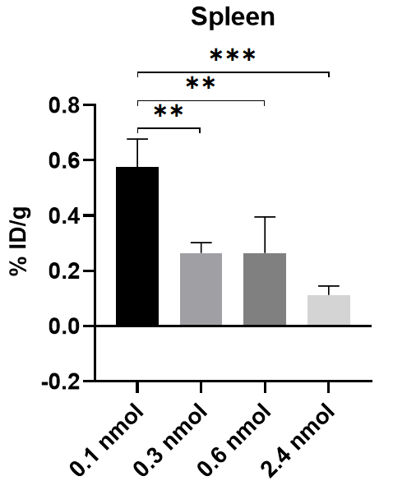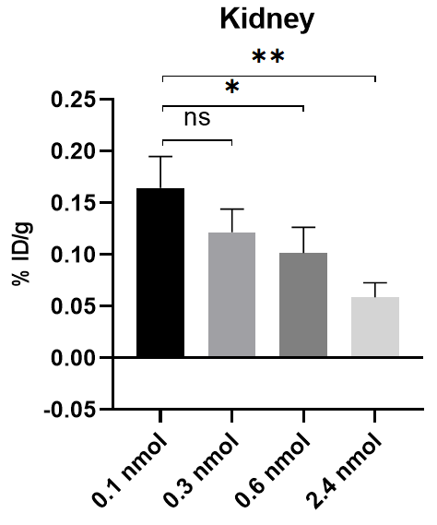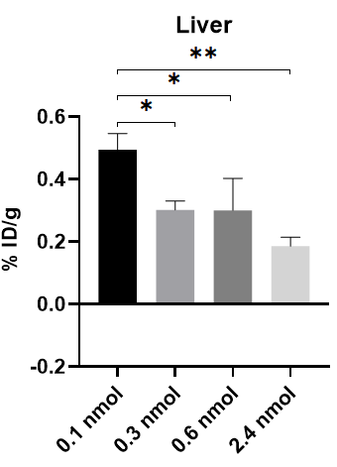Figure S47. Dose-dependent uptake of [¹⁷⁷Lu]Lu-eFAP-51 in (A) liver, (B) spleen, and (C) kidneys at 48 h p.i. in HT-1080.huFAP tumor-bearing mice. Data are presented as mean ± SD (n = 3 per group). Statistical significance was determined by One-way ANOVA with Tukey's multiple comparisons test. *p < 0.05, **p < 0.01, ***p < 0.001 vs. the 0.1 nmol group; ns, not significant. No significant differences were observed between the 0.3 and 0.6 nmol groups for any of the three organs (p > 0.05).
(A) (B) (C)

Table S6. Ex vivo biodistribution analysis of [¹⁷⁷Lu]Lu-eFAP-51 with different dose in HT-1080.huFAP and HT-1080.WT tumor bearing mice at 1, 4, 24, 48 h p.i. (n = 4 mice/compound); uptake in tissues is expressed as the percentage of the injected dose per gram of tissue (% ID/g)
 | 0.3 nmol |  |  |  | 0.6 nmol
Tissues | 1 h | 4 h | 24 h | 48 h | 1 h | 4 h | 24 h | 48 h
Blood | 3.930 ± 0.227 | 3.093 ± 0.175 | 0.676 ± 0.106 | 0.103 ± 0.003 | 5.485 ± 0.844 | 2.311 ± 0.282 | 0.424 ± 0.029 | 0.067 ± 0.011
Tumor | 10.313 ± 1.405 | 12.306 ± 4.106 | 7.298 ± 1.392 | 3.172 ± 0.600 | 10.263 ± 0.615 | 11.196 ± 1.308 | 6.697 ± 0.694 | 2.993 ± 0.350
Heart | 1.649 ± 0.134 | 1.362 ± 0.158 | 0.356 ± 0.025 | 0.071 ± 0.011 | 1.896 ± 0.316 | 1.000 ± 0.190 | 0.197 ± 0.022 | 0.042 ± 0.009
Lungs | 1.993 ± 0.330 | 1.159 ± 0.074 | 0.447 ± 0.006 | 0.108 ± 0.009 | 3.446 ± 0.714 | 1.362 ± 0.024 | 0.303 ± 0.064 | 0.062 ± 0.016
Liver | 1.194 ± 0.137 | 1.362 ± 0.061 | 0.863 ± 0.131 | 0.334 ± 0.043 | 2.857 ± 0.900 | 1.124 ± 0.162 | 0.514 ± 0.031 | 0.175 ± 0.027
Spleen | 0.965 ± 0.073 | 1.242 ± 0.138 | 0.770 ± 0.070 | 0.439 ± 0.047 | 1.318 ± 0.380 | 0.749 ± 0.085 | 0.432 ± 0.063 | 0.204 ± 0.069
Stomach | 0.326 ± 0.053 | 0.471 ± 0.075 | 0.160 ± 0.037 | 0.036 ± 0.009 | 0.365 ± 0.156 | 0.297 ± 0.038 | 0.365 ± 0.292 | 0.103 ± 0.004
Intestines | 0.892 ± 0.095 | 0.932 ± 0.061 | 0.263 ± 0.067 | 0.075 ± 0.012 | 0.881 ± 0.212 | 0.719 ± 0.089 | 0.225 ± 0.106 | 0.120 ± 0.048
Pancreas | 2.847 ± 0.166 | 2.521 ± 0.475 | 0.685 ± 0.130 | 0.076 ± 0.038 | 1.797 ± 0.074 | 1.265 ± 0.220 | 0.349 ± 0.089 | 0.067 ± 0.034
Kidneys | 2.708 ± 0.595 | 1.743 ± 0.328 | 0.603 ± 0.070 | 0.129 ± 0.015 | 7.619 ± 1.908 | 2.916 ± 0.520 | 0.442 ± 0.060 | 0.098 ± 0.019
Muscle | 1.967 ± 0.112 | 1.802 ± 0.223 | 0.466 ± 0.086 | 0.087 ± 0.009 | 1.387 ± 0.138 | 1.035 ± 0.148 | 0.286 ± 0.093 | 0.071 ± 0.026
Skin | 5.494 ± 0.463 | 6.217 ± 0.389 | 2.165 ± 0.089 | 0.351 ± 0.099 | 4.577 ± 0.318 | 3.772 ± 0.351 | 1.321 ± 0.111 | 0.310 ± 0.073
Bones | 6.364 ± 0.532 | 5.889 ± 0.834 | 1.972 ± 0.336 | 0.626 ± 0.076 | 4.222 ± 0.444 | 3.778 ± 0.339 | 1.345 ± 0.137 | 0.482 ± 0.071
WT | 3.229 ± 0.453 | 3.363 ± 0.740 | 1.107 ± 0.083 | 0.308 ± 0.088 | 2.836 ± 0.328 | 1.933 ± 0.347 | 0.694 ± 0.098 | 0.252 ± 0.026

1. van de Langemheen H, Korotkovs V, Bijl J, Wilson C, Kale SS, Heinis C, et al. Polar Hinges as Functionalized Conformational Constraints in (Bi)cyclic Peptides. Chembiochem. 2017;18(4):387-95.

