Supplementary Material
FIGURE 1. Structural comparison of clinically used PSMA radiopharmaceuticals. Chemical structures of [⁶⁸Ga]PSMA-11, [¹⁸F]PSMA-1007, [¹⁸F]JK-PSMA-7, and [¹⁸F]DCFPyL featuring the Glu–NH–CO–NH–Lys scaffold (in blue).
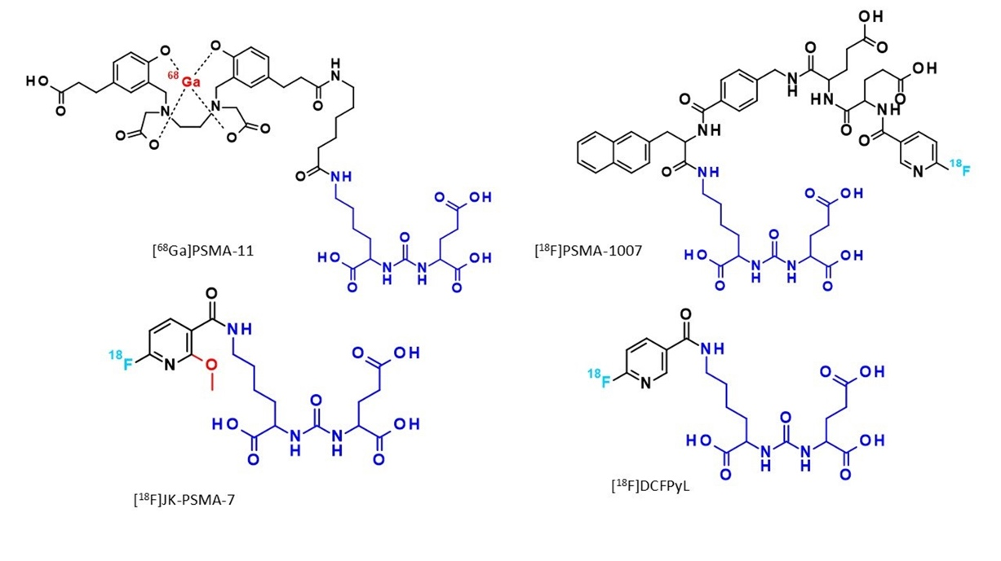

FIGURE 2. The Zinc coordination site. The amino acids involved in the interactions are represented as sticks, the red and grey spheres indicate the water molecule and Zinc ions, respectively. The dotted yellow lines represent the Zinc ions' coordination. WAT indicates the bridging water molecule that participates in the coordination network between the two zinc ions within the PSMA active site.
