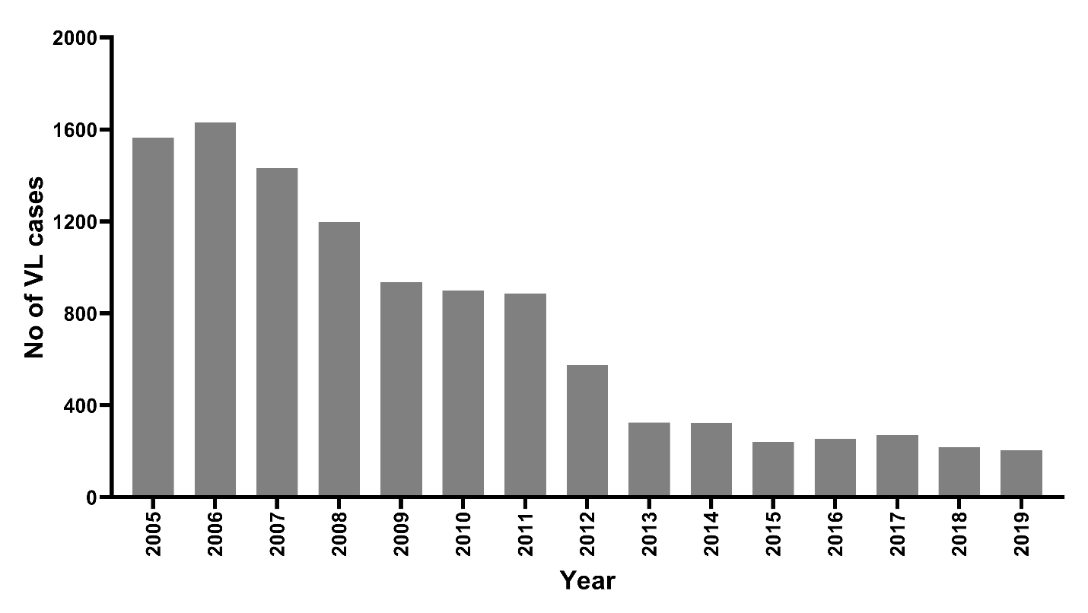
Figure S1. Trends of VL cases from 2005-2019 in Nepal.

