Additional file 1
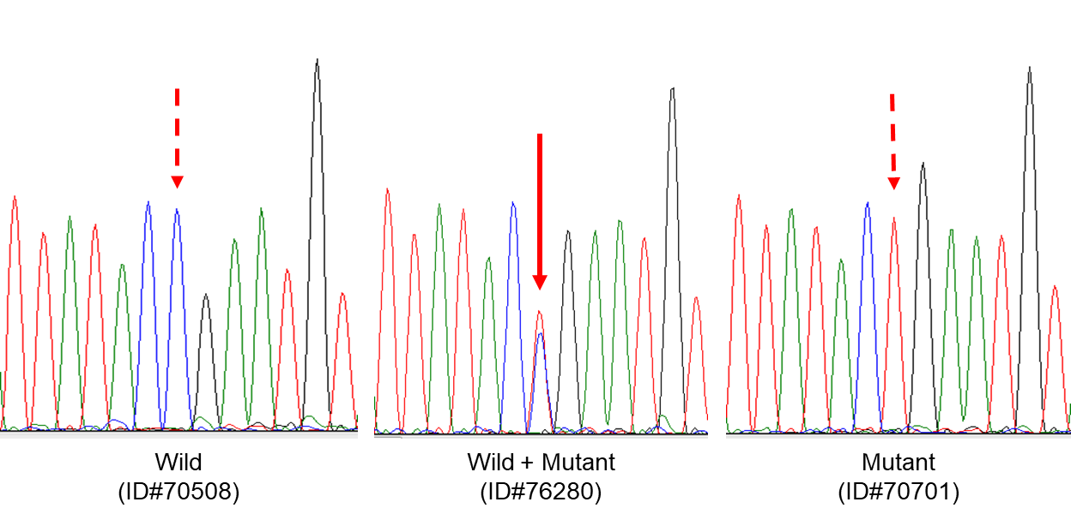
Fig. S1. Nucleotide sequences were analyzed in both directions. The two strains were considered to be co-infected if they were found to have reached more than half of the largest peak at the same site in the waveform, and if no noise was found in the surrounding waveform. If it was difficult to determine, a DNA insertion plasmid was used to analyze the sequence.

Table S1 Number of Plasmodium cases in Binh Phuoc Province in 2003, 2012, 2015, and 2018.
Year | Total | Pf | Pv | Pf + Pv
2003 | 3,953 | 3,263 | 676 | 14
2012 | 2,780 | 1,457 | 1,146 | 177
2015 | 1,799 | 1,000 | 706 | 93
2018 | 1,243 | 728 | 460 | 55
Pf, P. falciparum; Pv, P. vivax; Pf + Pv, mixed infection with Pf and Pv

