Supplementary materials

Multiple Kind Lottery model
The multiple-kind lottery (MKL) model was employed to calculate the expected numbers of parasite species infection assemblages in each population. This model assumes:
- Acquisition of infection is an independent event.
- One possible outcome of exposure is no acquisition of infection.
In this context:
- p1,p2, and p3 represent the probabilities of infection by P. falciparum, P. malariae, and P. ovale, respectively.
- q1,q2, and q3​ represent the probabilities of absence of infection by P. falciparum, P. malariae, and P. ovale, respectively.
The expected frequency of infection patterns are calculated as follows:
- Infection by P. falciparum only: p1q2q3 ​
- Infection by P. falciparum and P. malariae: p1p2q3
- Infection by P. falciparum and P. malariae and P. ovale: p1p2p3
- No infection: q1q2q3
- Chi-square values were computed using heterogeneity tests to compare observed values with these expected frequencies.
The multiple-kind lottery model is a valuable tool for understanding the dynamics of multispecies malaria infections and their potential implications for public health. However, researchers should consider its limitations and complement its findings with data from other approaches to gain a more comprehensive understanding of malaria parasite dynamics.
Understanding how multiple species interact, this model can inform the development of effective public health strategies, such as vaccination and drug treatment approaches.

A
Prevalence (%)
B

Supplementary Figure 1. Yearly malaria prevalence by polymerase chain reaction (PCR) and Microscopy. A) Ungoye. B) Mfangano island. Error bars represent 95% confidence intervals. No surveys were conducted in 2016.

A
Prevalence (%)
B

Supplemenatry Figure 2. Age-specific prevalence of Plasmodium spp. in Lake Victoria. A) Age-specific prevalence by Polymerase chain reaction (PCR). B) Age-specific prevalence by Microscopy. The error bars represent a 95% confidence interval (CI). Abbreviations: Pf, Plasmodium falciparum; Pm, Plasmodium malariae, Po, Plasmodium ovale, PCR, Polymerase chain reaction. *Overall, represents joint Plasmodium spp. prevalence by PCR in A and by microscopy in B.

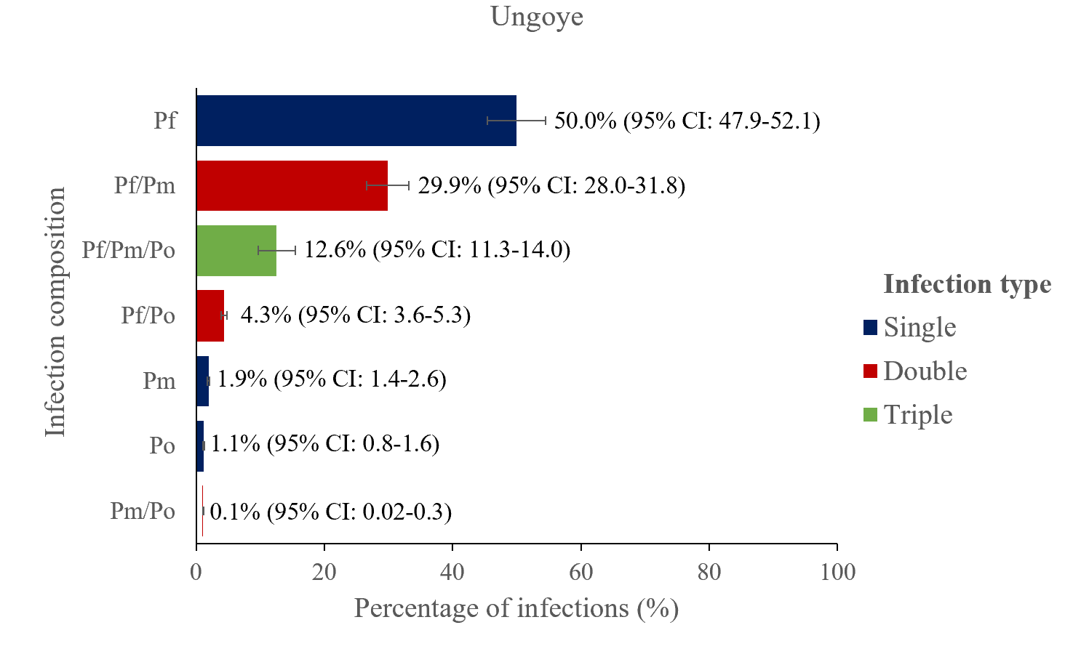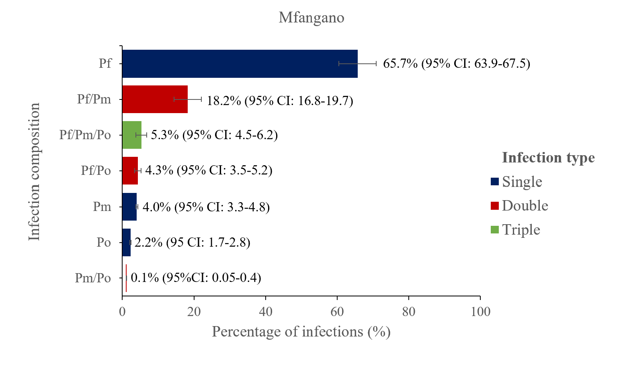Suplementary Figure 3. The proportion of Plasmodium mono and mixed-species infections among the positive cases by polymerase chain reaction in Mfangano island (n=2709) and Ungoye (n=2260). The error bars represent a 95% confidence interval (CI). Abbreviations; CI, confidence interval; Pf, Plasmodium falciparum; Pm, Plasmodium malariae; Po, Plasmodium ovale.

Supplementary Table 1. Changes in the relative frequency of P. falciparum mono- and mixed infections, as well as non-falciparum infections over time evaluated using multinomial logistic regression. Adjusted relative risk ratios (RRR) of mono-infection, mixed, or non-falciparum mono infections each year of survey, relative to being uninfected(negative) at baseline in 2012.

Pf mono-infection |  |  |  | Pm mono-infection |  |  | Po mono-infection |  |  | Pf/Pm |  |  | Pf/Po |  |  | Pf/Pm/Po
Year | RRR | 95% CI | P-value | RRR | 95% CI | P-value | RRR | 95% CI | P-value | RRR | 95% CI | P-value | RRR | 95% CI | P-value | RRR | 95% CI | P-value
2012 | 1.00 | … | … | 1.00 | … | … | 1.00 | … | … | 1.00 | … | … | 1.00 | … | … | 1.00 | … | …
2013 | 1.4 | 1.18-1.67 | <0.001 | 1.4 | 0.69-2.87 | 0.351 | 1.66 | 0.55-5.00 | 0.366 | 1.61 | 1.25-2.06 | <0.001 | 2.02 | 1.25-3.27 | 0.004 | 3.13 | 2.18-4.49 | <0.001
2014 | 0.93 | 0.80-1.08 | 0.385 | 2.12 | 1.26-3.58 | 0.005 | 2.57 | 1.10-6.00 | 0.028 | 1.34 | 1.08-1.66 | 0.007 | 1.31 | 0.83-2.06 | 0.246 | 2.01 | 1.43-2.82 | <0.001
2015 | 0.91 | 0.78-1.07 | 0.256 | 1.35 | 0.77-2.38 | 0.290 | 2.72 | 1.16-6.41 | 0.022 | 1.83 | 1.45-2.30 | <0.001 | 1.50 | 0.92-2.44 | 0.103 | 3.09 | 2.12-4.52 | <0.001
2017 | 1.07 | 0.92-1.24 | 0.364 | 2.18 | 1.31-3.64 | 0.003 | 4.58 | 2.11-9.93 | <0.001 | 2.07 | 1.69-2.54 | <0.001 | 1.68 | 1.08-2.61 | 0.020 | 2.85 | 2.03-3.99 | <0.001
2018 | 0.86 | 0.74 -1.00 | 0.056 | 1.15 | 0.65-2.05 | 0.623 | 4.04 | 1.82-8.96 | 0.001 | 1.26 | 0.99-1.60 | 0.055 | 1.55 | 0.97-2.46 | 0.065 | 1.49 | 0.97-2.27 | 0.063
All relative risk ratios are adjusted for age (as a categorical variable in five categories, <5, 5–10, 11–15), sex and study site. No survey was conducted in 2016.
Abbreviations: Pf, Plasmodium falciparum; Pm, Plasmodium malariae; Po, Plasmodium ovale, RRR; relative risk ratio. Non-falciparum mixed infection (Pm/Po) category was omitted due to consistently low frequencies observed over the years

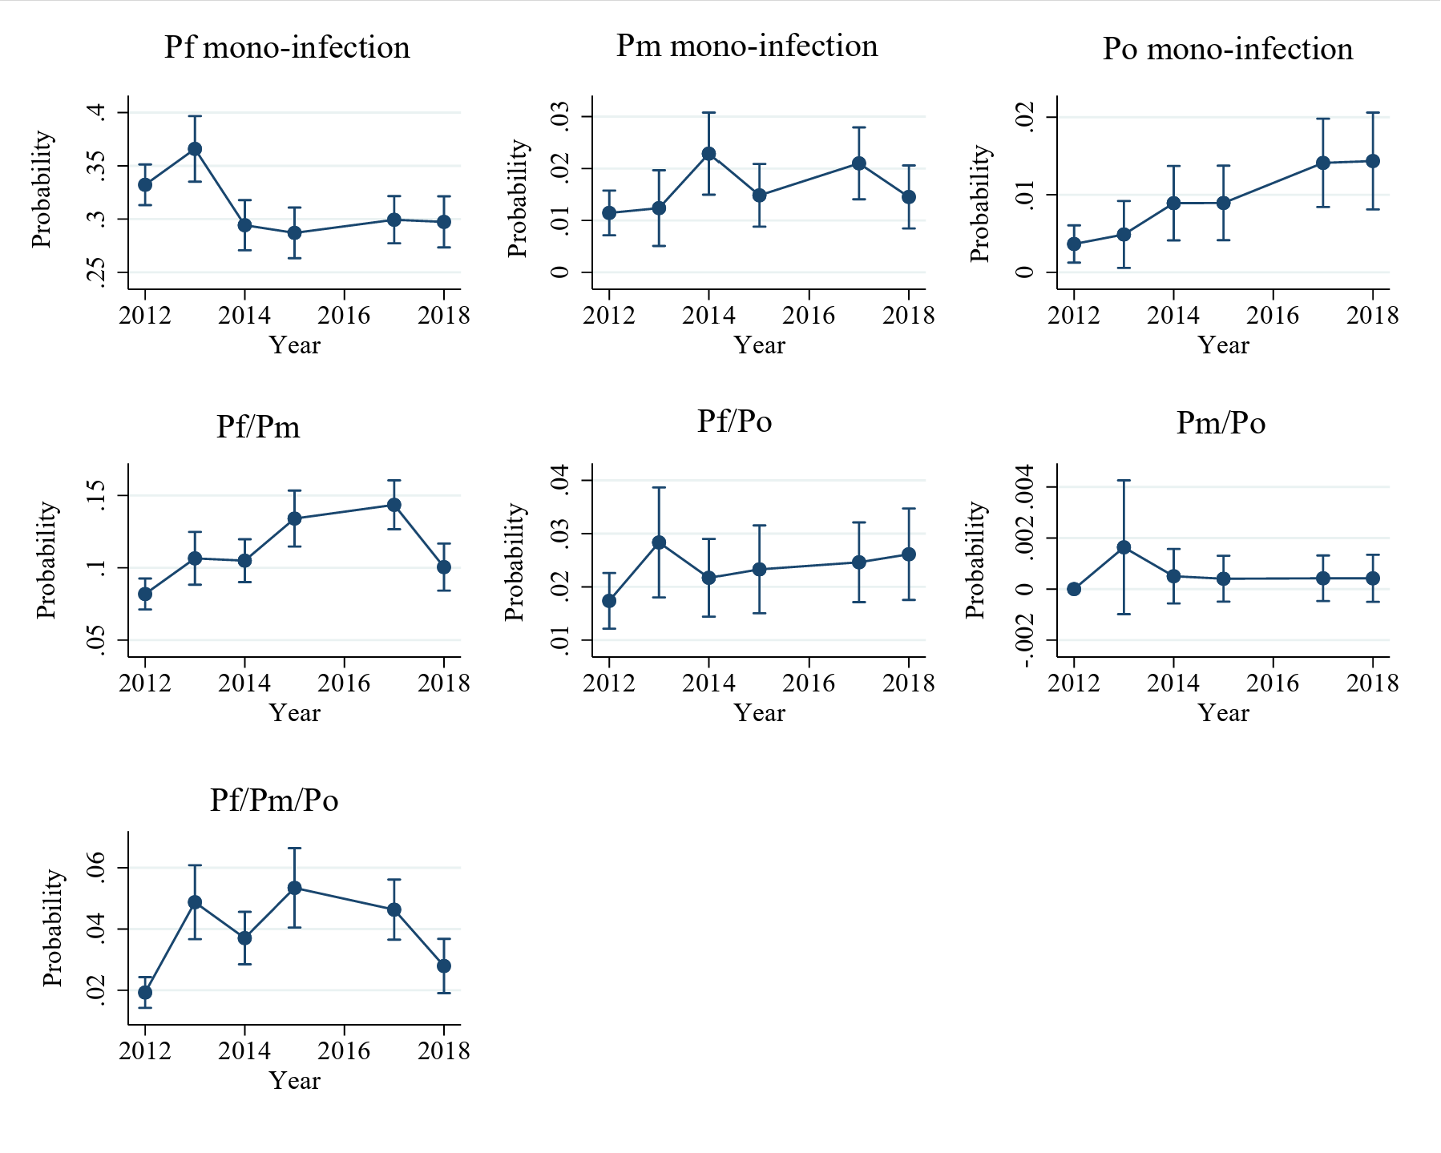
G
F
E
D
A
B
C
Supplementary Figure 4. Multinomial logistic model adjusted predicted probabilities Plasmodium infections overtime. A) P. falciparum mono-infection, B) P. malariae mono-infection, C) P. ovale mono-infection, D) P. falciparum + P. malariae mixed infection, E) P. falciparum + P. ovale mixed infection, F) P. malariae + P. ovale mixed infection, G) P. falciparum + P. malariae + P. ovale mixed infection. The model predicted the probability of infection over time. Predictions are adjusted for age, sex and study site with all covariates at their respective means. The error bars indicate the 95% confidence interval of the prediction. No surveys were conducted in 2016.

