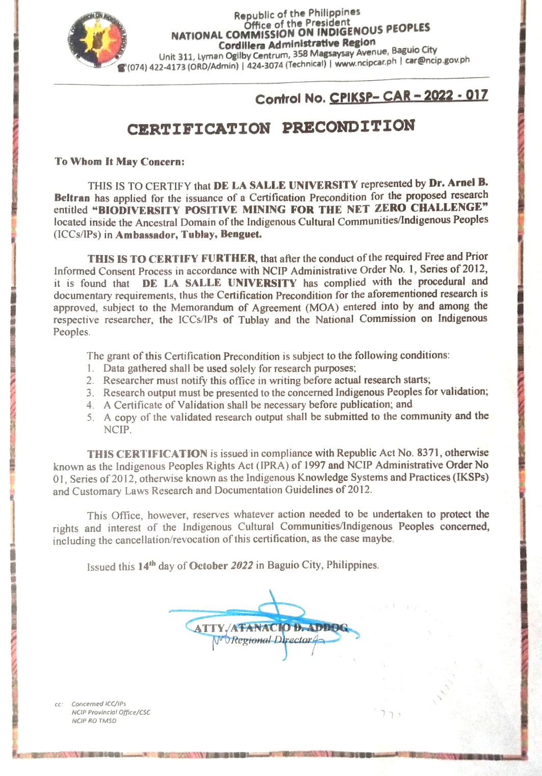

Supplementary Figure 1. Certificate of Precondition issued by the National Commission on Indigenous People (NCIP), Cordillera Administrative Region.

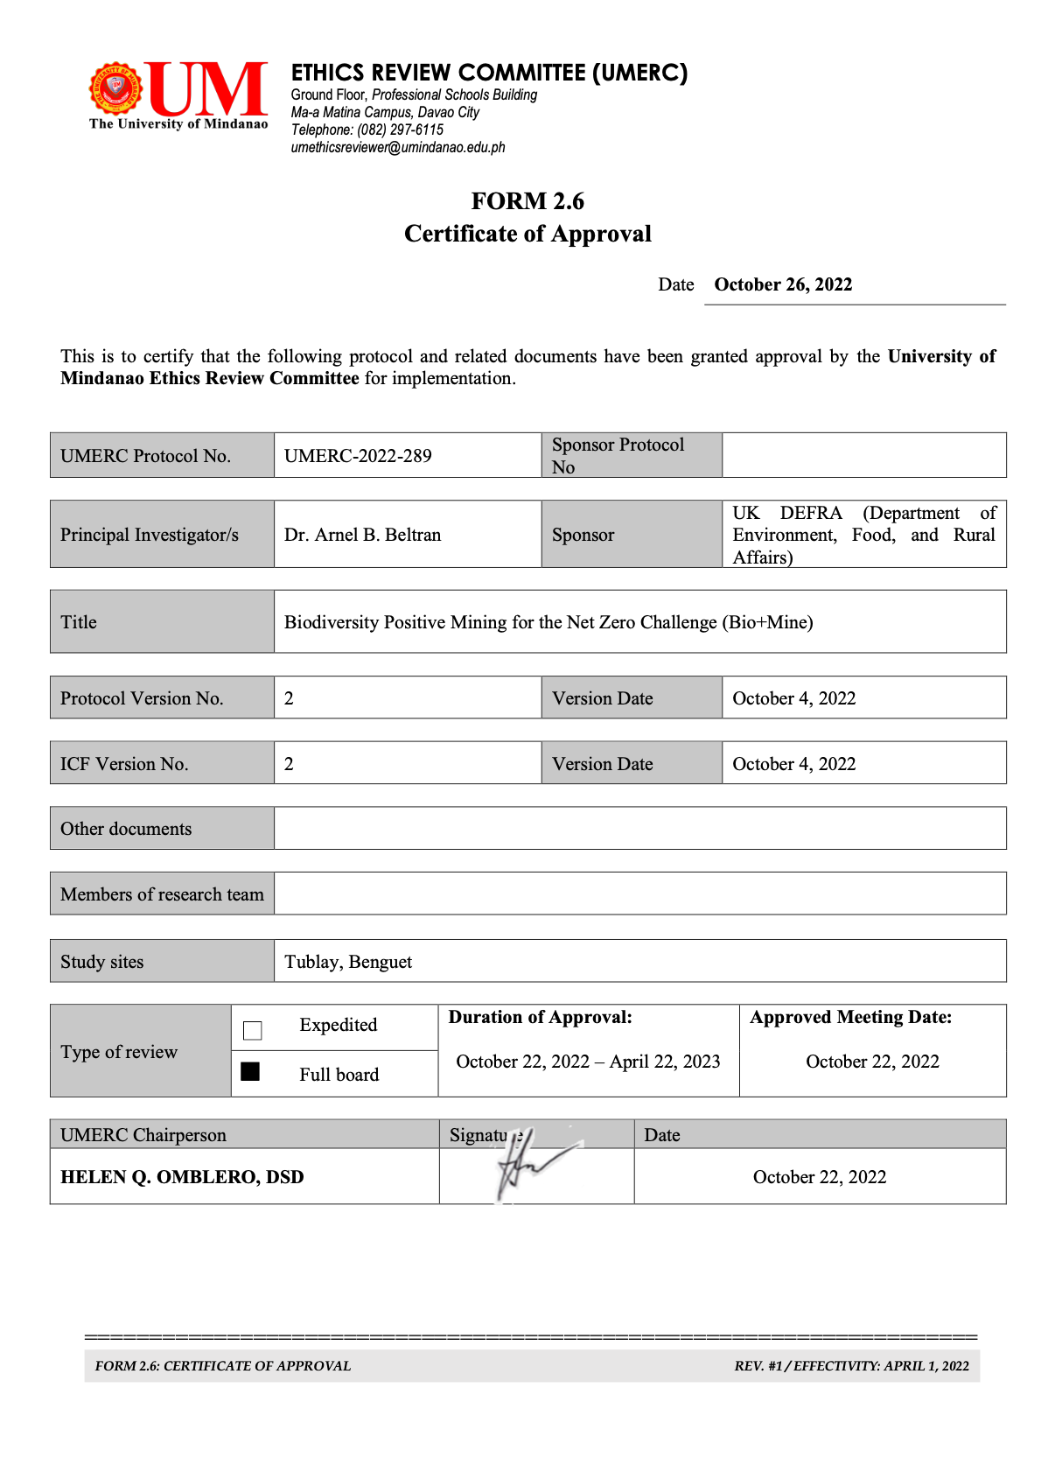

Supplementary Figure 2. Ethics approval granted by the University of Mindanao Ethics Review Committee, Davao City.

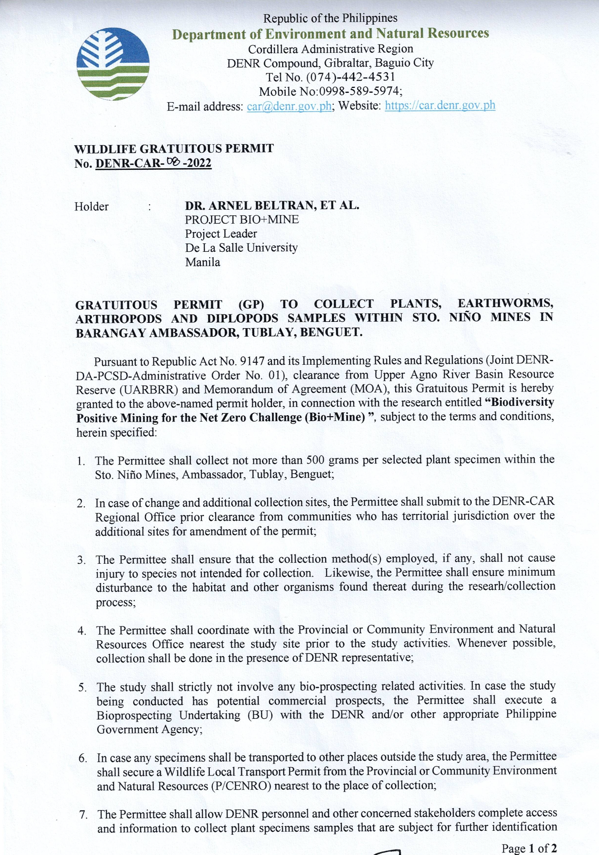

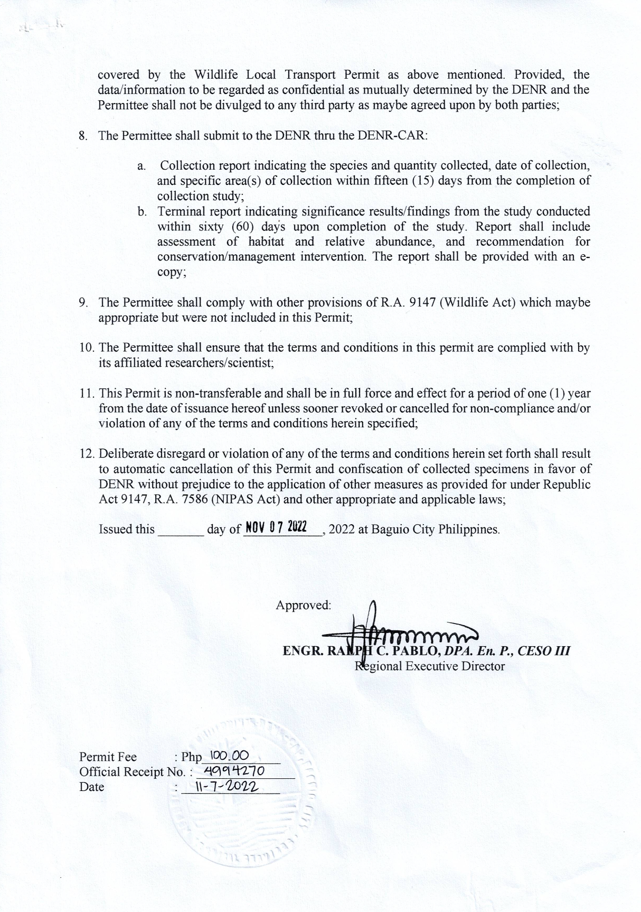

Supplementary Figure 3. Wildlife Gratuitous Permit issued by the Department of Environment and Natural Resources, Cordillera Administrative Region.
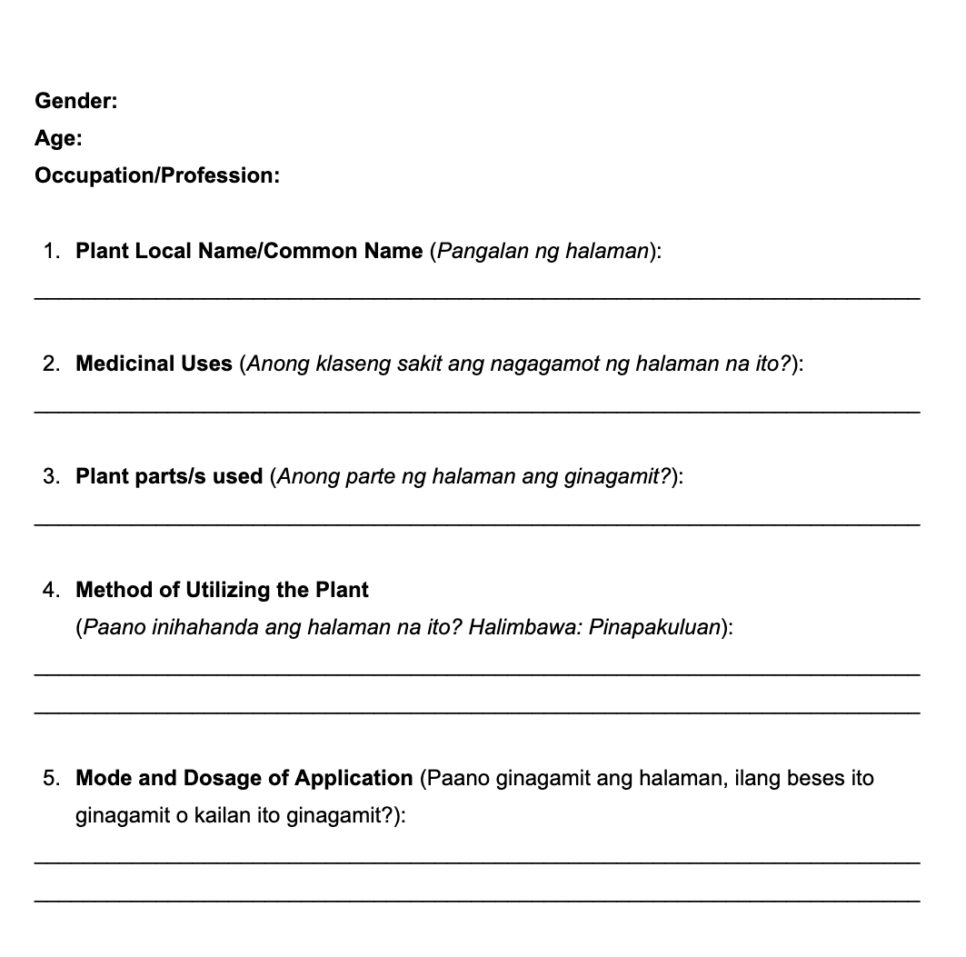
Supplementary Figure 4. Ethnobotanical survey questionnaire used during the collection of data.

