List of SARS-CoV-2 variants used for IIP
- hCoV-19/Japan/TY-WK-521/2020 (wild type A) GISAID: EPI_ISL_408667
- hCoV-19/Japan/QHN001/2020 (α variant B.1.1.7) GISAID: EPI_ISL_804007
- hCoV-19/Japan/TY11-927/2021 (δ variant AY.122) GISAID: EPI_ISL_2158617
- hCoV-19/Japan/TY38-871/2021 (ο variant BA.1.1) GISAID: EPI_ISL_7571618
- hCoV-19/Japan/TY40-385/2022 (ο variant BA.2) GISAID: EPI_ISL_9595859
- hCoV-19/Japan/TY41-702/2022 (ο variant BE.1) GISAID: EPI_ISL_13241867

Based on the material transfer agreement, all SARS-CoV-2 variants were provided by the National Institute of Infectious Diseases, Japan to the Fukushima Prefectural Institute of Public Health.

Inactivated SARS-CoV-2 infected whole-cell antigen preparation protocol
Note: The following procedures must be performed in the BSL 3 laboratory.
- Inoculate VeroE6/TMPRSS2 cells (4.2 x 10^6) in a 75 cm² flask with SARS-CoV-2 (multiplicity of infection 0.5), and culture in DMEM (low glucose) + 10% FBS + 1 mg/mL Geneticin + 100 unit/mL Penicillin + 100 µg/mL Streptomycin under 5% CO₂ at 37 °C for 14 hours. (VeroE6/TMPRSS2 cell ID: JCRB1819)
- Discard the liquid medium, wash twice with PBS, and discard the supernatant.
- After treatment with 0.25% trypsin – 0.02% EDTA, discard the supernatant, and harvest the cells with E-MEM into a 15 mL tube.
- Centrifuge the tube at 1500 rpm for 5 minutes, and discard the supernatant.
- Add 4% paraformaldehyde phosphate-buffered solution up to 15 mL and suspend the cells, incubate for >30 minutes at room temperature.
- Centrifuge the tube at 1500 rpm for 5 minutes, and discard the supernatant.
- Add PBS up to 15 mL and suspend the cells.
- Centrifuge the tube at 1500 rpm for 5 minutes, and discard the supernatant.
- Repeat 7 & 8.
- Add 1% fetal bovine serum + 0.1% formaldehyde added PBS up to 10 mL and suspend the cells.
- Store at 4 °C until use, or at -80 °C for storage longer than a couple of days. (The antigen cells may be taken out of the BSL 3 laboratory, as SARS-CoV-2 has already been inactivated.)

For negative control cell preparation, complete the above protocol without inoculation with SARS-CoV-2.

Antigen slide preparation protocol
- Dispense 1 mL each of the antigen cell suspension into two 1.5 mL microtubes per antigen.
- Centrifuge the tubes at 10000 rpm for 5 minutes, and discard the supernatant.
- Pipet one tube with 1 mL of 0.01 M PBS (pH 7.2) and collect all suspension, then put it into the other tube and mix the same antigen cells by a vortex.
- Centrifuge the tubes at 500 rpm for 3 minutes, collect 1 mL of the supernatant, then put it into a new 1.5 mL microtube per antigen. (*)
- Centrifuge the tubes at 10000 rpm for 5 minutes, and discard the supernatant.
- Add 50 µL each of 0.01 M PBS (pH 7.2) + 0.3% bovine serum albumin and mix well by a vortex.
- Aspirate the antigen cell suspension by capillary action of a micropipette tip and spot it on a glass slide. (Spots can be put on the same slide with caution to avoid contamination.)
- Completely dry the slide by air, and stain the spots with Giemsa staining.
- Check the antigen cell density under a microscope. (Approximately 50 cells/high power field at x400 is recommended.)
- If the cells are too many, add some 0.01 M PBS (pH 7.2) + 0.3% BSA. If the cells are too few, add 2 – 8 µL of centrifuged sediments (*). Then repeat 7 – 10 until obtaining adequate cell density.
- Spot antigen cells and negative control cells adjusted for concentration by the above procedure on a glass slide as shown below figure.
- Dry the slide at 37 °C for 30 minutes, then fix it in acetone at -20 °C for 10 minutes under light-shielded conditions.
- After drying, use the slide antigen immediately, otherwise keep it in a sealed plastic sachet and store at -20 °C under light-shielded conditions until use. (Caution for use: before opening the seal, place the sachet at room temperature until the slide reaches room temperature to avoid condensation.)
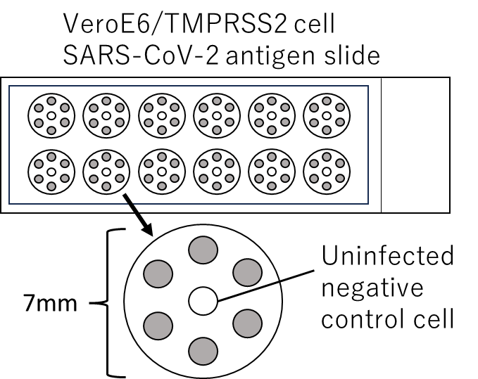

Serum absorption and preparation for IIP test
- Thaw stored serum samples and inactivated VeroE6/TEMPRSS2 for negative control (concentration: approximately 200 cells/µL) at room temperature.
- Dilute the serum 1:10 with 0.01 M PBS (pH 7.2) + 0.3% BSA. (Ex. 50 µL + 450 µL. The diluted samples can be stored at -80 °C until use.)
- Pipet 20 µL each of the 1:10 diluted serum sample and negative control cells in a new microtube and mix well by a vortex.
- Incubate the microtube at 37 °C for 30 minutes (1st absorption).
- Add 40 µL of the negative control cells in the microtube, and incubate the microtube at 37 °C for 30 minutes (2nd absorption).
- Centrifuge the microtube at 10000 rpm for 5 minutes, and pipet the supernatant in a new tube, which should be tested by IIP as a 1:40 diluted serum sample.

IIP test protocol
- Dilute the absorbed serum sample two-fold from 1:40 to 1:10240 with 0.01 M PBS (pH 7.2) + 0.3% BSA. (Ex. Prepare 25 µL of 0.01 M PBS (pH 7.2) + 0.3% BSA in 8 microtubes or 8 wells of a microplate, and pipet 25 µL of a 1:40 diluted serum sample in the 1st one, then dilute sequentially by pipetting.)
- Carefully load 10 µL of each diluted sample to the spotted antigens on a slide. (Note: avoid touching the antigen slide by the tip of the micropipette.)
- Incubate the slide in a humidified light-shielded chamber at 37 °C for 30 minutes.
- Wash the slide with a gentle stream of PBS and rinse in a PBS-filled chamber for 2 minutes, then repeat a 2-minute rinsing with PBS.
- Carefully load 10 µL of 1:100-diluted horseradish peroxidase-conjugated antihuman IgG or IgM rabbit serum (γ-chain specific or μ-chain specific, Dako Agilent Technologies Japan) to the spotted antigens on a slide. (Note: avoid contamination of the loaded reagents between antigen spots for different dilutions.)
- Repeat 3 & 4.
- Incubate the slide in the chamber filled with freshly prepared enzyme substrate solution composed of 1 volume of 80% ethanol containing 0.2% 4-Cl-1-naphtol, 4 volumes of PBS, and 0.01 volume of 3% hydrogen peroxide at room temperature for 5 minutes under light-shielded conditions.
- Wash the slide three times by changing the solution to distilled water in the chamber. (Pour out the solution, immediately pour in DW, and repeat three times.)
- After air drying, cover the slide with glycerol gelatin and a coverslip on a warm plate around 30-50 °C.
- Visually read the results by a light microscope at x100 – x400. (The titer should be determined as the highest dilution of the serum, which demonstrated blue or blue black-colored cellular surface dots.)

RT-qPCR protocol for the antigen cell suspensions
- Extract RNA from 140 µL each of the antigen cell suspension following the manufacturer’s instruction using QIAamp Viral RNA Mini (QIAGEN, Cat. No. 52904).
- Following the manufacturer’s instruction of One Step PrimeScript TM III RT-qPCR Mix, with UNG (TAKARA BIO INC., Cat. No. RR601A), prepare the reagents mix and set the heat protocol as shown below.
45 cycles
Reagent | Volume (µL)
RNase free H₂O | 3.6
One Step PrimeScript TM III RT-qPCR Mix, with UNG (2X) | 10.0
# Primer-probe mix (20X):  Forward (400 nM)  Reverse (700 nM)  Probe (200 nM) | 1.0
ROX Reference Dye II (50X) * | 0.4
RNA template | 5.0
Total | 20.0
Temp. | Time
25 °C | 10 min.
↓
52 °C | 5 min.
↓
95 °C | 10 sec.
↓
95 °C | 5 sec.
↓↑
60 °C | 30 sec.
*Addition is recommended by the manufacturer for a real-time PCR machine made by Applied Biosystems, etc. (Ex. Applied Biosystems 7500 Real-Time PCR System (Thermo Fisher Scientific))
# NIID-S ver. 2 (S2) set (PCR product size: 149 bp)
Name | Sequence (5’ to 3’) | Position | Concentration
SARS-CoV-2_  NIID_S_F1 | CAGTCAGCACCTCATGGTGTA | 24722-24742 | 400 nM
SARS-CoV-2_  NIID_S_R3 | AACCAGTGTGTGCCATTTGA | 24870-24851 | 700 nM
SARS-CoV-2_  NIID_S_P2 | FAM-TGCTCCTGCCATTTGTCATGATGG  -BHQ1 | 24793-24816 | 200 nM
Reference: The National Institute of Infectious Diseases, Japan protocol for SARS-CoV-2 gene detection and virus culture Ver. 1.1, 08/02/2021 (URL: https://www.niid.go.jp/niid/ja/lab-manual-m/10032-sars-cov-ref2.html), Japanese language.

