Title:
Community-based pathogen-specific incidence of influenza-like illness due to respiratory viruses in South-central Vietnam in 2009–2012, after a pandemic of influenza A viruses

Supplementary tables and figures

Supplementary table 1. Characteristics of selected household and members.
 | Beginning of the surveillance |  | End of the surveillance
 | (%) |  | (%)
Household numbers | 1,000 |  | 989
Commune
Vinh Phuoc | 247 | (25) | 242 | (24)
Vinh Hiep | 250 | (25) | 250 | (25)
Vinh Thanh | 250 | (25) | 247 | (25)
Vinh Hoa | 253 | (25) | 250 | (25)
Household size
≤4 persons | 435 | (44) | 534 | (54)
5–6 persons | 290 | (29) | 293 | (30)
≥7 persons | 275 | (28) | 162 | (16)
Household members | 4,716 |  | 4,755
Commune
Vinh Phuoc | 1,307 | (28) | 1,291 | (27)
Vinh Hiep | 1,087 | (23) | 1,089 | (23)
Vinh Thanh | 1,234 | (26) | 1,271 | (27)
Vinh Hoa | 1,088 | (23) | 1,104 | (23)
Sex
Female | 2405 | (51) | 2425 | (51)
Age (years)
Mean ± SD | 32.0 ± 20.0 |  | 33.7 ± 20.3
Median (IQR) | 30 (16 – 46) |  | 32 (18 – 48)
Age group (years)
<2 | 147 | (3) | 97 | (2)
2–4 | 199 | (4) | 194 | (4)
5–14 | 690 | (15) | 654 | (14)
15–29 | 1,249 | (26) | 1,223 | (26)
30–44 | 1,158 | (25) | 1,183 | (25)
45–59 | 824 | (17) | 888 | (19)
60+ | 449 | (10) | 516 | (11)
Four communes, Vinh Phuoc, Vinh Hiep, Vinh Thanh and Vinh Hoa were selected for the study. On the beginning of the surveillance in September 2009, number of households were 1,000 including 4,716 household members. At the end of the surveillance in December 2012, number of households were decreased but household members were slightly increased. Mean age was increased by 1.7 years.

Supplementary table 2. Movement of household members during study period
Movement | Number
New-born | 148
Died | 61
Moved in | 116
Khanh Hoa | 17
Nha Trang | 54
Other province | 33
Overseas | 2
Unknown | 10
Moved out | 93
Khanh Hoa | 11
Nha Trang | 30
Other provinces | 30
Overseas | 10
Unknown | 12
Dropped out | 59
Total increase | 264
Total decrease | 213
Total change | +51

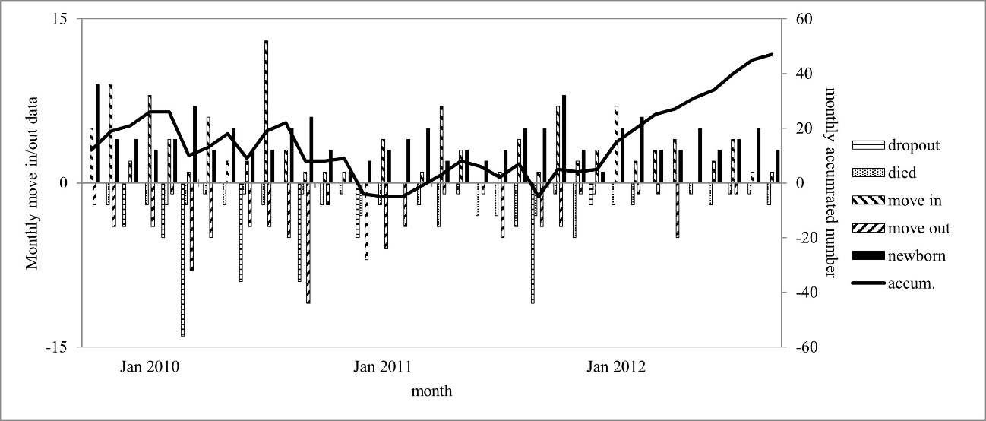
Supplementary figure 1. Monthly changes of sample population were recorded regarding to self-reports of household members. Persons who moved in households were defined as those who stay more than three weeks. Persons who moved out from households were defined as those who were absent for more than three weeks.

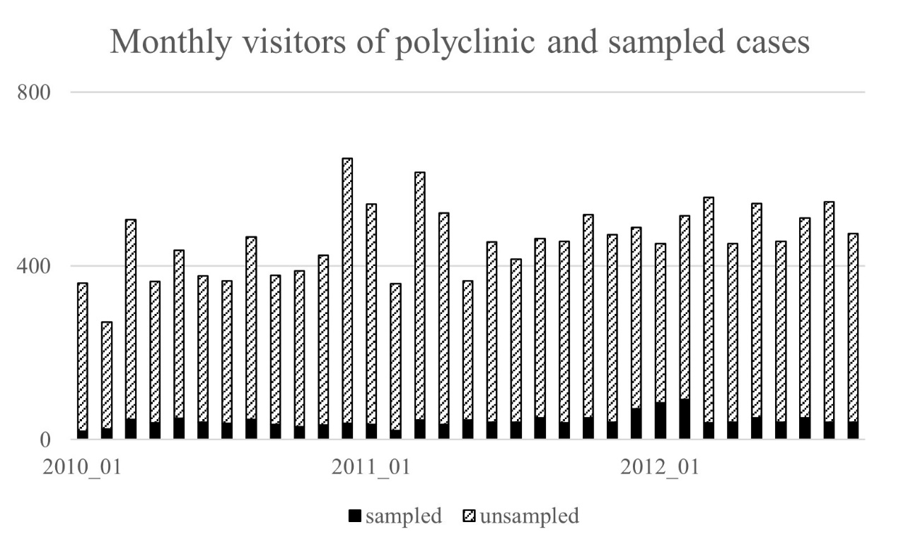
Supplementary figure 2.

Supplementary table 3. Number of visitors to polyclinics 1 and 2 from target commune and identified viruses
 | N | (%)
Total visitors from target population | 15,173
<2 years from target population | 9,344 | (61.5)
2–5 years from target population | 3,428 | (22.6)
Total sampled | 1,428
Influenza A | 82 | (5.7)
Influenza B | 45 | (3.2)
RSV | 129 | (9.0)
hMPV | 40 | (2.8)
PIV1 | 27 | (1.9)
PIV2 | 18 | (1.3)
PIV3 | 19 | (1.3)
PIV4 | 9 | (0.6)
Rhinovirus | 407 | (28.5)
Coronavirus | 19 | (1.3)
Adenovirus | 157 | (11.0)
Bocavirus | 13 | (0.9)
At least one virus | 769 | (53.8)
No virus detected | 659 | (46.2)
Multiple infection
2 viruses | 150 | (10.5)
3 viruses | 20 | (1.4)
4 viruses | 2 | (0.1)
RSV, respiratory syncytial virus. PIV 1-4, parainfluenza virus type 1-4. Numbers of children under 5 years old visited polyclinics were showed here. See also supplementary fig.1 for monthly numbers of visitors and those sampled.

