Supplementary Table 1: Total and subscales of J-CCCHP among participants
 |  |  | Total Score |  | Motivation/Curiosity |  | Emotion/Empathy |  | Attitude |  | Skill
 |  | n (%) | Mean (SD) | p-value* | Mean (SD) | p-value* | Mean (SD) | p-value* | Mean (SD) | p-value* | Mean (SD) | p-value*
Frequency of treating foreign patients | Several times a week | 203 (18.6%) | 80.5 (13.5) | 0.488 | 24.5 (6.4) | 0.083 | 15.1 (4.1) | 0.397 | 13.8 (3.6) | 0.002 | 27.0 (5.3) | 0.039
 | Several times a year | 516 (47.4%) | 81.3 (12.2) | 0.488 | 25.2 (5.8) | 0.083 | 14.5 (3.4) | 0.397 | 14.2 (3.4) | 0.002 | 27.1 (5.0) | 0.039
 | Almost none | 370 (34.0%) | 80.4 (11.7) | 0.488 | 24.3 (6.1) | 0.083 | 15.0 (3.1) | 0.397 | 14.8 (3.3) | 0.002 | 26.3 (5.5) | 0.039
J-CCCHP: Japanese validated version of cross-cultural competence instrument for healthcare professionals
SD: Standard deviation
*p-values represent comparisons across all groups., Bold: p-value<0.05

Supplementary Table 2: Total and subscales of J-CCCHP, stratified by participating in any form of training for treating foreign patients
Frequency of treating foreign patients | Total Score |  | Motivation/Curiosity |  | Emotion/Empathy |  | Attitude |  | Skill
Frequency of treating foreign patients | Training (No) | Training (Yes) | Training (No) | Training (Yes) | Training (No) | Training (Yes) | Training (No) | Training (Yes) | Training (No) | Training (Yes)
Several times a week | 80.0 (13.7) | 82.7 (12.2) | 24.0 (6.5) | 26.8 (5.6) | 15.2 (3.9) | 14.7 (4.9) | 14.0 (3.6) | 12.8 (3.6) | 26.8 (5.3) | 28.4 (5.0)
Several times a year | 80.9 (12.2) | 84.0 (12.3) | 24.9 (5.8) | 27.0 (5.9) | 14.8 (3.4) | 14.9 (3.1) | 14.2 (3.3) | 14.1 (3.6) | 27.0 (5.1) | 28.0 (4.7)
Almost none | 80.0 (11.8) | 86.1 (8.2) | 24.2 (6.2) | 25.9 (5.0) | 14.9 (3.1) | 15.5 (2.8) | 14.8 (3.3) | 15.5 (3.0) | 26.1 (5.6) | 29.3 (3.5)
Bold: p-value<0.05
J-CCCHP: Japanese validated version of cross-cultural competence instrument for healthcare professionals

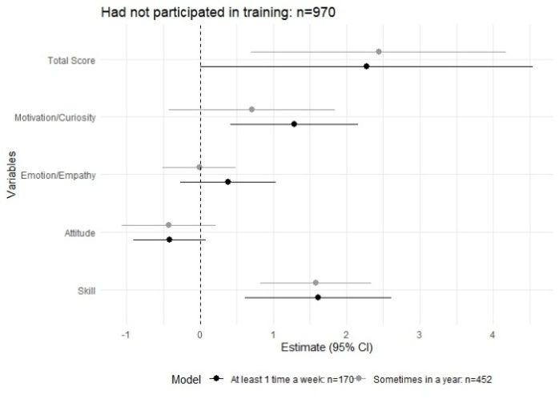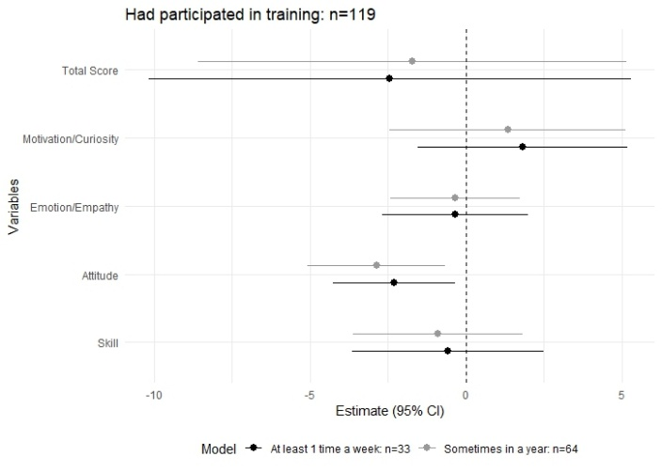
Figure 1 (b)
Supplementary Figure 1: Association between the frequency of treating foreign patients and the total and subscales of the J-CCCHP (a) among those who had not participated in training (b) among those who had participated in training (reference: Frequency of treating foreign patients= Almost none), J-CCCHP: Japanese validated version of cross-cultural competence instrument for healthcare professionals
Figure 1 (a)

Supplementary Table 3: Characteristics of participants in qualitative study (N=16)
 | Age | Sex | Job type | Type of facility | Experience of working in a foreign country
D01 | 33 | Male | Doctor | University hospital | No
D02 | 34 | Male | Doctor | University hospital | No
D03 | 45 | Male | Doctor | University hospital | Yes
D04 | 41 | Male | Doctor | University hospital | No
D05 | 29 | Male | Doctor | University hospital | No
D06 | 33 | Male | Doctor | Other hospital | No
D07 | 28 | Male | Doctor | Other hospital | No
Dt1 | 77 | Male | Dentist | Clinic | Yes
N01 | 37 | Female | Nurse | Clinic | No
N02 | 27 | Female | Nurse | Other hospital | No
N03 | 29 | Female | Nurse | Clinic | No
N04 | 37 | Female | Nurse | Other hospital | Yes
N05 | 32 | Female | Nurse | Clinic | No
N06 | 35 | Female | Nurse | Other hospital | No
N07 | 38 | Female | Nurse | Other hospital | Yes
N08 | 29 | Female | Nurse | Other hospital | Yes

Supplementary Table 4: Recommendations of Japanese healthcare professionals
Themes | Subthemes
Recommended training | Trainings that reflect real life experiences
 | Language trainings for healthcare professionals
Other recommendations | Developing manuals to support foreign patients
 | Involvement of third-party assistance

