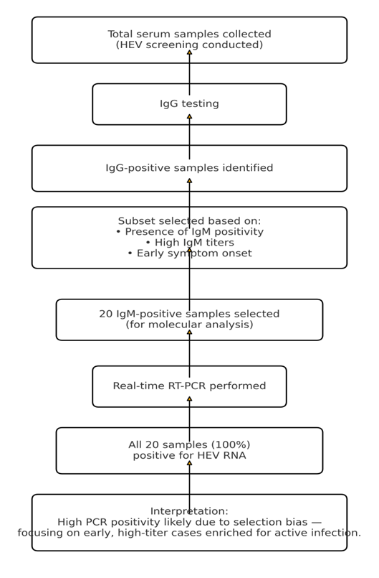
Figure S1: A flowchart providing an overview of the study inclusion/exclusion criteria

Accession | Sample Name | SPUID | Organism | Tax ID | Isolate | URL
SAMN52637457 | HEV0001 | HEV0001 | Hepatitis E virus | 291484 | Human | https://www.ncbi.nlm.nih.gov/sra/52637457
SAMN52637458 | HEV0002 | HEV0002 | Hepatitis E virus | 291484 | Human | https://www.ncbi.nlm.nih.gov/sra/52637458
SAMN52637459 | HEV0003 | HEV0003 | Hepatitis E virus | 291484 | Human | https://www.ncbi.nlm.nih.gov/sra/52637459
SAMN52637460 | HEV0004 | HEV0004 | Hepatitis E virus | 291484 | Human | https://www.ncbi.nlm.nih.gov/sra/52637460
SAMN52637461 | HEV0005 | HEV0005 | Hepatitis E virus | 291484 | Human | https://www.ncbi.nlm.nih.gov/sra/52637461
SAMN52637462 | HEV0006 | HEV0006 | Hepatitis E virus | 291484 | Human | https://www.ncbi.nlm.nih.gov/sra/52637462
SAMN52637463 | HEV0007 | HEV0007 | Hepatitis E virus | 291484 | Human | https://www.ncbi.nlm.nih.gov/sra/52637463
SAMN52637464 | HEV0008 | HEV0008 | Hepatitis E virus | 291484 | Human | https://www.ncbi.nlm.nih.gov/sra/52637464
SAMN52637465 | HEV0009 | HEV0009 | Hepatitis E virus | 291484 | Human | https://www.ncbi.nlm.nih.gov/sra/52637465
SAMN52637466 | HEV0010 | HEV0010 | Hepatitis E virus | 291484 | Human | https://www.ncbi.nlm.nih.gov/sra/52637466
SAMN52637467 | HEV0011 | HEV0011 | Hepatitis E virus | 291484 | Human | https://www.ncbi.nlm.nih.gov/sra/52637467
SAMN52637468 | HEV0012 | HEV0012 | Hepatitis E virus | 291484 | Human | https://www.ncbi.nlm.nih.gov/sra/52637468
SAMN52637469 | HEV0014 | HEV0014 | Hepatitis E virus | 291484 | Human | https://www.ncbi.nlm.nih.gov/sra/52637469
SAMN52637470 | HEV0015 | HEV0015 | Hepatitis E virus | 291484 | Human | https://www.ncbi.nlm.nih.gov/sra/52637470
SAMN52637471 | HEV0016 | HEV0016 | Hepatitis E virus | 291484 | Human | https://www.ncbi.nlm.nih.gov/sra/52637471
SAMN52637472 | HEV0017 | HEV0017 | Hepatitis E virus | 291484 | Human | https://www.ncbi.nlm.nih.gov/sra/52637472
SAMN52637473 | HEV0019 | HEV0019 | Hepatitis E virus | 291484 | Human | https://www.ncbi.nlm.nih.gov/sra/52637473
SAMN52637474 | HEV0020 | HEV0020 | Hepatitis E virus | 291484 | Human | https://www.ncbi.nlm.nih.gov/sra/52637474
Table S1: HEV-1e isolates GenBank with accession numbers and BioProject Metadata

Table S2: Concordance of IgM Serostatus and Viral RNA Detection

| Serological Status | Total Samples (N) | RNA Positive Samples (n) | RNA Positivity Rate |
|--------------------|-------------------|--------------------------|---------------------|
| IgM-Positive | 20 | 20 | 100% |
| IgM-Negative | [Not specified] | [Not specified] | [Not specified] |
| Total | [Not specified] | [Not specified] | [Not specified] |

