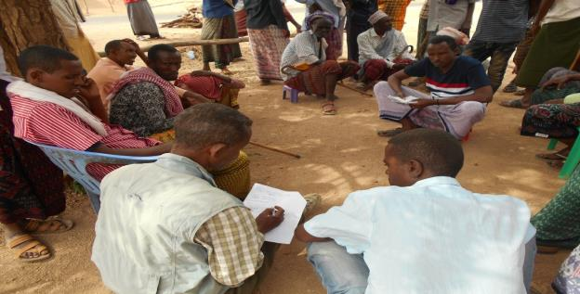
Figure S1 Interviews with local community members. (Photo credit: Getu Alemayehu, 2023)

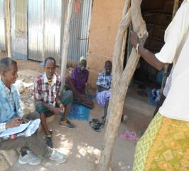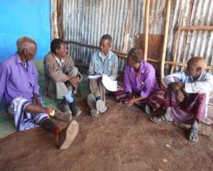
Figure S2 Photographs illustrating a group discussion with key informants (Photo credit: Getu Alemayehu, 2023)

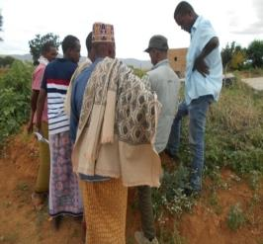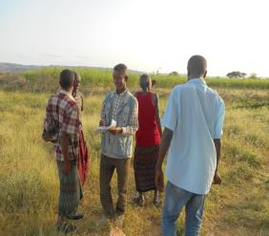
Figure S3 Guided field walk with a key informant and on-site observations. (Photo credit: Getu Alemayehu, 2023)
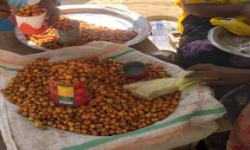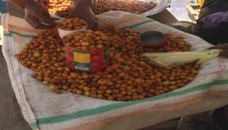
Figure S4 Ziziphus mauritiana Lam. selling at local markets (Photo credit: Getu Alemayehu, 2023)
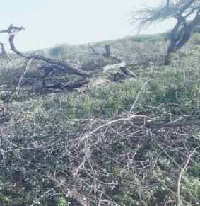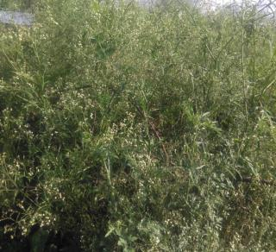
- Tree cutting for charcoal production b. Invasion by Parthenium hysterophorus L.
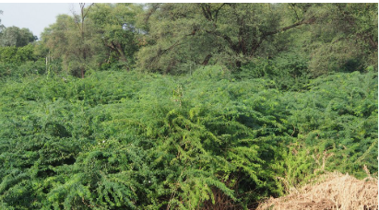
- Invasion by Prosopis juliflora (Sw.) DC.
Figure S5 Major threats to wild edible plants: (a) tree cutting for charcoal production, (b) invasion by Parthenium hysterophorus L., and (c) invasion by Prosopis juliflora (Sw.) DC.

