Guillain-Barré syndrome following dengue infection in a child in Lebanon: Case report and review of the literature
Supplementary Tables & Figures
Supplementary Table S1: Summary of laboratory findings
Complete blood count | WBC 6,100 cells/mm³; hemoglobin 10.9 g/dL; hematocrit 33%; MCV 74.2 fL; RDW 15.2%; neutrophils 34%; lymphocytes 63%; platelets 369,000 cells/mm³.
Basic metabolic panel | Glucose 108 mg/dL; BUN 10 mg/dL; creatinine 0.24 mg/dL; sodium 139 mmol/L; potassium 4.5 mmol/L; chloride 102 mmol/L; bicarbonate (CO₂) 20 mmol/L; anion gap 17 mmol/L.
Liver function tests | Total bilirubin 0.4 mg/dL; direct bilirubin 0.1 mg/dL; AST 47 IU/L; ALT 17 IU/L; alkaline phosphatase 190 U/L.
Respiratory viral PCR (N
  SARS-CoV-2: | Not Detected
  Influenza A: | Not Detected
  Influenza B: | Not Detected
  Respiratory syncytial virus: | Not Detected
Serum inflammatory, immunologic and infectious studies* | ESR 50 mm/h; CRP 1.7 mg/L; LDH 355 IU/L; creatine phosphokinase (CPK) 55 IU/L. Anti-ganglioside antibody profile (ELISA): anti-GD1a borderline positive (31; reference <30, negative), anti-GD1b, GM1, GT1a, and GQ1b negative (<30), and anti-MAG antibody negative. Quantitative immunoglobulins: IgG 10.87 g/L, IgA 0.70 g/L, and IgM 1.17 g/L. Chikungunya IgM and IgG, Epstein–Barr virus, cytomegalovirus, and malaria smear were negative. Brucella direct and indirect antibodies were negative (<1:20), and blood culture showed no growth. Anti-thyroglobulin antibody was 1.1 (normal), anti-thyroid peroxidase antibody 0.3 (normal), and anti-glutamic acid decarboxylase antibody was negative (<5.0). Autoimmune antibody panel (CASPR2, LGI1, MOG, DPPX, and aquaporin-4) was negative (<1:10). Oligoclonal bands were negative.
Urinalysis | Pale yellow urine; specific gravity 1.013; pH 6.0; rare RBCs and WBCs; otherwise, unremarkable.
Cerebrospinal fluid | RBC 152/mm³; total nucleated cells 0/mm³; glucose 59 mg/dL; protein 0.85 g/L (reference 0.1–0.5 g/L); Gram stain negative; bacterial culture no growth; acid-fast bacilli stain negative; mycobacterial culture no growth; 16S rDNA sequencing negative. CSF autoimmune antibody panel (MOG, CASPR2, LGI1, DPPX, glutamate receptor IgG, aquaporin-4, glutamate receptor antibodies) negative. Oligoclonal bands negative.
*Dengue serology is presented separately in Table 2.
Abbreviations: ALT, alanine aminotransferase; AST, aspartate aminotransferase; BUN, blood urea nitrogen; CPK, creatine phosphokinase; CRP, C-reactive protein; ELISA, enzyme-linked immunosorbent assay; ESR, erythrocyte sedimentation rate; LDH, lactate dehydrogenase; MCV, mean corpuscular volume; RBC, red blood cell; RDW, red cell distribution width; WBC, white blood cell.
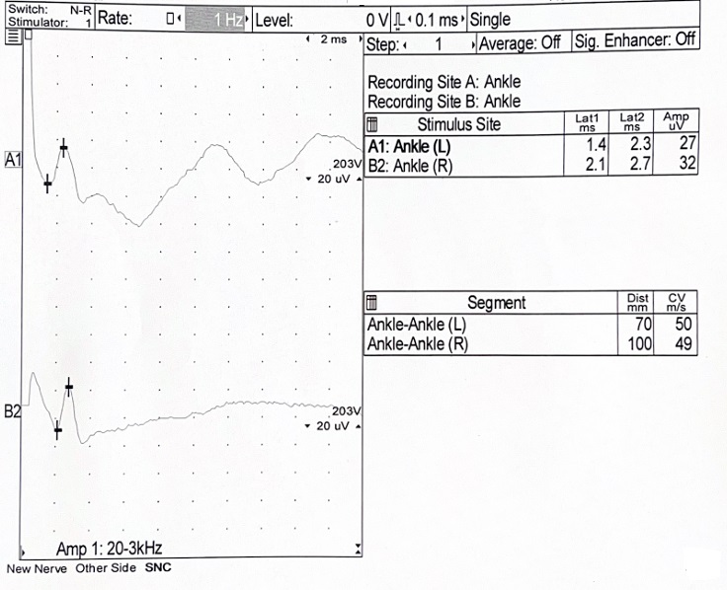
Supplementary Figure S1: Representative sensory nerve conduction studies of the bilateral sural nerves. The sensory nerve conduction studies demonstrated preserved sensory nerve action potential (SNAP) responses bilaterally.
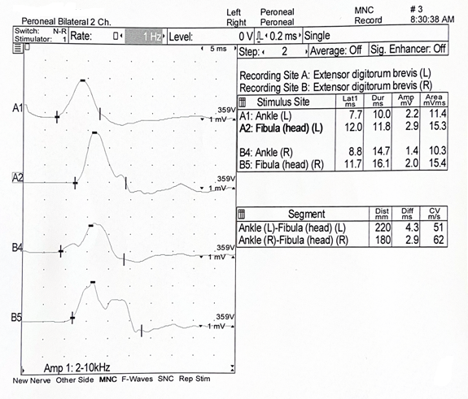
Supplementary Figure S2: Representative motor nerve conduction studies of the bilateral posterior tibial nerves. The motor nerve conduction studies demonstrated preserved compound muscle action potential (CMAP) amplitudes, slowed conduction velocities, and prolonged distal latencies bilaterally.

