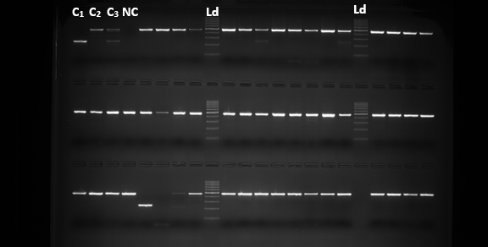
Supplementary Material 1. Representative agarose gel electrophoresis image of SINE-PCR products used for the molecular identification of members of the Anopheles gambiae complex. Diagnostic amplification fragments of 249 bp and 479 bp correspond to Anopheles gambiae and Anopheles coluzzii, respectively. Ld, 100-bp DNA ladder (molecular size marker); C1, positive control (An. gambiae); C2, positive control (An. coluzzii); C3, positive control containing both An. gambiae and An. coluzzii DNA; NC, negative control (no-template control).

