Supplementary information
Complex Exposure–Response Relationships between Meteorological Factors and Severe Fever with Thrombocytopenia Syndrome Risk

Guangju Mo^{1,2,3}, Chunyue Ai¹, Meng Shang², Shengping Dou², Wenyu Wang¹, Haoqiang Ji⁴, Huaiping Zhu^{3*}, Qiyong Liu^{1,2,4*}
¹ School of public health, Shandong Second Medical University, Weifang, Shandong Province, China
² National Key Laboratory of Intelligent Tracking and Forecasting for Infectious Diseases, National Institute for Communicable Disease Control and Prevention, Chinese Center for Disease Control and Prevention; WHO Collaborating Centre for Vector Surveillance and Management, Beijing, China
³ LAMPS and CDM, Department of Mathematics and Statistics, York University, Toronto, Canada
⁴ School of public health, Shandong University, Jinan, Shandong Province, China

*Corresponding authors: Qiyong Liu, PhD liuqiyong@icdc.cn; Huaiping Zhu, PhD huaiping@yorku.ca

Supplementary Methods: Lag Structure Definitions
Table S1. Detailed description of the Covariate data
Table S2. NB-GAM model diagnostics by lag structure
Table S3. Summary of Total SFTS Cases and Monthly Meteorological Variables from 2011 to 2023
Figure S1. Covariate collinearity diagnostics: (a) Spearman correlation matrix; (b) Variance Inflation Factor (VIF)
Figure S2. Deviance Explained of NB-GAM models by city and lag structure
Figure S3. Convergence Diagnostics for Anqing: (a) Trace Plots and (b) Posterior Density Plots of Beta Parameters
Figure S4. Convergence Diagnostics for Chizhou: (a) Trace Plots and (b) Posterior Density Plots of Beta Parameters
Figure S5. Convergence Diagnostics for Chuzhou: (a) Trace Plots and (b) Posterior Density Plots of Beta Parameters
Figure S6. Convergence Diagnostics for Hefei: (a) Trace Plots and (b) Posterior Density Plots of Beta Parameters
Figure S7. Convergence Diagnostics for Lu'an: (a) Trace Plots and (b) Posterior Density Plots of Beta Parameters
Figure S8. Convergence Diagnostics for Ma'anshan: (a) Trace Plots and (b) Posterior Density Plots of Beta Parameters
Figure S9. Convergence Diagnostics for Tongling: (a) Trace Plots and (b) Posterior Density Plots of Beta Parameters
Figure S10. Convergence Diagnostics for Xuancheng: (a) Trace Plots and (b) Posterior Density Plots of Beta Parameters
Figure S11. Heatmap of posterior inclusion probabilities (PIP) for meteorological variables across eight cities
Figure S12. Univariate effects of meteorological factors across eight cities
Figure S13. Bivariate relationship of two meteorological factors with the risk of SFTS in Chizhou
Figure S14. Bivariate relationship of two meteorological factors with the risk of SFTS in Chuzhou
Figure S15. Bivariate relationship of two meteorological factors with the risk of SFTS in Hefei
Figure S16. Bivariate relationship of two meteorological factors with the risk of SFTS in Lu’an
Figure S17. Bivariate relationship of two meteorological factors with the risk of SFTS in Ma’anshan
Figure S18. Bivariate relationship of two meteorological factors with the risk of SFTS in Tongling
Figure S19. Bivariate relationship of two meteorological factors with the risk of SFTS in Xuancheng
Figure S20. Forest Plots of Subgroup Analysis by Natural Geographic Regions
Supplementary Method: Core R code for city-specific BKMR analysis
References

Supplementary Methods: Lag Structure Definitions
For each city, six candidate lag structures were constructed for each meteorological variable:
single-month lags (lag1, lag2, lag3): The exposure value at a specified number of months prior to the outcome month. For a given month t:
lag1: exposure at month t−1; lag2: exposure at month t−2; lag3: exposure at month t−3
Cumulative moving averages (lag01, lag02, lag03): The average exposure over the current and preceding months. For a given month t:
lag01: average of exposure at months t and t−1, i.e., (Eₜ + Eₜ₋₁) / 2;
lag02: average of exposure at months t, t−1, and t−2, i.e., (Eₜ + Eₜ₋₁ + Eₜ₋₂) / 3;
lag03: average of exposure at months t, t−1, t−2, and t−3, i.e., (Eₜ + Eₜ₋₁ + Eₜ₋₂ + Eₜ₋₃) / 4
where Eₜ denotes the meteorological exposure value in month t. For each city, the optimal lag structure was initially identified according to the AIC of the city-specific NB-GAM. Considering cross-city model performance and comparability, the lag structure showing the best overall performance across cities was subsequently selected as the unified exposure window for the main BKMR analyses.

Table S1. Detailed description of the Covariate data
Variables | Spatio-temporalscale | Data source | Selection Rationale
Gross Domestic Product (GDP) per capita (CNY) | Annual data for cities from 2011 to 2023, linearly interpolated to monthly data | Statistical Yearbook | GDP per capita serves as a critical proxy for regional economic development and healthcare accessibility^{[1, 2]}.
Normalized Difference Vegetation Index (NDVI) | Monthly data by city level, 2011–2023 | The MOD13A3 dataset released by NASA with a spatial resolution of 1 km (https://search.earthdata.nasa.gov/search) | NDVI reflects vegetation coverage and greenness, serving as a key environmental determinant of tick habitat suitability^{[3]}.
Urbanization Rates (%) | Annual data by city level, 2011–2023 | Statistical Yearbook | Urbanization rate reflects the rural-urban structure and intensity of human activity^{[2]}.
Land use types (km²) | Annual data by city level, 2011–2023 | Chinese Land Cover Dataset (CLCD) (https://zenodo.org/records/15853565) | Land use patterns (forest, cropland, shrubland) determine tick habitat quality and human exposure risk^{[4]}.
Urban permanent population | Annual data by city level, 2011–2023 | Statistical Yearbook | /

Table S2. NB-GAM model diagnostics by lag structure
Lag | Deviance Explained (%) | SD | Mean AIC
lag01 | 69.9 | 12.2 | 519
lag02 | 69.2 | 12.4 | 522
lag1 | 68.1 | 11.2 | 528
lag03 | 65.9 | 10.9 | 538
lag3 | 62.1 | 12.6 | 550
lag2 | 61.7 | 11.5 | 553

Table S3. Summary of total SFTS cases and monthly meteorological variables from 2011 to 2023
City | Total SFTS cases | Monthly average
City | Total SFTS cases | Temperature (℃) | Relative humidity (%) | Atmospheric pressure (hPa) | Wind speed (m/s) | Precipitation (mm)
Chuzhou | 1501 | 16.15 | 71.99 | 1010.76 | 1.22 | 3.06
Lu’an | 1133 | 15.99 | 72.60 | 996.02 | 0.79 | 3.51
Hefei | 1117 | 16.76 | 72.54 | 1011.45 | 1.14 | 3.34
Anqing | 859 | 16.26 | 74.37 | 984.92 | 0.71 | 4.64
Ma’anshan | 420 | 16.81 | 72.89 | 1012.21 | 1.33 | 3.62
Xuancheng | 191 | 16.57 | 75.77 | 998.43 | 0.75 | 4.76
Tongling | 122 | 17.06 | 74.61 | 1009.91 | 0.80 | 4.16
Chizhou | 118 | 17.03 | 76.40 | 1004.32 | 0.61 | 5.05

Figure S1 Covariate collinearity diagnostics: (a) Spearman correlation matrix; (b) Variance Inflation Factor (VIF)
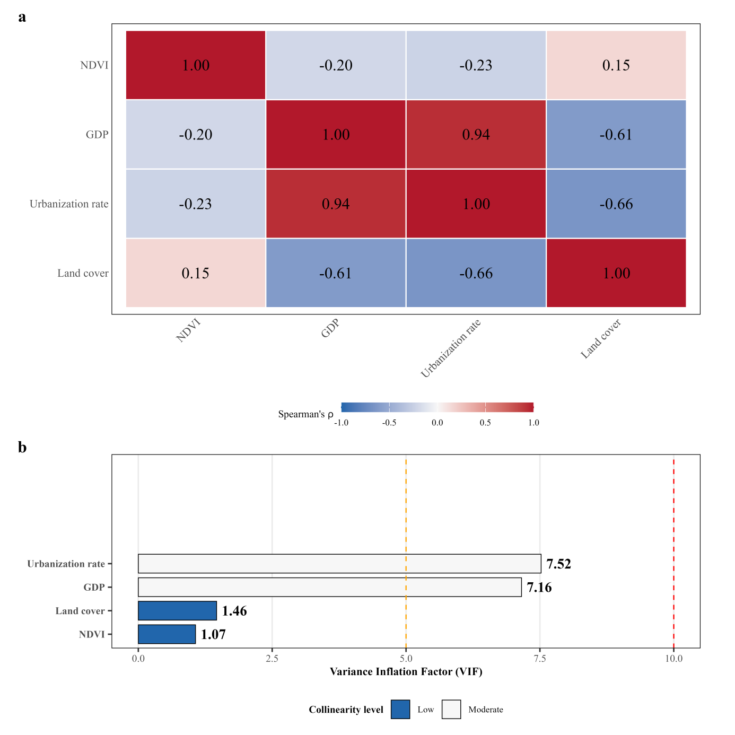
Note: GDP represents Gross Domestic Product per capita. NDVI stands for Normalized Difference Vegetation Index.
Figure S2. Deviance Explained of NB-GAM models by city and lag structure
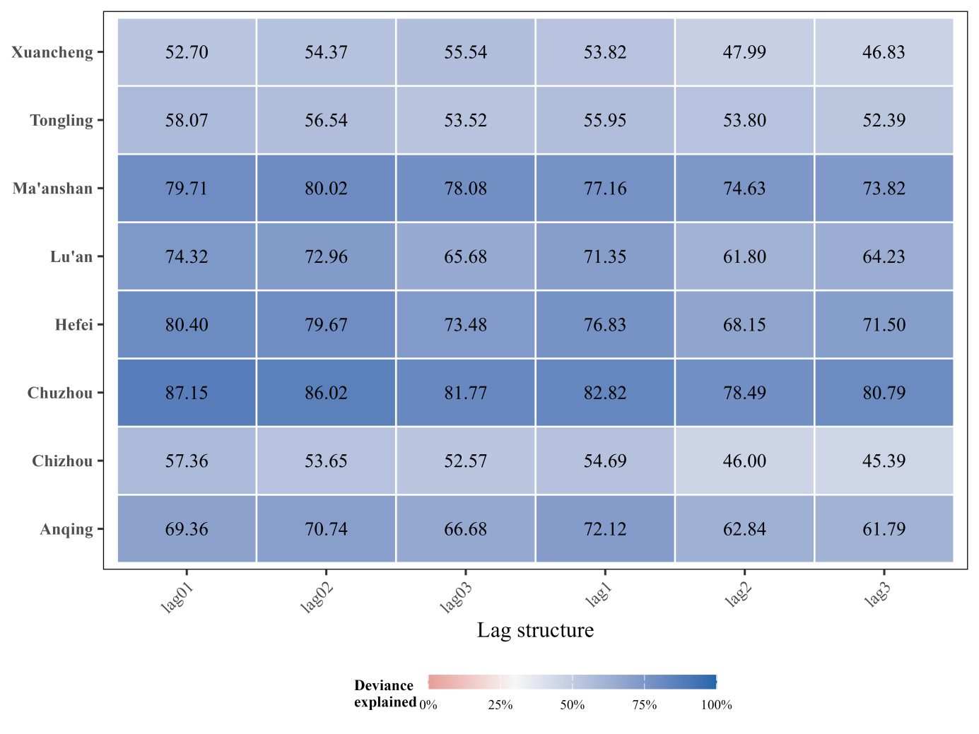
Figure S3. Convergence Diagnostics for Anqing: (a) Trace Plots and (b) Posterior Density Plots of Beta Parameters

Figure S4. Convergence Diagnostics for Chizhou: (a) Trace Plots and (b) Posterior Density Plots of Beta Parameters

Figure S5. Convergence Diagnostics for Chuzhou: (a) Trace Plots and (b) Posterior Density Plots of Beta Parameters

Figure S6. Convergence Diagnostics for Hefei: (a) Trace Plots and (b) Posterior Density Plots of Beta Parameters

Figure S7.Convergence Diagnostics for Lu'an: (a) Trace Plots and (b) Posterior Density Plots of Beta Parameters

Figure S8. Convergence Diagnostics for Ma'anshan: (a) Trace Plots and (b) Posterior Density Plots of Beta Parameters

Figure S9. Convergence Diagnostics for Tongling: (a) Trace Plots and (b) Posterior Density Plots of Beta Parameters

Figure S10. Convergence Diagnostics for Xuancheng: (a) Trace Plots and (b) Posterior Density Plots of Beta Parameters

Figure S11. Heatmap of posterior inclusion probabilities (PIP) for meteorological variables across eight cities
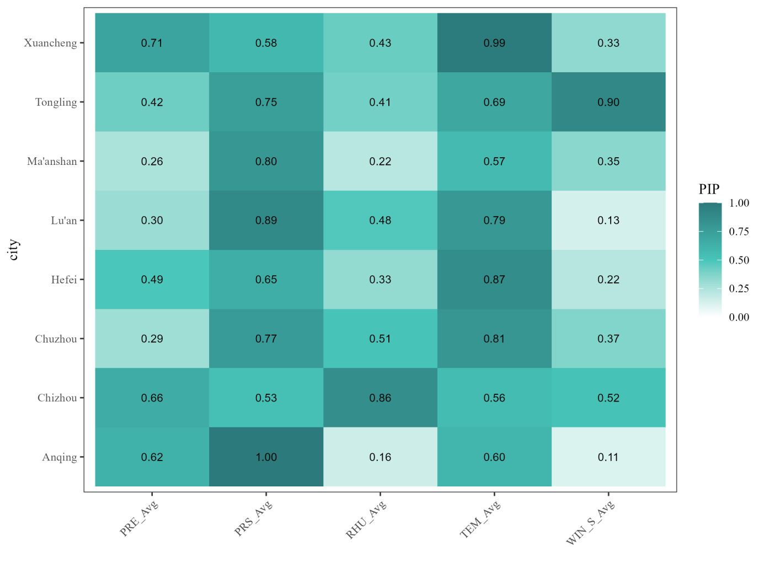

Figure S12. Univariate effects of meteorological factors across eight cities
Figure S13. Bivariate relationship of two meteorological factors with the risk of SFTS in Chizhou

Figure S14. Bivariate relationship of two meteorological factors with the risk of SFTS in Chuzhou

Figure S15. Bivariate relationship of two meteorological factors with the risk of SFTS in Hefei

Figure S16. Bivariate relationship of two meteorological factors with the risk of SFTS in Lu’an

Figure S17. Bivariate relationship of two meteorological factors with the risk of SFTS in Ma’anshan

Figure S18. Bivariate relationship of two meteorological factors with the risk of SFTS in Tongling

Figure S19. Bivariate relationship of two meteorological factors with the risk of SFTS in Xuancheng
Figure S20. Forest Plots of Subgroup Analysis by Natural Geographic Regions
Note: Forest plots showing city-specific joint effects stratified by natural geographic regions in Anhui Province. (a) Jianghuai hilly area (Chuzhou, Hefei, Lu'an; n=3). (b) Southern Mountains Region (Anqing, Chizhou, Ma'anshan, Tongling, Xuancheng; n=5). Squares represent city-specific estimates with 95% confidence intervals. Diamonds represent the overall meta-analytic estimate for each subgroup using random-effects models.
Supplementary Methods: Core R code for city-specific BKMR analysis
# 1. Required packages
# -----------------------------------------------------------------------------
library(readxl)
library(bkmr)
library(bkmrhat)
library(coda)
library(dplyr)
set.seed(2026)
# -----------------------------------------------------------------------------
# 2. Data import and preprocessing
# -----------------------------------------------------------------------------
dat <- read_excel("path/to/dat_Anhui.xlsx")
dat <- dat[order(dat$city, dat$Year, dat$month), ]
# Fourier terms for annual seasonality
dat$sin12 <- sin(2 * pi * dat$month / 12)
dat$cos12 <- cos(2 * pi * dat$month / 12)
# City-specific sequential time index
cities <- unique(dat$city)
dat$time <- NA_real_
for (city_i in cities) {
idx <- which(dat$city == city_i)
dat$time[idx] <- seq_along(idx)
}
# Meteorological exposures
weather_vars <- c("TEM_Avg", "RHU_Avg", "PRS_Avg", "WIN_S_Avg", "PRE")
for (v in weather_vars) {
lag_name <- paste0(v, "_lag01")
dat[[lag_name]] <- NA_real_
for (city_i in cities) {
idx <- which(dat$city == city_i)
if (length(idx) >= 2) {
dat[[lag_name]][idx[-1]] <- (
dat[[v]][idx[-1]] + dat[[v]][idx[-length(idx)]]
) / 2
}
}
}
# Monthly SFTS incidence per 100,000 population
dat$incidence <- dat$SFTS_case / (dat$Population / 100000)
# Variables used in the BKMR model
exposure_vars <- c(
"TEM_Avg_lag01", "RHU_Avg_lag01", "PRS_Avg_lag01",
"WIN_S_Avg_lag01", "PRE_lag01"
)
# Covariates used in the uploaded analysis code
covariate_vars <- c("NDVI", "GDP", "Land_Cover", "sin12", "cos12", "time")
required_vars <- c("city", "incidence", exposure_vars, covariate_vars)
dat <- dat[complete.cases(dat[, required_vars]), ]
# -----------------------------------------------------------------------------
# 3. City-specific BKMR model fitting
# -----------------------------------------------------------------------------
fit_city_bkmr <- function(city_data,
exposure_vars,
covariate_vars,
n_chains = 4,
iter_total = 20000,
burn = 10000,
thin = 10) {
# Exposure and covariate matrices were standardized within city
Z <- scale(as.matrix(city_data[, exposure_vars]))
X <- scale(as.matrix(city_data[, covariate_vars]))
# Continuous BKMR outcome: square-root-transformed incidence rate
y <- sqrt(city_data$incidence)
# Four-chain BKMR fit. Variable selection was enabled (varsel = TRUE).
# est.h = FALSE follows the original analysis call.
fit_parallel <- kmbayes_parallel(
nchains = n_chains,
y = y,
Z = Z,
X = X,
iter = iter_total,
verbose = FALSE,
varsel = TRUE,
est.h = FALSE,
control.params = list(
n.burn = burn,
n.thin = thin,
n.keep = (iter_total - burn) / thin
)
)
# Quantitative convergence diagnostics
diagnostics <- kmbayes_diagnose(fit_parallel, warmup = burn)
# Combine posterior samples across chains for downstream summaries
fit_combined <- kmbayes_combine(fit_parallel)
list(
fit_parallel = fit_parallel,
fit_combined = fit_combined,
diagnostics = diagnostics,
Z = Z,
X = X,
y = y
)
}
# -----------------------------------------------------------------------------
# 4. Fit models for all study cities
# -----------------------------------------------------------------------------
city_results <- list()
for (city_i in cities) {
city_data <- dat %>% filter(city == city_i)
if (nrow(city_data) < 30) next
city_results[[city_i]] <- fit_city_bkmr(
city_data = city_data,
exposure_vars = exposure_vars,
covariate_vars = covariate_vars,
n_chains = 4,
iter_total = 20000,
burn = 10000,
thin = 10
)
}
# -----------------------------------------------------------------------------
# 5. Posterior inclusion probabilities (PIPs)
# -----------------------------------------------------------------------------
# ExtractPIPs() returns posterior inclusion probabilities from the BKMR
# variable-selection procedure; it is not used to calculate Sobol indices.
pip_results <- lapply(city_results, function(res) {
ExtractPIPs(res$fit_combined)
})
# -----------------------------------------------------------------------------
# 6. Univariate exposure-response functions
# -----------------------------------------------------------------------------
univariate_results <- lapply(city_results, function(res) {
PredictorResponseUnivar(
fit = res$fit_combined,
quants = seq(0.25, 0.50, 0.75),
method = "approx"
)
})
# -----------------------------------------------------------------------------
# 7. Overall (joint) exposure-response summaries
# -----------------------------------------------------------------------------
# OverallRiskSummaries() estimates the response when all exposures are jointly
# fixed at specified quantiles, relative to a reference quantile.
joint_results <- lapply(city_results, function(res) {
OverallRiskSummaries(
fit = res$fit_combined,
qs = seq(0.25, 0.75, 0.01),
q.fixed = 0.50,
method = "approx"
)
})
# -----------------------------------------------------------------------------
# 8. Visual and quantitative MCMC convergence diagnostics
# -----------------------------------------------------------------------------
# Example for one city; repeat or loop over cities as needed.
example_city <- names(city_results)[1]
fit_parallel <- city_results[[example_city]]$fit_parallel
mcmc_list <- as.mcmc.list(fit_parallel)
# Trace and density plots for beta parameters
param_names <- colnames(mcmc_list[[1]])
beta_idx <- grep("^beta", param_names)
if (length(beta_idx) > 0) {
traceplot(mcmc_list[, beta_idx])
densplot(mcmc_list[, beta_idx])
# Gelman-Rubin R-hat
gelman_result <- gelman.diag(
mcmc_list[, beta_idx],
multivariate = FALSE)
rhat_beta <- gelman_result$psrf[, 1]
}
# ESS and R-hat summaries from bkmrhat are available in the diagnostics object
# returned by kmbayes_diagnose().
# -----------------------------------------------------------------------------
# 9. Bivariate response surfaces and formal interaction contrasts
# -----------------------------------------------------------------------------
pred_resp_bivar <- PredictorResponseBivar(
fit = fit_combined, min.plot.dist = 1)
# Evaluate conditional exposure-response functions
# with the second exposure fixed at its 25th, 50th,
# and 75th percentiles
pred_resp_bivar_levels <- PredictorResponseBivarLevels(
pred.resp.df = pred_resp_bivar,
Z = Z_scaled,qs = c(0.25, 0.50, 0.75))
# Plot conditional exposure-response curves
ggplot(pred_resp_bivar_levels,
aes(x = z1, y = est, color = quantile)) +
geom_smooth(stat = "identity") +
facet_grid(variable2 ~ variable1) +
labs(title = paste( "Conditional bivariate exposure-response functions -", city_name),
x = "Exposure 1", y = "Estimated response",color = "Exposure 2 quantile") +
theme_bw()

References
1. Yang Y, Ren J, Qin G, Lu Y, Liu Y, Sun J, Yao Y, Liu Y: Environmental, climatic, and social risk factors of severe fever with thrombocytopenia syndrome and the implications of climate change. One health-amsterdam 2026, 22:101430.
2. Miao D, Liu MJ, Wang YX, Ren X, Lu QB, Zhao GP, Dai K, Li XL, Li H, Zhang XA et al: Epidemiology and Ecology of Severe Fever With Thrombocytopenia Syndrome in China, 2010‒2018. Clinical infectious diseases 2021, 73(11):e3851-e3858.
3. Duan Q, Tian X, Pang B, Zhang Y, Xiao C, Yao M, Ding S, Zhang X, Jiang X, Kou Z: Spatiotemporal distribution and environmental influences of severe fever with thrombocytopenia syndrome in Shandong Province, China. BMC infectious diseases 2023, 23(1):891.
4. Nam HK, Min KD, Jo S, Cho SI: Association of Deforestation With Severe Fever With Thrombocytopenia Syndrome. Journal of infectious diseases 2023, 228(12):1730-1738.

