Appendix

3D printing for generating a patient-specific model of the abdominal aortic aneurysm

- 3D printer and material specifications

Table S1. Ninjatek Cheetah material data from Ninjatek datasheet [1].
General properties | Imperial | Metric
Specific gravity | 1.22 g/cc | 1.22 g/cc
Moisture absorption – 24 hours | 0.18% | 0.18%
Mechanical properties
Tensile strength, yield | 1250 psi | 9 MPa
Tensile strength, ultimate | 5650 psi | 39 MPa
Tensile modulus | 3800 psi | 26 MPa
Elongation at yield | 55% | 55%
Elongation at break | 580% | 580%
Toughness | 17000 in*lbF/in³ | 117.2 m*N/m³ x 10⁶
Hardness | 95 Shore A | 95 Shore A
Impact strength | 9.1 ft*lbf/in² | 19.1 kJ/m²
Abrasion resistance | 0.06 g | 0.06g
Thermal properties
Melting point | 428°F | 220°C
Glass transition | -11°F | -24°C
Heat deflection temperature at 10.75 psi/0.07 MPa | 165°F | 74°C
Heat deflection temperature at 66 psi/0.45 MPa | 120°F | 49°C

The technical specifications (Table S2) of the Ultimaker 3:

Table S2. Ultimaker 3 technical specifications from the Ultimaker 3 user’s manual [2].
Ultimaker 3
Precision | 20-200 micron
Minimum layer thickness | 20 micron
Minimum wall thickness | 0.4mm (with 0.4mm nozzle)
Build size | 215mm x 215mm x 200mm
Filament diameter | 2.85mm
Print head travel speed | 30-300mm/s
Nozzle temperature | 180-280°C
Build plate temperature | 20-100°C

Table S3. PVA support structure printing settings [3].
Layer height | 0.06mm
Wall thickness | 1.0mm
Infill density | 0%
Printing temperature | 215°C
Top and bottom layer printing speeds | 20 mm/s
Infill printing speed | 35 mm/s
Brim adhesion width | 3 mm

- Tear resistance comparison of Ninjatek Cheetah with silicone rubbers

Table S4. Comparing tear resistance of Ninjatek Cheetah TPU with silicone rubbers
Material | Cross-linker/ Reinforcement filler | Tear resistance  (kN/m) | Hardness  (Shore A)
Ninjatek Cheetah TPU | - | 83 | 95
Sylgard 160 [4] | - | 2.1 | 56
Sylgard 170 [5] | - | 3.5 | 41
Sylgard 184 [6] | - | 2.6 | 50
PDMS [7] | Silastic LSR 9280-40 | 37.7 | 40
PDMS [7] | One-part RTV acetoxy cure, Dow Corning 732 | 4.9 | 25
PDMS [7] | One-part RTV alcohol cure, Dow Corning1 737 | 6.48 | 37
PDMS [7] | One-part RTV oxime cure, Dow Corning 739 | 5.6 | 35
(1) Data taken from Dow Corning official datasheets for relevant materials; (2) Data taken from Kuo (1999)

- Tear resistance testing procedure

From the ISO standard 34-1:2015 entitled ‘Rubber, vulcanized or thermoplastic — Determination of tear strength’ [8], the procedure is described as:

  - Procedure

- Measure the thickness of the test piece in the region in which tearing is expected to occur and in accordance with ISO 23529.
- No measurement on any one test piece shall deviate by more than 2% from the median value of the thickness of that test piece.
- If groups of test pieces are being compared, the median thickness of each group shall be within 7.5 % of the grand median thickness of all the groups.
- Immediately mount the test piece in the testing machine.
- Extend the test piece at a rate of separation of the grips of 500mm/min ± 50 mm/min for angle and crescent type test pieces and 100mm/min ± 10mm/min for trouser test pieces until the test piece breaks.
- Record the maximum force for crescent and angle test pieces.
- When using trouser test pieces, make an autographic recording of the force throughout the tearing process.
- The tear strength $T_{s}$, expressed in kilonewtons per metre of thickness, is given in Equation S-1 as:

$$T_{s}= \frac{F}{d} (S1)$$

where:

$F$ is the maximum force, in newtons, when using method B or C, and the median force, in newtons, calculated in accordance with ISO 6133, when using method A;
$d$ is the median thickness, in millimetres, of the test piece

Express the results to the nearest kilonewton per metre.

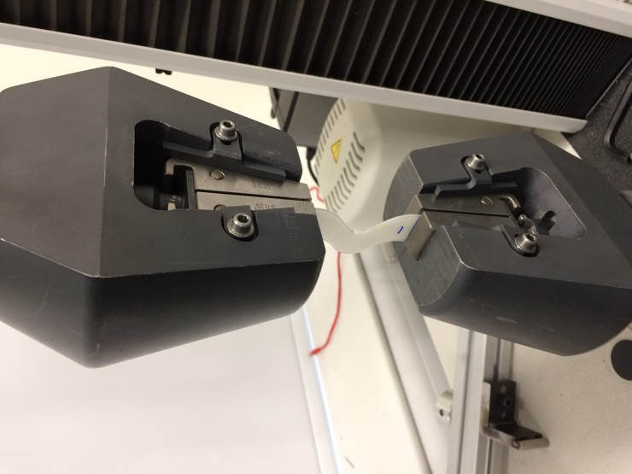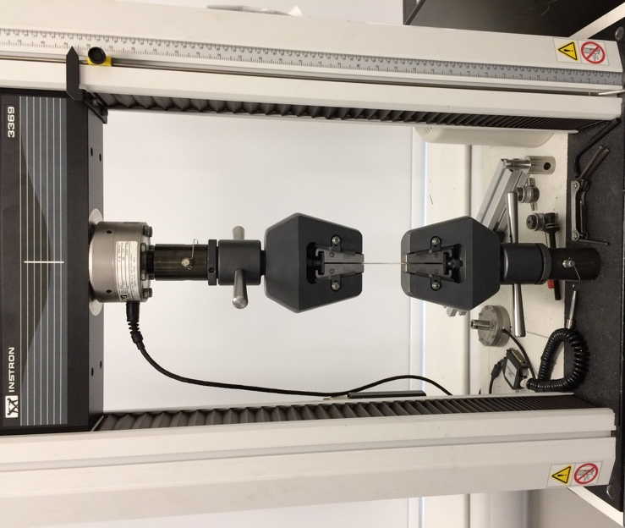

Figure S1. The test specimen had force applied by the testing machine in a vertical direction

- Sample details

The sample chosen for tear resistance testing was the angle test piece show below in Figure S2.

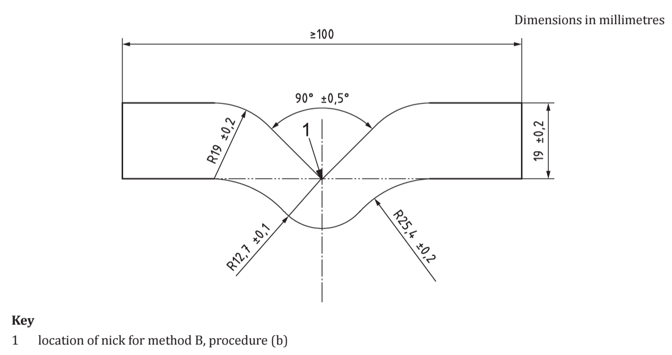
Figure S2. Angle test piece for tear resistance testing dimensions

The samples were manufactured by using the geometry defined in Figure S2 to generate a G-code for 3D printing from Ninjatek Cheetah thermoplastic polyurethane (TPU) filament. The 3D printer used was the Ultimaker 3 and had the following printing settings:

Table S5. Printing parameters for angle test piece manufacture
Printing speed | 30mm/s
Printing nozzle temperature | 255°C
Build plate temperature | 40°C
Layer thickness | 0.06mm
Wall thickness | 0.4mm
Infill percentage | 100%
Precision | 20 microns
Extrusion type | Bowden

Five test specimens were 3D printed and left 24 hours before nicking each sample at Point 1 (displayed in Figure S2) with a 1 mm cut.

The 3D printing method manufactured the test specimens using a cross-layer pattern to give even material grain strength in all directions.

Table S6 below shows the result of the median thickness measurements taken of the five test specimens:

Table S6. Median thickness measurements of angle test pieces
Specimen Number | Sample thickness (mm)
1 | 1.970
2 | 1.965
3 | 1.965
4 | 1.980
5 | 1.980
Mean value: | 1.972±0.007

- Average wall thickness measurements

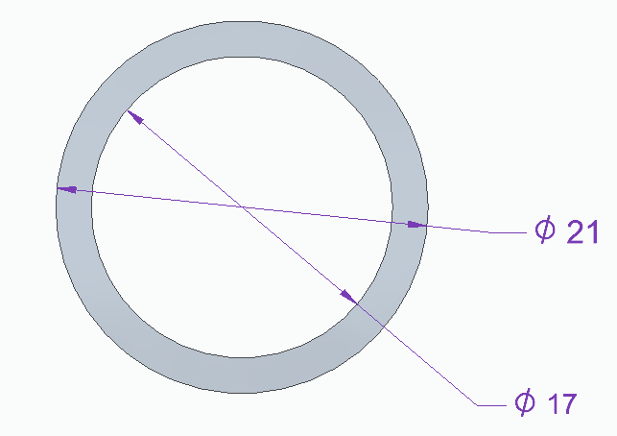

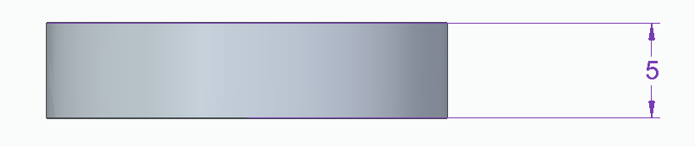
Figure S3. Ring test specimen dimensions used in precision and transparency optimisation for Ninjatek Cheetah TPU (dimensions in millimetres)

AAA model wall thickness measurement full results

Table S8. Wall thickness of rings with increased printing speed
Print speed  (mm/s) | Time for print  (mins) | Thickness measurement (mm) |  |  |  | Average  (mm)
Print speed  (mm/s) | Time for print  (mins) | 1 | 2 | 3 | 4 | Average  (mm)
30 | 23 | 1.98 | 2.01 | 2.02 | 2.00 | 2.00
40 | 18 | 2.02 | 2.00 | 2.04 | 2.02 | 2.02
50 | 16 | 2.04 | 2.03 | 2.09 | 2.05 | 2.05
60 | 14 | 2.08 | 2.05 | 2.07 | 2.06 | 2.07
70 | 13 | 2.08 | 2.06 | 2.11 | 2.05 | 2.08
80 | 13 | 2.10 | 2.08 | 2.07 | 2.14 | 2.10
90 | 13 | 2.15 | 2.14 | 2.17 | 2.23 | 2.17

Table S9. Wall thickness of rings with increased infill percentage
Infill Percentage  (%) | Thickness measurement (mm) |  |  |  | Average  (mm)
Infill Percentage  (%) | 1 | 2 | 3 | 4 | Average  (mm)
0 | 1.98 | 2.01 | 2.02 | 2.00 | 2.00
20 | 2.04 | 2.02 | 2.04 | 2.00 | 2.03
50 | 2.03 | 2.05 | 2.03 | 2.01 | 2.03
100 | 2.05 | 2.06 | 2.05 | 2.07 | 2.06

Table S10. Wall thickness of rings with increased printing temperature
Print temperature  (°C) | Thickness measurement (mm) |  |  |  | Average  (mm)
Print temperature  (°C) | 1 | 2 | 3 | 4 | Average  (mm)
240 | 2.10 | 2.09 | 2.08 | 2.08 | 2.09
245 | 2.12 | 2.07 | 2.08 | 2.07 | 2.09
250 | 2.06 | 2.07 | 2.07 | 2.03 | 2.06
255 | 1.97 | 2.03 | 2.01 | 2.04 | 2.01
260 | 1.95 | 1.96 | 1.91 | 1.95 | 1.94

- 3D printing parameters for precision and transparency

The printing guidelines provided by Ninjatek with the Cheetah Water filament are displayed in Table S6 below:

Table S11. Ninjatek Cheetah filament recommended printing guidelines
Printing nozzle temperature | 230°C – 240°C (highest temperature for increased transparency)
Printing bed temperature | 20°C – 40°C (highest temperature for improved print bed adhesion)
Top and bottom layer print speeds | 30-45 mm/s
Infill print speed | 60-80 mm/s

It should be noted that certain parameters were kept constant throughout the experiment. These are listed in Table S12 below:

Table S12. Experimental constant parameters
Layer height | 0.06mm
Wall thickness | 0.4mm
Print bed temperature | 40°C
Retraction | Enabled

The layer height, wall thickness and print bed temperature were all chosen in accordance with what would be used in printing of the AAA. The layer height and wall thickness were chosen as the minimum possible before under-extrusion occurs, where gaps are left in the print due to not enough material being deposited.
Once the parameters were chosen, the experiment followed the procedure listed below:
- Set parameters to those displayed in Table S12
- Set parameter to be altered at required value in range
- Set all other parameters to lowest value in range
- Import ring STL file with dimensions detailed in Figure S3
- Export G-code to USB drive
- Set Ultimaker 3 for automatic bed levelling for calibration
- 3D print the ring
- Retrieve printed model and investigate level of transparency and flexibility
- Use Vernier callipers to measure 4 evenly spaced thicknesses around the ring
- Repeat process, increasing the value of parameter in step 2

Table S13. Measured cross-section wall thicknesses of printed AAA model
Section name | Section No. | Cross-section thickness measurement (mm) |  |  |  |  |  |  | Average  (mm)
Section name | Section No. | 1 | 2 | 3 | 4 |  | 5 | 6 | Average  (mm)
Top flat | 1 | 2.09 | 2.08 | 2.07 | 2.04 | 2.05 |  | 2.08 | 2.07
Start of bulge | 2 | 2.18 | 2.15 | 2.18 | 2.17 | 2.11 |  | 2.04 | 2.14
Mid bulge | 3 | 2.03 | 2.08 | 1.99 | 1.98 | 2.03 |  | 2.06 | 2.03
Under bulge | 4 | 2.01 | 2.00 | 2.04 | 2.00 | 2.01 |  | 2.01 | 2.01
Thin neck | 5 | 1.98 | 2.01 | 2.09 | 2.04 | 2.00 |  | 2.03 | 2.03
Before bifurcation | 6 | 2.07 | 1.98 | 2.11 | 1.99 | 2.01 |  | 2.05 | 2.04
Bottom | 7 | 2.05 | 2.08 | 2.04 | 2.07 | 2.06 |  | 2.05 | 2.06
 |  |  |  |  |  | TOTAL |  |  | 2.05

Tear resistance results

Five test specimens were torn in total during this experiment using the angle test piece tear resistance test method B.

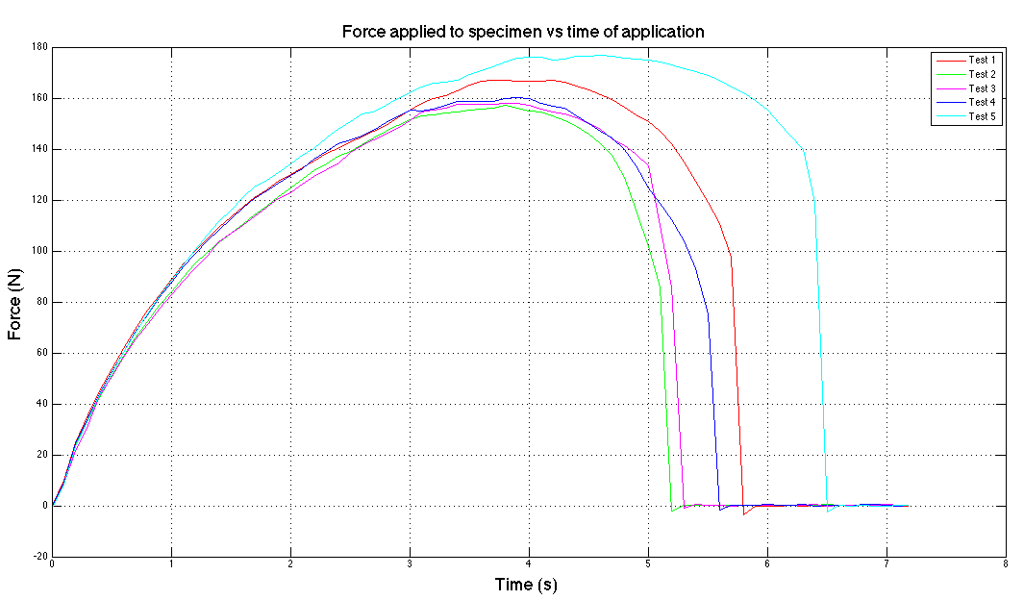
Figure S4. Variance of force with time with five test specimens for angle test piece tear resistance testing.

Table S14. Maximum force recorded for each test specimen
Specimen Number | Maximum force (kgf) | Maximum force (kN)
1 | 17.03421 | 0.167
2 | 16.00339 | 0.157
3 | 16.10578 | 0.158
4 | 16.33883 | 0.160
5 | 18.0272 | 0.177

References

- https://ninjatek.com/wp-content/uploads/2016/05/Cheetah-TDS.pdf
- https://ultimaker.com/download/61355/Ultimaker%203%20manual%20%28EN%29.pdf
- https://ultimaker.com/en/resources/23003-how-to-print-with-ultimaker-pva
- https://3.imimg.com/data3/AV/AB/MY-8890895/dow-corning.pdf
- http://webservice.oxygenekatalog.dk/getdoc.aspx?docid=10493
- http://webservice.oxygenekatalog.dk/getdoc.aspx?DocID=10494
- Kuo ACM. Poly (dimethylsiloxane). Polym. Data Handb. [Internet]. 1999;411–35. http://www.rubloffgroup.umd.edu/teaching/enma490fall03/resources/current/publications_etc/pdh-735(pdms).pdf
- ISO 34-1 Rubber, vulcanized or thermoplastic — Determination of tear strength — Part 1: Trouser, angle and crescent test pieces. Int. Organ. Stand. 2010;1–18.

