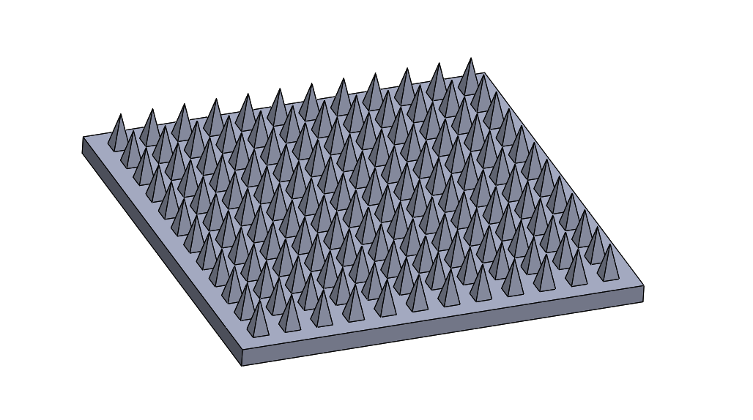
Additional File 1. Image of microneedle CAD file created in Solidworks® 2016.

