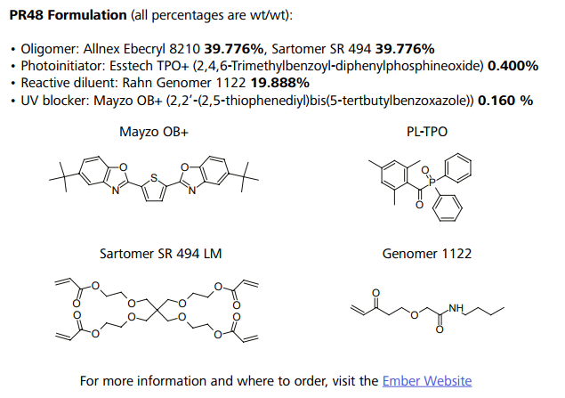
Additional File 2. Autodesk Ember PR48 resin formulation. Figure reproduced with permission from Autodesk.

