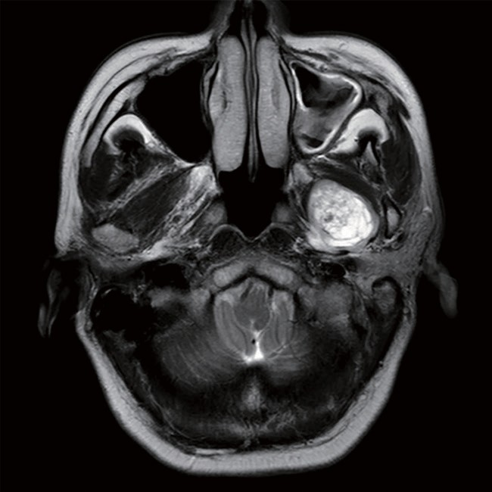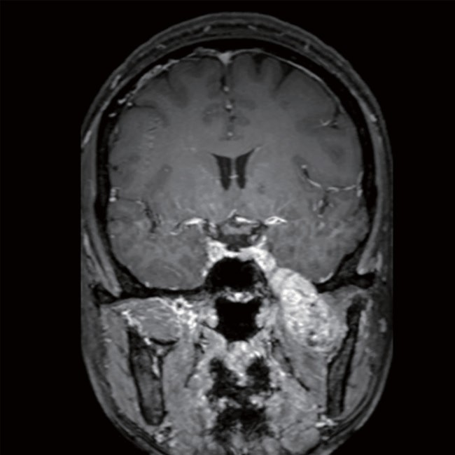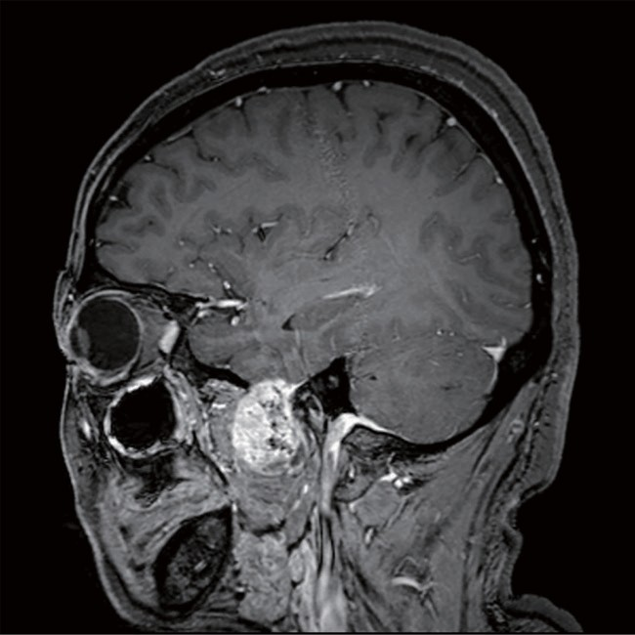
A
B
C

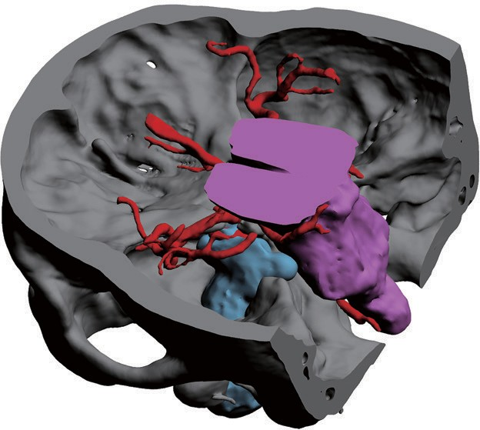
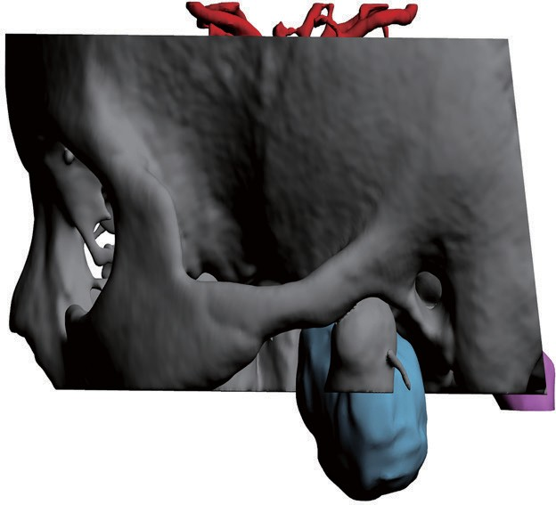
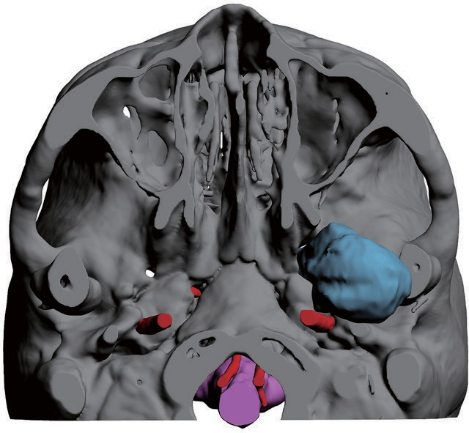E G
F

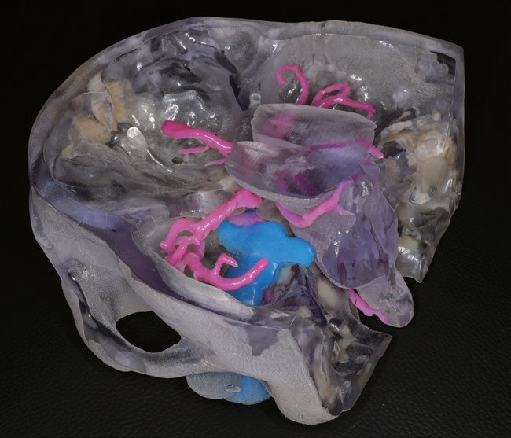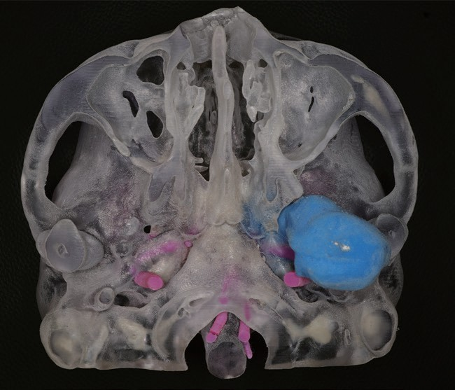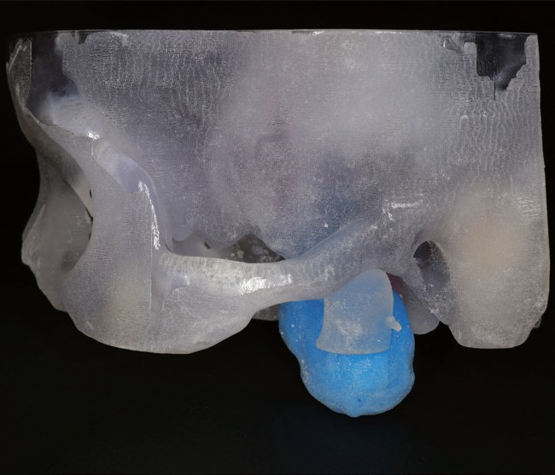
G
H
I

Figure S1 Demonstration of one 3D-printed model (case 9). (A-C) MRI (T1 weighted) images of the patient; (D-F) 3D reconstruction of the tumor and surrounding tissue; (G-I) the printed 3D model.

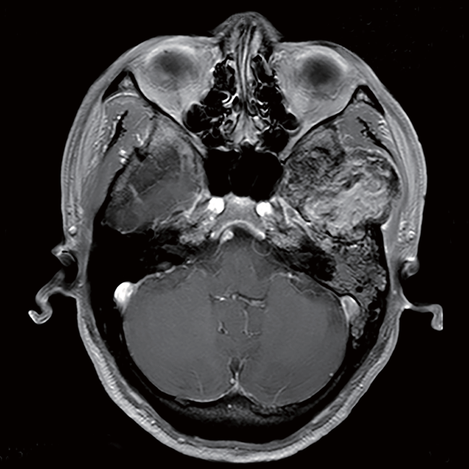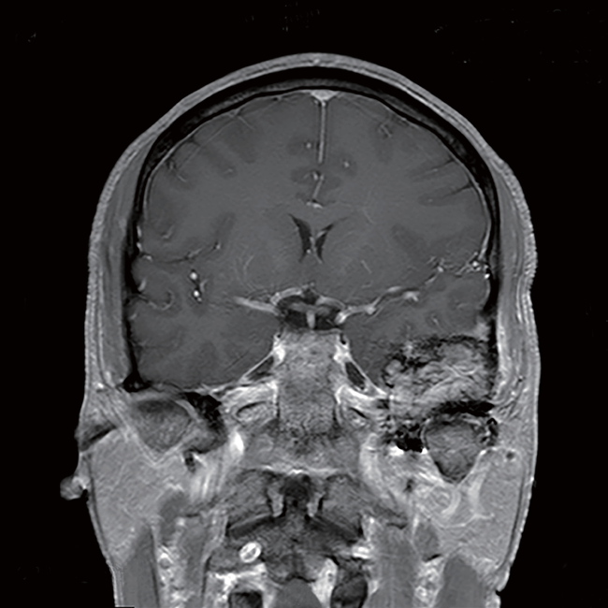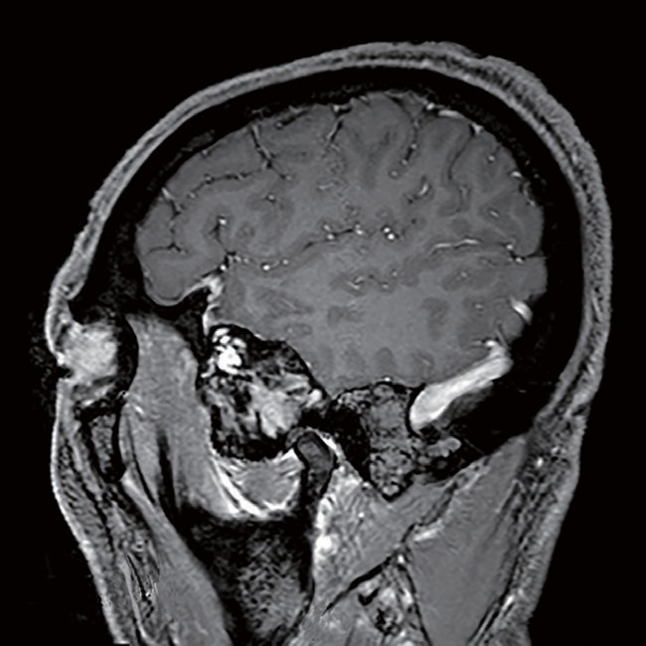
A
B
C
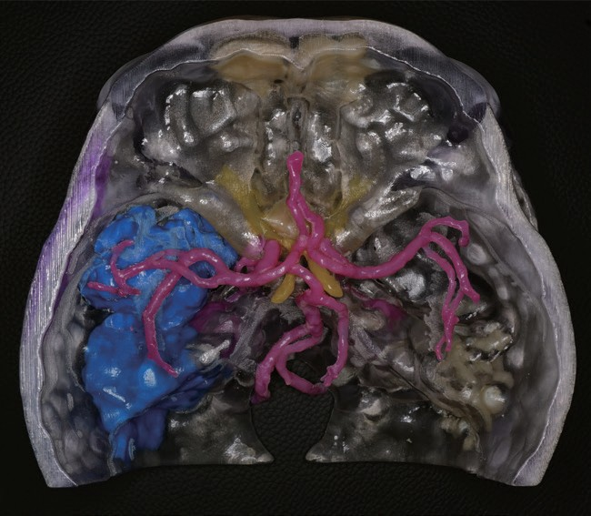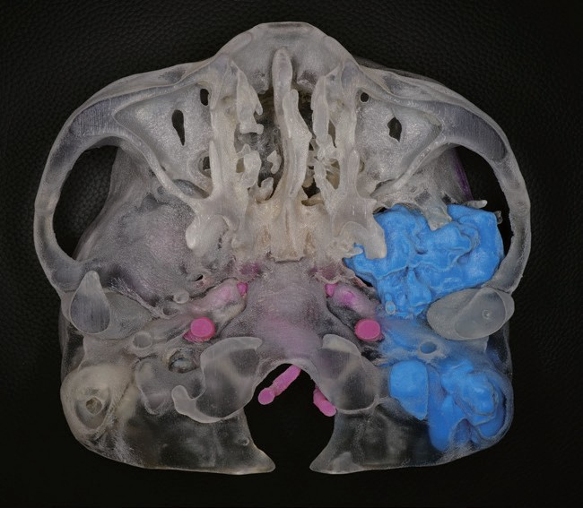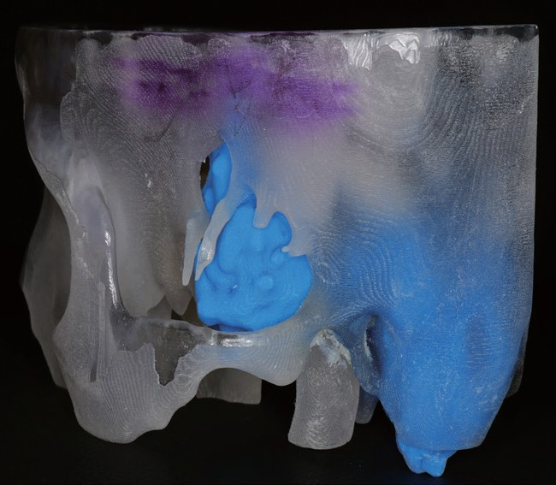
E
F
G

Figure S2 Demonstration of one 3D-printed model (case 2). (A-C) MRI (T1 weighted) images of the patient; (D-F) the printed 3D model.

Table S1. Clinicopathological features of all included patients.
Variables | Value | Percentage (%)
Mean age in years (range) | 46.5 (29-78) | 100
Sex
Male | 3 | 37.5
Female | 5 | 62.5
Skull base involvement
Anterior† | 1 | 12.5
Middle | 7 | 87.5
Posterior | 1 | 12.5
Tumor size (cm)
≥5 | 6 | 75
<5 | 2 | 25
Pathological diagnosis
Meningioma | 2 | 25
Others | 6 | 75
Complication
Yes | 1 | 12.5
No | 7 | 87.5
Mean operation time in hours (range) | 7.55 (3.50-12.75) | 100
Mean blood loss in milliliters (range) | 750 (100-2800) | 100
Mean length of stays in days (range) | 25 (20-35) | 100
†One case involved both anterior and middle skull base.

