Reviewer reports:
Reviewer #1: The manuscript Re et al., "Intranasal delivery of PEA-producing Lactobacillus paracasei F19 alleviates SARS-CoV-2 Spike protein-induced lung injury in mice" investigates the effects of an engineered probiotic in reducing lung inflammation caused by the SARS-CoV-2 Spike protein in mice. The study primarily focuses on the colonization of mouse lungs by the probiotic and its subsequent anti-inflammatory effects.
Weaknesses:
5. The manuscript does not provide data on the long-term effects of the treatment, which is critical for understanding its sustained effectiveness and safety. The author demonstrated colonization of L. paracasei F19 in only seven days. This is a very short time window to evaluate the strategy's long-term effectiveness. I suggest the author extend this study for two or three more weeks to observe the effects.
6. In the experimental setup, it would be essential to include a control group receiving only pNAPE-LP/Palmitate. This would help in understanding its specific effects on lung physiology and the lung microbiome.
The authors thank the Reviewer 1 for their valuable feedback, which will undoubtedly enhance the quality of our work.
Regarding the first two points raised by Reviewer 1:
We agree that investigating the effects after only one week does not provide a comprehensive picture of the safety profile and the impact of pNAPE-LP on the inflammatory milieu triggered by the spike protein. Nevertheless, our primary goal in this paper was to demonstrate its effectiveness and safety in the context of acute inflammation. A subsequent study is currently underway, in which we will explore the effects of our probiotic on the lung microbiota and the long-term implications of its integration into the pulmonary microbial community. For this reason, we opted not to include long-term data in this paper, as they will be the subject of another study in the future.
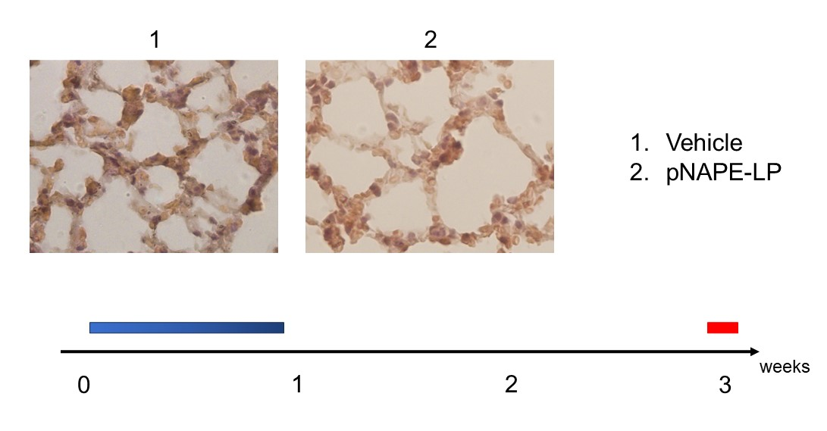
Supplementary Figure 1. Administration of pNAPE-LP/Palmitate do not cause histological damage. Hematoxylin and eosin (H and E) stained lung specimens (A), relative quantification of infiltrated epithelial cells (B), the global lung damage score (C) and the neutrophil count (D) showing the nontoxic effect of pNAPE-LP/palmitate treatment on healthy mice lungs (magnification 20×, scale bar: 20 μm).

In any case, we would be delighted to confidentially share with Reviewer 1 some preliminary data related to the aforementioned project we are currently undertaking on pNAPE-LP regarding its long-term effects on the microbiota and lung tissue. The attached histologies were conducted on tissue samples from animals treated for one week with daily intranasal doses of pNAPE-LP and sacrificed two weeks after the end of the treatment. As observed, there is no noticeable immune cell infiltration or morphological alterations when compared to tissue from untreated animals.
7. What is the rational to choose 0.003 micromolar of pNAPE-LP/Pamitate.
The concentration of palmitate is based on our previous research. We add a clear statement about it in the introduction section (lines 92-93)
8. Does overexpression of pNAPE-LP have a toxic effect on the epithelial cells in the lungs.
NAPE-PLD enzyme is well known to do not determine any kind of toxic effect on epithelial cells, and its expression is naturally upregulated in inflammatory environment because of is production of anti-inflammatory molecules. Moreover, NAPE-PLD is an ubiquitous enzyme expressed in all of the mammalian cells and in the present paper (as we showed) we did not observed any kind of epithelial alteration in the lungs after pNAPE-LP/palmitate administration.
I believe, addressing these points would greatly enhance the understanding of this study and reinforce its potential future implications.
Reviewer #2: Summary: Authors aimed to evaluate the potential of engineered probiotic lactobacillus paracasei expressing enzyme NAPE-PLD (pNAPE-LP) in counteracting the lung inflammation triggered by SARS-CoV-2. They found the protective effects of pNAPE-LP on alveolar morphology, innate immune cells infiltration, reduced neutrophil count, and reduced lung injury. They concluded that pNAPE-LP can actively protect from severe inflammatory-related symptoms in SP-challenged mice. Extensive language editing and careful revision is needed.
Recommendation: Revision
Comments:
The authors thank the Reviewer 2 for their valuable feedback, which will undoubtedly enhance the quality of our work.
1) Authors need to carefully articulate the hypothesis and predictions in introduction.
We add hypothesis and predictions in introduction section as requested (lines 97-102).
2) Extensive language editing is needed; many statements are clumsy or completely wrong. Use of long statements should be avoided, and authors need to take help from scientific writer/editor.
We edited the language in the manuscript avoiding long sentences as requested.
3) Authors need to elaborate more details in scheme 1 legend, it is very unclear.
We add a more detailed caption to scheme 1.
4) Material and methods: the manuscript material and methods section lack all the catalogue numbers of products and chemicals used in the study. Please include the catalogue numbers of antibodies used. Please include this important information.
We add the requested catalogue numbers in table 1 and 2.
5) Figure 1 and 3, please include the protein sizes in western blot image. GroEL is used as a control gene for bacterial pellets, please elaborate more information.
We have added the molecular weights of all proteins in the legends of figures 1 and 3. The use of GroEL as a housekeeping protein in Western blot analyses conducted on bacteria is considered a well-established practice in the literature.
6) What is CFU? The terminology or full forms at lot of places are missing which makes it a difficult reading for readers. Please check this thoroughly and correct it.
CFU stands for colony forming unit, as we stated at the first mention in the manuscript (line 128). We checked and corrected missing full form along the manuscript.
7) Figure 1, why the data graph is plotted differently than others? Please keep the format the same.
We plotted them differently because the experimental groups in figure 1 are different from the other figures. In order to avoid confusion, we preferred to keep them plotted in a different way.
8) Figure 2, the histological images are not clear in this figure, please use better resolution images and increase the size as well.
We increased the quality and the size of the figure 2 as requested.
9) Please increase the font size in Scheme 3, it is barely visible and includes a high-resolution image.
We modified Scheme 3 accordingly.
10) Discussion, please discuss the future directions and implications of current study in healthcare practices.
We add the requested part in the discussion.
- Supplementary material.

Composition | Medium | Inoculation volume
SARS-CoV-2 Spike Glycoprotein (SP) [500 µg/Kg]  (Acro Biosystems, Newark, DE, USA, Cat. No. SPN-C52H9) Purity 90-95%. | Steril Saline Solution | 50 µl/mouse
pNAPE-LP 10⁹ CFU/Kg  Palmitate [0.003 µM] (Merk KGaA, Darmstadt, Hesse, Germany) Purity >99% | Steril Saline Solution | 100 µl/mouse
pLP 10⁹ CFU/Kg  Palmitate [0.003 µM] (Merk KGaA, Darmstadt, Hesse, Germany) Purity >99% | Steril Saline Solution | 100 µl/mouse
Palmitate [0.003 µM] (Merk KGaA, Darmstadt, Hesse, Germany) Purity >99% | Steril Saline Solution | 100 µl/mouse
Supplementary Table 1. Solution for the intranasal inoculation and relative inoculation volumes.
 |  | Score per field
 | Parameter | 0 | 1 | 2
A. | Neutrophils in the alveolar space | None | 1-5 | > 5
B. | Neutrophils in the interstitial space | None | 1-5 | > 5
C. | Hyaline membranes | None | 1 | > 1
D. | Proteinaceous debris filling the airspace | None | 1 | > 1
E. | Alveolar Septal thickening | < 2X | 2X-4X | > 4X
$$Lung injury score=\frac{[\left(20*A\right)+\left(14*B\right)+\left(7*C\right)+\left(7*D\right)+2*E)]}{number of field*100}$$
Supplementary Table 2. Parameters for Lung injury score assessment

