Supplementary data

Gene expression analysis
Meta-analysis of mRNA gene expressions as a secondary analysis.

5-years disease free survival (5-years DFS)
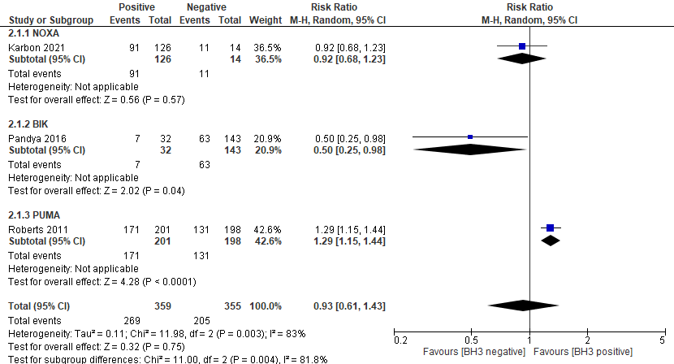
Figure 1. Forest plot of RR for 5-years DFS comparing gene expression of BH3-only protein positive and negative expressions in BC.

5-years overall survival (5-years OS)
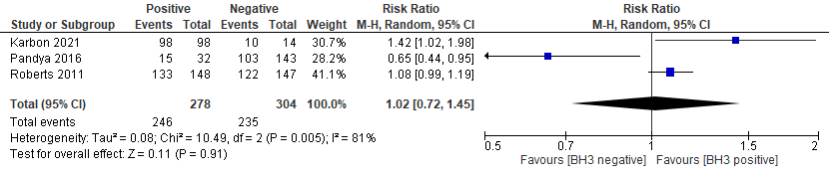
Figure 2. Forest plot of RR for 5-years OS comparing gene expression of BH3-only protein positive and negative expressions in BC.

