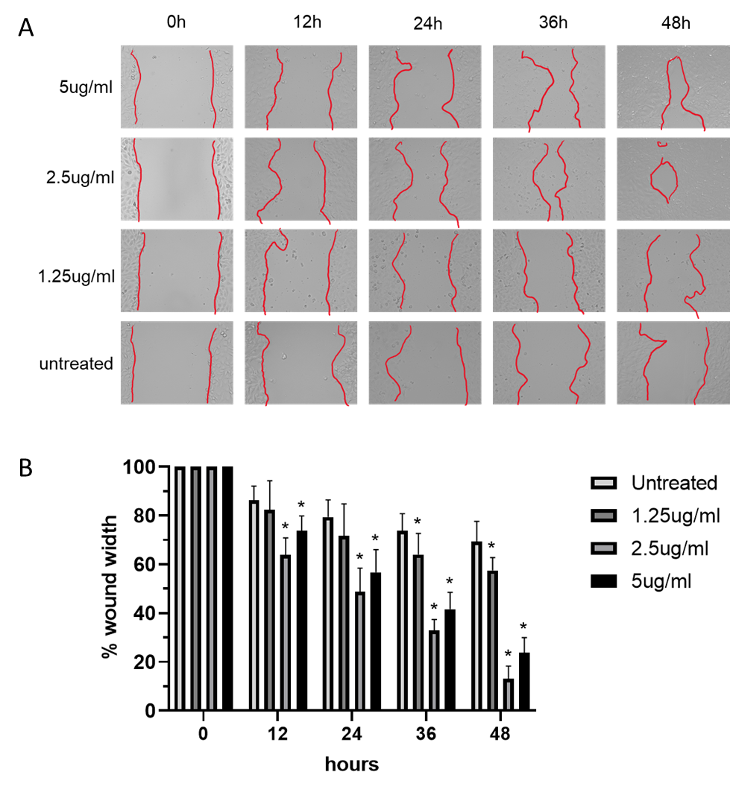
Supplementary Figure 1: Optimization of EV concentration for migration assay. (A) wound healing assay was performed in HaCaT cells and (B) cell migration was measured 48 hours after scratching (n = 24 scratches)

