Supplementary Material
Alveolar Type II Cell Therapy Ameliorates Pulmonary Fibrosis by Reprogramming Macrophage Activation

To further assess epithelial stability during co-culture conditions, expression of surfactant-related genes and the ATI marker Aqp-5 was evaluated after 48 h of co-culture with control, BLM-AM or BLM-IM macrophages (Supplementary Fig. S1). Surfactant gene expression showed a general downward trend under co-culture conditions, whereas Aqp-5 expression did not increase above freshly isolated ATII levels, suggesting no evidence of early transition toward an ATI-like phenotype during the experimental period.
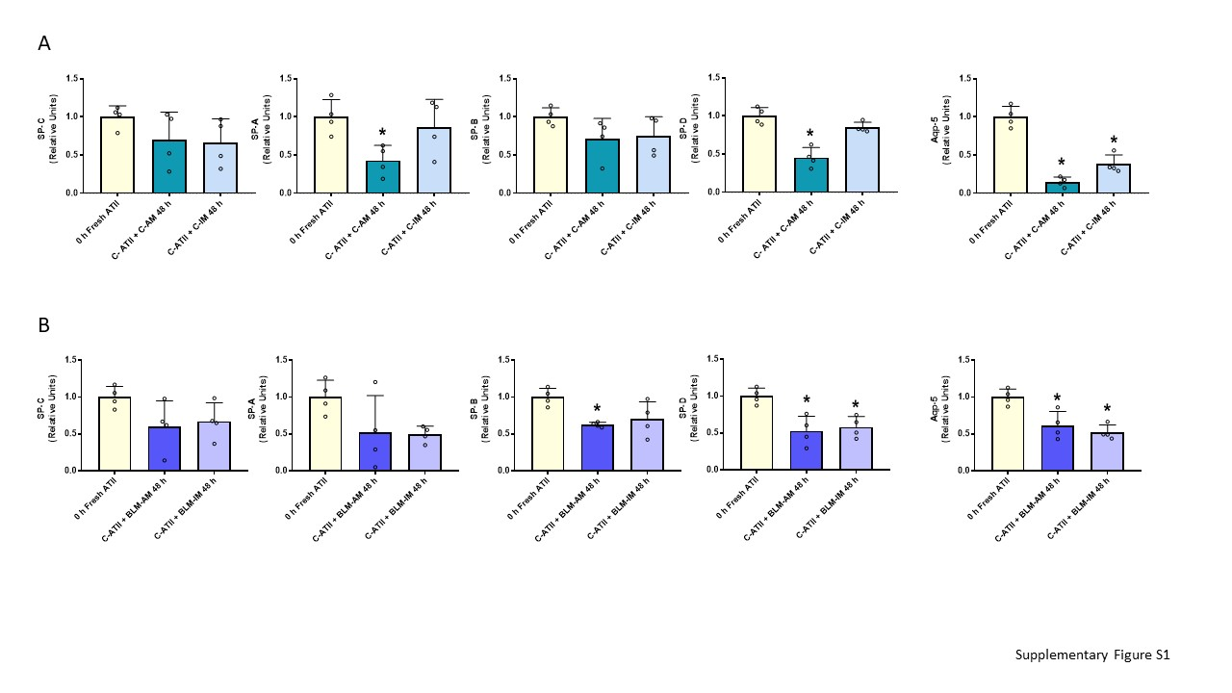
Supplementary Figure S1. ATII epithelial marker expression during co-culture conditions. (A) mRNA expression of ATII-associated genes (SP-C, SP-A, SP-B and SP-D) and the ATI-associated marker Aqp-5 in ATII cells after 48 h of co-culture with control-AM or control-IM. (B) mRNA expression of ATII-associated genes (SP-C, SP-A, SP-B and SP-D) and the ATI-associated marker Aqp-5 in ATII cells after 48 h of co-culture with BLM-AM or BLM-IM. Data are expressed as mean ± SD (n = 4). *p < 0.05 vs. freshly isolated ATII cells.
For fibroblast characterization, α-SMA immunofluorescence staining was performed in explant-derived fibroblast cultures used at passage 3. Nuclei were counterstained with DAPI.
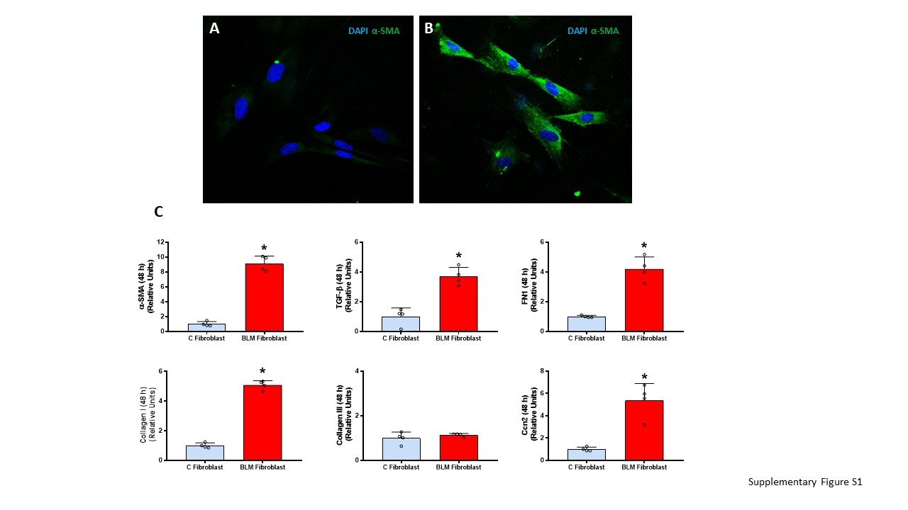
Supplementary Figure S2. Characterization of explant-derived fibroblast cultures. (A–B) Representative immunofluorescence images of α-SMA (green) and nuclei (blue, DAPI) in fibroblast cultures isolated from control (A) or BLM-treated animals (B) after 48 h of culture. (C) mRNA expression of fibroblast/myofibroblast-associated genes (α-SMA, TGF-β, collagen I, collagen III, FN1 and Ccn2/CTGF) in fibroblast cultures isolated from control or BLM-treated animals after 48 h of culture. Data are expressed as mean ± SD (n = 4). *p < 0.05 vs. control fibroblasts.
Supplementary Table S1. Primer sequences used for supplementary characterization of ATII cells and fibroblast cultures.
Primers | Forward | Reverse
SP-A | 5’-CCTGCAGGCTCTGTATGTGG-3’ | 5’-CCCCAGCACCATCTGGTATC-3’
SP-B | 5’-TACCCCTGGTGGTGGGTG-3’ | 5’-ACTCAGTGTCTTGCAGTGGC-3’
SP-C | 5’-GAAACTCAGAAACGCCTCGC-3’ | 5’-GGCTTATAGGCGGTCAGGAG-3’
SP-D | 5’-CTTGGGGCCACCAGGAAG-3’ | 5’-TCTCTGCGAGAGGGTCTTCA-3’
Aqp5 | 5’-GGGGATCTACTTCACCGGCT-3’ | 5’-CAGCATGGCCCCCACAATA-3’
TGF-β | 5’-TGAGTGGCTGTCTTTTGACG-3’ | 5’-TGGGACTGATCCCATTGATT-3’
α-SMA | 5’-TGTGCTGGACTCTGGAGATG-3’ | 5’-GAAGGAATAGCCACGCTCAG-3’
Collagen I | 5’-AATGGTGCTCCTGGTATTGC-3’ | 5’-GGTTCACCACTGTTGCCTTT-3’
Collagen III | 5’-GTCCACGAGGTGACAAAGGT-3’ | 5’-CATCTTTTCCAGGAGGTCCA-3’
FN1 | 5’-CGAGGTGACAGAGACCACAA-3’ | 5’-CTGGAGTCAAGCCAGACACA-3’
Ccn2/CTGF | 5’-ACTGTTGGCGAACAAATGGC-3’ | 5’-CTGCCTCCCAAACCAGTCAT-3’
GAPDH | 5’-CTGTGTCTTTCCGCTGTTTTC-3’ | 5’-TGTGCTGTGCTTATGGTCTCA-3’

