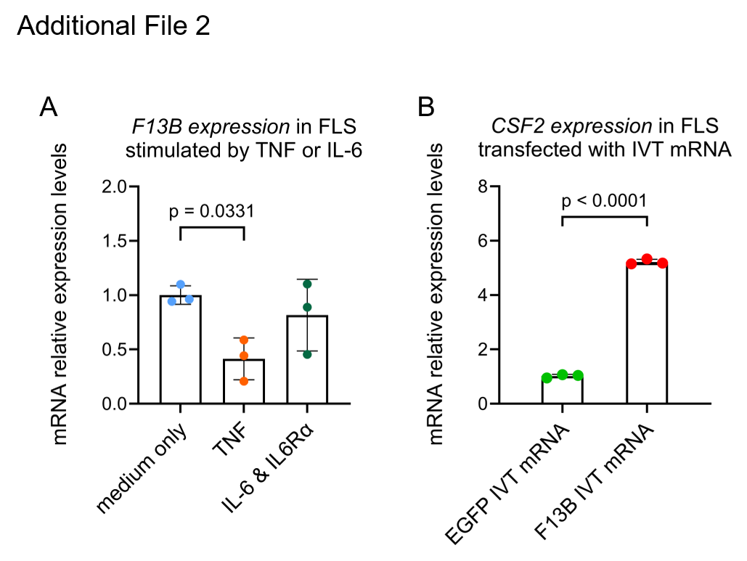
Additional File 2. Regulation of F13B expression by inflammatory cytokines and its effect on CSF2 expression in FLS
(A) F13B expression levels in FLS stimulated with TNF or IL-6 plus IL-6Rα for 24 hours were detected by RT-qPCR (n = 3, each from an individual subject). Data were analyzed using Dunnett’s test. (B) FLS were transfected with F13B IVT mRNA or EGFP IVT mRNA for 24 hours. EGFP IVT mRNA was used as a negative control. CSF2 expression levels in these cells were measured by RT-qPCR (n = 3). Data were analyzed using Student’s t-test. Abbreviations: TNF, tumor necrosis factor; IL-6, interleukin-6; FLS, fibroblast-like synoviocytes; CFH, complement factor H; EGFP, enhanced green fluorescent protein; F13B, factor XIII B subunit.

