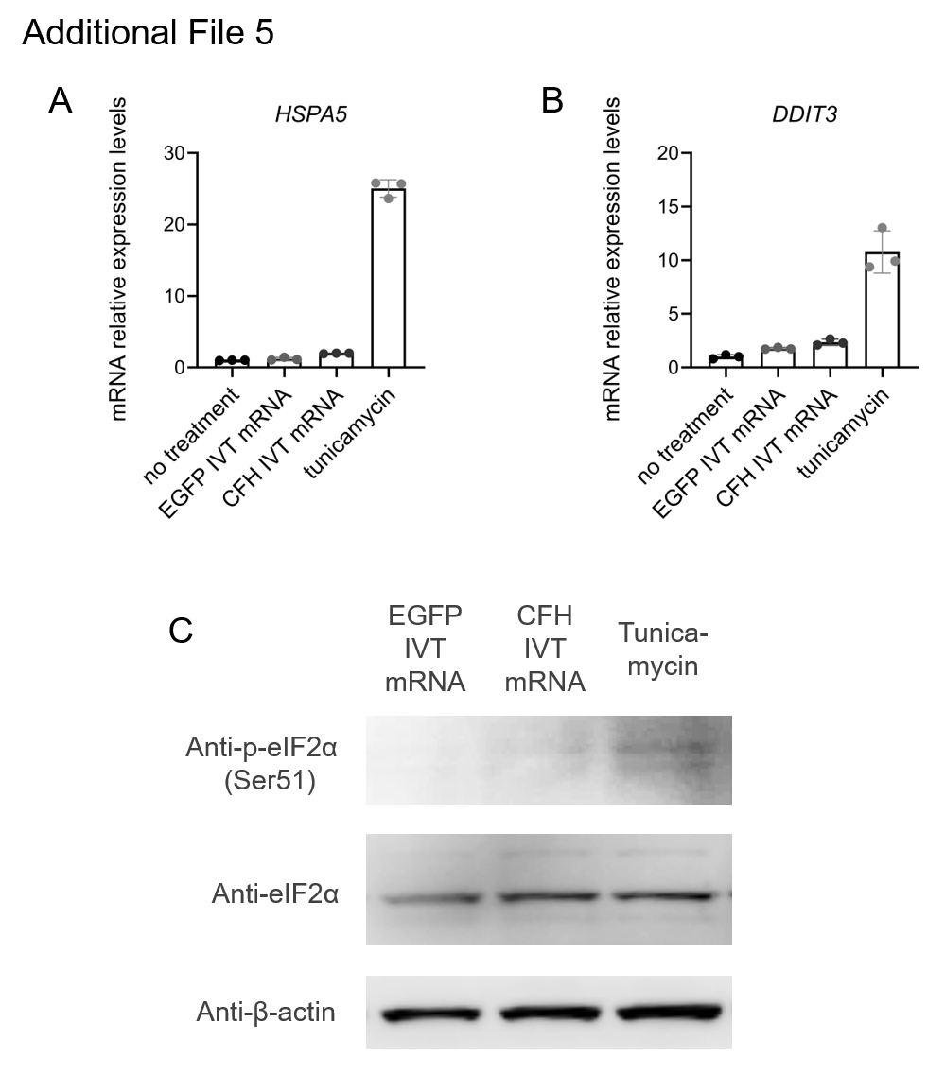

Additional File 5. IVT mRNA-mediated expressions do not associate with alteration in endoplasmic reticulum stress markers
(A, B) RT-qPCR was performed to assess the expression levels of endoplasmic reticulum (ER) stress-related factors in MH7A cells transfected with CFH IVT mRNA or EGFP IVT mRNA, or treated with tunicamycin for 24 hours (n = 3). (A) HSPA5 (B) DDIT3. (C) Western blotting analysis of eIF2α phosphorylation in MH7A cells transfected with CFH IVT mRNA or EGFP IVT mRNA, or treated with tunicamycin for 4 hours. Abbreviations: HSPA5, heat shock protein family A (Hsp70) member 5; DDIT3, DNA damage inducible transcript 3; eIF2α, eukaryotic translation initiation factor 2A.

