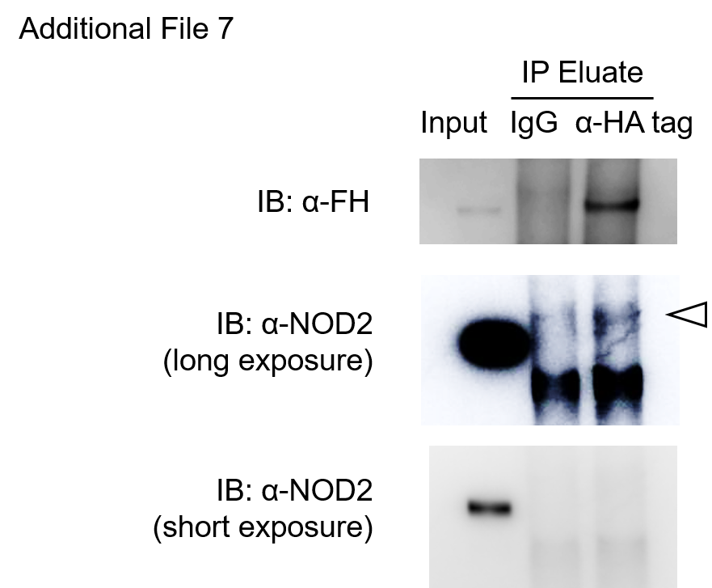

Additional File 7. NOD2 is detected in an FH-containing protein complex
MH7A was transfected with CFH IVT mRNA. Cell lysates were immunoprecipitated with either an anti-HA-tag antibody or control IgG, followed by capture with Protein G beads. The eluted samples were analyzed using western blotting. Input and IP panels were exposed for different durations. The white arrowhead indicates the band corresponding to endogenous NOD2. Abbreviations: IP, immunoprecipitation; FH, factor H; NOD2, nucleotide‐binding oligomerization domain 2.

