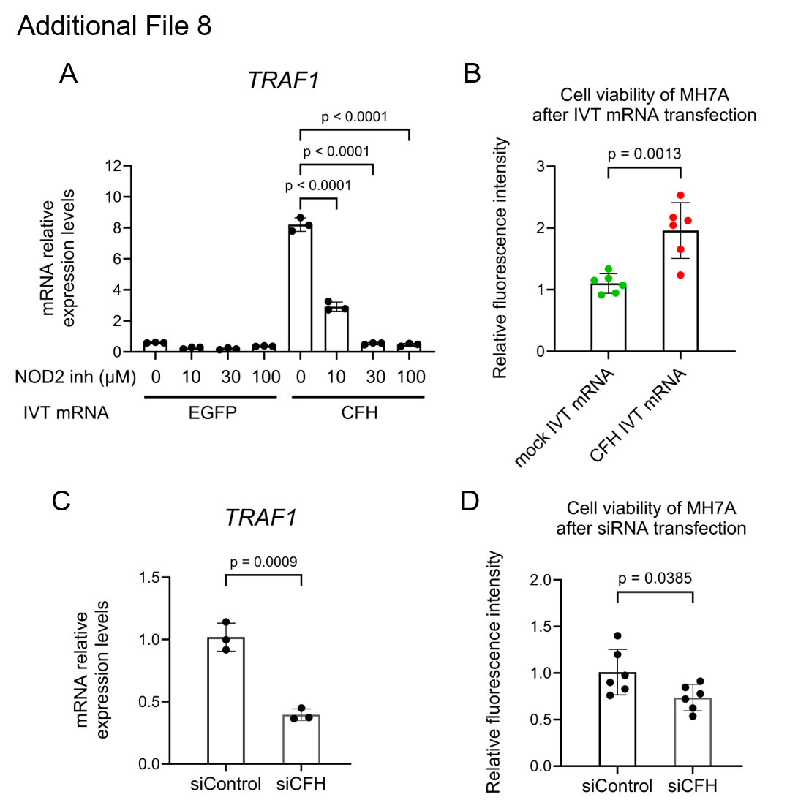
Additional File 8. FH-induced TRAF1 expression is associated with increased MH7A cell proliferation
(A, B) MH7A cells were transfected with CFH IVT mRNA, EGFP IVT mRNA, or mock IVT mRNA. (A) Cells were additionally treated with a NOD2 inhibitor (GSK717, a competitive antagonist). RT-qPCR showed that FH-induced TRAF1 expression was suppressed by GSK717 (n = 3, Dunnett’s test). (B) Cell viability assay using calcein-AM at 24 hours after transfection. Cell numbers in CFH IVT mRNA-transfected cells were higher than in controls (n = 6, Student’s t-test). (C, D) MH7A cells were transfected with 50 nM siRNA against CFH (siCFH) or control siRNA (siControl). Cells were harvested 96 hours after transfection. (C) RT-qPCR analysis showed decreased TRAF1 expression following CFH knockdown (n = 3, Student’s t-test). (D) Cell viability assay using calcein-AM. Cell numbers in siCFH-treated cells were lower than in siControl (n = 6, Student’s t-test).

