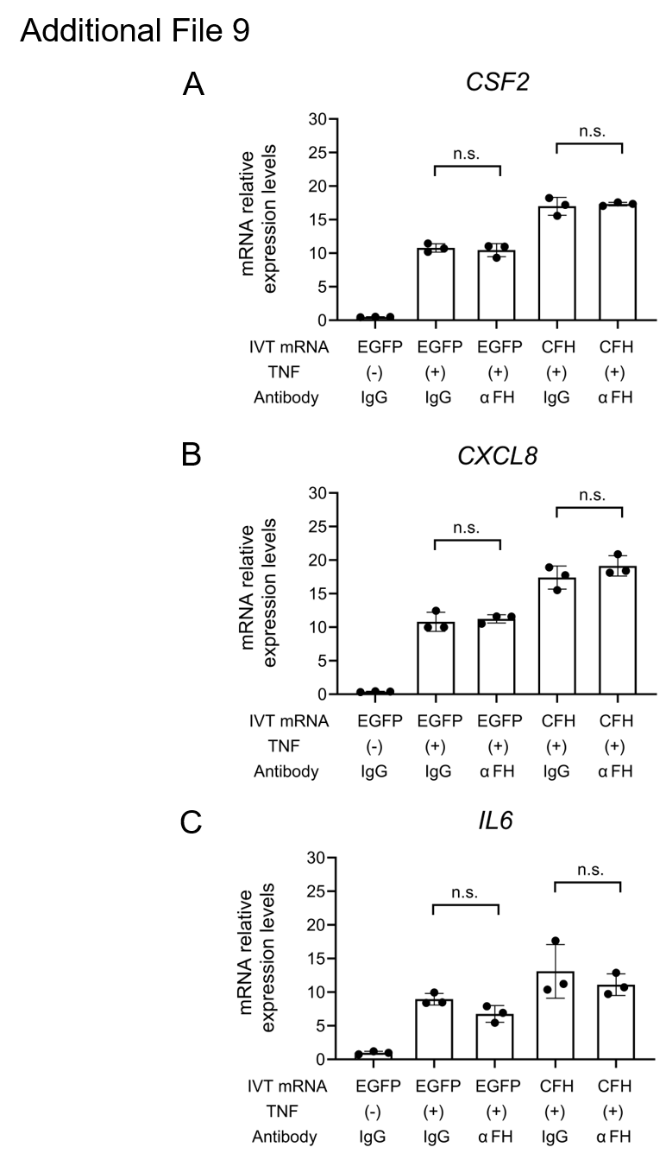
Additional File 9. Anti-FH antibody does not suppress TNF-induced cytokine gene expression
(A–C) MH7A cells were transfected with either CFH IVT mRNA or EGFP IVT mRNA. Cells were also treated with anti-FH antibody, control IgG, and/or TNF. IVT mRNA was transfected for 10 hours, after which neutralization was performed, followed by the addition of TNF for 12 hours. The expression levels of the following cytokines were measured by RT-qPCR (n = 3, Student’s t-test): (A) CSF2, (B) CXCL8, and (C) IL6. Abbreviations: FH, factor H; IgG, immunoglobulin G.

