Supplementary Materials

APPENDIX 1
Statistical comparison of results from Studies 1 and 2

To compare the results from Studies 1 and 2 statistically we used a 2 x 2 x 2 factorial ANOVA with factors: experiment (1 vs 2), manipulated between-subjects as well as image quantity (one vs many) and trial type (present vs absent), manipulated within subjects. This analysis revealed significant main effects of experiment (F (1, 62) = 10.34, p < .01, η_{p}² = .14), target image number (F (1, 62) = 8.82, p < .01, η_{p}² = .13), and trial type (F (1, 62) = 15.95, p < .001, η_{p}² = .21). Critically, there was no significant interaction between experiment and target image number (F (1, 62) < 1, p > .05, η_{p}² < .01).

APPENDIX 2
Search strategies in Study 2

In Study 2, 23.5% of trials were not recorded due to technical failure, and so the following summary statistics are based on 367 recordings (183 target-present and 184 target-absent trials). We observed the same five strategies as in Study 1: 1) watching the whole video once before making a target absent decision (13.6% of all trials, target present and target absent); 2) watching the whole video more than once before making a target absent decision (25.9% of all trials); 3) watching the whole video first, then going back to suspected targets and making an identification (33.2% of all trials); 4) making an identification during the video but continuing to watch until the end (8.2% of all trials); and 5) making an identification during the video and then terminating the trial without watching the rest of the clip (19.1% of all trials). No participants made a target absent decision without watching the CCTV video through at least once.

In trials where participants made a target absent decision, both strategies lead to a similar performance (watching the video once achieved 88% accuracy and watching the video more than once achieved 85.3% accuracy). In trials where participants made a target present decision, highest performance was achieved when participants identified a target during the clip but continue to watch the whole video till the end (90% accuracy), closely followed by making an identification during the clip and terminating the trial straight away (85.7% accuracy). Worst performance was associated with watching the whole video first and then going back to suspected targets and making an identification (52.5% accuracy). The number of unique misidentifications varied greatly across the target identities.

APPENDIX 3
Analysis of Response Time

Study 1
Mean response time across conditions is presented in Figure S1. A 2 (image number: 1 vs 3) x 2 (trial type: present vs absent) within subjects ANOVA revealed significant main effects of trial type (F (1, 45) = 45.78, p < .001, η_{p}² = .50). The main effect of image number as well as the interaction between image number and trial type were not significant (F (1, 46) < 1, p > .05, η_{p}² < .01).
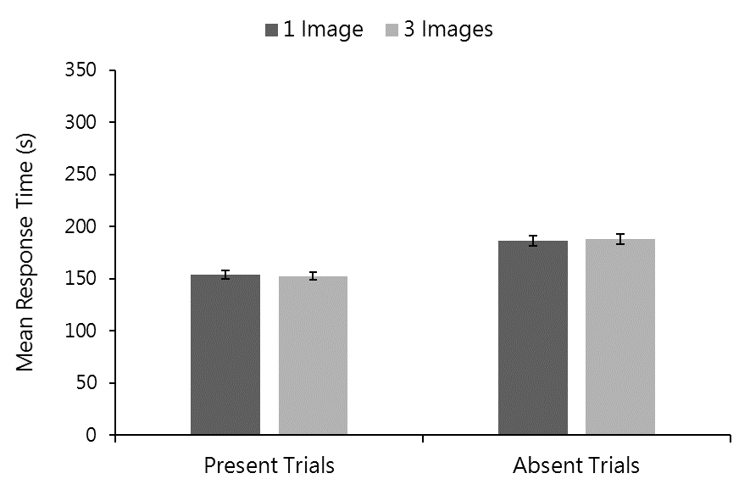
Figure S1. Mean response time across trial type for one and three image/s trials in Study 1. Error bars represent within-subjects standard error (Cousineau, 2005).

Study 2
Mean response time across conditions is presented in Figure S2. A 2 (image number: 1 vs 16) x 2 (trial type: present vs absent) within subjects ANOVA revealed significant main effects of image number (F (1, 18) = 26.49, p < .001, η_{p}² = .60) and trial type (F (1, 18) = 24.92, p < .001, η_{p}² = .58). There was no significant interaction (F (1, 18) = 2.19, p > .05, η_{p}² = .11).
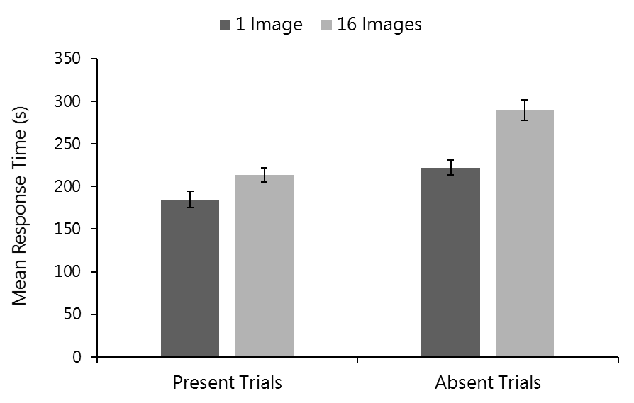
Figure S2. Mean response time across trial type for 1 and 16 image/s trials in Study 2. Error bars represent within-subjects standard error (Cousineau, 2005).

Study 3
Mean response time across conditions is presented in Figure S3. A 2 x 2 x 2 mixed factorial ANOVA (within-subjects factors: search stimulus, still image vs video, and trial type, present vs absent; between-subjects factor: video quality, SD vs HD) revealed a significant main effect of trial type (F (1, 36) = 40.36, p < .001, η_{p}² = .53) with longer response times for target absent than present trials. The main effect of search stimulus type presentation was not significant (F (1, 36) = 1.13, p > .05, η_{p}² = .03) and neither was the main effect of video quality (F (1, 36) < 1, p > .05, η_{p}² = .02). There were no significant two- or three-way interactions (F_{max} (1, 36) = 2.05, p > .05, η_{p}²_{max} = .05).
Study 4
Mean response time across conditions is presented in Figure S4. A 2 x 2 x 2 mixed factorial ANOVA (within-subjects factors: target exposure type, in context vs no context, and trial type, present vs absent; between-subjects factor: context type, wanted vs missing) revealed no significant main effects (F_{max} = 2.90, p > .05, η_{p}²_{max} = .16) and no significant two- or three-way interactions (all Fs < 1, p > .05, all η_{p}² < .01).

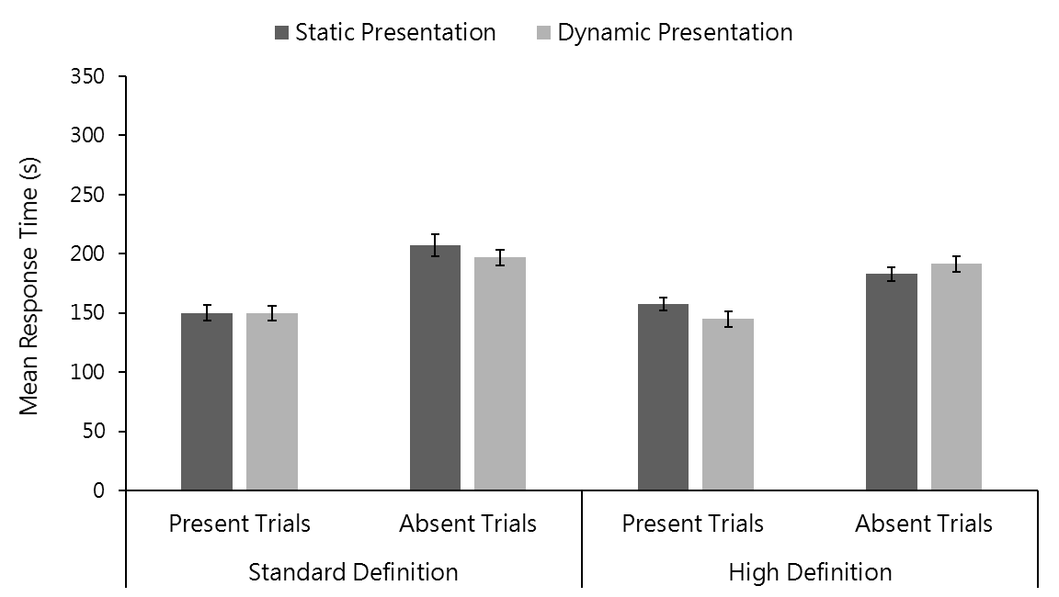
Figure S3. Mean response time across search stimulus, video quality and trial type in Study 3. Error bars represent within-subjects standard error (Cousineau, 2005).

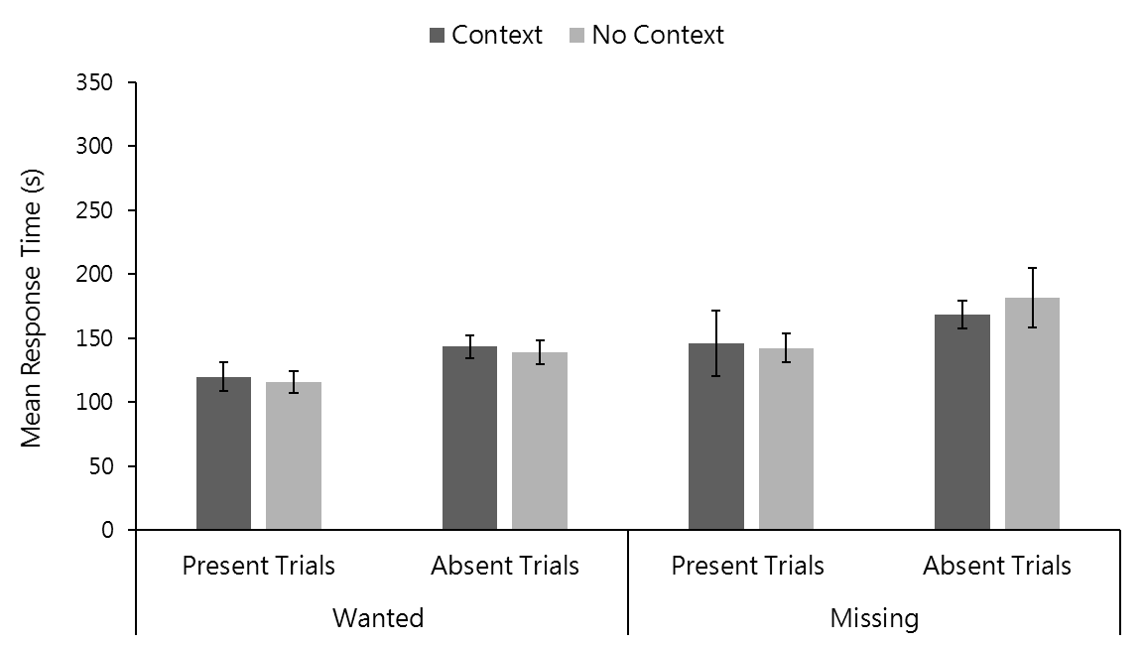
Figure S4. Mean response time across target exposure type, context type and trial type in Study 4. Error bars represent within-subjects standard error (Cousineau, 2005).
APPENDIX 4
Analysis of Errors in Target Present Trials

Study 1
Mean proportion of miss and misidentification errors in target present trials is presented in Figure S5. A 2 x 2 within subjects ANOVA with factors: image number (1 vs 3) and error type (miss vs misidentification) revealed a significant main effect of error type (F (1, 49) = 4.05, p < .05, η_{p}² = .08). There was no significant main effect of image number (F (1, 49) = 3.22, p > .05, η_{p}² = .06) and no significant interaction either (F (1, 49) < 1, p > .05, η_{p}² = .02).

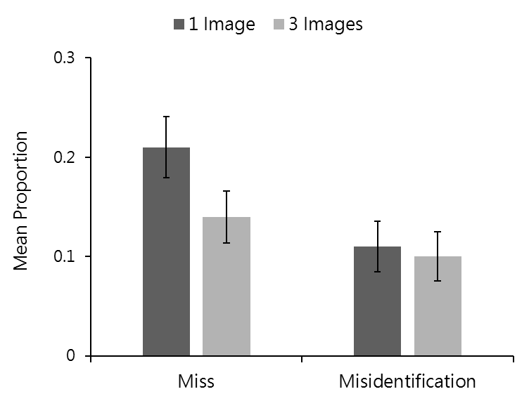
Figure S5. Mean proportion of miss and misidentification errors in Study 1. Error bars represent within-subjects standard error (Cousineau, 2005).

Study 2
Mean proportion of miss and misidentification errors in target present trials is presented in Figure S6. A 2 x 2 within subjects ANOVA with factors: image number (1 vs 16) and error type (miss vs misidentification) revealed no significant main effects of image number (F (1, 23) = 1.18, p > .05, η_{p}² = .05) or error type (F (1, 23) = 1.26, p > .05, η_{p}² = .05). There was no significant interaction either (F (1, 23) < 1, p > .05, η_{p}² = .01).

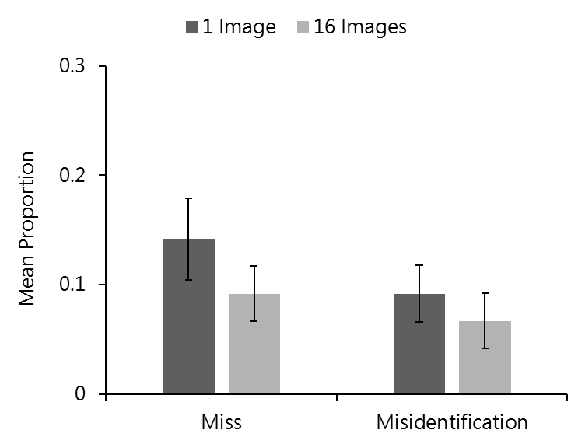

Figure S6. Mean proportion of miss and misidentification errors in Study 2. Error bars represent within-subjects standard error (Cousineau, 2005).

Study 3
Mean proportion of miss and misidentification errors in target present trials is presented in Figure S7. Data from trials with standard and high definition video quality was analysed separately using a 2 x 2 within subjects ANOVA with factors: search stimulus (still vs video) and error type (miss vs misidentification). There were no significant main effects or interactions for neither standard nor high definition video trials (all Fs < 1, all ps > .05, η_{p}²_{max} = .02).

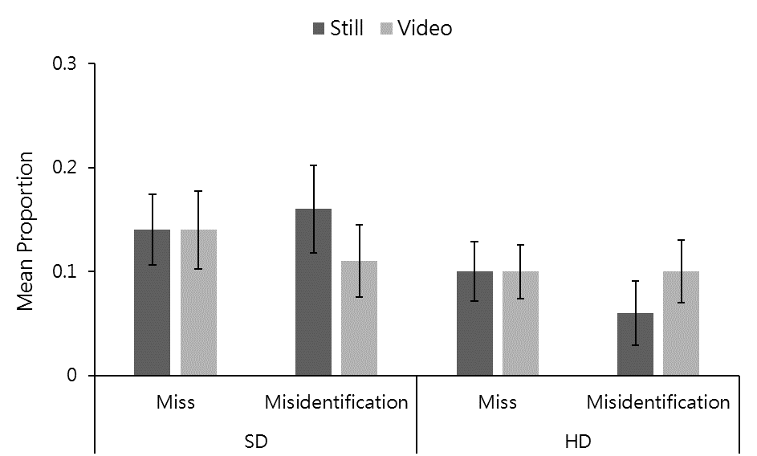

Figure S7. Mean proportion of miss and misidentification errors in Study 3. Error bars represent within-subjects standard error (Cousineau, 2005).

Study 4
Mean proportion of miss and misidentification errors in target present trials is presented in Figure S8. Data from trials with wanted and missing posters was analysed separately using a 2 x 2 within subjects ANOVA with factors: target exposure type (in context vs no context) and error type (miss vs misidentification). For wanted posters, there were no significant main effects of target exposure type (F (1, 11) < 1, p > .05, η_{p}² = .01) or error type (F (1, 11) = 1.06, p > .05, η_{p}² = .09) and no significant interaction either (F (1, 11) < 1, p > .05, η_{p}² < .01). For missing posters, there was a significant main effect of target exposure type (F (1, 11) = 6.77, p < .05, η_{p}² = .38). The main effect of error type (F (1, 11) < 1, p > .05, η_{p}² = .05) and the interaction between target exposure type and error type (F (1, 11) = 4.23, p > .05, η_{p}² = .28) were not significant.
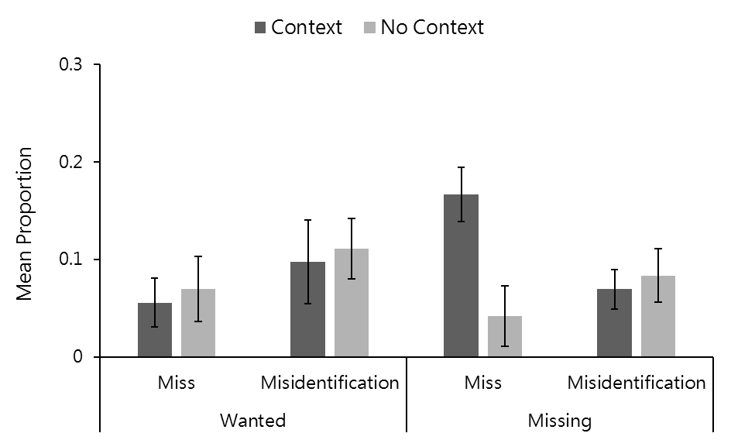

Figure S8. Mean proportion of miss and misidentification errors in Study 4. Error bars represent within-subjects standard error (Cousineau, 2005).

APPENDIX 5
By-Item Analysis on Data from Studies 1 and 2
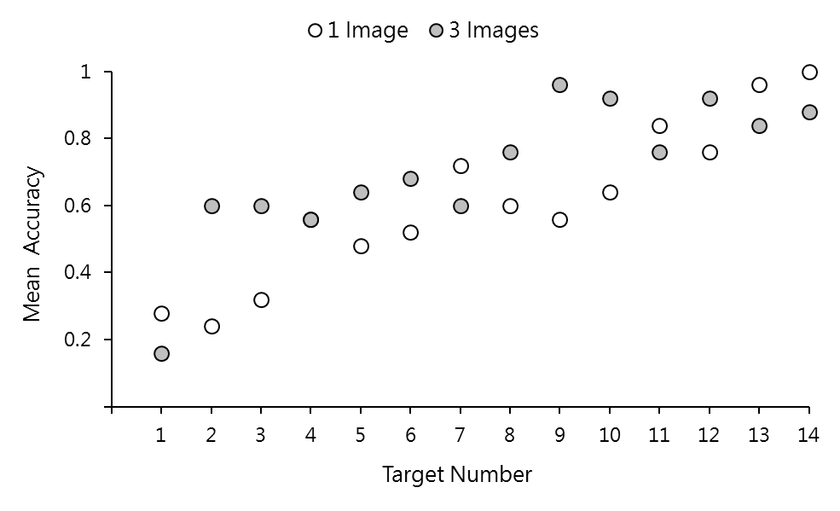
Figure S9. Mean identification accuracy for each target with 1 and 3 images in Study 1. Targets identities are ranked on the x-axis by mean score across both conditions.

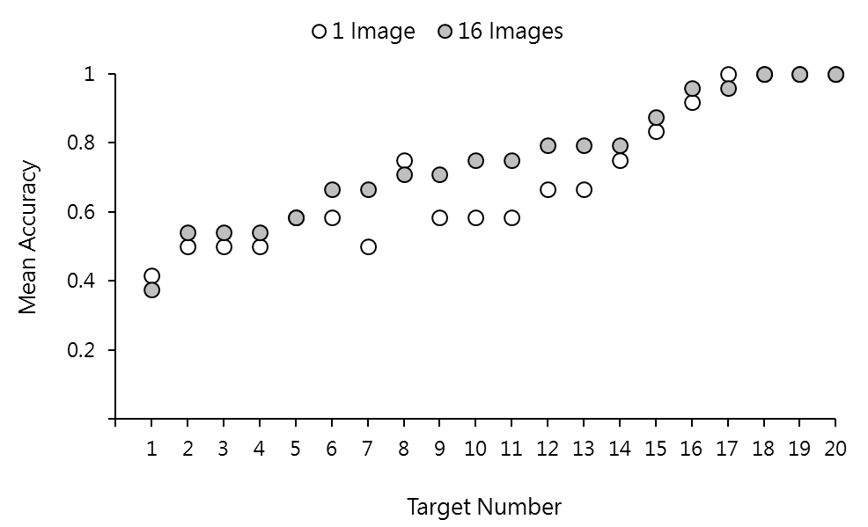
Figure S10. Mean identification accuracy for each target with 1 and 16 images in Study 2. Targets identities are ranked on the x-axis by mean score across both conditions.
APPENDIX 6
Table S1. Type and number of images used in Study 2.
Target Number | Standardised Images |  |  | Informal Images
Target Number | Frontal | Multi-pose* | Emotional Expressions | Neutral | Emotional Expressions | Document Images
1 | 3 | 6 | 4 | 3 | 0 | 1
2 | 4 | 5 | 0 | 3 | 4 | 0
3 | 5 | 6 | 1 | 2 | 0 | 2
4 | 7 | 6 | 0 | 0 | 2 | 1
5 | 5 | 7 | 1 | 2 | 0 | 1
6 | 6 | 4 | 0 | 2 | 3 | 1
7 | 3 | 4 | 3 | 2 | 1 | 3
8 | 5 | 9 | 0 | 0 | 1 | 1
9 | 4 | 3 | 1 | 1 | 3 | 4
10 | 4 | 8 | 0 | 1 | 1 | 2
11 | 3 | 5 | 0 | 5 | 2 | 1
12 | 3 | 8 | 2 | 2 | 0 | 1
13 | 3 | 8 | 0 | 0 | 2 | 3
14 | 3 | 6 | 0 | 0 | 4 | 3
15 | 3 | 8 | 0 | 2 | 2 | 1
16 | 4 | 9 | 0 | 1 | 2 | 0
17 | 3 | 9 | 0 | 0 | 2 | 2
18 | 4 | 11 | 0 | 0 | 0 | 1
19 | 3 | 6 | 1 | 2 | 1 | 3
20 | 6 | 8 | 0 | 0 | 2 | 0
* Multi-pose images were taken in a few different sessions and varied not only in pose and face angle but also in lighting, clothing, hairstyle and accessories.

