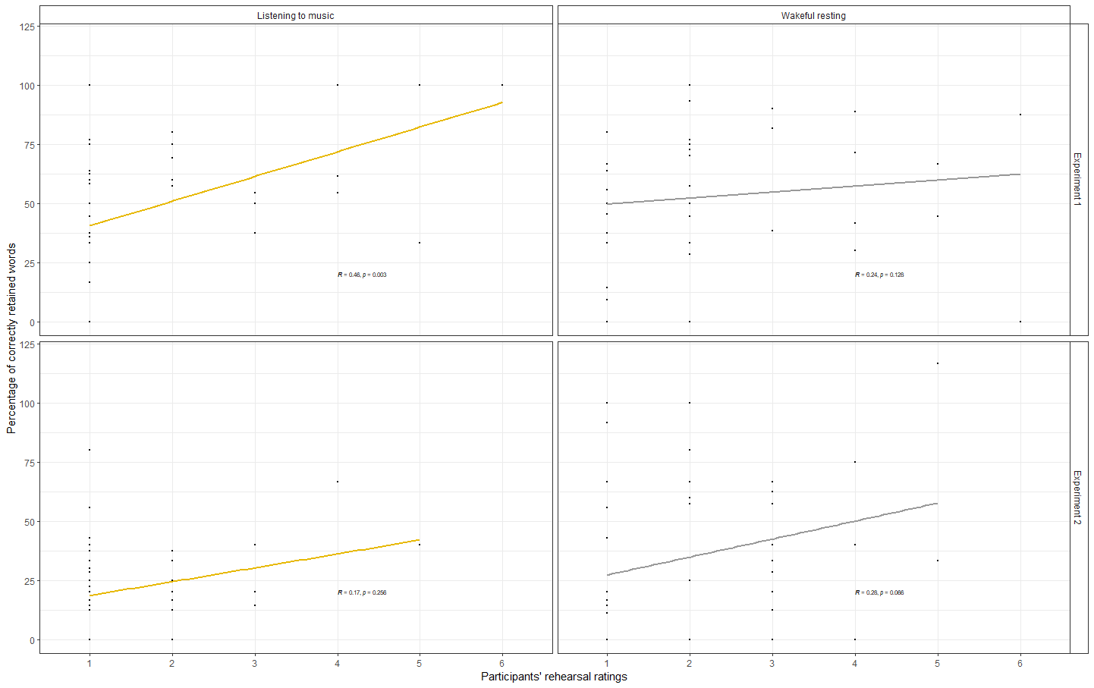
Figure 3. Scatterplots for the correlation between memory retention and participants‘ rehearsal ratings plotted separately for the post-encoding activity condition (wakeful resting [grey regression lines] vs. listening to music [yellow regression lines]) and experiment (Experiment 1 vs. Experiment 2).

