Appendix A. Flow diagram of participant’s recruitment and allocation (Study 1)
Participants selected (n= 64)

Enrollment
Allocation
Allocated to Training (n= 32)

Analysis
Lost to (n = 10)
- Dropouts (n= 6)
- Technical issues (n= 2)
- Failure to receive outcome measure package (n= 1)
- Outlier (n = 1)

Lost to (n = 6)
- Dropouts (n= 2)
- Technical issues (n= 0)
- Failure to receive outcome measure package (n= 3)
- Outlier (n = 1)

Analyzed (n= 24)

Analyzed (n= 22)

Allocated to Control (n= 32)

Lost (n = 16)

Appendix B. General task procedure.
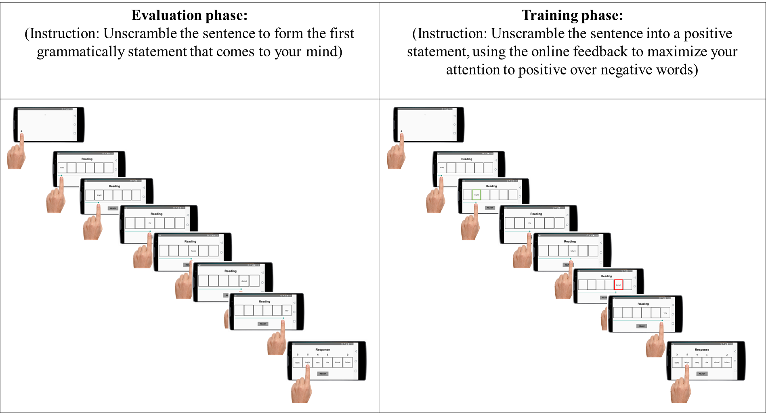
Appendix C. Multilevel analyses (Study 1).

- Model:
- Predictors: Group (0- CTL, 1-OCAT) x Time (1-Time1, 2-Time2) x Stimuli (0-negative, 1-positive)
- Outcome: Attention to emotional word

Linear mixed-effects model fit by maximum likelihood
Data: Data3
AIC BIC logLik
34941.88 34998.2 -17460.94

Random effects:
Formula: ~1 | id
(Intercept) Residual
StdDev: 729.8149 1109.284

Fixed effects: AT ~ 1 + Group * Emo * Assessment_Time
Value Std.Error DF t-value p-value
(Intercept) 2771.0203 211.3680 2011 13.109935 0.0000
Group 1079.5429 309.2535 44 3.490802 0.0011
Emo 1136.8757 211.1045 2011 5.385368 0.0000
Assessment_Time -415.4103 94.9776 2011 -4.373772 0.0000
Group:Emo -1115.7680 310.0363 2011 -3.598830 0.0003
Group:Assessment_Time -613.8958 140.5883 2011 -4.366619 0.0000
Emo:Assessment_Time -259.9179 133.6221 2011 -1.945171 0.0519
Group:Emo:Assessment_Time 492.6561 196.2900 2011 2.509839 0.0122
Correlation:
(Intr) Group Emo Asss_T Grp:Em Gr:A_T Em:A_T
Group -0.683
Emo -0.500 0.342
Assessment_Time -0.671 0.459 0.668
Group:Emo 0.341 -0.502 -0.681 -0.455
Group:Assessment_Time 0.454 -0.679 -0.451 -0.676 0.663
Emo:Assessment_Time 0.474 -0.324 -0.949 -0.704 0.646 0.476
Group:Emo:Assessment_Time -0.323 0.476 0.646 0.479 -0.949 -0.698 -0.681

Standardized Within-Group Residuals:
Min Q1 Med Q3 Max
-3.2648983 -0.6211352 -0.1776288 0.4249335 6.2668535

Based on the significant 3-way interaction, we then conducted separate models for each type of Stimuli (i.e., negative and positive)

  - Model:
- Predictors: Group (0- CTL, 1-OCAT) x Time (1-Time1, 2-Time2)
- Outcome: Attention to negative word

Linear mixed-effects model fit by maximum likelihood
Data: Data3
AIC BIC logLik
17382.67 17412.3 -8685.335

Random effects:
Formula: ~1 | id
(Intercept) Residual
StdDev: 643.302 1048.894

Fixed effects: ATneg ~ 1 + Group * Assessment_Time
Value Std.Error DF t-value p-value
(Intercept) 2768.4113 193.37524 983 14.316266 0.000
Group 1000.6159 284.12125 44 3.521792 0.001
Assessment_Time -413.4880 90.13932 983 -4.587210 0.000
Group:Assessment_Time -569.5292 134.22282 983 -4.243162 0.000
Correlation:
(Intr) Group Asss_T
Group -0.681
Assessment_Time -0.695 0.473
Group:Assessment_Time 0.467 -0.704 -0.672

Standardized Within-Group Residuals:
Min Q1 Med Q3 Max
-2.2501355 -0.6311828 -0.1920461 0.4017022 6.2003044

  - Model:
- Predictors: Group (0- CTL, 1-OCAT) x Time (1-Time1, 2-Time2)
- Outcome: Attention to positive word

Linear mixed-effects model fit by maximum likelihood
Data: Data3
AIC BIC logLik
17634.63 17664.26 -8811.313

Random effects:
Formula: ~1 | id
(Intercept) Residual
StdDev: 796.0269 1170.62

Fixed effects: ATpos ~ 1 + Group * Assessment_Time
Value Std.Error DF t-value p-value
(Intercept) 3911.085 226.8307 984 17.242308 0.0000
Group -5.917 332.9896 44 -0.017769 0.9859
Assessment_Time -679.063 100.5355 984 -6.754461 0.0000
Group:Assessment_Time -137.794 149.8567 984 -0.919503 0.3581
Correlation:
(Intr) Group Asss_T
Group -0.681
Assessment_Time -0.660 0.450
Group:Assessment_Time 0.443 -0.671 -0.671

Standardized Within-Group Residuals:
Min Q1 Med Q3 Max
-3.0947846 -0.6093676 -0.1941886 0.4282804 5.7588851

- Model:
- Predictors: Group (0- CTL, 1-OCAT) x Time (1-Time1, 2-Time2)
- Outcome: Interpretation bias index

Generalized linear mixed model fit by maximum likelihood (Laplace Approximation) [glmerMod]
Family: binomial ( logit )
Formula: IB ~ 1 + Group * Assessment_Time + (1 | id)
Data: Data3

AIC BIC logLik deviance df.resid
865.1 889.4 -427.6 855.1 936

Scaled residuals:
Min 1Q Median 3Q Max
-4.2669 0.1420 0.2830 0.4716 1.4244

Random effects:
Groups Name Variance Std.Dev.
id (Intercept) 1.296 1.138
Number of obs: 941, groups: id, 46

Fixed effects:
Estimate Std. Error z value Pr(>|z|)
(Intercept) 1.7000 0.4250 4.000 6.33e-05 ***
Group -0.6731 0.6786 -0.992 0.321263
Assessment_Time -0.4433 0.2173 -2.040 0.041399 *
Group:Assessment_Time 1.3889 0.3988 3.482 0.000497 ***
---
Signif. codes: 0 ‘***’ 0.001 ‘**’ 0.01 ‘*’ 0.05 ‘.’ 0.1 ‘ ’ 1

Correlation of Fixed Effects:
(Intr) Group Asss_T
Group -0.616
Assssmnt_Tm -0.789 0.488
Grp:Assss_T 0.433 -0.809 -0.547
Appendix D. Bivariate correlations between change delta scores of attention and interpretation and change delta scores of emotion regulation and symptoms variables (Study 1).

DV: Delta scores | Interpretation bias | Total attention time (positive) | Total attention time (negative)
Interpretation bias | 1
Total attention time (positive) | .202 | 1
Total attention time (negative) | .152 | .867** | 1
Depression | .025 | .262 | .389**
Anxiety | -.115 | -.084 | .043
Brooding Rumination | -.165 | .063 | .033
Reappraisal | .081 | .023 | .034
Note. ** p < .01
Appendix E. Flow diagram of participant’s recruitment and allocation (Study 2)
Analysis
Lost to (n = 6)
- Dropouts (n= 3)
- Technical issues (n= 3)

Lost to (n = 4)
- Dropouts (n= 3)
- Technical issues (n= 1)

Analyzed (n= 25)

Analyzed (n= 23)

Lost (n = 10)

Participants selected (n= 58)

Enrollment
Allocation
Allocated to Training (n= 29)

Allocated to Control (n= 29)

Appendix F. Multilevel analyses using within-subject differences as random effects (Study 2)
- Model:
- Predictors: Group (0- CTL, 1-OCAT) x Time (1-Time1, 2-Time2) x Stimuli (0-negative, 1-positive)
- Outcome: Attention to emotional word

Linear mixed-effects model fit by maximum likelihood
Data: Data3
AIC BIC logLik
38024.19 38081.39 -19002.1

Random effects:
Formula: ~1 | id
(Intercept) Residual
StdDev: 705.7821 1082.001

Fixed effects: AT ~ 1 + Group * Emo * Assessment_Time
Value Std.Error DF t-value p-value
(Intercept) 2086.0952 199.53778 2198 10.454638 0.0000
Group 1571.9885 289.08995 46 5.437714 0.0000
Emo 191.7003 198.72012 2198 0.964675 0.3348
Assessment_Time -315.1752 89.83406 2198 -3.508415 0.0005
Group:Emo -403.3821 288.55551 2198 -1.397936 0.1623
Group:Assessment_Time -760.2793 129.81339 2198 -5.856710 0.0000
Emo:Assessment_Time -65.6036 126.45826 2198 -0.518777 0.6040
Group:Emo:Assessment_Time 377.2630 182.92775 2198 2.062361 0.0393
Correlation:
(Intr) Group Emo Asss_T Grp:Em Gr:A_T Em:A_T
Group -0.690
Emo -0.498 0.344
Assessment_Time -0.669 0.462 0.667
Group:Emo 0.343 -0.499 -0.689 -0.460
Group:Assessment_Time 0.463 -0.671 -0.462 -0.692 0.668
Emo:Assessment_Time 0.472 -0.326 -0.948 -0.704 0.653 0.487
Group:Emo:Assessment_Time -0.326 0.473 0.655 0.487 -0.948 -0.705 -0.691

Standardized Within-Group Residuals:
Min Q1 Med Q3 Max
-3.1084907 -0.4594709 -0.1108934 0.2957160 18.5265940

Based on the significant 3-way interaction, we then conducted separate models for each type of Stimuli (i.e., negative and positive)

  - Model:
- Predictors: Group (0- CTL, 1-OCAT) x Time (1-Time1, 2-Time2)
- Outcome: Attention to negative word

Linear mixed-effects model fit by maximum likelihood
Data: Data3
AIC BIC logLik
18933.83 18963.99 -9460.916

Random effects:
Formula: ~1 | id
(Intercept) Residual
StdDev: 580.8173 1030.605

Fixed effects: ATneg ~ 1 + Group * Assessment_Time
Value Std.Error DF t-value p-value
(Intercept) 2079.9587 177.68771 1076 11.705698 0e+00
Group 1590.5294 257.62468 46 6.173824 0e+00
Assessment_Time -309.0387 85.85766 1076 -3.599430 3e-04
Group:Assessment_Time -788.3246 123.98283 1076 -6.358337 0e+00
Correlation:
(Intr) Group Asss_T
Group -0.690
Assessment_Time -0.716 0.494
Group:Assessment_Time 0.496 -0.719 -0.692

Standardized Within-Group Residuals:
Min Q1 Med Q3 Max
-2.7877216 -0.4643958 -0.1521791 0.3132286 19.7686820

  - Model:
- Predictors: Group (0- CTL, 1-OCAT) x Time (1-Time1, 2-Time2)
- Outcome: Attention to positive word

Linear mixed-effects model fit by maximum likelihood
Data: Data3
AIC BIC logLik
19136.42 19166.58 -9562.211

Random effects:
Formula: ~1 | id
(Intercept) Residual
StdDev: 835.4426 1115.287

Fixed effects: ATpos ~ 1 + Group * Assessment_Time
Value Std.Error DF t-value p-value
(Intercept) 2282.4948 221.6922 1076 10.295784 0e+00
Group 1136.7967 321.1457 46 3.539816 9e-04
Assessment_Time -385.4782 92.9856 1076 -4.145567 0e+00
Group:Assessment_Time -351.3227 134.2454 1076 -2.617018 9e-03
Correlation:
(Intr) Group Asss_T
Group -0.690
Assessment_Time -0.621 0.429
Group:Assessment_Time 0.430 -0.624 -0.693

Standardized Within-Group Residuals:
Min Q1 Med Q3 Max
-3.37434624 -0.45777740 -0.08472316 0.27207925 16.01903603

- Model:
  - Predictors: Group (0- CTL, 1-OCAT) x Time (1-Time1, 2-Time2)
- Outcome: Interpretation bias index
Generalized linear mixed model fit by maximum likelihood (Laplace Approximation) [glmerMod]
Family: binomial ( logit )
Formula: IB ~ 1 + Group * Assessment_Time + (1 | id)
Data: Data3
AIC BIC logLik deviance df.resid
987.2 1011.6 -488.6 977.2 965
Scaled residuals:
Min 1Q Median 3Q Max
-5.7327 -0.5754 0.2322 0.6017 2.6827

Random effects:
Groups Name Variance Std.Dev.
id (Intercept) 1.908 1.381
Number of obs: 970, groups: id, 48

Fixed effects:
Estimate Std. Error z value Pr(>|z|)
(Intercept) 0.5228 0.4281 1.221 0.221967
Group -2.3739 0.6735 -3.525 0.000424 ***
Assessment_Time -0.2656 0.2087 -1.273 0.202971
Group:Assessment_Time 2.7189 0.3881 7.005 2.47e-12 ***
---
Signif. codes: 0 ‘***’ 0.001 ‘**’ 0.01 ‘*’ 0.05 ‘.’ 0.1 ‘ ’ 1

Correlation of Fixed Effects:
(Intr) Group Asss_T
Group -0.637
Assssmnt_Tm -0.719 0.458
Grp:Assss_T 0.391 -0.754 -0.540

Appendix G. Bivariate correlations between change delta scores of the main variables (Study 2).

DV: Delta scores | Interpretation bias | Total attention time (positive) | Total attention time (negative)
Interpretation bias | 1
Total attention time (positive) | -.189 | 1
Total attention time (negative) | -.236 | .588** | 1
Depression | -.133 | .074 | .128
Anxiety | -.327* | .078 | .118
Rumination | -.292* | .107 | .098
Reappraisal | .193 | -.089 | -.145
Notes. * p < .05; ** p < .01

