Figure 2 (Supplementary Material)
Distribution of Scores: Prevalence of Use of the Study Techniques
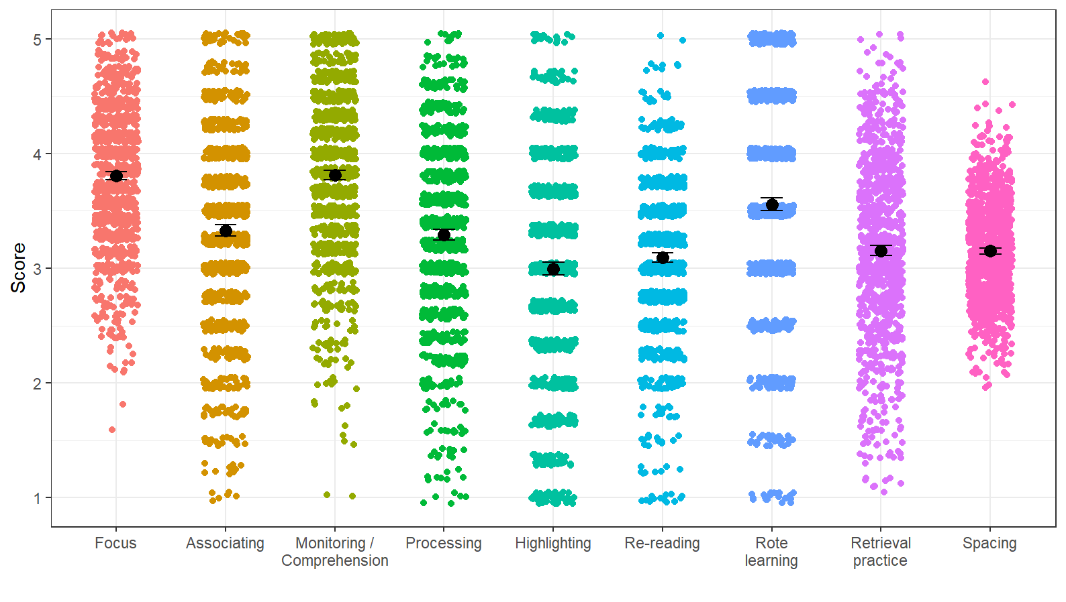
Note. Black dots represent the mean scores. Error bars depict 95% confidence intervals for the mean. Jitter has been added to data points to avoid overplotting.

Figure 3 (Supplementary Material)

Distribution of Scores: Prevalence of Beliefs Towards Learning

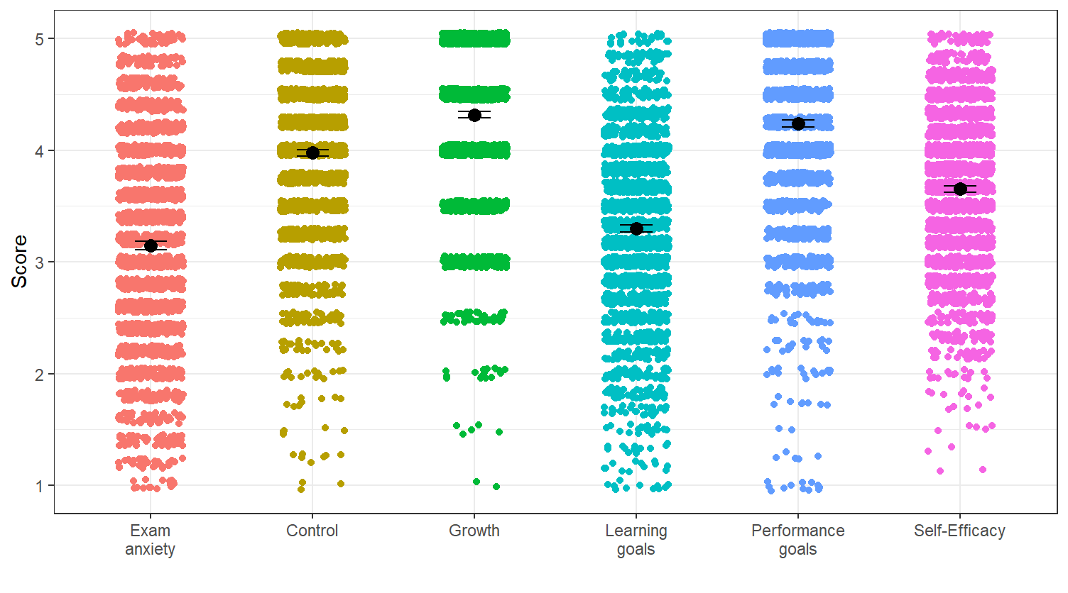

Note. Black dots represent the mean scores. Error bars depict 95% confidence intervals for the mean. Jitter has been added to data points to avoid overplotting.

