Supplementary Materials
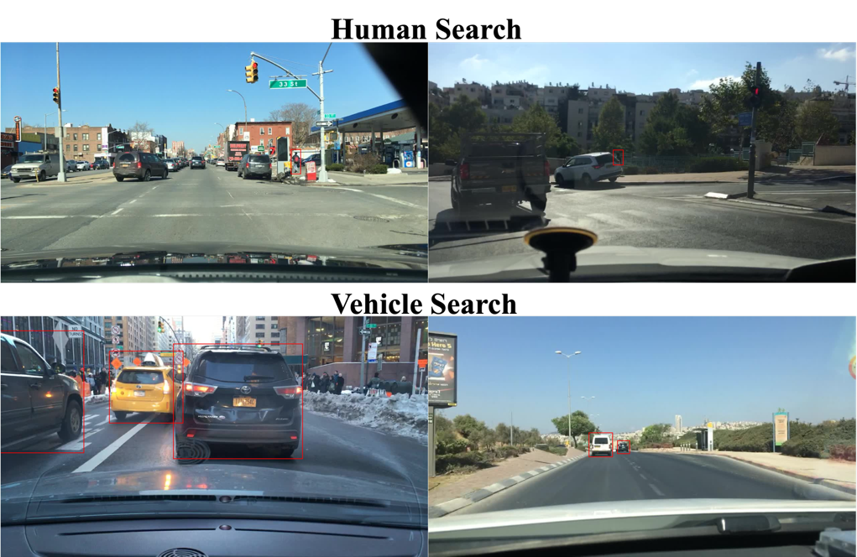
Figure S1. Example stimuli for the vehicle search and human search task for high (left) vs. low (right) complexity scenes.

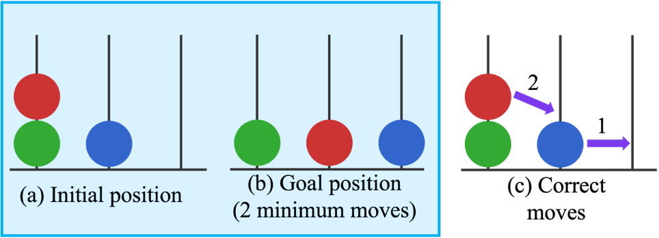
Figure S2. An example of the Tower of London Task. (a) and (b) are the initial position and goal position presented to the participants for each trial. (c) The example of correct moves.

Table S1: Cognitive Task Scores for Participant Groups
Participant group |  | ASD group | NT group
Navon task – Global processing accuracy | Mean | 0.89 | 0.88
Navon task – Global processing accuracy | SD | 0.13 | 0.14
Navon task – Global processing accuracy | Range | 0.44-1.00 | 0.47-1.00
Navon task – Global processing RT (ms) | Mean | 712 | 715
Navon task – Global processing RT (ms) | SD | 134 | 146
Navon task – Global processing RT (ms) | Range | 396-1041 | 464-1098
Navon task – Local processing accuracy | Mean | 0.84 | 0.89
Navon task – Local processing accuracy | SD | 0.15 | 0.08
Navon task – Local processing accuracy | Range | 0.44-1.00 | 0.69-1.00
Navon task – Local processing RT | Mean | 740 | 740
Navon task – Local processing RT | SD | 150 | 155
Navon task – Local processing RT | Range | 404-1119 | 542-1248
Tower of London – Accuracy | Mean | 0.71 | 0.67
Tower of London – Accuracy | SD | 0.21 | 0.13
Tower of London – Accuracy | Range | 0.25-1.00 | 0.42-0.92
Tower of London – Average number of moves | Mean | 3.9 | 3.6
Tower of London – Average number of moves | SD | 0.54 | 0.22
Tower of London – Average number of moves | Range | 3.29-5.75 | 3.20-4.00
Tower of London –  Execution time (ms) | Mean | 6040 | 4556
Tower of London –  Execution time (ms) | SD | 2763 | 836
Tower of London –  Execution time (ms) | Range | 3138-14056 | 3198-6427
Tower of London –  Planning time (ms) | Mean | 7518 | 6192
Tower of London –  Planning time (ms) | SD | 3915 | 3317
Tower of London –  Planning time (ms) | Range | 2947-16872 | 2021-17013
Verbal two-back accuracy | Mean | 0.94 | 0.93
Verbal two-back accuracy | SD | 0.07 | 0.08
Verbal two-back accuracy | Range | 0.69-1.00 | 0.70-1.00
Verbal two-back RT | Mean | 770 | 845
Verbal two-back RT | SD | 211 | 309
Verbal two-back RT | Range | 463-1468 | 470-1910
Visuospatial two-back accuracy | Mean | 0.73 | 0.71
Visuospatial two-back accuracy | SD | 0.09 | 0.09
Visuospatial two-back accuracy | Range | 0.59-0.93 | 0.52-0.96
Visuospatial two-back RT | Mean | 749 | 853
Visuospatial two-back RT | SD | 178 | 250
Visuospatial two-back RT | Range | 473-1226 | 505-1476
Flanker effect in accuracy | Mean | 0.07 | 0.02
Flanker effect in accuracy | SD | 0.18 | 0.03
Flanker effect in accuracy | Range | 0.00-1.00 | 0.00-0.18
Flanker effect in RT | Mean | -0.06 | -0.07
Flanker effect in RT | SD | 0.05 | 0.05
Flanker effect in RT | Range | -0.19-0.12 | -0.17-0.07
Means, standard deviations, and range of all cognitive ability scores for the participant groups.

