Structural equation modeling and confirmatory factor analysis of Social media use and education

(Supplementary information Tables S1-S7)

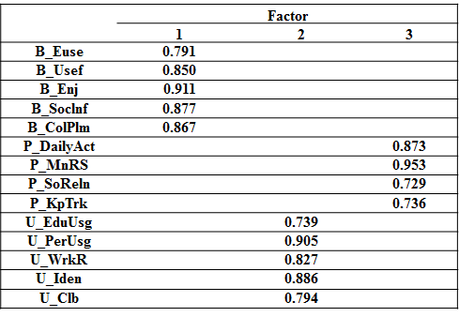

Table S1. Pattern Matrix

 | Benefit | Purpose | Usage
Benefit | 0.547
Purpose | 0.1 | 0.32
Usage | 0.049 | 0.159 | 0.492

Table S2. Covariance matrix of latent variables

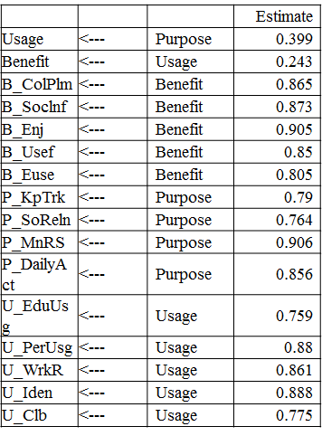

Table S3. Standardized Regression Weights

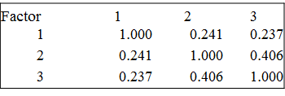

Table S4. Factor Correlation Matrix

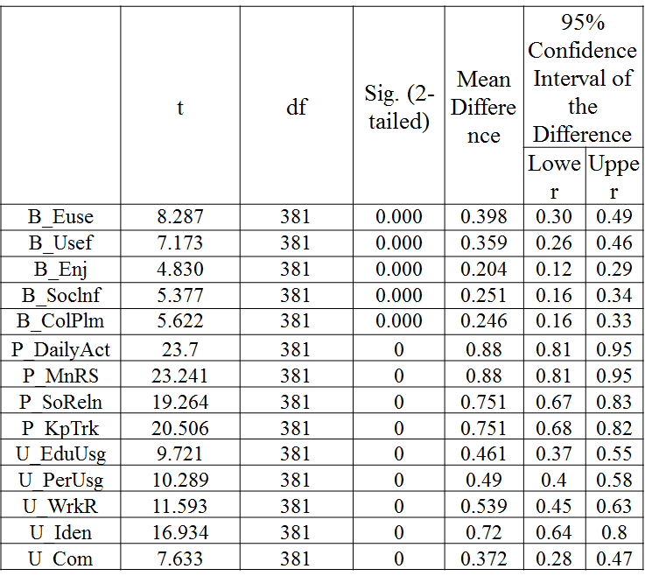

Table S5. One-Sample T-test Value

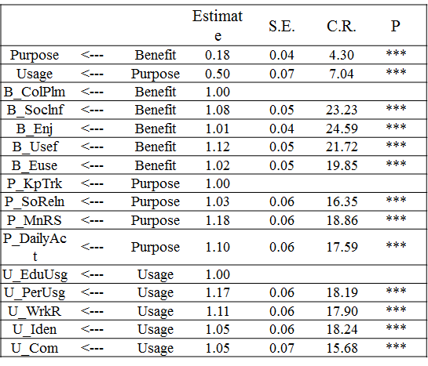

Table S6. Regression Weights: Hypothesis testing results

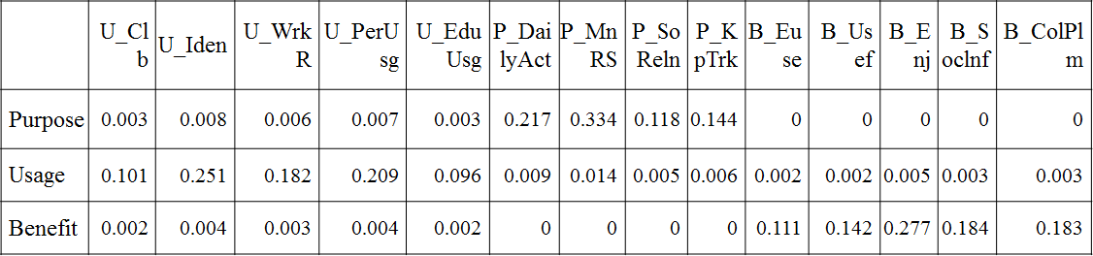

Table S7. Factor Score Weights

