Appendix I Students’ DST products
No | Samples of DST products
1 | - DST name: Why do bears have short tails?  - Duration: 2min52s  - Number of generated images: 47
 | 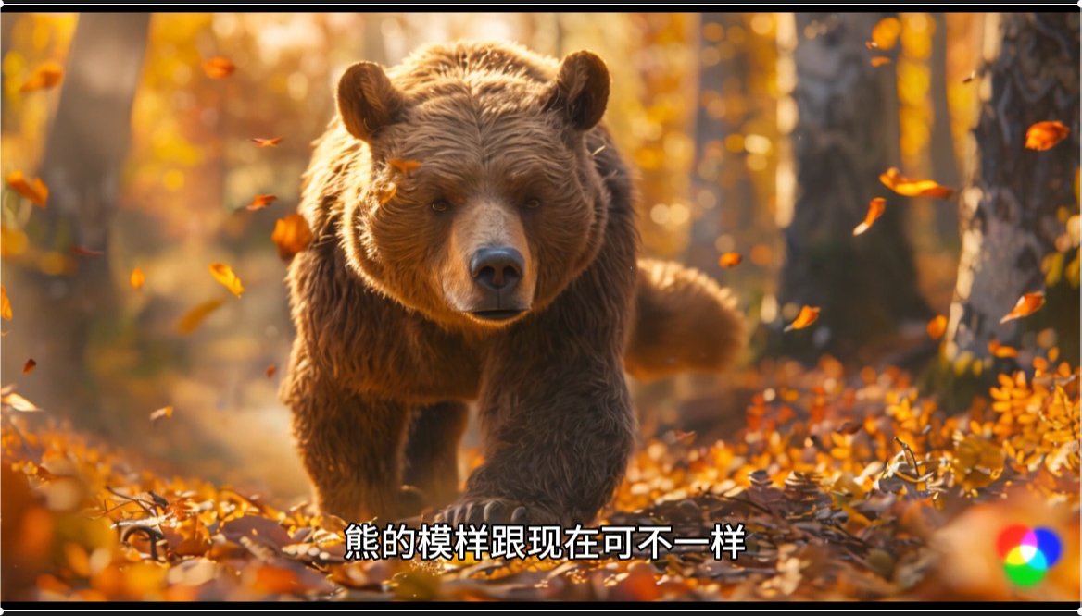 | 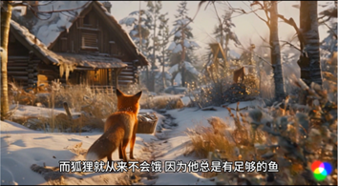
 | Image 1: Bears once had long tails, and they often felt hungry as they searched for food. | Image 2: One cold winter, when the river froze, the bear stole fish from the fox’s trap.
 | 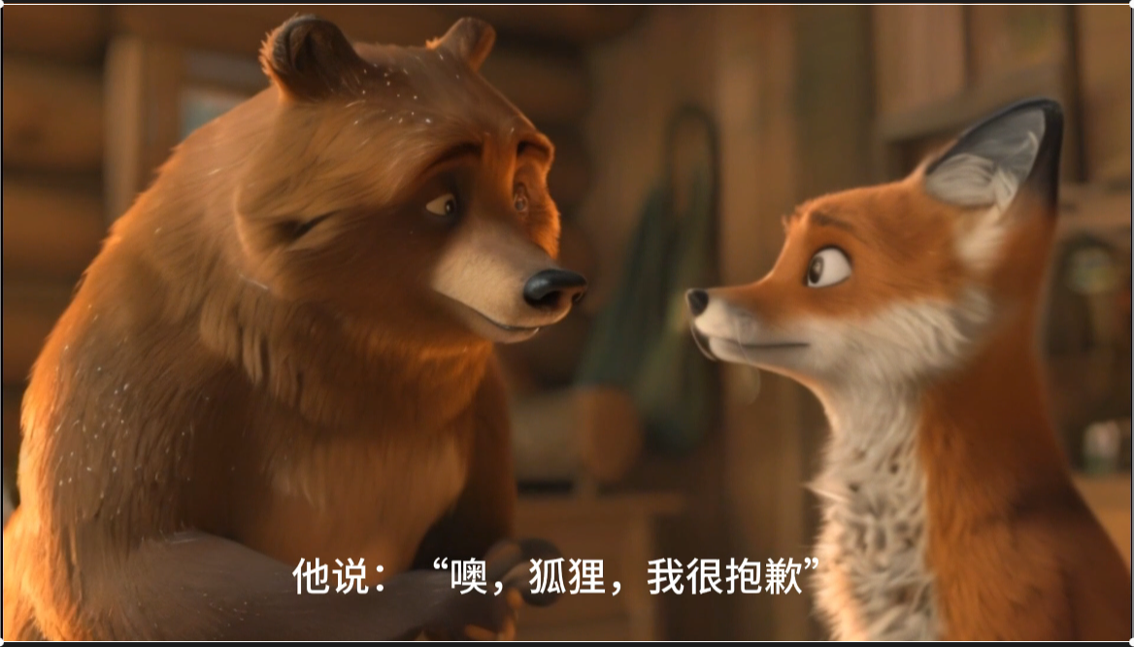 | 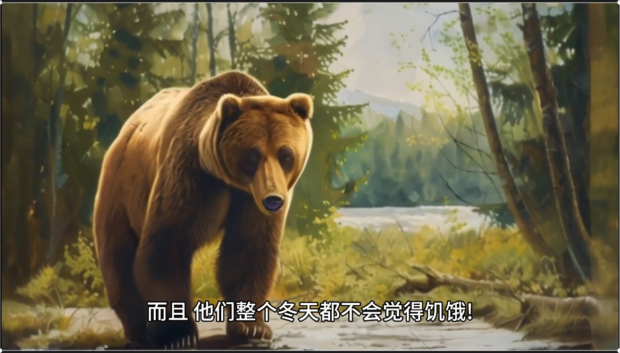
 | Image 3:The fox taught the bear a valuable lesson, causing the bear to feel both ashamed and sad. | Image 4: From that moment on, bears had short tails and no longer felt hungry in winter, learning to be more resourceful.
2 | - DST name: Lunch time  - Duration: 3min  - Number of generated images : 53
 | 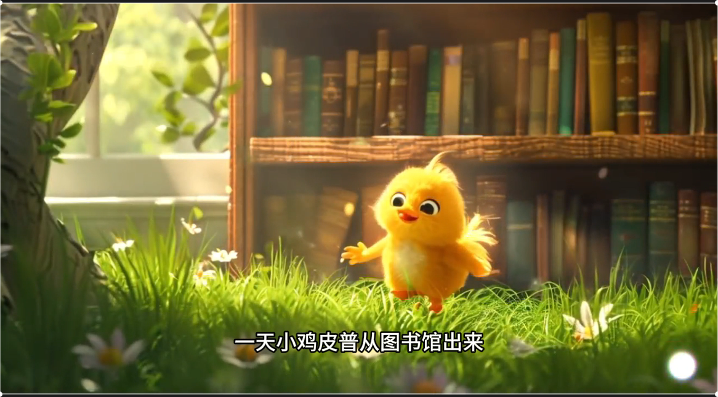 | 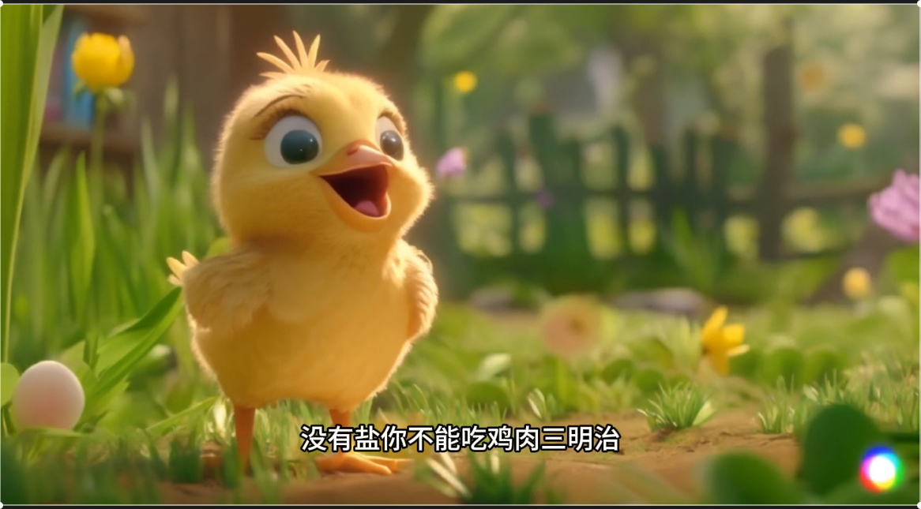
 | Image 1: On her way back from the library, Pip encountered a hungry fox who wanted to eat her. | Image 2: Using the knowledge from her books, Pip cleverly convinced the fox to fetch bread, salt, and pepper to make a sandwich.
 | 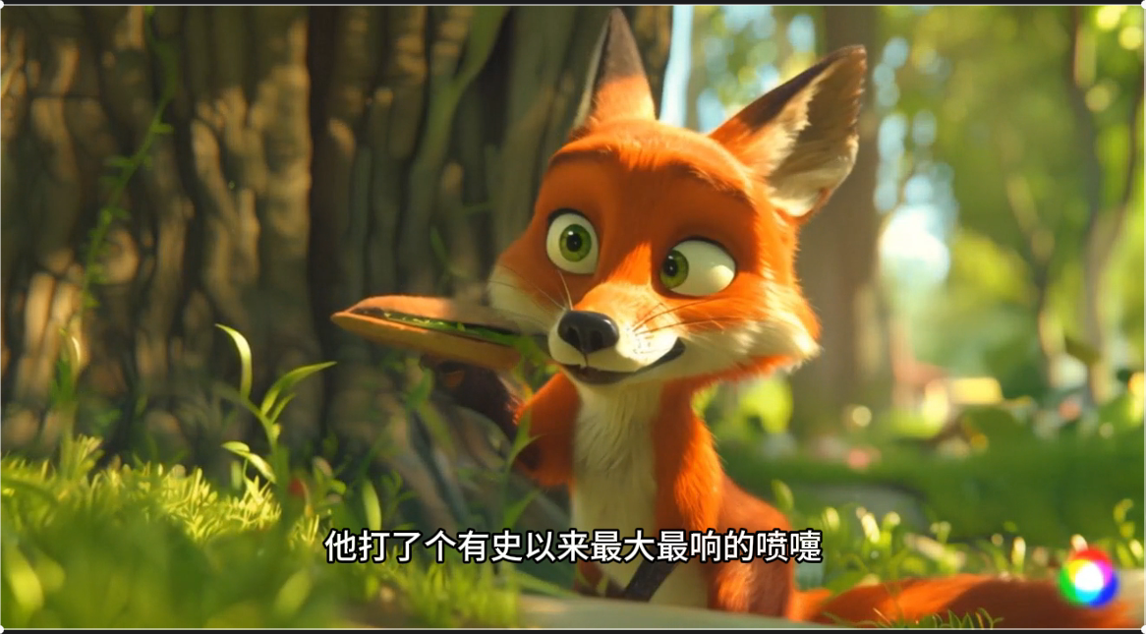 | 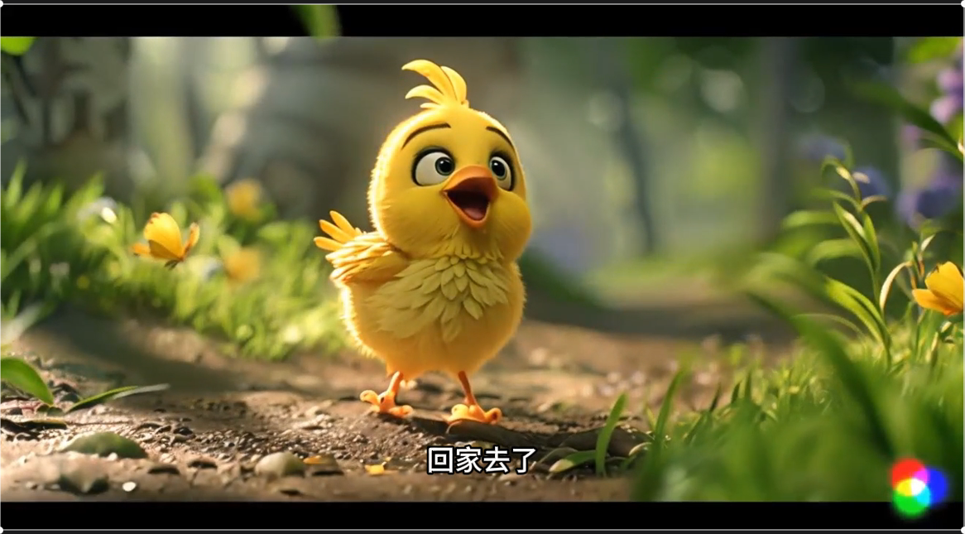
 | Image 3: The pepper made the fox sneeze violently, sending Pip flying up into a tree and alerting the farmer. | Image 4: After the adventure, Pip told her mother that she had borrowed some very helpful books for future use.
3 | - DST name:Warm home  - Duration: 2min58s  - Number of generated images : 48
 | 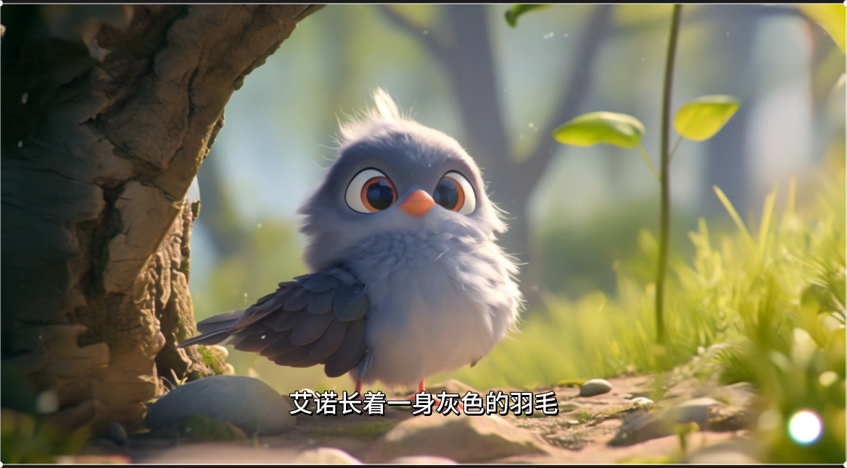 | 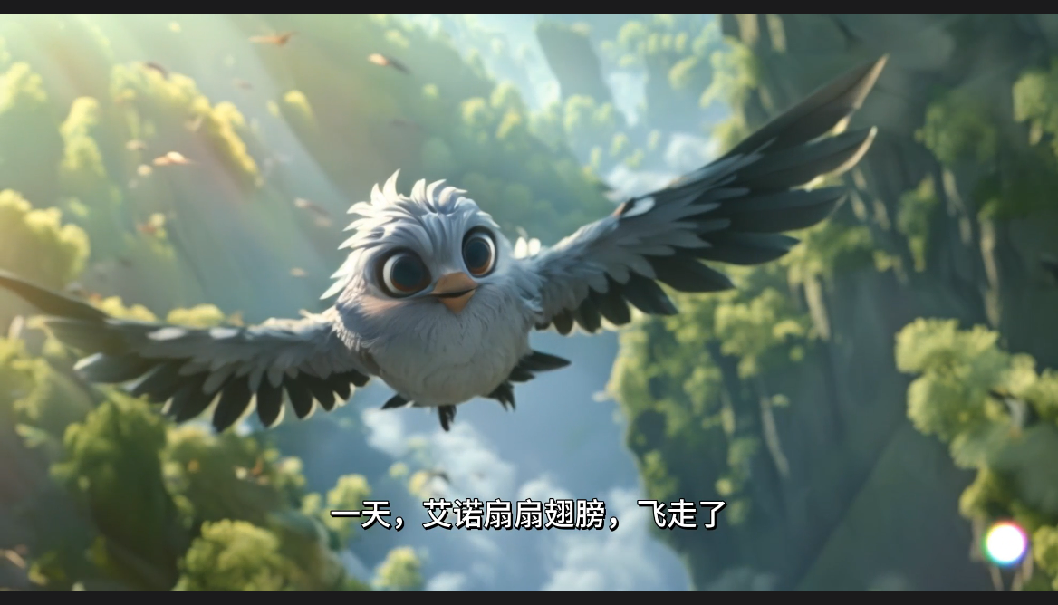
 | Image1:Eno is a shy grey bird who feels overlooked by other birds. | Image 2: Eno flies around the world in search of a new home, but none meet his needs.
 | 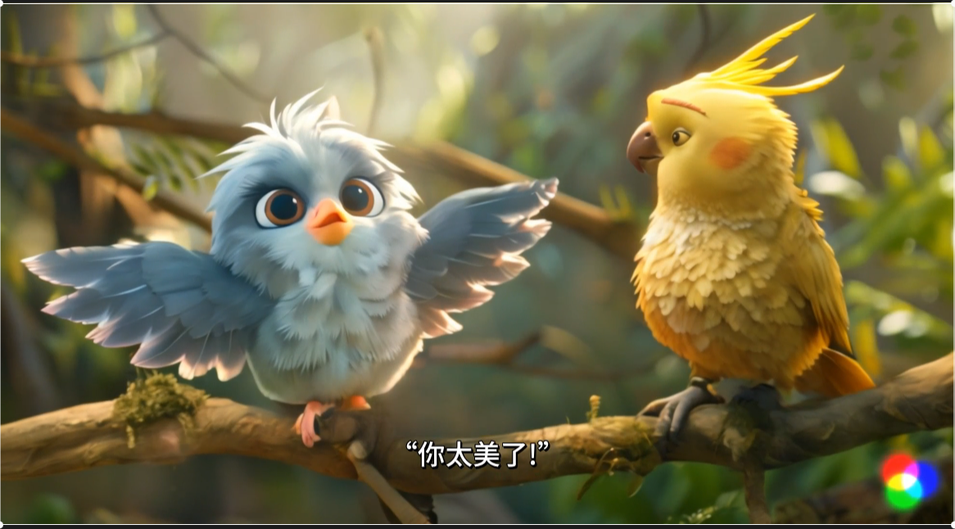 | 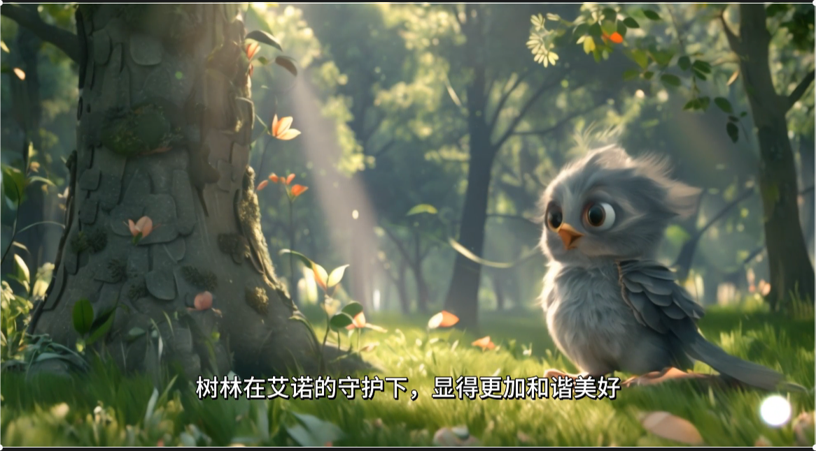
 | Image 3: The jungle birds praise Eno for his beauty, but the attention feels overwhelming. | Image 4: After reflecting on his journey, Eno realizes the warmth of home and decides to stay.
4 | - DST name:Breakfast, bananas!  - Duration: 3min44s  - Number of generated images : 47
 | 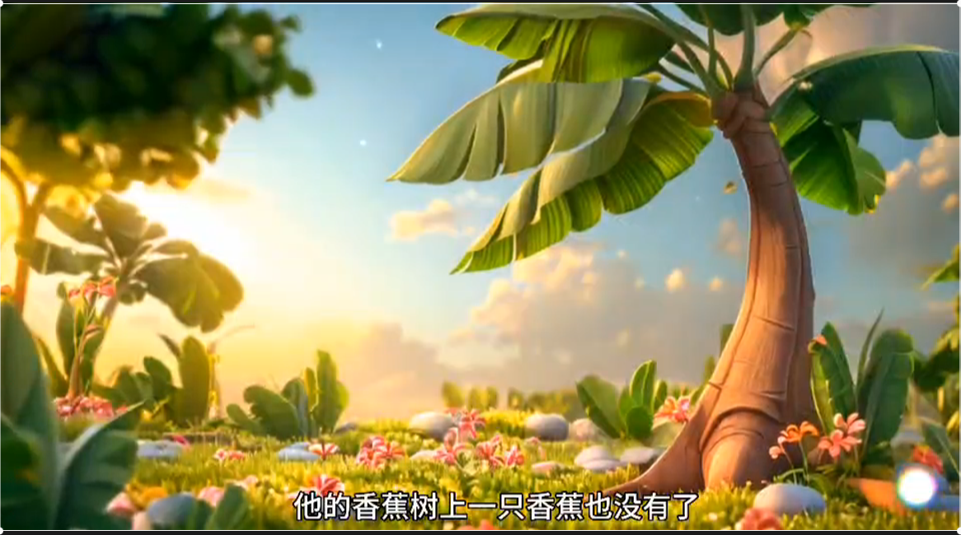 | 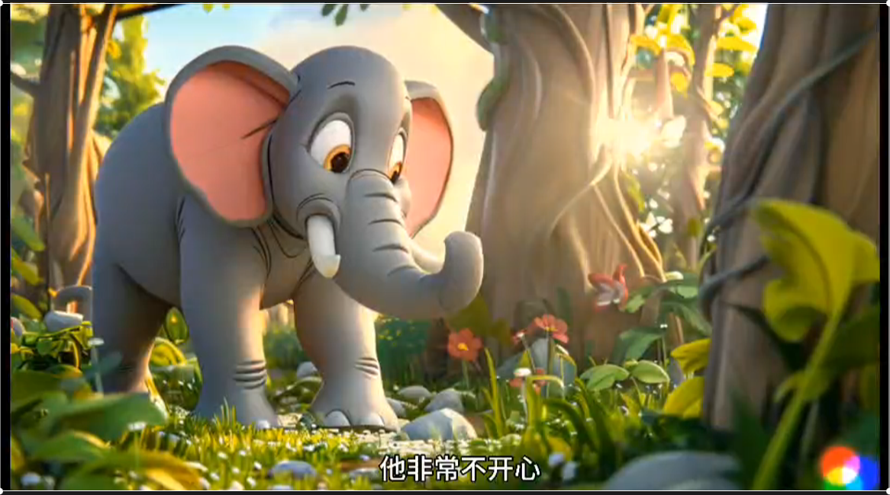
 | Image 1: Kofi was hungry for bananas, but his tree had none, while Effie’s tree was full of them. | Image 2: Kofi decided to push down Effie’s tree to take the bananas for himself.
 | 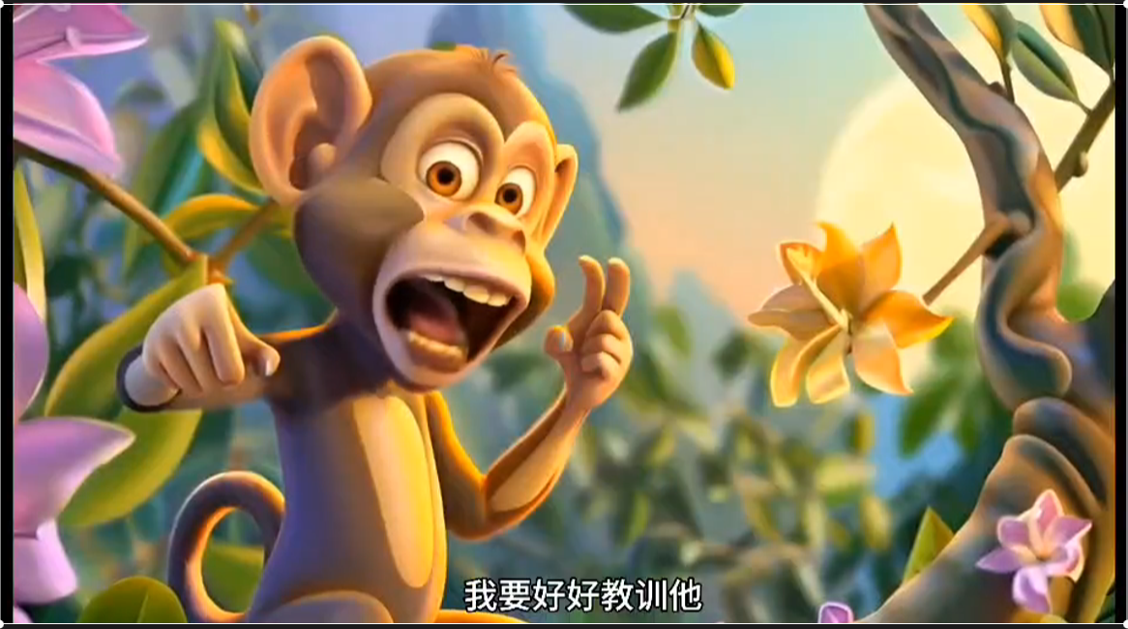 | 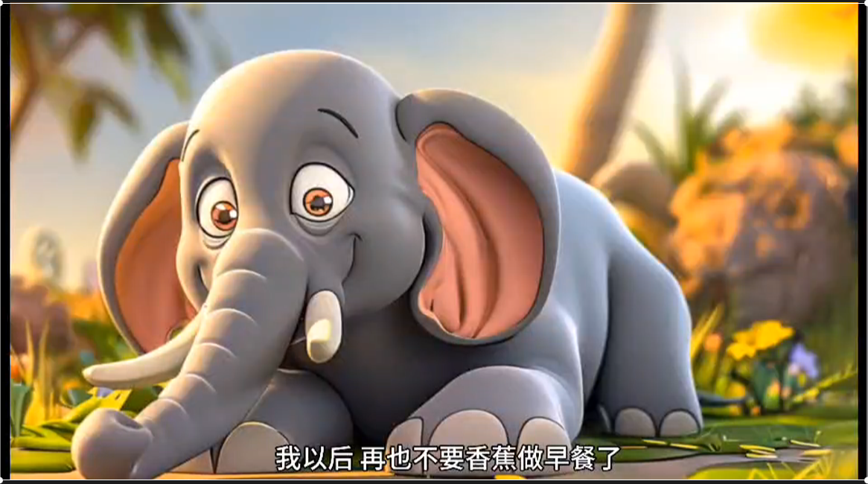
 | Image 3: Effie caught Kofi in the act and hid, feeling upset. | Image 4: Feeling guilty, Kofi apologized to Effie and promised never to want bananas for breakfast again.

Appendix II Learning activities for DST creation
Curriculum stage | Experimental group | Control group
Introduction and Topic Selection  （4 hour） | Pre-class evaluation: CPS, and basic information
Introduction and Topic Selection  （4 hour） | 1.Students were introduced to the learning goals of DST.  2.Students were presented various completed GAI-enhanced DST. | 1.Students were introduced to the learning goals of the digital story.  2.Students were presented various DST.
Introduction and Topic Selection  （4 hour） | 1. Students familiarized with GAI tools.  2. Students prepared the GAI tools that to be used in the DST.  3. Students decided the topic of the DST through discussions with ChatGPT. | 1.Students familiarized with digital tools such as PS, AE, PR.  2.Students decided on the topic of the digital story  3.Students collected audio, videos, and content resources from websites.
Project A: Story scenario writing（4 hour） | 1. Students were provided instruction on the basic knowledge of the project A.  2. Students were trained on how to use ChatGPT to generate story text  3.Students worked in groups to use ChatGPT to generate a draft for their story text.  4. Students were then asked to re-prompt ChatGPT to iteratively generate drafts until they were satisfied.  5. Students in groups selected the most appearing version of the drafts generated from ChatGPT | 1.Students were provided instruction on the basic knowledge of the project  2.Students worked in groups to use Microsoft Word to create their story text.  3. Students modified and revised the story text manually.
Project B: Storyboard design and creation  （4 hour） | Instruction provided on the basic knowledge of the project B
Project B: Storyboard design and creation  （4 hour） | 1. Students were trained in the ethical and reasonable use of ChatGPT to create storyboard.  2. Students in groups used ChatGPT to generate draft for their storyboard  3. Students were then asked to re-prompt ChatGPT to iteratively generate drafts until they were satisfied.  4.Students in groups selected the most appearing version of the Storyboard generated from ChatGPT | 1.Students worked in groups to use Microsoft Word to create their storyboard  2. Students modified and revised the storyboard manually.
Project C: Static image production  （8 hour） | Instruction provided on the basic knowledge of the project C
Project C: Static image production  （8 hour） | 1. Students were trained in the ethical and reasonable use of Midjourney to create static images based on the storyboard.  2. Students worked in groups to use Midjourney to generate draft for their static images.  3. Students were then asked to re-prompt Midjourney to iteratively generate drafts until they were satisfied.  4. Students in groups selected the most appearing version of the relevant images generated from Midjourney. | 1.Students further searched on search engines to gather supplementary materials related to image production.  2.Students used PS to edit corresponding static images from the prepared materials.  3.Students evaluated, adjusted, and iterated completed images.
Project D: Animation design and development（8 hour） | Instruction provided on the basic knowledge of the project D
Project D: Animation design and development（8 hour） | 1. Students were trained in the ethical and reasonable use of Runway to generate draft for their digital animation.  2. Students were then asked to re-prompted Runway to iteratively generate drafts until they were satisfied.  3. Students in groups selected the most appearing version of the animations generated from Runway. | 1.Students were provided instruction on the basic knowledge of animation creation  2. Students in groups used AE to transform static images into digital animations.  3.Students used AE to modify and revise the digital animation.
Project E: Editing, recording, and finalization  （6 hour） | Instruction provided on the basic knowledge of the project E
Project E: Editing, recording, and finalization  （6 hour） | 1. Students were trained in the ethical and reasonable use of Capcut to record and edit video.  2. Students worked in groups to use Capcut to generate complete DST.  3. Students drafted and iterated the final work. | 1.Students used PR to edit and record the DST.  2.Students drafted and iterated the final work using PR.
Project F：Sharing and publishing stories（2 hour） | 1.Students presented completed DST to peers  2.Students evaluated and received feedback on the quality of the finalized DST.  3.Students shared their products in online websites.
Post-class evaluation: CPS, TCP, perceptions, and semi-structured interviews

