Supplementary Material A

To further assess the pre-intervention comparability, descriptive data of feedback literacy and two other trait variables are reported in Table A1. Self-perceptions of IT skills were measured through an instrument of the International Computer and Information Literacy Study (ICILS2018, Eickelmann et al., 2008). Here, a total of 30 points would indicate perfect proficiency. With a mode of 13 points, the self-perceptions did not differ between students in the experimental and control conditions (see Table A1). Further, students in both groups did not differ with regard to both dimensions of feedback literacy and both dimensions of Grit (Schmidt et al., 2019).

Table A1. Descriptive data to assess pre-intervention comparability of experimental groups.
 | Simple feedback (experimental)  N = 96 | Highly-informative feedback (control)  N = 100 | Total sample  N = 196
ICILS | 13 | 13 | 13
Consistency of interest (Grit) | 2.27 (0.53) | 2.34 (0.59) | 2.30 (0.56)
Perseverance of effort (Grit) | 3.04 (0.57) | 3.03 (0.54) | 3.04 (0.55)
Feedback attitudes (Feedback Literacy) | 4.14 (0.47) | 4.12 (0.55) | 4.13 (0.51)
Feedback practices (Feedback literacy) | 3.75 (0.51) | 3.77 (0.55) | 3.76 (0.53)
Note. For ICILS the mode is reported, while the remaining variables are reported as means and standard deviations in parantheses. No test statistics are reported as means and standard deviations are nearly identical between groups.

Supplementary Material B

Task instruction:
As part of a first-semester lecture course on the foundations of teaching and educational diagnostics, teacher education students engaged with key dimensions of instructional quality, including cognitive activation—a construct associated with deep learning processes such as elaboration, linking new content to prior knowledge, cognitive conflict, and higher-order thinking (Klieme et al., 2001; Kunter, 2005; Praetorius et al., 2018). Because cognitive activation is not directly observable, it must be inferred from classroom discourse and task structure. Recognizing its importance in fostering meaningful learning, students must learn to identify and reason about cognitive activation potential in authentic classroom contexts (Junghans, 2022).

To address these goals, a computer-supported collaborative learning (CSCL) task was implemented. CSCL approaches promote knowledge co-construction, argumentation, and social regulation of learning when appropriately structured (Jeong et al., 2019; Fischer et al., 2013; Johnson & Johnson, 2014). The task asked students to collaboratively evaluate two classroom video excerpts: one drawn from the TIMSS 1997 Video Study (Stigler et al., 1999), and the other from www.guterunterricht.de. These clips presented contrasting instructional scenarios, and students were asked to determine which of the two demonstrated greater potential for cognitive activation.

To scaffold productive collaboration, the task employed a macro script that divided the activity into three sequenced phases, and micro scripts to guide interaction and use of academic language. In Phase 1, groups identified relevant teaching activities from both videos, citing timestamps and writing brief descriptions. In Phase 2, they evaluated the cognitive activation potential of the selected scenes using conceptual terminology and theory-informed reasoning. Students were encouraged to express agreement or disagreement constructively and extend one another’s ideas using interaction prompts such as “I agree with this analysis because…” or “I would like to add…”. In Phase 3, groups synthesized their discussion into a joint written statement that justified their final judgment and supported it with evidence from the videos and course concepts.

The task was conducted asynchronously over one week on Moodle. Each group was assigned a private message board, which was pre-structured into three distinct discussion threads, each corresponding to one of the macro script’s phases. Each thread contained detailed instructions tailored to the corresponding phase, and students were asked to post their contributions and collaboratively build their group output within these threads. Groups advanced through the phases in order, completing each before moving on to the next. This structure ensured that students remained focused on each subtask, while also enabling instructors to monitor progress if needed.

The task was formative in nature and contributed to students’ overall coursework, with the group statement serving as the final product. No individual grading was applied. While no fixed roles (e.g., leader, scribe) were assigned, the structure and scripting were designed to encourage equitable participation and mutual accountability. Overall, this design aimed to foster interdependence, critical engagement, and collaborative reasoning, grounded in research on productive CSCL environments (Fischer et al., 2013; Kreijns et al., 2023; Weinberger & Fischer, 2006).

Supplementary Material C
Table C1. Task instructions for the learning activity.
Original | English (transl.)
Aufgabe: Tiefenstrukturen von Unterricht  Das Potenzial zur kognitiven Aktivierung ist eine wichtige Tiefenstruktur von Unterricht und eine Voraussetzung für erfolgreiches Lernen. Um selbst kognitiv aktivierenden Unterricht gestalten zu können, ist es wichtig diesen zunächst einmal selbst zu erkennen. Dies ist jedoch nicht immer einfach. Deshalb wird mit dieser Aufgabe die Einschätzung von Unterricht bezüglich dessen Potenzials zur kognitiven Aktivierung mit einer Gruppendiskussion in einem Online-Diskussionsforum vertieft. In der Gruppendiskussion können Sie vom Wissen Ihrer Mitstudierenden profitieren und umgekehrt. Zudem helfen andere Sicht- und Ausdrucksweisen, das Thema tiefgehend zu verarbeiten und dadurch noch besser zu verstehen.  In dem für Sie bereitgestellten Diskussionsforum sind “Themen” angelegt. Innerhalb dieser Themen können Sie Beiträge sowie Antworten auf Beiträge verfassen. Dieses Forum wurde ausschließlich für Ihre Gruppe angelegt, weshalb Sie Aktivitäten anderer Gruppen nicht sehen.  In der Gruppendiskussion haben Sie die folgende Fragestellung zu bearbeiten:  „Welche der beiden Unterrichtssequenzen hat ein höheres Potenzial zur kognitiven Aktivierung und wieso?“  - Video 1 – Stationsarbeit mit digitalin Medie nim Fremdsprachenunterricht  Quelle: guterunterricht.de (https://www.guterunterricht.de/unterrichtsvideos)  - Video 2 – Lösung quadratischer Gleichungen im Mathematikunterricht  Quelle: TIMSS Study (https://www.youtube.com/watch?v=g3MPpwKuR7w&t=1s)  Um diese Frage gemeinsam und systematisch zu bearbeiten, verwenden Sie bitte den folgenden Ablauf. Dieser ist in drei Phasen gegliedert:  Phase 1: Sammlung und Identifikation der Unterrichtsaktivitäten  Phase 2: Analyse und Diskussion des kognitiven Aktivierungspotenzials  Phase 3: Gemeinsames Statement zur Beantwortung der Frage  Weitere generelle Informationen zu dieser Aufgabe finden Sie im Forum. Genauere Informationen zu den Erarbeitungsphasen finden Sie im jeweils dafür angelegten Thema im Diskussionsforum. | Task: Deep Structures of Teaching  The potential for cognitive activation is a significant deep structure of instruction and a prerequisite for successful learning. To design instruction that cognitively activates students, it is essential first to recognize cognitively activating teaching practices. However, this is not always straightforward. Thus, this task aims to deepen your assessment of instructional activities regarding their potential for cognitive activation through a group discussion in an online discussion forum. In this discussion, you can benefit from your fellow students' knowledge and vice versa. Additionally, different perspectives and expressions can help you process the topic more thoroughly and enhance your understanding.  Within the provided discussion forum, specific "topics" have been created. Within these topics, you can create posts and reply to posts. This forum has been set up exclusively for your group, which means you will not be able to see activities from other groups.  In the group discussion, you are expected to address the following question:  "Which of the two instructional sequences has a higher potential for cognitive activation and why?"  - Video 1 – Station-based learning with digital media in foreign language teaching ([LINK to edited clip])  Source: guterunterricht.de (https://www.guterunterricht.de/unterrichtsvideos)  - Video 2 – Solving quadratic equations in mathematics teaching ([LINK to edited clip])  Source: TIMSS Study (https://www.youtube.com/watch?v=g3MPpwKuR7w&t=1s)  To collaboratively and systematically address this question, please follow the process outlined below, structured into three phases:  Phase 1: Collection and identification of instructional activities  Phase 2: Analysis and discussion of cognitive activation potential  Phase 3: Joint statement answering the guiding question  Further general information about this task is available in the forum. More detailed instructions about each phase can be found within the respective topic in the discussion forum.

Supplementary Material D

An exemplary joint statement produced by collaborative group 47 (chosen at random). The statement was translated via ChatGPT from German into English language. For data protection purposes, we do not reproduce the German original here.

Re: Phase 3: Joint Statement in Response to the Question

Hi,

I’ve gone ahead and compiled all the contributions. I mostly adopted the arguments just as you had formulated them. I’m not sure if the text is too long now, but we can still make changes to it this evening.

Which of the two teaching sequences has greater potential for cognitive activation, and why?

In our view, the teaching sequence described in Video 1 (station-based work with digital media in foreign language teaching) offers a greater potential for cognitive activation.

Cognitive activation refers to learning and thinking processes through which learners engage actively and intensively with the learning content. This happens when students draw on their prior knowledge and connect it with new content. Such activation must be deliberately encouraged by the teacher through appropriate instructional activities.

To complete the station-based tasks in Video 1, various thought processes are stimulated, such as auditory perception or the recall of prior knowledge like vocabulary or familiar sentence structures. In dialogue with peers, students must apply already known grammatical rules to form new, grammatically correct sentences. In doing so, they are prompted to use and expand their language skills, as they recall and apply what they already know in order to acquire new linguistic knowledge and apply it in practice.

Furthermore, students are given the opportunity to interact with classmates at a similar language level, which can support a high level of cognitive activity. Students tend to be more motivated to communicate with peers, particularly when there is an overlap in interests. This often results in a more enjoyable and engaging exchange, even when it takes place in a foreign language.

When working on the tasks, students are free to decide the order in which they complete them. This allows them to begin with tasks that they find interesting and motivating and that match their individual level of challenge. In addition, this teaching sequence places a strong emphasis on the importance of active engagement with the content by providing ample practice time. This gives students more time to deal with the learning tasks intensively and to receive individual support from the teacher as needed.

The sequence shown in Video 2 (solving quadratic equations in mathematics class) also has great potential for cognitive activation. Students are expected to solve a mathematical problem based on their prior knowledge by analyzing the structure of the task and comparing it with familiar patterns. The more prior knowledge students have—and the more easily it is accessible—the easier they find such demanding cognitive processes. This explains why some students in this sequence are quicker to come up with solutions than others. If prerequisite knowledge is missing or not easily retrievable, students are less able to apply it to the new content.

In such situations, the teacher provides support by offering hints or prompting recall of familiar structures. Furthermore, analyzing and solving the problem requires the students to construct and store new knowledge. For this to happen effectively, sufficient time for practice must be provided. However, in this sequence, that is not the case: the teacher ends the activity even though only part of the class has completed the first subtask.

Later in the lesson, the teacher discusses the solutions with the students but allows little time for reflection before giving the answers. This means that the content may not enter students' working memory through the sensory registers. The connection between working memory and long-term memory is essential for drawing on prior knowledge and applying it to new problems. If the teacher gives the answer after only a few seconds, many students are still in the middle of the cognitive process and lack the time to retrieve and filter their knowledge. As a result, not all students are able to engage actively with the material, since the answer is presented before they have had a chance to think it through.

Learning content can only be actively stored in memory. If students do not have time to reflect on the task or the material, only passive participation occurs, and the lesson offers limited potential for cognitive activation for some students.

Conclusion:

We therefore conclude that while the teaching in classroom video #2 also has great potential for cognitive activation, this potential is not fully realized because students are not given enough processing time. Given the learning activities in video #1, we therefore evaluate it as having more potential for cognitive activation.

Comment by first author on statement quality: This is a strong statement, as it has important key features required by this task. First, the statement uses concepts and theories from the lecture to reason about cognitive activation in the observed learning activities, for example, connecting prior knowledge with new content or storing of information in long-term memory. Further, the analysis operates at the correct unit-of-analysis, that is, inferred cognitive processes at the level of the individual student, as opposed to, for example, behavioral activation indicated by lots of movement in the class. This can be seen by the reference to, for example, “the teacher provides support by offering hints or prompting recall of familiar structures“. Lastly, however, it does not provide timestamps to bolster its analyses with concrete evidence.

Supplementary Material E

Table F1. Example of feedback message in the highly informative feedback condition. Students in the simple feedback conditions received only the greetings and overview section as well as the simple feedback section.
Feedback section  (this information is not presented to students) | English text  (transl.) | German text  (original)
Greetings and overview | Hello [student name],  Task 4: Deep Structures of Teaching from the lecture BW-A/Sb1 - Introduction to Teaching, Counseling, and Diagnostics has now been graded. Below you will receive feedback on the quality of the final statement and your participation in the discussion task. | Hallo [student name],  Die Aufgabe 4: Tiefenstrukturen von Unterricht aus der Vorlesung BW-A/Sb1 – Einführung in Unterricht sowie Beratung und Diagnostik ist nun fertig korrigiert. Im Folgenden erhalten Sie Rückmeldung zur Qualität des finalen Statements sowie zu Ihrer Mitarbeit in der Diskussionsaufgabe.
Product feedback
(overall 2 out of 5 points)
Use of concepts and theory  (0 out of 2 points) | The statement from your group contains few or no appropriate technical terms, which may indicate that you have not sufficiently based your argumentation on theories and concepts related to the topic. Please make sure in the future to argue with theories and concepts to clarify the scientific context. | Das Statement Ihrer Gruppe enthält wenige oder keine passenden Fachbegriffe, was bedeuten kann, dass Sie sich in Ihrer Argumentation nicht genügend auf Theorien und Konzepte zum Thema gestützt haben. Bitte achten Sie in Zukunft darauf, mit Theorien und Konzepten zu argumentieren, um den wissenschaftlichen Bezug deutlicher zu machen.
Correct level of analysis  (2 out of 2 points) | Your group statement primarily focuses on the potential for cognitive activation. In doing so, you avoided the mistake of confusing cognitive activation with behavioral activation or surface structures. This means you have solved this aspect of the task very well. | Ihr Gruppen-Statement bezieht sich hauptsächlich auf das Potenzial zur kognitiven Aktivierung. Sie haben dabei den Fehler vermieden, kognitive Aktivierung mit Verhaltensaktivierung bzw. Sichtstrukturen zu verwechseln. Damit haben Sie diesen Aspekt der Aufgabenstellung sehr gut gelöst.
Use of examples as evidence  (0 out of 1 points) | To answer the discussion question comprehensively, the statement should include specific references to learning activities in both videos. In your group statement, there are too few or no explicit references to both videos. When making your arguments, ensure that you clearly state the basis of your assessment, ideally using very specific examples. | Um die Diskussionsfrage fundiert zu beantworten, sollte das Statement konkrete Bezüge zu Lernaktivitäten beider Videos enthalten. In Ihrem Gruppen-Statement gibt es zu wenige oder keine expliziten Bezüge zu beiden Videos. Achten Sie bei Ihren Argumentationen darauf, dass Sie deutlich machen, worauf Sie Ihre Einschätzung stützen, am besten mit ganz konkreten Beispielen.
Process feedback
(Emergent Role: “Driver”)
Description of Role | You consistently made strong contributions throughout the conversation. Your contributions were very coherent in content.  You often introduced new information that later played an important role in the discourse.  When you were uncertain about something, you made it clear in your contributions. This helped to keep the discussion going. | Sie haben sich in der Konversation durchgehend stark eingebracht. Dabei waren Ihre Beiträge inhaltlich sehr zusammenhängend.  Sie haben dabei oft neue Informationen eingebracht, die später eine wichtige Rolle im Diskurs spielten.  Wenn Sie mit etwas unsicher waren, haben Sie das in Ihren Beiträgen deutlich gemacht. Damit konnten Sie dazu beitragen, die Diskussion aufrechtzuerhalten.
Positive message | You worked closely with some of your group members. You were a good team, keep it up! | Mit einigen Ihrer Gruppenmitglieder haben Sie intensiv zusammengearbeitet. Sie waren ein gutes Team, weiter so!
Co-occurences  (with “Left Behind” or “Deferrers”) | We suspect that some of your group members had little opportunity to contribute. If necessary, try to give your group members a bit more space in the future by allowing them more time to respond. | Wir vermuten, dass einige Ihrer Gruppenmitglieder kaum Möglichkeiten hatten, sich einzubringen. Versuchen Sie gegebenenfalls, Ihren Gruppenmitgliedern künftig ein wenig Raum zu lassen, indem Sie ihnen etwas mehr Zeit geben zu antworten.
Simple feedback
Phase 1 | In Phase 1 (Collection of Teaching Activities), you made 6 contributions. | In Phase 1 (Sammlung von Unterrichtsaktivitäten) haben Sie 6 Beiträge gemacht.
Phase 2 | In Phase 2 (Analysis and Discussion of Cognitive Activation Potential), you wrote 8 contributions. | In Phase 2 (Analyse und Diskussion des kognitiven Aktivierungspotenzial) haben Sie 8 Beiträge geschrieben.
Phase 3 | In Phase 3 (Joint Statement), you composed 5 contributions. | In Phase 3 (Gemeinsames Statement) haben Sie 5 Beiträge verfasst.
Summary | With this number of contributions, you have sufficiently contributed to the group discussion. In summary, Task 4 is considered solved by you. Congratulations! Keep up the good work.  Best regards,  [Instructor Names] | Mit dieser Menge an Beiträgen haben Sie sich ausreichend an der Gruppendiskussion beteiligt. Zusammenfassend gilt Aufgabe 4 von Ihnen als gelöst. Gratulation! Machen Sie weiter so.  Viele Grüße  [Instructor Names]

Supplementary Material F

To generate product feedback, we implemented a natural language processing pipeline. The idea behind this pipeline was to implement a multi-label classifier that can identify a set of pre-defined codes within the produced statement. These codes then trigger feedback rules that govern the assembly of feedback texts. Figure 2 illustrates this pipeline. For this purpose, we first collected a training corpus of 181 group statements from a cohort of students who had solved the task in a previous semester in order to train the classifier. These statements comprised a total of 2,399 sentences. They were parallel-coded by four trained coders using the tool INCEpTION (Klie et al., 2018). These codes aimed to measure the quality of the group statement. To acquire the final training corpus, an expert curated codes from all four coders into a final dataset.
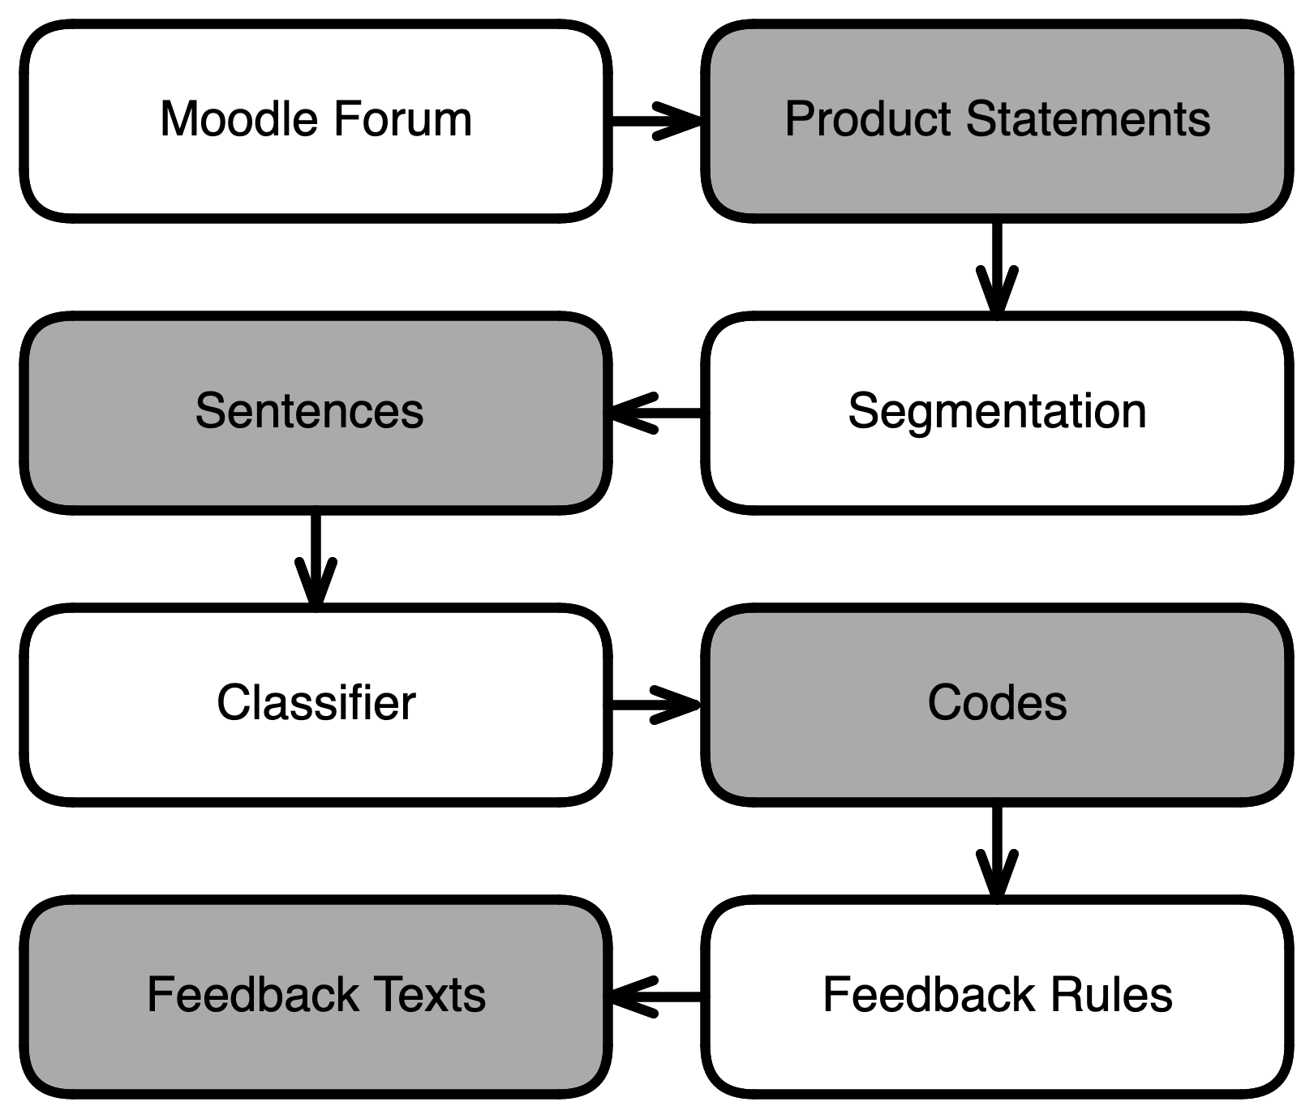
Figure E1: Schematic illustration of the pipeline used to generate the product feedback.

The statement quality was determined by the degree to which three quality criteria were satisfied. First, the statement needed to an contain appropriate use of terminology. Second, statements needed to contain evidence for inferred cognitive activation; that is, a statement should explicitly reference both videos and at least one activity from each with timestamps. Finally, the statements needed to correctly identify moments of cognitive activation within those videos. This criterion was heuristically determined to be true if a given statement predominantly mentioned arguments regarding inferred cognitive processes, as opposed to mere behavioral activation.
The presence of terminology was determined with the help of a simple word list manually extracted from what was coded in the statements. Whether the other criteria were met was detected with the help of a sentence classifier. As a sentence classifier, we implemented a multilabel classification model based on GBERT-large (Chan et al., 2020), a BERT (Devlin et al., 2019) variant pre-trained on exclusively German data. The model was trained on the sentence level in a multi-label setup for up to five epochs using the AdamW optimizer (Lochilov & Hutter, 2019) and early stopping to predict whether a given input sentence contained one or multiple respective codes. Sentence segmentation was carried out using SoMaJo (Proisl & Uhrig, 2016), a highly accurate toolkit for tokenization and sentence segmentation in German.
Each feedback text was assembled based on whether and to what extent the criteria were met. For instance, if appropriate terminology was missing, the product feedback explicitly noted this. Thus, each product feedback section provided information in three sections, one for each criterion. Because the feedback was on the level of the statement, students within a collaborative group received the same product feedback. An annotated example is provided in Supplementary Material A, available online at: https://tinyurl.com/wsdnfnwkfw [temporary URL for blind peer-review].

Supplementary Material G
Table G1. Proportional odds cumulative link models for broad feedback perception, including non-passers.

 | Understandable? |  | Helpful for  ongoing learning? |  | Motivation  for learning?
Fixed Effects Parameters | Coefficient (SE) | Exp(B) | Coefficient (SE) | Exp(B) | Coefficient (SE) | Exp(B)
Threshold
1I2 | -3.71 (0.45)*** | 0.02 | -2.47 (0.27)*** | 0.08 | -2.95 (0.31)*** | 0.05
2I3 | -2.24 (0.24)*** | 0.11 | -0.74 (0.17)*** | 0.48 | -0.75 (0.17)*** | 0.47
3I4 | 0.09 (0.14) | 1.10 | 1.57 (0.21)*** | 4.81 | 1.42 (0.19)*** | 4.12
HILAF - FAS | 0.08 (0.27) | 1.08 | 1.33 (0.30)*** | 3.77 | 0.03 (0.14) | 1.03
Feedb_Lit_A | 0.37 (0.38) | 1.45 | -0.45 (0.38) | 0.64 | 0.75 (0.37)* | 2.12
Feedb_Lit_B | -0.20 (0.33) | 0.82 | 0.06 (0.33) | 1.06 | 0.41 (0.33) | 1.51
Cond x Feedb_Lit_A | 0.40 (0.75) | 1.49 | 1.80 (0.78)* | 6.04 | 0.84 (0.37)* | 2.32
Cond x Feedb_Lit_B | -0.57 (0.66) | 0.57 | -1.07 (0.66) | 0.34 | -0.04 (0.33) | 0.96
Random Components | Variance (SD) | ICC | Variance (SD) | ICC | Variance (SD) | ICC
Intercept I Group | 0.00 (0.00) | 0.00 | 0.14 (0.37) | 0.04 | 0.00 (0.00) | 0.00
Condition I Group | 0.00 (0.00) |  | 0.28 (0.53) |  | 0.26 (0.51)
Residual | 3.29 (1.81) |  | 3.29 (1.81) |  | 3.29 (1.81)
R² marginal | .01 |  | .14 |  | .15
R² conditional | .01 |  | .18 |  | .15

Table G2. Proportional odds cumulative link models for self-regulation-related feedback perceptions, including non-passers.

 | Understand  learning progress? |  | Reflect on learning  behavior? |  | Regulate learning behavior?
Fixed Effects Parameters | Coefficient (SE) | Exp(B) | Coefficient (SE) | Exp(B) | Coefficient (SE) | Exp(B)
Threshold
1I2 | -2.39 (0.27)*** | 0.09 | -2.39 (0.27)*** | 0.09 | -2.37 (0.25)*** | 0.09
2I3 | -0.29 (0.16) | 0.75 | -0.21 (0.16) | 0.81 | -0.28 (0.16) | 0.76
3I4 | 1.72 (0.20)*** | 5.56 | 1.62 (0.21)*** | 5.04 | 1.75 (0.21)*** | 5.73
HILAF - FAS | 0.94 (0.28)** | 2.55 | 1.14 (0.30)*** | 3.12 | 0.69 (0.14)*** | 1.99
Feedb_Lit_A | -0.37 (0.38) | 0.69 | -0.07 (0.36) | 0.94 | 0.06 (0.37) | 1.06
Feedb_Lit_B | 0.38 (0.32) | 1.46 | 0.21 (0.32) | 1.23 | 0.27 (0.33) | 1.31
Cond x Feedb_Lit_A | 0.93 (0.76) | 2.53 | 0.87 (0.75) | 2.39 | 0.29 (0.37) | 1.34
Cond x Feedb_Lit_B | -1.33 (0.65)* | 0.26 | -0.58 (0.65) | 0.56 | -0.12 (0.33) | 0.89
Random Components | Variance (SD) | ICC | Variance (SD) | ICC | Variance (SD) | ICC
Intercept I Group | 0.22 (0.47) | 0.06 | 0.17 (0.41) | 0.05 | 0.00 (0.00) | 0.00
Condition I Group | 0.22 (0.47) |  | 0.31 (0.55) |  | 0.06 (0.24)
Residual | 3.29 (1.81) |  | 3.29 (1.81) |  | 3.29 (1.81)
R² marginal | .08 |  | .10 |  | .14
R² conditional | .14 |  | .14 |  | .14

