Supplementary Materials for Human-Centered GenAI Feedback Design in Higher Education: A Multisite Experiment on Direct, Reflective, and Hybrid Approaches to Scientific Argumentation

1. Supplementary Overview
This supplementary document provides the supporting materials referenced in the main manuscript, including the analytic scientific argumentation rubric, the GenAI prompting and interface protocol, fidelity-audit materials, additional analytic notes, and supplementary tables. The document is organized to improve transparency, reproducibility, and internal alignment between the main manuscript and the supporting documentation.
The supplement is structured to mirror the claims made in the main text. Appendix A documents the scientific argumentation rubric and associated scoring guidance. Appendix B documents the GenAI prompting architecture, output constraints, interface procedures, and representative LMS-integrated screens. Appendix C provides the fidelity-audit framework and checklist. Appendix D provides supplementary analytic notes and expanded sensitivity-analysis reporting. Appendix E documents the feedback uptake coding protocol, including post-revision rationale coding, feedback-revision alignment coding, traceable substantive revision coding, and double-coding reliability procedures. Existing Supplementary Tables S1 and S2 are retained without changes to their reported values. Supplementary Tables S3-S6 document the sensitivity analyses referenced in the Results section, including the baseline-adjusted final-score sensitivity model used to examine possible ceiling-related constraints in gain-score estimation. Supplementary Table S7 provides an overview of all measures, data sources, timing, and scoring procedures referenced in the main text. Supplementary Table S8 provides the qualitative themes and representative quotations supporting the qualitative findings on feedback use and epistemic agency.

2. Supplementary Appendix A. Scientific Argumentation Rubric and Scoring Materials

A1. Rubric overview
Students’ drafts were evaluated with a five-dimension analytic scientific argumentation framework adapted for introductory university science writing tasks. To preserve stage comparability, the initial draft was scored on the four content dimensions shared across draft stages—claim quality, evidence relevance and sufficiency, coherence of reasoning, and treatment of limitations or alternative explanations (possible range = 4–16). The revised submission was scored on these same four content dimensions and, in addition, on a strategic-quality-of-revision dimension derived from side-by-side comparison of the initial and revised drafts (possible revised-draft range = 5–20). For the primary revision-gain models, improvement was estimated on the common four-dimension argument score from first draft to final draft; the separate strategic-quality-of-revision dimension was retained to characterize the strategic quality of revision itself and to support supplementary interpretive analyses.
The framework was designed to privilege disciplinary reasoning over surface-level fluency. Accordingly, high scores required not only coherent prose but also the accurate formulation of claims, relevant and sufficient evidence, explicit reasoning linking evidence to claims, and attention to limitations or alternative explanations. When the strategic-quality-of-revision dimension was scored on revised submissions, raters also evaluated the extent to which changes between drafts were purposeful, substantive, and well integrated across the argument. Raters completed two 2-hour calibration sessions using anchor responses from biology, chemistry, and physics prior to scoring study data.

A2. Rubric dimensions
Scoring note. The first four dimensions below were scored for both initial and revised drafts. The fifth dimension, strategic quality of revision, was scored only for revised submissions on the basis of a paired comparison with the student’s initial draft.
Dimension | Level 1 | Level 2 | Level 3 | Level 4
Claim quality | The response presents no clear scientific claim, or the claim is substantially inaccurate, vague, or inconsistent with the task and evidence. | A claim is present but is only partially accurate, weakly specified, or insufficiently aligned with the data or problem context. | The response presents a clear and mostly accurate claim that is aligned with the task and generally supported by the available evidence. | The response presents a precise, well-bounded, and scientifically appropriate claim that is explicitly aligned with the task and qualified where necessary.
Evidence relevance and sufficiency | Evidence is absent, largely irrelevant, or too limited to support the claim. | Some relevant evidence is used, but important evidence is omitted, weakly selected, or insufficiently developed. | Relevant evidence is selected and is generally sufficient to support the claim, although some integration or precision may be limited. | Evidence is highly relevant, sufficient, and well integrated, with clear selection of the most probative information for the claim.
Coherence of reasoning | Reasoning is absent, erroneous, or disconnected from both the claim and the evidence. | Reasoning is present but underdeveloped, partially flawed, or only loosely connects evidence to the claim. | Reasoning generally explains how the evidence supports the claim, although some logical steps may remain implicit or incomplete. | Reasoning is explicit, coherent, and scientifically sound, making clear why the selected evidence justifies the claim.
Treatment of limitations or alternative explanations | No limitation, uncertainty, or alternative explanation is acknowledged. | A limitation or alternative explanation is mentioned, but treatment is minimal, generic, or disconnected from the argument. | At least one plausible limitation, uncertainty, or alternative explanation is acknowledged and related to the argument. | The response critically addresses uncertainty, limitations, or alternative explanations and explains how they strengthen, qualify, or constrain the conclusion.
Strategic quality of revision | Revision is minimal and consists primarily of cosmetic or surface-level changes with little improvement in argument quality. | Revision includes some targeted changes, but improvements are uneven and the argument remains only partly strengthened. | Revision includes substantive improvements to one or more major dimensions of the argument and results in a clearer, stronger response. | Revision is strategic, substantive, and comprehensive, improving the claim, evidence, reasoning, and/or treatment of limitations in a well-integrated way.

A3. Scoring notes
Each dimension was scored independently on the 1–4 scale. First drafts received scores on the four common content dimensions only. Revised submissions received scores on the same four content dimensions and a fifth strategic-quality-of-revision score based on side-by-side comparison with the student’s initial draft. For analyses requiring equivalent pre/post scaling, a common four-dimension subtotal was used at both draft stages; the separate strategic-quality-of-revision score was archived alongside the revised draft and used in adjudication, calibration checks, and supplementary interpretation. Two trained raters independently scored all submissions. When discrepancies exceeded one point on any rubric dimension, scores were resolved through discussion and the adjudicated ratings were used in the analyses.
The same four content dimensions were applied across intervention and transfer tasks, with topic-specific descriptors used to preserve disciplinary appropriateness within biology, chemistry, and physics. The strategic-quality-of-revision dimension was reserved for revised submissions in the intervention cycles because its scoring required direct comparison between a student’s initial and revised drafts. During rater training, emphasis was placed on distinguishing disciplinary adequacy from stylistic polish so that higher scores reflected stronger scientific argumentation rather than merely more fluent writing.
Revision depth was coded separately from the rubric on a 3-point scale (1 = predominantly surface-level, 2 = mixed, 3 = predominantly substantive). Surface-level changes included wording, grammar, punctuation, and formatting edits that did not alter the argument. Substantive changes included revisions to the claim, the selection or use of evidence, the explanatory reasoning, or the treatment of uncertainty and alternatives. Revision-depth scores were averaged across the three intervention cycles for descriptive and supplementary analyses and were interpreted alongside, rather than as substitutes for, the final-draft strategic-quality-of-revision rating.

A4. Anchor descriptors and exemplar guidance
The anchor descriptors used in rater calibration were organized around the contrast between low-, middle-, and high-quality scientific argumentation. The descriptors below summarize the characteristics used to calibrate the scoring of anchor responses across disciplines. The first four descriptor rows apply to all scored texts; the strategic-quality-of-revision row was used only when revised submissions were evaluated alongside the corresponding initial draft.
Dimension | Low-anchor characteristics | Mid-anchor characteristics | High-anchor characteristics
Claim quality | Claim absent, inaccurate, or overly vague; not responsive to the central task demand. | Claim present and partly accurate, but incompletely bounded or insufficiently aligned with evidence. | Claim explicit, accurate, appropriately qualified, and clearly responsive to the task.
Evidence relevance and sufficiency | Little or irrelevant evidence; reliance on general assertion. | Some relevant evidence, but incomplete, selectively weak, or insufficiently developed. | Well-chosen, relevant, and sufficient evidence integrated into the argument.
Coherence of reasoning | No mechanism, warrant, or explanatory logic connecting evidence to claim. | Some explanatory logic present, but partially implicit or unevenly developed. | Clear, explicit, and scientifically appropriate explanation of how evidence justifies the claim.
Treatment of limitations or alternative explanations | No acknowledgement of uncertainty, limitation, or counterposition. | One uncertainty or alternative is mentioned but treated superficially. | Uncertainty or alternatives are explicitly addressed and used to qualify the conclusion.
Strategic quality of revision | Mostly cosmetic changes; underlying argument largely unchanged. | Some substantive changes, but improvements are uneven. | Revision is strategic and substantive, strengthening the overall argument across dimensions.
During calibration, raters also reviewed exemplar responses representing each performance band within each science domain. Low anchors typically contained unsupported or weakly specified claims, limited evidence, and little explicit reasoning. Mid-range anchors generally showed partial but incomplete coordination of claim, evidence, and reasoning. High anchors presented precise claims, sufficient evidence, explicit explanatory warrants, and, in revised drafts, clear evidence of substantive improvement. These anchor materials were used during both pre-study calibration sessions and follow-up scoring checks across the intervention period.

A5. Illustrative anchor excerpts
To make the calibration logic more concrete, brief exemplar fragments used during rater training are reproduced below. These fragments were adapted from pilot responses and lightly edited for reporting clarity; they are intended to illustrate the textual features associated with low-, mid-, and high-anchor judgments rather than to function as full student responses.
Biology. A low-anchor response typically asserted that a treatment “probably increased enzyme activity” without citing any comparative pattern in the data or identifying the relevant control condition. Mid-anchor fragments usually stated a defensible claim and referred to the observed increase in reaction rate, but left the warrant implicit, for example by noting the pattern without explaining why it supported the causal interpretation. High-anchor fragments linked the claim to the strongest observed data pattern, identified the comparison condition, and explicitly explained why the evidence supported the proposed mechanism while also qualifying the conclusion in light of sample or measurement limits.
Chemistry. Low-anchor chemistry responses often repeated the task prompt and listed isolated observations such as pH change or precipitate formation without integrating them into a coherent claim. Mid-anchor responses usually selected one relevant piece of evidence and proposed a plausible explanation, but did not fully connect stoichiometric or mechanistic reasoning to the conclusion. High-anchor responses coordinated multiple observations, used discipline-appropriate terminology accurately, and explained how the selected evidence constrained alternative interpretations of the reaction pathway or product identification.
Physics. Low-anchor physics responses commonly described the graph or trend line but stopped short of articulating a testable claim about the underlying relationship. Mid-anchor responses usually inferred the general relationship correctly and cited a relevant section of the dataset, yet omitted a clear explanation of how the quantitative pattern justified the claim. High-anchor responses stated a bounded claim, drew on the most diagnostic numerical or graphical evidence, and explained the physical reasoning that connected the observed pattern to the underlying principle while acknowledging uncertainty, simplifying assumptions, or plausible sources of error.

3. Supplementary Appendix B. GenAI Prompting and Interface Protocol

B1. Institutional GenAI interface overview
The AI-supported conditions used a secure, institutionally hosted large language model interface based on OpenAI’s GPT-5 model, accessed through the universities’ approved application environment and integrated directly into the learning-management system (LMS). The interface was configured to support feedback generation rather than answer production. Students accessed the interface through the assignment page corresponding to their course section and intervention cycle. Interaction logs, time stamps, and feedback views were captured within the LMS while maintaining institutional data-governance requirements.
Access to the GenAI interface was restricted to students in the direct, reflective, and hybrid conditions. Students were instructed not to enter personally identifying information into the system. The interface accepted a single draft per task cycle, generated one feedback response per submission, and prevented iterative regeneration within the same cycle. Chat history was reset between cycles to avoid carryover across tasks.

B2. Prompt architecture

B2.1. Core system prompt
You are an academic feedback assistant for introductory university science courses. Your task is to provide criterion-referenced feedback on a student's scientific argumentation draft. Evaluate the draft using the following dimensions: (1) claim quality, (2) evidence relevance and sufficiency, (3) coherence of reasoning, (4) treatment of limitations or alternative explanations, and (5) quality of revision potential. Your response must: 1. identify clear strengths in the argument; 2. identify weaknesses or omissions in claim, evidence, reasoning, or treatment of limitations; 3. point out missing, insufficient, or weak evidence where relevant; 4. question unsupported or weakly supported claims; 5. suggest revision moves that the student can implement; and 6. pose one or two follow-up questions intended to deepen the student's reasoning. Do not provide a full rewritten answer. Do not complete the task on the student's behalf. Keep the response constructive, concise, and academically appropriate. Limit the total response to approximately 400 tokens.

B2.2. Student-facing submission prompt
Please review the following draft and provide feedback aligned with the scientific argumentation rubric. Focus on strengths, weaknesses, missing or weak evidence, unsupported claims, and concrete revision moves. Do not rewrite the entire answer. End with one or two follow-up questions that would help the student improve the argument.

B2.3. Condition-specific prompt wrapper
The same core system prompt was used across AI-supported conditions. Condition differences were implemented through sequencing rather than through different core prompts. For direct GenAI-supported feedback, students submitted the draft alone. For reflective and hybrid conditions, the interface first required structured self-evaluation and then passed the student’s self-evaluation fields to the model as contextual information appended after the draft.
Context fields appended in reflective and hybrid conditions:
- Student-identified strongest aspect of the draft
- Student-identified weakest aspect of the draft
- Student-identified uncertainty related to claim, evidence, or reasoning
- Student revision priority
Instruction to model:
Use the student's self-evaluation as additional context. Compare the draft against the student's own diagnosis where relevant, but still provide independent criterion-referenced feedback.

B3. Output constraints
Constraint | Operationalization
Model family | OpenAI GPT-5 model
Model snapshot date | 2025-09-15
Temperature | 0.20
Top-p | 1.00
Frequency penalty | 0.00
Presence penalty | 0.00
Maximum response length | 400 tokens
Generation policy | Single feedback generation per draft
Rewrite restriction | Full-answer rewriting disabled
Prompt modification | Instructor prompt changes disabled during the intervention
Chat memory | History reset between task cycles

B4. Implementation rules
- Students in AI-supported conditions could generate feedback only after submitting the draft associated with the assigned task cycle.
- Within a given cycle, only one model output could be generated for each submitted draft.
- Students could review the generated feedback during revision, but could not regenerate alternative feedback versions for the same draft.
- The model was explicitly instructed to provide criterion-referenced critique, revision suggestions, and follow-up questions rather than replacement text.
- All AI-supported sections used the same core system prompt, rubric anchor structure, and model settings throughout the study.
- Instructors were not permitted to edit prompts or system settings during the intervention period.
- Interaction logs recorded draft submission time, feedback generation time, feedback view duration, and subsequent revision activity.

B5. Interface screenshots
Figures B1 and B2 reproduce the LMS-integrated GenAI feedback environment used across the AI-supported conditions. Figure B1 illustrates the draft-submission screen with the reflective self-evaluation panel visible. Figure B2 illustrates the criterion-referenced feedback output screen, including strengths, priority revisions, and follow-up questions.
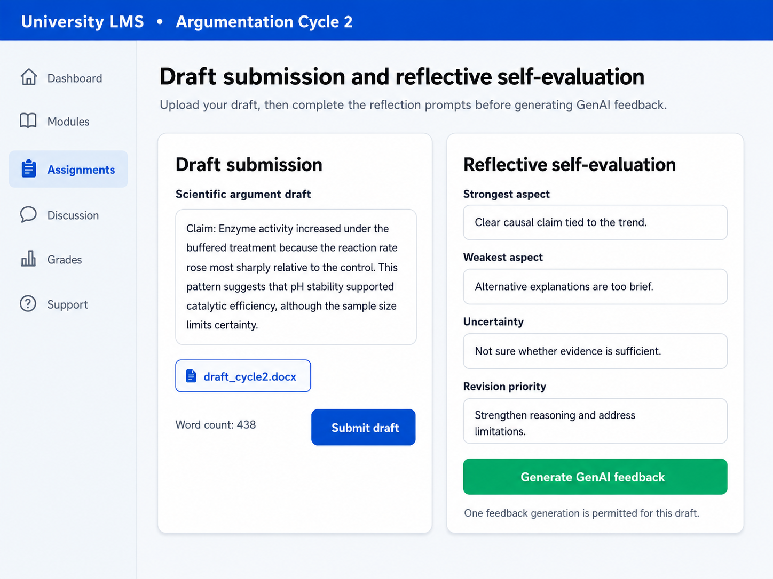
Figure B1. LMS-integrated draft submission and reflective self-evaluation screen used in the AI-supported conditions.

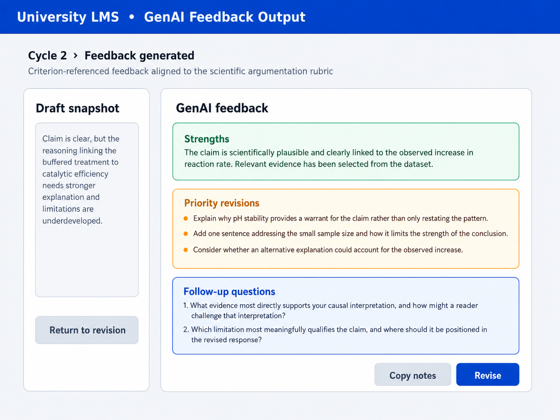
Figure B2. Criterion-referenced GenAI feedback output screen showing strengths, priority revisions, and follow-up questions.

4. Supplementary Appendix C. Fidelity Audit Materials

C1. Audit checklist structure
Implementation fidelity was assessed using a case-based checklist applied to a stratified random audit sample of 176 student cases (15.0% of the final analytic sample). The audit framework covered four domains: sequence integrity, timing compliance, access restrictions, and completion of condition-specific activities. Each item was scored dichotomously (0 = criterion not met, 1 = criterion met). For each case, a fidelity proportion was calculated by dividing the number of completed items by the number of applicable items for that condition.
Checklist item | Domain | Applicable condition(s) | Scoring rule
Initial draft submitted within the assigned cycle window | Timing compliance | All conditions | 1 = submitted within cycle window; 0 = otherwise
Assigned feedback sequence completed in the correct order | Sequence integrity | All conditions | 1 = correct order documented; 0 = order violation
Structured self-evaluation completed before AI feedback | Sequence integrity | Reflective, Hybrid | 1 = all self-evaluation fields completed before feedback generation; 0 = otherwise
Two peer-feedback forms submitted | Completion of condition-specific activities | Peer, Hybrid | 1 = two completed peer forms logged; 0 = otherwise
AI feedback generated only through the assigned institutional interface | Access restrictions | Direct, Reflective, Hybrid | 1 = assigned interface only; 0 = otherwise
Single-generation rule respected | Access restrictions | Direct, Reflective, Hybrid | 1 = one generation logged; 0 = multiple generations
Revision memo submitted | Completion of condition-specific activities | Hybrid | 1 = revision memo present; 0 = absent
No access to non-assigned feedback resources | Access restrictions | All conditions | 1 = no logged attempt; 0 = attempted access
Final revised draft submitted | Completion of condition-specific activities | All conditions | 1 = final draft present; 0 = absent
Platform log record complete and internally consistent | Sequence integrity | All conditions | 1 = no missing audit-critical log field; 0 = otherwise

C2. Audit procedures
The audit sample was selected using stratified random sampling across institutions, disciplines, and conditions. A minimum of three cases were audited per course section (48 sections × 3 cases = 144 cases), and the remaining 32 cases were allocated proportionally to section size and condition distribution to reach the prespecified target of 176 audited cases. Audit selection was conducted after completion of data collection and before final model estimation.
For each audited case, research assistants reviewed the LMS audit trail, condition-specific assignment records, peer-feedback submissions where applicable, AI-generation logs in the AI-supported conditions, and revision memo submissions in the hybrid condition. Audit decisions were recorded in a standardized scoring form and converted into a proportion-of-applicable-steps-completed metric. Site-level fidelity summaries were computed as the mean of the case-level fidelity proportions across audited cases within each institution.
Institution | Audited cases (n) | Mean fidelity proportion
University A | 44 | 0.96
University B | 44 | 0.95
University C | 44 | 0.96
University D | 44 | 0.96

C3. Double-coding and agreement procedures
All fidelity audits were conducted by trained research assistants who were not involved in course instruction. Before independent auditing began, the assistants completed a 3-hour common training session using twelve practice cases drawn from all four conditions and all three science domains. The training emphasized interpretation of the checklist criteria, use of the written scoring guide, and documentation of ambiguous cases.
A total of 36 audited cases (20.5% of the full audit sample) were double-coded to assess audit consistency. Agreement on individual checklist items was high (Cohen’s κ = .89). Where discrepancies arose, assistants first documented the source of disagreement and then met with the senior methods coordinator to reach a consensus classification. The consensus-coded record was retained as the final audit record for those cases.

5. Supplementary Appendix D. Additional Analytic Notes and Sensitivity Analyses

D1. Per-protocol analysis note
Per-protocol analyses were estimated using a restricted sample that excluded students who completed fewer than two of the three intervention cycles. This resulted in a per-protocol sample of 1,102 students. The purpose of the analysis was to determine whether the main findings depended heavily on intention-to-treat inclusion of minimally exposed participants. Across primary, secondary, and process outcomes, the overall pattern of results remained substantively unchanged. Reflective and hybrid feedback designs continued to outperform direct GenAI-supported feedback on the process variables and on delayed AI-free transfer, and hybrid feedback continued to yield the highest adjusted mean for four-dimension argument-quality gain.

D2. Low-fidelity sections exclusion note
To evaluate whether the primary findings were sensitive to variation in implementation quality, the primary models were re-estimated after excluding the three sections with the lowest fidelity scores. This exclusion yielded an analytic sample of 1,101 students across 45 sections. Parameter estimates in these sensitivity models differed by no more than 0.04 standardized units from the main intention-to-treat analyses, indicating that the principal findings were not driven by the lowest-fidelity implementations.

D3. Alternative missing-data specification note
Primary analyses used multiple imputation by chained equations with 20 imputations under a missing-at-random assumption. To test the dependence of results on the missing-data strategy, the primary models were re-estimated using full-information maximum likelihood (FIML). The resulting estimates and substantive conclusions were effectively unchanged, supporting the robustness of the findings to the handling of incomplete data.

D4. Exploratory moderation note
Exploratory moderation models examined whether the effects of feedback condition varied as a function of baseline feedback literacy and science domain. The interaction between condition and baseline feedback literacy was statistically significant for delayed AI-free transfer, F(3, 1158) = 2.83, p = .037, indicating that the disadvantage of direct GenAI-supported feedback relative to the reflective and hybrid designs was more pronounced among students with lower initial feedback literacy. By contrast, the interaction between condition and science domain was not statistically significant for any primary or secondary outcome (all p > .10), indicating that the overall pattern of effects was broadly consistent across biology, chemistry, and physics.

D5. Alternative baseline-adjusted final-score sensitivity model
Because the revision outcome was modeled as gain on the four common rubric dimensions, we conducted an additional sensitivity analysis to examine whether the main pattern was robust to a model that adjusted for initial-draft performance while using the revised-draft score as the outcome. This analysis was motivated by the possibility that students with stronger initial drafts may have had less available room for improvement on the four shared rubric dimensions.
The sensitivity model used the revised-draft four-dimension common-content score averaged across the three intervention cycles as the dependent variable. The corresponding initial-draft four-dimension common-content score was entered as a covariate. The model otherwise matched the primary mixed-effects structure: feedback condition was included as the principal fixed effect; section was included as a random intercept; and the same student-level covariates, science-domain indicators, and institution fixed effects were retained. Planned pairwise contrasts were estimated using estimated marginal means with Holm-adjusted p values.
The initial-draft four-dimension score was a strong predictor of revised-draft argument quality, b = 0.72, SE = 0.04, 95% CI [0.64, 0.80], p < .001, indicating that students’ starting level of argument quality was closely related to their revised performance. Feedback condition also remained statistically significant in the baseline-adjusted final-score model, F(3, 43.7) = 17.21, p < .001. The pattern of contrasts was substantively consistent with the primary gain-score model. Direct GenAI-supported feedback showed an advantage over peer feedback, and both reflective GenAI-supported feedback and hybrid feedback showed advantages over direct GenAI-supported feedback. The hybrid–reflective contrast was not statistically significant. This pattern suggests that the primary findings were not solely attributable to ceiling-related constraints in gain-score estimation. The estimates are reported in Supplementary Table S6.

6. Supplementary Appendix E. Feedback uptake coding protocol

E1. Overview
Feedback uptake was operationalized as a multi-indicator construct capturing the extent to which students attended to, interpreted, selected, and incorporated critique during revision. The index used four evidence sources: post-revision rationales, coder-rated feedback-revision alignment, log-based feedback review time, and the proportion of substantive revisions traceable to feedback content. The coding protocol was designed to distinguish surface-level editing from substantive revision and to identify whether substantive changes were connected to feedback available to the student in the relevant intervention cycle.

E2. Feedback records by condition
For each cycle, coders first identified the feedback record available to the student. In the peer-feedback condition, this record consisted of the two peer-feedback forms. In the direct GenAI-supported feedback condition, it consisted of the GenAI-generated feedback output. In the reflective GenAI-supported feedback condition, it consisted of the student's structured self-evaluation fields and the GenAI-generated feedback output. In the hybrid condition, it consisted of the structured self-evaluation fields, two peer-feedback forms, GenAI-generated feedback output, and the revision memo.

E3. Post-revision rationale coding
Post-revision rationales were coded for the specificity and selectivity of students' stated revision decisions. In the hybrid condition, the revision memo served as the post-revision rationale. In the peer feedback, direct GenAI-supported feedback, and reflective GenAI-supported feedback conditions, students submitted a shorter structured rationale with the final draft.
Rationales were scored on a three-point scale:
Score | Descriptor
0 | The rationale was absent, purely generic, or did not identify a specific revision decision.
1 | The rationale identified a revision but did not clearly link it to feedback, self-evaluation, or rubric criteria.
2 | The rationale explicitly linked a revision decision to a specific feedback point, self-evaluation judgment, or rubric criterion and indicated why the suggestion was accepted, modified, or rejected.

E4. Identification of revision episodes
Coders compared each student's initial and revised draft side by side and identified major revision episodes. A revision episode was defined as a meaningful change to the argument between the initial and revised draft. Surface-level edits included wording, grammar, punctuation, formatting, or sentence-level polishing that did not change the underlying argument. Substantive revisions included changes to claim quality, evidence selection or integration, explanatory reasoning, or treatment of uncertainty and alternative explanations.

E5. Feedback-revision alignment coding
For each major implemented revision, coders determined whether the change was aligned with the feedback record available to the student in that cycle. A revision was coded as aligned when it addressed a specific issue raised in peer comments, GenAI-generated feedback, structured self-evaluation, or the revision memo, depending on condition. Examples included revising an overly broad claim after feedback requested a more bounded claim, adding evidence after feedback identified insufficient support, clarifying reasoning after feedback pointed to a weak claim-evidence connection, or adding a limitation after feedback noted the absence of uncertainty or alternative explanations.
The alignment score was calculated as:
number of major implemented revisions aligned with at least one available feedback point / total number of major implemented revisions.

E6. Traceable substantive revision coding
Traceable substantive revision coding focused only on substantive revisions. The purpose was to determine whether substantive improvements in the revised draft could be linked to feedback content available to the student. The traceable-substantive-revision proportion was calculated as:
number of substantive revisions linked to at least one received feedback point / total number of substantive revisions identified in the draft comparison.
When no substantive revision was identified in a cycle, the traceable-substantive-revision score for that cycle was coded as 0 because no feedback-linked substantive revision had occurred. This rule prevented cases with only surface-level editing from being misclassified as high uptake.

E7. Log-based feedback review time
Feedback review time was extracted from learning-management-system logs. The indicator represented the amount of time students spent viewing the feedback resources assigned to their condition before submitting the revised draft. To reduce the influence of inactive browser sessions, extreme log-duration values were winsorized at the 99th percentile before z-standardization. The resulting log-based indicator was interpreted as behavioral evidence of engagement with assigned feedback resources, not as a stand-alone measure of feedback quality or learning.

E8. Double-coding and reliability
A stratified random 20% of coded revision episodes was independently double-coded by a second trained coder. The double-coded sample was stratified by institution, discipline, condition, and intervention cycle to ensure representation across the full intervention structure. Agreement was substantial for post-revision rationale specificity, weighted Cohen's κ = .81, feedback-revision alignment, Cohen's κ = .84, and traceable substantive revisions, Cohen's κ = .82. Disagreements were first documented and then resolved through discussion before final indicator computation. The consensus-coded records were retained as the final coded dataset for double-coded cases.

E9. Construction of the uptake index
For each student, the four uptake indicators were averaged across the three intervention cycles and z-standardized across the full analytic sample. The indicators were then examined using a one-factor measurement model. Standardized loadings ranged from .58 to .81, supporting the use of a composite uptake index. The final index was computed as the equal-weight mean of the four z-standardized indicators, with higher values indicating stronger feedback uptake.

7. Supplementary Tables
Reporting note. Unless otherwise indicated, the sensitivity tables prioritize the preregistered theory-driven focal contrasts that treated the direct GenAI-supported feedback condition as the primary comparison category for reflective and hybrid designs. Full pairwise contrast matrices were examined during model estimation but are not reproduced here in order to keep the supplementary tables concise and aligned with the confirmatory analytic plan.

Supplementary Table S1. Section-level random-effect estimates, variance components, and intraclass correlation coefficients for the primary mixed-effects models
Outcome model | Random intercept SD (section) | Section-level variance (τ00) | Residual variance (σ²) | ICC (section)
Four-dimension argument-quality gain | 0.46 | 0.21 | 2.49 | .078
Conceptual learning | 0.24 | 0.06 | 0.93 | .061
Delayed AI-free transfer | 0.61 | 0.37 | 4.68 | .073
Feedback uptake | 0.26 | 0.07 | 0.96 | .068
Self-regulated learning during revision | 0.25 | 0.06 | 1.03 | .055
Note. Values are based on the final mixed-effects models reported in the main text. Institutions were entered as fixed effects; accordingly, no institution-level random-effect variance is reported. Section was modeled as a random intercept in all primary models. For four-dimension argument-quality gain, feedback uptake, and self-regulated learning during revision, outcomes were averaged across the three intervention cycles before modeling. Intraclass correlation coefficients (ICCs) were calculated as τ00 / (τ00 + σ²).

Supplementary Table S2. Mixed-effects model predicting revision depth across conditions
Panel A. Estimated marginal means by condition
Condition | Adjusted M | SE | 95% CI
Peer feedback only | 1.72 | 0.05 | [1.62, 1.82]
Direct GenAI-supported feedback | 1.96 | 0.05 | [1.86, 2.06]
Reflective GenAI-supported feedback | 2.23 | 0.05 | [2.13, 2.33]
Hybrid feedback | 2.31 | 0.05 | [2.21, 2.41]
Panel B. Pairwise contrasts
Contrast | b | SE | p | 95% CI for b
Direct GenAI – Peer | 0.24 | 0.07 | .006 | [0.10, 0.38]
Reflective GenAI – Peer | 0.51 | 0.07 | < .001 | [0.37, 0.65]
Hybrid – Peer | 0.59 | 0.07 | < .001 | [0.45, 0.73]
Reflective GenAI – Direct GenAI | 0.27 | 0.07 | < .001 | [0.13, 0.41]
Hybrid – Direct GenAI | 0.35 | 0.08 | < .001 | [0.19, 0.51]
Hybrid – Reflective GenAI | 0.08 | 0.07 | .267 | [-0.06, 0.22]
Panel C. Overall model summary
Effect | Test statistic | p
Feedback condition | F(3, 43.1) = 14.62 | < .001
Note. Revision depth was coded on a 3-point scale (1 = predominantly surface-level, 2 = mixed, 3 = predominantly substantive) and averaged across the three intervention cycles before modeling. Models were adjusted for prior knowledge, baseline scientific argumentation, prior achievement, feedback literacy, prior GenAI experience, gender, science domain, and institution fixed effects, with section included as a random intercept. Holm-adjusted p values are reported for pairwise contrasts. Higher scores indicate more substantive revision.

Supplementary Table S3. Per-protocol sensitivity analyses
Outcome | Contrast | Estimate (b) | SE | 95% CI | p | Per-protocol interpretation
Four-dimension argument-quality gain | Reflective GenAI – Direct GenAI | 0.64 | 0.17 | [0.31, 0.97] | < .001 | Direction and significance unchanged
Four-dimension argument-quality gain | Hybrid – Direct GenAI | 0.88 | 0.17 | [0.55, 1.21] | < .001 | Direction and significance unchanged
Conceptual learning | Reflective GenAI – Direct GenAI | 0.19 | 0.10 | [-0.01, 0.39] | .068 | Remained marginal/non-significant
Conceptual learning | Hybrid – Direct GenAI | 0.24 | 0.10 | [0.04, 0.44] | .017 | Direction and significance unchanged
Delayed AI-free transfer | Reflective GenAI – Direct GenAI | 1.12 | 0.27 | [0.59, 1.65] | < .001 | Direction and significance unchanged
Delayed AI-free transfer | Hybrid – Direct GenAI | 1.38 | 0.27 | [0.85, 1.91] | < .001 | Direction and significance unchanged
Feedback uptake | Reflective GenAI – Direct GenAI | 0.25 | 0.07 | [0.11, 0.39] | < .001 | Direction and significance unchanged
Feedback uptake | Hybrid – Direct GenAI | 0.32 | 0.07 | [0.18, 0.46] | < .001 | Direction and significance unchanged
Self-regulated learning during revision | Reflective GenAI – Direct GenAI | 0.25 | 0.08 | [0.09, 0.41] | .003 | Direction and significance unchanged
Self-regulated learning during revision | Hybrid – Direct GenAI | 0.34 | 0.08 | [0.18, 0.50] | < .001 | Direction and significance unchanged
Note. Per-protocol analyses excluded students who completed fewer than two of the three intervention cycles (n = 1,102). Estimates are presented for the theory-driven focal contrasts relative to the direct GenAI-supported feedback condition. Across all outcomes, including the primary immediate outcome of four-dimension argument-quality gain, the substantive interpretation of the findings remained unchanged relative to the intention-to-treat analyses.

Supplementary Table S4. Sensitivity analyses excluding low-fidelity sections
Outcome | Contrast | ITT estimate (b) | Low-fidelity exclusion estimate (b) | Absolute difference | Difference in SD units | Interpretation
Four-dimension argument-quality gain | Hybrid – Direct GenAI | 0.90 | 0.87 | 0.03 | 0.02 | Difference below 0.04 SD
Four-dimension argument-quality gain | Reflective – Direct GenAI | 0.66 | 0.64 | 0.02 | 0.01 | Difference below 0.04 SD
Conceptual learning | Hybrid – Direct GenAI | 0.25 | 0.22 | 0.03 | 0.03 | Difference below 0.04 SD
Conceptual learning | Reflective – Direct GenAI | 0.18 | 0.16 | 0.02 | 0.02 | Difference below 0.04 SD
Delayed AI-free transfer | Hybrid – Direct GenAI | 1.42 | 1.38 | 0.04 | 0.04 | Difference below 0.04 SD
Delayed AI-free transfer | Reflective – Direct GenAI | 1.15 | 1.12 | 0.03 | 0.03 | Difference below 0.04 SD
Feedback uptake | Hybrid – Direct GenAI | 0.33 | 0.30 | 0.03 | 0.03 | Difference below 0.04 SD
Self-regulated learning during revision | Hybrid – Direct GenAI | 0.35 | 0.32 | 0.03 | 0.03 | Difference below 0.04 SD
Note. Sensitivity models excluded the three sections with the lowest fidelity scores, resulting in an analytic sample of 1,101 students across 45 sections. Absolute differences between the intention-to-treat and exclusion models were all smaller than 0.04 standardized units, including those for the primary immediate outcome of four-dimension argument-quality gain, consistent with the robustness statement in the main manuscript.

Supplementary Table S5. Alternative missing-data specification analyses
Outcome | Contrast | MI estimate (b) | MI SE | FIML estimate (b) | FIML SE | Absolute difference | Interpretation
Four-dimension argument-quality gain | Reflective – Direct GenAI | 0.66 | 0.17 | 0.64 | 0.17 | 0.02 | Conclusion unchanged
Four-dimension argument-quality gain | Hybrid – Direct GenAI | 0.90 | 0.17 | 0.88 | 0.17 | 0.02 | Conclusion unchanged
Conceptual learning | Reflective – Direct GenAI | 0.18 | 0.10 | 0.17 | 0.10 | 0.01 | Conclusion unchanged
Conceptual learning | Hybrid – Direct GenAI | 0.25 | 0.10 | 0.24 | 0.10 | 0.01 | Conclusion unchanged
Delayed AI-free transfer | Reflective – Direct GenAI | 1.15 | 0.26 | 1.12 | 0.26 | 0.03 | Conclusion unchanged
Delayed AI-free transfer | Hybrid – Direct GenAI | 1.42 | 0.27 | 1.39 | 0.27 | 0.03 | Conclusion unchanged
Feedback uptake | Reflective – Direct GenAI | 0.26 | 0.07 | 0.25 | 0.07 | 0.01 | Conclusion unchanged
Feedback uptake | Hybrid – Direct GenAI | 0.33 | 0.07 | 0.31 | 0.07 | 0.02 | Conclusion unchanged
Self-regulated learning during revision | Reflective – Direct GenAI | 0.26 | 0.08 | 0.25 | 0.08 | 0.01 | Conclusion unchanged
Self-regulated learning during revision | Hybrid – Direct GenAI | 0.35 | 0.08 | 0.33 | 0.08 | 0.02 | Conclusion unchanged
Note. MI = multiple imputation by chained equations; FIML = full-information maximum likelihood. Estimates compare the primary missing-data strategy used in the main analyses with the alternative full-information estimation approach. Substantive conclusions were identical across the two methods for all focal contrasts, including the primary immediate outcome of four-dimension argument-quality gain.

Supplementary Table S6. Baseline-adjusted final-score sensitivity model for revised-draft four-dimension argument quality
Contrast | Primary gain-score model b | Baseline-adjusted final-score model b | SE | 95% CI | p | Interpretation
Direct GenAI – Peer | 0.57 | 0.51 | 0.16 | [0.20, 0.82] | .004 | Direction and significance unchanged
Reflective GenAI – Peer | 1.23 | 1.08 | 0.16 | [0.77, 1.39] | < .001 | Direction and significance unchanged
Hybrid – Peer | 1.47 | 1.31 | 0.16 | [1.00, 1.62] | < .001 | Direction and significance unchanged
Reflective GenAI – Direct GenAI | 0.66 | 0.57 | 0.15 | [0.28, 0.86] | < .001 | Direction and significance unchanged
Hybrid – Direct GenAI | 0.90 | 0.80 | 0.15 | [0.51, 1.09] | < .001 | Direction and significance unchanged
Hybrid – Reflective GenAI | 0.24 | 0.23 | 0.14 | [-0.04, 0.50] | .102 | Non-significant in both models
Note. The baseline-adjusted final-score sensitivity model used the revised-draft four-dimension common-content score as the dependent variable and included the corresponding initial-draft four-dimension common-content score as a covariate. The model otherwise followed the same fixed- and random-effects structure as the primary mixed-effects model: feedback condition as the principal fixed effect, section as a random intercept, and adjustment for prior knowledge, baseline scientific argumentation, prior achievement, feedback literacy, prior GenAI experience, gender, science domain, and institution fixed effects. Primary gain-score estimates are reproduced from the main model to facilitate comparison. Holm-adjusted p values are reported for pairwise contrasts.

Supplementary Table S7. Overview of measures, data sources, timing, and scoring
Variable | Construct type | Operational definition | Instrument/source | Time of measurement | Scoring/format
Prior knowledge | Covariate | Domain-specific understanding of core course concepts before the intervention | Instructor-developed pre-test | Week 1 | Standardized test score
Baseline scientific argumentation | Covariate | Initial quality of written scientific argumentation before the intervention | Scientific argumentation task scored on the four common content dimensions of the analytic framework | Week 1 | Four-dimension common-content subtotal, range = 4–16
Prior achievement | Covariate | Academic achievement prior to university study | Institutional entry records | Week 1 | Institution-standardized university-entry score
Prior GenAI experience | Covariate | Self-reported familiarity and prior use of GenAI tools for study-related tasks | Background questionnaire | Week 1 | 5-point self-report scale
Feedback literacy | Covariate / exploratory moderator | Students’ readiness to interpret, value, and act on feedback | 22-item Student Feedback Literacy Instrument | Week 1 | Mean scale score, range = 1–5
Four-dimension argument-quality gain | Primary outcome | Improvement from first draft to final draft on the four content dimensions shared across draft stages | Analytic scientific argumentation framework; strategic quality of revision and revision-depth coding used as supplementary indicators | Weeks 3–8 | Change in common-content subtotal, final minus initial; four shared dimensions only
Conceptual learning | Secondary outcome | Understanding of disciplinary concepts addressed in the intervention tasks | Discipline-specific post-test | Week 9 | Discipline-standardized post-test score
Delayed AI-free transfer | Secondary outcome | Ability to construct a scientific argument on a novel task without AI support | Novel scientific argumentation task scored on the four common content dimensions of the analytic framework | Week 10 | Four-dimension common-content rubric score
Feedback uptake | Process variable / mediator | Extent to which feedback was attended to, interpreted, selected, and incorporated into revision | Post-revision rationales, coded feedback–revision alignment, platform log data, and traceable substantive revisions | Weeks 3–8 | Equal-weight mean of four z-standardized indicators averaged across cycles
Self-regulated learning during revision | Process variable / mediator | Planning, monitoring, strategic adjustment, and evaluation during revision | 12-item task-specific SRL scale plus digital trace indicators | Weeks 3–10 | Mean of z-standardized self-report score and z-standardized trace-based subindex
Implementation fidelity | Quality-control indicator | Degree to which the intervention was delivered as intended across sites and sections | Instructor logs, platform records, and manual audits | Throughout intervention | Fidelity checklist / audit record
Note. For pooled analyses across biology, chemistry, and physics, discipline-specific conceptual-learning scores were standardized within discipline before modeling. Institutional variation in prior achievement was addressed by standardizing university-entry scores within institution before inclusion in pooled analyses. Baseline scientific argumentation, four-dimension argument-quality gain, and delayed AI-free transfer were based on the four common content dimensions shared across draft stages. Strategic quality of revision was scored only for revised intervention submissions and was interpreted as a concurrent supplementary indicator rather than as part of pre/post gain estimation.

Supplementary Table S8
Qualitative Themes and Representative Quotations
Theme | Description | Representative quotation | Typical conditions
AI as a fast but sometimes over-directive feedback source | Students valued the speed and clarity of AI-generated critique but sometimes felt that it encouraged formulaic revision. | “It helped me see what was missing almost immediately, but sometimes it felt as though I was borrowing its structure instead of testing my own reasoning.” (S07, direct GenAI-supported feedback, biology) | Mostly direct GenAI-supported feedback
Reflective prompting as support for evaluative judgment | Completing self-evaluation before reading AI feedback prompted comparison, verification, and more active judgment. | “Because I had already written down what I thought was weak, I was not just accepting the AI’s comments. I was checking where it agreed with me and where it made me rethink the argument.” (S18, reflective GenAI-supported feedback, chemistry) | Mostly reflective GenAI-supported feedback
Hybrid feedback as comparison across perspectives | Students described hybrid feedback as helpful because self, peer, and AI input highlighted different weaknesses in the same draft. | “The peer comments showed me what was unclear to a reader, and the AI pointed out where my evidence still was not doing enough work. Seeing both made it easier to decide what actually needed revision.” (S24, hybrid feedback, physics) | Mostly hybrid feedback
Tensions between efficiency and ownership of revision | Students reported a trade-off between faster revision and maintaining a sense of authorship and control over argument quality. | “It definitely saved time, but I had to stop and ask whether this was still my explanation or whether I was just polishing the version the tool seemed to prefer.” (S31, hybrid feedback, chemistry) | Across AI-supported conditions
Note. Quotations are representative examples selected to illustrate the four qualitative themes reported in the main manuscript. Participant identifiers are pseudonymous and indicate condition and discipline.

