Survival analysis of time to reimbursement of novel medicines in five Eurasian countries

Supplementary material

Directory

Table S1: Definitions of novel medicines 1
Table S2: Data source 2
Table S4: Time to reimbursement in different settings and different sub-groups 5
Table S5: Kruskal-Wallis H test for difference in TTR between countries 8
Table S6: Kruskal-Wallis H test with Bonferroni correction for difference in TTR between countries 8
Figure S1: Kaplan–Meyer curves of public funding reimbursement and time to reimbursement (by priority review) 9
Figure S2: Kaplan–Meyer curves of public funding reimbursement and time to reimbursement (by conditional marketing authorization) 10
Figure S3: Kaplan–Meyer curves of public funding reimbursement and time to reimbursement (by medicines for rare diseases) 11
Figure S4: Kaplan–Meyer curves of public funding reimbursement and time to reimbursement (by anti-cancer medicines) 12
Figure S5: Kaplan–Meyer curves of public funding reimbursement and time to reimbursement (by origin) 13
Figure S6: Kaplan–Meyer curves of public funding reimbursement and time to reimbursement (by big pharma) 14
Figure S7: Kaplan–Meyer curves of public funding reimbursement and time to reimbursement (by year) 15
Table S7: Univariate Cox proportional hazard regression analysis in different countries 16
Table S8: Multiple Cox proportional hazard regression analysis in different countries 20
Figure S8: Hazard Ratios for public funding reimbursement of novel medicines in Japan 21
Figure S9: Hazard Ratios for public funding reimbursement of novel medicines in France 22
Figure S10: Hazard Ratios for public funding reimbursement of novel medicines in United Kingdom 23
Figure S11: Hazard Ratios for public funding reimbursement of novel medicines in Switzerland 24
Figure S12: Sensitivity analysis of boxplots of time to reimbursement for the reimbursed novel medicines in five countries 25
Figure S13: Sensitivity analysis of Kaplan-Meyer curve of time to reimbursement in five countries 26
Table S9: Sensitivity analysis of Kruskal-Wallis H test for difference in TTR between the countries 27
Table S10: Sensitivity analysis of Kruskal-Wallis H test with Bonferroni correction for difference in TTR between the countries 27
Table S11: Sensitivity analysis of univariate Cox proportional hazard regression analysis in all countries and China 28
Table S12: Sensitivity analysis of multiple Cox proportional hazard regression analysis in all countries and China 30
Table S13: Cross-country comparisons of mechanisms for reimbursement decision on novel medicines 31
Appendix: The list of big pharma (sort by alphabet) 32
Reference 33

Table S1: Definitions of novel medicines
Settings | Definitions of novel medicines
All countries | In this study, novel medicines are defined as medicines or combinations containing new active ingredients, including chemical and biological products. This definition excludes new indications, new dosage forms, new administration routes, and new target population. It also excludes generics and biosimilars, vaccines, allergenic products, blood and blood products, plasma derivatives, cell therapy and gene therapy, as well as cosmetics and over-the-counter medicines that are usually not publicly funded.[1]
China | Novel medicines are categorized into four types: traditional Chinese medicine, chemical novel medicines, novel vaccines, and novel biological products. Among these, chemical novel medicines refer to compounds that have not yet been approved either domestically or internationally, containing new and structurally defined compounds with pharmacological effects and clinical value, excluding modified new medicines; novel vaccines refer to vaccines that have not yet been approved either domestically or internationally; novel biological products refer to therapeutic biological products that have not yet been approved at home or abroad.[2] In this study, novel medicines are defined as medicines or combinations containing new active ingredients, including chemical and biological products. Chemical medicines include class 1 products (novel medicines not yet approved domestically or internationally) and Class 5.1 products (foreign-approved medicines). Biological products are domestic or imported biologics that are first approved by the National Medical Products Administration.
Japan | Novel medicines refer to medicines containing new active ingredients, new combinations, new administration routes, new therapeutic effects, new indications, as well as new formulations or new dosages.[3] They differ from medicines that have already been approved in terms of active ingredients, dosage form, administration routes, dose, efficacy, and effects significantly.
France | Medicines that contain new active substance or combination of new active substances that have not been authorized before.[4]
United Kingdom | UK official agency does not provide a specific definition for novel medicines. However, the academic community defines novel medicines as entirely or partially new active substances or biological entities, or combinations of these entities, that combat diseases, alleviate symptoms, or prevent illnesses, and improve patient management and outcomes. It includes new indications, new technologies and manufacturing processes, new formulations, new combinations, and new delivery systems.[5, 6]
Switzerland | The novel medicine is authorized by the Swiss Agency for Therapeutic Products as the first containing a specific new active substance, including all dosage forms authorized simultaneously or subsequently as novel medicine.[7]

Table S2: Data source
 | China | Japan | France | United Kingdom | Switzerland
Market authorization | "Annual Review Report" published by the National Medical Products Administration.[8-13]  Cross-referenced with data of China from the "Global Approved New Drugs" section of the Pharmacodia database.[14]  Cross-referenced with the "China Approved Drug System" in the Yaozhi database.[15]  Cross-referenced with the "Global New Drug Database" in the Insight database.[16] | Filtered the "new active ingredients" from the annual "List of Approved Products" published by the Pharmaceuticals and Medical Devices Agency (PMDA).[17]  Cross-referenced with data of Japan from the "Global Approved New Drugs" section of the Pharmacodia database.[14]  Cross-referenced with the "Japan Approved Drug System" in the Yaozhi database.[18]  Cross-referenced with the "Global New Drug Database" in the Insight database.[16] | The list of "Approved medicines" published by the European Medicines Agency (EMA).[19]  Cross-referenced with data of France from the "Global Approved New Drugs" section of the Pharmacodia database.[14]  Cross-referenced with the "New Active Substances approved by six major authorities" published by the Center for Innovation in Regulatory Science (CIRS) database.[20-24]  Cross-referenced with the "EMA Approved Drug System" in the Yaozhi database.[25]  Cross-referenced with the "Global New Drug Database" in the Insight database.[16] | The list of “Approved Medicines” in the years between 2018 and 2023, published by the Medicines and Healthcare products Regulatory Agency (MHRA).[26]  The data prior to Brexit was cross-referenced with UK data from the "Global Approved New Drugs" section of the Pharmacodia database.[14]  The data prior to Brexit was cross-referenced with the "New Active Substances approved by six major authorities" published by the CIRS database.[20-24]  Cross-referenced with the "EMA Approved Drug System" prior to Brexit,[25] and the "UK Approved Drug System" after Brexit[27] in the Yaozhi database.  Cross-referenced with the "Global New Drug Database" in the Insight database for the years 2018 to 2023.[16] | The List of “Authorised medicinal products" published by the Swiss Agency for Therapeutic Products (Swissmedic).[28]  Search for "human medicinal products with a new active substance" in the "Swissmedic Annual Report" published by Swissmedic.[29-34]  Cross-referenced with the "Global Approved Drug Screening System" in the Yaozhi database.[35]  Cross-referenced with the "New Active Substances approved by six major authorities" published by the CIRS database.[20-24]  Cross-referenced with the "Global New Drug Database" in the Insight database[16]
Public funding reimbursement | The annual national basic health insurance reimbursement list of medicines, published annually by the National Healthcare Security Administration to obtain the public funding reimbursement date.[36-41] | The meeting records of the Central Social Insurance Medical Council, published by the Ministry of Health, Labour and Welfare to obtain the public funding reimbursement date.[42] | Search the names of novel medicines published on the official website of the Haute Autorité de Santé in the section of "All publications-Recommendations, medications, procedures, devices, etc." to obtain the public funding reimbursement date.[43] | Search the names of novel medicines published on the official website of the National Institute for Health and Care Excellence (NICE) in the section of "NICE guidance" to obtain the corresponding guideline documents. The publication date of the guideline was regarded as the public funding reimbursement date.[44] | Search fthe names of novel medicines in the Specialty List published by the Federal Office of Public Health to obtain the public funding reimbursement date.[45]
Priority review | Description of "priority review procedure" extracted from the first Technical Review Report of the target novel medicines.[46]  Cross-referenced with the "Annual Review Reports" regarding the expedited approval pathways.[8-13] | Filtered the "priority review" and "SAKIGAKE designation" from the annual list of “Approved Products" published by the PMDA.[17]  Cross-referenced with the list of “Products subject to SAKIGAKE designation System and the SAKIGAKE designation System" published by the PMDA.[47] | Filtered "accelerated assessment" from the list of "Approved medicines" published by the EMA.[19]  Cross-referenced with the "Assessment report" by searching “accelerated assessment”.[48]  Cross-referenced with the "expedited review" section for France from the "New Active Substances approved by six major authorities" published by the CIRS database.[20-24] | "Early access to medicines scheme: expired scientific opinions" published by the MHRA.[49]  The data prior to Brexit was cross-referenced with the "Accelerated assessment" in the list of "Approved medicines" published by the EMA.[19]  The data prior to Brexit was cross-referenced with the "expedited review" section for UK from the "New Active Substances approved by six major authorities", published by the CIRS database.[20-24] | Cross-referenced with the "expedited review" section for Switzerland from the "New Active Substances approved by six major authorities", published by the CIRS database.[20-24]
Conditional market authorization | Description of "conditional market authorization" in the first technical review report of the target novel medicines.[46]  Cross-referenced with the "Annual Review Reports" regarding the expedited approval pathways.[8-13] | Filtered "conditional early approval" from the annual list of “Approved Products" published by the PMDA.[17]  Cross-referenced with "the conditional early approval system for pharmaceuticals" published by the PMDA.[50] | Filterteed "conditional approval" in the list of "Approved medicines" published by the EMA.[19]  Cross-referenced with the "Assessment report" by searching “conditional approval”.[48]  Cross-referenced with the "conditional approval" section for France from the "New Active Substances approved by six major authorities", published by the CIRS database.[20-24] | The data prior to Brexit was cross-referenced with the "conditional approval" in the list of "Approved medicines" published by the EMA.[19]  The data prior to Brexit was cross-referenced with the "conditional approval" section for UK from the "New Active Substances approved by six major authorities" published by the CIRS database.[20-24]  After Brexit, search for "conditional marketing authorisation" in the "Public Assessment Report" published by MHRA.[51] | The list of "Temporarily authorised human medicines" published by the Swissmedic.[52]  Cross-referenced with the "Temporary authorisation" section in the "Swiss Public Assessment Report" (SwissPAR) published by the Swissmedic.[53]  Cross-referenced with the "conditional approval" section for Switzerland from the "New Active Substances approved by six major authorities" published by the CIRS database.[20-24]
Medicines for rare diseases | Medicines for rare diseases were judged based on the first and second lists of rare diseases published by the National Health Commission.[54, 55]  Description of "rare disease" in the first Technical Review Report of the target novel medicines.[46] | Filtered "orphan drug" from the annual list of “Approved Products" published by the PMDA.[17]  Cross-referenced with the "List of Designated Drugs for Orphan Diseases" published by the PMDA.[56] | Filtered "orphan medicine" from the list of "Approved medicines" published by the EMA.[19]  Cross-referenced with the "Assessment report" by searching “orphan drug”.[48]  Cross-referenced with the list of “Opinions on Orphan Medicinal Product Designation" published by the EMA.[57, 58]  Cross-referenced with the "orphan" section for France from the "New Active Substances approved by six major authorities" published by the CIRS database.[20-24] | The "Orphan register" website.[59]  The data prior to Brexit was cross-referenced with the "orphan medicine" in the list of "Approved medicines" published by the EMA.[19]  The data prior to Brexit was cross-referenced with the "orphan" section for UK from the "New Active Substances approved by six major authorities" published by the CIRS database.[20-24]  After Brexit, searched "orphan drug" in the "Public Assessment Report" published by the MHRA.[51] | The list of "Important medicinal products for rare diseases (orphan drugs in the case of human medicines)" published by the Swissmedic.[60]  Cross-referenced "orphan drug status" in the SwissPAR published by the Swissmedic.[53]  Cross-referenced with the "orphan" section for Switzerland from the "New Active Substances approved by six major authorities" published by the CIRS database.[20-24]
Note: PMDA = Pharmaceuticals and Medical Devices Agency; EMA = European Medicines Agency; CIRS = Center for Innovation in Regulatory Science; MHRA = Medicines and Healthcare products Regulatory Agency; NHSA = National Healthcare Security Administration; NICE = National Institute for Health and Care Excellence; PAR = Public Assessment Report; SwissPAR = Swiss Public Assessment Report; Expedited review refers to the accelerated assessment in EMA and the fast-track procedure in Switzerland.
Table S3: Summary of characteristics of target medicines
 | No. of novel medicines covered by public funding/No. of novel medicines obtained market authorization (%)
 | 2018-2023 |  | 2019-2023
All countries | 845/1186 (71.25%) | 699/1000 (69.90%)
Country
China | 186/300 (62.00%) | 153/253 (60.47%)
Japan | 211/226 (93.36%) | 176/191 (92.15%)
France | 169/233 (72.53%) | 137/195 (70.26%)
United Kingdom | 158/228 (69.30%) | 129/190 (67.89%)
Switzerland | 121/199 (60.80%) | 104/171 (60.82%)
Year
2018 | 146/186 (78.49%)
2019 | 131/165 (79.39%) | 131/165 (79.39%)
2020 | 155/202 (76.73%) | 155/202 (76.73%)
2021 | 181/230 (78.70%) | 181/230 (78.70%)
2022 | 147/220 (66.82%) | 147/220 (66.82%)
2023 | 85/183 (46.45%) | 85/183 (46.45%)
Priority review
No | 648/915 (70.82%) | 541/779 (69.45%)
Yes | 197/271 (72.69%) | 158/221 (71.49%)
Conditional marketing authorization
No | 738/1016 (72.64%) | 594/835 (71.14%)
Yes | 107/170 (62.94%) | 105/165 (63.64%)
Medicines for rare diseases
No | 585/846 (69.15%) | 486/715 (67.97%)
Yes | 260/340 (76.47%) | 213/285 (74.74%)
Anti-cancer medicines
No | 576/814 (70.76%) | 473/679 (69.66%)
Yes | 269/372 (72.31%) | 226/321 (70.40%)
Origin
Imported | 622/882 (70.52%) | 509/735 (69.25%)
Domestic | 223/304 (73.36%) | 190/265 (71.70%)
Big pharma
No | 472/696 (67.82%) | 397/596 (66.61%)
Yes | 373/490 (76.12%) | 302/404 (74.75%)

Table S4: Time to reimbursement in different settings and different sub-groups
Settings and sub-groups |  |  | No. of novel medicines reimbursed by public funding by July1,2024 /No. of novel medicines obtained MA (%) | Median TTR (min-max) (days)
All countries | All medicines |  | 845/1186 (71.25) | 221 (1-2225)
All countries | Country | China | 186/300 (62.00) | 441 (185-1945)
All countries | Country | Japan | 211/226 (93.36) | 58 (8-1156)
All countries | Country | France | 169/233 (72.53) | 197 (63-2225)
All countries | Country | United Kingdom | 158/228 (69.30) | 322 (1-2091)
All countries | Country | Switzerland | 121/199 (60.80) | 220 (20-1781)
All countries | Year | 2018 | 146/186 (78.49) | 261 (8-2225)
All countries | Year | 2019 | 131/165 (79.39) | 324 (8-1781)
All countries | Year | 2020 | 155/202 (76.73) | 272 (8-1405)
All countries | Year | 2021 | 181/230 (78.70) | 211 (7-1156)
All countries | Year | 2022 | 147/220 (66.82) | 134 (8-789)
All countries | Year | 2023 | 85/183 (46.45) | 185 (1-358)
All countries | Priority review | No | 648/915 (70.82) | 167 (8-2225)
All countries | Priority review | Yes | 197/271 (72.69) | 384 (1-1945)
All countries | Conditional marketing authorization | No | 738/1016 (72.64) | 196 (7-2225)
All countries | Conditional marketing authorization | Yes | 107/170 (62.94) | 294 (1-1007)
All countries | Medicines for rare diseases | No | 585/846 (69.15) | 216 (7-2225)
All countries | Medicines for rare diseases | Yes | 260/340 (76.47) | 197 (1-2091)
All countries | Anti-cancer medicines | No | 576/814 (70.76) | 199 (7-2225)
All countries | Anti-cancer medicines | Yes | 269/372 (72.31) | 236 (1-1707)
All countries | Origin | Imported | 622/882 (70.52) | 225 (1-2225)
All countries | Origin | Domestic | 223/304 (73.36) | 188 (19-1404)
All countries | Big pharma | No | 472/696 (67.82) | 234 (7-2091)
All countries | Big pharma | Yes | 373/490 (76.12) | 194 (1-2225)
China | All medicines |  | 186/300 (62.00) | 441 (185-1945)
China | Year | 2018 | 33/47 (70.21) | 660 (215-1945)
China | Year | 2019 | 33/44 (75.00) | 737 (372-1764)
China | Year | 2020 | 33/46 (71.74) | 386 (215-1135)
China | Year | 2021 | 45/60 (75.00) | 425 (190-1007)
China | Year | 2022 | 18/38 (47.37) | 392 (246-656)
China | Year | 2023 | 24/65 (36.92) | 234 (185-356)
China | Priority review | No | 61/109 (55.96) | 425 (185-1764)
China | Priority review | Yes | 125/191 (65.45) | 462 (185-1945)
China | Conditional marketing authorization | No | 154/231 (66.67) | 450 (185-1945)
China | Conditional marketing authorization | Yes | 32/69 (46.38) | 410 (199-1007)
China | Medicines for rare diseases | No | 161/264 (60.98) | 442 (185-1764)
China | Medicines for rare diseases | Yes | 25/36 (69.44) | 436 (185-1945)
China | Anti-cancer medicines | No | 122/186 (65.59) | 442 (185-1945)
China | Anti-cancer medicines | Yes | 64/114 (56.14) | 435 (188-1674)
China | Origin | Imported | 103/178 (57.87) | 593 (214-1945)
China | Origin | Domestic | 83/122 (68.03) | 372 (185-1303)
China | Big pharma | No | 120/191 (62.83) | 406 (185-1945)
China | Big pharma | Yes | 66/109 (60.55) | 577 (214-1764)
Japan | All medicines |  | 211/226 (93.36) | 58 (8-1156)
Japan | Year | 2018 | 35/35 (100.00) | 60 (8-123)
Japan | Year | 2019 | 37/37 (100.00) | 57 (8-519)
Japan | Year | 2020 | 37/37 (100.00) | 58 (8-462)
Japan | Year | 2021 | 44/47 (93.62) | 58 (50-1156)
Japan | Year | 2022 | 45/46 (97.83) | 59 (8-398)
Japan | Year | 2023 | 13/24 (54.17) | 58 (8-156)
Japan | Priority review | No | 194/209 (92.82) | 59 (8-1156)
Japan | Priority review | Yes | 17/17 (100.00) | 56 (19-89)
Japan | Conditional marketing authorization | No | 208/223 (93.27) | 58 (8-1156)
Japan | Conditional marketing authorization | Yes | 3/3 (100.00) | 56 (54-60)
Japan | Medicines for rare diseases | No | 140/152 (92.11) | 59 (19-1156)
Japan | Medicines for rare diseases | Yes | 71/74 (95.95) | 58 (8-240)
Japan | Anti-cancer medicines | No | 157/169 (92.90) | 58 (8-1156)
Japan | Anti-cancer medicines | Yes | 54/57 (94.74) | 58 (49-154)
Japan | Origin | Imported | 113/123 (91.87) | 58 (8-462)
Japan | Origin | Domestic | 98/103 (95.15) | 58 (19-1156)
Japan | Big pharma | No | 123/132 (93.18) | 58 (8-1156)
Japan | Big pharma | Yes | 88/94 (93.62) | 59 (8-462)
France | All medicines |  | 169/233 (72.53) | 197 (63-2225)
France | Year | 2018 | 32/38 (84.21) | 261 (76-2225)
France | Year | 2019 | 20/29 (68.97) | 293 (128-1608)
France | Year | 2020 | 25/38 (65.79) | 176 (75-944)
France | Year | 2021 | 35/46 (76.09) | 166 (63-1125)
France | Year | 2022 | 35/52 (67.31) | 177 (68-582)
France | Year | 2023 | 22/30 (73.33) | 186 (93-336)
France | Priority review | No | 162/226 (71.68) | 200 (63-2225)
France | Priority review | Yes | 7/7 (100.00) | 195 (103-975)
France | Conditional marketing authorization | No | 143/199 (71.86) | 205 (63-2225)
France | Conditional marketing authorization | Yes | 26/34 (76.47) | 190 (68-754)
France | Medicines for rare diseases | No | 107/157 (68.15) | 195 (63-2225)
France | Medicines for rare diseases | Yes | 62/76 (81.58) | 206 (65-1036)
France | Anti-cancer medicines | No | 115/160 (71.88) | 196 (63-2225)
France | Anti-cancer medicines | Yes | 54/73 (73.97) | 200 (77-754)
France | Origin | Imported | 162/223 (72.65) | 197 (63-2225)
France | Origin | Domestic | 7/10 (70.00) | 219 (139-288)
France | Big pharma | No | 93/134 (69.40) | 237 (65-1959)
France | Big pharma | Yes | 76/99 (76.77) | 173 (63-2225)
United Kingdom | All medicines |  | 158/228 (69.30) | 322 (1-2091)
United Kingdom | Year | 2018 | 29/38 (76.32) | 539 (86-2091)
United Kingdom | Year | 2019 | 22/29 (75.86) | 475 (117-1707)
United Kingdom | Year | 2020 | 29/43 (67.44) | 384 (12-1405)
United Kingdom | Year | 2021 | 35/44 (79.55) | 269 (7-1146)
United Kingdom | Year | 2022 | 28/44 (63.64) | 224 (13-789)
United Kingdom | Year | 2023 | 15/30 (50.00) | 127 (1-358)
United Kingdom | Priority review | No | 124/188 (65.96) | 322 (12-2091)
United Kingdom | Priority review | Yes | 34/40 (85.00) | 324 (1-1405)
United Kingdom | Conditional marketing authorization | No | 134/199 (67.34) | 326 (7-2091)
United Kingdom | Conditional marketing authorization | Yes | 24/29 (82.76) | 260 (1-833)
United Kingdom | Medicines for rare diseases | No | 109/158 (68.99) | 324 (7-1707)
United Kingdom | Medicines for rare diseases | Yes | 49/70 (70.00) | 320 (1-2091)
United Kingdom | Anti-cancer medicines | No | 102/160 (63.75) | 371 (7-2091)
United Kingdom | Anti-cancer medicines | Yes | 56/68 (82.35) | 247 (1-1707)
United Kingdom | Origin | Imported | 145/206 (70.39) | 329 (1-2091)
United Kingdom | Origin | Domestic | 13/22 (59.09) | 454 (82-1404)
United Kingdom | Big pharma | No | 87/138 (63.04) | 390 (7-2091)
United Kingdom | Big pharma | Yes | 71/90 (78.89) | 251 (1-1707)
Switzerland | All medicines |  | 121/199 (60.8) | 220 (20-1781)
Switzerland | Year | 2018 | 17/28 (60.71) | 168 (49-1644)
Switzerland | Year | 2019 | 19/26 (73.08) | 101 (30-1781)
Switzerland | Year | 2020 | 31/38 (81.58) | 518 (21-1200)
Switzerland | Year | 2021 | 22/33 (66.67) | 386 (39-702)
Switzerland | Year | 2022 | 21/40 (52.50) | 135 (24-534)
Switzerland | Year | 2023 | 11/34 (32.35) | 178 (20-343)
Switzerland | Priority review | No | 107/183 (58.47) | 206 (20-1781)
Switzerland | Priority review | Yes | 14/16 (87.50) | 345 (40-1200)
Switzerland | Conditional marketing authorization | No | 99/164 (60.37) | 203 (21-1781)
Switzerland | Conditional marketing authorization | Yes | 22/35 (62.86) | 363 (20-888)
Switzerland | Medicines for rare diseases | No | 68/115 (59.13) | 156 (21-1016)
Switzerland | Medicines for rare diseases | Yes | 53/84 (63.10) | 302 (20-1781)
Switzerland | Anti-cancer medicines | No | 80/139 (57.55) | 187 (21-1781)
Switzerland | Anti-cancer medicines | Yes | 41/60 (68.33) | 307 (20-1200)
Switzerland | Origin | Imported | 99/152 (65.13) | 220 (21-1781)
Switzerland | Origin | Domestic | 22/47 (46.81) | 223 (20-1190)
Switzerland | Big pharma | No | 49/101 (48.51) | 225 (24-1781)
Switzerland | Big pharma | Yes | 72/98 (73.47) | 216 (20-1200)

Table S5: Kruskal-Wallis H test for difference in TTR between countries
 | China | Japan | France | United Kingdom | Switzerland
China
Japan | <0.000001
France | <0.000001 | <0.000001
United Kingdom | 0.001 | <0.000001 | 0.006
Switzerland | 0.000005 | <0.000001 | 0.15 | 0.08
Notes: Bold means statistically significant.

Table S6: Kruskal-Wallis H test with Bonferroni correction for difference in TTR between countries
 | China | Japan | France | United Kingdom | Switzerland
China
Japan | <0.001
France | 0.001 | <0.001
United Kingdom | >0.99 | <0.001 | 0.15
Switzerland | 0.16 | <0.001 | >0.99 | >0.99
Notes: Bold means statistically significant. Given the number of statistical tests performed within this study we used a Bonferroni correction. For this correction we corrected for individual comparisons between countries. The correction used for the paired differences between the countries was the number of individual paired comparisons (n = 10).

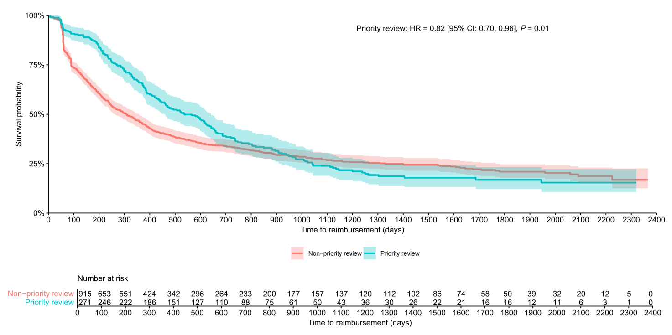

Figure S1: Kaplan–Meyer curves of public funding reimbursement and time to reimbursement (by priority review)
Notes: HR = hazard ratio; P for test of group difference; Bold means statistically significant.

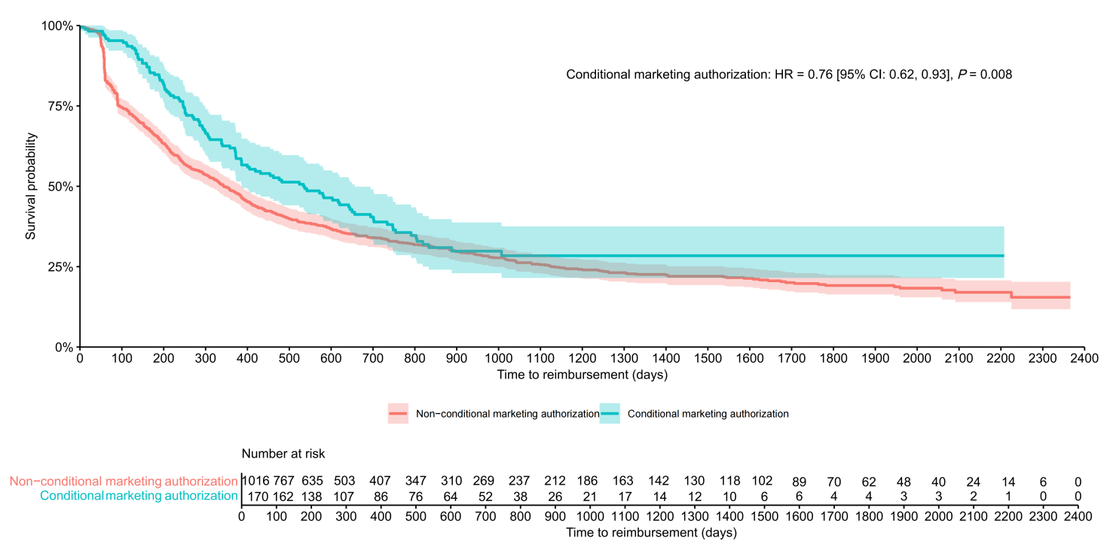

Figure S2: Kaplan–Meyer curves of public funding reimbursement and time to reimbursement (by conditional marketing authorization)
Notes: HR = hazard ratio; P for test of group difference; Bold means statistically significant.

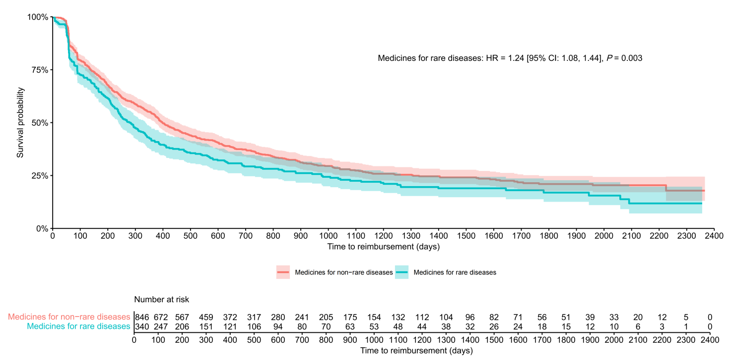

Figure S3: Kaplan–Meyer curves of public funding reimbursement and time to reimbursement (by medicines for rare diseases)
Notes: HR = hazard ratio; P for test of group difference; Bold means statistically significant.

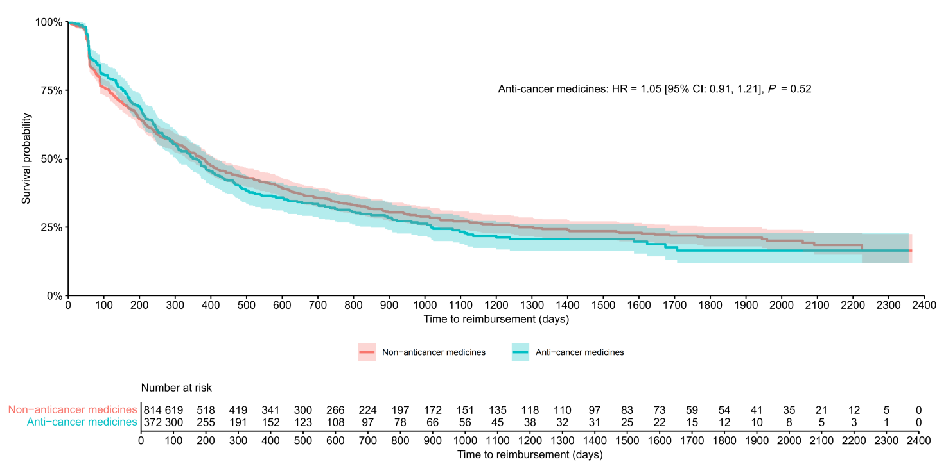

Figure S4: Kaplan–Meyer curves of public funding reimbursement and time to reimbursement (by anti-cancer medicines)
Notes: HR = hazard ratio; P for test of group difference; Bold means statistically significant.

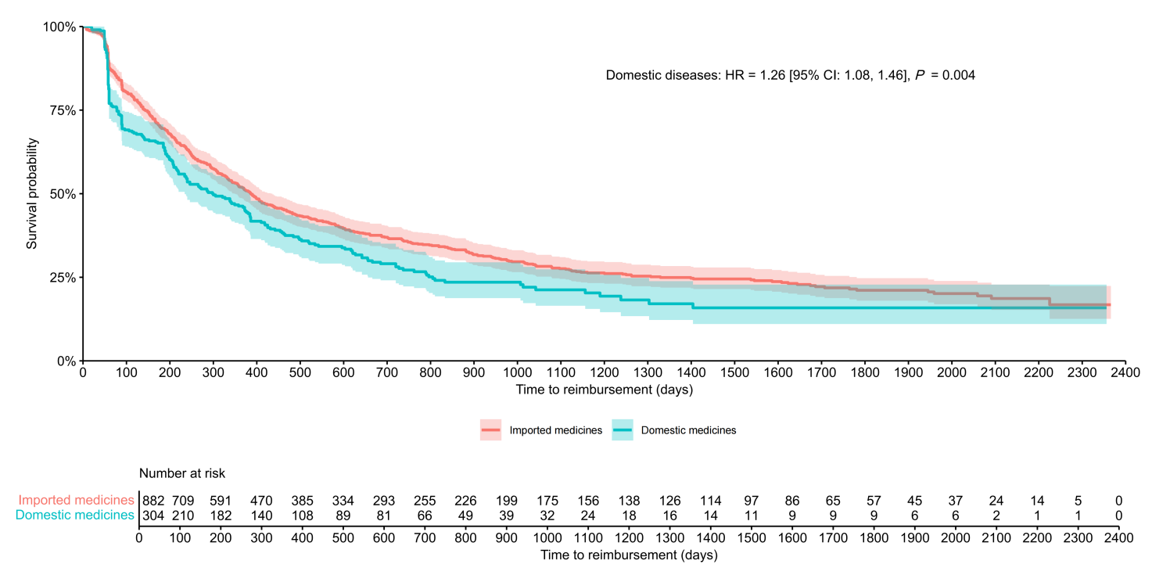

Figure S5: Kaplan–Meyer curves of public funding reimbursement and time to reimbursement (by origin)
Notes: HR = hazard ratio; P for test of group difference; Bold means statistically significant.

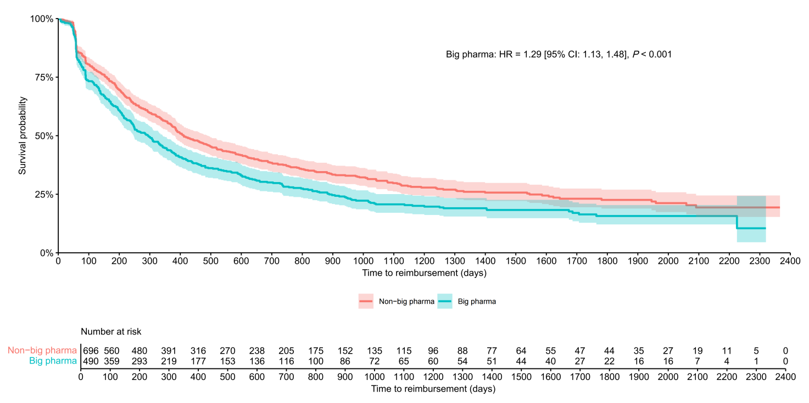

Figure S6: Kaplan–Meyer curves of public funding reimbursement and time to reimbursement (by big pharma)
Notes: HR = hazard ratio; P for test of group difference; Bold means statistically significant.

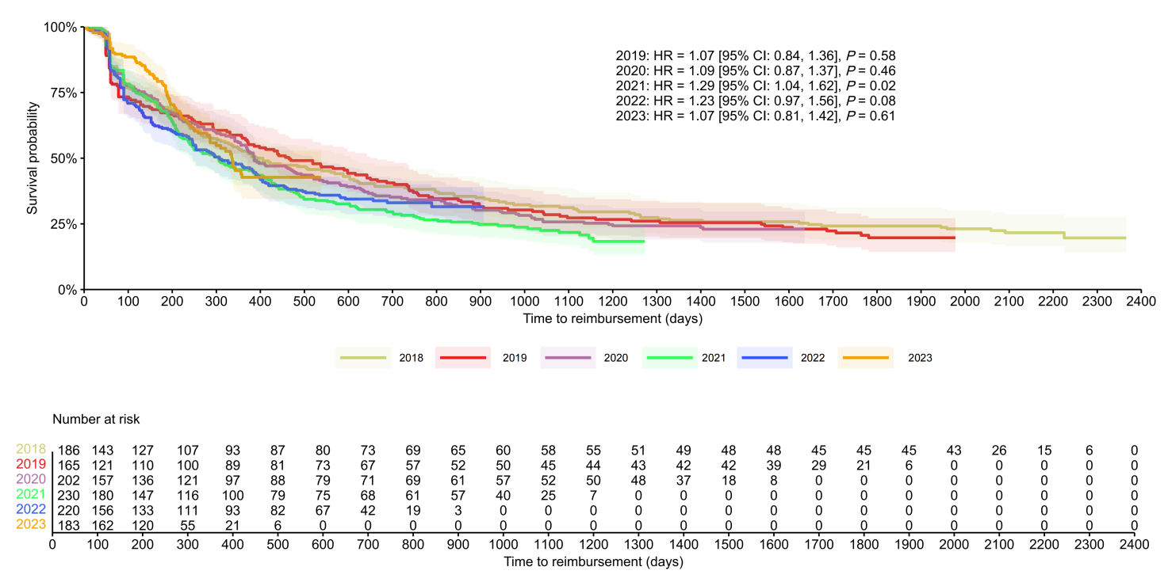

Figure S7: Kaplan–Meyer curves of public funding reimbursement and time to reimbursement (by year)
Notes: HR = hazard ratio; P for test of group difference; Bold means statistically significant.

Table S7: Univariate Cox proportional hazard regression analysis in different countries
Category | Variable | No. of medicines | Hazard Ratio | 95% CI | P-value
All countries | Country
All countries | China (Ref.) | 300
All countries | Japan | 226 | 9.11 | 7.38, 11.25 | <0.001
All countries | France | 233 | 1.59 | 1.29, 1.97 | <0.001
All countries | United Kingdom | 228 | 1.27 | 1.03, 1.57 | 0.03
All countries | Switzerland | 199 | 1.21 | 0.96, 1.52 | 0.11
All countries | Year
All countries | 2018 (Ref.) | 186
All countries | 2019 | 165 | 1.07 | 0.84, 1.36 | 0.58
All countries | 2020 | 202 | 1.09 | 0.87, 1.37 | 0.46
All countries | 2021 | 230 | 1.29 | 1.04, 1.62 | 0.02
All countries | 2022 | 220 | 1.23 | 0.97, 1.56 | 0.08
All countries | 2023 | 183 | 1.07 | 0.81, 1.42 | 0.61
All countries | Priority review
All countries | No (Ref.) | 915
All countries | Yes | 271 | 0.82 | 0.70, 0.96 | 0.01
All countries | Conditional marketing authorization
All countries | No (Ref.) | 1016
All countries | Yes | 170 | 0.76 | 0.62, 0.93 | 0.008
All countries | Orphan medicines
All countries | No (Ref.) | 846
All countries | Yes | 340 | 1.24 | 1.08, 1.44 | 0.003
All countries | Anti-cancer medicines
All countries | No (Ref.) | 814
All countries | Yes | 372 | 1.05 | 0.91, 1.21 | 0.52
All countries | Origin
All countries | Imported (Ref.) | 882
All countries | Domestic | 304 | 1.26 | 1.08, 1.46 | 0.004
All countries | Big pharma
All countries | No (Ref.) | 696
All countries | Yes | 490 | 1.29 | 1.13, 1.48 | <0.001
China | Year
China | 2018 (Ref.) | 47
China | 2019 | 44 | 1.12 | 0.69, 1.83 | 0.64
China | 2020 | 46 | 1.48 | 0.91, 2.43 | 0.12
China | 2021 | 60 | 1.95 | 1.22, 3.11 | 0.005
China | 2022 | 38 | 1.29 | 0.71, 2.34 | 0.39
China | 2023 | 65 | 3.56 | 1.99, 6.35 | <0.001
China | Priority review
China | No (Ref.) | 109
China | Yes | 191 | 1.10 | 0.81, 1.50 | 0.54
China | Conditional marketing authorization
China | No (Ref.) | 231
China | Yes | 69 | 0.65 | 0.45, 0.96 | 0.03
China | Orphan medicines
China | No (Ref.) | 264
China | Yes | 36 | 1.15 | 0.76, 1.76 | 0.50
China | Anti-cancer medicines
China | No (Ref.) | 186
China | Yes | 114 | 0.81 | 0.60, 1.10 | 0.17
China | Origin
China | Imported (Ref.) | 178
China | Domestic | 122 | 1.97 | 1.47, 2.65 | <0.001
China | Big pharma
China | No (Ref.) | 191
China | Yes | 109 | 0.79 | 0.59, 1.07 | 0.13
Japan | Year
Japan | 2018 (Ref.) | 35
Japan | 2019 | 37 | 1.44 | 0.90, 2.29 | 0.13
Japan | 2020 | 37 | 1.25 | 0.78, 2.00 | 0.35
Japan | 2021 | 47 | 0.86 | 0.54, 1.35 | 0.51
Japan | 2022 | 46 | 0.94 | 0.60, 1.46 | 0.77
Japan | 2023 | 24 | 0.34 | 0.18, 0.65 | 0.001
Japan | Priority review
Japan | No (Ref.) | 209
Japan | Yes | 17 | 1.94 | 1.18, 3.21 | 0.009
Japan | Conditional marketing authorization
Japan | No (Ref.) | 223
Japan | Yes | 3 | 2.09 | 0.67, 6.57 | 0.21
Japan | Orphan medicines
Japan | No (Ref.) | 152
Japan | Yes | 74 | 1.50 | 1.13, 2.01 | 0.006
Japan | Anti-cancer medicines
Japan | No (Ref.) | 169
Japan | Yes | 57 | 1.27 | 0.93, 1.73 | 0.14
Japan | Origin
Japan | Imported (Ref.) | 123
Japan | Domestic | 103 | 1.15 | 0.88, 1.51 | 0.32
Japan | Big pharma
Japan | No (Ref.) | 132
Japan | Yes | 94 | 1.00 | 0.76, 1.32 | 0.98
France | Year
France | 2018 (Ref.) | 38
France | 2019 | 29 | 0.70 | 0.40, 1.23 | 0.22
France | 2020 | 38 | 0.88 | 0.52, 1.50 | 0.64
France | 2021 | 46 | 1.20 | 0.73, 1.95 | 0.47
France | 2022 | 52 | 1.02 | 0.63, 1.67 | 0.92
France | 2023 | 30 | 1.57 | 0.90, 2.75 | 0.11
France | Priority review
France | No (Ref.) | 226
France | Yes | 7 | 2.02 | 0.94, 4.31 | 0.07
France | Conditional marketing authorization
France | No (Ref.) | 199
France | Yes | 34 | 1.23 | 0.81, 1.87 | 0.33
France | Orphan medicines
France | No (Ref.) | 157
France | Yes | 76 | 1.45 | 1.06, 1.99 | 0.02
France | Anti-cancer medicines
France | No (Ref.) | 160
France | Yes | 73 | 1.09 | 0.79, 1.51 | 0.61
France | Origin
France | Imported (Ref.) | 223
France | Domestic | 10 | 1.02 | 0.48, 2.18 | 0.96
France | Big pharma
France | No (Ref.) | 134
France | Yes | 99 | 1.43 | 1.05, 1.93 | 0.02
United Kingdom | Year
United Kingdom | 2018 (Ref.) | 38
United Kingdom | 2019 | 29 | 1.05 | 0.60, 1.84 | 0.87
United Kingdom | 2020 | 43 | 1.01 | 0.60, 1.71 | 0.97
United Kingdom | 2021 | 44 | 1.81 | 1.08, 3.01 | 0.02
United Kingdom | 2022 | 44 | 1.63 | 0.94, 2.82 | 0.08
United Kingdom | 2023 | 30 | 2.43 | 1.26, 4.70 | 0.008
United Kingdom | Priority review
United Kingdom | No (Ref.) | 188
United Kingdom | Yes | 40 | 1.55 | 1.06, 2.26 | 0.02
United Kingdom | Conditional marketing authorization
United Kingdom | No (Ref.) | 199
United Kingdom | Yes | 29 | 1.88 | 1.21, 2.92 | 0.005
United Kingdom | Orphan medicines
United Kingdom | No (Ref.) | 158
United Kingdom | Yes | 70 | 0.99 | 0.71, 1.39 | 0.96
United Kingdom | Anti-cancer medicines
United Kingdom | No (Ref.) | 160
United Kingdom | Yes | 68 | 2.01 | 1.45, 2.80 | <0.001
United Kingdom | Origin
United Kingdom | Imported (Ref.) | 206
United Kingdom | Domestic | 22 | 0.71 | 0.40, 1.25 | 0.23
United Kingdom | Big pharma
United Kingdom | No (Ref.) | 138
United Kingdom | Yes | 90 | 1.71 | 1.24, 2.34 | 0.001
Switzerland | Year
Switzerland | 2018 (Ref.) | 28
Switzerland | 2019 | 26 | 1.53 | 0.80, 2.95 | 0.20
Switzerland | 2020 | 38 | 1.34 | 0.73, 2.45 | 0.34
Switzerland | 2021 | 33 | 1.18 | 0.62, 2.24 | 0.62
Switzerland | 2022 | 40 | 1.06 | 0.55, 2.04 | 0.86
Switzerland | 2023 | 34 | 0.88 | 0.40, 1.91 | 0.74
Switzerland | Priority review
Switzerland | No (Ref.) | 183
Switzerland | Yes | 16 | 1.75 | 1.01, 3.06 | 0.051
Switzerland | Conditional marketing authorization
Switzerland | No (Ref.) | 164
Switzerland | Yes | 35 | 1.02 | 0.64, 1.63 | 0.92
Switzerland | Orphan medicines
Switzerland | No (Ref.) | 115
Switzerland | Yes | 84 | 0.93 | 0.65, 1.33 | 0.68
Switzerland | Anti-cancer medicines
Switzerland | No (Ref.) | 139
Switzerland | Yes | 60 | 1.18 | 0.81, 1.72 | 0.39
Switzerland | Origin
Switzerland | Imported (Ref.) | 152
Switzerland | Domestic | 47 | 0.59 | 0.37, 0.93 | 0.02
Switzerland | Big pharma
Switzerland | No (Ref.) | 101
Switzerland | Yes | 98 | 2.07 | 1.44, 2.99 | <0.001
Notes: CI = confidence interval; P-value for test of group difference; Bold means statistically significant.

Table S8: Multiple Cox proportional hazard regression analysis in different countries
 | HR (95%CI)
 | All countries | China | Japan | France | United Kingdom | Switzerland
Priority review | 1.45 (1.17, 1.79) ** | 1.48 (1.05, 2.09) * | 1.58 (0.91, 2.74) | 1.93 (0.84, 4.48) | 1.5 (1.01, 2.22) * | 1.45 (0.79, 2.67)
Conditional marketing authorization | 0.87 (0.69, 1.09) | 0.42 (0.27, 0.68) *** | 1.71 (0.51, 5.74) | 1.04 (0.64, 1.70) | 1.18 (0.71, 1.95) | 0.88 (0.52, 1.49)
Medicines for rare diseases | 1.29 (1.11, 1.51) ** | 0.93 (0.58, 1.48) | 1.52 (1.11, 2.08) ** | 1.45 (1.04, 2.04) * | 1.15 (0.80, 1.65) | 0.85 (0.58, 1.25)
Anti-cancer medicines | 1.18 (1.01, 1.38) * | 0.87 (0.62, 1.23) | 1.09 (0.77, 1.53) | 0.99 (0.68, 1.43) | 1.91 (1.34, 2.71) *** | 1.01 (0.67, 1.53)
Domestic medicines | 1.24 (1.04, 1.47) * | 2.09 (1.43, 3.06) *** | 1.19 (0.82, 1.72) | 1.13 (0.52, 2.46) | 0.59 (0.33, 1.06) | 0.61 (0.38, 0.98) *
Big pharma | 1.38 (1.19, 1.60) *** | 1.21 (0.83, 1.78) | 1.18 (0.81, 1.74) | 1.49 (1.08, 2.06) * | 1.80 (1.29, 2.52) *** | 2.01 (1.36, 2.99) ***
Year (2018 as reference)
2019 | 1.11 (0.87, 1.41) | 1.18 (0.72, 1.93) | 1.46 (0.91, 2.34) | 0.91 (0.50, 1.66) | 1.01 (0.56, 1.81) | 1.04 (0.52, 2.08)
2020 | 1.08 (0.86, 1.36) | 1.55 (0.94, 2.55) | 1.41 (0.88, 2.28) | 0.87 (0.49, 1.54) | 0.98 (0.57, 1.66) | 1.06 (0.55, 2.01)
2021 | 1.07 (0.85, 1.35) | 2.34 (1.41, 3.87) ** | 0.86 (0.54, 1.37) | 1.36 (0.80, 2.29) | 1.68 (0.99, 2.85) | 1.06 (0.54, 2.08)
2022 | 1.15 (0.90, 1.46) | 1.66 (0.88, 3.12) | 1.01 (0.64, 1.59) | 1.16 (0.69, 1.95) | 1.65 (0.95, 2.87) | 0.97 (0.48, 1.95)
2023 | 0.97 (0.73, 1.28) | 4.28 (2.31, 7.90) *** | 0.38 (0.19, 0.73) ** | 1.75 (0.97, 3.17) | 2.38 (1.19, 4.74) * | 0.72 (0.33, 1.60)
Country (China as reference)
Japan | 11.29 (8.63, 14.77) ***
France | 2.08 (1.60, 2.72) ***
United Kingdom | 1.55 (1.21, 1.99) **
Switzerland | 1.37 (1.04, 1.8) *
Notes: HR = hazard ratio; CI = confidence interval; P-value for test of group difference: *P-value < 0.05; **P-value < 0.01; ***P-value < 0.001.

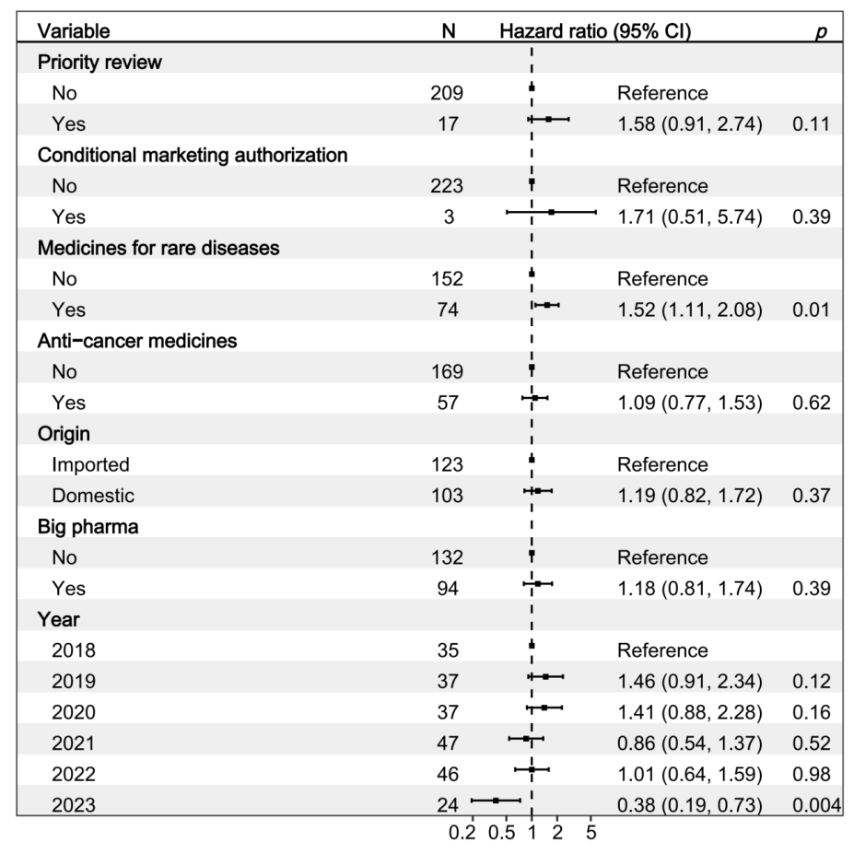

Figure S8: Hazard Ratios for public funding reimbursement of novel medicines in Japan
Notes: CI = confidence interval

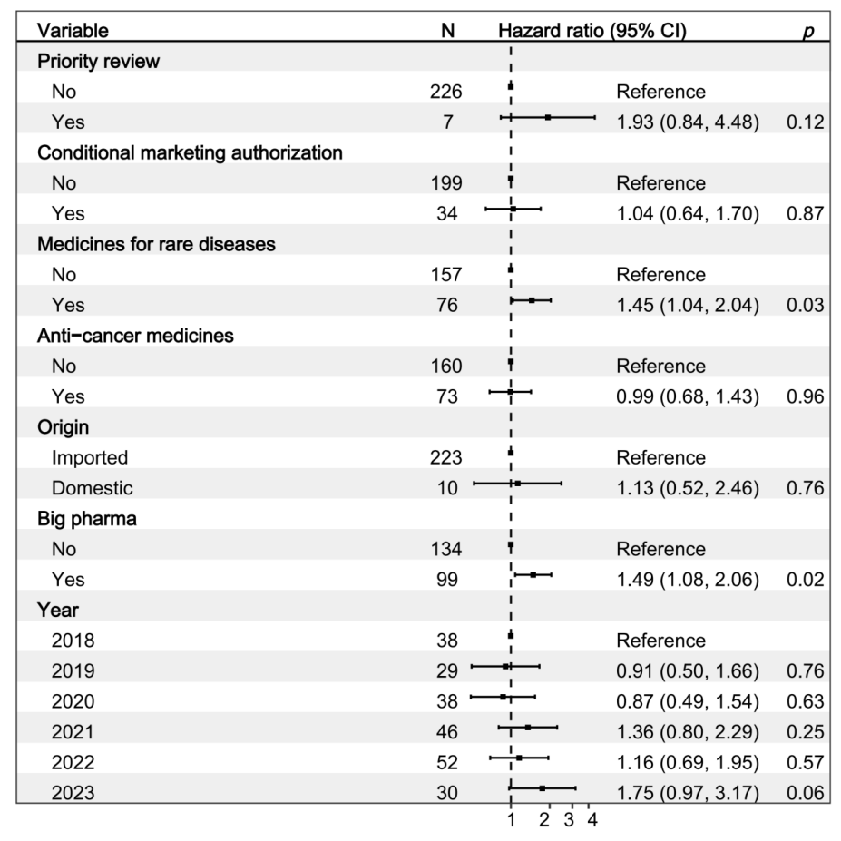

Figure S9: Hazard Ratios for public funding reimbursement of novel medicines in France
Notes: CI = confidence interval

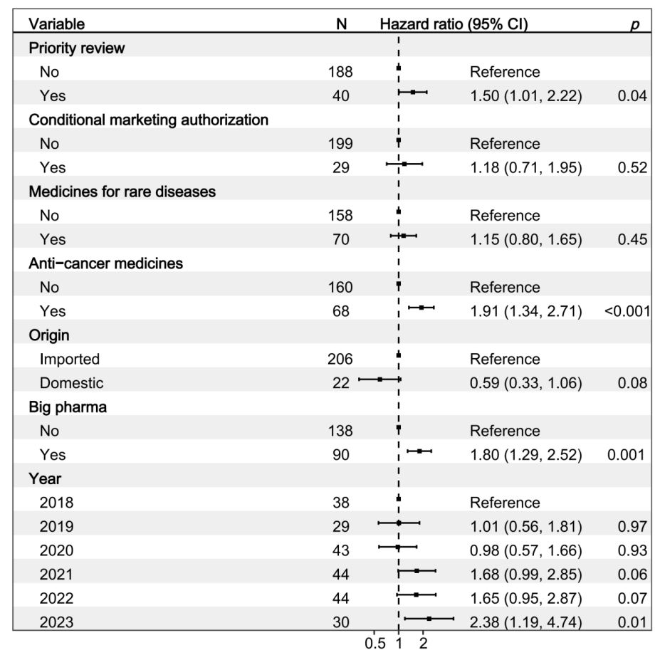

Figure S10: Hazard Ratios for public funding reimbursement of novel medicines in United Kingdom
Notes: CI = confidence interval

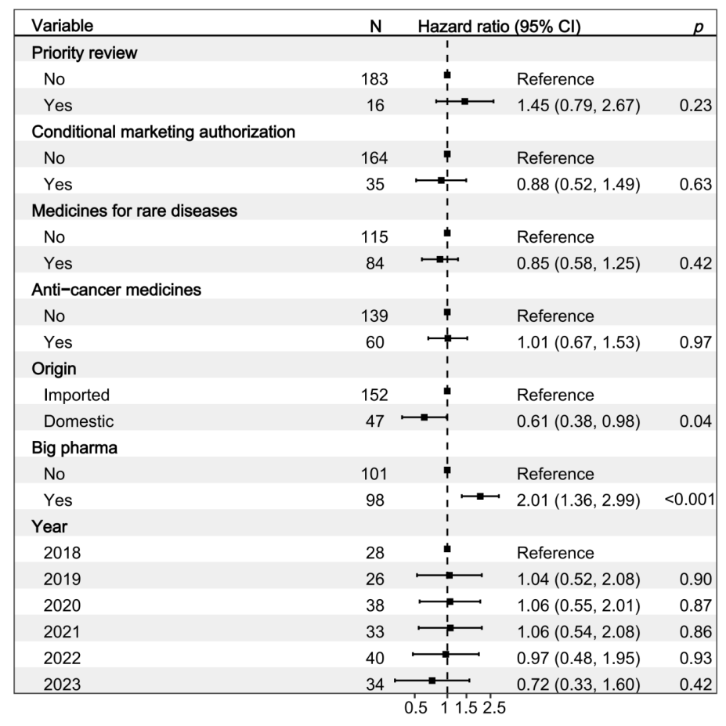

Figure S11: Hazard Ratios for public funding reimbursement of novel medicines in Switzerland
Notes: CI = confidence interval

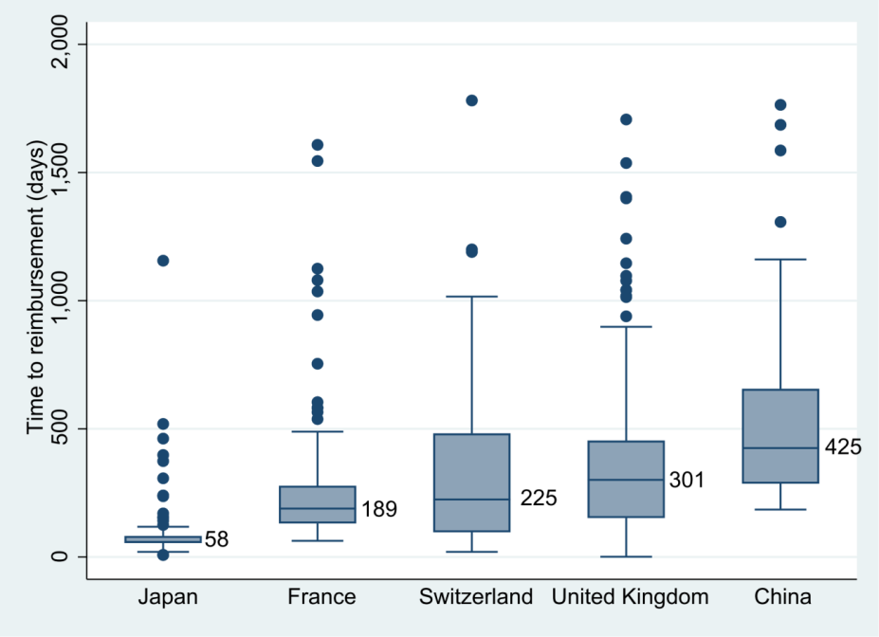

Figure S12: Sensitivity analysis of boxplots of time to reimbursement for the reimbursed novel medicines in five countries

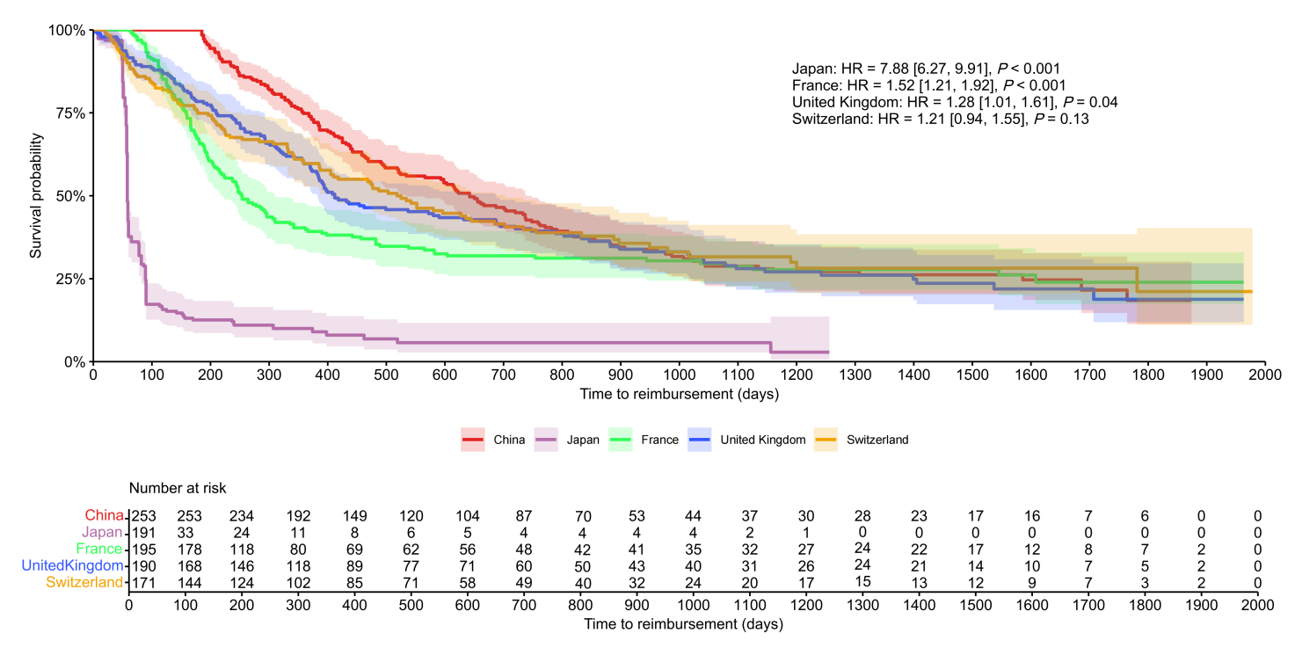

Figure S13: Sensitivity analysis of Kaplan-Meyer curve of time to reimbursement in five countries

Table S9: Sensitivity analysis of Kruskal-Wallis H test for difference in TTR between the countries
 | China | Japan | France | United Kingdom | Switzerland
China
Japan | <0.000001
France | <0.000001 | <0.000001
United Kingdom | 0.002 | <0.000001 | 0.03
Switzerland | 0.0001 | <0.000001 | 0.16 | 0.19
Notes: Bold means statistically significant.

Table S10: Sensitivity analysis of Kruskal-Wallis H test with Bonferroni correction for difference in TTR between the countries
 | China | Japan | France | United Kingdom | Switzerland
China
Japan | <0.001
France | 0.03 | <0.001
United Kingdom | >0.99 | <0.001 | 0.97
Switzerland | 0.22 | <0.001 | >0.99 | >0.99
Notes: Bold means statistically significant. Given the number of statistical tests performed within this study we used a Bonferroni correction. For this correction we corrected for individual comparisons between countries. The correction used for the paired differences between the countries was the number of individual paired comparisons (n = 10).

Table S11: Sensitivity analysis of univariate Cox proportional hazard regression analysis in all countries and China
Categories | Variables | No. of medicines | Hazard Ratio | 95% CI | P-value
All countries | Country
All countries | China (Ref.) | 253
All countries | Japan | 191 | 7.88 | 6.27, 9.91 | <0.001
All countries | France | 195 | 1.52 | 1.21, 1.92 | <0.001
All countries | United Kingdom | 190 | 1.28 | 1.01, 1.61 | 0.04
All countries | Switzerland | 171 | 1.21 | 0.94, 1.55 | 0.13
All countries | Year
All countries | 2019 (Ref.) | 165
All countries | 2020 | 202 | 1.04 | 0.82, 1.31 | 0.76
All countries | 2021 | 230 | 1.23 | 0.98, 1.54 | 0.08
All countries | 2022 | 220 | 1.17 | 0.92, 1.49 | 0.21
All countries | 2023 | 183 | 1.03 | 0.77, 1.36 | 0.85
All countries | Priority review
All countries | No (Ref.) | 779
All countries | Yes | 221 | 0.83 | 0.70, 0.99 | 0.04
All countries | Conditional marketing authorization
All countries | No (Ref.) | 835
All countries | Yes | 165 | 0.76 | 0.62, 0.93 | 0.009
All countries | Medicines for rare diseases
All countries | No (Ref.) | 715
All countries | Yes | 285 | 1.27 | 1.08, 1.49 | 0.004
All countries | Anti-cancer medicines
All countries | No (Ref.) | 679
All countries | Yes | 321 | 1.01 | 0.86, 1.18 | 0.93
All countries | Origin
All countries | Imported (Ref.) | 735
All countries | Domestic | 265 | 1.22 | 1.04, 1.45 | 0.02
All countries | Big pharma
All countries | No (Ref.) | 596
All countries | Yes | 404 | 1.26 | 1.09, 1.46 | 0.002
China | Year
China | 2019 (Ref.) | 44
China | 2020 | 46 | 1.35 | 0.83, 2.21 | 0.23
China | 2021 | 60 | 1.72 | 1.08, 2.73 | 0.02
China | 2022 | 38 | 1.13 | 0.63, 2.05 | 0.68
China | 2023 | 65 | 3.02 | 1.69, 5.39 | <0.001
China | Priority review
China | No (Ref.) | 97
China | Yes | 156 | 1.11 | 0.79, 1.55 | 0.55
China | Conditional marketing authorization
China | No (Ref.) | 188
China | Yes | 65 | 0.65 | 0.44, 0.97 | 0.03
China | Medicines for rare diseases
China | No (Ref.) | 221
China | Yes | 32 | 1.10 | 0.69, 1.74 | 0.69
China | Anti-cancer medicines
China | No (Ref.) | 158
China | Yes | 95 | 0.74 | 0.53, 1.03 | 0.08
China | Origin
China | Imported (Ref.) | 142
China | Domestic | 111 | 1.84 | 1.33, 2.54 | <0.001
China | Big pharma
China | No (Ref.) | 168
China | Yes | 85 | 0.84 | 0.60, 1.18 | 0.32
Notes: CI = confidence interval; P-value for test of group difference; Bold means statistically significant.

Table S12: Sensitivity analysis of multiple Cox proportional hazard regression analysis in all countries and China
 | All countries |  |  |  | China
Variables | Hazard Ratio | 95% CI | P-value |  | Hazard Ratio | 95% CI | P-value
Year
2020 | 0.99 | 0.78, 1.25 | 0.92 |  | 1.35 | 0.82, 2.23 | 0.24
2021 | 1.00 | 0.79, 1.27 | 0.997 |  | 2.01 | 1.21, 3.34 | 0.007
2022 | 1.05 | 0.82, 1.35 | 0.68 |  | 1.40 | 0.74, 2.64 | 0.30
2023 | 0.91 | 0.68, 1.21 | 0.52 |  | 3.54 | 1.89, 6.63 | <0.001
Priority review
No (Ref.)
Yes | 1.45 | 1.14, 1.84 | 0.002 |  | 1.51 | 1.03, 2.22 | 0.04
Conditional marketing authorization
No (Ref.)
Yes | 0.89 | 0.70, 1.12 | 0.32 |  | 0.47 | 0.29, 0.76 | 0.002
Orphan medicines
No (Ref.)
Yes | 1.29 | 1.09, 1.53 | 0.003 |  | 0.86 | 0.51, 1.44 | 0.56
Anti-cancer medicines
No (Ref.)
Yes | 1.13 | 0.96, 1.35 | 0.15 |  | 0.76 | 0.52, 1.12 | 0.17
Origin
Imported (Ref.)
Domestic | 1.23 | 1.02, 1.49 | 0.03 |  | 2.14 | 1.36, 3.36 | 0.001
Big pharma
No (Ref.)
Yes | 1.34 | 1.14, 1.58 | <0.001 |  | 1.32 | 0.83, 2.10 | 0.25
Country
China (Ref.)
Japan | 9.65 | 7.23, 12.9 | <0.001
France | 1.98 | 1.48, 2.67 | <0.001
United Kingdom | 1.55 | 1.18, 2.03 | 0.002
Switzerland | 1.34 | 0.99, 1.80 | 0.06
 | N = 1000 |  |  |  | N = 253
Notes: HR = hazard ratio; CI = confidence interval; P-value for test of group difference; Bold means statistically significant.

Table S13: Cross-country comparisons of mechanisms for reimbursement decision on novel medicines
 | China | Japan | France | United Kingdom | Switzerland
Dominated health security system | Basic Health Insurance | Social Health Insurance | Mandatory Social Health Insurance | National Health Service | Mandatory health insurance managed in the non-profit part of commercial insurers under strict government regulation
Centralized reimbursement list | Yes | Yes | Separate lists for outpatient and inpatient | Yes (Through inclusion in the published Guidance) | Separate lists for outpatient and inpatient
Update frequency | Once per year | Four times per year | Once per year | As needed | Once per year
Centralized health technology assessment agency | No | Health Technology Assessment Center for Health and Medical Economics | Transparency Committee | National Institute for Health and Care Excellence | No
Criteria for public funding reimbursement | Efficacy, safety, innovativeness, equity and cost-effectiveness | Improvement in treatment, disease severity, clinical outcome including efficacy and safety, therapeutic class, availability of alternative therapies, public health impact | Clinical benefit and improvement of clinical benefit comparing with existing therapeutics | Clinical efficacy, cost-effectiveness, budget impact | Clinical efficacy, appropriateness, and economic benefit

Appendix: The list of big pharma (sort by alphabet)
AbbVie Inc., Amgen Inc., AstraZeneca PLC, Bayer AG, Bristol-Myers Squibb Company, Eli Lilly and Company, Gilead Sciences, Inc., GlaxoSmithKline plc (GSK), Johnson & Johnson, Merck & Co., Inc., Novo Nordisk A/S, Novartis International AG, Pfizer Inc., Roche Holding AG, Sanofi S.A., Takeda Pharmaceutical Company Limited.

Reference
[1] U.S. Food and Drug Administration. New Drugs at FDA: CDER’s New Molecular Entities and New Therapeutic Biological Products [Internet]. https://www.fda.gov/drugs/development-approval-process-drugs/new-drugs-fda-cders-new-molecular-entities-and-new-therapeutic-biological-products. Accessed 3 Jun 2025.
[2] State Administration for Market Regulation. Provisions for Drug Registration. https://www.gov.cn/zhengce/zhengceku/2020-04/01/content_5498012.htm. Accessed 3 Jun 2025.
[3] Pharmaceuticals and Medical Devices Agency. New Pharmaceuticals (Prescription Drugs). https://www.pmda.go.jp/review-services/drug-reviews/about-reviews/p-drugs/0021.html. Accessed 3 Jun 2025.
[4] European Medicines Agency. Innovative medicine. https://www.ema.europa.eu/en/glossary/innovative-medicine. Accessed 3 Jun 2025.
[5] Erice statement on drug innovation. Br J Clin Pharmacol. 2008;65(3):440-1. doi:10.1111/j.1365-2125.2007.03033.x.
[6] Ward DJ, Martino OI, Simpson S, Stevens AJ. Decline in new drug launches: myth or reality? Retrospective observational study using 30 years of data from the UK. BMJ Open. 2013;3(2):e002088. doi:10.1136/bmjopen-2012-002088.
[7] Swiss Agency for Therapeutic Products. Federal Act on Medicinal Products and Medical Devices (Therapeutic Products Act, TPA). https://www.fedlex.admin.ch/eli/cc/2001/422/en. Accessed 3 Jun 2025.
[8] Center for Drug Evaluation, National Medical Products Administration. 2023 Annual Drug Review Report. https://www.nmpa.gov.cn/xxgk/fgwj/gzwj/gzwjyp/20240204154334141.html. Accessed 3 Jun 2025.
[9] Center for Drug Evaluation, National Medical Products Administration. 2022 Annual Drug Review Report. https://www.nmpa.gov.cn/xxgk/fgwj/gzwj/gzwjyp/20230906163722146.html. Accessed 3 Jun 2025.
[10] Center for Drug Evaluation, National Medical Products Administration. 2021 Annual Drug Review Report. https://www.nmpa.gov.cn/directory/web/nmpa/xxgk/fgwj/gzwj/gzwjyp/20220601110541120.html. Accessed 3 Jun 2025.
[11] Center for Drug Evaluation, National Medical Products Administration. 2020 Annual Drug Review Report. https://www.nmpa.gov.cn/directory/web/nmpa/xxgk/fgwj/gzwj/gzwjyp/20210621142436183.html. Accessed 3 Jun 2025.
[12] Center for Drug Evaluation, National Medical Products Administration. 2019 Annual Drug Review Report. https://www.nmpa.gov.cn/xxgk/fgwj/gzwj/gzwjyp/20200731114330106.html. Accessed 3 Jun 2025.
[13] Center for Drug Evaluation, National Medical Products Administration. 2018 Annual Drug Review Report. https://www.nmpa.gov.cn/directory/web/nmpa/xxgk/fgwj/gzwj/gzwjyp/20190701175801236.html. Accessed 3 Jun 2025.
[14] Global Approved New Drugs. Beijing, China. 2025. https://data.pharmacodia.com/innovativeDrugs. Accessed 3 Jun 2025.
[15] China Approved Drug System. Shanghai, China. 2025. https://webvpn.cpu.edu.cn/https/77726476706e69737468656265737421e6fe51d23e31674a76468aa395/cfdadrug/list. Accessed 3 Jun 2025.
[16] Global New Drug Database. Hangzhou, China. 2025. https://db.dxy.cn/v5/globaldrugproject. Accessed 3 Jun 2025.
[17] Pharmaceuticals and Medical Devices Agency. List of Approved Products. https://www.pmda.go.jp/english/review-services/reviews/approved-information/drugs/0002.html. Accessed 3 Jun 2025.
[18] Japan Approved Drug System. Shanghai, China. 2025. https://webvpn.cpu.edu.cn/https/77726476706e69737468656265737421e6fe51d23e31674a76468aa395/pmda. Accessed 3 Jun 2025.
[19] European Medicines Agency. Medicines. https://www.ema.europa.eu/en/medicines/download-medicine-data. Accessed 3 Jun 2025.
[20] Lara J, Bujar M, Kermad A, McAuslane N, Somuyiwa A. List of NASs approved by the six regulatory authorities. London, United Kingdom: Center for Innovation in Regulatory Science; 2024.
[21] Lara J, Bujar M, Kermad A, McAuslane N, Somuyiwa A. List of NASs approved by the six regulatory authorities. London, United Kingdom: Center for Innovation in Regulatory Science; 2023.
[22] Lara J, Bujar M, McAuslane N. New Active Substances (NASs) approved by six major authorities in 2021. London, United Kingdom: Center for Innovation in Regulatory Science; 2022.
[23] Bujar M, McAuslane N. New Active Substances (NASs) approved by six major authorities in 2020. London, United Kingdom: Center for Innovation in Regulatory Science; 2021.
[24] Rodier C, Bujar M, McAuslane N, Liberti L, Munro JW. New Active Substances (NASs) approved by six major authorities in 2019. London, United Kingdom: Center for Innovation in Regulatory Science; 2020.
[25] EMA Approved Drug System. Shanghai, China. 2025. https://webvpn.cpu.edu.cn/https/77726476706e69737468656265737421e6fe51d23e31674a76468aa395/epyp/list. Accessed 3 Jun 2025.
[26] Medicines and Healthcare products Regulatory Agency. Marketing authorisations: lists of granted licences. https://www.gov.uk/government/collections/marketing-authorisations-lists-of-granted-licences. Accessed 3 Jun 2025.
[27] UK Approved Drug System. Shanghai, China. 2025. https://webvpn.cpu.edu.cn/https/77726476706e69737468656265737421e6fe51d23e31674a76468aa395/uk. Accessed 3 Jun 2025.
[28] Swiss Agency for Therapeutic Products. List of authorised medicinal products. https://www.swissmedic.ch/swissmedic/en/home/services/listen_neu.html. Accessed 3 Jun 2025.
[29] Swiss Agency for Therapeutic Products. Swissmedic Annual Report 2018. https://www.swissmedic.ch/swissmedic/en/home/about-us/publications/aktueller-geschaeftsbericht/swissmedic-geschaeftsbericht-2018.html. Accessed 3 Jun 2025.
[30] Swiss Agency for Therapeutic Products. Swissmedic Annual Report 2019. https://www.swissmedic.ch/swissmedic/en/home/about-us/publications/aktueller-geschaeftsbericht/swissmedic-geschaeftsbericht-2019.html. Accessed 3 Jun 2025.
[31] Swiss Agency for Therapeutic Products. Swissmedic Annual Report 2020. https://www.swissmedic.ch/swissmedic/en/home/about-us/publications/aktueller-geschaeftsbericht/swissmedic-geschaeftsbericht-2020.html. Accessed 3 Jun 2025.
[32] Swiss Agency for Therapeutic Products. Swissmedic Annual Report 2021. https://www.swissmedic.ch/swissmedic/en/home/about-us/publications/aktueller-geschaeftsbericht/swissmedic-geschaeftsbericht-2021.html. Accessed 3 Jun 2025.
[33] Swiss Agency for Therapeutic Products. Swissmedic Annual Report 2022. https://www.swissmedic.ch/swissmedic/en/home/about-us/publications/aktueller-geschaeftsbericht/swissmedic-geschaeftsbericht-2022.html. Accessed 3 Jun 2025.
[34] Swiss Agency for Therapeutic Products. Swissmedic Annual Report 2023. https://www.swissmedic.ch/swissmedic/en/home/about-us/publications/aktueller-geschaeftsbericht/swissmedic-geschaeftsbericht-2023.html. Accessed 3 Jun 2025.
[35] Global Approved Drug Screening System. Shanghai, China. 2025. https://webvpn.cpu.edu.cn/https/77726476706e69737468656265737421e6fe51d23e31674a76468aa395/globalapproval/list. Accessed 3 Jun 2025.
[36] National Healthcare Security Administration. Notice on the issuance of the "National Basic Medical Insurance, Work-related Injury Insurance and Maternity Insurance Drug Catalogue (2023)". https://www.nhsa.gov.cn/art/2023/12/13/art_104_11673.html. Accessed 3 Jun 2025.
[37] National Healthcare Security Administration. Notice on the issuance of the "National Basic Medical Insurance, Work-related Injury Insurance and Maternity Insurance Drug Catalogue (2022)". https://www.nhsa.gov.cn/art/2023/1/18/art_104_10078.html. Accessed 3 Jun 2025.
[38] National Healthcare Security Administration. Notice on the issuance of the "National Basic Medical Insurance, Work-related Injury Insurance and Maternity Insurance Drug Catalogue (2021)". https://www.nhsa.gov.cn/art/2021/12/3/art_104_7438.html. Accessed 3 Jun 2025.
[39] National Healthcare Security Administration. Notice on the issuance of the "National Basic Medical Insurance, Work-related Injury Insurance and Maternity Insurance Drug Catalogue (2020)". https://www.nhsa.gov.cn/art/2020/12/28/art_53_4223.html. Accessed 3 Jun 2025.
[40] National Healthcare Security Administration. Notice on the issuance of the "National Basic Medical Insurance, Work-related Injury Insurance and Maternity Insurance Drug Catalogue (2019)". https://www.nhsa.gov.cn/art/2019/8/20/art_53_1667.html. Accessed 3 Jun 2025.
[41] National Healthcare Security Administration. Notice on the inclusion of 17 anti-cancer drugs in the Category B of the National Basic Medical Insurance, Work-related Injury Insurance, and Maternity Insurance Drug Catalogue. https://www.nhsa.gov.cn/art/2018/10/10/art_53_1058.html. Accessed 3 Jun 2025.
[42] Pharmaceuticals and Medical Devices Agency. Central Social Insurance Medical Council (Central Social Insurance Medical Council General Meeting). https://www.mhlw.go.jp/stf/shingi/shingi-chuo_128154.html. Accessed 3 Jun 2025.
[43] Haute Autorité de santé. All publications-Recommendations, medications, procedures, devices, etc. https://www.has-sante.fr/jcms/fc_2875208/fr/rechercher-une-recommandation-un-avis. Accessed 3 Jun 2025.
[44] National Institute for Health and Care Excellence. Technology appraisal guidance. https://www.nice.org.uk/About/What-we-do/Our-Programmes/NICE-guidance/NICE-technology-appraisal-guidance. Accessed 3 Jun 2025.
[45] Federal Office of Public Health. Spezialitätenliste (SL) und Geburtsgebrechen-Spezialitätenliste (GGSL). https://www.xn--spezialittenliste-yqb.ch/. Accessed 3 Jun 2025.
[46] National Medical Products Administration. Center For Drug Evaluation. https://www.cde.org.cn/main/xxgk/listpage/b40868b5e21c038a6aa8b4319d21b07d. Accessed 3 Jun 2025.
[47] Pharmaceuticals and Medical Devices Agency. List of products subject to SAKIGAKE designation System and the SAKIGAKE designation System. https://www.pmda.go.jp/review-services/drug-reviews/0003.html#:~:text=%E5%85%88%E9%A7%86%E3%81%91%E5%AF%A9%E6%9F%BB%E6%8C%87%E5%AE%9A%E5%88%B6%E5%BA%A6%E3%81%AB. Accessed 3 Jun 2025.
[48] European Medicines Agency. European public assessment report (EPAR). https://www.ema.europa.eu/en/medicines. Accessed 3 Jun 2025.
[49] Medicines and Healthcare products Regulatory Agency. Early access to medicines scheme: expired scientific opinions. https://www.gov.uk/government/publications/early-access-to-medicines-scheme-expired-scientific-opinions. Accessed 3 Jun 2025.
[50] Pharmaceuticals and Medical Devices Agency. The conditional early approval system for pharmaceuticals. https://www.mhlw.go.jp/content/10601000/000954228.pdf. Accessed 3 Jun 2025.
[51] Medicines and Healthcare products Regulatory Agency. Products. https://products.mhra.gov.uk/. Accessed 3 Jun 2025.
[52] Swiss Agency for Therapeutic Products. Temporarily authorised human medicines. https://www.swissmedic.ch/swissmedic/en/home/services/listen_neu.html. Accessed 3 Jun 2025.
[53] Swiss Agency for Therapeutic Products. Swiss Public Assessment Report (SwissPAR). https://www.swissmedic.ch/swissmedic/en/home/humanarzneimittel/authorisations/swisspar.html. Accessed 3 Jun 2025.
[54] National Health Commission of the People's Republic of China. Notice on the releases first catalog of rare diseases. http://www.nhc.gov.cn/yzygj/s7659/201806/393a9a37f39c4b458d6e830f40a4bb99.shtml. Accessed 3 Jun 2025.
[55] National Health Commission of the People's Republic of China. Notice on the releases second catalog of rare diseases. http://www.nhc.gov.cn/yzygj/s7659/202309/19941f5eb0994615b34273bc27bf360d.shtml. Accessed 3 Jun 2025.
[56] Pharmaceuticals and Medical Devices Agency. List of Designated Drugs for Orphan Diseases. https://www.nibiohn.go.jp/nibio/part/promote/files/ph_orphanlist_drug_jp.pdf. Accessed 3 Jun 2025.
[57] European Medicines Agency. Public - List of Opinions on Orphan Medicinal Product Designation. https://iris.ema.europa.eu/odpublicregister/. Accessed 3 Jun 2025.
[58] European Medicines Agency. Orphan designations. https://www.ema.europa.eu/en/medicines/download-medicine-data#orphan-designations-69050. Accessed 3 Jun 2025.
[59] Medicines and Healthcare products Regulatory Agency. Orphan register. https://www.gov.uk/government/publications/orphan-registered-medicinal-products/orphan-register. Accessed 3 Jun 2025.
[60] Swiss Agency for Therapeutic Products. Important medicinal products for rare diseases (orphan drugs in the case of human medicines). https://www.swissmedic.ch/swissmedic/en/home/services/listen_neu.html. Accessed 3 Jun 2025.

