Figure 1 supplementary. Escalating and de-escalating protocol for NIRT management in the study population

Figure 2 supplementary. Distribution of NIRT outcome according to the single or combined applied devices.
NIRT=Non Invasive Respiratory Therapies; NIV= Non invasive ventilation; HFNC= High flow nasal cannula; CPAP= Continuous positive airway pressure

PaO2/FiO2 at to | NIRT Failure
PaO2/FiO2 at to | NO |  | YES
PaO2/FiO2 at to | N. | % | N. | %
<100 | 13 | 59,1 | 9 | 40,9
100-200 | 87 | 66,9 | 43 | 33,1
201-300 | 146 | 84,4 | 27 | 15,6
>300 | 36 | 83,7 | 7 | 16,3
Total | 282 | 76,6 | 86 | 23,4

Table 1 supplementary. Distribution of PaO2/FiO2 ratio according to NIRT failure before starting.
t0= baseline; NIRT= Non Invasive Respiratory Therapies

Arterial blood gases parameters | Patients Group |  | p | Logistic regression analysis
Arterial blood gases parameters | NIRT success | NIRT failure |  | OR | p | 95%CI
At t0
PaCO2 | 33,9±4,60 | 32,7±4,48 | 0,0233 | 1,07 | 0,019 | 1,01-1,14
PaO2 (mmHg) | 69,1±21,4 | 68,2±21,6 | 0,3708 | 1,00 | 0,794 | 0,99-1,02
sPaO2 (mmHg) | 57,0±23,1 | 58,1±22,8 | 0,708 | 1,01 | 0,291 | 0,99-1,02
PaO2/FiO2 | 223,1±70,0 | 185,7±78,6 | <0,0001 | 0,99 | 0,002 | 0,99-1,00
sPaO2/FiO2 | 180,0±62,3 | 155,4±72,9 | 0,0028 | 0,99 | 0,049 | 0,99-1,00
SpO2/FiO2 | 316,6±112,6 | 254,3±98,7 | <0,0001 | 0,99 | <0,0001 | 0,99-1,00
a-ADO2 | 138,0±107,0 | 197,7±189,8 | <0,0001 | 1,00 | 0,002 | 1,00-1,01
adj-a-ADO2D | 117,5±106,9 | 165,6±126,3 | 0,0005 | 1,00 | 0,003 | 1,00-1,01
RI | 2,0±1,5 | 3,0±2,3 | <0,0001 | 1,29 | 0,001 | 1,11-1,51
At t12
PaCO2 | 33,7±5,17 | 35,3±6,5 | 0,0198 | 1,03 | 0,134 | 0,99-1,09
PaO2 (mmHg) | 107,5±43,2 | 88,7±44,9 | 0,0005 | 0,99 | 0,042 | 0,98-1,00
sPaO2 (mmHg) | 97,0±43,8 | 80,8±44,4 | 0,0029 | 0,99 | 0,087 | 0,99-1,00
PaO2/FiO2 | 217,7±82,8 | 167,3±75,5 | <0,0001 | 0,99 | 0,002 | 0,99-1,00
sPaO2/FiO2 | 195,2±82,6 | 151,8±74,4 | <0,0001 | 0,99 | 0,009 | 0,99-1,00
SpO2/FiO2 | 200,8±49,7 | 183,6±46,1 | 0,028 | 0,99 | 0,067 | 0,99-1,00
a-ADO2 | 211,1±76,4 | 254,5±87,9 | <0,0001 | 1,00 | 0,008 | 1,00-1,01
adj-a-ADO2D | 190,6±76,0 | 230,3±87,9 | 0,0001 | 1,00 | 0,014 | 1,00-1,01
RI | 2,3±1,3 | 3,4±1,7 | <0,0001 | 1,40 | 0,001 | 1,16-1,70
At t24
PaCO2 | 34,5±4,9 | 36,3±9,7 | 0,0208 | 1,04 | 0,038 | 1,00-1,08
PaO2 (mmHg) | 105,9±40,6 | 78,2±25,5 | <0,0001 | 0,98 | <0,0001 | 0,97-0,99
sPaO2 (mmHg) | 96,8±40,2 | 70,9±25,4 | <0,0001 | 0,98 | <0,0001 | 0,97-0,99
PaO2/FiO2 | 228,8±86,3 | 155,1±67,9 | <0,0001 | 0,99 | <0,0001 | 0,98-0,99
sPaO2/FiO2 | 208,2±83,2 | 139,2±62,5 | <0,0001 | 0,99 | <0,0001 | 0,99-1,00
SpO2/FiO2 | 213,3±54,6 | 185,1±47,8 | <0,0001 | 0,99 | 0,001 | 0,98-0,99
a-ADO2 | 191,7±75,6 | 262,0±102,9 | <0,0001 | 1,01 | <0,0001 | 1,00-1,01
adj-a-ADO2D | 171,2±75,3 | 237,8±102,8 | <0,0001 | 1,01 | <0,0001 | 1,00-1,01
RI | 2,1±1,3 | 3,7±1,8 | <0,0001 | 1,70 | <0,0001 | 1,39-2,08

Table 2 supplementary. Distribution of arterial blood gases parameters according to NIRT outcome at t0, t12, t24 (values are considered as continuous variables adjusted for age).
sPaO2/FiO2= standardized PaO2/FiO2 ratio; a-ADO2: alveolar-arterial oxygen gradient; adj-a-ADO2D_: alveolar-arterial oxygen gradient adjusted for age; RI= Respiratory Index; NIRT=non invasive respiratoy therapies; t0= baseline; t12=after 12 hours of NIRT; t24= after 24 hours of NIRT

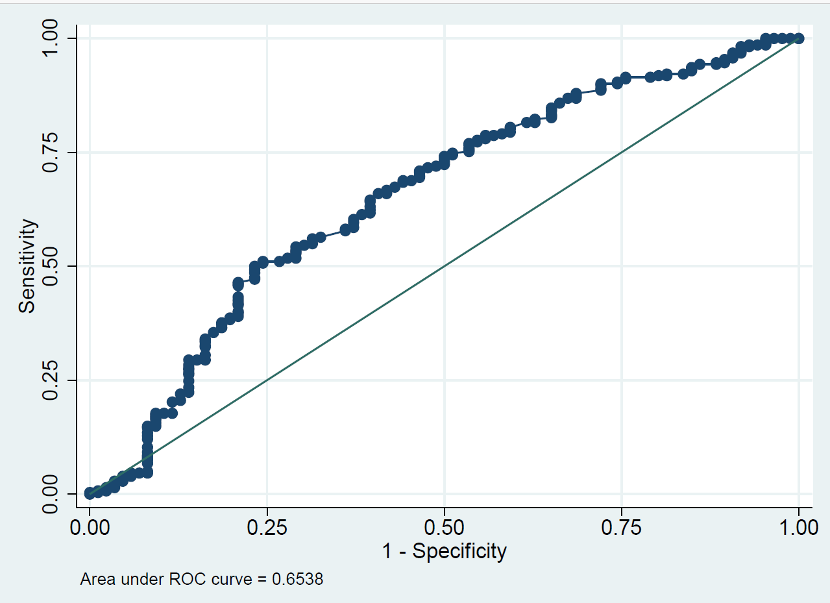
Figure 3a supplementary. ROC curve of PaO2/FiO2 at t0

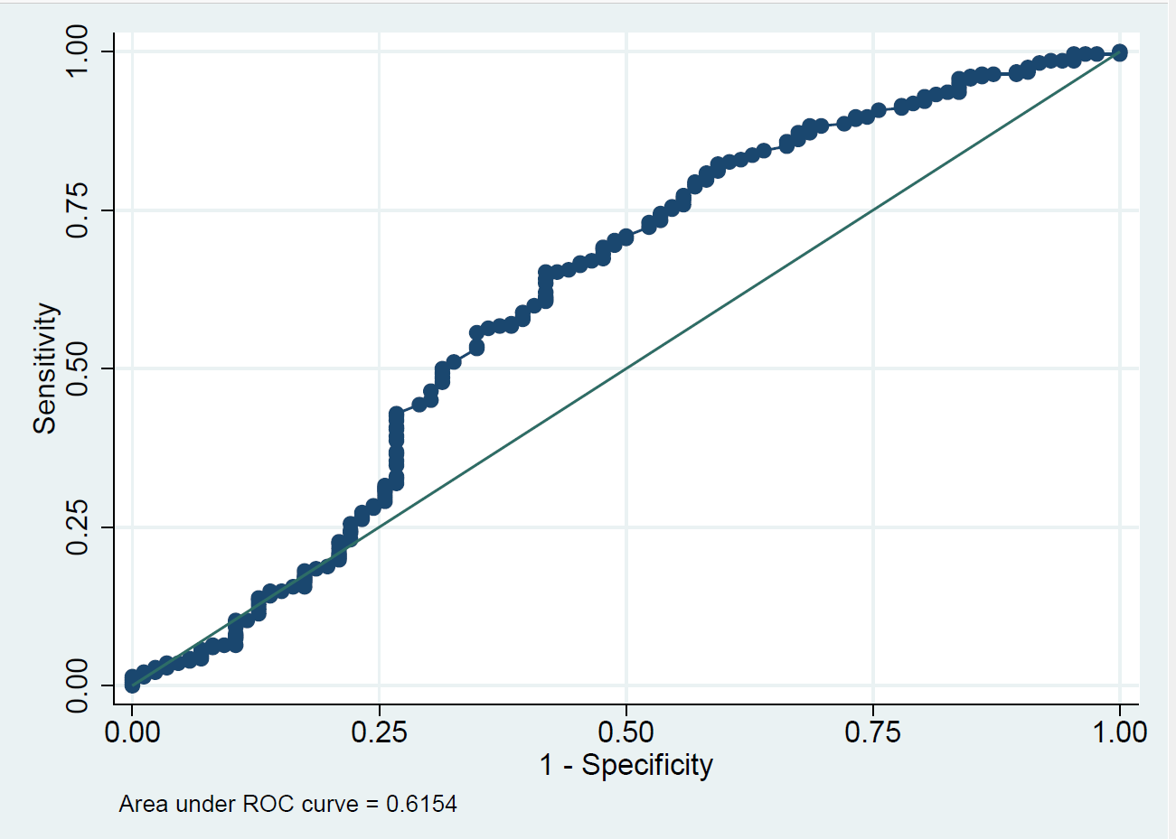
Figure 3b supplementary. ROC curve of sPaO2/FiO2 at t0

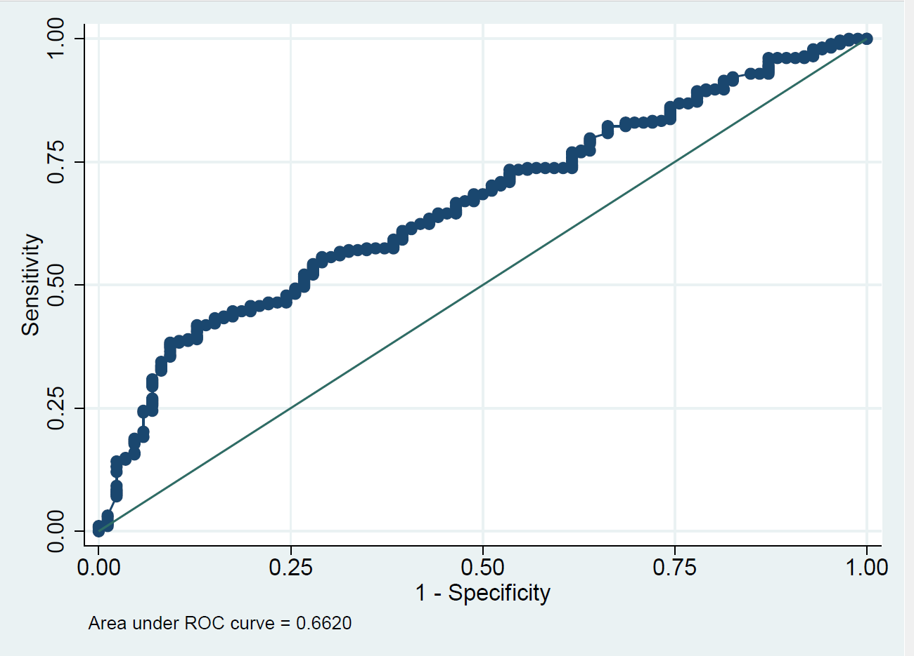
Figure 3c supplementary. ROC curve of SpO2/FiO2 at t0

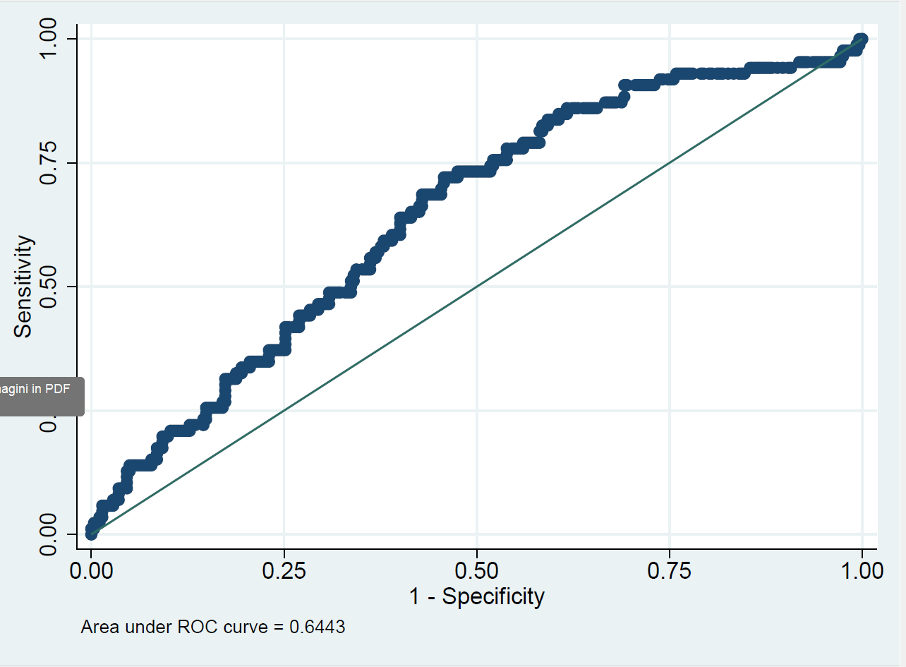
Figure 3d supplementary. ROC curve of a-ADO2 at t0

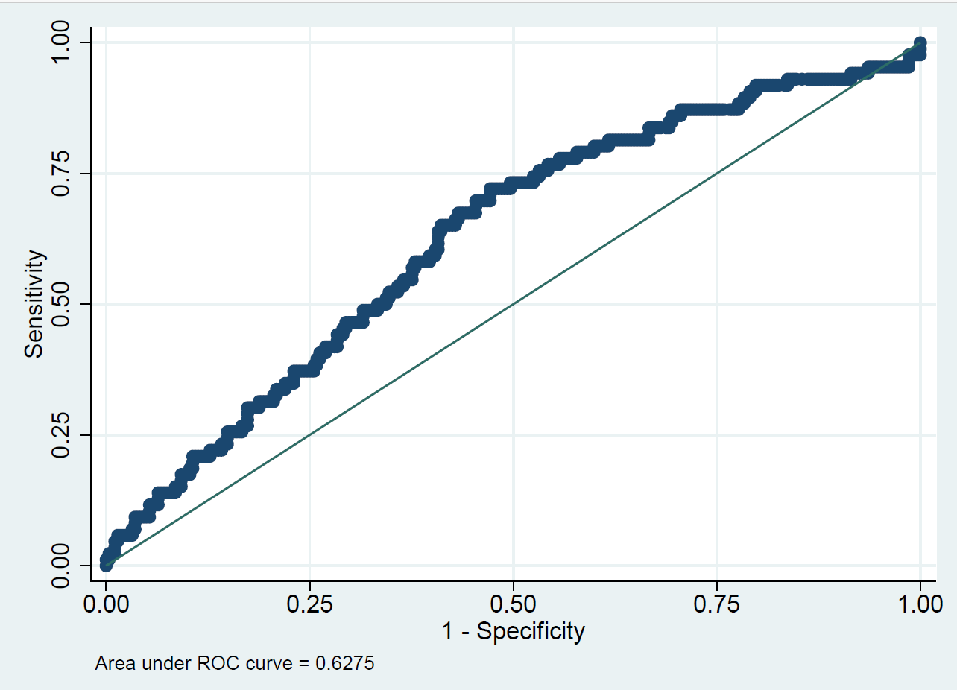
Figure 3e supplementary. ROC curve of adj-ADO2 at t0

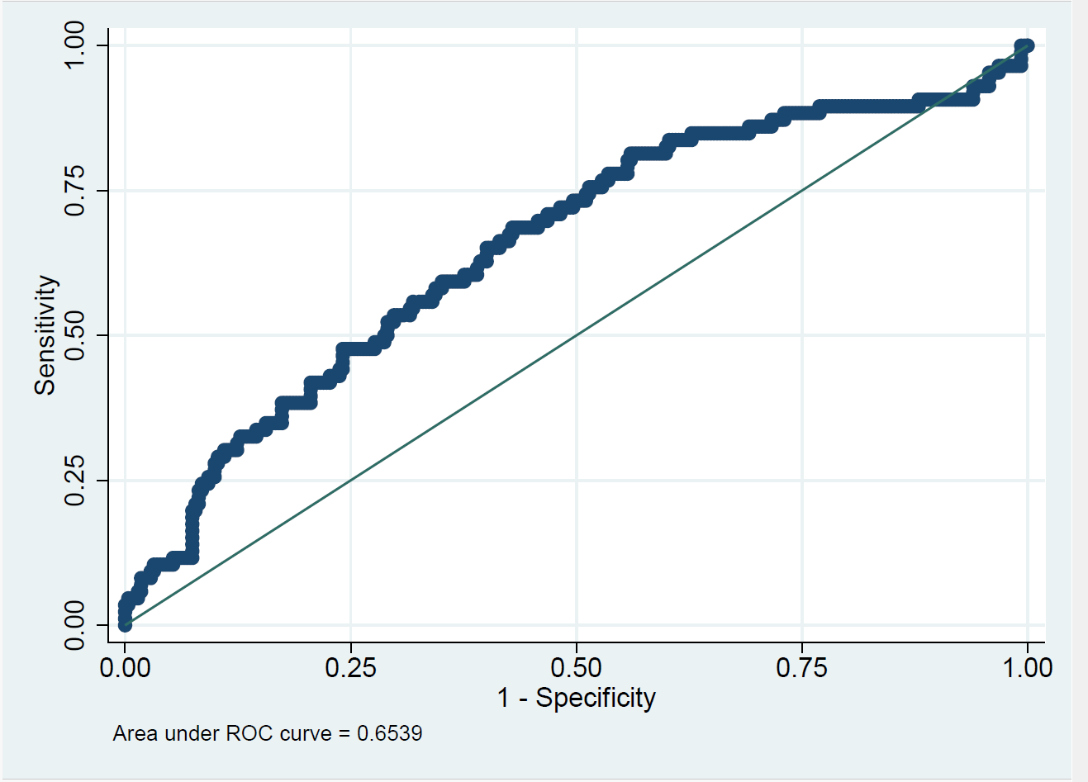
Figure 3f supplementary. ROC curve of RI at t0

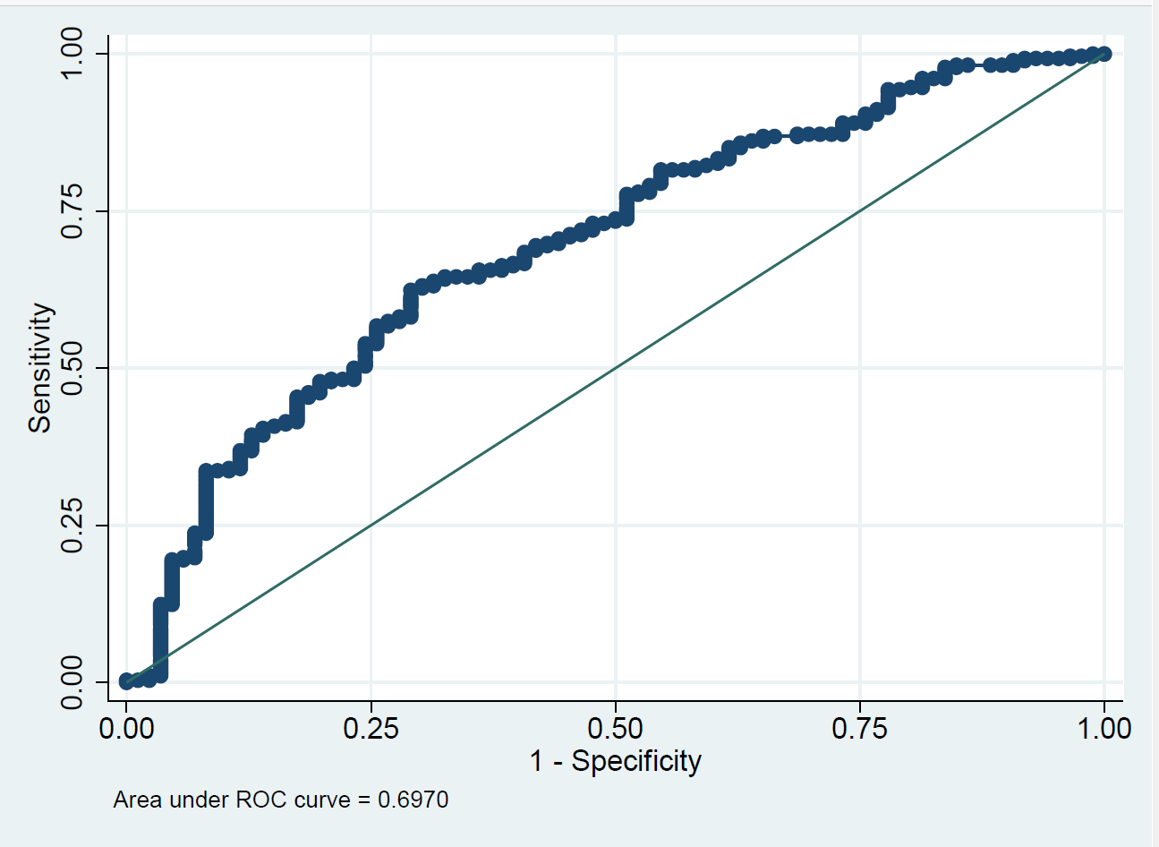
Figure 4a supplementary. ROC curve of PaO2/FiO2 at t12

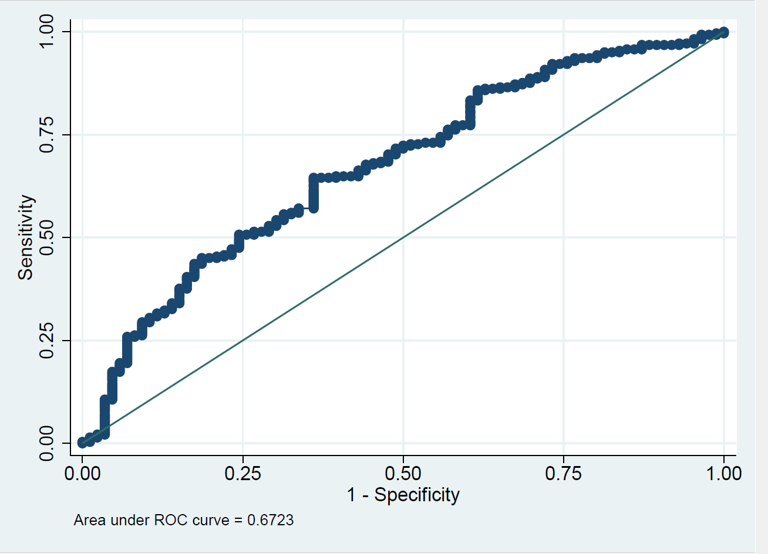
Figure 4b supplementary. ROC curve of sPaO2/FiO2 at t12

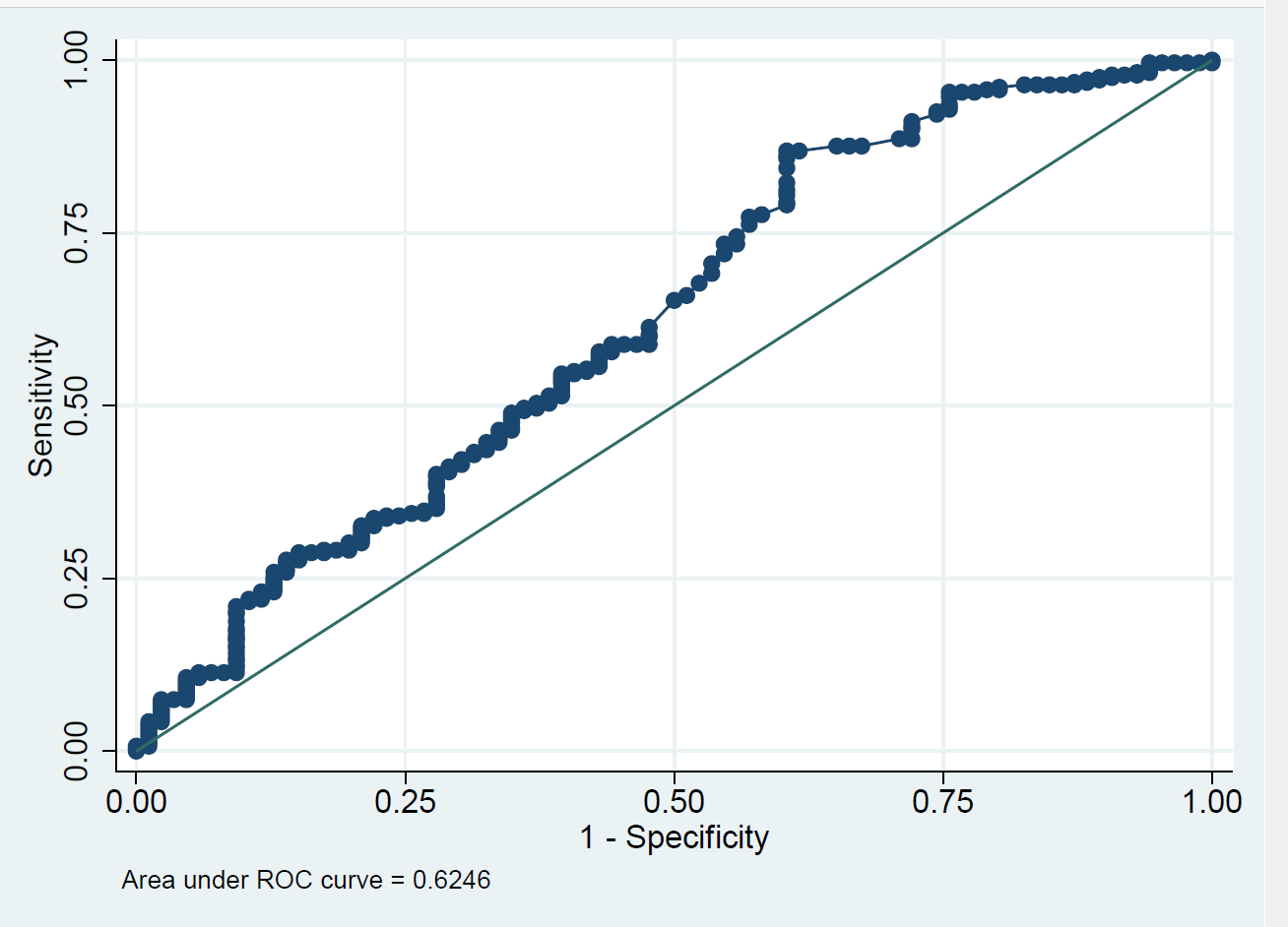
Figure 4c supplementary. ROC curve of SpO2/FiO2 at t12

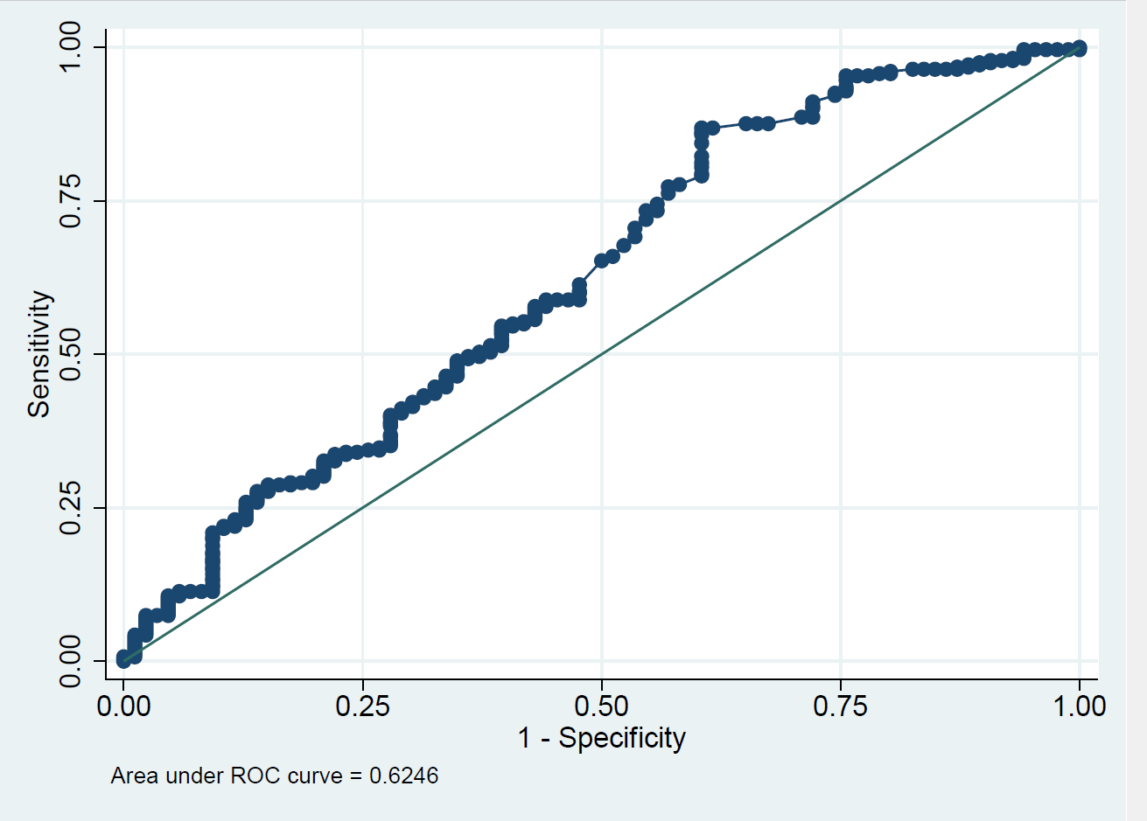
Figure 4d supplementary. ROC curve of ADO2 at t12

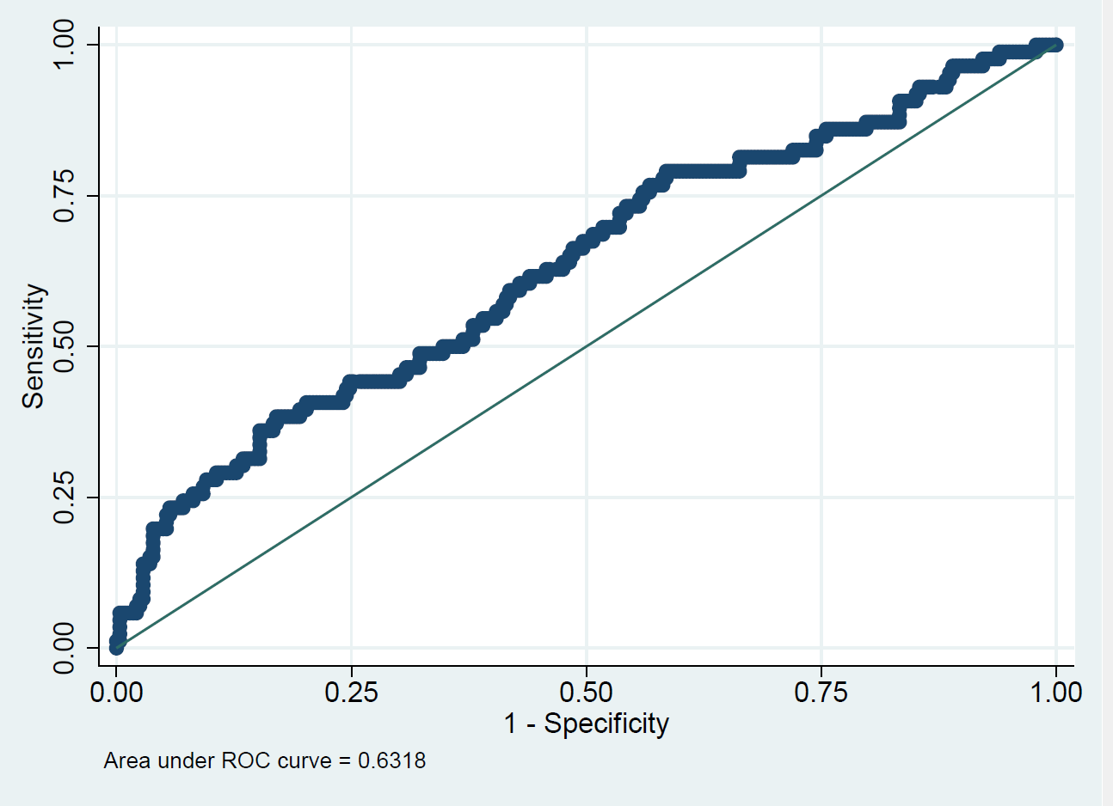
Figure 4e supplementary. ROC curve of adj-ADO2 at t12

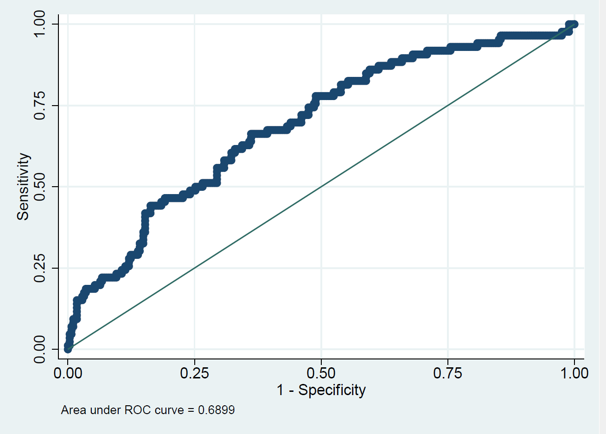
Figure 4f supplementary. ROC curve of RI at t12

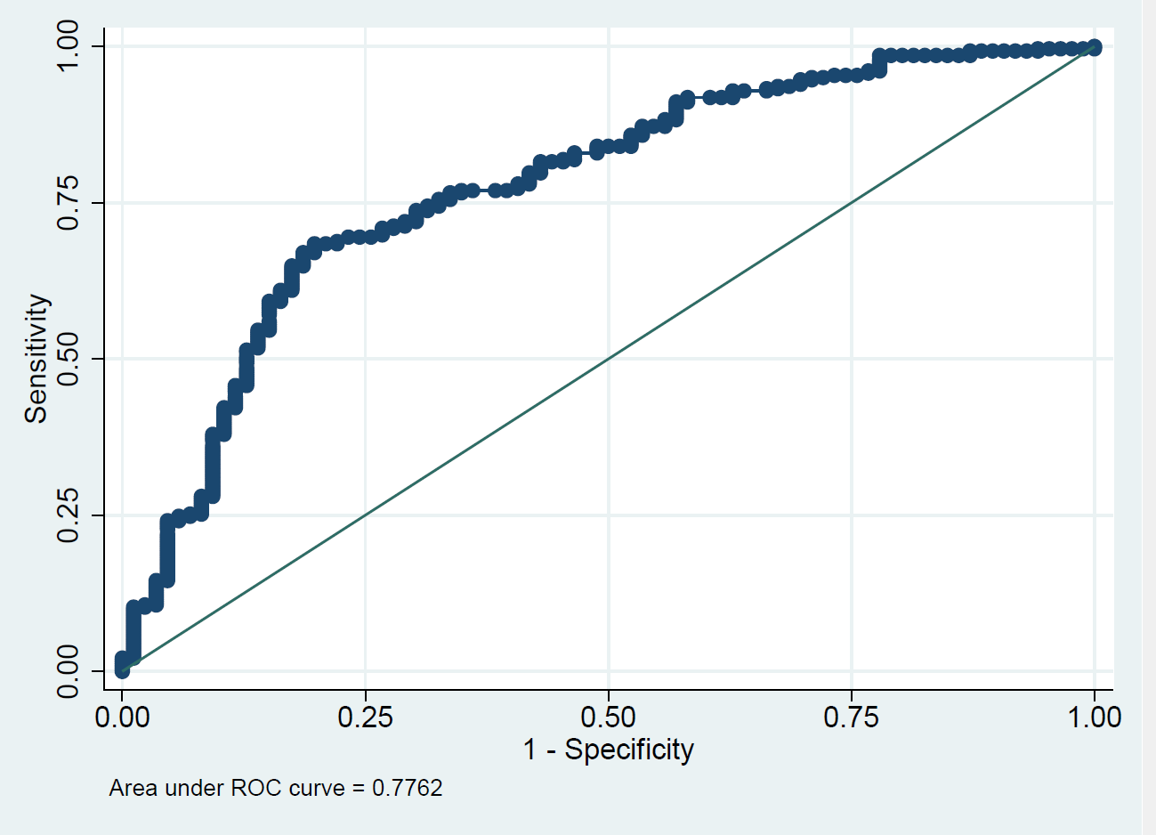
Figure 5a supplementary. ROC curve of PaO2/FiO2 at t24

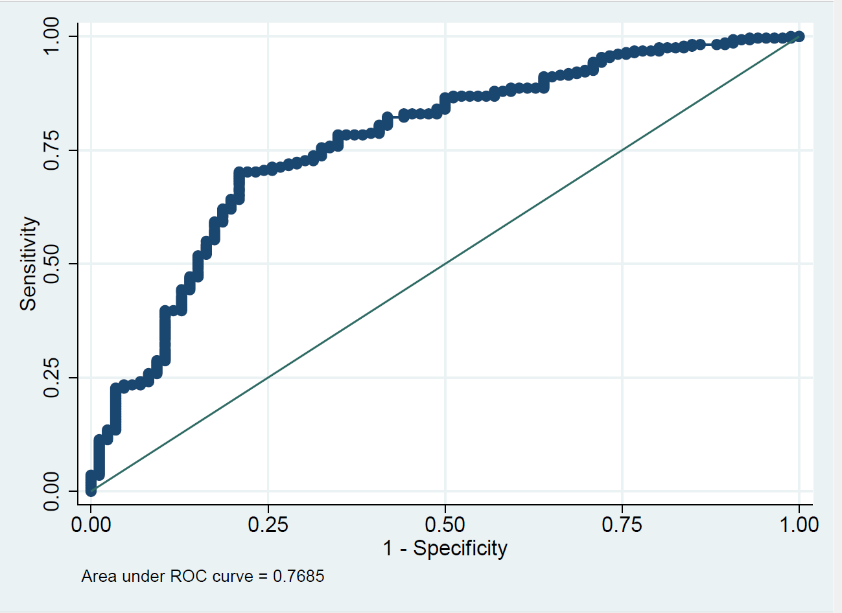
Figure 5b supplementary. ROC curve of sPaO2/FiO2 at t24

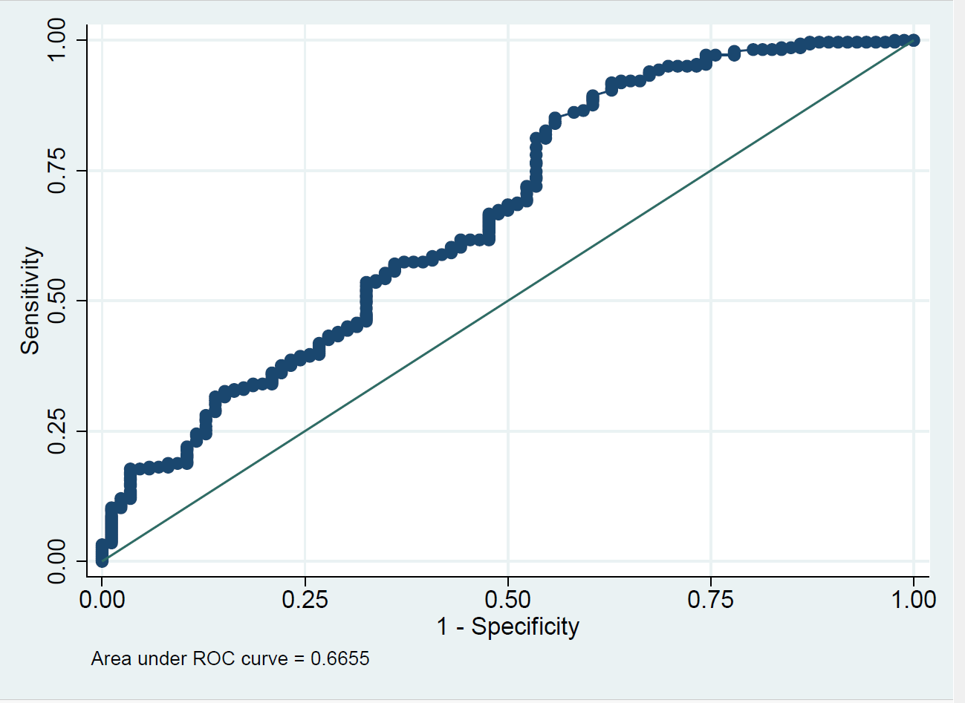
Figure 5c supplementary. ROC curve of SpO2/FiO2 at t24

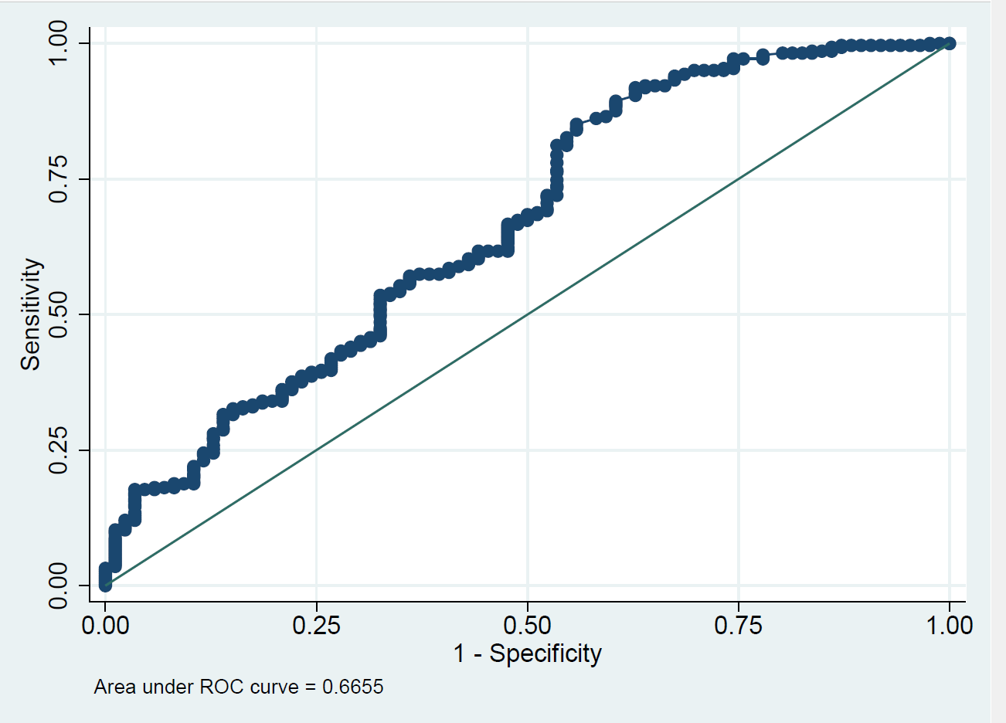
Figure 5d supplementary. ROC curve of ADO2 at t24

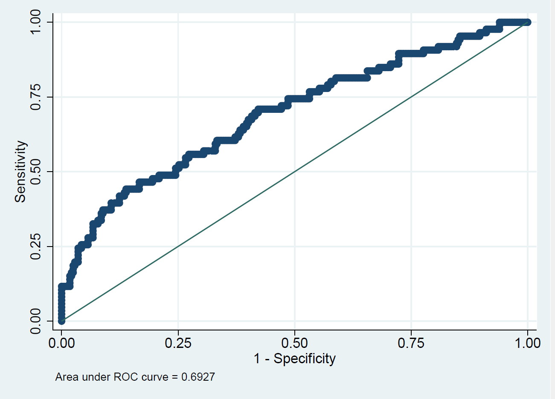
Figure 5e supplementary. ROC curve of adj-ADO2 at t24

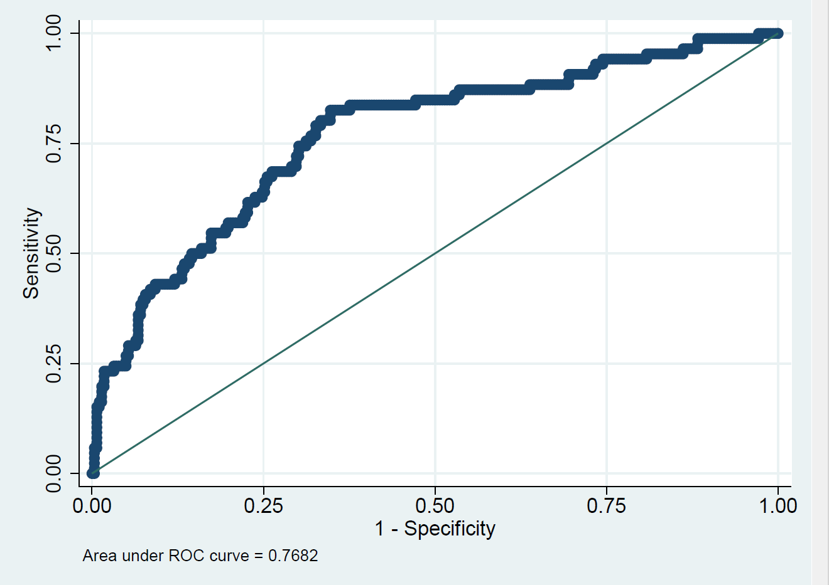
Figure 5f supplementary. ROC curve of RI at t24

Figure 1 supplementary. Escalating and de-escalating protocol for NIRT management in the study population

Figure 2 supplementary. Distribution of NIRT outcome according to the single or combined applied devices.
NIRT=Non Invasive Respiratory Therapies; NIV= Non invasive ventilation; HFNC= High flow nasal cannula; CPAP= Continuous positive airway pressure

PaO2/FiO2 at to | NIRT Failure
PaO2/FiO2 at to | NO |  | YES
PaO2/FiO2 at to | N. | % | N. | %
<100 | 13 | 59,1 | 9 | 40,9
100-200 | 87 | 66,9 | 43 | 33,1
201-300 | 146 | 84,4 | 27 | 15,6
>300 | 36 | 83,7 | 7 | 16,3
Total | 282 | 76,6 | 86 | 23,4

Table 1 supplementary. Distribution of PaO2/FiO2 ratio according to NIRT failure before starting.
t0= baseline; NIRT= Non Invasive Respiratory Therapies

Arterial blood gases parameters | Patients Group |  | p | Logistic regression analysis
Arterial blood gases parameters | NIRT success | NIRT failure |  | OR | p | 95%CI
At t0
PaCO2 | 33,9±4,60 | 32,7±4,48 | 0,0233 | 1,07 | 0,019 | 1,01-1,14
PaO2 (mmHg) | 69,1±21,4 | 68,2±21,6 | 0,3708 | 1,00 | 0,794 | 0,99-1,02
sPaO2 (mmHg) | 57,0±23,1 | 58,1±22,8 | 0,708 | 1,01 | 0,291 | 0,99-1,02
PaO2/FiO2 | 223,1±70,0 | 185,7±78,6 | <0,0001 | 0,99 | 0,002 | 0,99-1,00
sPaO2/FiO2 | 180,0±62,3 | 155,4±72,9 | 0,0028 | 0,99 | 0,049 | 0,99-1,00
SpO2/FiO2 | 316,6±112,6 | 254,3±98,7 | <0,0001 | 0,99 | <0,0001 | 0,99-1,00
a-ADO2 | 138,0±107,0 | 197,7±189,8 | <0,0001 | 1,00 | 0,002 | 1,00-1,01
adj-a-ADO2D | 117,5±106,9 | 165,6±126,3 | 0,0005 | 1,00 | 0,003 | 1,00-1,01
RI | 2,0±1,5 | 3,0±2,3 | <0,0001 | 1,29 | 0,001 | 1,11-1,51
At t12
PaCO2 | 33,7±5,17 | 35,3±6,5 | 0,0198 | 1,03 | 0,134 | 0,99-1,09
PaO2 (mmHg) | 107,5±43,2 | 88,7±44,9 | 0,0005 | 0,99 | 0,042 | 0,98-1,00
sPaO2 (mmHg) | 97,0±43,8 | 80,8±44,4 | 0,0029 | 0,99 | 0,087 | 0,99-1,00
PaO2/FiO2 | 217,7±82,8 | 167,3±75,5 | <0,0001 | 0,99 | 0,002 | 0,99-1,00
sPaO2/FiO2 | 195,2±82,6 | 151,8±74,4 | <0,0001 | 0,99 | 0,009 | 0,99-1,00
SpO2/FiO2 | 200,8±49,7 | 183,6±46,1 | 0,028 | 0,99 | 0,067 | 0,99-1,00
a-ADO2 | 211,1±76,4 | 254,5±87,9 | <0,0001 | 1,00 | 0,008 | 1,00-1,01
adj-a-ADO2D | 190,6±76,0 | 230,3±87,9 | 0,0001 | 1,00 | 0,014 | 1,00-1,01
RI | 2,3±1,3 | 3,4±1,7 | <0,0001 | 1,40 | 0,001 | 1,16-1,70
At t24
PaCO2 | 34,5±4,9 | 36,3±9,7 | 0,0208 | 1,04 | 0,038 | 1,00-1,08
PaO2 (mmHg) | 105,9±40,6 | 78,2±25,5 | <0,0001 | 0,98 | <0,0001 | 0,97-0,99
sPaO2 (mmHg) | 96,8±40,2 | 70,9±25,4 | <0,0001 | 0,98 | <0,0001 | 0,97-0,99
PaO2/FiO2 | 228,8±86,3 | 155,1±67,9 | <0,0001 | 0,99 | <0,0001 | 0,98-0,99
sPaO2/FiO2 | 208,2±83,2 | 139,2±62,5 | <0,0001 | 0,99 | <0,0001 | 0,99-1,00
SpO2/FiO2 | 213,3±54,6 | 185,1±47,8 | <0,0001 | 0,99 | 0,001 | 0,98-0,99
a-ADO2 | 191,7±75,6 | 262,0±102,9 | <0,0001 | 1,01 | <0,0001 | 1,00-1,01
adj-a-ADO2D | 171,2±75,3 | 237,8±102,8 | <0,0001 | 1,01 | <0,0001 | 1,00-1,01
RI | 2,1±1,3 | 3,7±1,8 | <0,0001 | 1,70 | <0,0001 | 1,39-2,08

Table 2 supplementary. Distribution of arterial blood gases parameters according to NIRT outcome at t0, t12, t24 (values are considered as continuous variables adjusted for age).
sPaO2/FiO2= standardized PaO2/FiO2 ratio; a-ADO2: alveolar-arterial oxygen gradient; adj-a-ADO2D_: alveolar-arterial oxygen gradient adjusted for age; RI= Respiratory Index; NIRT=non invasive respiratoy therapies; t0= baseline; t12=after 12 hours of NIRT; t24= after 24 hours of NIRT

Figure 3a supplementary. ROC curve of PaO2/FiO2 at t0

Figure 3b supplementary. ROC curve of sPaO2/FiO2 at t0

Figure 3c supplementary. ROC curve of SpO2/FiO2 at t0

Figure 3d supplementary. ROC curve of a-ADO2 at t0

Figure 3e supplementary. ROC curve of adj-ADO2 at t0

Figure 3f supplementary. ROC curve of RI at t0

Figure 4a supplementary. ROC curve of PaO2/FiO2 at t12

Figure 4b supplementary. ROC curve of sPaO2/FiO2 at t12

Figure 4c supplementary. ROC curve of SpO2/FiO2 at t12

Figure 4d supplementary. ROC curve of ADO2 at t12

Figure 4e supplementary. ROC curve of adj-ADO2 at t12

Figure 4f supplementary. ROC curve of RI at t12

Figure 5a supplementary. ROC curve of PaO2/FiO2 at t24

Figure 5b supplementary. ROC curve of sPaO2/FiO2 at t24

Figure 5c supplementary. ROC curve of SpO2/FiO2 at t24

Figure 5d supplementary. ROC curve of ADO2 at t24

Figure 5e supplementary. ROC curve of adj-ADO2 at t24

Figure 5f supplementary. ROC curve of RI at t24

