Supplemental Online Material
Eosinopenia and Prognosis in Severe Community-Acquired Pneumonia

Catia Cillóniz^{1,2,5*}, Tatiana Castañeda⁴*, Antonio Campanella³, Riccardo Guglielmi³, Albert Gabarrús¹, Sara Granero⁷, Cristina Calvo-García⁷ Maria Angeles Marcos⁶, Antoni Torres^{1,2,4}
¹ August Pi i Sunyer Biomedical Research Institute–IDIBAPS, Barcelona, Spain.
² Ciber de Enfermedades Respiratorias (CIBERES), Barcelona, Spain
³ Department of Medical –Surgical Sciences and Translational Medicine, Sapienza University of Rome, Italy
⁴ University of Barcelona, Barcelona, Spain
⁵ Faculty of Health Sciences, Continental University, Huancayo, Peru
⁶ Microbiology Department, Hospital Clinic of Barcelona, Spain
⁷Respiratory Intensive Care Unit, Hospital Clinic of Barcelona, Spain
*Equal contribution as first author

Correspondence: Prof. Antoni Torres (primary) or Dr Catia Cillóniz (alternative)
August Pi i Sunyer Biomedical Research Institute–IDIBAPS
C/ Villarroel 170, 08036 Barcelona, Spain
Tel: (+34) 93-227-5779
Email: atorres@recerca.clinic.cat (primary) or cilloniz@recerca.clinic.cat (alternative)

Data collection, evaluation, and microbiological diagnosis
The aetiology was considered definite if one of the following criteria was met: (1) a positive blood culture (in the absence of an apparent extra-pulmonary focus); (2) a positive bacterial culture of pleural fluid or transthoracic needle aspiration samples; (3) elevated serum levels of IgM against Chlamydophila pneumoniae (≥1:64), Coxiella burnetii (≥1:80) and Mycoplasma pneumoniae (any positive titre); (4) seroconversion (i.e., a fourfold increase in IgG titres) for C. pneumoniae and L. pneumophila > 1:128, C. burnetii > 1:80 and respiratory viruses (influenza viruses A and B, parainfluenza viruses 1–3, respiratory syncytial virus, adenovirus); (5) positive urinary antigen for L. pneumophila (Binax Now L. pneumophila urinary Antigen Test; Trinity Biotech, Bray, Ireland); (6) positive urinary antigen for S. pneumoniae (Binax Now Streptococcus pneumoniae urinary Antigen Test; Emergo Europe, The Hague, The Netherlands); (7) bacterial growth in cultures of TBAS (≥105 cfu/ml), in protected specimen brush (≥103 cfu/ml), and BAL (≥104 cfu/ml); (8) detection of antigens by IFA plus virus isolation or detection by reverse transcriptase polymerase chain reaction (RT-PCR) testing for respiratory virus (influenza viruses A and B, parainfluenza virus 1–3, respiratory syncytial virus, rhinovirus, adenovirus).
The aetiology of pneumonia was classified as presumptive when a predominant microorganism was isolated from a purulent sample (leukocytes > 25 per high power microscopic field and few epithelial cells < 10 per high power microscopic field) and the findings of Gram staining were compatible. For the purpose of this study, presumptive and definitive diagnoses were analyzed together.

Supplementary Table 1. Linear regression analyses showing the association of log-transformed eosinophil counts with lymphocyte, leukocyte, neutrophil, and C-reactive protein levels, including interaction with systemic corticosteroid use
model | dependent.variable | term | estimate | std.error | statistic | p.value
1 | Log10(Lymphocytes [×10⁹/L] + 0.01) | (Intercept) | 3.092228074 | 0.042458026 | 72.83023615 | <0.001
 |  | log_eosinof1 | 0.218534696 | 0.032230242 | 6.78042374 | <0.001
 |  | cortisistrSí | 0.225585952 | 0.139947414 | 1.611933694 | 0.108
 |  | log_eosinof1:cortisistrSí | 0.185167987 | 0.117736554 | 1.572731508 | 0.116
2 | Log10(Leukocytes [×10⁹/L] + 0.01) | (Intercept) | 4.291530862 | 0.036102543 | 118.8705976 | <0.001
 |  | log_eosinof1 | 0.247125393 | 0.027405741 | 9.017285422 | <0.001
 |  | cortisistrSí | 0.103826544 | 0.118998879 | 0.872500184 | 0.383
 |  | log_eosinof1:cortisistrSí | 0.027457321 | 0.100112732 | 0.274264032 | 0.784
3 | Log10(Neutrophils [×10⁹/L] + 0.01) | (Intercept) | 4.197862899 | 0.041763766 | 100.5144729 | <0.001
 |  | log_eosinof1 | 0.25189149 | 0.031941487 | 7.886029034 | <0.001
 |  | cortisistrSí | 0.076041869 | 0.137172948 | 0.55435033 | 0.580
 |  | log_eosinof1:cortisistrSí | -0.010644498 | 0.115460389 | -0.09219177 | 0.927
4 | Log10(C-reactive protein [mg/L] + 0.01) | (Intercept) | 1.11635808 | 0.045557602 | 24.50432044 | <0.001
 |  | log_eosinof1 | -0.065763148 | 0.034176726 | -1.924208536 | 0.055
 |  | cortisistrSí | -0.143217614 | 0.154960323 | -0.924221184 | 0.356
 |  | log_eosinof1:cortisistrSí | 0.085300757 | 0.126986379 | 0.671731544 | 0.502

Linear regression models were fitted with log-transformed eosinophil counts (log₁₀[eosinophils + 0.01]) as the main independent variable. Dependent variables were the log-transformed counts of lymphocytes, leukocytes, neutrophils, and C-reactive protein (CRP). An interaction term between eosinophil counts and systemic corticosteroid use was included to evaluate potential effect modification. Positive coefficients indicate a direct association between eosinophil counts and the corresponding hematological parameter. p-values <0.05 were considered statistically significant.

Supplementary Table 2. Distribution of respiratory viral pathogens according to eosinopenia status
 | Eosinopenia  (<0.05 x10⁹/L)  (N=163) | Non-eosinopenia  (≥0.05 x10⁹/L)  (N=333) | P-value
Defined etiology, n (%) | 115 (71) | 187 (56) | 0.002
Influenza A | 9 (8) | 9 (5) | 0.283
Influenza B | 14 (12) | 9 (5) | 0.019
Respiratory syncytial virus | 5 (4) | 4 (2) | 0.309
Parainfluenza virus type 1 | 4 (3) | 0 (0) | 0.020
Parainfluenza virus type 2 | 0 (0) | 1 (1) | >0.999
Adenovirus | 1 (1) | 0 (0) | 0.381
Coronavirus (non–SARS-CoV-2) | 0 (0) | 1 (1) | >0.999
Herpesvirus | 0 (0) | 2 (1) | 0.527
Other viruses | 1 (1) | 0 (0) | 0.381
Note. Percentages calculated on non-missing data. P-values marked in bold indicate numbers that are statistically significant at the 95% confidence limit.

Supplementary Table 3. Internal validation of the multivariable Cox regression model for 30-day mortality using nonparametric bootstrap technique
Variable | Original | Bias | SE | P-value | 95% BCa CI
Age ≥65 years | 1.009 | 0.043 | 0.311 | 0.002 | 0.429 to 1.743
Male sex | 0.176 | 0.007 | 0.277 | 0.502 | -0.356 to 0.741
Chronic heart disease | 0.293 | -0.027 | 0.323 | 0.339 | -0.364 to 0.816
Chronic liver disease | 1.143 | 0.009 | 0.377 | 0.002 | 0.304 to 1.905
Previous neoplasm | 0.108 | -0.019 | 0.402 | 0.768 | -0.779 to 0.795
Decreased level of consciousness | 0.394 | 0.003 | 0.257 | 0.110 | -0.123 to 0.887
PSI score IV-V | -0.320 | 0.002 | 0.261 | 0.198 | -0.804 to 0.238
Eosinopenia (<0.05 x10⁹/L) | 0.670 | 0.024 | 0.270 | 0.006 | 0.074 to 1.250
Abbreviations. BCa indicates adjusted bootstrap; CI, confidence interval; SE, standard error.

Supplementary Table 4. Multivariable Cox regression model including an expanded set of comorbidities and treatments for 30-day mortality
Variable | HR | 95% CI | P-value
Age ≥65 years | 2.70 | 1.47 to 4.93 | 0.001
Male sex | 1.15 | 0.68 to 1.97 | 0.601
Systemic corticosteroids | 0.78 | 0.31 to 1.99 | 0.605
Diabetes mellitus | 1.05 | 0.62 to 1.78 | 0.863
Chronic lung disease | 0.90 | 0.55 to 1.47 | 0.673
Neurologic disease | 1.51 | 0.85 to 2.67 | 0.159
Chronic heart disease | 1.33 | 0.70 to 2.54 | 0.380
Chronic liver disease | 3.06 | 1.58 to 5.93 | 0.001
Chronic renal disease | 1.09 | 0.55 to 2.15 | 0.799
Previous neoplasm | 1.17 | 0.59 to 2.34 | 0.648
Decreased level of consciousness | 1.44 | 0.89 to 2.35 | 0.139
PSI score IV-V | 0.77 | 0.47 to 1.28 | 0.311
Eosinopenia (<0.05 x10⁹/L) | 1.94 | 1.18 to 3.19 | 0.009
Abbreviations. HR indicates hazard ratio. CI, confidence interval.
Note. Data are presented as estimated HRs (95% CIs) of the explanatory variables in the 30-day mortality group. The HR is defined as the ratio of the hazard rates corresponding to the conditions described by two levels of an explanatory variable (the hazard rate is the risk of death [i.e., the probability of death], given that the patient has survived up to a specific time). The P-value is based on the null hypothesis that all HRs relating to an explanatory variable equal unity (no effect). Harrell's C statistic is 0.71 and Somers' D statistic is 0.43.

Supplementary Table 5. Multivariable Cox regression model including an expanded set of comorbidities, treatments and inflammatory and hematological parameters for 30-day mortality
Variable | HR | 95% CI | P-value
Age ≥65 years | 2.74 | 1.48 to 5.07 | 0.001
Male sex | 1.16 | 0.68 to 1.99 | 0.578
Systemic corticosteroids | 0.78 | 0.31 to 2.00 | 0.606
Diabetes mellitus | 1.07 | 0.63 to 1.82 | 0.805
Chronic lung disease | 0.90 | 0.55 to 1.47 | 0.671
Neurologic disease | 1.55 | 0.86 to 2.77 | 0.142
Chronic heart disease | 1.33 | 0.69 to 2.57 | 0.388
Chronic liver disease | 3.02 | 1.56 to 5.88 | 0.001
Chronic renal disease | 1.10 | 0.56 to 2.18 | 0.777
Previous neoplasm | 1.20 | 0.60 to 2.40 | 0.613
Decreased level of consciousness | 1.46 | 0.89 to 2.37 | 0.131
PSI score IV-V | 0.78 | 0.47 to 1.30 | 0.347
C-reactive protein ≥15 mg/L | 1.11 | 0.67 to 1.82 | 0.691
Neutrophil count |  |  | 0.924
<1.5 x10⁹/L | 1.06 | 0.39 to 2.94 | 0.905
1.5 – 7.5 x10⁹/L | 1.00 | - | -
≥7.5 x10⁹/L | 0.91 | 0.52 to 1.61 | 0.747
Lymphopenia (<1 x10⁹/L) | 0.84 | 0.49 to 1.44 | 0.526
Eosinopenia (<0.05 x10⁹/L) | 1.97 | 1.17 to 3.34 | 0.011
Abbreviations. HR indicates hazard ratio. CI, confidence interval.
Note. Data are presented as estimated HRs (95% CIs) of the explanatory variables in the 30-day mortality group. The HR is defined as the ratio of the hazard rates corresponding to the conditions described by two levels of an explanatory variable (the hazard rate is the risk of death [i.e., the probability of death], given that the patient has survived up to a specific time). The P-value is based on the null hypothesis that all HRs relating to an explanatory variable equal unity (no effect). Harrell's C statistic is 0.72 and Somers' D statistic is 0.44.

Supplementary Figure 1. Association between eosinophil count and lymphocyte count, stratified by systemic corticosteroid use
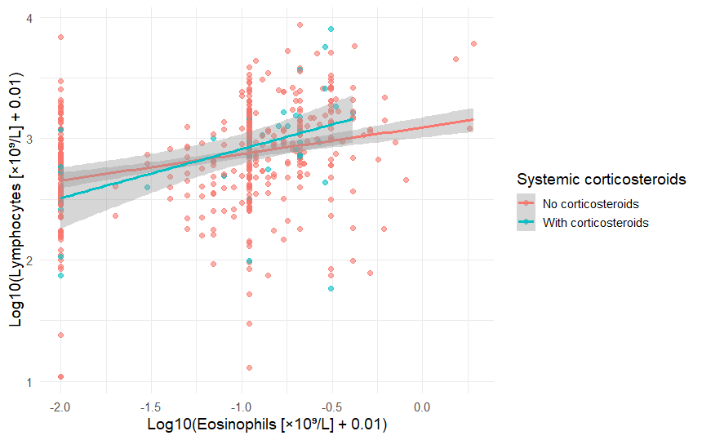

Supplementary Figure 2. Association between eosinophil count and total leukocyte count, stratified by systemic corticosteroid use
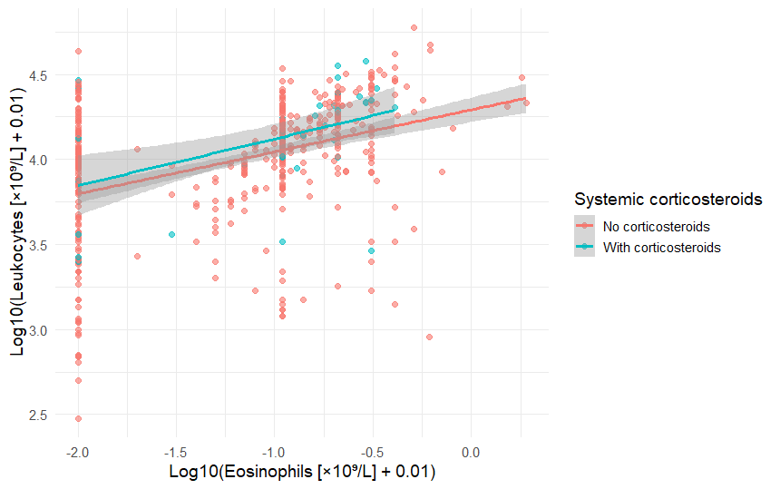

Supplementary Figure 3. Association between eosinophil count and neutrophil count, stratified by systemic corticosteroid use
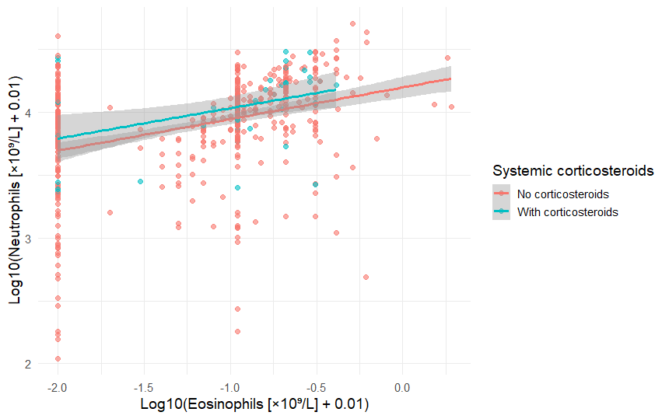

Supplementary Figure 4. Association between eosinophil count and C-reactive protein levels, stratified by systemic corticosteroid use
