Supplementary Data

Development and internal validation of a Viremia-Integrated Risk Assessment (VIRA score) for predicting mortality at diagnosis of COVID-19 pneumonia

Table of Contents:
Tables S1 to S5
Figures S1 and S2
Table S1. Unadjusted association between candidate predictor variables and mortality in the derivation cohort of immunocompetent patients (N=539)
Characteristic | Number/with data (%) | Dead by day 30 | Alive by day 30 | OR (95% CI) | P value
Age ≥65 years | 260/539 (48.2) | 26 | 234 | 15.39 (3.61-65.52) | <0.001
Male sex | 348/539 (64.6) | 14 | 334 | 0.53 (0.25-1.14) | 0.103
CCI ≥3 | 298/539 (55.3) | 28 | 270 | - | 1.000
Dyspnea | 284/539 (52.7) | 21 | 263 | 2.83 (1.18-6.77) | 0.020
SpO₂ ≤90% | 60/539 (11.1) | 13 | 47 | 8.56 (3.84-19.06) | <0.001
CURB-65 ≥2 | 90/422 (21.3) | 16 | 74 | 11.75 (4.45-31.04) | <0.001
RNAemia | 105/539 (19.5) | 14 | 91 | 4.62 (2.13-10.02) | <0.001
Lymphocytes <1000/µL | 253/537 (47.1) | 21 | 232 | 3.58 (1.50-8.58) | 0.004
Platelets <130,000/µL | 62/537 (11.5) | 4 | 58 | 1.30 (0.43-3.87) | 0.642
Creatinine >1.3 mg/dL | 95/537 (17.7) | 11 | 84 | 3.27 (1.48-7.24) | 0.003
LDH >300 U/L | 259/529 (49.0) | 18 | 241 | 2.17 (0.96-4.91) | 0.064
CRP >100 mg/L | 196/536 (36.6) | 18 | 178 | 3.34 (1.51-7.38) | 0.003
DD >600 ng/mL | 229/479 (47.8) | 15 | 214 | 2.43 (0.97-6.08) | 0.057
CCI, Charlson Comorbidity Index; SpO₂, peripheral oxygen saturation; LDH, lactate dehydrogenase; CRP, C-reactive protein; DD, D-dimer.

Table S2. Unadjusted association between candidate predictor variables and mortality in the derivation cohort of immunocompromised patients (N=280)

Characteristic | Number/with data (%) | Dead by day 30 | Alive by day 30 | OR (95% CI) | P value
Age ≥65 years | 151/280 (53.9) | 33 | 118 | 3.73 (1.71-8.13) | 0.001
Male sex | 177/280 (63.2) | 20 | 157 | 0.47 (0.24-0.91) | 0.025
Dyspnea | 130/280 (46.4) | 29 | 101 | 3.03 (1.50-6.11) | 0.002
SpO₂ ≤90% | 23/280 (8.2) | 7 | 16 | 2.78 (1.07-7.23) | 0.037
CURB-65 ≥2 | 63/222 (28.4) | 18 | 45 | 3.34 (1.59-7.02) | 0.001
RNAemia | 153/280 (54.6) | 34 | 119 | 4.25 (1.89-9.56) | <0.001

Table S3. CURB-65 score to predict 30-day mortality in patients with SARS-CoV-2 pneumonia
Table S3.1. Immunocompetent patients: CURB-65 sensitivity, specificity, and predictive values for the different score groups
Score | Total | Dying within 30 days (%) | Sen (%) | Spe (%) | PPV (%) | NPV (%)
0 | 149 | 1 (0.7) | - | - | - | -
1 | 183 | 5 (2.7) | 95.5 | 37.0 | 7.7 | 99.3
2 | 82 | 14 (17.1) | 72.7 | 81.5 | 17.8 | 98.2
3 | 8 | 2 (25.0) | 9.1 | 98.5 | 25.0 | 95.2
4 | 0 | - | - | - | - | -
The number of individuals in different risk categories was as follows: low (0 to 1 points; 332 individuals (78.7%), moderate (2 points; 82 (19.4%), and high (3 points; 8 (1.9%).
Sen, sensitivity; Spe, specificity; PPV, positive predictive value; NPV, negative predictive value.

Table S3.2. Immunocompromised patients: CURB-65 sensitivity, specificity, and predictive values for the different score groups
Score | Total | Dying within 30 days (%) | Sen (%) | Spe (%) | PPV (%) | NPV (%)
0 | 64 | 5 (7.8) | - | - | - | -
1 | 95 | 12 (12.6) | 85.7 | 31.6 | 19.0 | 92.2
2 | 58 | 15 (25.9) | 51.4 | 75.9 | 28.6 | 89.3
3 | 4 | 2 (50.0) | 8.6 | 98.9 | 60.0 | 85.3
4 | 1 | 1 (100) | 2.9 | 100.0 | 100.0 | 84.6
The number of individuals in different risk categories was as follows: low (0 to 1 points; 159 individuals (71.6%), moderate (2 points; 58 (26.1%), high (3 points; 4 (1.8%), and very high (4 points; 1 (1.0%).
Sen, sensitivity; Spe, specificity; PPV, positive predictive value; NPV, negative predictive value.

Table S4. Simplified scores to predict 30-day mortality in patients with SARS-CoV-2 pneumonia
Table S4.1. Immunocompetent patients, excluding CURB-65: sensitivity, specificity, and predictive values for the different score groups
Score | Total | Dying within 30 days (%) | Sen (%) | Spe (%) | PPV (%) | NPV (%)
0 | 210 | 2 (1.0) | - | - | - | -
1 | 45 | 0 (0.0) | 92.9 | 40.7 | 7.9 | 99.1
2 | 203 | 7 (3.5) | 92.9 | 49.5 | 9.2 | 99.2
3 | 45 | 6 (13.3) | 67.9 | 87.9 | 23.5 | 98.0
4 | 21 | 5 (23.8) | 46.4 | 95.5 | 36.1 | 97.0
5 | 15 | 8 (53.3) | 28.6 | 98.6 | 53.3 | 96.2
The number of individuals in different risk categories was as follows: low (0 to 1 points; 255 individuals (47.3%), moderate (2 points; 203 (37.7%), high (3 to 4 points; 66 (12.3%), and very high (5 points; 15 (2.8%).
Sen, sensitivity; Spe, specificity; PPV, positive predictive value; NPV, negative predictive value.

Table S4.2. Immunocompetent patients, including CURB-65 (VIRA score): sensitivity, specificity, and predictive values for the different score groups
Score | Total | Dying within 30 days (%) | Sen (%) | Spe (%) | PPV (%) | NPV (%)
0 | 277 | 4 (1.4) | - | - | - | -
1 | 55 | 2 (3.6) | 81.8 | 68.3 | 12.4 | 98.6
2 | 62 | 8 (12.9) | 72.7 | 81.5 | 17.8 | 98.2
3 | 28 | 8 (28.6) | 36.4 | 95.0 | 28.6 | 96.5
The number of individuals in different risk categories was as follows: low (0 points; 277 individuals (65.6%), moderate (1 point; 55 (13.0%), high (2 points; 62 (14.7%), and very high (3 points; 28 (6.6%).
Sen, sensitivity; Spe, specificity; PPV, positive predictive value; NPV, negative predictive value.

Table S4.3. Immunocompromised patients, excluding CURB-65: sensitivity, specificity, and predictive values for the different score groups
Score | Total | Dying within 30 days (%) | Sen (%) | Spe (%) | PPV (%) | NPV (%)
-1 | 25 | 0 (0.0) | - | - | - | -
0 | 63 | 4 (6.4) | 100 | 10.5 | 16.5 | 100
1 | 118 | 10 (8.5) | 90.5 | 35.3 | 19.8 | 95.5
2 | 58 | 18 (31.0) | 66.7 | 80.7 | 37.8 | 93.2
3 | 16 | 10 (62.5) | 23.8 | 97.5 | 62.5 | 87.9
The number of individuals in different risk categories was as follows: low (-1 point; 25 individuals (8.9%), moderate (0 to 1 points; 181 (64.6%), high (2 points; 58 (20.7%), and very high (3 points; 16 (5.7%).
Sen, sensitivity; Spe, specificity; PPV, positive predictive value; NPV, negative predictive value.

Table S4.4. Immunocompromised patients, including CURB-65 (VIRA score): sensitivity, specificity, and predictive values for the different score groups
Score | Total | Dying within 30 days (%) | Sen (%) | Spe (%) | PPV (%) | NPV (%)
-1 | 26 | 2 (7.7) | - | - | - | -
0 | 68 | 5 (7.4) | 94.3 | 12.8 | 16.8 | 92.3
1 | 79 | 7 (8.9) | 80.0 | 46.5 | 21.9 | 92.6
2 | 40 | 14 (35.0) | 60.0 | 85.0 | 42.9 | 91.9
3 | 9 | 7 (77.8) | 20.0 | 98.9 | 77.8 | 86.9
The number of individuals in different risk categories was as follows: moderate (-1 to 1 points; 173 (77.9%), high (2 points; 40 (18.0%), and very high (3 points; 9 (4.1%).
Sen, sensitivity; Spe, specificity; PPV, positive predictive value; NPV, negative predictive value.

Table S5. Performance of the final prediction models and the simplified scores for 30-day mortality at presentation
 | Nº Participants | AUROC | 95% CI
Immunocompetent patients with SARS-CoV-2 pneumonia excluding CURB-65
Final prediction model | 539 | 0.846 | 0.763-0.928
Simplified score | 539 | 0.840 | 0.756-0.924
Immunocompetent patients with SARS-CoV-2 pneumonia including CURB-65
Final prediction model | 422 | 0.806 | 0.701-0.910
VIRA score | 422 | 0.806 | 0.701-0.910
CURB-65 score* | 422 | 0.771 | 0.661-0.881
Immunocompromised patients with SARS-CoV-2 pneumonia excluding CURB-65
Final prediction model | 280 | 0.793 | 0.717-0.869
Simplified score | 280 | 0.777 | 0.698-0.856
Immunocompromised patients with SARS-CoV-2 pneumonia including CURB-65
Final prediction model | 222 | 0.745 | 0.639-0.851
VIRA score | 222 | 0.744 | 0.643-0.846
CURB-65 score** | 222 | 0.637 | 0.532-0.742
AUROC; Area Under the Receiver Operating Characteristics Curve; CI, confidence interval.
* Statistically significant improvement in performance compared to CURB-65 alone, with an integrated discrimination improvement (IDI) of 0.02 (95% CI, 0.01-0.09).
** Statistically significant improvement in performance compared to CURB-65 alone, with an IDI of 0.12 (95% CI, 0.04-0.25).

Figure S1. (A) Calibration of the prognostic model in the developing cohort of immunocompetent patients, excluding CURB-65. Observed versus predicted risk of 30-day mortality, with estimates of the calibration slope and intercept (Hosmer-Lemeshow test=3.21, p=0.524 vs. p<0.05). (B) Calibration of the prognostic model in the developing cohort of immunocompetent patients, including CURB-65. Observed versus predicted risk of 30-day mortality, with estimates of the calibration slope and intercept (Hosmer-Lemeshow test=0.002, p=0.999 vs. p<0.05). (C) Calibration of the prognostic model in the developing cohort of immunocompromised patients, excluding CURB-65. Observed versus predicted risk of 30-day mortality, with estimates of the calibration slope and intercept (Hosmer-Lemeshow test=8.296, p=0.405 vs. p<0.05). (D) Calibration of the prognostic model in the developing cohort of immunocompromised patients, including CURB-65. Observed versus predicted risk of 30-day mortality, with estimates of the calibration slope and intercept (Hosmer-Lemeshow test=12.602, p=0.082 vs. p<0.05).
Figure S2. Kaplan-Meier survival plots for the different 30-day mortality risk categories according to the simplified scores
A. Immunocompetent patients with SARS-CoV-2 pneumonia excluding CURB-65. We considered the risk of 30-day mortality as low with 0-1 points, moderate with 2, high with 3-4, and very high with 5.
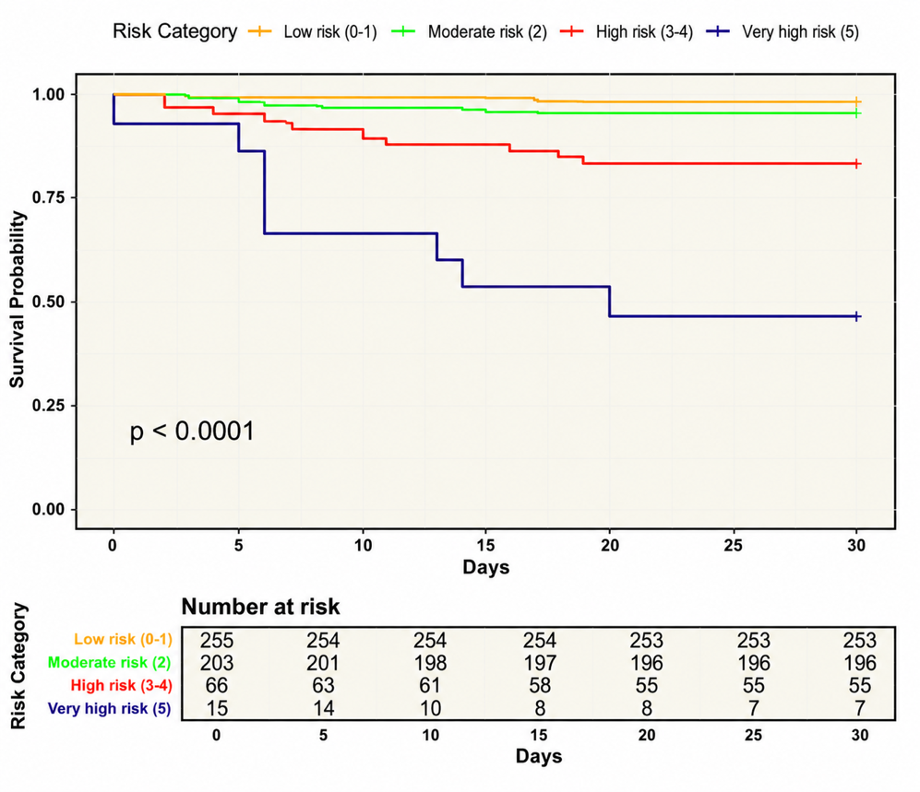
B. Immunocompetent patients with SARS-CoV-2 pneumonia including CURB-65 (VIRA score). We considered the risk of 30-day mortality as low with 0 points, moderate with 1, high with 2, and very high with 3.
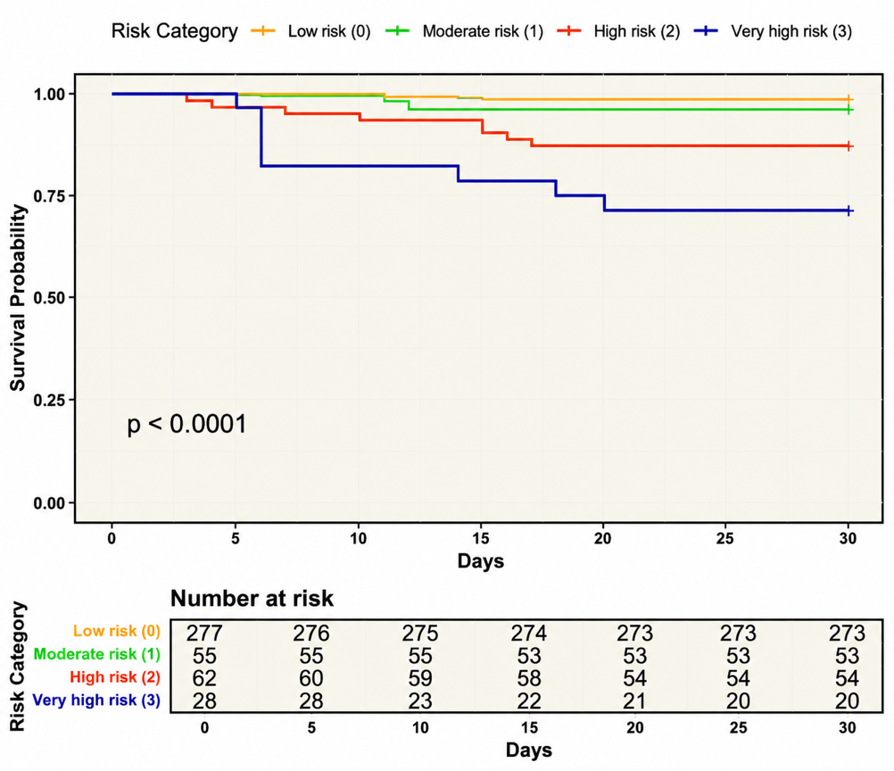

C. Immunocompromised patients with SARS-CoV-2 pneumonia excluding CURB-65. We considered the risk of 30-day mortality as low with -1 points, moderate with 0-1, high with 2, and very high with 3.
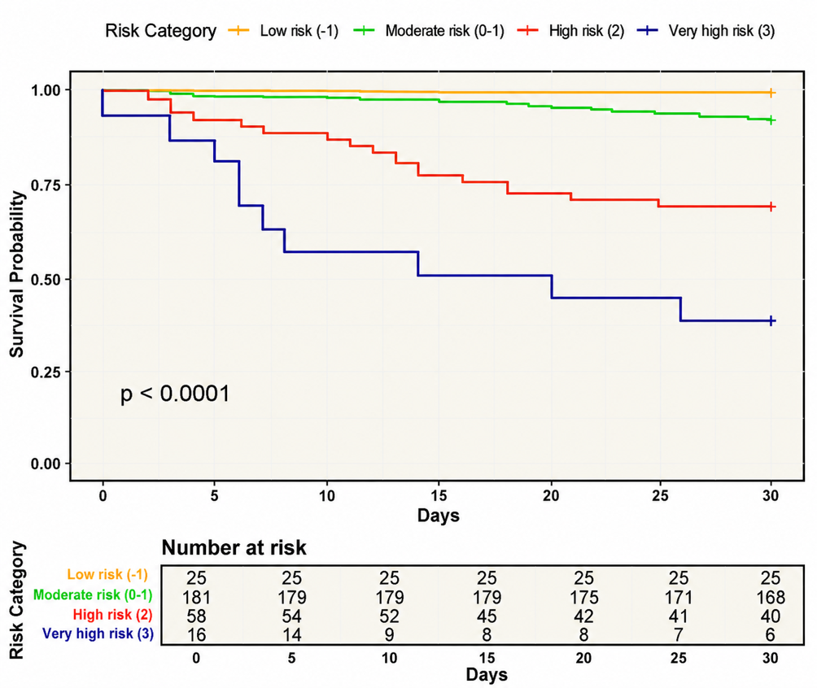

D. Immunocompromised patients with SARS-CoV-2 pneumonia including CURB-65 (VIRA score). We considered the risk of 30-day mortality as moderate with -1 to 1 points, high with 2, and very high with 3.
