Community-acquired Haemophilus influenzae pneumonia in people living with HIV: a 30-year propensity score–matched cohort study

Methods
Statistical analysis
Categorical variables were reported as counts (N) and percentages, while continuous variables were summarized as means with standard deviations (SD) or medians with interquartile range (1st quartile; 3rd quartile), depending on the normality of their distribution. Comparisons between categorical variables were conducted using the χ² test or Fisher’s exact test, as appropriate. Continuous variables were compared using the Student’s t-test or the non-parametric Mann-Whitney U test, depending on data distribution.
To reduce confounding in the comparison between PWH and without HIV hospitalized with CAP, we applied propensity score matching (PSM)(1, 2). The propensity score was estimated through logistic regression, with HIV infection as the dependent variable. Covariates included age, sex, smoking habit, chronic respiratory disease, chronic cardiovascular disease, diabetes mellitus, chronic neurologic disease, chronic renal disease, chronic liver disease, previous neoplasm, PSI class (I-III vs. IV-V), and year of hospital admission, following the recommendations by Brookhart et al.(3) . Matching was performed using optimal matching with a 1:3 ratio, pairing each HIV-infected patient with up to three controls. Covariate balance between matched groups was assessed using standardized mean differences (SMDs)(4): an absolute SMD below 0.1 was considered indicative of good balance, while values below 0.2 were interpreted as acceptable balance. A Love plot was generated to visually assess covariate balance before and after matching (see Supplementary Figure 1).
Differences in 30-day, 90-day and 1-year mortality between groups were evaluated using the Kaplan-Meier method, with comparisons made via the Gehan-Breslow-Wilcoxon test. Additionally, Cox proportional hazards regression models(5) were applied to assess the association between HIV status and 30-day and 1-year mortality among patients with CAP. The hazard ratio (HR) and its 95% confidence intervals (CI) were calculated. To evaluate the influence of HIV status on ICU admission, we conducted analysis using generalized linear models (GLMs)(6) with a binomial distribution and a logit link function. Odds ratios (ORs) and their 95% confidence intervals (CIs) were calculated.
We used the multiple imputation method(7) for missing data in the covariates of the PSM model and the multivariable regression model.
Statistical significance was set at p<0.05 (two-tailed). All statistical analyses were performed using IBM SPSS version 26.0 (IBM Corp., Armonk, NY, USA) and R version 4.4.2 (R Foundation for Statistical Computing, Vienna, Austria).

Online Tables

Supplementary Table 1. Detailed distribution of empiric antibiotic monotherapy according to HIV status
Variables | Full cohort (N=202) |  |  | Propensity score matching (N=72)
Variables | Non-HIV infection  (N=184) | PWH  (N=18) |  | Non-HIV infection  (N=54) | PWH  (N=18)
Empiric antibiotic therapy, n (%)
Monotherapy | 28 (16) | 7 (39) |  | 7 (13) | 7 (39)
Fluoroquinolones | 15 (8) | 3 (17) |  | 2 (4) | 3 (17)
Levofloxacin | 14 (8) | 3 (17) |  | 2 (4) | 3 (17)
Ciprofloxacin | 1 (1) | 0 (0) |  | 0 (0) | 0 (0)
β-lactams | 13 (7) | 3 (17) |  | 5 (10) | 3 (17)
Amoxicillin/clavulanate | 5 (3) | 0 (0) |  | 3 (6) | 0 (0)
Ceftriaxone | 5 (3) | 3 (17) |  | 1 (2) | 3 (17)
Cefepime | 2 (1) | 0 (0) |  | 1 (2) | 0 (0)
Ceftazidime | 1 (1) | 0 (0) |  | 0 (0) | 0 (0)
Macrolide | 0 (0) | 1 (6) |  | 0 (0) | 1 (6)
Clarithromycin | 0 (0) | 1 (6) |  | 0 (0) | 1 (6)
Abbreviations. HIV indicates human immunodeficiency virus.
Note. Percentages calculated on non-missing data.

Supplementary Table 2. Main epidemiological, clinical, immunological, virological, and therapeutical of the 18 PWH and H. influenzae pneumonia
Variable | n (%) / Value
HIV-risk factors
Men who have sex with men (MSM) | 0 (0%)
Heterosexual | 14 (77.7%)
Injecting drug users (IDU) | 3 (17%)
Gender
Males | 10 (56%)
Females | 8 (44%)
Previous AIDS-defining diseases | 6 (33%)
HCV coinfection
No | 10 (55.6%)
Yes, active | 8 (44%)
Yes, cured (SVR) | 0 (0%)
CD4+ T-cell count (median, IQR)
Nadir | 228 (110–500)
Current | 282 (84–406)
Plasma HIV viral load (copies log10/ml)
Peak | 369,700 (76,370–1,158,000)
Current | 969 (37–15,465)
Current Antiretroviral therapy
No | 19%
Yes | 81%
Type of ART (if yes), n (%)
INSTI-based | 1 (6.3%)
PI-based | 6 (37.3%)
NNRTI-based | 3 (18.9%)
Other | 1 (6.3%)
Plasma HIV viral load on ART
VL < 200 copies/mL | 7 (53%)

Supplementary Table 3. Microbial etiology
Variables | Full cohort  (N=202) |  |  | Propensity score matching  N=72)
Variables | Non-HIV infection  (N=184) | PWH  (N=18) | P-value | Non-HIV infection  (N=54) | PWH  (N=18) | P-value
Blood culture, n (%)
Negative | 122 (87) | 13 (87) | >0.999 | 37 (90) | 13 (87) | 0.654
Haemophilus influenzae | 13 (9) | 1 (7) | >0.999 | 3 (7) | 1 (7) | >0.999
Streptococcus pneumoniae | 4 (3) | 1 (7) | 0.403 | 0 (0) | 1 (7) | 0.268
Others | 1 (1) | 0 (0) | >0.999 | 1 (2) | 0 (0) | >0.999
Pleural fluid n (%)
Negative | 10 (71) | 0 (0) | 0.333 | 6 (100) | 0 (0) | 0.143
Haemophilus influenzae | 2 (14) | 0 (0) | >0.999 | 0 (0) | 0 (0) | -
Streptococcus pneumoniae | 1 (7) | 0 (0) | >0.999 | 0 (0) | 0 (0) | -
Others | 1 (7) | 1 (100) | 0.133 | 0 (0) | 1 (100) | 0.143
BAS culture n (%)
Negative | 4 (13) | 1 (17) | >0.999 | 3 (20) | 1 (17) | >0.999
Haemophilus influenzae | 11 (63) | 1 (17) | 0.641 | 7 (47) | 1 (17) | 0.336
Streptococcus pneumoniae | 4 (13) | 1 (17) | >0.999 | 0 (0) | 1 (17) | 0.286
Streptococcus pneumoniae + Haemophilus influenza | 1 (3) | 1 (17) | 0.302 | 0 (0) | 1 (17) | 0.286
Others | 11 (63) | 2 (33) | >0.999 | 5 (33) | 2 (33) | >0.999
Sputum culture n (%)
Negative | 1 (1) | 0 (0) | >0.999 | 1 (2) | 0 (0) | >0.999
Haemophilus influenzae | 109 (68) | 12 (86) | 0.231 | 27 (57) | 12 (86) | 0.109
Streptococcus pneumoniae | 9 (6) | 0 (0) | >0.999 | 1 (2) | 0 (0) | >0.999
Staphylococcus aureus | 3 (2) | 0 (0) | >0.999 | 1 (2) | 0 (0) | >0.999
Streptococcus pneumoniae + Haemophilus influenza | 28 (17) | 2 (14) | >0.999 | 11 (23) | 2 (14) | 0.713
Others | 11 (7) | 0 (0) | 0.604 | 4 (9) | 0 (0) | 0.564
Abbreviations. HIV indicates human immunodeficiency virus, PWH, people with HIV; BAS, bronchial aspirate sample.
Note. Percentages were calculated using the number of patients with available results for each specimen type as the denominator (i.e., percentages reflect the distribution within each group and culture type, rather than the entire cohort). P-values marked in bold indicate numbers that are statistically significant at the 95% confidence limit.

Online Figures

Supplementary Figure 1. Covariate balance before and after propensity score matching
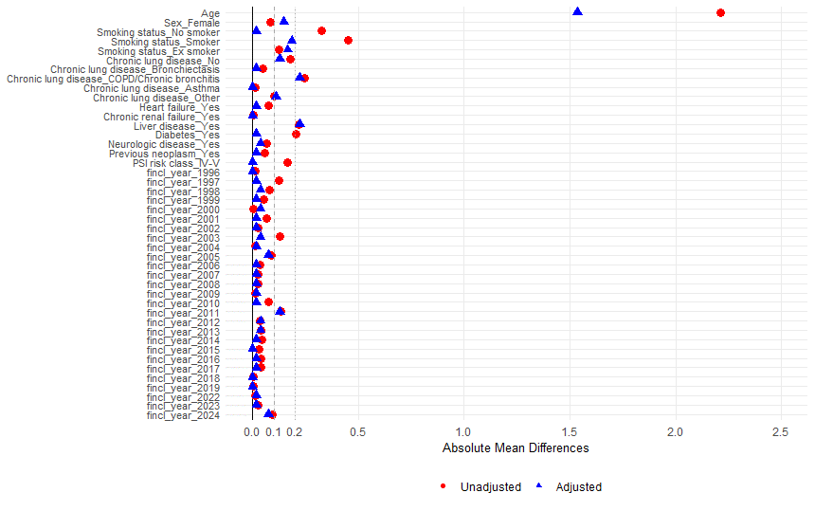

Supplementary Figure 2. Kaplan–Meier survival curves for 30-day mortality by study group
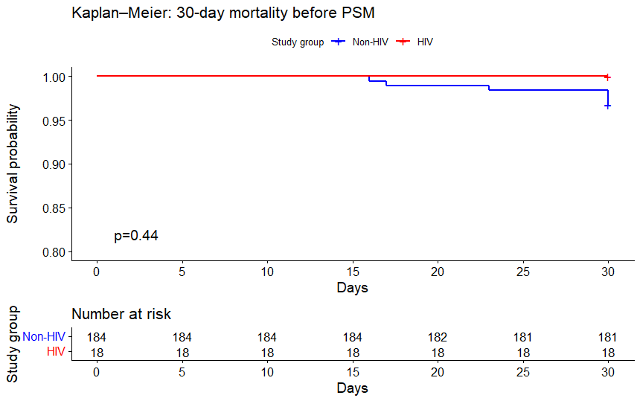 | 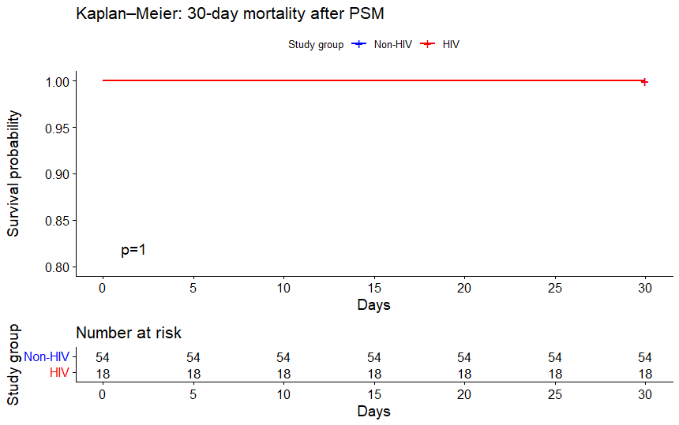
Abbreviations. HIV indicates human immunodeficiency viruses.
Note. P-values are based on Breslow (Wilcoxon) test. Y-axis truncated at 80% to enhance visibility.

Supplementary Figure 3. Kaplan–Meier survival curves for 90-day mortality by study group
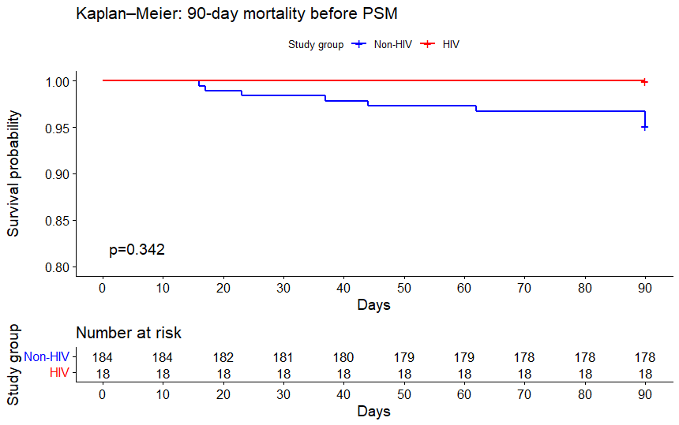 | 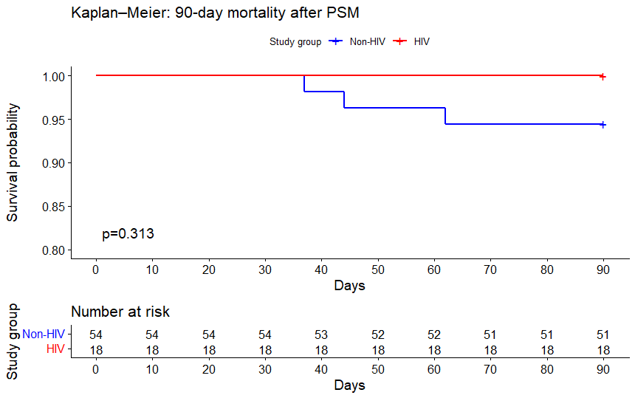
Abbreviations. HIV indicates human immunodeficiency viruses.
Note. P-values are based on Breslow (Wilcoxon) test. Y-axis truncated at 80% to enhance visibility.

Supplementary Figure 4. Kaplan–Meier survival curves for 1-year mortality by study group
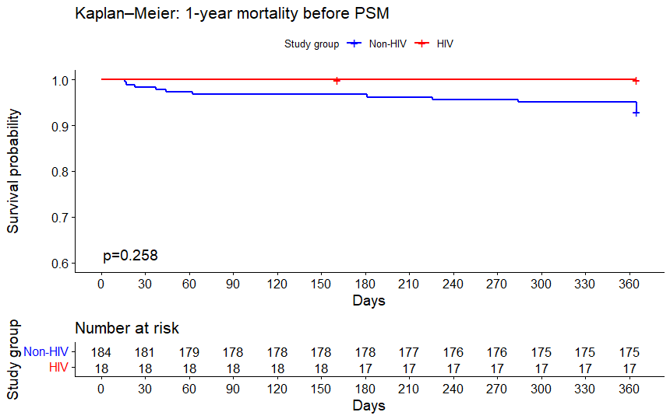 | 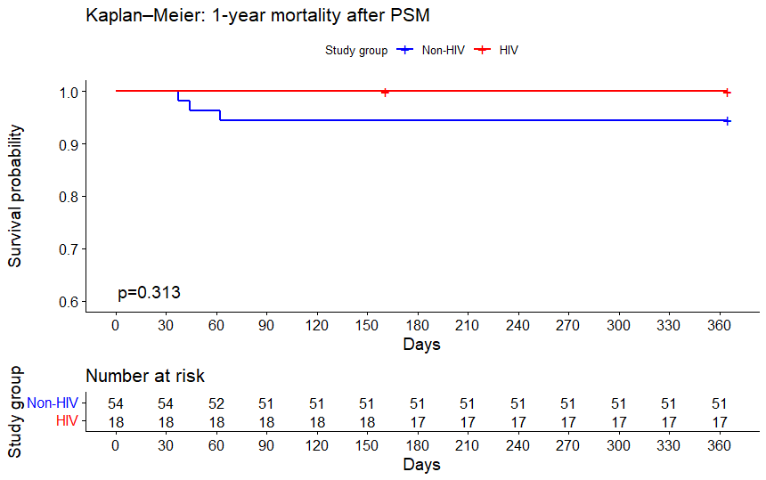
Abbreviations. HIV indicates human immunodeficiency viruses.
Note. P-values are based on Breslow (Wilcoxon) test. Y-axis truncated at 60% to enhance visibility.

