Additional file S1. MEDLINE and EMBASE literature search strategies
Additional file S2. QUIPS domains-items considering for assessment.
Additional file S3. Excluded studies and reason for exclusion
Additional file S4. Characteristics of Included Studies
Additional file S5. Methodological quality of included studies using the QUIPS tool
Additional Table S6. Baseline PCT values and mortality: measure effects
Additional Table S7. Baseline CRP values and mortality: measure effects
Additional Table S8. Baseline IL-6 values and mortality: measure effects
Additional Table S9. Baseline sCD14 values and mortality: measure effects

Additional Figure S1. Procalcitonin and prediction of mortality at 28-30 days in critically-ill septic patients
Additional Figure S2. C-reactive protein and prediction of mortality at 28-30 days in critically-ill septic patients
Additional Figure S3. Interleukin-6 and prediction of mortality at 28-30 days in critically-ill septic patients
Additional Figure S4. Summary of mortality at 28-30 days and baseline biomarkers measures
Additional Figure S5. Summary of mortality, no details provided and baseline biomarkers measures

Additional references

S1Table. MEDLINE and EMBASE Literature search strategies
Ovid MEDLINE(R) ALL <1946 to March 24 2023>
1 Hemorrhagic Septicemia/
2 exp Sepsis/
3 exp Shock, Septic/
4 exp Critical Illness/
5 exp Bacteremia/
6 Systemic Inflammatory Response Syndrome/
7 (sepsis or septic* or bacter?em*).mp.
8 (Flavimonas oryzihabitans Bacteremia or Systemic Inflammatory Response).mp.
9 (critical* adj3 ill*).ab,ti.
10 1 or 2 or 3 or 4 or 5 or 6 or 7 or 8 or 9
11 exp Interleukin-6/
12 exp Receptors, Interleukin-6/
13 exp Interleukin-6 Receptor alpha Subunit/
14 (interleukin* or IL?6* or IL 6*).mp.
15 11 or 12 or 13 or 14
16 exp Procalcitonin/
17 exp Calcitonin/
18 (procalcitonin or PCT).ab,ti.
19 (calcitonin and precursor*).ab,ti.
20 16 or 17 or 18 or 19
21 exp C-Reactive Protein/
22 (C?Reactive protein* or CRP).ab,ti.
23 21 or 22
24 (presepsin or Solube CD14 or SCD14 or SCD?14).mp.
25 15 or 20 or 23 or 24
26 10 and 25
27 ((child* or nenonat* or infant*) not adult*).af.
28 (animal* not human*).af.
29 26 not 27
30 29 not 28
31 exp COVID-19/
32 exp SARS-CoV-2/
33 (covid-19 or Sars-cov-2).tw.
34 31 or 32 or 33
35 30 not 34
36 (201906* or 201907* or 201908* or 201909* or 201910* or 201911* or 201912* or 2020* or 2021*).ez,tw.
37 35 and 36

Embase-Elsevier
#40 #36 NOT #37 AND [embase]/lim AND [17-6-2019]/sd NOT [13-4-2021]/sd
#39 #36 NOT #37 AND [embase]/lim
#38 #36 NOT #37
#37 (child* OR nenonat* OR infant*) NOT adult
#36 #31 NOT #35
#35 #32 OR #33 OR #34
#34 'covid 19' OR 'sars cov 2':ab,ti
#33 'severe acute respiratory syndrome coronavirus 2'/exp
#32 'coronavirus disease 2019'/exp
#31 #29 NOT #30
#30 animal* NOT human*
#29 #10 AND #28
#28 #15 OR #19 OR #22 OR #27
#27 #23 OR #24 OR #25 OR #26
#26 scd?14:ab,kw,ti,de
#25 scd14:ab,kw,ti,de
#24 soluble AND cd14:ab,kw,ti,de
#23 presepsin:ab,ti,kw,de
#22 #20 OR #21
#21 c$reactive AND protein*:ti,ab OR crp:ti,ab
#20 'c reactive protein'/exp
#19 #16 OR #17 OR #18
#18 calcitonin AND precursor:ti,ab
#17 procalcitonin OR pct:ti,ab
#16 'procalcitonin'/exp
#15 #11 OR #12 OR #13 OR #14
#14 interleukin*:ti,ab OR il$6:ti,ab OR ((il NEAR/2 6*):ti,ab)
#13 'interleukin 6 receptor alpha'/exp
#12 'interleukin 6 receptor'/exp
#11'interleukin 6'/exp
#10 #1 OR #2 OR #3 OR #4 OR #5 OR #6 OR #7 OR #8 OR #9
#9 (critical* NEAR/3 ill*):ti,ab
#8 'flavimonas oryzihabitans oryzihabitans bacteremia' OR 'systemic inflammatory response':ti,ab
#7 sepsis OR septic* OR bacter$em*:ti,ab
#6 'systemic inflammatory response syndrome'/exp
#5 'bacteremia'/exp
#4 'critical illness'/exp
#3 'septic shock'/exp
#2 'sepsis'/exp
#1 'hemorrhagic septicemia'/exp

S2 Table. QUIPS domains-items considering for assessment.

Domain | Items considered for assessment | Risk of bias rating
1. Study participation | The source population or population of interest is adequately described for our key characteristics. Baseline characteristics of interest are clearly indicated for the population (e.g., disease severity).  Eligibility criteria and recruitment are adequately described (e.g., diagnosis of sepsis correctly reported). There is a description of the period and place of recruitment.  There is adequate participation in the study by eligible participants. There are no exclusions due to biomarker values or caused by the evolution of the patient. | LOW: if all items are indicated as non-problematic, the relationship between the biomarker and outcome is unlikely to be different for participants and eligible nonparticipants.  MODERATE: some items are not clearly reported, or some are indicated as problematic.  HIGH: if more than one item is reported as problematic, the relationship between the biomarker and outcome is very likely to be different for participants and eligible nonparticipants.
2. Study attrition | There should be no subsequent unwarranted exclusions or a notable number of non-participants. Furthermore, in the presence of lost follow-ups, there are descriptions of attempts to collect information on participants who dropped out.  In the case of justified exclusions (e.g., no outcome-related or biomarker-related exclusions), there are no important differences among participants who completed the study and those who did not. | LOW: if all items are indicated as non-problematic, the relationship between the biomarker and outcome is unlikely to be different for completing and non-completing participants.  MODERATE: some items are not clearly reported, or some are indicated as problematic.  HIGH: if more than one item is reported as problematic, the relationship between the biomarker and outcome is very likely to be different for completing and non-completing participants.
3. Biomarker measurement | The laboratory technique or method for measuring the biomarker is clearly reported. The same method and setting of measurement are used in all study participants (e.g., all patients have the same number of samples analysed; in the presence of several biomarkers, there are differences in their measurement).  Methods of measurement were accurate, valid, consistent and reliable, e.g., the information is collected by a laboratory test instead of the medical record.  Continuous variables are treated appropriately, and rationale provided for cut-off values if analysed as categorical. Penalised if the cut-off point is derived in the same sample (e.g., obtaining the cut-off point by ROC).  Adequate proportion of the study sample has complete data for prognostic factors and, if not, appropriate methods of imputation were used for missing data (e.g., group average). | LOW: if all items are indicated as non-problematic, the relationship between the biomarker and outcome is unlikely to be different levels of the outcome of interest.  MODERATE: some items are not clearly reported, or some are indicated as problematic.  HIGH: if more than one item is reported as problematic, the relationship between the biomarker and outcome is very likely to be different levels of the outcome of interest.
4. Mortality measurement | The assessment of mortality does not require an evaluation of the accuracy of the outcome measure since death is an objectively measurable endpoint. However, the methods of measurement should be accurate, valid, consistent and reliable (e.g., 28-day mortality, ICU mortality, sepsis-related mortality, etc).  The method and setting of measurement were the same for all participants. | LOW: if all items are indicated as non-problematic, the measurement of the outcome is unlikely to be different related to the baseline level of the biomarker.  MODERATE: some items are not clearly reported, or some are indicated as problematic.  HIGH: if more than one item is reported as problematic, the measurement of the outcome is very likely to be different related to the baseline level of the biomarker.
5. Adjustment for other prognostic factors | All-important confounders are measured, and clear definitions are provided:  - Age (years).  - Severity score (SOFA, SAPS-II, APACHE).  The method and setting of measurement were the same for all participants, ensuring accuracy, validity, consistency, and reliability (e.g., validated scales used).  The two important potential confounders are accounted for in the study design or in the analysis, and appropriate methods were used to account for missing data. | LOW: if all items are indicated as non-problematic, the observed effect of the biomarker on the outcome is unlikely to be distorted by a confounder.  MODERATE: some items are not clearly reported, or some are indicated as problematic.  HIGH: if more than one item is reported as problematic, the observed effect of the biomarker on the outcome is very likely to be distorted by a confounder.
6. Statistical analysis and reporting | There is sufficient presentation of the data to assess the adequacy of the analysis. The strategy for model building was acceptable and based on a conceptual framework (e.g., no model overfitting, 1 variable/10 events). The analysis is appropriate for the design of the study.  There is no selective reporting of results (e.g., measure of effect not only reported when the results are statistically significant or inconsistent reported data). | LOW: if all items are indicated as non-problematic, the reported results are unlikely to be spurious or biased related to analysis or reporting.  MODERATE: some items are not clearly reported, or some are indicated as problematic.  HIGH: if more than one item is reported as problematic, the reported results are very likely to be spurious or biased related to analysis or reporting.

S3 Table. Excluded studies and reason for exclusion

ID | Reason for exclusion
Azevedo 2012 ¹ | Wrong outcome
Calandra 1991 ² | Wrong population
Gao C 2022 ³ | Wrong prognostic factor
Gao Q 2021 ⁴ | Wrong prognostic factor
Di 2020 ⁵ | Wrong outcome
El Said 2020 ⁶ | Wrong outcome
Hashim 2020 ⁷ | Wrong outcome
Hillas 2010 ⁸ | Wrong outcome
Honorato 2023 ⁹ | Wrong prognostic factor
Kandaswamy 2018 ¹⁰ | Wrong population
Kang 2008 ¹¹ | Wrong outcome
Karampela 2019 ¹² | Wrong population
Kellum 2007 ¹³ | Wrong outcome
Kim 2013 ¹⁴ | Wrong prognostic factor
Li Y 2022 ¹⁵ | Wrong prognostic factor
Li Z 2022 ¹⁶ | Wrong prognostic factor
Nanda 2016 ¹⁷ | Wrong outcome
Pieralli 2015 ¹⁸ | Wrong prognostic factor
Schroder 1999 ¹⁹ | Wrong outcome
Schuetz 2007 ²⁰ | Wrong prognostic factor
Sharma 2014 ²¹ | Wrong study design
Stalder 2016 ²² | Wrong prognostic factor
Su 2012 ²³ | Wrong outcome
Sunden 2005 ²⁴ | Wrong outcome
Tan 2017 ²⁵ | Wrong outcome
Thao 2018 ²⁶ | Wrong prognostic factor
Yao 2016 ²⁷ | Wrong prognostic factor
Zhang 2019 ²⁸ | Wrong prognostic factor
Baoquan 2019 ²⁹ | Wrong outcome
Malek 2019 ³⁰ | Wrong study design
Naderpour 2019 ³¹ | Wrong study design
C. Peng 2020 ³² | Wrong prognostic factor
Tschaikowsky 2011 ³³ | Wrong prognostic factor
Behnes 2014 ³⁴ | Wrong population
Frencken 2017 ³⁵ | Wrong prognostic factor
Goldberg 2021 ³⁶ | Wrong prognostic factor
Gradel 2013 ³⁷ | Wrong population
Kurisu 2019 ³⁸ | Wrong prognostic factor
Matera 2017 ³⁹ | Wrong population
Owasawara 2020 ⁴⁰ | Wrong prognostic factor
Pallas 2016 ⁴¹ | Wrong population
Pauly 2016 ⁴² | Wrong population
Peng 2017 ⁴³ | Wrong prognostic factor
Shen 2020 ⁴⁴ | Wrong population
Suarez de la Rica 2015 ⁴⁵ | Wrong prognostic factor
Tanriverdi 2015 ⁴⁶ | Wrong prognostic factor
Taskin 2016 ⁴⁷ | Wrong prognostic factor
Wunder 2004 ⁴⁸ | Wrong prognostic factor
Yan 2021 ⁴⁹ | Wrong population

S4 Table. Characteristics of Included Studies

Study ID | Countries | Number of study centers | Hospital setting at admission | Total sample included in the analysis | Age (years) | Sex  (% females) | Criteria used for sepsis definition | Sepsis origin | APACHE-II | SOFA | SAPS II | PCT | CRP | IL6 | PSP, SCD14
Aalto 2007 | Finland | Single center | Emergency room | 142 | 60  Expressed as  Mean | 59 (41.5%) | Mix | Mixed | NR | NR | NR | No | Yes | No | Yes
Amancio 2013 | Brazil | Multi-center – 4 centers | ICU | 60 | 32 (26; 43)  66 (46; 78)  Expressed as  Median (25th – 75th) | 20 (33.0%) | ACCP/SCCM 1991 criteria | Mixed | NR | 8 (6; 10.5)  10 (9; 13)  Expressed as  Median | 55 (47; 58)  55 (44; 63)  Expressed as  Median | No | Yes | Yes | No
Andaluz-Ojeda 2012 | Spain | Single center | ICU | 29 | 66.1  Expressed as  Mean | 12 (41.3%) | Levy criteria (2001 SCCM/ESICM/ACCP/ATS/SIS International Sepsis Definitions Conference) | Mixed | 22.2  Expressed as  Mean | 8.1  Expressed as  Mean | NR | No | No | Yes | No
Andaluz-Ojeda 2017 | Spain-France | Multi-center – 2 centers | ICU | 326 | 65.4 (14)  Expressed as  Mean (SD) | 105 (38.6%) | Levy criteria (2001 SCCM/ESICM/ACCP/ATS/SIS International Sepsis Definitions Conference) | Mixed | NR | 9 (3.7)  Expressed as  Mean | NR | Yes | Yes | No | No
Belli 2022 | Italy | Single center | ICU | 35 | 59 (48; 60)  Expressed as  Median (25th – 75th) | 14 (40.0%) | Singer criteria (2015 SCCM/ESICM Sepsis-3) | Mixed | NR | NR | NR | Yes | No | Yes | No
Carbonell 2021 | Spain | Multi-center – more than 5 centers | ICU | 422 | 59 (49; 71)  61 (48; 74)  Expressed as  Median (25th – 75th) | 159 (37.7%) | Levy criteria (2001 SCCM/ESICM/ACCP/ATS/SIS International Sepsis Definitions Conference) | Respiratory | 18 (13; 24)  23 (18; 28)  Expressed as  Median (25th – 75th) | 6 (4; 9)  9 (6.2; 12)  Expressed as  Median (25th – 75th) | NR | Yes | Yes | No | No
Chen 2020 | China | Single center | ICU | 120 | 50.3 (8.4)  Expressed as  Mean (SD) | 66 (55.0%) | Singer criteria (2015 SCCM/ESICM Sepsis-3) | Mixed | 15.2 (4.6)  Expressed as  Mean (SD) | 7.3 (3.8)  Expressed as  Mean (SD) | NR | Yes | No | No | No
De la Torre-Prados 2016 | Spain | Single center | ICU | 100 | 64 (56; 72)  Expressed as  Median (25th – 75th) | 41 (41.0%) | Levy criteria (2001 SCCM/ESICM/ACCP/ATS/SIS International Sepsis Definitions Conference) | Mixed | 26 (8)  Expressed as  Median (IQR) | 10 (4)  Expressed as  Median (IQR) | NR | Yes | Yes | No | No
Eidt 2016 | Brazil | Single center | ICU | 48 | 61.4 (18.7)  65.9 (17.8)  Expressed as  Mean (SD) | 24 (50.0%) | Levy criteria (2001 SCCM/ESICM/ACCP/ATS/SIS International Sepsis Definitions Conference) | NR | 11.4 (4.7)  16.0 (6.7)  Expressed as  Mean (SD) | 7.2 (3.0)  7.6 (5.2)  Expressed as  Mean (SD) | NR | No | No | Yes | No
Elke 2018 | Germany | Multi-center – more than 5 centers | ICU | 1076 | 65.7 (13.7)  Expressed as  Mean (SD) | 395 (36.7%) | Singer criteria (2015 SCCM/ESICM Sepsis-3) | Mixed | 24.2 (7.6)  Expressed as  Mean (SD) | 10.3 (3.3)  Expressed as  Mean (SD) | 63.2 (14.1)  Expressed as  Mean (SD) | Yes | Yes | No | No
Erdogan 2021 | Turkey | Single center | ICU | 187 | 74 (66; 80)  Expressed as  Median (25th – 75th) | 105 (56.0%) | Singer criteria (2015 SCCM/ESICM Sepsis-3) | NR | 19 (16; 24)  33 (26; 39)  Expressed as  Median (25th – 75th) | 5 (5; 8)  6 (6; 12)  Expressed as  Median (25th – 75th) | NR | Yes | Yes | No | No
Gao C 2022 | China | Single center | ICU | 205 | 45 (36; 54)  Expressed as  Median (25th – 75th) | 84 (40.9%) | Other | NR | 16.4 (5.6)  Expressed as  Mean (SD) | 9.8 (3.4)  Expressed as  Mean (SD) | NR | Yes | No | No | No
Guo 2018 | China | Single center | ICU | 59 | 63.6 (17.9)  Expressed as  Mean (SD) | 17 (28.8%) | singer criteria (2015 SCCM/ESICM Sepsis-3) | Mixed | 15 (9; 21)  Expressed as  Median (25th – 75th) | 4 (3; 8)  Expressed as  Median (25th – 75th) | NR | Yes | Yes | No | No
Hu 2018 | China | Single center | ICU | 141 | 63 (33; 78)  Expressed as  Median (25th – 75th) | 55 (39.0%) | Singer criteria (2015 SCCM/ESICM Sepsis-3) | Mixed | 21 (10; 36)  Expressed as  Median (25th – 75th) | 5 (2; 14)  Expressed as  Median (25th – 75th) | NR | Yes | Yes | No | No
Huang N 2022 | China | Single center | ICU | 349 | 66 (52; 77)  Expressed as  Median (25th – 75th) | 120(34.4%) | Singer criteria (2015 SCCM/ESICM Sepsis-3) | Mixed | 20 (14.5; 26)  Expressed as  Median (25th – 75th) | 8 (5; 11)  Expressed as  Median (25th – 75th) | NR | Yes | Yes | No | No
Jain 2014 | India | Single center | ICU | 54 | 50.7 (18.7)  Expressed as  Mean (SD | 24 (46.0%) | Levy criteria (2001 SCCM/ESICM/ACCP/ATS/SIS International Sepsis Definitions Conference) | Mixed | 24.7 (7.8)  Expressed as  Mean (SD) | 8.3 (3.7)  Expressed as  Mean (SD) | 53.2 (16.8)  Expressed as  Mean (SD) | Yes | Yes | No | No
Jekarl 2019 | South Korea | Single center | Emergency room | 185 | 70.1 (14.9)  Expressed as  Mean (SD) | 124 (67.0%) | Singer criteria (2015 SCCM/ESICM Sepsis-3) | Mixed | NR | 3.54 (2.81)  4.65 (3.12)  Expressed as  Mean (SD) | NR | Yes | Yes | No | No
Jiang 2019 | China | Single center | ICU | 198 | 69.9 (29; 91)  68.7 (18; 91)  Expressed as  Median (25th – 75th) | 72 (18.2%) | Singer criteria (2015 SCCM/ESICM Sepsis-3) | Mixed | NR | 7 (4; 13)  10 (6; 15)  Expressed as  Median (25th – 75th) | NR | No | No | Yes | No
Karamouzos 2021 | Greece | NR | ICU | 128 | 72.4 (15)  77.3 (10)  Expressed as  Mean (SD) | 72 (56.2%) | Levy criteria (2001 SCCM/ESICM/ACCP/ATS/SIS International Sepsis Definitions Conference) | Mixed | 19 (6.6)  22 (6.3)  Expressed as  Mean (SD) | 6.5 (4)  9.2 (3.6)  Expressed as  Mean (SD) | NR | No | No | Yes | No
Karampela 2022 | Greece | Single center | ICU | 102 | 64.7 (15.6)  Expressed as  Mean (SD) | 45 (44.1%) | Singer criteria (2015 SCCM/ESICM Sepsis-3) | Mixed | 23 (7.2)  Expressed as  Mean (SD) | 10 (3.3)  Expressed as  Mean (SD) | NR | No | No | Yes | No
Khashaba 2022 | Egypt | Single center | ICU | 178 | 53.9 (10.3)  57.4 (8.6)  Expressed as  Mean (SD) | 71 (39.9%) | Singer criteria (2015 SCCM/ESICM Sepsis-3) | NR | 22.5 (4.1)  24.4 (6.8)  Expressed as  Mean (SD) | 9.5 (2.5)  10.5 (2.7)  Expressed as  Mean (SD) | NR | Yes | No | No | Yes
Kim S 2022 | Korea | Single center | ICU | 282 | 60.6  Expressed as  Mean | 80 (28.4%) | Other | Respiratory | 25.3  Expressed as  Mean (SD) | NR | NR | No | Yes | No | No
Koozi 2023 | Sweden | Multi-center – 4 centers | ICU | 1984 | 69 (59; 76)  Expressed as  Median (25th – 75th) | 831 (41.9%) | Singer criteria (2015 SCCM/ESICM Sepsis-3) | NR | NR | 7 (5; 10)  Expressed as  Median (25th – 75th) | NR | No | Yes | No | No
Lai X 2022 | China | Single center | ICU | 117 | 56 (52; 59)  59 (46; 71)  Expressed as  Median (25th – 75th) | 58 (49.6%) | Singer criteria (2015 SCCM/ESICM Sepsis-3) | Mixed | 22(16; 32)  18(13; 23)  Expressed as  Median (25th – 75th) | 10.5 (7.3; 14.5)  6.9 (3.7; 9.9)  Expressed as  Median (25th – 75th) | NR | Yes | No | Yes | No
Lee J 2021 | Korea | Single center | ICU | 100 | 71.0 (61.0; 79.0)  69.5 (54.0; 83.0)  Expressed as  Median (25th – 75th) | 41 (46.6%) | Singer criteria (2015 SCCM/ESICM Sepsis-3) | NR | NR | 8.0 (7.0; 11.0)  11.0 (8.0; 13.0)  Expressed as  Median (25th – 75th) | 72.2 (11.6)  83.6 (12.9)  Expressed as  Median (25th – 75th) | Yes | No | No | Yes
Lee S 2022 | Korea | Single center | Emergency room | 278 | 77 (64; 84)  Expressed as  Median (25th – 75th) | 116 (42.0%) | Singer criteria (2015 SCCM/ESICM Sepsis-3) | Mixed | 26 (22; 32)  29 (25; 33)  Expressed as  Median (25th – 75th) | 6 (5; 8)  10 (8; 12)  Expressed as  Median (25th – 75th) | NR | No | No | No | Yes
Li 2019 | China | Single center | ICU | 245 | 84.3 (7.6)  Expressed as  Mean (SD) | 58 (23.7%) | NR | Mixed | 13.8 (5.1)  Expressed as  Mean (SD) | NR | NR | No | Yes | No | No
Li X 2021 Clinica | China | Single center | ICU | 220 | 69 (11)  63 (18)  Expressed as  Mean (SD) | 68 (30.9%) | Singer criteria (2015 SCCM/ESICM Sepsis-3) | Mixed | NR | 11 (4:21)  5 (2;15)  Expressed as  Median (25th – 75th) | NR | Yes | No | No | No
Liu 2021 | China | Single center | ICU | 264 | 52.9 (12.6)  Expressed as  Mean (SD) | 97 (36.0%) | Singer criteria (2015 SCCM/ESICM Sepsis-3) | Mixed | 20.79 (6.89)  Expressed as  Mean (SD) | 8 (6; 11)  Expressed as  Median (25th – 75th) | NR | Yes | Yes | Yes | No
Masson 2014 | Italy | Multi-center – more than 5 centers | ICU | 100 | 71.6 (10.8)  71.3 (13.6)  Expressed as  Mean (SD) | 46 (46.0%) | Mix | Mixed | NR | 8 (6; 10)  9 (7; 11)  Expressed as  Median (25th – 75th) | 50 (14)  51 (12)  Expressed as  Mean (SD) | Yes | No | No | Yes
Oberholzer 2015 | USA | Multi-center – more than 5 centers | Mixed | 124 | 58.3 (17.5)  Expressed as  Mean (SD) | 56 (45.0%) | Other | NR | 21.6 (8.2)  Expressed as  Mean (SD) | NR | NR | Yes | No | Yes | No
Phua 2008 | Singapore | Single center | ICU | 72 | 55 (16)  54 (17)  Expressed as  Mean (SD) | 26 (36.0%) | Levy criteria (2001 SCCM/ESICM/ACCP/ATS/SIS International Sepsis Definitions Conference) | Mixed | 23.1 (7.5)  32.3 (8.7)  Expressed as  Mean (SD) | 10.1 (3.0)  12.7 (4.4)  Expressed as  Mean (SD) | NR | Yes | No | Yes | No
Ryoo 2019 | South Korea | Multi-center – more than 5 centers | Emergency room | 1772 | 67.5 (13.6)  Expressed as  Mean (SD) | 727 (41.0%) | NR | Mixed | 19 (14; 26)  Expressed as  Median (25th – 75th) | 8 (5; 11)  Expressed as  Median (25th – 75th) | NR | Yes | Yes | No | No
Shao 2015 | China | Single center | Emergency room | 227 | 71 (66; 78)  73 (62; 77)  74 (64; 79)  Expressed as  Median (25th – 75th) | 88 (38.7%) | Levy criteria (2001 SCCM/ESICM/ACCP/ATS/SIS International Sepsis Definitions Conference) | Mixed | NR | NR | NR | Yes | No | No | No
Shimoyama 2021 | Japan | Single center | ICU | 83 | 74.0 (65.5; 78.5)  Expressed as  Median (25th – 75th) | 32 (38.6%) | Singer criteria (2015 SCCM/ESICM Sepsis-3) | NR | NR | 8.0 (5; 11)  Expressed as  Median (25th – 75th) | NR | No | No | No | Yes
Siddiqui 2019 | Singapore | Single center | ICU | 198 | 63.0 (49.5; 73.5)  54.0 (45.0; 64.0)  61.0 (40.0; 68.8)  Expressed as  Mean (SD) | 78 (39.4%) | NR | NR | NR | NR | NR | No | No | Yes | No
Song 2019 | South Korea | Single center | Emergency room | 97 | 75 (42; 98)  Expressed as  Median (25th – 75th) | 43 (44.3%) | Singer criteria (2015 SCCM/ESICM Sepsis-3) | Mixed | 21 (13; 30)  Expressed as  Median (25th – 75th) | 8 (4; 11)  Expressed as  Median (25th – 75th) | NR | Yes | Yes | Yes | No
Su 2013 | China | Single center | ICU | 100 | 58.9 (19.5)  Expressed as  Mean (SD) | 33 (33.0%) | Levy criteria (2001 SCCM/ESICM/ACCP/ATS/SIS International Sepsis Definitions Conference) | Mixed | 13.4 (6.1)  Expressed as  Mean (SD) | 7.8 (4.4)  Expressed as  Mean (SD) | NR | Yes | Yes | No | No
Suberviola 2013 | Spain | Single center | ICU | 137 | 62.6 (15.9)  Expressed as  Mean (SD) | 47 (34.3%) | Levy criteria (2001 SCCM/ESICM/ACCP/ATS/SIS International Sepsis Definitions Conference) | Mixed | 20.6 (7.2)  Expressed as  Mean (SD) | 8.6 (3.0)  Expressed as  Mean (SD) | NR | Yes | Yes | No | No
Sun 2011 | china | Single center | ICU | 50 | 66 (17)  Expressed as  Mean (SD) | 20 (40.0%) | ACCP/SCCM 1991 criteria | NR | 19.0 (5.8)  24.9 (6.0)  Expressed as  Mean (SD) | NR | NR | Yes | Yes | No | No
Suranadi 2022 | Indonesia | Single center | ICU | 228 | 53.6 (16.4)  Expressed as  Mean (SD) | 94 (41.2%) | Levy criteria (2001 SCCM/ESICM/ACCP/ATS/SIS International Sepsis Definitions Conference) | Mixed | NR | 7.1 (3.25)  Expressed as  Mean (SD) | NR | Yes | No | No | No
Taha 2023 | Egypt | Single center | ICU | 54 | 54.4 (9.3)  40.5 (9.6)  Expressed as  Mean (SD) | 23 (42.6%) | Singer criteria (2015 SCCM/ESICM Sepsis-3) | Mixed | NR | 29.33 (5.28  29.72 (5.85  Expressed as  Mean (SD) | NR | No | Yes | No | No
Tian 2021 | China | Single center | ICU | 194 | 78 (63.5; 83)  81 (76; 86.5)  Expressed as  Median (25th – 75th) | 76 (38.2%) | Singer criteria (2015 SCCM/ESICM Sepsis-3) | Mixed | 18.0 (13.0; 26.3)  36.0 (32.0; 39.0)  Expressed as  Median (25th – 75th) | 4.0 (3.0; 6.0)  5.5 (4.0; 9.0)  Expressed as  Median (25th – 75th) | NR | Yes | Yes | No | No
Tokur 2022 | Turkey | Single center | ICU | 39 | 72 (52; 84)  Expressed as  Median (25th – 75th) | 17 (43.6%) | Other | Bacteriemia | NR | NR | 63 (58; 70)  41 (25; 51.7)  Expressed as  Median (25th – 75th) | No | Yes | No | No
Viallon 2008 | France | Single center | Mixed | 131 | 71 (15)  74 (14)  61 (21)  Expressed as  Mean (SD) | NR | Levy criteria (2001 SCCM/ESICM/ACCP/ATS/SIS International Sepsis Definitions Conference) | Mixed | NR | NR | 22.2 (1.0)  50.2 (3.6)  Expressed as  Mean (SD) | Yes | Yes | Yes | No
Wang 2014 | China | Single center | Emergency room | 360 | 71 (59; 78)  73 (60; 78)  73 (65; 78)  Expressed as  Median (25th – 75th) | 178 (40.4%) | ACCP/SCCM 1991 criteria | Mixed | NR | NR | NR | Yes | No | No | No
Webb 2020 | USA | Single center | Emergency room | 148 | 72 (60; 82)  Expressed as  Median (25th – 75th) | 67 (45.3%) | Singer criteria (2015 SCCM/ESICM Sepsis-3) | Mixed | NR | NR | NR | yes | No | No | No
Wu CX 2021 | China | Single center | ICU | 114 | 72 (60; 81)  Expressed as  Median (25th – 75th) | 31 (27.1%) | Singer criteria (2015 SCCM/ESICM Sepsis-3) | Mixed | 17.5 (12.75; 22)  Expressed as  Median (25th – 75th) | 7 (4; 11)  Expressed as  Median (25th – 75th) | NR | Yes | Yes | Yes | No
Wu HP 2009 | China | Single center | Mixed | 63 | 70.0 (2.0)  69.1 (4.1)  Expressed as  Mean (SD) | 23 (36.5%) | Other | Respiratory | 22.7 (1.0)  28.7 (2.3)  Expressed as  Mean (SD) | NR | NR | No | No | Yes | No
Xia 2020 | China | Single center | Emergency room | 821 | 56.8 (17.8)  59.9 (17.6)  Expressed as  Mean (SD) | 293 (35.6%) | Levy criteria (2001 SCCM/ESICM/ACCP/ATS/SIS International Sepsis Definitions Conference) | Mixed | 15.2 (7.2)  20.5 (7.1)  Expressed as  Mean (SD) | 4.7 (3.2)  9.1 (5.0)  Expressed as  Mean (SD) | NR | Yes | No | No | No
Xie 2021 | China | Multi-center – 2 centers | Emergency room | 90 | 74 (26; 97)  Expressed as  Median (25th – 75th) | 32 (35.0%) | Singer criteria (2015 SCCM/ESICM Sepsis-3) | Mixed | NR | 7.5 (4.3)  Expressed as  Mean (SD) | NR | Yes | Yes | Yes | No
Xie 2023 | China | Single center | Emergency room | 367 | 73 (19; 98)  Expressed as  Median (25th – 75th) | 115 (34.1%) | Singer criteria (2015 SCCM/ESICM Sepsis-3) | Mixed | NR | NR | NR | Yes | No | Yes | No
Yang 2019 | China | Single center | ICU | 185 | 68.3 (17.1)  Expressed as  Mean (SD) | 71 (38.3%) | Other | NR | 24.1 (5.9)  21.6 (6.0)  Expressed as  Mean (SD) | 2.7 (0.5)  2.3 (0.6)  Expressed as  Mean (SD) | NR | Yes | No | No | No
Yin 2013 | China | Single center | Emergency room | 680 | 72 (60; 78)  Expressed as  Median (25th – 75th) | 264 (38.8%) | Levy criteria (2001 SCCM/ESICM/ACCP/ATS/SIS International Sepsis Definitions Conference) | Mixed | NR | NR | NR | Yes | No | No | No
Yu 2022 | China | Single center | Emergency room | 63 | 79 (34; 95)  Expressed as  Median (25th – 75th) | 23 (36.5%) | Singer criteria (2015 SCCM/ESICM Sepsis-3) | NR | 3.56 (11.91)  Expressed as  Mean (SD) | 5 (3; 6)  Expressed as  Median (25th – 75th) | NR | No | No | Yes | No
Zhang 2019 | China | Single center | ICU | 150 | 70 (24; 91)  74.5 (24; 89)  Expressed as  Median (25th – 75th) | 55 (36.6%) | Singer criteria (2015 SCCM/ESICM Sepsis-3) | Mixed | NR | 4 (2; 10)  6 (4; 8)  Expressed as  Median (25th – 75th) | NR | Yes | No | Yes | No
Zhang J 2021 | China | Single center | Emergency room | 236 | 76 (59; 88)  Expressed as  Median (25th – 75th) | 98 (41.5%) | Singer criteria (2015 SCCM/ESICM Sepsis-3) | Mixed | 22.5 (5.2)  Expressed as  Mean (SD) | NR | NR | Yes | Yes | No | No
Zhang LT 2022 | China | Single center | ICU | 75 | 71.5 (14.7)  75.7 (13.4)  Expressed as  Mean (SD) | 21 (28.0%) | Singer criteria (2015 SCCM/ESICM Sepsis-3) | Mixed | 18 (15; 23)  0.5 (16.5; 25.5)  Expressed as  Median (25th – 75th) | NR | NR | No | No | Yes | No
Zhao 2013 | China | Single center | Emergency room | 501 | 74 (61; 80)  Expressed as  Median (25th – 75th) | 222 (44.3%) | Levy criteria (2001 SCCM/ESICM/ACCP/ATS/SIS International Sepsis Definitions Conference) | NR | NR | NR | NR | Yes | Yes | Yes | No
Zhao J 2020 | China | Multi-center – 2 centers | Emergency room | 316 | 63.8 (0.9)  Expressed as  Mean (SD) | 115 (36.4%) | Singer criteria (2015 SCCM/ESICM Sepsis-3) | Mixed | NR | 6 (4; 9)  Expressed as  Median (25th – 75th) | NR | No | Yes | No | No
Zhao M 2020 | China | Single center | ICU | 478 | 60.5 (12.3)  Expressed as  Mean (SD) | 166 (34.7%) | Singer criteria (2015 SCCM/ESICM Sepsis-3) | Mixed | 24.6 (7.0)  Expressed as  Mean (SD) | 7.8 (3.3)  Expressed as  Mean (SD) | NR | Yes | No | No | No

S5 Table. Methodological quality of included studies using the QUIPS tool
PCT assessments
Study | Outcome | Outcome category | D1-Study participation: risk of bias rating (high/low/moderate) | D2-Study attrition: risk of bias rating (high/low/moderate) | D3-Biomarker measurement: risk of bias rating (high/low/moderate) | D4-Outcome measurement: risk of bias rating (high/low/moderate) | D5-Adjustment for other prognostic factors: risk of bias rating (high/low/moderate) | D6-Statistical analysis and reporting: risk of bias rating (high/low/moderate) | Model adjusted by
Andaluz-Ojeda 2017 | Hospital mortality during the first 28-30 days | Mortality/general at 28-30 days | MODERATE | HIGH | MODERATE | MODERATE | MODERATE | MODERATE | Age, septic shock, cardiovas-cular disease, immunosuppression, chronic renal failure, neoplasia, respiratory source of infection, renal replace-ment therapy, hospital (Valladolid/Dijon), presence of fungal infection, limitation of therapeutic effort.
Carbonell 2021 | ICU mortality (no-survival), no details provided | Mortality/general, no details | HIGH | HIGH | LOW | MODERATE | MODERATE | MODERATE | SOFA, chronic heart failure, hematological disease, acute renal failure, mechanical ventilation, shock
Chen 2020 | Hospital mortality during the first 28-30 days | Mortality/general at 28-30 days | MODERATE | HIGH | MODERATE | MODERATE | MODERATE | HIGH | Septic shock, MALAT1, Lac, SOFA, APACHE II
De la Torre Prado 2016 | Mortality during the first 28-30 days, no details provided | Mortality/general at 28-30 days | LOW | MODERATE | LOW | MODERATE | MODERATE | MODERATE | MR-proADM, APACHE II, SOFA, PCT
Elke 2018 | Mortality during the first 28-30 days, no details provided | Mortality/general at 28-30 days | LOW | HIGH | MODERATE | MODERATE | MODERATE | HIGH | Age, presence of comorbidities and septic shock, lactate, SOFA, APACHE-II, SAPS-II
Elke 2018 | ICU mortality (no-survival), no details provided | Mortality/general, no details | LOW | HIGH | MODERATE | MODERATE | MODERATE | HIGH | Age, presence of comorbidities and septic shock, lactate, SOFA, APACHE-II, SAPS-II
Elke 2018 | Hospital mortality (no-survival), no details provided | Mortality/general, no details | LOW | HIGH | MODERATE | MODERATE | MODERATE | HIGH | Age, presence of comorbidities and septic shock, lactate, SOFA, APACHE-II, SAPS-II
Erdogan 2021 | Mortality during the first 28-30 days, no details provided | Mortality/general at 28-30 days | LOW | MODERATE | MODERATE | MODERATE | MODERATE | HIGH | Not adjusted
Guo 2018 | Mortality during the first 28-30 days, no details provided | Mortality/general at 28-30 days | HIGH | MODERATE | LOW | MODERATE | HIGH | HIGH | arterial lactate and NT-proBNP
Hu 2018 | All-cause mortality at 28-days | Mortality/general at 28-30 days | MODERATE | MODERATE | MODERATE | MODERATE | HIGH | HIGH | Septic shock, SOFA score, APACHE II, Lactate and PTX3
Jain 2014 | Sepsis-related hospital mortality measured at 28-30 days | Mortality/general at 28-30 days | LOW | LOW | MODERATE | MODERATE | MODERATE | HIGH | Renal dysfunction, low mean blood pressure,APACHE II, SOFA, SAPS II score, serum lactate
Jekarl 2019 | In-hospital mortality, no details | Mortality/general, no details | LOW | MODERATE | MODERATE | LOW | LOW | MODERATE | Age, WBC, ESR and SOFA score
Liu 2021 | Mortality during the first 28-30 days, no details provided | Mortality/general at 28-30 days | MODERATE | LOW | low | MODERATE | LOW | LOW | Age, sex, BMI, SBP, APACHE II, and SOFA scores.
Masson 2014 | Mortality during the first 28-30 days | Mortality/general at 28-30 days | LOW | MODERATE | LOW | MODERATE | LOW | MODERATE | SAPS II score, SOFA score, Serum lactate concentratio, mean arterial pressure, central venous oxygen saturation and randomized treatment (matched by age and sex)
Masson 2014 | ICU mortality, no details provided | Mortality/general, no details | LOW | MODERATE | LOW | MODERATE | LOW | MODERATE | SAPS II score, SOFA score, Serum lactate concentratio, mean arterial pressure, central venous oxygen saturation and randomized treatment (matched by age and sex)
Oberholzer 2005 | Mortality measured at 28-30 days | Mortality/general at 28-30 days | HIGH | MODERATE | LOW | LOW | LOW | HIGH | Not adjusted
Phua 2008 | Mortality measured at 28-30 days | Mortality/general at 28-30 days | LOW | LOW | LOW | MODERATE | MODERATE | HIGH | Not adjusted
Ryoo 2019 | Mortality measured at 28-30 days | Mortality/general at 28-30 days | HIGH | MODERATE | MODERATE | LOW | LOW | HIGH | Age, pneumonia, UTI, SOFA, APACHE-II, creatinine, lactate level
Shao 2015 | Mortality at 28-days | Mortality/general at 28-30 days | LOW | MODERATE | MODERATE | MODERATE | MODERATE | MODERATE | MEDS score, ALC, BTLA+/CD4+T cells, MFI of BTLA
Song 2019 | Mortality measured at 28-30 days | Mortality/general at 28-30 days | MODERATE | MODERATE | MODERATE | MODERATE | MODERATE | HIGH | Not adjusted
Su 2013 | Mortality measured at 28-30 days | Mortality/general at 28-30 days | LOW | MODERATE | MODERATE | MODERATE | LOW | HIGH | Sex, age, temperature, serum sTREM-1, WBC, APACHE-II, SOFA, use of life support technology, etiological factors, pathogens
Suberviola 2013 | In-hospital mortality, no details | Mortality/general, no details | LOW | MODERATE | MODERATE | MODERATE | LOW | HIGH | Sex, age, immunosupression status, APACHE-II
Viallon 2008 | Mortality measured at 28-30 days | Mortality/general at 28-30 days | MODERATE | MODERATE | MODERATE | MODERATE | MODERATE | HIGH
Wang 2014 | Mortality measured at 28-30 days | Mortality/general at 28-30 days | MODERATE | MODERATE | MODERATE | MODERATE | MODERATE | HIGH | NGAL, MMP-9, TIMP-1, MEDS score
Webb 2020 | In-hospital mortality, no details | Mortality/general, no details | MODERATE | MODERATE | MODERATE | MODERATE | HIGH | HIGH | Age, gender
Xia 2020 | Sepsis-related mortality measured at 28-30 days | Mortality/general at 28-30 days | HIGH | LOW | MODERATE | MODERATE | HIGH | HIGH | Fibrinogen, Lactic acid, albumin, oxygenation index
Xie 2021 | Sepsis-related mortality measured at 28-30 days | Mortality/general at 28-30 days | LOW | LOW | MODERATE | MODERATE | HIGH | HIGH | Neutrophil-to-WBC, lactate
Yang 2019 | Mortality during the first 28-30 days, no details provided | Mortality/general at 28-30 days | LOW | MODERATE | MODERATE | MODERATE | LOW | MODERATE | Age, sex, GCS, qSOFA; APACHE II, MODS, Myo, cTnl, Lactate
Yin 2013 | All-cause mortality during the first 28-30 days | Mortality/general at 28-30 days | LOW | MODERATE | MODERATE | LOW | LOW | MODERATE | Age, sex, types of infection, comorbidities, sTM, D-Dimer, PCT and the MEDS score
Zhang 2019 | 28 day mortality | Mortality/general at 28-30 days | HIGH | MODERATE | MODERATE | MODERATE | MODERATE | HIGH | SOFA, NT-proBNP, IL-6, Prothombin time, thrombin time
Zhao 2013 | 28 day mortality | Mortality/general at 28-30 days | LOW | LOW | LOW | LOW | LOW | LOW | MEDS score and age
Zhao M 2020 | Mortality during the first 28-30 days, no details provided | Mortality/general at 28-30 days | LOW | MODERATE | MODERATE | MODERATE | MODERATE | MODERATE | SOFA, APACHE-II, CVP, PAO/FIO2, ALT, SCr, LACTATE, 24H LCR
Belli 2022 | 30 day mortality | Mortality/general at 28-30 days | LOW | MODERATE | MODERATE | MODERATE | HIGH | HIGH | Univariable
Gao 2022 | 28 day mortality | Mortality/general at 28-30 days | LOW | MODERATE | MODERATE | MODERATE | LOW | LOW | Age + Sofa+APACHE+ PCT + mir 127
Huang 2022 | 28 day mortality | Mortality/general at 28-30 days | MODERATE | MODERATE | LOW | LOW | HIGH | HIGH
Karampela 2022 | 28-day mortality | Mortality/general at 28-30 days | HIGH | MODERATE | LOW | MODERATE | MODERATE | HIGH | Cheperin APACHE IL6
Khashab 2022 | 28-day mortality | Mortality/general at 28-30 days | LOW | MODERATE | LOW | MODERATE | MODERATE | HIGH | SOFA, NEWS2 PSP
Lai 2022 | 28-day mortality | Mortality/general at 28-30 days | LOW | LOW | LOW | MODERATE | MODERATE | HIGH | HE4, SOFA, IL-6
Lee J 2021 | in-hospital mortality, no details | Mortality/general, no details | HIGH | MODERATE | MODERATE | MODERATE | HIGH | HIGH
Li X 2021 | 28-day mortality | Mortality/general at 28-30 days | LOW | MODERATE | MODERATE | MODERATE | HIGH | HIGH
Suranadi 2022 | 28-day mortality | Mortality/general at 28-30 days | MODERATE | HIGH | LOW | LOW |  | MODERATE | Age, Sex CCI Tipo de UCI, Uso de antibiotico, Microorganismo
Taha 2023 | 28-day mortality | Mortality/general at 28-30 days | LOW | LOW | LOW | MODERATE | HIGH | HIGH | MPV, PLT, PDW
Xie 2023 | 28-day mortality | Mortality/general at 28-30 days | LOW | MODERATE | LOW | MODERATE | HIGH | HIGH | IL-6 PCT dia 1 y dia 3 Lactato
Zhang 2021 | 28-day mortality | Mortality/general at 28-30 days | LOW | LOW | MODERATE | MODERATE | HIGH | HIGH | Lactato RDW Shocjk septico

CRP assessments
Study | Outcome | Outcome category | D1-Study participation: risk of bias rating (high/low/moderate) | D2-Study attrition: risk of bias rating (high/low/moderate) | D3-Biomarker measurement: risk of bias rating (high/low/moderate) | D4-Outcome measurement: risk of bias rating (high/low/moderate) | D5-Adjustment for other prognostic factors: risk of bias rating (high/low/moderate) | D6-Statistical analysis and reporting: risk of bias rating (high/low/moderate) | Model adjusted by
Andaluz-Ojeda 2017 | Hospital mortality during the first 28-30 days | Mortality/general at 28-30 days | MODERATE | HIGH | MODERATE | MODERATE | MODERATE | HIGH | Not adjusted
Carbonell 2021 | ICU mortality (no-survival), no details provided | Mortality/general, no details | HIGH | HIGH | LOW | MODERATE | MODERATE | HIGH | SOFA, chronic heart failure, hematological disease, acute renal failure, mechanical ventilation, shock
De la Torre Prado 2016 | Mortality during the first 28-30 days, no details provided | Mortality/general at 28-30 days | LOW | MODERATE | LOW | MODERATE | MODERATE | MODERATE | MR-proADM, APACHE II, SOFA, CRP
Elke 2018 | Mortality during the first 28-30 days, no details provided | Mortality/general at 28-30 days | LOW | HIGH | MODERATE | MODERATE | MODERATE | HIGH | Age, presence of comorbidities and septic shock, lactate, SOFA, APACHE-II, SAPS-II
Elke 2018 | ICU mortality (no-survival), no details provided | Mortality/general, no details | LOW | HIGH | MODERATE | MODERATE | MODERATE | HIGH | Age, presence of comorbidities and septic shock, lactate, SOFA, APACHE-II, SAPS-II
Elke 2018 | Hospital mortality (no-survival), no details provided | Mortality/general, no details | LOW | HIGH | MODERATE | MODERATE | MODERATE | HIGH | Age, presence of comorbidities and septic shock, lactate, SOFA, APACHE-II, SAPS-II
Erdogan 2021 | Mortality during the first 28-30 days, no details provided | Mortality/general at 28-30 days | LOW | MODERATE | MODERATE | MODERATE | MODERATE | MODERATE | APACHE II score, levels of SOFA, platelet,lactate and SCUBE-1
Guo 2018 | Mortality during the first 28-30 days, no details provided | Mortality/general at 28-30 days | HIGH | MODERATE | LOW | MODERATE | HIGH | HIGH | arterial lactate and NT-proBNP
Hu 2018 | All-cause mortality at 28-days | Mortality/general at 28-30 days | MODERATE | MODERATE | MODERATE | MODERATE | HIGH | HIGH | Not adjusted
Jain 2014 | Sepsis-related hospital mortality measured at 28-30 days | Mortality/general at 28-30 days | LOW | LOW | MODERATE | MODERATE | MODERATE | HIGH | Not adjusted
Jekarl 2019 | In-hospital mortality, no details | Mortality/general, no details | LOW | MODERATE | MODERATE | LOW | LOW | HIGH | Not adjusted
Li 2019 | ICU mortality, no details provided | Mortality/general, no details | LOW | LOW | LOW | MODERATE | LOW | MODERATE | Age, APACHE II, Log-NT-pro-BNP, Lactic acid, HCT, NEU, Prealbumin
Liu 2021 | Mortality during the first 28-30 days, no details provided | Mortality/general at 28-30 days | MODERATE | LOW | low | MODERATE | LOW | LOW | age, sex, BMI, SBP, APACHE II, and SOFA scores.
Ryoo 2019 | Mortality measured at 28-30 days | Mortality/general at 28-30 days | HIGH | MODERATE | MODERATE | LOW | LOW | HIGH | age, pneumonia, UTI, SOFA, APACHE-II, creatinine, lactate level
Song 2019 | Mortality measured at 28-30 days | Mortality/general at 28-30 days | MODERATE | MODERATE | MODERATE | MODERATE | MODERATE | HIGH | Not adjusted
Su 2013 | Mortality measured at 28-30 days | Mortality/general at 28-30 days | LOW | MODERATE | MODERATE | MODERATE | LOW | HIGH | Sex, age, temperature, serum sTREM-1, WBC, APACHE-II, SOFA, use of life support technology, etiological factors, pathogens
Suberviola 2013 | In-hospital mortality, no details | Mortality/general, no details | LOW | MODERATE | MODERATE | MODERATE | LOW | HIGH | Sex, age, immunosupression status, APACHE-II
Sun 2011 | Mortality measured at 28-30 days | Mortality/general at 28-30 days | LOW | MODERATE | MODERATE | MODERATE | MODERATE | MODERATE | sTREM-1, b APACHE 11 score, WBC
Viallon 2008 | Mortality measured at 28-30 days | Mortality/general at 28-30 days | MODERATE | MODERATE | MODERATE | MODERATE | MODERATE | HIGH | SAPS-II, lactate
Xie00202021 | Sepsis-related mortality measured at 28-30 days | Mortality/general at 28-30 days | LOW | LOW | MODERATE | MODERATE | HIGH | HIGH | neutrophil-to-WBC, lactate
Zhao 2013 | 28 day mortality | Mortality/general at 28-30 days | LOW | LOW | LOW | LOW | LOW | LOW | MEDS score and age
Zhao J 2020 | Mortality measured at 28-30 days | Mortality/general at 28-30 days | MODERATE | MODERATE | HIGH | LOW | MODERATE | HIGH | Heart rate, Systolic blood pressure, SOFA, leukocyte and serum ammonia
Huang 2022 | 28 day mortality | Mortality/general at 28-30 days | MODERATE | MODERATE | LOW | LOW | LOW | LOW | age, sex, comorbidities, site of infection,lymphocytes, platelets, APACHE II and SOFA score,
Kim 2022 | 28-day mortality | Mortality/general at 28-30 days | MODERATE | MODERATE | LOW | MODERATE | LOW | MODERATE
Koozi 2023 | 30-day mortality | Mortality/general at 28-30 days | MODERATE | LOW | MODERATE | MODERATE | LOW | MODERATE | Age, GCs, Temperatura, CRP, Inmunosupresion, Biliirubina
Tokur 2022 | 28-day mortality | Mortality/general at 28-30 days | LOW | LOW | LOW | LOW | HIGH | HIGH | Red Cell Distribution Width

IL-6 assessments
Study | Outcome | Outcome category | D1-Study participation: risk of bias rating (high/low/moderate) | D2-Study attrition: risk of bias rating (high/low/moderate) | D3-Biomarker measurement: risk of bias rating (high/low/moderate) | D4-Outcome measurement: risk of bias rating (high/low/moderate) | D5-Adjustment for other prognostic factors: risk of bias rating (high/low/moderate) | D6-Statistical analysis and reporting: risk of bias rating (high/low/moderate) | Model adjusted by
Amancio 2013 | Hospital mortality (no-survival), no details provided | Mortality/general, no details | MODERATE | HIGH | MODERATE | MODERATE | LOW | HIGH | Age, Severe comorbidity and SOFA score, Immunosupression (HIV diagnosis)
Andaluz-Ojeda 2012 | ICU mortality during the first 28-30 days | Mortality/general at 28-30 days | LOW | MODERATE | MODERATE | MODERATE | MODERATE | HIGH | APACHE II, other biomarkers
Eidt 2016 | Mortality, no details provided | Mortality/general, no details | MODERATE | MODERATE | MODERATE | MODERATE | HIGH | HIGH | age, sex, lactate, other biomarkers
Jiang 2019 | Mortality during the first 28-30 days, no details provided | Mortality/general at 28-30 days | LOW | MODERATE | LOW | MODERATE | MODERATE | HIGH | Plasma levels of EPO, hepcidin, ferritin, sTfR/log ferritin as well as the RDW and SOFA score
Liu 2021 | Mortality during the first 28-30 days, no details provided | Mortality/general at 28-30 days | MODERATE | LOW | low | MODERATE | LOW | LOW | age, sex, BMI, SBP, APACHE II, and SOFA scores.
Oberholzer 2005 | Mortality measured at 28-30 days | Mortality/general at 28-30 days | HIGH | MODERATE | LOW | LOW | LOW | HIGH | APACHE-II. Age, treatments, baseline MOD
Phua 2008 | Mortality measured at 28-30 days | Mortality/general at 28-30 days | LOW | LOW | LOW | MODERATE | MODERATE | HIGH | APACHE II, SOFA scores, IL-1B, IL 10 and lactate levels
Siddiqui 2019 | All-cause mortality during the first 28-30 days | Mortality/general at 28-30 days | MODERATE | MODERATE | HIGH | MODERATE | LOW | MODERATE | baseline age, gender, surgical method and Qsofa.
Song 2019 | Mortality measured at 28-30 days | Mortality/general at 28-30 days | MODERATE | MODERATE | MODERATE | MODERATE | MODERATE | HIGH | APACHE-II, SOFA, pentraxin, lactate, septi shock
Viallon 2008 | Mortality measured at 28-30 days | Mortality/general at 28-30 days | MODERATE | MODERATE | MODERATE | MODERATE | MODERATE | HIGH | SAPS-II, lactate
Wu C 2021 | ICU mortality during the first 28-30 days | Mortality/general at 28-30 days | HIGH | LOW | LOW | MODERATE | MODERATE | MODERATE | SOFA and IL37
Wu H 2009 | Mortality measured at 28-30 days | Mortality/general at 28-30 days | LOW | MODERATE | MODERATE | MODERATE | MODERATE | HIGH | APACHE II, septic shock, gas-trointestinal bleeding, and plasma IL-6, IL-10 andTGF-β1
Xie 2021 | Sepsis-related mortality measured at 28-30 days | Mortality/general at 28-30 days | LOW | LOW | MODERATE | MODERATE | HIGH | HIGH | neutrophil-to-WBC, lactate
Zhang 2019 | 28 day mortality | Mortality/general at 28-30 days | HIGH | MODERATE | MODERATE | MODERATE | MODERATE | HIGH | SOFA, PCT, NT-proBNP,Prothombin time, thrombin time
Zhao 201 | 28 day mortality | Mortality/general at 28-30 days | LOW | LOW | LOW | LOW | LOW | LOW | MEDS score and age
Belli 2022 | 30 day mortality | Mortality/general at 28-30 days | LOW | MODERATE | MODERATE | MODERATE | HIGH | HIGH | Univariable
Karamouzos 2021 | 28-day mortality | Mortality/general at 28-30 days | MODERATE | LOW | LOW | MODERATE | MODERATE | HIGH | Sexo, microorganismo, suceptibilidad, tipode infeccion, diabetes, Citokinas
Karampela 2022 | 28-day mortality | Mortality/general at 28-30 days | HIGH | MODERATE | LOW | MODERATE | MODERATE | HIGH | Cheperin APACHE PCT
Lai 2022 | 28-day mortality | Mortality/general at 28-30 days | LOW | LOW | LOW | MODERATE | MODERATE | HIGH | HE4, SOFA, PCT
Xie 2023 | 28-day mortality | Mortality/general at 28-30 days | LOW | MODERATE | LOW | MODERATE | HIGH | HIGH | IL-6 PCT dia 1 y dia 3 Lactato
Yu 2023 | 28-day mortality | Mortality/general at 28-30 days | LOW | LOW | LOW | LOW | LOW | LOW | Sofa IL-6 LACT BUN Age
Zang LT 2022 | ICU mortality | Mortality/general, no details | LOW | MODERATE | MODERATE | MODERATE | MODERATE | HIGH | NSE, APACHE

sCD14 assessments
Study | Outcome | Outcome category | D1-Study participation: risk of bias rating (high/low/moderate) | D2-Study attrition: risk of bias rating (high/low/moderate) | D3-Biomarker measurement: risk of bias rating (high/low/moderate) | D4-Outcome measurement: risk of bias rating (high/low/moderate) | D5-Adjustment for other prognostic factors: risk of bias rating (high/low/moderate) | D6-Statistical analysis and reporting: risk of bias rating (high/low/moderate) | Model adjusted by
Aalto 2007 | Hospital mortality during the first 28-30 days | Mortality/general at 28-30 days | MODERATE | HIGH | HIGH | MODERATE | HIGH | HIGH | Age and gender
Masson 2014 | Mortality during the first 28-30 days | Mortality/general at 28-30 days | LOW | MODERATE | LOW | MODERATE | LOW | MODERATE | SAPS II score, SOFA score, Serum lactate concentratio, mean arterial pressure, central venous oxygen saturation and randomized treatment (matched by age and sex)
Masson 2014 | ICU mortality, no details provided | Mortality/general, no details | LOW | MODERATE | LOW | MODERATE | LOW | MODERATE | SAPS II score, SOFA score, Serum lactate concentratio, mean arterial pressure, central venous oxygen saturation and randomized treatment (matched by age and sex)
Khashab 2022 | 28-day mortality | Mortality/general at 28-30 days | LOW | MODERATE | LOW | MODERATE | MODERATE | HIGH | SOFA, NEWS2 PCT
Lee J 2021 | in-hospital mortality, no details | Mortality/general, no details | HIGH | MODERATE | MODERATE | MODERATE | HIGH | HIGH
Lee S 2022 | 30 day mortality | Mortality/general at 28-30 days | LOW | MODERATE | MODERATE | MODERATE | MODERATE | MODERATE | SOFA, Apache lactato, shock septico, WBC ; Bilirrubin Platetel
Shymoyama 2021 | 28-day mortality | Mortality/general at 28-30 days | LOW | MODERATE | MODERATE | MODERATE | LOW | HIGH

S6 Table. Baseline PCT values and mortality: measure effects

 | Number of studies (deaths/Total) | Adjustment by | Measure of effect (95% CI)
Mortality at 28-30 days
Categorical
Threshold ≥ 4270 pg/ml | 1 study (NR/360) | Age, severity score or other covariates | OR = 0.89 (0.82 to 0.97)
Threshold ≥ 500 pg/ml | 1 study (173/821) | Age, severity score or other covariates | OR = 10.9 (5.38 to 22.1)
Threshold ≥ 3870 pg/ml | 1 study (134/501) | Age, severity score or other covariates | OR = 1.09 (1.03 to 1.16)
Quartiles | 1 study (46/220) | Age, severity score or other covariates | HR = 1.42 (1.08 to 1.86)
Threshold ≥ 7000 pg/ml | 1 study (131/228) | Age, severity score or other covariates | RR = 1.55 (1.07 to 2.25)
Continuous
Individual HR – adjusted | 1 study (57/205) | Both age and a severity score | HR = 1.04 (1.01 to 1.07)
Pooled HR – partially or no adjusted | 9 studies (>665/>2344) | Age, severity score or other covariates | HR = 1.16 (0.95 to 1.40)ª
HR Narrative | 2 studies (66/154) | Age, severity score or other covariates | No significant (p-values)
Pooled OR – adjusted | 3 studies (409/1129) | Both age and a severity score | OR = 0.99 (0.99 to 1.00) ^{b}
Pooled OR – partially or no adjusted | 11 studies (927/3565) | Age, severity score or other covariates | OR = 1.03 (0.85 to 1.24) ^{c}
OR Narrative | 2 studies (43/131) | Age, severity score or other covariates | No significant (p-values)
Log-transformed
log (ng/mL) | 1 study (101/326) | Age, severity score or other covariates | HR = 1.1 (0.9 to 1.4)
log (µg/mL) | 1 study (50/100) | Both age and a severity score | HR = 0.97 (0.84 to 1.12)
Mortality, no details
Categorical
Threshold ≥ 830 pg/ml | 1 study (41/137) | Both age and a severity score | OR = 2.70 (0.48 to 15.30)
Threshold ≥ 2000 pg/mL | 1 study (NR/148) | Age, severity score or other covariates | OR = 3.67 (1.54 to 8.70)
Continuous
Individual HR | 1 study (289/1076) | Age, severity score or other covariates | HR = 1.60 (1.30 to 2.10) ^{d}
Pooled OR – partially or no adjusted | 2 study (155/510) | Age, severity score or other covariates | OR = 0.98 (0.97 to 1.01)^{e}
Log-transformed
log (µg/mL) | 1 study (50/100) | Both age and a severity score | HR = 0.89 (0.75 to 1.05)
log (ng/mL) | 1 study (26/185) | Age, severity score or other covariates | OR = 2.01 (1.24 to 3.23)

Notes: a) I-squared= 99.84%, P=0.00; predictive interval 95%= 0.39, 3.66; b) I-squared= 4.88%, P=0.730; predictive interval 95%= 0.97, 1.03; c) I-squared= 99.96%, P<0.01; predictive interval 95%= 0.48, 2.01; d) Elke 2018 provided 2 assessments (ICU mortality and hospital mortality), the bigger measure effect is showed in the table; e) I-squared= 0.00%, P=0.974; predictive interval 95%= No estimable.

S1 Figure. Procalcitonin and prediction of mortality at 28-30 days in critically-ill septic patients

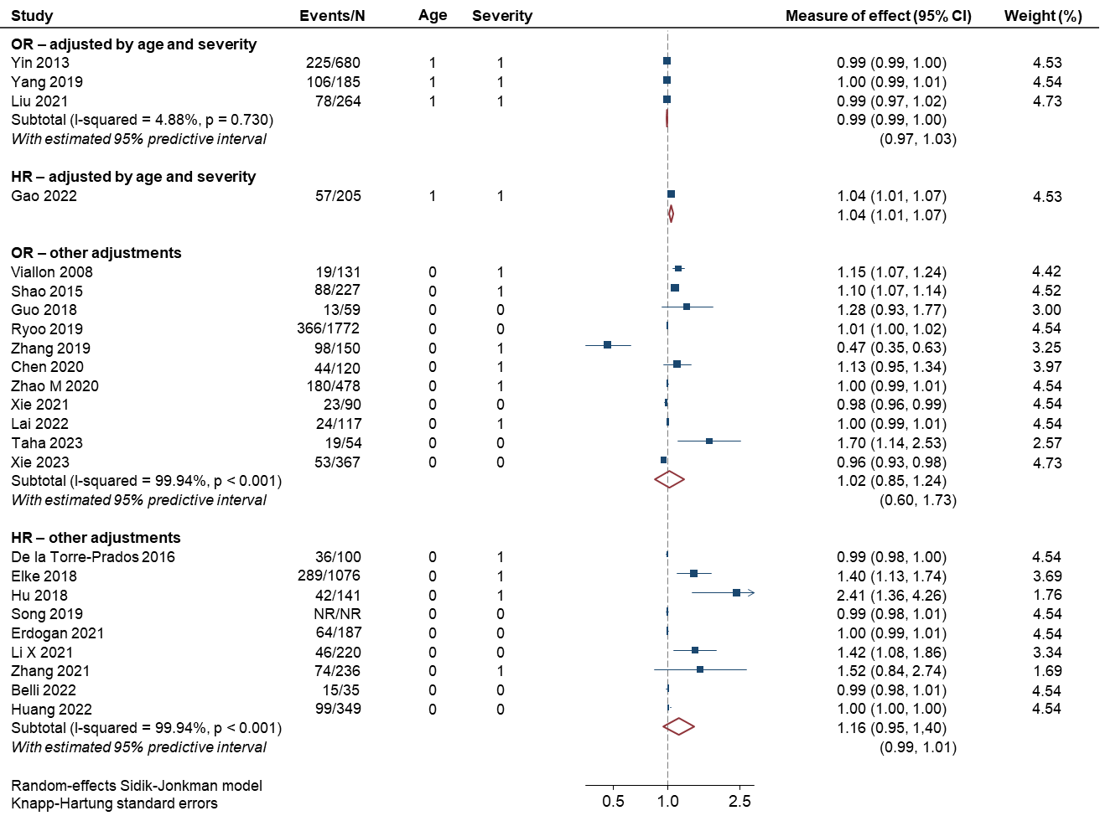
S7 Table. Baseline CRP values and mortality: measure effects

 | Number of studies (deaths/Total) |  |  | Adjustment by | Measure of effect (95% CI)
Mortality at 28-30 days
Categorical
Threshold ≥ 27.5 mg/L | 1 study (134/501) |  |  | Both age and a severity score | OR = 1.00 (0.99 to 1.01)
Continuous
Pooled HR – adjusted |  | 2 (188/631) | Both age and a severity score |  | HR = 1.01 (0.92 to 1.11)ª
Pooled HR – partially or no adjusted | 6 studies (>505/>1740) |  |  | Age, severity score or other covariates | HR = 1.03 (0.96 to 1.10)^{b}
HR Narrative | 2 studies (66/154) |  |  | Age, severity score or other covariates | No significant (p-values)
Pooled OR – adjusted | 2 study (103/303) |  |  | Both age and a severity score | OR = 1.01 (0.87 to 1.17)^{c}
Pooled OR – partially or no adjusted | 5 studies (513/2287) |  |  | Age, severity score or other covariates | OR = 1.01 (0.99 to 1.03)^{d}
OR Narrative | 1 study (19/131) |  |  | Age, severity score or other covariates | No significant (p-values)
Log-transformed
log (mg/dL) | 1 study (101/326) |  |  | Age, severity score or other covariates | HR = 1.30 (0.80 to 1.90)
Mortality, no details
Categorical
Threshold ≥ 3.55 mg/dL | 1 study (41/137) |  |  | Both age and a severity score | No significant (p-values)
Continuous
Individual HR | 1 study (289/1076) |  |  | Age, severity score or other covariates | HR = 1.20 (1.00 to 1.40) ^{e}
OR Narrative | 2 studies (143/607) |  |  | Age, severity score or other covariates | No significant (p-values)
Log-transformed
log (mg/L) | 1 study (62/245) |  |  | Both age and a severity score | OR = 1.81 (1.20 to 2.72)

Notes: a) I-squared = 57.74%, P = 0.116; predictive interval 95% = Not estimable; b) I-squared = 98.77%, P = 0.238; predictive interval 95%= 0.99 to 1.02; c) I-squared = 61.76%, P = 0.096; predictive interval 95% = Not estimable; d) I-squared = 95.41%, P = 0.004; predictive interval 95% = 0.98 to 1.03; e) Elke 2018 provided 2 assessments (ICU mortality and hospital mortality), the bigger measure effect is showed in the table

S2 Figure. C-reactive protein and prediction of mortality at 28-30 days in critically-ill septic patients
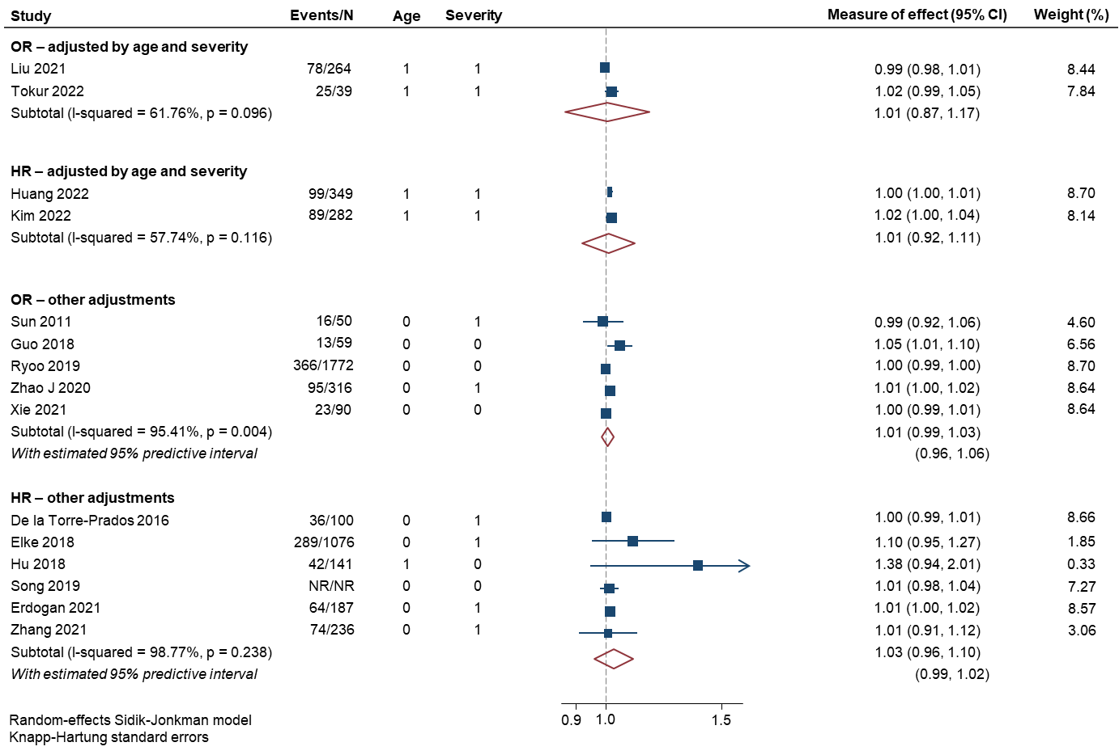

S8 Table. Baseline IL-6 values and mortality: measure effects
 | Number of studies (deaths/Total) | Adjustment by | Measure of effect (95% CI)
Mortality at 28-30 days
Categorical
Threshold ≥ 201.68 pg/mL | 1 study (51/114) | Age, severity score or other covariates | OR = 1.66 (0.67 to 4.10)
Threshold ≥ 22.8 pg/mL | 1 study (134/501) | Both age and a severity score | OR = 1.00 (1.00 to 1.00)
Log-transformed
log (Threshold ≥ 867.2 pg/mL) | 1 study (12/29) | Age, severity score or other covariates | HR = 2.00 (1.22 to 3.27)
Continuous
Individual HR | 1 study (NR/97) | Age, severity score or other covariates | HR = 1.00 (1.00 to 1.00)
Individual OR– adjusted | 1 study (78/264) | Both age and a severity score | OR = 1.02 (1.01 to 1.03)
Pooled OR– partially or no adjusted | 7 studies (>224/>963) | Age, severity score or other covariates | OR = 1.00 (0.99 to 1.01)ª
OR Narrative | 3 studies (70/251) | Age, severity score or other covariates | No significant (p-values)
Log-transformed
log (pg/mL+log) | 1 study (NR/198) | Both age and a severity score | HR = 1.46 (1.11 to 1.92)
log (pg/mL+log) | 1 study (39/124) | Both age and a severity score | No significant (p-values)
Mortality, no details
Log-transformed
log (pg/mL) | 1 study (33/60) | Both age and a severity score | OR = 1.00 (1.00 to 1.01)
log (pg/mL) | 1 study (18/75) | Age, severity score or other covariates | OR = 1.00 (1.00 to 1.00)
Notes: a) I-squared= 99.52%, P=0.270; predictive interval 95%= 0.98 to 1.03.

S3 Figure. Interleukin-6 and prediction of mortality at 28-30 days in critically-ill septic patients
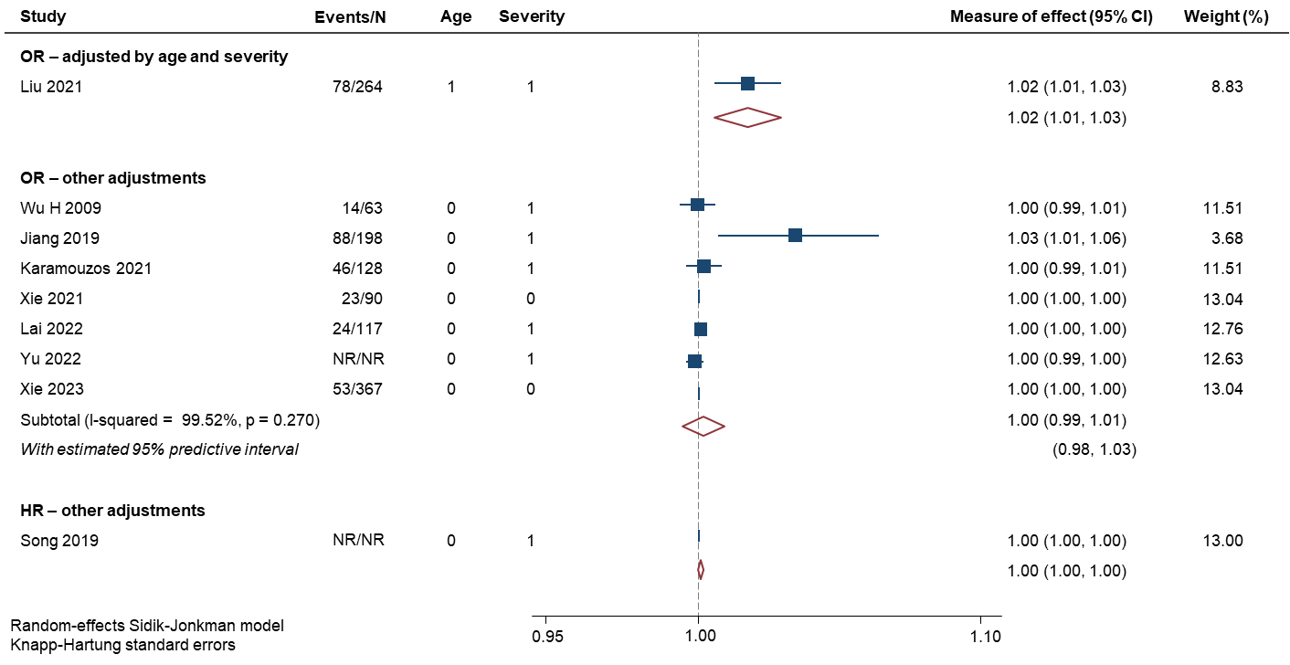

S9 Table. Baseline sCD14 values and mortality: measure effects

 | Number of studies (deaths/Total) | Adjustment by | Measure of effect (95% CI)
Mortality at 28-30 days
Categorical
Threshold ≥ highest tertile, no details provided | 1 study (10/142) | Age, severity score or other covariates | HR= 1.22 (0.20 to 5.47)
Continuous
Pooled HR | 2 (>74/>278) | Age, severity score or other covariates | HR = 1.00 (1.00 to 1.01)ª
Individual unclear model | 1 (41/178) | Age, severity score or other covariates | Unclear = 1.28 (1.09 to 1.49)
Log-transformed
log (pg/mL) | 1 study (50/100) | Both age and a severity score | HR = 1.55 (1.12 to 2.13)^{b}
Mortality, no details
Log-transformed
log (pg/mL) | 1 study (50/100) | Both age and a severity score | HR = 1.51 (1.05 to 2.17)^{b}

Notes: a) I-squared = 0.43%, P = 0.757; predictive interval 95% = Not estimable; b) Masson 2017 provided two analysis, one for mortality at 28-30 days and another for mortality-no details.

S4 Figure. sCD14 and prediction of mortality at 28-30 days in critically-ill septic patients
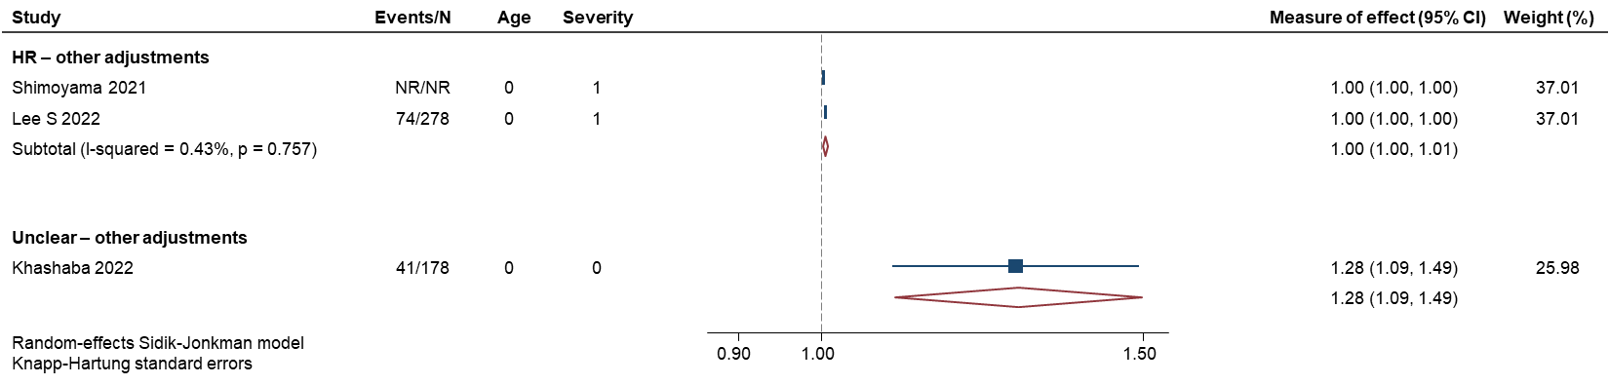
S4 Figure. Summary of mortality at 28-30 days and baseline biomarkers measures
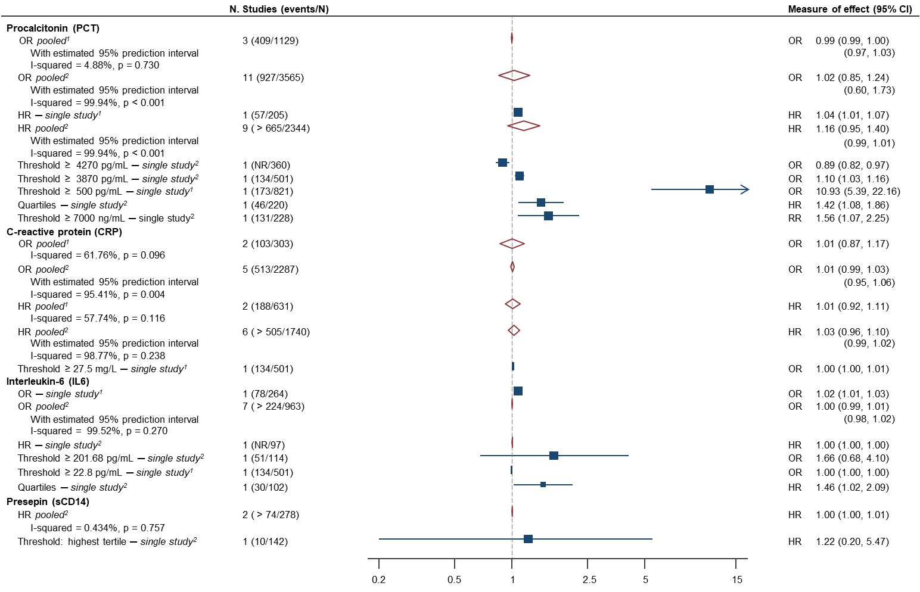
Notes: 1) Measure of effect adjusted by both sex and a severity score plus other covariates; 2) measure of effect adjusted by sex, a severity score, or by other covariates; 3) two additional studies evaluating 131 septic patients and 43 deaths found no statistical significantly OR values (narrative report); 4) two additional studies evaluating 154 septic patients and 66 deaths found no statistical significantly HR values (narrative report); 5) one additional study evaluating 131 septic patients and 19 deaths found no statistical significantly OR values (narrative report); 6) two additional studies evaluating 154 septic patients and 66 deaths found no statistical significantly HR values (narrative report).

S5 Figure. Summary of mortality, no details provided and baseline biomarkers measures

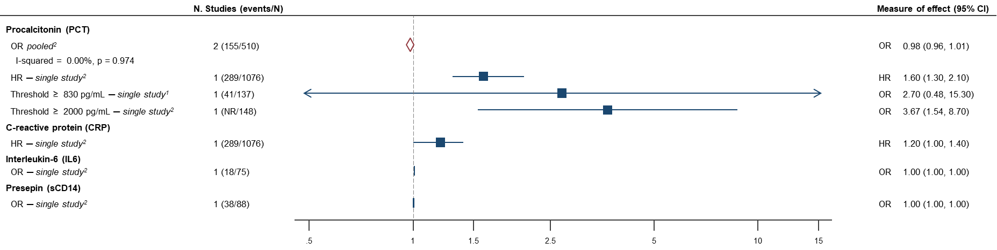

Notes: 1) Measure of effect adjusted by both sex and a severity score plus other covariates; 2) measure of effect adjusted by sex, a severity score, or by other covariates. More info in Supplements

EXCLUDED REFERENCES

1. Azevedo JRAd, Torres OJM, Czeczko NG, Tuon FF, Nassif PAN, Souza GDd. Procalcitonin as a prognostic biomarker of severe sepsis and septic shock. Revista do Colegio Brasileiro de Cirurgioes 2012; 39(6): 456-61.
2. Calandra T, Gerain J, Heumann D, Baumgartner JD, Glauser MP. High circulating levels of interleukin-6 in patients with septic shock: evolution during sepsis, prognostic value, and interplay with other cytokines. The Swiss-Dutch J5 Immunoglobulin Study Group. The American journal of medicine 1991; 91(1): 23-9.
3. Gao C, Chen H. Correlation of serum miR-127 level with severity and prognosis of sepsis. American Journal of Translational Research 2022; 14(11): 7994-8001.
4. Gao Q, Cheng Y, Li Z, et al. Association between nutritional risk screening score and prognosis of patients with sepsis. Infection and Drug Resistance 2021; 14: 3817-25.
5. Di S, Wang Y, Sun L, Zhao H, Guo L. The value of TLR-4, CRP, PCT and WBC levels in assessing the diagnosis and prognosis of sepsis patients. International Journal of Clinical and Experimental Medicine 2020; 13(12): 9419-28.
6. El Said AM, Fayed AM, El-Reweny EM. Comparative study between complete blood picture indices and presepsin as early prognostic markers in septic shock patients. Egyptian Journal of Anaesthesia 2020; 36(1): 118-25.
7. Hashim RM, Abdelaziz MM, Hassan RM. Higher accuracy of concurrent use of corrected QT interval and procalcitonin serum level to predict sepsis related mortality in ICU patients. Egyptian Journal of Anaesthesia 2020; 36(1): 38-43.
8. Hillas G, Vassilakopoulos T, Plantza P, Rasidakis A, Bakakos P. C-reactive protein and procalcitonin as predictors of survival and septic shock in ventilator-associated pneumonia. The European respiratory journal 2010; 35(4): 805-11.
9. Honorato MO, Filho JTS, Honorato Junior LFB, Watanabe N, Goulart GM, Do Prado RR. Atrial Fibrillation and Sepsis in Elderly Patients and Their Associaton with In-Hospital Mortality. Arquivos Brasileiros de Cardiologia 2023; 120(3).
10. Kandaswamy P, Hemlata, Singh GP, Ahmad MK. Comparative evaluation of procalcitonin and interleukin-6 as diagnostic and prognostic biomarkers for sepsis. Journal of Clinical and Diagnostic Research 2018; 12(10): UC17-UC21.
11. Kang FX, Wang RL, Yu KL, Wei Q. The study on pro-adrenomedullin as a new biomarker in sepsis prognosis and risk stratification. Chinese Critical Care Medicine 2008; 20(8): 452-5.
12. Karampela I, Christodoulatos GS, Kandri E, et al. Circulating eNampt and resistin as a proinflammatory duet predicting independently mortality in critically ill patients with sepsis: A prospective observational study. Cytokine 2019; 119: 62-70.
13. Kellum JA, Kong L, Fink MP, et al. Understanding the inflammatory cytokine response in pneumonia and sepsis: Results of the genetic and inflammatory markers of sepsis (GenIMS) study. Archives of Internal Medicine 2007; 167(15): 1655-63.
14. Kim CH, Park JT, Kim EJ, et al. An increase in red blood cell distribution width from baseline predicts mortality in patients with severe sepsis or septic shock. Critical Care 2013; 17(6).
15. Li Y, Wang J, Wei B, Zhang X, Hu L, Ye X. Value of Neutrophil:Lymphocyte Ratio Combined with Sequential Organ Failure Assessment Score in Assessing the Prognosis of Sepsis Patients. International Journal of General Medicine 2022; 15: 1901-8.
16. Li Z, Luo Z, Shi X, Pang B, Ma Y, Jin J. The Levels of Oxidized Phospholipids in High-Density Lipoprotein During the Course of Sepsis and Their Prognostic Value. Frontiers in Immunology 2022; 13.
17. Nanda SK, Dinakaran A, Sandhya Bhat K, Ravichandran, Kanungo R. Diagnostic and prognostic role of Procalcitonin in sepsis in a tertiary care hospital. Biomedical Research (India) 2016; 27(1): 79-83.
18. Pieralli F, Vannucchi V, Mancini A, et al. Procalcitonin Kinetics in the First 72 Hours Predicts 30-Day Mortality in Severely Ill Septic Patients Admitted to an Intermediate Care Unit. Journal of clinical medicine research 2015; 7(9): 706-13.
19. Schroder J, Staubach KH, Zabel P, Stuber F, Kremer B. Procalcitonin as a marker of severity in septic shock. Langenbeck's archives of surgery 1999; 384(1): 33-8.
20. Schuetz P, Christ-Crain M, Morgenthaler NG, Struck J, Bergmann A, Muller B. Circulating precursor levels of endothelin-1 and adrenomedullin, two endothelium-derived, counteracting substances, in sepsis. Endothelium : journal of endothelial cell research 2007; 14(6): 345-51.
21. Sharma R, Vijayakumar M. Procalcitonin for improved assessment and an answer to sepsis dilemma in critically ill - a myth, a hype, or a reality ? Nitte university journal of health science 2014; 4(1): 57‐65.
22. Stalder G, Que YA, Calzavarini S, et al. Study of Early Elevated Gas6 Plasma Level as a Predictor of Mortality in a Prospective Cohort of Patients with Sepsis. PloS one 2016; 11(10): e0163542.
23. Su L-x, Meng K, Zhang X, et al. Diagnosing ventilator-associated pneumonia in critically ill patients with sepsis. American journal of critical care : an official publication, American Association of Critical-Care Nurses 2012; 21(6): e110-9.
24. Sunden-Cullberg J, Norrby-Teglund A, Rouhiainen A, et al. Persistent elevation of high mobility group box-1 protein (HMGB1) in patients with severe sepsis and septic shock. Critical care medicine 2005; 33(3): 564-73.
25. Tan Y, Zhou K, Tang X, et al. Bacteremic and non-bacteremic pneumonia caused by Acinetobacter baumannii in ICUs of South China: A Clinical and Microbiological Study. Scientific reports 2017; 7(1): 15279.
26. Thao PTN, Tra TT, Son NT, Wada K. Reduction in the IL-6 level at 24 h after admission to the intensive care unit is a survival predictor for Vietnamese patients with sepsis and septic shock: a prospective study. BMC emergency medicine 2018; 18(1): 39.
27. Yao L, Liu Z, Zhu J, Li B, Chai C, Tian Y. Higher serum level of myoglobin could predict more severity and poor outcome for patients with sepsis. The American journal of emergency medicine 2016; 34(6): 948-52.
28. Zhang L, Qiu C, Yang L, et al. GPR18 expression on PMNs as biomarker for outcome in patient with sepsis. Life sciences 2019; 217: 49-56.
29. Baoquan W, Nan L, Haiyan F, Zhansheng H. Analysis of prognostic factors in patients with sepsis and septic shock in intensive care unit. Chinese Journal of Infection and Chemotherapy 2019; 19(5): 499-504.
30. Malek F, Gohari A, Mirmohammadkhani M, Ardiani F. Relationship between the serum level of C-reactive protein and severity and outcomes of community-acquired pneumonia. Archives of Clinical Infectious Diseases 2019; 14(2).
31. Naderpour Z, Momeni M, Vahidi E, Safavi J, Saeedi M. Procalcitonin and D-dimer for Predicting 28-Day-Mortality Rate and Sepsis Severity based on SOFA Score; A Cross-sectional Study. Bulletin of emergency and trauma 2019; 7(4): 361-5.
32. Peng JC, Xu QY, Ding J, et al. Usefulness of procalcitonin clearance to predict mortality in abdominal sepsis. European Journal of Inflammation 2020; 18.
33. Tschaikowsky K, Hedwig-Geissing M, Braun GG, Radespiel-Troeger M. Predictive value of procalcitonin, interleukin-6, and C-reactive protein for survival in postoperative patients with severe sepsis. Journal of critical care 2011; 26(1): 54-64.
34. Behnes M, Bertsch T, Lepiorz D, et al. Diagnostic and prognostic utility of soluble CD 14 subtype (presepsin) for severe sepsis and septic shock during the first week of intensive care treatment. Critical care (London, England) 2014; 18(5): 507.
35. Frencken JF, van Vught LA, Peelen LM, et al. An Unbalanced Inflammatory Cytokine Response Is Not Associated With Mortality Following Sepsis: A Prospective Cohort Study. Critical care medicine 2017; 45(5): e493-e9.
36. Goldberg I, Shalmon D, Shteinvil R, et al. The superiority of 72 h leukocyte descent over CRP for mortality prediction in patients with sepsis. Clinica chimica acta; international journal of clinical chemistry 2021; 514: 34-9.
37. Gradel KO, Jensen TG, Kolmos HJ, Pedersen C, Vinholt PJ, Lassen AT. Does C-reactive protein independently predict mortality in adult community-acquired bacteremia patients with known sepsis severity? APMIS : acta pathologica, microbiologica, et immunologica Scandinavica 2013; 121(9): 835-42.
38. Kurisu K, Yoshiuchi K, Ogino K, Okada Y, Oda T. Peak C-reactive protein levels do not predict 30-day mortality for bacteremia: A retrospective cohort study. Journal of infection and chemotherapy : official journal of the Japan Society of Chemotherapy 2020; 26(1): 23-7.
39. Matera G, Quirino A, Peronace C, et al. Soluble CD14 Subtype-A New Biomarker in Predicting the Outcome of Critically Ill Septic Patients. The American journal of the medical sciences 2017; 353(6): 543-51.
40. Ogasawara S, Saito N, Hirano R, Minakawa S, Kimura M, Kayaba H. Clinical relevance of procalcitonin values in bacteremia. Journal of infection and chemotherapy : official journal of the Japan Society of Chemotherapy 2020; 26(10): 1048-53.
41. Pallas Beneyto LA, Rodriguez Luis O, Saiz Sanchez C, Coltell O, Bautista Rentero D, Miguel Bayarri V. [Prognostic value of interleukin 6 for death of patients with sepsis]. Medicina critica 2016; 147(7): 281-6.
42. Pauly D, Hamed S, Behnes M, et al. Endothelial cell-specific molecule-1/endocan: Diagnostic and prognostic value in patients suffering from severe sepsis and septic shock. Journal of critical care 2016; 31(1): 68-75.
43. Peng J, Zhang R, Zhao Y, et al. Prognostic value of preoperative prognostic nutritional index and its associations with systemic inflammatory response markers in patients with stage III colon cancer. Chinese journal of cancer 2017; 36(1): 96.
44. Shen YF, Chen LY, He F. A Study on clinical outcomes and death risk factors in adult patients with klebsiella pneumoniae septicemia. Acta Medica Mediterranea 2020; 36(5): 3167-71.
45. Suarez De La Rica A, Maseda E, Anillo V, Hernandez Gancedo C, Lopez-Tofiño A, Gilsanz F. Procalcitonin, c-reactive protein and lactate as prognostic markers of mortality in patients with complicated intraabdominal infection admitted to the ICU. Intensive Care Medicine 2013; 39: S341.
46. Tanriverdi H, Tor MM, Kart L, Altin R, Atalay F, SumbSumbuloglu V. Prognostic value of serum procalcitonin and C-reactive protein levels in critically ill patients who developed ventilator-associated pneumonia. Annals of thoracic medicine 2015; 10(2): 137-42.
47. Taskin G, Ozturk K, Turker T, et al. Assessment of mortality risk factors for criticaly ill patients with acinetobacter baumannii bacteremia with a new perspective. Acta Medica Mediterranea 2016; 32(6): 1892-7.
48. Wunder C, Eichelbronner O, Roewer N. Are IL-6, IL-10 and PCT plasma concentrations reliable for outcome prediction in severe sepsis? A comparison with APACHE III and SAPS II. Inflammation research : official journal of the European Histamine Research Society [et al] 2004; 53(4): 158-63.
49. Yan Y, Hu Y, Wang X, et al. The predictive prognostic values of serum interleukin-2, interleukin-6, interleukin-8, tumor necrosis factor-alpha, and procalcitonin in surgical intensive care unit patients. Annals of translational medicine 2021; 9(1): 56.

