Supplementary Table 1 - TRIPOD Checklist

Section/Topic | Item |  | Checklist Item | Page
Title and abstract
Title | 1 | D;V | Identify the study as developing and/or validating a multivariable prediction model, the target population, and the outcome to be predicted. | Title
Abstract | 2 | D;V | Provide a summary of objectives, study design, setting, participants, sample size, predictors, outcome, statistical analysis, results, and conclusions. | Abstract
Introduction
Background and objectives | 3a | D;V | Explain the medical context (including whether diagnostic or prognostic) and rationale for developing or validating the multivariable prediction model, including references to existing models. | Intro; paragraphs 1-3
Background and objectives | 3b | D;V | Specify the objectives, including whether the study describes the development or validation of the model or both. | Intro; paragraph 6
Methods
Source of data | 4a | D;V | Describe the study design or source of data (e.g., randomized trial, cohort, or registry data), separately for the development and validation data sets, if applicable. | Methods; paragraph 1
Source of data | 4b | D;V | Specify the key study dates, including start of accrual; end of accrual; and, if applicable, end of follow-up. | Methods; paragraph 1
Participants | 5a | D;V | Specify key elements of the study setting (e.g., primary care, secondary care, general population) including number and location of centres. | Methods; paragraph 1
Participants | 5b | D;V | Describe eligibility criteria for participants. | Methods; paragraph 1
Participants | 5c | D;V | Give details of treatments received, if relevant. | Not relevant
Outcome | 6a | D;V | Clearly define the outcome that is predicted by the prediction model, including how and when assessed. | Methods; paragraph 1
Outcome | 6b | D;V | Report any actions to blind assessment of the outcome to be predicted. | NA
Predictors | 7a | D;V | Clearly define all predictors used in developing or validating the multivariable prediction model, including how and when they were measured. | Methods; paragraphs 1-2
Predictors | 7b | D;V | Report any actions to blind assessment of predictors for the outcome and other predictors. | NA
Sample size | 8 | D;V | Explain how the study size was arrived at. | Methods; paragraphs 1,3
Missing data | 9 | D;V | Describe how missing data were handled (e.g., complete-case analysis, single imputation, multiple imputation) with details of any imputation method. | Methods; paragraph 4
Statistical analysis methods | 10a | D | Describe how predictors were handled in the analyses. | Methods; paragraph 4, supporting information
Statistical analysis methods | 10b | D | Specify type of model, all model-building procedures (including any predictor selection), and method for internal validation. | Methods; paragraphs 9, 12
Statistical analysis methods | 10c | V | For validation, describe how the predictions were calculated. | Methods; paragraph 5,  supporting information
Statistical analysis methods | 10d | D;V | Specify all measures used to assess model performance and, if relevant, to compare multiple models. | Methods; paragraphs 6-7
Statistical analysis methods | 10e | V | Describe any model updating (e.g., recalibration) arising from the validation, if done. | Methods; paragraph 8, Table 1
Risk groups | 11 | D;V | Provide details on how risk groups were created, if done. | Methods; paragraph 5
Development vs. validation | 12 | V | For validation, identify any differences from the development data in setting, eligibility criteria, outcome, and predictors. | Results; Table 2 caption
Results
Participants | 13a | D;V | Describe the flow of participants through the study, including the number of participants with and without the outcome and, if applicable, a summary of the follow-up time. A diagram may be helpful. | Results; paragraph 2, Table 2
Participants | 13b | D;V | Describe the characteristics of the participants (basic demographics, clinical features, available predictors), including the number of participants with missing data for predictors and outcome. | Results; paragraph 1-2, Table 2
Participants | 13c | V | For validation, show a comparison with the development data of the distribution of important variables (demographics, predictors and outcome). | Results; Table 2 caption
Model development | 14a | D | Specify the number of participants and outcome events in each analysis. | Results; Table 2
Model development | 14b | D | If done, report the unadjusted association between each candidate predictor and outcome. | NA
Model specification | 15a | D | Present the full prediction model to allow predictions for individuals (i.e., all regression coefficients, and model intercept or baseline survival at a given time point). | Supporting information
Model specification | 15b | D | Explain how to the use the prediction model. | Supporting information
Model performance | 16 | D;V | Report performance measures (with CIs) for the prediction model. | Results; Paragraphs 3-10, Table 3, Figures 1-2, Supporting information
Model-updating | 17 | V | If done, report the results from any model updating (i.e., model specification, model performance). | Results; Paragraph 7, Table 4, 6, Supporting information
Discussion
Limitations | 18 | D;V | Discuss any limitations of the study (such as nonrepresentative sample, few events per predictor, missing data). | Discussion; Paragraph 10
Interpretation | 19a | V | For validation, discuss the results with reference to performance in the development data, and any other validation data. | Discussion; Paragraphs 5,6,9
Interpretation | 19b | D;V | Give an overall interpretation of the results, considering objectives, limitations, results from similar studies, and other relevant evidence. | Discussion
Implications | 20 | D;V | Discuss the potential clinical use of the model and implications for future research. | Discussion; paragraphs 5-7, 11
Other information
Supplementary information | 21 | D;V | Provide information about the availability of supplementary resources, such as study protocol, Web calculator, and data sets. | Supporting information
Funding | 22 | D;V | Give the source of funding and the role of the funders for the present study. | Funding

Supplementary Table 2 – A comparison of the updates made to models 2-4.

 | Original KFRE | Model 2a |  | Model 2b | Model 3a |  | Model 3b | Model 4
 |  | White | South Asian |  | White | South Asian
Baseline survival | 0.9365 | 0.9605 | 0.9389 |  | 0.9614 | 0.9306 |  | 0.9605
Adjustment factor | 1 | 1 | 1 |  | 1.0298 | 0.9188 |  | 0.9994
South Asian coefficient (95% CI) | -- | -- | -- |  | -- | -- |  | 0.4435 (0.250, 0.637)

Included are: baseline survival, linear predictor adjustment factor, β coefficient (corresponding to the log hazard ratio) for ethnicity with 95% confidence interval. Ethnicity was coded as a categorical variable with white as the reference category. The original KFRE and models 2a, 2b, 3a, 3b did not include a coefficient for ethnicity.
KFRE; Kidney Failure Risk Equation CI; confidence interval

Supplementary Table 3 – Model selection for model 5

Model | Interaction with ethnicity | Log-likelihood | Difference in log-likelihood | P-value
Sex, Age, ACR, eGFR, Ethnicity |  | -3942.5
 | Age | -3942.3 | 0.2 | 0.545
 | Sex | -3942.5 | 0.0 | 0.903
 | ACR | -3940.4 | 2.1 | 0.0397
 | eGFR | -3940.4 | 2.1 | 0.0415
+ Ethnicity*ACR | Age | -3939.7 | 0.3 | 0.243
 | Sex | -3940.4 | 0.0 | 0.961
 | eGFR | -3935.9 | 4.5 | 0.0026
+ Ethnicity*eGFR | Age | -3935.0 | 0.9 | 0.184
 | Sex | -3935.9 | 0.0 | 0.907

Likelihood ratio tests used for model selection. Interactions between ACR and ethnicity and eGFR and ethnicity were found to be significant. Values in bold indicate a p-value <0.05 and thus the addition of a new term.
ACR; albumin-to-creatinine ratio eGFR; estimated glomerular filtration rate

Supplementary Table 4 – Optimism-adjusted coefficients in models 5 and 6

Covariate | Model 5 coefficients | Model 6 coefficients | Original KFRE coefficient
Baseline survival | 0.9975 | 0.9650 | 0.9570
Age | -0.5584 | -0.5562 | -0.2201
eGFR | -0.5006 | -0.4131 | -0.5567
ACR | 0.5626 | 0.4382 | 0.4510
Male | 0.5339 | 0.4429 | 0.2467
South Asian | 0.1838 | 0.2655 | --
ACR*South Asian | 0.2370 | 0.1894 | --
eGFR*South Asian | 0.1233 | 0.0943 | --

The coefficients of the original KFRE are also reported for comparison.
ACR; albumin-to-creatinine ratio eGFR; estimated glomerular filtration rate KFRE; Kidney Failure Risk Equation

Supplementary Figure 1 – Kaplan-Meier ESKD-free curves for each risk group, by ethnicity

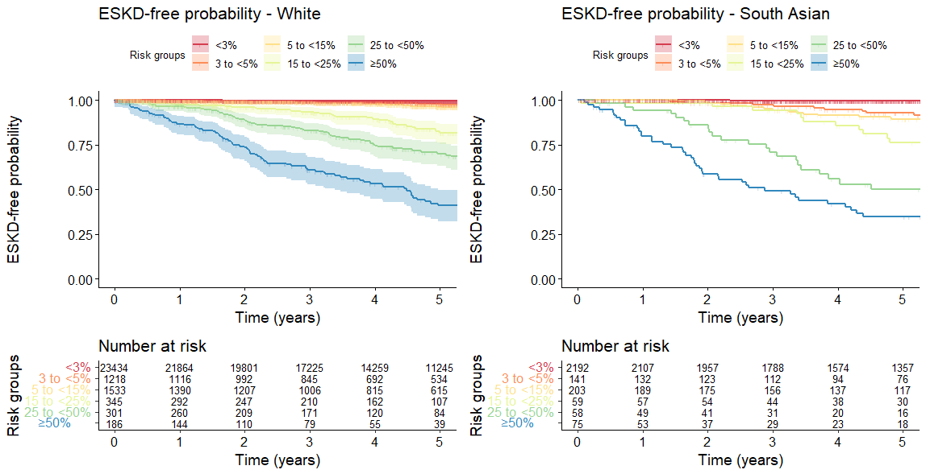
The risk table shows number at risk of ESKD, therefore needing KRT, in each group at yearly intervals.
ESKD; end-stage kidney disease

Supplementary Figure 2 – The observed risk of KRT found using the Kaplan-Meier estimates and Aalen-Johansen estimates

Kaplan-Meier estimates are dashed lines and Aalen-Johansen estimates are solid lines. The lines were separated by risk group to illustrate separation of risk more clearly.
KRT; kidney replacement therapy
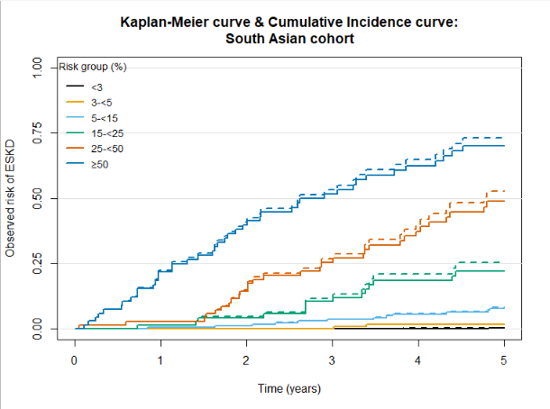
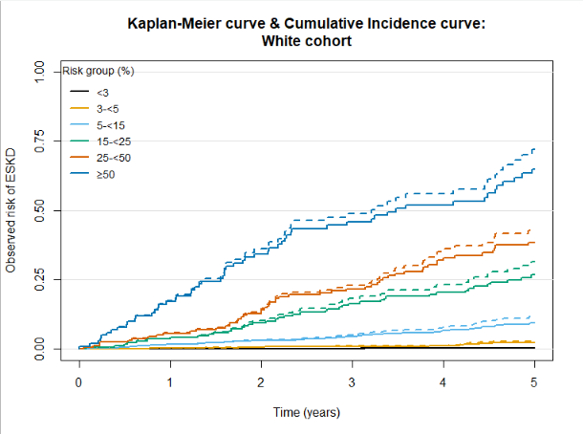

Supplementary Figure 3 – Calibration plots for models 5 and 6 using Aalen-Johansen estimates of incidence of KRT within 5 years
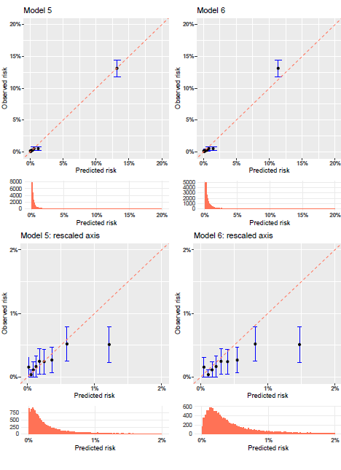

Histograms beneath the plots show the distribution of the linear predictor. The range of risk was very low, so the first row of plots were truncated at 20%, and the second row at 2%, to allow for closer inspection.

Supplementary Figure 4 – Scatter plot of 5-year predicted risk according to models 5 and 6

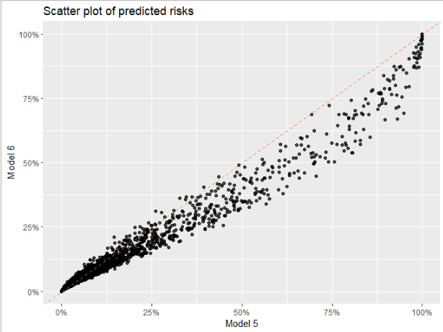
The dashed line indicates perfect agreement between the models.

Supplementary Text 1 - Non-North American Kidney Failure Risk Equation for 5-year risk

The risk of KRT using the KFRE 4-variable equation calibrated to a non-North American population is calculated as:

1 - 0.9365^{exp(βsum)}

Where βsum = -0.2201 × (age/10 – 7.036)
+ 0.2467 × (male – 0.5642)
– 0.5567 × (eGFR/5 – 7.222)
+ 0.4510 × (logACR – 5.137)

KRT; kidney replacement therapy eGFR; estimated glomerular filtration rate ACR; albumin-to-creatinine ratio

Supplementary Text 2 – Model equations for models 2-5

Further information on model updates is seen by providing model equations, which highlights the difference in each model from the non-North American KFRE.

Model 2a (white cohort) – update 5-year baseline hazard

1 - 0.9605^{exp(βsum)}

Where βsum = -0.2201 × (age/10 – 7.036)
+ 0.2467 × (male – 0.5642)
– 0.5567 × (eGFR/5 – 7.222)
+ 0.4510 × (logACR – 5.137)

Model 2b (South Asian cohort) – update 5-year baseline hazard

1 - 0.9389^{exp(βsum)}

Where βsum = -0.2201 × (age/10 – 7.036)
+ 0.2467 × (male – 0.5642)
– 0.5567 × (eGFR/5 – 7.222)
+ 0.4510 × (logACR – 5.137)

Model 3a (white cohort) – update 5-year baseline hazard & scale of linear predictor

1 - 0.9306^{exp(βsum)}

Where βsum = 1.030 × [-0.2201 × (age/10 – 7.036)
+ 0.2467 × (male – 0.5642)
– 0.5567 × (eGFR/5 – 7.222)
+ 0.4510 × (logACR – 5.137)]

Model 3b (South Asian cohort) – update 5-year baseline hazard & scale of linear predictor

1 - 0.9614^{exp(βsum)}

Where βsum = 0.9188 × [-0.2201 × (age/10 – 7.036)
+ 0.2467 × (male – 0.5642)
– 0.5567 × (eGFR/5 – 7.222)
+ 0.4510 × (logACR – 5.137)]

Model 4 – Addition of ethnicity as a predictor & update 5-year baseline hazard, scale of linear predictor

1 - 0.9605^{exp(βsum)}

Where βsum = 0.9994 × [-0.2201 × (age/10 – 7.036)
+ 0.2467 × (male – 0.5642)
– 0.5567 × (eGFR/5 – 7.222)
+ 0.4510 × (logACR – 5.137)
+ 0.4435 × South Asian]

Model 5 – development of a new model

1 - 0.9975^{exp(βsum)}

Where βsum = – 0.5584 × (age/10 – 7.036)
+ 0.5339 × (male – 0.5642)
– 0.5006 × (eGFR/5 – 7.222)
+ 0.5626 × (logACR – 5.137)
+ 0.1838 × South Asian
+ 0.1233 × South Asian × (eGFR/5 – 7.222)
+ 0.2370 × South Asian × (logACR – 5.137)

KRT; kidney replacement therapy eGFR; estimated glomerular filtration rate ACR; albumin-to-creatinine ratio

Supplementary Text 3 - Prediction model equation for model 6

The risk of KRT within 5 years using model 6 (a Fine and Gray model) can be calculated as follows:

1 - 0.9650^{exp(βsum)}

Where βsum = -0.5662 × (age/10 – 7.036)
+ 0.4429 × (male – 0.5642)
– 0.4131 × (eGFR/5 – 7.222)
+ 0.4382 × (logACR – 5.137)
+ 0.2655 × South Asian
+ 0.0943 × South Asian × (eGFR/5 – 7.222)
+ 0.1894 × South Asian × (logACR – 5.137)
KRT; kidney replacement therapy eGFR; estimated glomerular filtration rate ACR; albumin-to-creatinine ratio

