Supplemental File

Validation of prognostic models predicting mortality or ICU admission in patients with COVID-19 in low- and middle-income countries: a global individual participant data meta-analysis

Johanna A.A. Damen, Banafsheh Arshi, Maarten van Smeden, Silvia Bertagnolio, Janet V. Diaz, Ronaldo Silva, Soe Soe Thwin, Laure Wynants, Karel G.M. Moons

Table of Contents
Supplemental Methods: Characteristics of imputation models 3
Supplemental Methods: Model equations 4
Supplemental Methods: Definition of predictors and outcomes 5
Supplemental Table 1. Risk of bias of eligible models 7
Supplemental Table 2. Characteristics of the study population by country 11
Supplemental Table 3. Number (%) of missing data by country 12
Supplemental Table 4. Comparison of baseline characteristics between development cohorts and validation cohort 13
Supplemental Table 5. Comparison of Rubin’s rules with medians for combining performance over imputed datasets 14
Supplemental Figure 1. OE ratio of selected prediction models for predicting in-hospital mortality (Berzuini et al., Wang et al., Zhang et al.) or ICU admission (Zhou et al.). 16
Supplemental Figure 2. Calibration-in-the-large of selected prediction models for predicting in-hospital mortality (Berzuini et al., Wang et al., Zhang et al.) or ICU admission (Zhou et al.) 17
Supplemental Figure 3. Calibration slope of selected prediction models for predicting in-hospital mortality (Berzuini et al., Wang et al., Zhang et al.) or ICU admission (Zhou et al.) 18
Supplemental Figure 4. Calibration plots for predicted vs observed probabilities of mortality based on Berzuini et al. model by country 19
Supplemental Figure 5. Calibration plots for predicted vs observed probabilities of mortality based on Wang et al.model by country 20
Supplemental Figure 6. Calibration plots for predicted vs observed probabilities of mortality based on Zhang et al.model by country 21
Supplemental Figure 7. Calibration plots for predicted vs observed probabilities of ICU admission based on Zhou et al. model by country 22

Supplemental Methods: Characteristics of imputation models
Data were imputed using joint modeling multiple imputation using the R package mitml. To account for the multilevel structure of the dataset, country was taken as the cluster variable. Other variable included in the imputation model were age, sex, smoking, hypertension, coronary heart disease, pulmonary disease, diabetes, cancer, liver disease, chronic kidney disease, immunosuppressive disorders, cough, dyspnea, temperature, oxygen saturation, respiratory rate, mortality and ICU admission. None of the included variables had completely observed data. After running 50,000 burn-in iterations, data were imputed 50 times with 5000 iterations between imputations. Convergence was checked visually.

Supplemental Methods: Model equations

Berzuini et al.(1)
Logit(outcome) = -5.37 + 0.064 * age - 0.028 * O₂ saturation + 0.085 * respiratory rate + 0.7 * smoking

The used equation is different from the published equation. After contacting the study authors because of abnormal predicted risks (mostly >50% predicted risk of mortality), it turned out that the wrong equation was reported and the correct equation was provided.

Wang et al.(2)
Logit(outcome) = -8.6 + 0.10 * age + 0.60 * hypertension + 1.11 * coronary heart disease

Zhang et al.(3)
Logit(outcome) = -8.5016 + 0.0461 * age + 0.3177 * male sex + 1.0975 * pulmonary disease +
0.4448 * diabetes + 1.3798 * immunocompromised + 0.0185 * cancer + 0.3457 * hypertension + 0.6761 * coronary heart disease + 1.3210 * chronic kidney disease + 0.7409 * cough + 1.5245 * dyspnea

Zhou et al.(4)
Logit(outcome) = -5.111 + 1.473 * temperature<37.2 + 0.984 8 temperature 37.3-39 + 2.170 * cough + 1.329 * dyspnea + 1.821 * hypertension + 3.232 * coronary heart disease + 2.232 * liver disease + 3.732 *chronic kidney disease

Supplemental Methods: Definition of predictors and outcomes
Predictor | Definition / measurement details
Age | Calculated from date of birth
Sex | Sex at birth
Smoking | Smoking at least one cigarette, cigar, pipe or equivalent per day before the onset of the current illness. Excluding smoke-free tobacco products such as chewed tobacco or electronic nicotine delivery devices.
Hypertension | One of the following:  - High blood pressure for which medication has been prescribed  - Systolic blood pressure ≥140 mmHg  - Diastolic blood pressure ≥90 mmHg
Coronary heart disease | Angina, ischemic heart disease, atherosclerotic heart disease, previous coronary artery bypass graft, previous cardiac stenting/coronary intervention
Pulmonary disease | Chronic obstructive pulmonary disease (also chronic obstructive airways disease, chronic bronchitis, emphysema), cystic fibrosis, bronchiectasis, interstitial lung disease (e.g. pulmonary fibrosis, asbestosis, autoimmune), or a pre-existing requirement for long-term oxygen therapy
Diabetes | Current diagnosis of or is being treated for type I or type II diabetes mellitus requiring oral or subcutaneous treatment
Cancer | Current solid organ or haematological malignancy. Excluding malignancies that have been declared “cured” ≥ 5 years ago with no evidence of ongoing disease, non-melanoma skin cancers, and benign growths or dysplasia.
Liver disease | Recorded at admission as yes/no/unclear. No further instructions provided.
Chronic kidney disease | Clinician-diagnosed chronic kidney disease, including any with:  - Markers of kidney damage (albuminuria, haematuria of renal origin, electrolyte abnormalities due to tubular disorders, renal histological abnormalities, structural abnormalities detected by imaging)  - Estimated glomerular filtration rate < 60 mL/min/1.73 m2  - History of kidney transplantation.
Immunosuppressive disorders | One of the following:  - HIV: history of laboratory-confirmed HIV infection or AIDS-defining illness regardless of current viral load or CD4+ count. Regardless whether the patient is currently taking antiretroviral treatment.  - Tuberculosis: receiving treatment for tuberculosis. Excluding latent tuberculosis, patients who have been cured of tuberculosis, and those who have chronic pulmonary sequelae following their tuberculosis.
Cough | Reported by the patient or observed on physical exam at admission
Dyspnea | Reported by the patient or observed on physical exam at admission
Temperature | First documented patient temperature, regardless of route (oral,  peripheral, etc.) in degrees Celsius
Oxygen saturation | First documented patient peripheral oxygen saturation measurement as a percentage, either while the patient was breathing room air or any form of supplemental oxygen. In case the pulse oximeter has given two different readings in succession, with no change to oxygen therapy, the greater measurement was recorded.
Respiratory rate | First documented patient respiratory rate in breaths/min
Outcome
Mortality | In-hospital mortality
ICU admission | Admitted to ICU or a high dependency unit at any point during their stay in hospital

Supplemental Table 1. Risk of bias of eligible models
 | Risk of bias domain
Reference | Participants | Predictors | Outcome | Analysis | Overall
Abdulaal, Patel et al | Low | Low | Low | High | High
Abdulaal, Patel et al 2 | Low | Low | Low | High | High
Acar, Can et al | Low | Low | Low | High | High
Altschul, Unda et al | Low | Low | Low | High | High
Alvarez-Mon, Ortega et al | Unclear | Low | Unclear | High | High
Bellos, Lourida et al | Low | Low | Low | High | High
Bennouar, Cherif et al | High | Low | Low | High | High
Bertsimas, Lukin et al | Unclear | Low | Low | High | High
Berzuini, Hannan et al | Unclear | Low | Low | High | High
Berzuini, Hannan et al | Unclear | Low | Low | High | High
Berzuini, Hannan et al | Unclear | Low | Low | High | High
Binchen Wang, Feiyang Zhong | Low | Low | Low | High | High
Booth, Abels et al | Low | HIgh | Low | High | High
Bradley, Frost et al | Low | Unclear | Low | High | High
Bradley, Frost et al | Low | Unclear | Low | High | High
Cao, Li et al | Low | Unclear | Unclear | High | High
Cao, Zhang et al | Low | Unclear | Low | High | High
Carr, Bendayan et al | Low | Low | Low | High | High
Carr, Bendayan et al | low | Low | Low | Unclear | Unclear
Chen et al. Risk factors for mortality | Unclear | Unclear | Low | High | High
Chen et al. Risk factors for mortality | Unclear | Unclear | Low | High | High
Chen et al. Risk factors for mortality | Unclear | Low | Low | High | High
Chen, et al. Development and validation of a nomogram | Unclear | Low | Low | High | High
Chen, et al. Predicting severe or critical symptoms | High | Unclear | Low | High | High
Cheng, et al. Diagnostic performance of unitial blood urea nitrogen | Unclear | Unclear | Unclear | High | High
Cho et al. Prognosis score system | Low | Unclear | Low | High | High
Dai, Zeng et al | Low | Low | Unclear | High | High
Dai, Zeng et al | Low | Low | Unclear | High | High
Das, Mishra, et al | Low | Low | Low | High | High
Ding, Li et al | High | Low | Low | High | High
Doganci, Ince et al | High | Unclear | Low | High | High
Dong, Sun et al | Low | Unclear | Low | High | High
Ebrahimian, Homayounieh et al | High | Unclear | Low | High | High
Ebrahimian, Homayounieh et al | High | Unclear | Low | High | High
Fan, Hao et al | High | Low | Unclear | High | High
Fumagalli, Rozzini | Low | Low | Low | High | High
Galloway, Norton et al | Low | Low | Low | High | High
Gao, Cai et al | Low | Low | Low | Unclear | Unclear
Gidari, de Socio et al | Low | Low | Low | High | High
Gong, Ou et al. | Low | Unclear | Unclear | High | High
Guan, Zhang 2021 | Unclear | Unclear | Unclear | High | High
Gue, Tennyson 2020 | Low | Low | Low | High | High
Guo, Liu et al. | Low | High | Unclear | High | High
Guo, Xiong et al | Low | Low | High | High | High
Hachim, Hachim et al | Low | Low | High | High | High
Haimovich, Ravindra et al | Low | Low | High | High | High
Holten, Nore et al | low | Unclear | Low | high | High
Hong, Wu et al | Low | Unclear | Low | High | High
Hu, Du et al | High | unclear | High | High | High
Hu, Liu et al | High | Low | Low | Low | High
Hu, Liu et al | High | Low | Low | High | High
Hu, Ni et al | low | low | low | high | High
Huang, Cai, et al. | High | Unclear | High | High | High
Huang, Cheng et al | Low | Unclear | Low | High | High
Huang, Cheng et al | Low | Unclear | Low | High | High
Ikemura, Bellin et al | low | low | low | Unclear | Unclear
Jamal, Doi et al | Low | Low | Low | High | High
Ji, Zhang et al | Low | Low | Low | High | High
Jian, Kansal et al | low | low | low | high | High
Jimenez-Solem, Petersen et al | Low | Unclear | Unclear | High | High
Junhong Wang, Hua Zhang | Low | Low | Low | High | High
Kaeuffer, Ruch, et al | Low | Unclear | Unclear | High | High
Kivrak, Guldogan, et al. | High | Unclear | Low | Unclear | Unclear
Ko, Chung, et al. | Unclear | Low | Low | High | High
Laguna-Goya, Utrero-Rico, et al | High | Low | Low | High | High
Levy, Richardson et al. | Low | Low | Low | High | High
Li, Zhang et al | Unclear | Low | Unclear | High | High
Li, Zhang, et al. | Unclear | Unclear | High | High | High
Liu et al, CD8+ T cels predicted the | High | Low | High | High | High
Liu et al, Evaluation of the risk pre | High | Low | Low | High | High
Liu et al: A nomogram for predi | High | Low | Low | High | High
Liu, Fang et al. | Low | Low | Low | High | High
Liu, Shi et al. | Low | Unclear | Unclear | High | High
Lui H et al. Development and valid | Low | Low | Low | High | High
Luo, Liu et al. | Unclear | Low | Low | High | High
Luo, Mao et al | low | Low | Unclear | High | High
Ma, Li et al | Unclear | Unclear | high | high | High
Ma, Wang et al | low | Low | Low | High | High
magro, Zuccaro et al | Low | low | low | Unclear | Unclear
Manocha, Kirzner et al | high | High | Low | high | high
McRae, Dapkins et al | Unclear | Unclear | High | High | High
McRae, Simmons et al. | High | High | High | High | High
Mei, Hu et al | Low | Low | Low | High | High
Mei, Hu et al | Low | Low | Low | Unclear | Unclear
Mei, Wang et al | Low | Unclear | Low | High | High
Nicholson, Wooster et al | Low | Low | Low | High | High
Niu, Zhan et al | Unclear | Low | Low | High | High
Pan, Cheng, et al | Unclear | Low | Low | High | High
Pan, Li, et al | Low | Low | Low | High | High
Parchure, Joshi, et al | Low | Low | Low | High | High
Qin, Liu, et al | High | Low | Unclear | High | High
Rechtman, Curtin, et al | Unclear | Low | Low | Unclear | Unclear
Ruoran Wang, Min He | Low | Low | Low | High | High
Sanchez-Montanes, Rodriquez-Belenguer et al. | Low | Low | Low | High | High
Satici, Dermikol et al | Low | Low | Low | High | High
Satici, Dermikol et al | Low | Low | Low | High | High
Song, Dong et al | Low | Low | Low | High | High
Soto-Mota, Marfil-Garza et al | High | Low | High | High | High
Sourij, Aziz et al | Low | Low | Low | High | High
Sun, Hong et al | High | Low | Low | High | High
Taiyao Wang, Aris Paschalidis | Low | High | Low | High | High
Taiyao Wang, Aris Paschalidis | Low | High | Low | High | High
Taiyao Wang, Aris Paschalidis | Low | Low | Low | High | High
Torres-Macho, Ryan et al | low | Low | low | high | High
Wang, Hou et al. | High | Low | Low | High | High
Wang, Zha et al. | Low | Low | Low | High | High
Wang, Zuo et al | Low | Low | Low | High | High
Wang, Zuo et al | low | low | Low | High | High
Wollenstein - Betech 2020 | Low | High | Low | Unclear | High
Wu, Du et al | unclear | low | low | High | High
Wu, Yang et al. 2020 | High | Low | High | High | High
Wu, Zhou et al. 2020 | High | Low | Low | High | High
Xie, Hungerford et al. | Low | Low | Low | High | High
Xue, Gan et al | Low | Low | Unclear | High | High
Yan, Zhang et al. | Low | High | Low | High | High
Yang, Shen, et al | Low | Low | Unclear | High | High
Yu, let, et al | Low | Low | Low | High | High
Yu, Zhu et al | Unclear | Low | Low | High | High
Yu, Zhu et al | Unclear | Low | Low | High | High
Yuan, Sun et al | Low | Low | Unclear | High | High
Zeng, Deng et al | Unclear | Low | Low | High | High
Zhang, Guo et al | High | Low | Low | High | High
Zhang, Guo et al | High | Low | Low | High | High
Zhang, Qin et al. | Low | Low | Unclear | High | High
Zhang, Shi et al | Low | Unclear | Low | High | High
Zhang, Shi et al | Low | Unclear | Low | High | High
Zhang, Shi et al | Low | Unclear | Low | High | High
Zhang, Wu et al | Low | Low | High | High | High
Zhang, Zhang et al | High | Unclear | Unclear | High | High
Zhang, Zhang et al | High | Unclear | Unclear | High | High
Zheng, Xu et al. | High | Low | Unclear | High | High
Zhihong Weng, Qiaosen Chen | Low | Low | Low | High | High
Zhou, He et al. | Low | Low | Low | High | High
Zhou, He et al. | Low | Unclear | Low | High | High
Zhou, Huang et al, | Low | Unclear | Low | High | High
Zhou, Qin et al. | Low | Unclear | Low | High | High
Zhou, Qin et al. | Low | Unclear | Unclear | High | High
Zhou, Qin et al. | Low | Unclear | Low | High | High
Zhou, Qin et al. | Low | Unclear | Unclear | High | High
Zhu, Ge, et al. | High | Low | Unclear | High | High
Zou, Li et al | High | Low | Low | High | High

Supplemental Table 2. Characteristics of the study population by country

 | Burkina Faso  (N=352) | Cameroon (N=1903) | Democratic Republic of Congo  (N=353) | Guinea  (N=1848) | India  (N=409) | Niger  (N=220) | Nigeria  (N=3956) | Zambia  (N=112) | Zimbabwe (N=2185)
Age, years | 42 (26, 56) | 45 (34, 58) | 58 (45, 67) | 42 (31, 58) | 26 (24, 30) | 42 (30, 58) | 40 (30, 54) | 40 (29, 50) | 51 (38, 64)
Men, (%) | 223 (63.4) | 1162 (61.3) | 242 (68.6) | 1207 (65.4) | 30 (7.4) | 129 (70.1) | 2402 (61.4) | 69 (62.2) | 1147 (52.6)
Comorbidities
Hypertension, (%) | 77 (21.9) | 251 (13.2) | 166 (47) | 367 (19.9) | 45 (11) | 45 (20.5) | 614 (15.5) | 26 (23.2) | 645 (29.5)
CHD, (%) | 5 (1.4) | 9 (0.5) | 32 (9.1) | 23 (1.2) | 3 (0.7) | 15 (6.8) | 28 (0.7) | 2 (1.8) | 80 (3.7)
CKD, (%) | 24 (6.8) | 1 (0.1) | 44 (12.5) | 3 (0.2) | 0 (0) | 5 (2.3) | 14 (0.4) | 0 (0) | 48 (2.2)
Pulmonary disease, (%) | 1 (0.3) | 5 (0.3) | 2 (0.6) | 18 (1) | 2 (0.5) | 6 (2.7) | 9 (0.2) | 2 (1.8) | 23 (1.1)
Diabetes, (%) | 28 (8) | 120 (6.3) | 105 (29.7) | 220 (11.9) | 8 (2) | 33 (15) | 298 (7.5) | 8 (7.1) | 370 (16.9)
Cancer, (%) | 0 (0) | 0 (0) | 7 (2) | 5 (0.3) | 3 (0.7) | 3 (1.4) | 8 (0.2) | 1 (0.9) | 12 (0.5)
Immunosuppression, (%) | 1 (0.5) | 17 (1.3) | 4 (1.8) | 19 (1.8) | 8 (2) | 4 (2.1) | 25 (0.8) | 22 (27.5) | 193 (9.9)
Liver disease | 10 (2.8) | 1 (0.1) | 8 (2.3) | 11 (0.6) | 1 (0.2) | 1 (0.5) | 8 (0.2) | 0 (0) | 2 (0.1)
Smoking, (%) | 0 (0) | 0 (0) | 9 (2.5) | 12 (0.6) | 0 (0) | 4 (1.8) | 23 (0.6) | 5 (4.5) | 26 (1.2)
Symptoms/clinical presentation at admission
Respiratory rate*, breaths/min | 20 (17, 23) | 26 (22, 34) | 28 (23, 34) | 22 (19, 25) | 16 (16, 18) | 76 (73, 78) | 22 (20, 24) | 20 (18, 20) | 23 (20, 30)
Systolic blood pressure, mmHg | 131 (120, 150) | 132.5 (118, 150) | 132 (120, 150) | 130 (120, 140) | 118 (110,124) | 130 (120, 140) | 123 (110, 140) | 131 (120, 148) | 127 (115, 142)
Diastolic blood pressure, mmHg | 83 (74, 91) | 83 (76, 93) | 84 (74, 94) | 80 (80,90) | 78 (72, 82) | 80 (70, 90) | 80 (70, 89) | 84 (77, 93) | 78 (70, 89)
Oxygen saturation, (%)* | 97 (95, 98) | 95 (90, 98) | 92 (81, 96) | 98 (95, 99) | 98 (98, 99) | 98 (95, 99) | 97 (92, 98) | 97 (96, 98) | 93 (86, 97)
Heart rate, beats/minute | 89 (78, 101) | 95 (82, 107) | 98 (87, 110) | 91 (82, 103) | 85 (82, 92) | 91 (78, 101) | 87 (78, 96) | 82 (74, 94) | 90 (80, 101)
Body temperature, °C s
≤37.2 | 251 (71.3) | 817 (42.9) | 207 (58.6) | 883 (47.8) | 132 (32.3) | 149 (67.7) | 2607 (65.9) | 104 (92.9) | 1086 (49.7)
37.3–38.0 | 61 (17.3) | 181 (9.5) | 53 (15) | 219 (11.9) | 76 (18.6) | 21 (9.5) | 321 (8.1) | 3 (2.7) | 124 (5.7)
>38.0 | 24 (6.8) | 165 (8.7) | 71 (20.1) | 147 (8) | 24 (5.9) | 11 (5) | 180 (4.6) | 3 (2.7) | 72 (3.3)
Cough, (%) | 106 (30.1) | 165 (8.7) | 217 (61.5) | 857 (46.4) | 48 (11.7) | 63 (28.6) | 1608 (40.6) | 19 (17) | 1040 (47.6)
Dyspnea, (%) | 72 (20.5) | 64 (3.4) | 302 (85.6) | 434 (23.5) | 17 (4.2) | 57 (25.9) | 465 (11.8) | 7 (6.2) | 978 (44.8)
Diarrhea, (%) | 3 (0.9) | 34 (1.8) | 22 (6.2) | 104 (5.6) | 6 (1.5) | 7 (3.2) | 102 (2.6) | 1 (0.9) | 147 (6.7)
Outcomes
Mortality, (%) | 21 (6) | 233 (12.2) | 110 (31.2) | 98 (5.3) | 7 (1.7) | 7 (3.2) | 186 (4.7) | 2 (1.8) | 399 (18.3)
ICU admission, (%) | 0 (0) | 0 (0) | 134 (38) | 81 (4.4) | 26 (6.4) | 30 (13.6) | 76 (1.9) | 2 (1.8) | 165 (7.6)
CHD: coronary heart disease, CKD: chronic kidney disease, PaO2: Partial pressure of oxygen, ICU admission: intensive care unit admission. Data are mean (SD), * median (interquartile range (IQR)) for skewed variables, and number (percentage) for categorical variables from the original data

Supplemental Table 3. Number (%) of missing data by country
 | Total population (N=11338) | Burkina Faso  (N=352) | Cameroon (N=1903) | Democratic Republic of Congo  (N=353) | Guinea  (N=1848) | India  (N=409) | Niger  (N=220) | Nigeria  (N=3956) | Zambia  (N=112) | Zimbabwe (N=2185)
Age, years | 1382 (12.2) | 4 (1.1) | 627 (33) | 4 (1.1) | 132 (7.1) | 67 (16.4) | 7 (3.2) | 420 (10.6) | 7 (6.3) | 114 (5.2)
Sex, (%) | 105 (0.9) | 0 (0) | 9 (0.5) | 0 (0) | 5 (0.3) | 5 (1.2) | 36 (16.4) | 43 (1.1) | 1 (0.9) | 6 (0.3)
Hypertension, (%) | 1645 (14.5) | 8 (2.3) | 661 (34.7) | 11 (3.1) | 37 (2) | 5 (1.2) | 40 (18.2) | 237 (6) | 1 (0.9) | 645 (29.5)
CHD, (%) | 2290 (20.2) | 8 (2.3) | 985 (51.8) | 11 (3.1) | 44 (2.4) | 4 (1) | 44 (20) | 368 (9.3) | 1 (0.9) | 825 (37.8)
CKD, (%) | 3201 (28.2) | 8 (2.3) | 1490 (78.3) | 10 (2.8) | 41 (2.2) | 4 (1) | 41 (18.6) | 772 (19.5) | 1 (0.9) | 834 (38.2)
Pulmonary disease, (%) | 2538 (22.4) | 8 (2.3) | 1016 (53.4) | 10 (2.8) | 42 (2.3) | 5 (1.2) | 44 (20) | 557 (14.1) | 1 (0.9) | 855 (39.1)
Diabetes, (%) | 1909 (16.8) | 10 (2.8) | 662 (34.8) | 7 (2) | 47 (2.5) | 1 (0.2) | 41 (18.6) | 382 (9.7) | 1 (0.9) | 758 (34.7)
Cancer, (%) | 3705 (32.7) | 8 (2.3) | 1626 (85.4) | 11 (3.1) | 60 (3.2) | 5 (1.2) | 56 (25.5) | 1053 (26.6) | 1 (0.9) | 885 (40.5)
Immunosuppression, (%) | 2344 (26.9) | 7 (3.4) | 677 (50.6) | 13 (5.9) | 39 (3.7) | 1 (0.3) | 37 (19.5) | 752 (22.9) | 1 (1.2) | 817 (41.9)
Liver disease, (%) | 3433 (30.3) | 9 (2.6) | 1492 (78.4) | 12 (3.4) | 38 (2.1) | 0 (0) | 42 (19.1) | 975 (24.6) | 1 (0.9) | 864 (39.5)
Smoking, (%) | 3348 (29.5) | 8 (2.3) | 1585 (83.3) | 14 (4) | 39 (2.1) | 3 (0.7) | 81 (36.8) | 727 (18.4) | 2 (1.8) | 889 (40.7)
Respiratory rate, breaths/min | 6406 (56.5) | 334 (94.9) | 1740 (91.4) | 32 (9.1) | 855 (46.3) | 14 (3.4) | 217 (98.6) | 1986 (50.2) | 7 (6.2) | 1221 (55.9)
Systolic blood pressure, mmHg | 4656 (41.1) | 28 (8) | 1467 (77.1) | 23 (6.5) | 701 (37.9) | 32 (7.8) | 62 (28.2) | 1388 (35.1) | 5 (4.5) | 950 (43.5)
Diastolic blood pressure, mmHg | 4728 (41.7) | 29 (8.2) | 1503 (79) | 24 (6.8) | 699 (37.8) | 30 (7.3) | 70 (31.8) | 1410 (35.6) | 5 (4.5) | 958 (43.8)
Oxygen saturation, (%) | 5099 (45.0) | 26 (7.4) | 1337 (70.3) | 52 (14.7) | 731 (39.6) | 5 (1.2) | 69 (31.4) | 1881 (47.5) | 6 (5.4) | 992 (45.4)
Heart rate, beats/minute | 5428 (47.9) | 38 (10.8) | 1421 (74.7) | 17 (4.8) | 703 (38) | 9 (2.2) | 94 (42.7) | 2130 (53.8) | 4 (3.6) | 1012 (46.3)
Body temperature, °C | 3346 (29.5) | 16 (4.5) | 740 (38.9) | 22 (6.2) | 599 (32.4) | 177 (43.3) | 39 (17.7) | 848 (21.4) | 2 (1.8) | 903 (41.3)
Cough, (%) | 1612 (14.2) | 1 (0.3) | 1001 (52.6) | 0 (0) | 0 (0) | 0 (0) | 2 (0.9) | 59 (1.5) | 0 (0) | 549 (25.1)
Dyspnea, (%) | 1680 (14.8) | 1 (0.3) | 1033 (54.3) | 0 (0) | 2 (0.1) | 4 (1) | 6 (2.7) | 144 (3.6) | 0 (0) | 490 (22.4)
Diarrhea, (%) | 2967 (26.2) | 4 (1.1) | 1112 (58.4) | 2 (0.6) | 16 (0.9) | 0 (0) | 40 (18.2) | 933 (23.6) | 2 (1.8) | 858 (39.3)
Mortality, (%) | 1552 (13.7) | 6 (1.7) | 12 (0.6) | 48 (13.6) | 37 (2) | 4 (1) | 20 (9.1) | 788 (19.9) | 5 (4.5) | 632 (28.9)
ICU admission, (%) | 5902 (52.1) | 349 (99.1) | 1719 (90.3) | 48 (13.6) | 1289 (69.8) | 10 (2.4) | 17 (7.7) | 1198 (30.3) | 4 (3.6) | 1268 (58)
CHD: coronary heart disease, CKD: chronic kidney disease, ICU admission: intensive care unit admission

Supplemental Table 4. Comparison of baseline characteristics between development cohorts and validation cohort
 | Validation (n=11338) | Berzuini et al. (n=392) | Wang et al. (n=296) | Zhang et al. (n=775) | Zhou et al. (n=366)
General characteristics
Age, years | 43 (31, 58) | 71 (22) | Mean (SD): 47.32 (14.95) | 61 (50-68) | 43 (31.8-51)
Men, (%) | 6611 (58.9) | 255 (65) | 140 (47.3) | 379 (48.9) | 207 (56.6)
Smoking, (%) | 79 (1) | 24 (7) | 12 (4)
Comorbidities
Hypertension, (%) | 2236 (23.1) |  | 42 (14.2) | 239 (30.8) | 38 (10.4)
CHD, (%) | 197 (2.2) |  | 10 (3.4) | 85 (11)
CKD, (%) | 139 (1.7) | 45 (12) |  | 25 (3.2) | 4 (1.1)
Pulmonary disease, (%) | 68 (0.8) |  |  | 48 (6.2)
Diabetes, (%) | 1190 (12.6) | 95 (24) | 30 (10.1) | 106 (13.7) | 21 (5.7)
Cancer, (%) | 39 (0.5) |  | 1 (0.3) | 24 (3.1) | 1 (0.3)
Liver disease, (%) |  | 14 (2) |  |  | 8 (2.2)
Immunosuppression, (%) | 293 (4.6) |  |  | 12 (1.5)
Symptoms/clinical presentation at admission
Respiratory rate, breaths/min | 22.0 (19, 26) | Rate >24: 109 (30%) |  |  | Rate ≥25: 74 (20.2)
Systolic blood pressure, mmHg | 126 (114, 140) | MAP <70: 30 (8%) |  |  | ≥110: 337 (92.1)
Diastolic blood pressure, mmHg | 80 (70, 90)
Oxygen saturation, % | 96 (92, 98) | Saturation <90%: 59 (17%) | 97.0 (95.0, 99) |  | Saturation <96%: 64 (17.5%)
Heart rate, breaths/minute | 89 (80, 100)
Body temperature, °C
≤37.2 | 6236 (78) |  |  |  | 258 (70.5)
37.3–38.0 | 1059 (13.3) |  |  |  | 37 (10.1)
>38.0 | 697 (8.7) | 30 (8) | Fever: 213 (73.5%) | Fever: 532 (68.6%) | 71 (19.4)
Cough, (%) | 4123 (42.4) | 240 (61) | 197 (67) | 528 (68.1) | 115 (31.4)
Dyspnea, (%) | 2396 (24.8) | 245 (65) |  | 355 (45.8) | 23 (6.3)
Diarrhea, (%) | 426 (5.1) |  |  | 36 (4.6)
Outcomes
Mortality, (%) | 1063 (10.9) | 110 (27) | 19 (6.4) | 33 (4.3)
ICU admission, (%) | 514 (9.5) | 31 (12)

Supplemental Table 5. Comparison of Rubin’s rules with medians for combining performance over imputed datasets

 | Berzuini |  | Wang |  | Zhang |  | Zhou
Country | Rubin’s (95% CI) | Median (IQR) | Rubin’s (95% CI) | Median (IQR) | Rubin’s (95% CI) | Median (IQR) | Rubin’s (95% CI) | Median (IQR)
AUC
Burkina Faso | 0.87 (0.74 to 0.94) | 0.87 (0.86 to 0.88) | 0.79 (0.67 to 0.87) | 0.79 (0.79 to 0.79) | 0.92 (0.87 to 0.95) | 0.92 (0.92 to 0.93) | 0.77 (0.44 to 0.94) | 0.77 (0.72 to 0.81)
Cameroon | 0.81 (0.77 to 0.84) | 0.81 (0.80 to 0.81) | 0.78 (0.75 to 0.82) | 0.78 (0.78 to 0.79) | 0.85 (0.81 to 0.88) | 0.85 (0.84 to 0.86) | 0.82 (0.74 to 0.88) | 0.82 (0.80 to 0.83)
Democratic Republic of Congo | 0.77 (0.72 to 0.82) | 0.78 (0.77 to 0.78) | 0.69 (0.62 to 0.75) | 0.69 (0.68 to 0.69) | 0.69 (0.63 to 0.75) | 0.69 (0.69 to 0.70) | 0.68 (0.62 to 0.73) | 0.68 (0.67 to 0.68)
Guinea | 0.88 (0.85 to 0.91) | 0.88 (0.88 to 0.88) | 0.81 (0.77 to 0.85) | 0.82 (0.81 to 0.82) | 0.85 (0.81 to 0.88) | 0.85 (0.85 to 0.85) | 0.72 (0.68 to 0.77) | 0.73 (0.71 to 0.74)
India | 0.56 (0.33 to 0.77) | 0.55 (0.52 to 0.61) | 0.56 (0.35 to 0.75) | 0.55 (0.54 to 0.56) | 0.73 (0.10 to 0.99) | 0.69 (0.68 to 0.79) | 0.66 (0.53 to 0.78) | 0.66 (0.64 to 0.68)
Niger | 0.89 (0.46 to 0.99) | 0.89 (0.86 to 0.91) | 0.87 (0.71 to 0.95) | 0.87 (0.85 to 0.89) | 0.87 (0.49 to 0.98) | 0.86 (0.84 to 0.89) | 0.79 (0.70 to 0.86) | 0.79 (0.77 to 0.80)
Nigeria | 0.85 (0.82 to 0.88) | 0.85 (0.85 to 0.85) | 0.80 (0.77 to 0.83) | 0.80 (0.80 to 0.81) | 0.89 (0.86 to 0.91) | 0.89 (0.88 to 0.89) | 0.78 (0.72 to 0.82) | 0.78 (0.77 to 0.78)
Zambia | 0.92 (0.01 to 1.00) | 0.92 (0.85 to 0.96) | 0.75 (0.01 to 1.00) | 0.76 (0.69 to 0.83) | 0.94 (0.11 to 1.00) | 0.95 (0.93 to 0.96) | 0.93 (0.01 to 1.00) | 0.93 (0.93 to 0.93)
Zimbabwe | 0.75 (0.72 to 0.78) | 0.75 (0.75 to 0.76) | 0.73 (0.70 to 0.76) | 0.73 (0.73 to 0.73) | 0.78 (0.76 to 0.81) | 0.78 (0.78 to 0.79) | 0.75 (0.72 to 0.78) | 0.75 (0.74 to 0.75)
CITL
Burkina Faso | -0.05 (-0.62 to 0.53) | -0.05 (-0.16 to 0.06) | 0.14 (-0.35 to 0.63) | 0.13 (0.12 to 0.14) | 1.82 (1.32 to 2.31) | 1.82 (1.80 to 1.84) | -1.74 (-4.16 to 0.69) | -1.79 (-2.52 to -0.99)
Cameroon | -0.20 (-0.39 to -0.00) | -0.20 (-0.24 to -0.17) | 0.78 (0.60 to 0.96) | 0.78 (0.76 to 0.80) | 2.79 (2.58 to 3.00) | 2.79 (2.75 to 2.84) | -2.37 (-3.88 to -0.86) | -2.28 (-2.93 to -1.84)
Democratic Republic of Congo | 0.77 (0.50 to 1.04) | 0.78 (0.75 to 0.79) | 1.49 (1.22 to 1.76) | 1.50 (1.46 to 1.51) | 2.48 (2.22 to 2.75) | 2.48 (2.47 to 2.51) | -0.13 (-0.44 to 0.19) | -0.13 (-0.17 to -0.11)
Guinea | -0.44 (-0.67 to -0.22) | -0.44 (-0.46 to -0.43) | -0.09 (-0.32 to 0.14) | -0.09 (-0.10 to -0.08) | 1.66 (1.43 to 1.89) | 1.66 (1.65 to 1.67) | 0.02 (-0.29 to 0.33) | 0.01 (-0.08 to 0.12)
India | 0.04 (-0.79 to 0.87) | 0.05 (-0.02 to 0.10) | 1.36 (0.58 to 2.14) | 1.37 (1.33 to 1.40) | 2.35 (1.59 to 3.12) | 2.36 (2.33 to 2.38) | 0.49 (0.04 to 0.94) | 0.48 (0.44 to 0.53)
Niger | -4.40 (-5.69 to -3.12) | -4.43 (-4.67 to -4.08) | -1.09 (-1.92 to -0.26) | -1.08 (-1.20 to -0.99) | 0.71 (-0.16 to 1.59) | 0.72 (0.57 to 0.86) | -0.22 (-0.82 to 0.37) | -0.23 (-0.34 to -0.11)
Nigeria | -0.39 (-0.55 to -0.22) | -0.39 (-0.40 to -0.37) | 0.01 (-0.16 to 0.18) | 0.01 (-0.01 to 0.03) | 1.89 (1.71 to 2.06) | 1.88 (1.85 to 1.91) | -1.94 (-2.26 to -1.63) | -1.91 (-1.99 to -1.86)
Zambia | -0.79 (-2.22 to 0.64) | -0.80 (-0.85 to -0.78) | -0.80 (-2.24 to 0.65) | -0.82 (-0.84 to -0.81) | 1.05 (-0.39 to 2.48) | 1.02 (0.97 to 1.07) | -1.49 (-3.15 to 0.16) | -1.54 (-1.58 to -1.54)
Zimbabwe | 0.71 (0.58 to 0.84) | 0.71 (0.69 to 0.73) | 1.14 (1.00 to 1.28) | 1.14 (1.11 to 1.16) | 1.86 (1.70 to 2.02) | 1.86 (1.83 to 1.89) | -1.23 (-1.54 to -0.92) | -1.21 (-1.29 to -1.14)
Calibration slope
Burkina Faso | 1.18 (0.68 to 1.68) | 1.18 (1.08 to 1.27) | 0.64 (0.35 to 0.93) | 0.64 (0.63 to 0.65) | 1.06 (0.66 to 1.46) | 1.07 (1.00 to 1.11) | 0.37 (0.11 to 0.64) | 0.37 (0.32 to 0.43)
Cameroon | 0.82 (0.68 to 0.95) | 0.81 (0.79 to 0.84) | 0.58 (0.48 to 0.68) | 0.58 (0.57 to 0.60) | 0.84 (0.69 to 0.99) | 0.84 (0.80 to 0.87) | 0.39 (0.28 to 0.49) | 0.39 (0.37 to 0.40)
Democratic Republic of Congo | 0.73 (0.53 to 0.94) | 0.74 (0.72 to 0.76) | 0.39 (0.24 to 0.55) | 0.39 (0.38 to 0.40) | 0.52 (0.33 to 0.72) | 0.53 (0.50 to 0.54) | 0.26 (0.16 to 0.36) | 0.26 (0.25 to 0.27)
Guinea | 1.05 (0.87 to 1.24) | 1.05 (1.03 to 1.07) | 0.67 (0.54 to 0.80) | 0.67 (0.66 to 0.68) | 0.87 (0.71 to 1.02) | 0.86 (0.85 to 0.88) | 0.44 (0.34 to 0.55) | 0.44 (0.42 to 0.47)
India | 0.17 (-0.60 to 0.93) | 0.17 (0.13 to 0.22) | 0.17 (-0.74 to 1.09) | 0.17 (0.12 to 0.21) | 1.02 (0.24 to 1.80) | 1.01 (0.93 to 1.09) | 0.44 (0.16 to 0.71) | 0.44 (0.39 to 0.46)
Niger | 1.18 (0.37 to 1.99) | 1.17 (1.03 to 1.23) | 0.74 (0.23 to 1.24) | 0.73 (0.64 to 0.81) | 0.77 (0.25 to 1.28) | 0.76 (0.67 to 0.88) | 0.34 (0.17 to 0.51) | 0.34 (0.31 to 0.37)
Nigeria | 0.95 (0.83 to 1.07) | 0.95 (0.93 to 0.97) | 0.62 (0.54 to 0.71) | 0.62 (0.61 to 0.63) | 0.95 (0.84 to 1.06) | 0.95 (0.94 to 0.96) | 0.44 (0.36 to 0.52) | 0.44 (0.42 to 0.46)
Zambia | 1.73 (-0.83 to 4.30) | 1.59 (1.09 to 2.33) | 0.47 (-0.64 to 1.58) | 0.45 (0.31 to 0.66) | 1.62 (-0.25 to 3.50) | 1.60 (1.29 to 1.97) | 0.82 (0.14 to 1.50) | 0.81 (0.79 to 0.81)
Zimbabwe | 0.65 (0.55 to 0.74) | 0.64 (0.63 to 0.67) | 0.45 (0.38 to 0.51) | 0.44 (0.44 to 0.46) | 0.57 (0.49 to 0.65) | 0.57 (0.56 to 0.58) | 0.33 (0.28 to 0.39) | 0.34 (0.32 to 0.34)
OE ratio
Burkina Faso | 0.96 (0.59 to 1.57) | 0.96 (0.88 to 1.05) | 1.11 (0.73 to 1.69) | 1.11 (1.10 to 1.12) | 4.43 (2.89 to 6.79) | 4.49 (4.26 to 4.61) | 0.40 (0.10 to 1.54) | 0.39 (0.26 to 0.61)
Cameroon | 0.88 (0.76 to 1.01) | 0.87 (0.85 to 0.89) | 1.67 (1.46 to 1.90) | 1.67 (1.64 to 1.69) | 6.98 (5.63 to 8.64) | 6.93 (6.62 to 7.46) | 0.37 (0.19 to 0.71) | 0.38 (0.29 to 0.47)
Democratic Republic of Congo | 1.50 (1.29 to 1.75) | 1.51 (1.49 to 1.52) | 2.38 (2.04 to 2.76) | 2.38 (2.34 to 2.40) | 5.48 (4.60 to 6.53) | 5.54 (5.36 to 5.66) | 0.96 (0.84 to 1.10) | 0.96 (0.95 to 0.97)
Guinea | 0.71 (0.58 to 0.86) | 0.71 (0.70 to 0.72) | 0.93 (0.77 to 1.13) | 0.93 (0.92 to 0.94) | 4.02 (3.29 to 4.92) | 4.03 (3.98 to 4.10) | 1.01 (0.84 to 1.22) | 1.00 (0.95 to 1.07)
India | 1.04 (0.49 to 2.22) | 1.04 (0.98 to 1.09) | 3.69 (1.74 to 7.83) | 3.71 (3.57 to 3.87) | 9.95 (4.73 to 20.94) | 10.04 (9.68 to 10.33) | 1.45 (1.00 to 2.11) | 1.44 (1.40 to 1.49)
Niger | 0.07 (0.03 to 0.16) | 0.07 (0.06 to 0.08) | 0.45 (0.22 to 0.92) | 0.45 (0.42 to 0.49) | 1.77 (0.83 to 3.75) | 1.79 (1.59 to 1.99) | 0.91 (0.65 to 1.27) | 0.91 (0.86 to 0.95)
Nigeria | 0.74 (0.65 to 0.86) | 0.74 (0.73 to 0.76) | 1.01 (0.88 to 1.16) | 1.01 (0.99 to 1.02) | 4.24 (3.63 to 4.95) | 4.23 (4.10 to 4.39) | 0.34 (0.28 to 0.41) | 0.34 (0.33 to 0.35)
Zambia | 0.48 (0.12 to 1.91) | 0.47 (0.45 to 0.48) | 0.49 (0.12 to 1.94) | 0.48 (0.47 to 0.49) | 2.73 (0.69 to 10.84) | 2.67 (2.55 to 2.79) | 0.37 (0.09 to 1.48) | 0.36 (0.35 to 0.36)
Zimbabwe | 1.53 (1.40 to 1.66) | 1.53 (1.51 to 1.55) | 1.86 (1.71 to 2.03) | 1.87 (1.84 to 1.88) | 2.81 (2.53 to 3.13) | 2.80 (2.74 to 2.87) | 0.64 (0.57 to 0.73) | 0.64 (0.63 to 0.66)

Supplemental Figure 1. OE ratio of selected prediction models for predicting in-hospital mortality (Berzuini et al., Wang et al., Zhang et al.) or ICU admission (Zhou et al.).

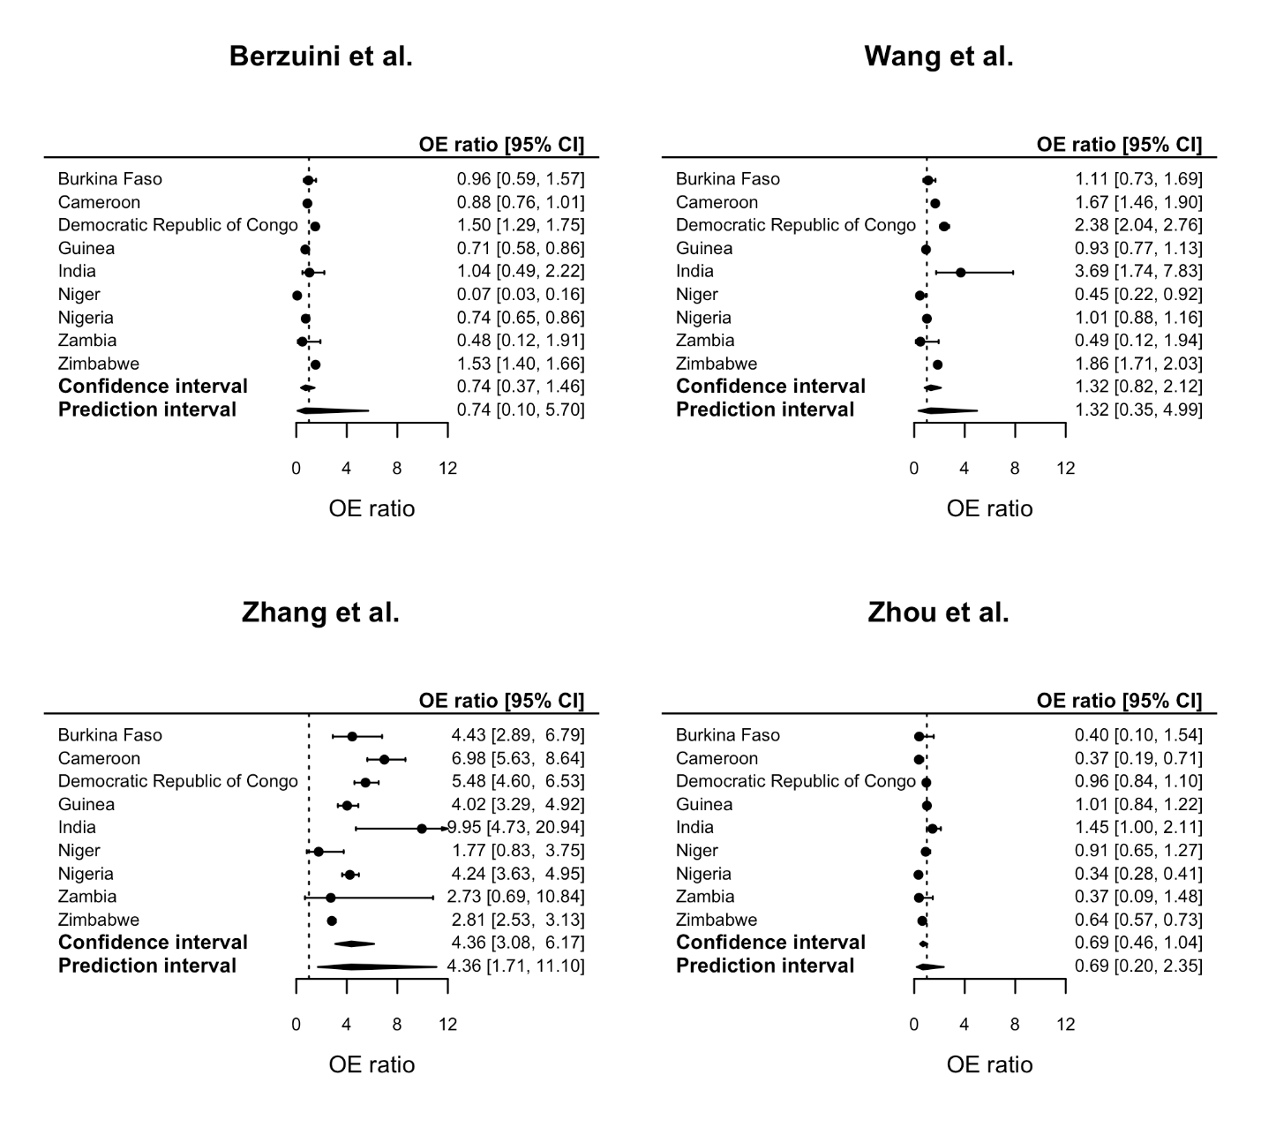

Supplemental Figure 2. Calibration-in-the-large of selected prediction models for predicting in-hospital mortality (Berzuini et al., Wang et al., Zhang et al.) or ICU admission (Zhou et al.)

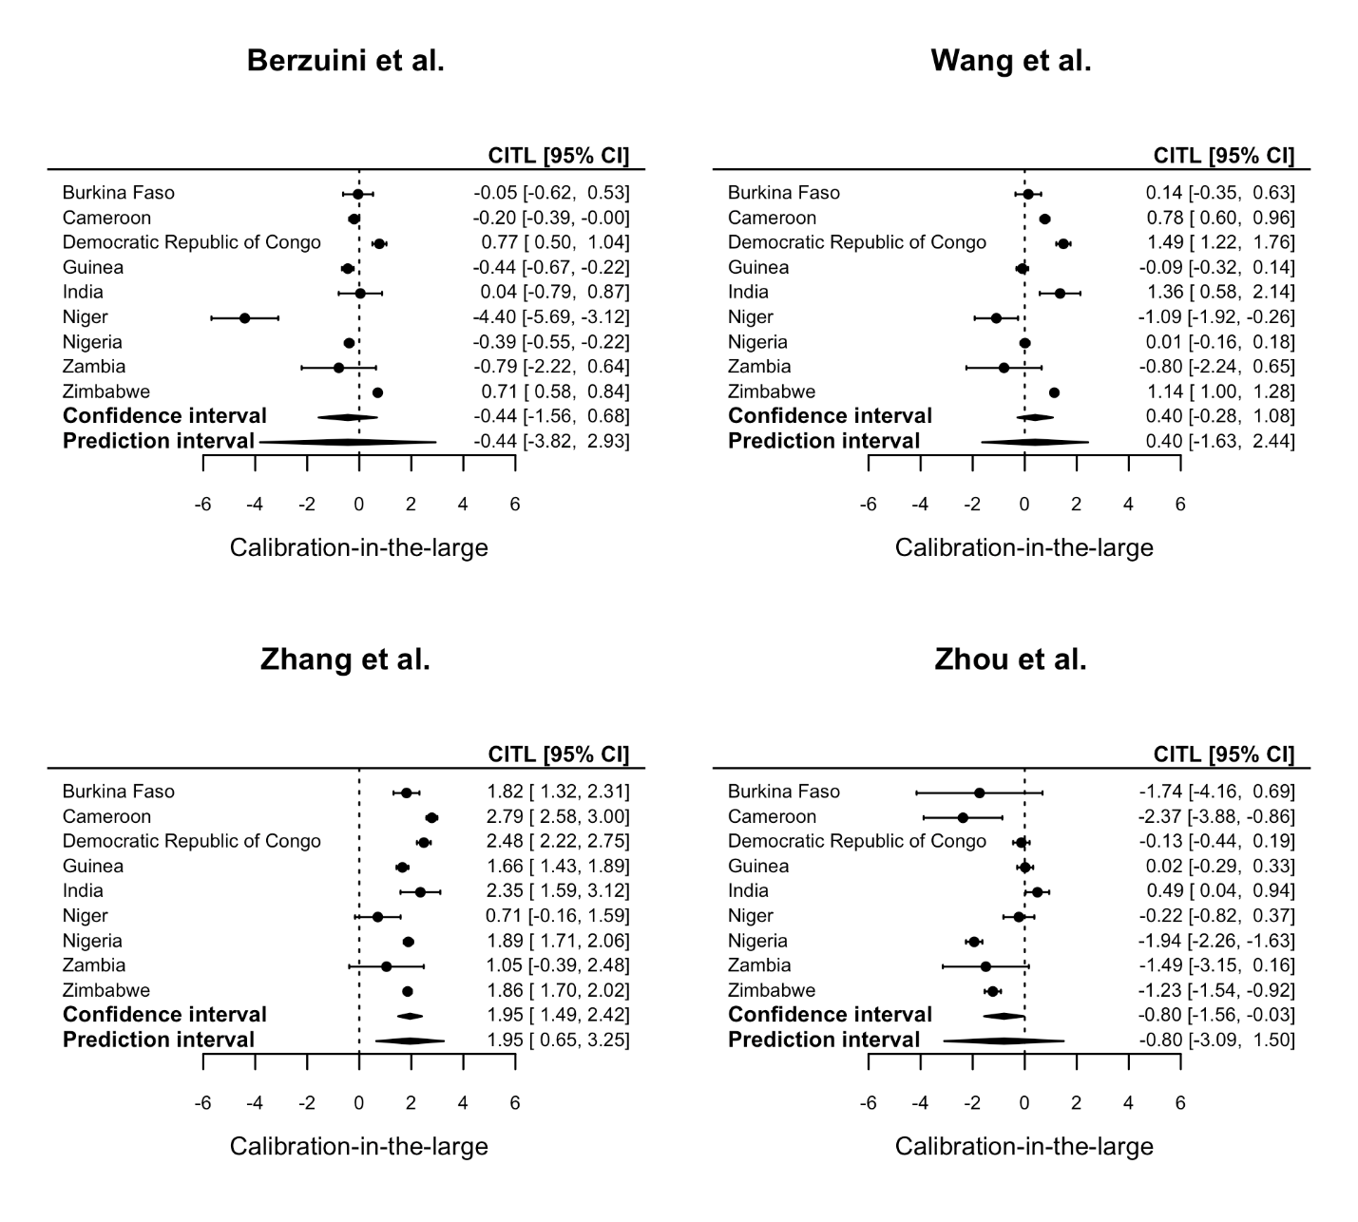

Supplemental Figure 3. Calibration slope of selected prediction models for predicting in-hospital mortality (Berzuini et al., Wang et al., Zhang et al.) or ICU admission (Zhou et al.)

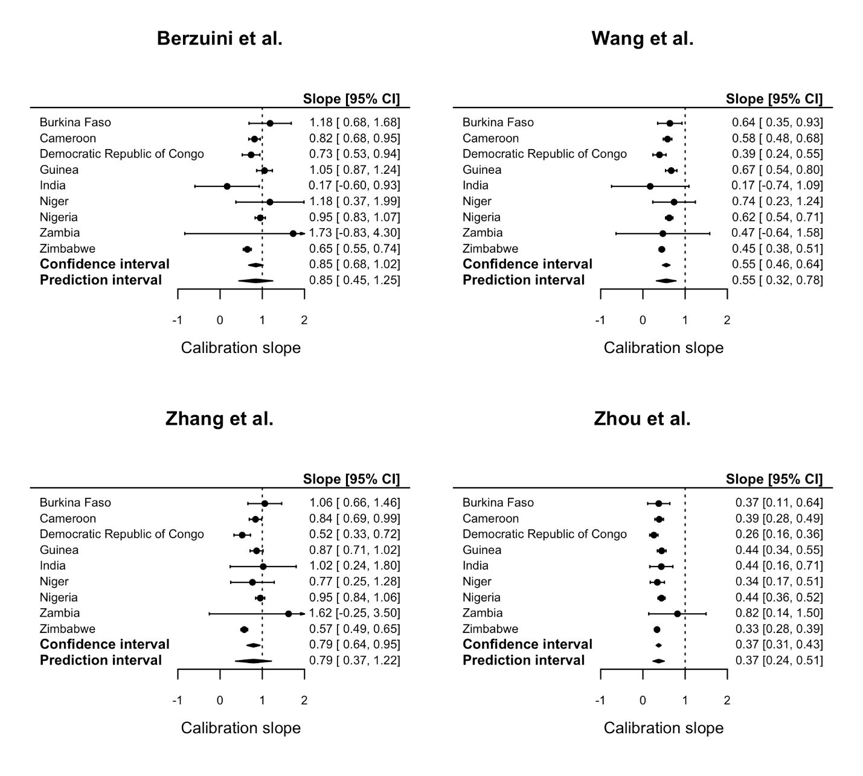

Supplemental Figure 4. Calibration plots for predicted vs observed probabilities of mortality based on Berzuini et al. model by country
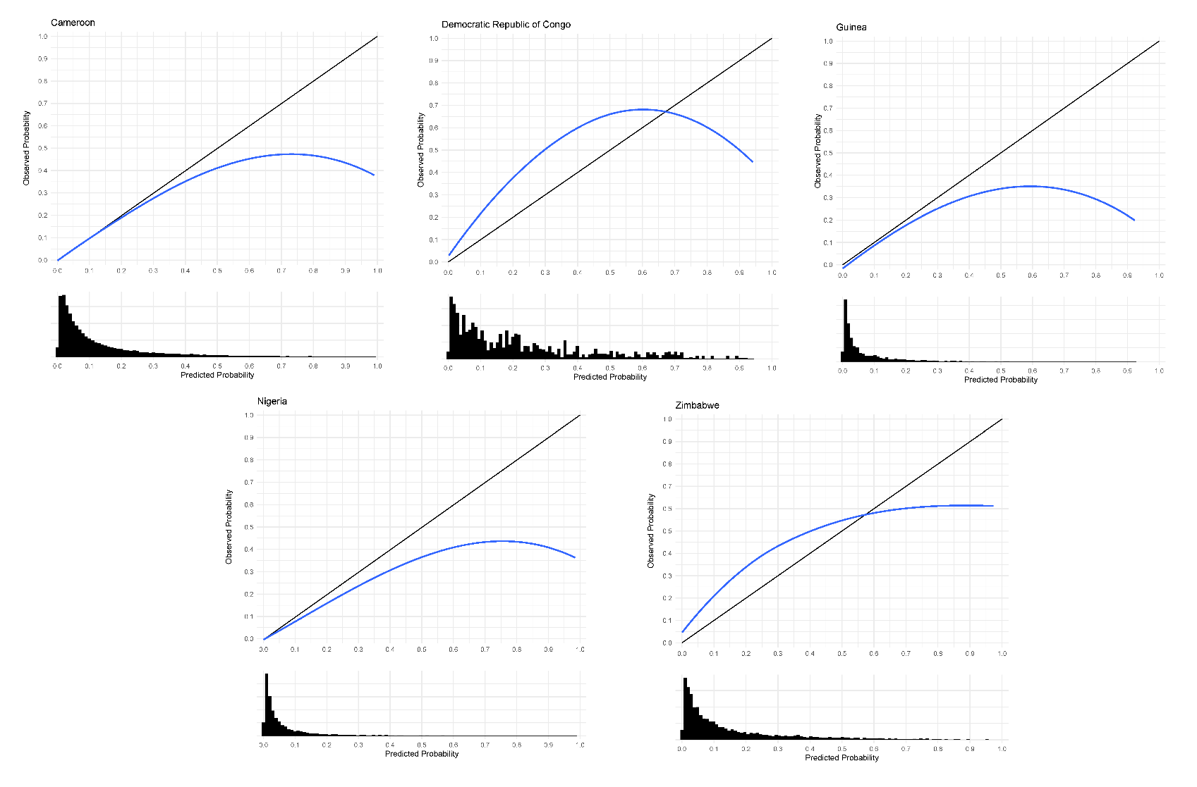
Calibration plots and loess lines were drawn in the stacked dataset (including all 50 imputed datasets) in the total population.

Supplemental Figure 5. Calibration plots for predicted vs observed probabilities of mortality based on Wang et al.model by country
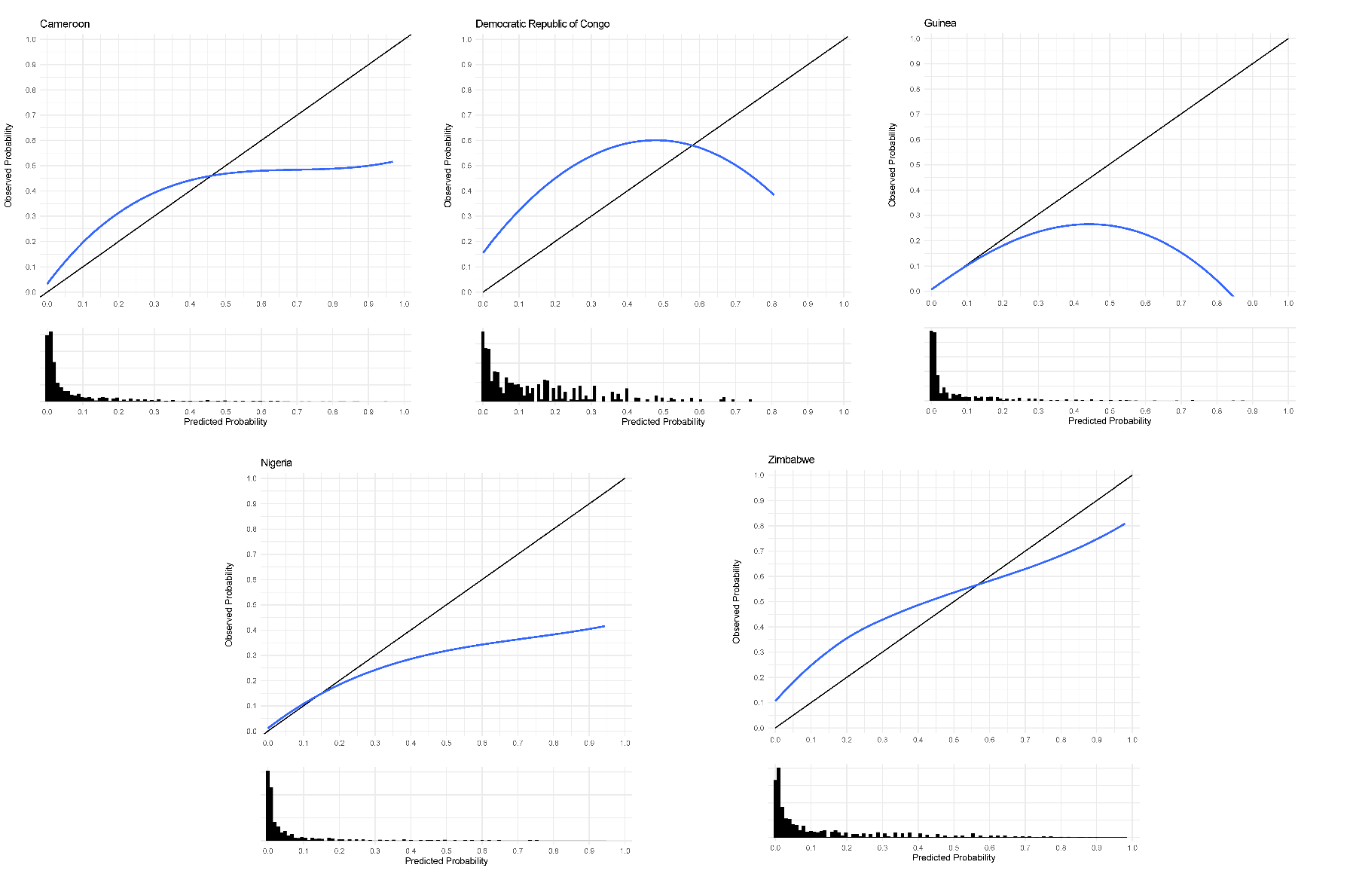
Calibration plots and loess lines were drawn in the stacked dataset (including all 50 imputed datasets) in the total population.

Supplemental Figure 6. Calibration plots for predicted vs observed probabilities of mortality based on Zhang et al.model by country
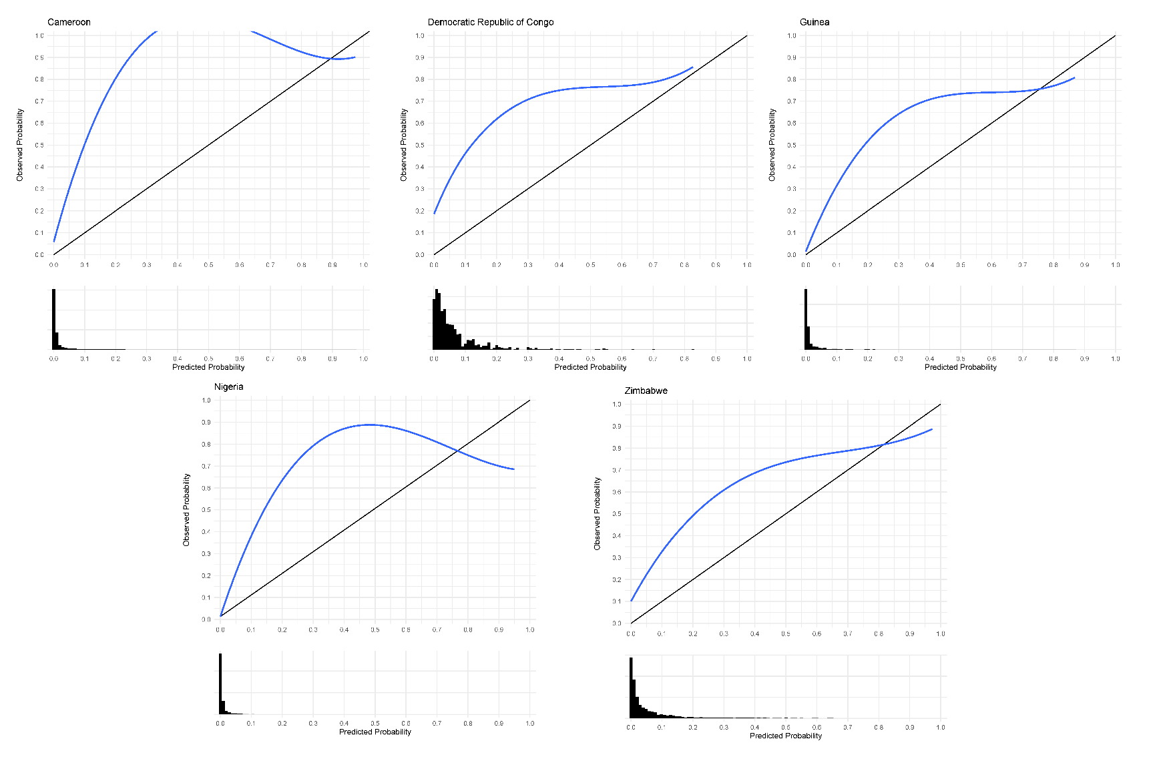
Calibration plots and loess lines were drawn in the stacked dataset (including all 50 imputed datasets) in the total population.

Supplemental Figure 7. Calibration plots for predicted vs observed probabilities of ICU admission based on Zhou et al. model by country
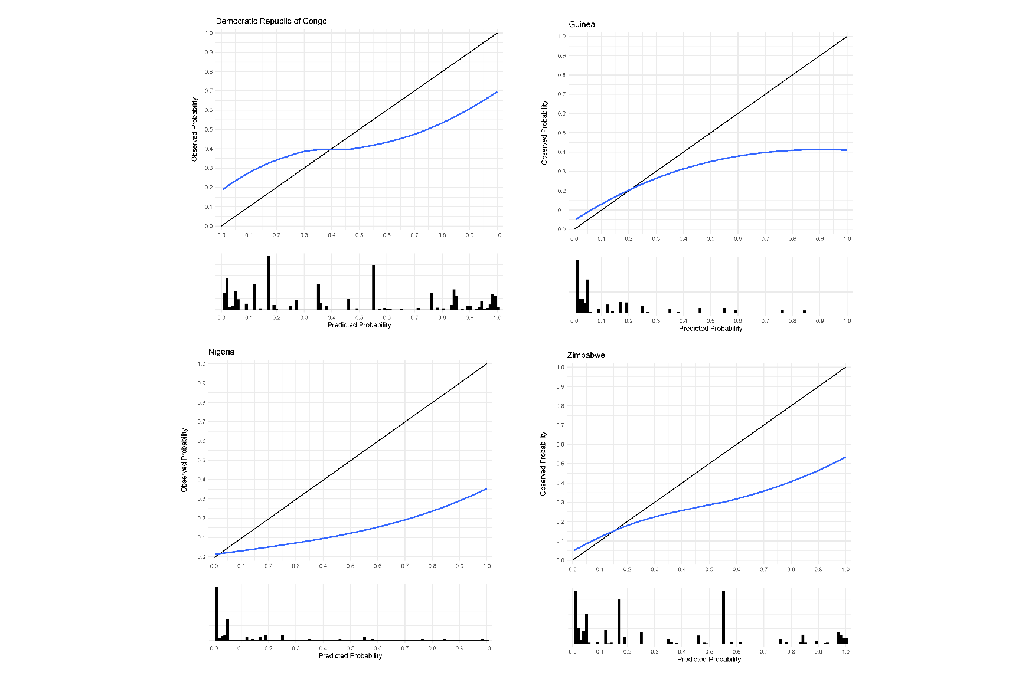
Calibration plots and loess lines were drawn in the stacked dataset (including all 50 imputed datasets) in the total population.

